efrigeration & Air_conditioning System မ်ားအ﻿ေၾကာင္﻿းနွင္﻿့ ျပစ္﻿ခ်က္﻿မ်ားရွာ﻿ေဖြျပဳျပင္﻿ျခင္﻿း
A/C အဲယားကြန္﻿း လုပ္﻿ငန္﻿းမ်ား လုပ္﻿ကုိင္﻿﻿ေန﻿ေသာ
အင္﻿/ယာမ်ားနွင္﻿့တစ္﻿ကြ ပညာရွင္﻿မ်ားအားလံုးအတြက္﻿
ျပန္﻿လည္﻿မ်ွ﻿ေဝပါသည္﻿။ A/C #Note မ်ား
လူၿပိန္﻿းနားလည္﻿﻿ေစရန္﻿ပါ ﻿ေရးသားသည္﻿့အတြက္﻿
မည္﻿သူမဆုိ လြယ္﻿ကူစြာ﻿ေလ့လာႏုိင္﻿မည္﻿ဟု ထင္﻿ပါ၏။
===================================
#Q : Refrigeration System မွာ Overcharge ျဖစ္﻿ရင္﻿ ဘာျဖစ္﻿မလဲ ? ဘာလုပ္﻿မလဲ ?
* Compressor Discharge Pressure တက္﻿မယ္﻿။
* Compressor ﻿ေအး﻿ေနမယ္﻿။
* Compressor suction line မွာ Frost တက္﻿မယ္﻿။
* ျပဳျပင္﻿ရန္﻿မွာ - condenser အ﻿ေပၚမွာရွိတဲ့ Air Purging v/v ကုိဖြင္﻿့ၿပီး Refrigerant ﻿ေလ်ွာ႔ Discharge pressure မွန္﻿ရင္﻿ရပ္﻿လိမ့္﻿မယ္﻿။
===================================
#Q : Refrigeration System မွာ Under Charge ျဖစ္﻿ရင္﻿ ဘာျဖစ္﻿မလဲ ။ ဘာလုပ္﻿မလဲ ?
* Compressor Discharge pressure က်မယ္﻿။
* Compressor Dicharge Temperature တက္﻿မယ္﻿။
* Liquid sight glass မွာ Large bubble ﻿ေတြ﻿ေတြ႕ရမယ္﻿။
* Running Period ၾကာမယ္﻿။
* ျပဳျပင္﻿ရန္﻿မွာ - Liquid sight glass တြင္﻿ bubble မ်ား﻿ေပ်ာက္﻿သည္﻿အထိ Refrigerant ျဖည္﻿့﻿ေပးရမည္﻿။
===================================
#Q : Refrigeration System မွာ High pressure cut out ျဖစ္﻿ရင္﻿ ဘာလုပ္﻿မလဲ ဘာလုိ႔ျဖစ္﻿တာလဲ။
:) ျဖစ္﻿ရျခင္﻿း အ﻿ေၾကာင္﻿းအရင္﻿းကုိရွာရမယ္﻿။ ျပဳျပင္﻿မယ္﻿။ Reset လုပ္﻿ၿပီးျပန္﻿﻿ေမာင္﻿းမယ္﻿
:) High Pressure cut out ျဖစ္﻿ရျခင္﻿းအ﻿ေၾကာင္﻿းအရင္﻿း﻿ေတြက
* Cooling water failure ျဖစ္﻿လုိ႔
* Condenser Tube ﻿ေတြမွာ Scale မ်ားလုိ႔
* Over charge ျဖစ္﻿﻿ေနလုိ႔
===================================
#Q : Refrigeration system short cycling ျဖစ္﻿﻿ေနရင္﻿ ဘယ္﻿လုိသိမလဲ။ ျဖစ္﻿﻿ေနရင္﻿ ဘာလုပ္﻿မလဲ ဘာလုိ႔ျဖစ္﻿တာလဲ ။
Refrigeration Compressor ﻿ေမာင္﻿းလုိက္﻿ ရပ္﻿လုိက္﻿ မၾကာခဏျဖစ္﻿﻿ေနရင္﻿ (အခ်ိန္﻿တုိ အတြင္﻿းမွာျဖစ္﻿﻿ေနရင္﻿ ) Short Cycling ျဖစ္﻿တာ။
Short Cycle ျဖစ္﻿ရျခင္﻿းမွာ
* Expension valve choke ျဖစ္﻿လုိ႔
* Filter choke ျဖစ္﻿လုိ႔
* Dehydrator choke ျဖစ္﻿လုိ႔
ျပဳျပင္﻿ရန္﻿မွာ - Filter clean လုပ္﻿မယ္﻿။ Dehydrator အသစ္﻿လဲမယ္﻿။ Expension v/v choke ျဖစ္﻿ရျခင္﻿းအ﻿ေၾကာင္﻿းမွာ Sytem ထဲတြင္﻿ Moisture ﻿ေတြပါလုိ႔။ ဖုန္﻿အညစ္﻿အ﻿ေၾကး﻿ေတြ ပါလုိ႔။
===================================
#Q : R12 compound gauge ကုိ R22 systm မွာ သံုးလုိ႔ရမလား ။ မရရင္﻿ ဘာ﻿ေၾကာင္﻿့မရတာလဲ ?
- မရပါဘူး။
- Pressure သာအမွန္﻿ျပၿပီး Temperature အမွန္﻿မျပ﻿ေတာ့ပါ။
- ဘာ﻿ေၾကာင္﻿့လဲဆုိ﻿ေတာ့ R12 နဲ႔ R22 boiling point temperature မတူညီလုိ႔ပဲျဖစ္﻿တယ္﻿။
===================================
#Q : Solenoid v/v & Expension v/v ဘယ္﻿မွာထားလဲ။
• Solenoid v/v & expension v/v ၂ ခုလံုး Refrigeration system မွာရွိပါတယ္﻿။
• Solenoid v/v သည္﻿ condenser နွင္﻿့ expension v/v ၾကားမွာရွိပါတယ္﻿။
• Expension v/v သည္﻿ solenoid v/v နွင္﻿့ evaporator ၾကားမွာရွိပါတယ္﻿။
===================================
#Q: Refrigeration system မွာ compressor suction pressure & discharge pressure ဘယ္﻿﻿ေလာက္﻿ရွိသလဲ?
In R12 : Compressor suction pressure & Temperature -2kg/cm2 & -10°C
: Compressor discharge pressure & Temperature -8.5kg/cm2 & 93°C
In R22 : Compressor suction pressure & Temperature 3.5kg/cm2 & -10°C
: Compressor discharge pressure & Temperature 13kg/cm2 & 93°C
: Oil Pressure 3-8 kg/cm2
In NH3 : Compressor suction pressure -2kg/cm2
: Compressor discharge pressure 11.5kg/cm2
===================================
#Q : Refrigeration System မွာ High pressure cut out နဲ႔ Low Pressure cut out ဘာကြာသလဲ ?
* High Pressure cut out ျဖစ္﻿ရင္﻿ Reset လုပ္﻿ၿပီးမွ ျပန္﻿﻿ေမာင္﻿းလုိ႔ရတယ္﻿။ H/P cut out က Compressor discharge side မွာရွိတယ္﻿။
* Low pressure cut out ျဖစ္﻿ရင္﻿ suction pressure ျပန္﻿တက္﻿လာတဲ့ အခါမွ cut in ျပန္﻿ျဖစ္﻿ၿပီး compressor ျပန္﻿လည္﻿လာပါတယ္﻿။ low pressure cut out က compressor suction side မွာရွိတယ္﻿
* (Cool Room temperature တက္﻿လာလုိ႔ thermostat က solenoid v/v ကုိျပန္﻿ပြင္﻿့သြားတဲ့အတြက္﻿ suction pressure ျပန္﻿တက္﻿လာမယ္﻿။)
===================================
#Q : Refrigerant ရဲ႕ Property ﻿ေတြကုိ﻿ေျပာျပပါ။
* Low boiling point temperature
* High critial temperature
* Non corrosive
* Non Toxic
* Non Flamable and non explosive
* Non chemical reaction with L.O
* Low Condensing pressure
* Easy leak detecting
* High Latent heat
* Stable under working conditio
* Cheap and Easily stored
===================================
#Q : Refrigeration System မွာ leakage ဘယ္﻿လုိစမ္﻿းမလဲ ?
- R12 နဲ႔ R22 သံုးရင္﻿ leakage နဲရင္﻿ Haylydé Torch နဲ႔စမ္﻿းမယ္﻿။ Haylydé Torch မီး﻿ေတာက္﻿အစိမ္﻿း﻿ေရာင္﻿﻿ေျပာင္﻿းသြားရင္﻿ Leakage ရွိတယ္﻿။
- Leakage မ်ားရင္﻿ ဆပ္﻿ျပာ﻿ေရနဲ႔စမ္﻿းမယ္﻿။ Bubble ထလာရင္﻿ Leakage အ﻿ေပါက္﻿ရွိတယ္﻿။
- Ammoia ဆုိရင္﻿ Litmas paper နဲ႔စမ္﻿းမယ္﻿။ အျပာ﻿ေရာင္﻿﻿ေျပာင္﻿းသြားခဲ့ရင္﻿ Leakage ရွိတယ္﻿။
- (Leakage အနဲအမ်ားကုိ Pressure & Reciever sight glass level ကုိၾကည္﻿့ပါ။)
===================================
#Q : Refrigeration system မွာ Refrigeration ကုိ Purging လုပ္﻿ရင္﻿ဘယ္﻿ကုိထုတ္﻿မလဲ?
* Feron System ဆုိရင္﻿ ﻿ေလထဲကုိပဲထုတ္﻿ျပစ္﻿မယ္﻿။
* Ammonia သံုးရင္﻿ ﻿ေရပံုးထဲက ﻿ေရထဲကုိ စြန္﻿႔ထုတ္ မယ္﻿။Ammonia ကေရထဲမွာပဲ﻿ေပ်ာ္﻿ဝင္﻿တယ္﻿။
* Vacuum မျဖစ္﻿ရန္﻿သတိျပဳပါ။ Purge လုပ္﻿﻿ေနစဥ္﻿ System ထဲမွာ Vacuum ျဖစ္﻿ပါက ﻿ေရမ်ား Systemထဲဝင္﻿ရာက္﻿လာမည္﻿။ (Ammonia Sytem မွာ Relief valve ﻿ေပါက္﻿ရင္﻿ compressor suction ဘက္﻿ကုိျပန္﻿ဝင္﻿လိမ့္﻿မယ္﻿။
===================================
#Q : Air_conditioning System မွာ Temperature ဘယ္﻿လုိခ်ိန္﻿ညႇိမလဲ။ဘယ္﻿လို Control လုပ္﻿မလဲ ?
Temperature ခ်ိန္﻿ဖုိ႔ Thermostat ရွိတယ္﻿။ အခန္﻿းရဲ႕ Temperatue အတက္အက်ဟာ Thermostat အ﻿ေပၚမူတည္﻿ၿပီး အရးႀကီးတာက ဘယ္﻿လုိ Air_condition မ်ဳိးလဲ :) Individual (or) Common Single Air duct လား။ Individual ကုိယ္﻿့အခန္﻿းနဲ႔ ကုိယ္﻿ဆုိ Portable thermostat နဲ႔ temperature အတင္﻿အခ်လုပ္﻿လုိ႔ရတယ္﻿။ Common Room System ဆုိဘံုတုိး/﻿ေလ်ွာ႔သြားမယ္﻿။ ကုိယ္﻿့အခန္﻿းထဝင္﻿﻿ေနတဲ့ ﻿ေလကုိပဲ အတုိးအ﻿ေလ်ွာ႔လုပ္﻿﻿ေပးရမယ္﻿။
===================================
#Q : Refrigeration မွာ Pumping Down လုပ္﻿ျပပါ။ Safety Device အ﻿ေနနဲ႔ ဘာ﻿ေတြထားလဲ ?
Pumping down ဆုိတာ ျမန္﻿မာလုိဘာသာျပန္﻿﻿ေတာ့ ﻿ေလခ်ဴတာကုိ﻿ေခၚတယ္﻿။ ﻿ေလခ်ဴတာပဲျဖစ္﻿ျဖစ္﻿ switch plant တစ္﻿ခုကုိ ရပ္﻿ခ်င္﻿ရင္﻿ပဲျဖစ္﻿ျဖစ္﻿ ရပ္﻿တဲ့ Procedure :)
* Condenser Out let မပိတ္﻿ခင္﻿ Plant ကုိ Auto မွ Manual သုိ႔﻿ေျပာင္﻿း﻿ေမာင္﻿းရမယ္﻿။ ဘာ﻿ေၾကာင္﻿့လဲဆုိ﻿ေတာ့ Low Pressure ျဖစ္﻿လုိ႔ L.P cut out ျဖဳတ္﻿ခ်လုိ႔ Plant ရပ္﻿သြားၿပီး Nearly Zero (0) ျဖစ္﻿﻿ေအာင္﻿ ﻿ေမာင္﻿းလုိ႔မရတဲ့အတြက္﻿ေၾကာင္﻿့ပါ။
ဒါ﻿ေ﻿ၾကာင္﻿့ Auto ﻿ေမာင္﻿းလုိ႔မရဘူး။
(1) Compressor Change over auto to manual
(2) Condenser outlet v/v ကုိပိတ္﻿မယ္﻿။ၿပီးရင္﻿
Refrigerant ﻿ေတြအားလံုးကုိ Condenser ထဲမွာသြားစုမယ္﻿။ Return ကလည္﻿းမလာ﻿ေတာ့ဘူး။ Suction pressure က်လာမယ္﻿။ Suction pressure က Just about Zero(0) .
Zero ﻿ေတာ့မဟုတ္﻿ဘူး Vacuum ျဖစ္﻿မွာဆုိးလုိ႔ အဲ့မွာရပ္﻿မယ္﻿။
(3) ၿပီးရင္﻿ Condenser inlet valve ကုိပိတ္﻿လုိက္﻿။
Safety Device
1) L.P cut out
2) H.P cut out
3) Cooling water failure cut out
4) L.O failure cut out
5) Relief valve on condenser (ကြန္﻿ဒန္﻿ဆာအ﻿ေပၚက Relief v/v)
Air Purging လုပ္﻿တဲ့အခါ Condenser in /out Sea Water temperatuee တူမွလုပ္﻿လုိ႔ရတယ္﻿။ Liquid ျဖစ္﻿လာရင္﻿ temperature မ﻿ေျပာင္﻿း﻿ေတာ့ဘူး။
Air Purging လုပ္﻿တဲ့အခါ Refrigerant liquid ထြက္﻿လာမွပိတ္﻿လုိက္﻿။ Sight Glass မွာ Small bubble ﻿ေတြ႕လိမ့္﻿မယ္﻿။
===================================
#IMPORTANT
R22 Gas သည္﻿ ကမ႓ာ့ Ozone အလႊာ ကုိထိခုိက္﻿ႏုိင္﻿﻿ေစတာမုိ႔ ခ်မ္﻿းသာတဲ့ ႏုိင္﻿ငံအမ်ားစုမွာ လံုးဝသံုးစြဲ﻿ေရာင္﻿းခ်ခင္﻿့ ပိတ္﻿ပင္﻿ၿပီး အစားထုိးအ﻿ေနနဲ႔ R410a ကုိအသံုးျပဳလာၾကပါၿပီ။
ျမန္﻿မာႏုိင္﻿ငံ အ﻿ေနနဲ႔﻿ေတာ့မသိလုိ႔ပဲလား? မသိခ်င္﻿ဟန္﻿﻿ေဆာင္﻿﻿ေနတာပဲလား﻿ေတာ့မသိဘူး။?
A/C service technician ﻿ေတာ္﻿﻿ေတာ္﻿မ်ားမ်ား A/C ﻿ေတြ maintenance :)(သုိ႔မဟုတ္﻿ ) Installation လုပ္﻿ၿပီဆုိရင္﻿ လက္﻿ကကုိင္﻿ထားတဲ့ Gas အုိး﻿ေလးက R22 ျဖစ္﻿﻿ေနတက္﻿လုိ႔ပါပဲ။ ျဖစ္﻿ႏုိင္﻿ရင္﻿ R410a ကုိအစားထုိးအသံုးျပဳၾကပါလုိ႔ အႀကံ﻿ေပးပါရ﻿ေစ။
ဆရာလုပ္﻿ျခင္﻿းလုံးဝမဟုတ္﻿ပါ။
ႏုိင္﻿ငံကုိ ကာကြယ္﻿ခ်င္﻿တဲ့ သ﻿ေဘာဆနၵသက္﻿သက္﻿ပါ။
﻿ေအာက္﻿ပါပံု﻿ေလးမ်ားကုိ တြဲဖက္﻿ၾကည္﻿့ၾကပါ။
=====================================
THE MAIN FUNCTIONS OF THERMOSTATIC EXPANSION VALVE (T.E.V)
1. Automatic and prompt response of refrigerant flow to match Evaporator Load
2. Prevention of Liquid Refrigerant being entered into the compressor
3. Maintaining appropriate amounts of Refrigerant in the High pressure side and Low pressure side of the
system
#SENSIBLE_HEAT
Heat given to or taken from a substance which raises or lowers its temperature respectively.
#LATENT_HEAT
Heat given to or taken from a substance which changes its state without changing its temperature.
#BASIC_OPERATIONAL_FEATURES
The System mainly consists of Compressor, Oil Separator, Condenser and /or Liquid Reservoir, Drier,Expansion Valve and Evaporator Unit.The compressor is started and stopped by L.P cut out in response to the compressor suction pressure. TheH.P cut out with a hand reset which shut down the compressor in the event of high discharge pressure.The compressor supplies a number of cold rooms through thermostatically controlled solenoid valve.
And when each room temperature has been brought down, its solenoid will close off the liquid refrigerantsto that space. When all compartments’ solenoid are shut, the pressure drop in the compressor suction will actuatesthe L.P cut out and stop the compressor in turn.Subsequent rise of room temperature will cause the solenoid to reopen by the room thermostats.
Thatpressure refrigerants flooding at the compressor suction will cause the L.P cut out to restart the compressor.
Master Solenoid Valve may be fitted on larger system to prevent liquid refrigerants flooding at theCompressor suction side if when the compressor is stopped due to some fault.Each room has a T.E.V as the regulator through which the correct amount of refrigerant is passed,expanded and the via the Evaporator the refrigerants evaporated, and return back to the compressor suction asvapor side.
Air blown through the Evaporator acts as a secondary refrigerant and it cool down the things inside theroom and Regulator defrosting must be done to keep the evaporator free from ice by means of electric heatingelements through timer unit.
===================================
#SYSTEM_ERROR
* Air in the system
This is indicated by abnormal and shaking of compressor discharge pressure gauge reading and sight
glass shows small air bubbles.
It can be removed by pumping down the system into the condenser or reservoir and let cooling water
running for some period. Then air at the top of the refrigerant can be purged out from the vent valve.
===================================
* PRESENCE OF N.C.G (Non Condensable Gas)
Its effect to raise the delivery pressure which it turn increases the rate of wear of the compressor and its
power consumption. Non condensable gases may be due to
1. Air left in the system after installation or repair where evacuation was not carried out properly.
2. Air drawn in through leaking joints on the L.P side of the system.
3. Chemical breakdown of refrigerant or oil owing to high delivery temperature
It can be detected by ; when standing head pressure will be greater than the vapor pressure of the
refrigerant at the surrounding air temperature.
===================================
* MOISTURE IN THE SYSTEM.
This is indicated by blockage in the line especially at the expansion valve. The machine tends to stop bythe H.P cut out. In some plant, the presence of moisture can be observed at the liquid sight glass where it providesan colour indicators. The level of Moisture in the system being limited as safe 15 ppm for R 12 plant and 60 ppm forR22 plant.It can be removed by renewing Drying agents. They are Activated Alumina, Silica Gel, Molecular sievesand calcium Oxide.
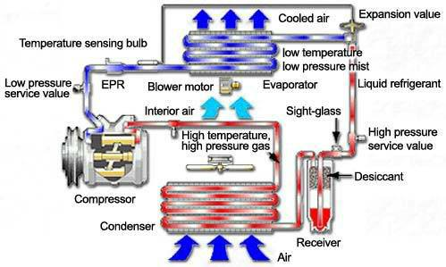
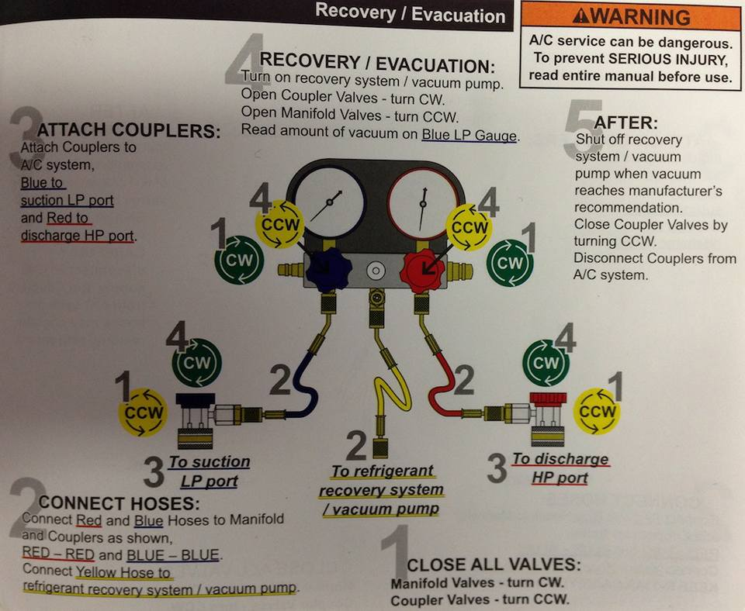
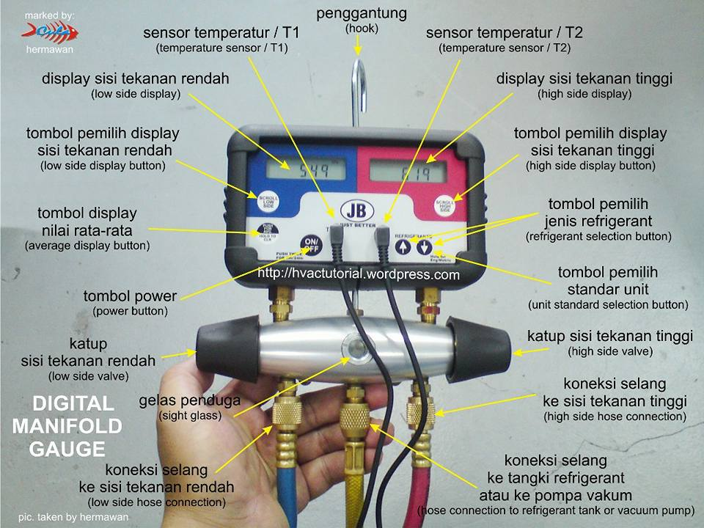
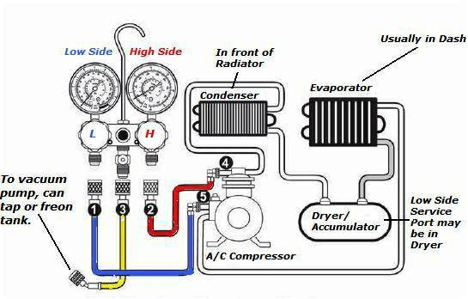
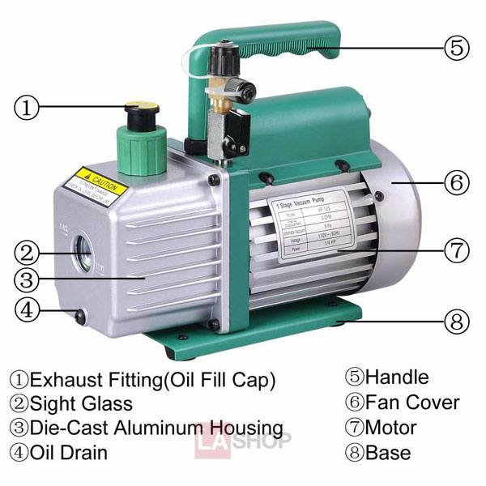
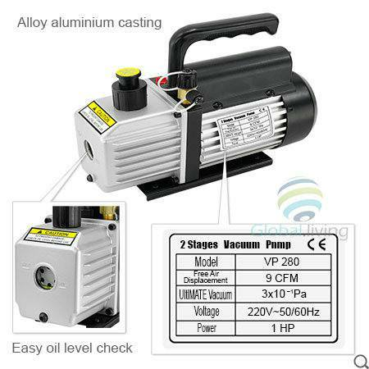
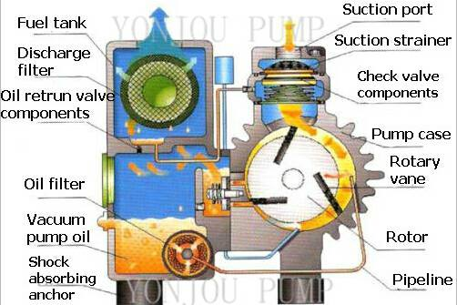
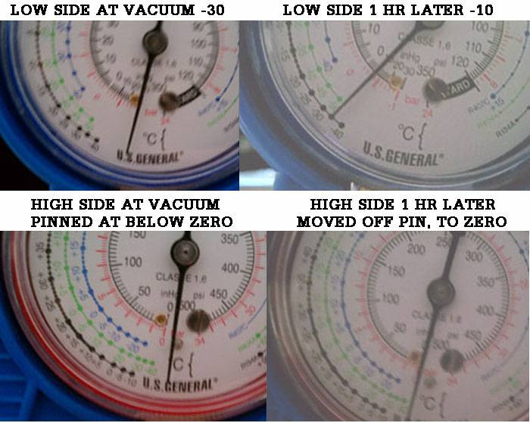
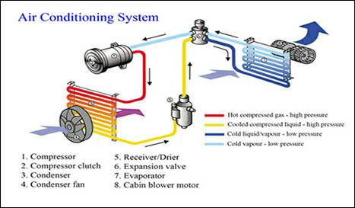
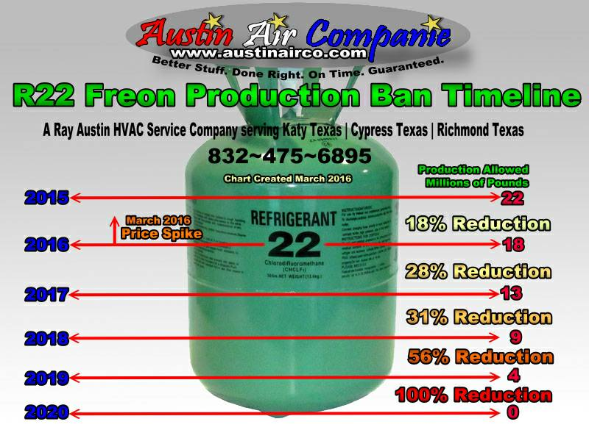
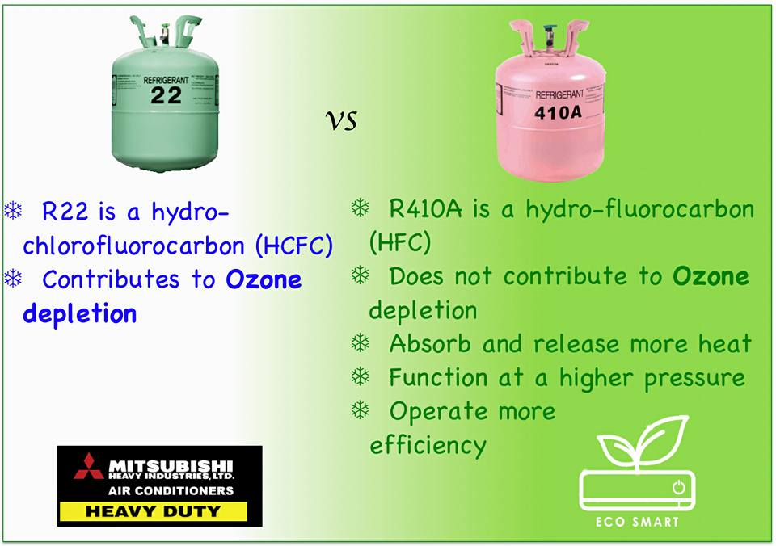
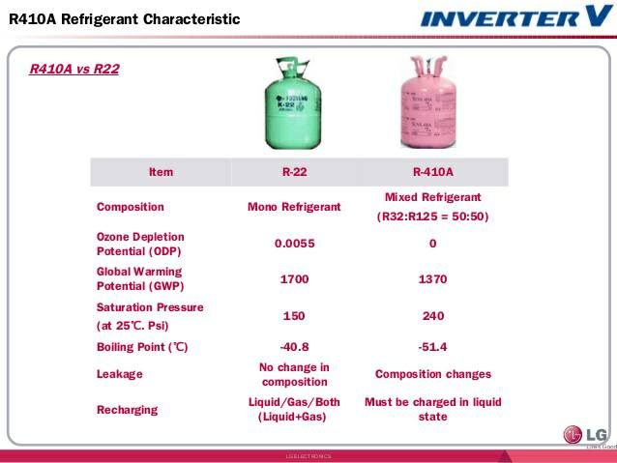
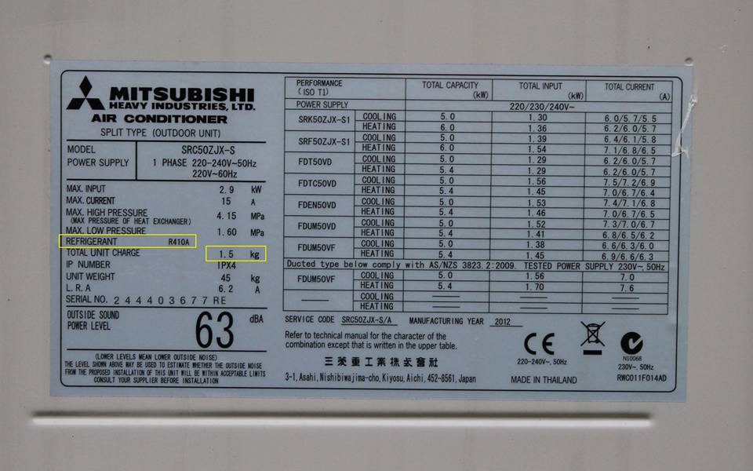
efrigeration & Air_conditioning System မ်ားအ﻿ေၾကာင္﻿းနွင္﻿့ ျပစ္﻿ခ်က္﻿မ်ားရွာ﻿ေဖြျပဳျပင္﻿ျခင္﻿း
A/C အဲယားကြန္﻿း လုပ္﻿ငန္﻿းမ်ား လုပ္﻿ကုိင္﻿﻿ေန﻿ေသာ
အင္﻿/ယာမ်ားနွင္﻿့တစ္﻿ကြ ပညာရွင္﻿မ်ားအားလံုးအတြက္﻿
ျပန္﻿လည္﻿မ်ွ﻿ေဝပါသည္﻿။ A/C #Note မ်ား
လူၿပိန္﻿းနားလည္﻿﻿ေစရန္﻿ပါ ﻿ေရးသားသည္﻿့အတြက္﻿
မည္﻿သူမဆုိ လြယ္﻿ကူစြာ﻿ေလ့လာႏုိင္﻿မည္﻿ဟု ထင္﻿ပါ၏။
===================================
#Q : Refrigeration System မွာ Overcharge ျဖစ္﻿ရင္﻿ ဘာျဖစ္﻿မလဲ ? ဘာလုပ္﻿မလဲ ?
* Compressor Discharge Pressure တက္﻿မယ္﻿။
* Compressor ﻿ေအး﻿ေနမယ္﻿။
* Compressor suction line မွာ Frost တက္﻿မယ္﻿။
* ျပဳျပင္﻿ရန္﻿မွာ - condenser အ﻿ေပၚမွာရွိတဲ့ Air Purging v/v ကုိဖြင္﻿့ၿပီး Refrigerant ﻿ေလ်ွာ႔ Discharge pressure မွန္﻿ရင္﻿ရပ္﻿လိမ့္﻿မယ္﻿။
===================================
#Q : Refrigeration System မွာ Under Charge ျဖစ္﻿ရင္﻿ ဘာျဖစ္﻿မလဲ ။ ဘာလုပ္﻿မလဲ ?
* Compressor Discharge pressure က်မယ္﻿။
* Compressor Dicharge Temperature တက္﻿မယ္﻿။
* Liquid sight glass မွာ Large bubble ﻿ေတြ﻿ေတြ႕ရမယ္﻿။
* Running Period ၾကာမယ္﻿။
* ျပဳျပင္﻿ရန္﻿မွာ - Liquid sight glass တြင္﻿ bubble မ်ား﻿ေပ်ာက္﻿သည္﻿အထိ Refrigerant ျဖည္﻿့﻿ေပးရမည္﻿။
===================================
#Q : Refrigeration System မွာ High pressure cut out ျဖစ္﻿ရင္﻿ ဘာလုပ္﻿မလဲ ဘာလုိ႔ျဖစ္﻿တာလဲ။
:) ျဖစ္﻿ရျခင္﻿း အ﻿ေၾကာင္﻿းအရင္﻿းကုိရွာရမယ္﻿။ ျပဳျပင္﻿မယ္﻿။ Reset လုပ္﻿ၿပီးျပန္﻿﻿ေမာင္﻿းမယ္﻿
:) High Pressure cut out ျဖစ္﻿ရျခင္﻿းအ﻿ေၾကာင္﻿းအရင္﻿း﻿ေတြက
* Cooling water failure ျဖစ္﻿လုိ႔
* Condenser Tube ﻿ေတြမွာ Scale မ်ားလုိ႔
* Over charge ျဖစ္﻿﻿ေနလုိ႔
===================================
#Q : Refrigeration system short cycling ျဖစ္﻿﻿ေနရင္﻿ ဘယ္﻿လုိသိမလဲ။ ျဖစ္﻿﻿ေနရင္﻿ ဘာလုပ္﻿မလဲ ဘာလုိ႔ျဖစ္﻿တာလဲ ။
Refrigeration Compressor ﻿ေမာင္﻿းလုိက္﻿ ရပ္﻿လုိက္﻿ မၾကာခဏျဖစ္﻿﻿ေနရင္﻿ (အခ်ိန္﻿တုိ အတြင္﻿းမွာျဖစ္﻿﻿ေနရင္﻿ ) Short Cycling ျဖစ္﻿တာ။
Short Cycle ျဖစ္﻿ရျခင္﻿းမွာ
* Expension valve choke ျဖစ္﻿လုိ႔
* Filter choke ျဖစ္﻿လုိ႔
* Dehydrator choke ျဖစ္﻿လုိ႔
ျပဳျပင္﻿ရန္﻿မွာ - Filter clean လုပ္﻿မယ္﻿။ Dehydrator အသစ္﻿လဲမယ္﻿။ Expension v/v choke ျဖစ္﻿ရျခင္﻿းအ﻿ေၾကာင္﻿းမွာ Sytem ထဲတြင္﻿ Moisture ﻿ေတြပါလုိ႔။ ဖုန္﻿အညစ္﻿အ﻿ေၾကး﻿ေတြ ပါလုိ႔။
===================================
#Q : R12 compound gauge ကုိ R22 systm မွာ သံုးလုိ႔ရမလား ။ မရရင္﻿ ဘာ﻿ေၾကာင္﻿့မရတာလဲ ?
- မရပါဘူး။
- Pressure သာအမွန္﻿ျပၿပီး Temperature အမွန္﻿မျပ﻿ေတာ့ပါ။
- ဘာ﻿ေၾကာင္﻿့လဲဆုိ﻿ေတာ့ R12 နဲ႔ R22 boiling point temperature မတူညီလုိ႔ပဲျဖစ္﻿တယ္﻿။
===================================
#Q : Solenoid v/v & Expension v/v ဘယ္﻿မွာထားလဲ။
• Solenoid v/v & expension v/v ၂ ခုလံုး Refrigeration system မွာရွိပါတယ္﻿။
• Solenoid v/v သည္﻿ condenser နွင္﻿့ expension v/v ၾကားမွာရွိပါတယ္﻿။
• Expension v/v သည္﻿ solenoid v/v နွင္﻿့ evaporator ၾကားမွာရွိပါတယ္﻿။
===================================
#Q: Refrigeration system မွာ compressor suction pressure & discharge pressure ဘယ္﻿﻿ေလာက္﻿ရွိသလဲ?
In R12 : Compressor suction pressure & Temperature -2kg/cm2 & -10°C
: Compressor discharge pressure & Temperature -8.5kg/cm2 & 93°C
In R22 : Compressor suction pressure & Temperature 3.5kg/cm2 & -10°C
: Compressor discharge pressure & Temperature 13kg/cm2 & 93°C
: Oil Pressure 3-8 kg/cm2
In NH3 : Compressor suction pressure -2kg/cm2
: Compressor discharge pressure 11.5kg/cm2
===================================
#Q : Refrigeration System မွာ High pressure cut out နဲ႔ Low Pressure cut out ဘာကြာသလဲ ?
* High Pressure cut out ျဖစ္﻿ရင္﻿ Reset လုပ္﻿ၿပီးမွ ျပန္﻿﻿ေမာင္﻿းလုိ႔ရတယ္﻿။ H/P cut out က Compressor discharge side မွာရွိတယ္﻿။
* Low pressure cut out ျဖစ္﻿ရင္﻿ suction pressure ျပန္﻿တက္﻿လာတဲ့ အခါမွ cut in ျပန္﻿ျဖစ္﻿ၿပီး compressor ျပန္﻿လည္﻿လာပါတယ္﻿။ low pressure cut out က compressor suction side မွာရွိတယ္﻿
* (Cool Room temperature တက္﻿လာလုိ႔ thermostat က solenoid v/v ကုိျပန္﻿ပြင္﻿့သြားတဲ့အတြက္﻿ suction pressure ျပန္﻿တက္﻿လာမယ္﻿။)
===================================
#Q : Refrigerant ရဲ႕ Property ﻿ေတြကုိ﻿ေျပာျပပါ။
* Low boiling point temperature
* High critial temperature
* Non corrosive
* Non Toxic
* Non Flamable and non explosive
* Non chemical reaction with L.O
* Low Condensing pressure
* Easy leak detecting
* High Latent heat
* Stable under working conditio
* Cheap and Easily stored
===================================
#Q : Refrigeration System မွာ leakage ဘယ္﻿လုိစမ္﻿းမလဲ ?
- R12 နဲ႔ R22 သံုးရင္﻿ leakage နဲရင္﻿ Haylydé Torch နဲ႔စမ္﻿းမယ္﻿။ Haylydé Torch မီး﻿ေတာက္﻿အစိမ္﻿း﻿ေရာင္﻿﻿ေျပာင္﻿းသြားရင္﻿ Leakage ရွိတယ္﻿။
- Leakage မ်ားရင္﻿ ဆပ္﻿ျပာ﻿ေရနဲ႔စမ္﻿းမယ္﻿။ Bubble ထလာရင္﻿ Leakage အ﻿ေပါက္﻿ရွိတယ္﻿။
- Ammoia ဆုိရင္﻿ Litmas paper နဲ႔စမ္﻿းမယ္﻿။ အျပာ﻿ေရာင္﻿﻿ေျပာင္﻿းသြားခဲ့ရင္﻿ Leakage ရွိတယ္﻿။
- (Leakage အနဲအမ်ားကုိ Pressure & Reciever sight glass level ကုိၾကည္﻿့ပါ။)
===================================
#Q : Refrigeration system မွာ Refrigeration ကုိ Purging လုပ္﻿ရင္﻿ဘယ္﻿ကုိထုတ္﻿မလဲ?
* Feron System ဆုိရင္﻿ ﻿ေလထဲကုိပဲထုတ္﻿ျပစ္﻿မယ္﻿။
* Ammonia သံုးရင္﻿ ﻿ေရပံုးထဲက ﻿ေရထဲကုိ စြန္﻿႔ထုတ္ မယ္﻿။Ammonia ကေရထဲမွာပဲ﻿ေပ်ာ္﻿ဝင္﻿တယ္﻿။
* Vacuum မျဖစ္﻿ရန္﻿သတိျပဳပါ။ Purge လုပ္﻿﻿ေနစဥ္﻿ System ထဲမွာ Vacuum ျဖစ္﻿ပါက ﻿ေရမ်ား Systemထဲဝင္﻿ရာက္﻿လာမည္﻿။ (Ammonia Sytem မွာ Relief valve ﻿ေပါက္﻿ရင္﻿ compressor suction ဘက္﻿ကုိျပန္﻿ဝင္﻿လိမ့္﻿မယ္﻿။
===================================
#Q : Air_conditioning System မွာ Temperature ဘယ္﻿လုိခ်ိန္﻿ညႇိမလဲ။ဘယ္﻿လို Control လုပ္﻿မလဲ ?
Temperature ခ်ိန္﻿ဖုိ႔ Thermostat ရွိတယ္﻿။ အခန္﻿းရဲ႕ Temperatue အတက္အက်ဟာ Thermostat အ﻿ေပၚမူတည္﻿ၿပီး အရးႀကီးတာက ဘယ္﻿လုိ Air_condition မ်ဳိးလဲ :) Individual (or) Common Single Air duct လား။ Individual ကုိယ္﻿့အခန္﻿းနဲ႔ ကုိယ္﻿ဆုိ Portable thermostat နဲ႔ temperature အတင္﻿အခ်လုပ္﻿လုိ႔ရတယ္﻿။ Common Room System ဆုိဘံုတုိး/﻿ေလ်ွာ႔သြားမယ္﻿။ ကုိယ္﻿့အခန္﻿းထဝင္﻿﻿ေနတဲ့ ﻿ေလကုိပဲ အတုိးအ﻿ေလ်ွာ႔လုပ္﻿﻿ေပးရမယ္﻿။
===================================
#Q : Refrigeration မွာ Pumping Down လုပ္﻿ျပပါ။ Safety Device အ﻿ေနနဲ႔ ဘာ﻿ေတြထားလဲ ?
Pumping down ဆုိတာ ျမန္﻿မာလုိဘာသာျပန္﻿﻿ေတာ့ ﻿ေလခ်ဴတာကုိ﻿ေခၚတယ္﻿။ ﻿ေလခ်ဴတာပဲျဖစ္﻿ျဖစ္﻿ switch plant တစ္﻿ခုကုိ ရပ္﻿ခ်င္﻿ရင္﻿ပဲျဖစ္﻿ျဖစ္﻿ ရပ္﻿တဲ့ Procedure :)
* Condenser Out let မပိတ္﻿ခင္﻿ Plant ကုိ Auto မွ Manual သုိ႔﻿ေျပာင္﻿း﻿ေမာင္﻿းရမယ္﻿။ ဘာ﻿ေၾကာင္﻿့လဲဆုိ﻿ေတာ့ Low Pressure ျဖစ္﻿လုိ႔ L.P cut out ျဖဳတ္﻿ခ်လုိ႔ Plant ရပ္﻿သြားၿပီး Nearly Zero (0) ျဖစ္﻿﻿ေအာင္﻿ ﻿ေမာင္﻿းလုိ႔မရတဲ့အတြက္﻿ေၾကာင္﻿့ပါ။
ဒါ﻿ေ﻿ၾကာင္﻿့ Auto ﻿ေမာင္﻿းလုိ႔မရဘူး။
(1) Compressor Change over auto to manual
(2) Condenser outlet v/v ကုိပိတ္﻿မယ္﻿။ၿပီးရင္﻿
Refrigerant ﻿ေတြအားလံုးကုိ Condenser ထဲမွာသြားစုမယ္﻿။ Return ကလည္﻿းမလာ﻿ေတာ့ဘူး။ Suction pressure က်လာမယ္﻿။ Suction pressure က Just about Zero(0) .
Zero ﻿ေတာ့မဟုတ္﻿ဘူး Vacuum ျဖစ္﻿မွာဆုိးလုိ႔ အဲ့မွာရပ္﻿မယ္﻿။
(3) ၿပီးရင္﻿ Condenser inlet valve ကုိပိတ္﻿လုိက္﻿။
Safety Device
1) L.P cut out
2) H.P cut out
3) Cooling water failure cut out
4) L.O failure cut out
5) Relief valve on condenser (ကြန္﻿ဒန္﻿ဆာအ﻿ေပၚက Relief v/v)
Air Purging လုပ္﻿တဲ့အခါ Condenser in /out Sea Water temperatuee တူမွလုပ္﻿လုိ႔ရတယ္﻿။ Liquid ျဖစ္﻿လာရင္﻿ temperature မ﻿ေျပာင္﻿း﻿ေတာ့ဘူး။
Air Purging လုပ္﻿တဲ့အခါ Refrigerant liquid ထြက္﻿လာမွပိတ္﻿လုိက္﻿။ Sight Glass မွာ Small bubble ﻿ေတြ႕လိမ့္﻿မယ္﻿။
===================================
#IMPORTANT
R22 Gas သည္﻿ ကမ႓ာ့ Ozone အလႊာ ကုိထိခုိက္﻿ႏုိင္﻿﻿ေစတာမုိ႔ ခ်မ္﻿းသာတဲ့ ႏုိင္﻿ငံအမ်ားစုမွာ လံုးဝသံုးစြဲ﻿ေရာင္﻿းခ်ခင္﻿့ ပိတ္﻿ပင္﻿ၿပီး အစားထုိးအ﻿ေနနဲ႔ R410a ကုိအသံုးျပဳလာၾကပါၿပီ။
ျမန္﻿မာႏုိင္﻿ငံ အ﻿ေနနဲ႔﻿ေတာ့မသိလုိ႔ပဲလား? မသိခ်င္﻿ဟန္﻿﻿ေဆာင္﻿﻿ေနတာပဲလား﻿ေတာ့မသိဘူး။?
A/C service technician ﻿ေတာ္﻿﻿ေတာ္﻿မ်ားမ်ား A/C ﻿ေတြ maintenance :)(သုိ႔မဟုတ္﻿ ) Installation လုပ္﻿ၿပီဆုိရင္﻿ လက္﻿ကကုိင္﻿ထားတဲ့ Gas အုိး﻿ေလးက R22 ျဖစ္﻿﻿ေနတက္﻿လုိ႔ပါပဲ။ ျဖစ္﻿ႏုိင္﻿ရင္﻿ R410a ကုိအစားထုိးအသံုးျပဳၾကပါလုိ႔ အႀကံ﻿ေပးပါရ﻿ေစ။
ဆရာလုပ္﻿ျခင္﻿းလုံးဝမဟုတ္﻿ပါ။
ႏုိင္﻿ငံကုိ ကာကြယ္﻿ခ်င္﻿တဲ့ သ﻿ေဘာဆနၵသက္﻿သက္﻿ပါ။
﻿ေအာက္﻿ပါပံု﻿ေလးမ်ားကုိ တြဲဖက္﻿ၾကည္﻿့ၾကပါ။
=====================================
THE MAIN FUNCTIONS OF THERMOSTATIC EXPANSION VALVE (T.E.V)
1. Automatic and prompt response of refrigerant flow to match Evaporator Load
2. Prevention of Liquid Refrigerant being entered into the compressor
3. Maintaining appropriate amounts of Refrigerant in the High pressure side and Low pressure side of the
system
#SENSIBLE_HEAT
Heat given to or taken from a substance which raises or lowers its temperature respectively.
#LATENT_HEAT
Heat given to or taken from a substance which changes its state without changing its temperature.
#BASIC_OPERATIONAL_FEATURES
The System mainly consists of Compressor, Oil Separator, Condenser and /or Liquid Reservoir, Drier,Expansion Valve and Evaporator Unit.The compressor is started and stopped by L.P cut out in response to the compressor suction pressure. TheH.P cut out with a hand reset which shut down the compressor in the event of high discharge pressure.The compressor supplies a number of cold rooms through thermostatically controlled solenoid valve.
And when each room temperature has been brought down, its solenoid will close off the liquid refrigerantsto that space. When all compartments’ solenoid are shut, the pressure drop in the compressor suction will actuatesthe L.P cut out and stop the compressor in turn.Subsequent rise of room temperature will cause the solenoid to reopen by the room thermostats.
Thatpressure refrigerants flooding at the compressor suction will cause the L.P cut out to restart the compressor.
Master Solenoid Valve may be fitted on larger system to prevent liquid refrigerants flooding at theCompressor suction side if when the compressor is stopped due to some fault.Each room has a T.E.V as the regulator through which the correct amount of refrigerant is passed,expanded and the via the Evaporator the refrigerants evaporated, and return back to the compressor suction asvapor side.
Air blown through the Evaporator acts as a secondary refrigerant and it cool down the things inside theroom and Regulator defrosting must be done to keep the evaporator free from ice by means of electric heatingelements through timer unit.
===================================
#SYSTEM_ERROR
* Air in the system
This is indicated by abnormal and shaking of compressor discharge pressure gauge reading and sight
glass shows small air bubbles.
It can be removed by pumping down the system into the condenser or reservoir and let cooling water
running for some period. Then air at the top of the refrigerant can be purged out from the vent valve.
===================================
* PRESENCE OF N.C.G (Non Condensable Gas)
Its effect to raise the delivery pressure which it turn increases the rate of wear of the compressor and its
power consumption. Non condensable gases may be due to
1. Air left in the system after installation or repair where evacuation was not carried out properly.
2. Air drawn in through leaking joints on the L.P side of the system.
3. Chemical breakdown of refrigerant or oil owing to high delivery temperature
It can be detected by ; when standing head pressure will be greater than the vapor pressure of the
refrigerant at the surrounding air temperature.
===================================
* MOISTURE IN THE SYSTEM.
This is indicated by blockage in the line especially at the expansion valve. The machine tends to stop bythe H.P cut out. In some plant, the presence of moisture can be observed at the liquid sight glass where it providesan colour indicators. The level of Moisture in the system being limited as safe 15 ppm for R 12 plant and 60 ppm forR22 plant.It can be removed by renewing Drying agents. They are Activated Alumina, Silica Gel, Molecular sievesand calcium Oxide.
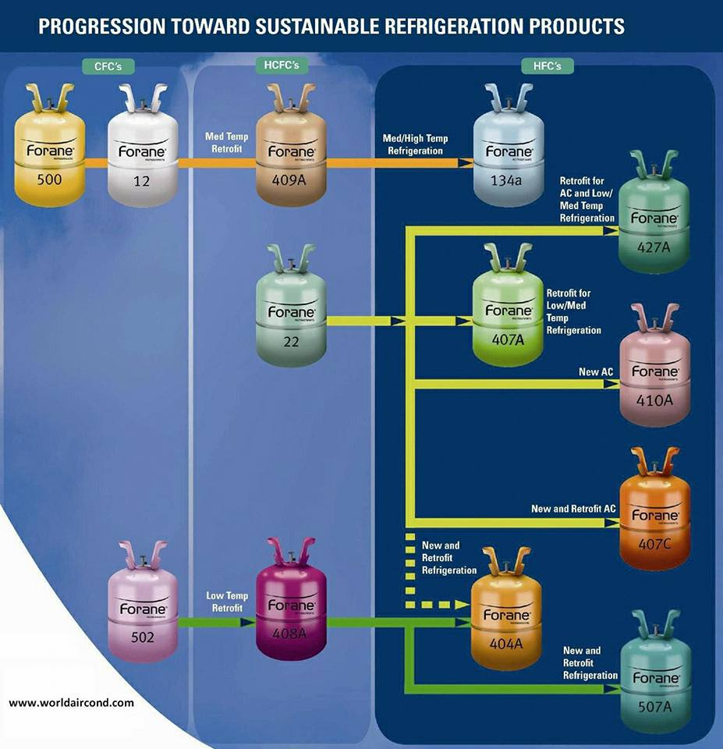
အကယ္၍ (IF)
မင္းအသိုင္းအ၀ိုင္းက တုန္လွဳပ္ေျခာက္ျခားၿပီး
ဒါေတြဟာ မင္းေၾကာင္းလို႔ ၀ိုင္း၀န္းအျပစ္တင္ၾကတဲ့အခါ
မင္းဟာေခါင္းေအးေအးနဲ႔ ရင္ဆိုင္နဳိင္မယ္ဆိုရင္…….
အကယ္၍
အားလုံးက မင္းကို မယုံသကၤာျဖစ္လာတဲ့အခါ
သူတို႔ကို နားလည္စြာ ခြင့္လႊတ္ရင္းနဲ႔
မင္းကိုမင္း ယုံၾကည္မွဳ အျပည့္ရွိမယ္ဆိုရင္………
အကယ္၍
ေစာင့္သင့္တဲ့ အခ်ိန္ကိုေစာင့္ၿပီး
အဲဒီအတြက္လည္း မေမာမပန္း ေနနိဳင္မယ္ဆိုရင္
ဒါမွမဟုတ္..
မင္းရဲ႕အေၾကာင္း မဟုတ္တရား မုသားစကားၾကားရတဲ႔အခါ
မင္းကလည္း အလိမ္အညာေတြနဲ႔ မတုန္႔ျပန္ဘူး ဆိုရင္
ဒါမွမဟုတ္..
မင္းကို လူတကာက ၀ိုင္း၀န္းမုန္းတီးတဲ့အခါ
မင္းကလည္း အမုန္းေတြ ျပန္မပြားဘူးဆိုရင္………..
အကယ္၍
စိတ္ကူးယဥ္ အိပ္မက္ေတြဟာ မင္းအေပၚမလႊမ္းမိုးေစပဲ
စိတ္ကူးနိဳင္မယ္ဆိုရင္- ၿပီးေတာ့ အေတြးအေခၚ စိတ္ကူးေတြဟာ
ေမွ်ာ္မွန္းခ်က္သက္သက္သာ မျဖစ္ေစပဲ ေတြးေခၚနိဳင္မယ္ဆိုရင္……
အကယ္၍
ေအာင္ျမင္မွဳသုခနဲ႔ ဆုံးရွံဳးမွဳ ဒုကၡေတြကို ႀကံဳေတြရတဲ့အခါ
တူညီေသာ ေလာကဓံ တရားေတြပါလားရယ္လို႔
ခံယူထားနိဳင္မယ္ဆိုရင္………
အကယ္၍
မင္းရဲ႕ အမွန္စကားေတြကို
လူလိမ္လူညစ္္ေတြက လွဲ႔စားေျပာင္းလဲၿပီး
မုသားအျဖစ္ ေထာင္ေခ်ာက္ဆင္ ညစ္တဲ့အခါ
မင္းဟာ တည္ၿငိမ္စြာနဲ႔ နာၾကားနိဳင္မယ္ဆိုရင္…..
အကယ္၍
မင္းဘ၀တစ္ခုလုံးေပးၿပီး အရိပ္တၾကည့္ၾကည့္နဲ႔
ျဖည့္ဆည္းခဲ့ရတဲ့ အရာရာကို ဖ်က္စီးခံလိုက္ရၿပီးတဲ့ ေနာက္မွာ
အင္မတန္မွေသးငယ္တဲ့ တန္ဆာပလာ အရာရာနဲ႔
ျပန္လည္တည္ေဆာက္နိဳင္မယ္ဆိုရင္……..
အကယ္၍
မင္းနိဳင္ခဲ့သမ်ွေတြ အားလုံးဟာ
ေၾကြတလွည့္ ၾကက္တခုန္ပမာ
တလွည့္ တခါတည္းနဲ႔ ဆုံးရွဳံးသြားခဲ့ရင္
ၿပီးေတာ့ အစကေန ျပန္စနိဳင္မယ္ဆိုရင္……
ျပီးေတာ့ တခါ ဆိုးလွတဲ့ ကံၾကမၼာရယ္လို႔
ဘယ္ေသာအခါမွ ညည္းျငဴ မေနဘူးဆိုရင္…….
အကယ္၍
သူမ်ားတကာေတြ လုပ္ၿပီးသြားၾကလို႔
အခ်ိန္ အေတာ္ၾကာမွ မင္းအလွည့္ ေရာက္လာတဲ့အခါ
မင္းတေယာက္တည္းနဲ႔ပဲ
အားနဲ႔ မာန္နဲ႔ ဇြဲသတၱိရွိရွိ ဆက္ႀကိဳးစား နိဳင္မယ္ဆိုရင္……
အဲဒီလိုပဲ
မင္းမွာ စိတ္အင္အားကလြဲလို႔ ဘာဆိုဘာမွ မရွိေတာ့တဲ့အခါ
အဲဒီစိတ္အင္အားကို ခိုင္မာစြာနဲ႔ပဲ
လက္ဆုပ္လက္ကိုင္ ထားနိဳင္မယ္ဆိုရင္……
အကယ္၍
လူေတြနဲ႔ ထိေတြ႕ ဆက္ဆံေျပာဆိုတဲ့အခါ
ကိုက်င့္သိကၡာကို ေစာင့္ထိန္းနိဳင္မယ္ဆိုရင္…..
ဒါမွမဟုတ္ မင္းကရာဇ္ေတြနဲ႔အတူ လမ္းေလွ်ာက္ေနရေပမဲ့
မာန္မာနေသြး မၾကြဘူးဆိုရင္……….
အကယ္၍
ရန္သူကျဖစ္ေစ မိတ္ေဆြကျဖစ္္္္္္္္္္ေစ
မင္းကိုသိပ္ၿပီး နာက်ည္းေအာင္ မလုပ္နိဳင္ေစရင္……
အကယ္၍
လူတိုင္းကို တန္ဘိုးထား ေလးစားရေပမဲ့
စြဲလမ္းမွဳ သံေယာဇဥ္ေတြ ထားမေနဘူးဆိုရင္…….
အကယ္၍
တိုေတာင္းလွတဲ့ မပစ္ပယ္နိဳင္တဲ့ တမိနစ္အတြင္းမွာ
အဓိပၸာယ္ရွိလွတဲ့ စကၠန္႔ေျခာက္ဆယ္ အျဖစ္ အသံုးခ်နိဳင္မယ္ဆိုရင္……
ငါ့သားေရ
မင္းဟာအရာရာရွိတဲ့ အရာရာျဖစ္တဲ့ ကမၠာႀကီးကို ဆုပ္ကိုင္လို႔
အရာရာဘာမဆို မင္းစြမ္းနိဳင္ၿပီေပါ့
အဲဒီေတာ့ မင္းဟာလည္း ေယာက္်ားေကာင္းတေယာက္ပဲေပါ့….။
(Rudyard Kipling ၏ IF ကဗ်ာကို ေဒၚေအာင္ဆန္းစုၾကည္ဘာသာျပန္သည္)။

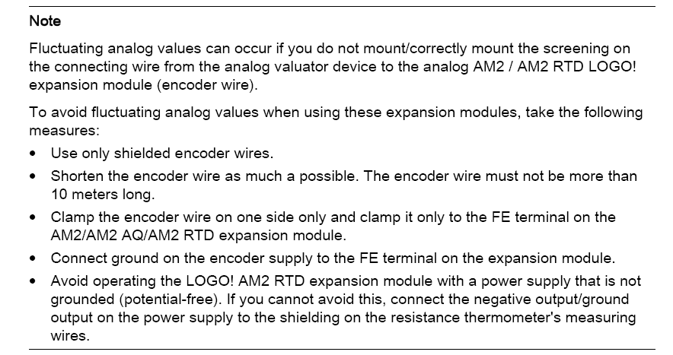
[Edited] Update at 9.50am: As of 8.25 am, Singtel fibre broadband services have been fully restored.
We are very sorry for the disruption. We understand it was a frustrating experience for customers and we would like to thank them for their patience.
We are taking this incident very seriously and are taking steps to review our processes to prevent a recurrence.
We will be offering all affected customers a 10% discount on this month's broadband subscription. This will be reflected in their January bill. Affected broadband customers who are also Singtel postpaid mobile customers will have their local mobile data charges waived for both Saturday (3 December 2016) and Sunday (4 December 2016).
Once again, we apologise for the inconvenience caused and thank our customers for their patience.
----------------------
Update at 7am: As of 7am this morning, about 80% of our fibre broadband services have been restored, and our engineers estimate that we will achieve full service restoration in the next few hours.
We will provide further updates when restoration is complete.
Once again, we apologise for the inconvenience caused and seek your further patience.
----------------------
Update at 1.30am: About 20% of our fibre broadband services have been restored. Our engineers are still working towards full resolution.
We apologise for the inconvenience caused and seek your further patience.
Our next update will be at 7am.
----------------------
Update at 11:55pm: As our engineers are still working to resolve our fibre broadband issues, we will be extending our offer of local mobile data waivers until service is restored.
To clarify, these two groups of customers will have their mobile data waived.
1. Singtel postpaid mobile subscribers who are also Singtel fibre broadband subscribers
2. Singtel postpaid mobile subscribers with same billing addresses as the fibre broadband subscriber
Do note that the mobile data waivers will be applied in your next bill.
We regret and apologise for the inconvenience caused and thank our customers for their patience.
----------------------
Update at 7:50pm: Singtel's engineers have been working tirelessly since this morning to resolve our fibre broadband issues which have regrettably, caused islandwide disruption. This has affected our residential customers and some business customers.
We are currently still investigating why our servers cannot assign IP addresses to our customers' modems to enable broadband connectivity.
So far, while we have ascertained that the service disruption is not due to a DDoS attack, we are not ruling out other plausible causes.
We will be working with our vendors throughout the evening and overnight to isolate the problem and get our broadband services up and running again.
Meanwhile, affected customers who are also Singtel postpaid mobile subscribers have been advised to use their Singtel mobile broadband. Charges for such use of local mobile data will be waived.
Our TV, mobile and fixed line services are not affected. Fans can still catch their Premier League and other football matches on Singtel TV tonight.
We regret and apologise for the inconvenience caused and thank our customers for their patience.
Further updates will be available on our Facebook page.
----------------------
Media Statement/Update at 4.20pm: At about 8.45am this morning, our fibre broadband customers started experiencing difficulties accessing their services.
Our engineers and specialists have been onsite since and are still working to resolve the issue.
In the meantime, we are offering local mobile data waivers for today to affected customers who are also Singtel postpaid mobile customers.
We sincerely apologise for the inconvenience caused.
----------------------
Update at 1:30pm: As our engineers continue working to resolve our fibre broadband outage issues, we advise affected customers who are also Singtel postpaid mobile subscribers to use their Singtel mobile broadband in the meantime. We will waive their Singtel mobile data charges for today. We apologise for the disruption and thank you once again for your patience.
----------------------
Update at 11:55am: We regret to inform that some customers may still be experiencing difficulties accessing their fibre broadband services. Our engineers are still investigating the cause behind this. Please bear with us as we try to resolve the problem. Thank you once again for your patience.
----------------------
Some customers may be experiencing difficulties accessing their Fibre Broadband services. Our engineers are working to resolve the problem. Thank you for your patience.

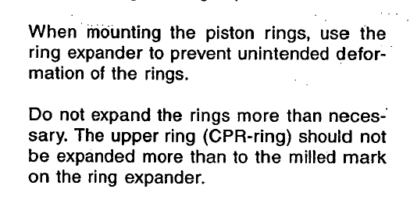
ဂ်ိဳင္ ရုိ ကြန္ ပတ္ စ္ , အလုိေလွ်ာက္ ပဲ႔ထိမ္းစနစ္ ႏွင္႔ စတီယာရင္ ထိမ္းခ်ဳပ္ စနစ္မ်ား ””
************************************************************************
““ GYRO COMPASS , AUTO PILOT AND STEERING CONTROL SYSTEMS ””
***********************************************************
ကုိကုိဦး (Chief Engineer , Mitsui OSK Lines)
************************************
IMO ရဲ႕ SOLAS Regulation နဲ႔ Requirement မ်ားအတုိင္း တည္ေဆာက္ ထားတဲ႔ Gyro Compass , Auto Pilot and Steering Control System မ်ားရဲ႕အဓိက စြမ္းေဆာင္ရည္နဲ႔ လုပ္ငန္းကေတာ႔ သေဘာၤတစီး ဟာ ပင္လယ္ျပင္ မွာ မိမိ ဦးတည္ထားရာ Course အတုိင္း အလုိေလ်ာက္ ျဖစ္ေစ၊ လူကုိယ္တုိင္ လုိအပ္တဲ႔ေနရာမွာ လုိအပ္သလုိ Steering Hand Wheel ကုိ လွည္႔ ျပီး ထိမ္းေၾကာင္း ပဲ႔ကုိင္ ျခင္းျဖင္႔ ျဖစ္ေစ လုိရာခရီးကုိ အႏၵာရယ္ကင္းစြာ ထိမ္းသိမ္းေမာင္း နွင္ ႏုိင္ ျပီး နုိင္ငံတကာ ဆိပ္ကမ္းတခု မွ တခု သုိ႔ Gyro Compass , Auto Pilot နဲ႔ Steering ပုိင္းဆုိင္ရာ မည္သည္႔ အခက္ အခဲ အေႏွာက္အယွက္မွ် မရွိဘဲ အဆင္ေျပေျပ ေခ်ာေခ်ာ ေမာေမာ ေရာက္ရွိႏုိင္ဘုိ႔ ဘဲ ျဖစ္ပါတယ္။ Gyro Compass , Auto Pilot and Steering Control System မ်ားဟာ သေဘာၤတစီးရဲ႕အသက္တမွ် အဓိက အေရးပါတဲ႔ စက္မွဳ႕ ႏွင္႔ အဆင္႔ျမင္႔ လွ်ပ္စစ္ နည္းပညာမ်ား ေပါင္းစပ္ထားတဲ႔ ေရေၾကာင္း သြားလာေရး ကိရိယာ မ်ား ျဖစ္ၾကပါတယ္။
ဒီစနစ္ေတြဟာ အေၾကာင္းတခုခုေၾကာင္႔ ပ်က္တာ ေလာင္တာ မ်ိဳးျဖစ္ဘုိ႔ အလြန္ခဲယင္း ပါတယ္။ ပ်က္ရင္လဲ သေဘာၤ မွာရွိတဲ႔ အင္ဂ်င္နီယာ အမ်ားစုက မိမိတုိ႔ သိပ္မကြ်မ္းက်င္တဲ႔ လက္ပြန္းတတီး လုပ္ေနကုိင္ေနၾက လုပ္ငန္း မ်ား မဟုတ္လုိ႔ ျပဳျပင္ဘုိ႔ အလြန္ခက္ခဲျပီး အေၾကာင္းမလွရင္ Emergency Steering Drill လုပ္သလုိမ်ိဳး Steering Gear Room ကေန လူကုိယ္တုိင္ တုိက္ရုိက္ Control လုပ္ျပီး ဆိပ္ကမ္းေရာက္ေအာင္ ေမာင္းနွင္ၾကရမွာျဖစ္ပါတယ္။ အဲဒါေၾကာင္႔ ဒီတၾကိမ္ေတာ႔ မိတ္ေဆြ Marine Engineer မ်ား ဖတ္တဲ႔ အခါ စာအနည္းငယ္ ေလးႏုိင္တဲ႔ Gyro Compass , Auto Pilot နဲ႔ Steering Control စနစ္မ်ား အေၾကာင္း တင္ျပပါ႔မယ္။ ေဖာ္ျပပါ Gyro Compass , Auto Pilot and Steering Control System မ်ားကေတာ႔ Japan ႏူိင္ငံက တည္ေဆာက္ခဲ႔တဲ႔ သေဘာၤအမ်ားစု မွာ တပ္ဆင္ အသုံးျပဳထားတဲ႔ TOKYO KEIKI INC. ကုပၼဏီက ထုတ္လုပ္တဲ႔ PR 6000-E နဲ႔ စနစ္မ်ားကုိ အေျခခံ ေရး ထားျခင္း ျဖစ္ျပီး Steering Gear Unit ကေတာ႔ Mitsubishi Heavy Industries LTD. က ထုတ္ တဲ႔ Electro Hydraulic Steering Gear ဘဲ ျဖစ္ပါတယ္ ။
Gyro Compass , Auto Pilot and Steering Control System မ်ားအေၾကာင္း မတင္ျပမွီ သေဘာၤ ဝန္ထမ္းမ်ား နားလည္မွဳ႕ လြဲမွားႏူိင္တဲ႔ အေရးေပၚ တတ္မ ကုိင္ စနစ္ (Emergency Steering Gear) အေၾကာင္း အနည္း ငယ္ ေျပာျပျခင္ပါတယ္။ အေရးေပၚ တတ္မကုိင္စနစ္ (Emergency Steering Gear) ဆုိတာ မွာ ပင္လယ္ျပင္ တြင္ျဖစ္ေစ ဆိပ္ကမ္း အဝင္ / အထြက္တြင္ ျဖစ္ေစ ပဲ႔စင္ (Bridge) မွ တတ္မ ကုိ လုိအပ္သလုိ ထိမ္း သိမ္းေမာင္းႏွင္ ႏူိင္စြမ္းမရွိေတာ႔ဘဲ သေဘာၤဧ။္ ပဲ႔ထိမ္းစနစ္ခ်ိဳ႕ယြင္းျခင္း (Steering Failure) ျဖစ္ေပၚသည္႔ အခါ တြင္ တတ္မ ကုိ အေရးေပၚ လုိသလုိ ထိမ္းသိမ္း ေမာင္းႏွင္ေပးျခင္းဘဲ ျဖစ္ပါတယ္။
ပဲ႔ထိမ္းစနစ္ခ်ိဳ႕ယြင္းျခင္း (Steering Failure) ဆုိတာကေတာ႔ ပဲ႔စင္ (Bridge) မွ Steering Hand Wheel
ကုိ လုိအပ္သည္႔ ဒီကရီ ေရာက္ေအာင္ လွည္႔ ေပး ေသာ္လည္း ခ်ိဳ႕ယြင္းခ်က္ တခုခုေၾကာင္႔ Steering Gear မွ တတ္မ (Rudder) ဟာ လုိက္ပါ ေရြ႕လ်ားျခင္းမရွိသည္႔ အေျခအေန ကုိ ေခၚ ဆုိ ျခင္းျဖစ္ပါတယ္။
Steering Gear မွာ တပ္ဆင္ထားတဲ႔ Hydraulic Pump မ်ား မေကာင္းျခင္း ၊ Hydraulic Pump မ်ားကုိ ေမာင္းနွင္္ေပးမယ္႔ Motor မ်ား ေလာင္သြားျခင္း ၊ Solenoid Valve မ်ားမေကာင္းျခင္း စသည္တုိ႔ေၾကာင္႔ တတ္မ (Rudder) မေရြ႕လ်ား ႏူိင္ျခင္းကုိ ဆုိလုိျခင္း မဟုတ္ပါ။ အဲလုိမ်ိဳး ေတြျဖစ္လာႏူိင္လုိ႔ Steering Gear ကုိ SOLAS Charpter II-1 , Regulation 29 နဲ႔ Requirement ေတြအရ ႏွစ္ စုံ (Two Unit) တပ္ဆင္ ထားရတာ ျဖစ္ပါတယ္ ။
စကားကပ္ျပီး Steering Gear ႏွစ္ခုလုံးက Pump ေတြ ၊ Motor ေတြ ၊ Solenoid Valves ေတြလဲ မေကာင္း ဘူးဗ်ာ ဆုိရင္ေတာ႕ အဲဒါကုိ Total Failure လုိ႔ေခၚပါတယ္ ။ အဲလုိ Hydraulic Pump ေတြ ၊ Driven လုပ္ေပးမယ္႔ Electric Motor ေတြ ၊ Solenoid Valve ေတြ ေလာင္ကြ်မ္း ပ်က္စီး ျပီး Total Failure ျဖစ္ႏူိင္ တာေၾကာင္႔ အေရးေပၚတတ္မ ကုိင္တြယ္ ထိမ္းသိမ္း ႏူိင္ရန္ စီစဥ္ တပ္ဆင္ ထားသည္႔ စနစ္ (Emergency Steering Arrangement System) အျပင္ ကြ်န္ေတာ္ စီး ခဲ႕ဘူးတဲ႔ Germany ႏူိင္ငံ ကတည္ ေဆာက္တဲ႔ Bulk Carrier သေဘာၤတစီး မွာေတာ႔ Hydraulic Pump (အေသး) တလုံး ကုိ Motor နဲ႔ တြဲရက္ တပ္ဆင္ ထားျပီး Steering Gear က Hydraulic Line ေတြဆီ Valve ေတြခံထားျပီး Pump နဲ႔ Solenoid Valve ေတြ မေကာင္းတဲ႔ အေရးေပၚ အေျခအေန မွာ အသုံးျပဳ ႏူိင္ေအာင္ သီးျခား တပ္ဆင္ ထားပါတယ္ ။ ေနာက္ GRT 10000 ခန္႔ ရွိတဲ႔ Container သေဘာၤတစီးမွာေတာ႔ သေဘာၤ အရြယ္အစား အရ တပ္ဆင္ ထားတဲ႔ Steering Gear ရဲ႕ Hydraulic Cylinder နဲ႔ Ram ေတြရဲ႕ အရြယ္အစား လဲ ေသးငယ္တဲ႔ အတြက္ Hand Pump ၂ ခု ကုိ Steering Gear က Hydraulic Cylinder ေတြနဲ႔ ခ်ိတ္ဆက္ ႏူိင္၍ Ram ေတြကုိ ေရြ႕လ်ားေစျပီး Rudder ကုိ လုိသလုိ လွည္႔ေပး ႏူိင္ ရန္ စီစဥ္ ထားပါတယ္ ။ Total Failure ျဖစ္ေနတဲ႔ အေရးေပၚ အေျခအေန အတြက္ ဘဲ ရည္ရြယ္ျပီး စီစဥ္ ျပဳ လုပ္ထား တာျဖစ္လုိ႔ Steering Performance က ေတာ႔အလြန္ဘဲ ေႏွးေကြး ပါတယ္။ အဲလုိမ်ိဳး Total Failure ျဖစ္ေနရင္ Rudder ကုိ လုိသလုိ လွည္႔ေပးဘုိ႔ စီစဥ္ ထားမွဳ႕ေတြဟာ Steering Gear Type ေပၚမွာ မူ တည္ျပီး ကြဲ ျပားပါတယ္ ။
စက္မွဳ႕ စြမ္းအားျဖင္႔ ၄င္း ၊ လွ်ပ္စစ္အားျဖင္႔ ၄င္း Total Failure ျဖစ္ရင္ အသုံးခ်ႏူိင္ရန္ သီးျခား စီစဥ္ တပ္ဆင္ထား တာေတြ ဟာ သေဘာၤ တုိင္းမွာ ေတာ႔ မရွိႏူိင္ ပါဘူး ။ အေၾကာင္းကေတာ႔ သေဘာၤေတြမွာ တပ္ဆင္ ထားတဲ႔ Steering Gear အဖြဲ႔အစည္း ကုိ SOLAS Charpter II-1 , Regulation 29 နဲ႔ Requirement ေတြနဲ႔ အညီ သက္ဆုိင္ရာ Class က Performance Test မ်ား ၊ Survey မ်ား ျပဳလုပ္ ထားျပီး ထုတ္လုပ္တဲ႔ ကုပၼဏီမ်ား ကလဲ ႏုိင္ငံတကာ စံခ်ိန္ စံညႊန္းမ်ား အတုိင္း Design လုပ္ ၊ တြက္ခ်က္ ၊ စမ္းသပ္ျပီးမွ ထုတ္လုပ္ထားတဲ႔ စက္ကရိယာ ပစၥည္းမ်ားဟာ တခ်ိန္ထဲ တျပိဳင္ထဲ ပ်က္စီးျပီး Total Failure ျဖစ္ဘုိ႔ အလြန္ ခဲယင္း တဲ႔အျပင္ ပ်က္စီးဘုိ႔ ရာႏူန္း မ်ားတဲ႔ Pump အစိတ္အပုိင္းမ်ား Solenoid မ်ား စတာေတြနဲ႔ Steering Gear နဲ႔ ပက္သက္တဲ႔ အပုိပစၥည္းမ်ား (Spare Parts) ကုိ သေဘာၤေရခ်စဥ္ ထဲက ေထာက္ပံ႔ ေပးထားျပီး သေဘာၤနဲ႔ တပါတည္း သယ္ေဆာင္ သြားျခင္းအားျဖင္႔ ပ်က္လွ်င္ ပ်က္ျခင္း ခ်က္ျခင္း ျပဳျပင္ ႏုိင္၍ သီးသန္႔ စီစဥ္ထား ရွိစရာမလုိ အပ္ေတာ႔ လုိ႔ တပ္ဆင္မထားတာဟာ ဥပေဒပါ ျပဌာန္းခ်က္မ်ားနဲ႔ ညီညြတ္ေန လုိ႔ ဘဲ ျဖစ္ပါ တယ္ ။
Electro Hydraulic Steering Gear စနစ္ အတြက္ (Total Failure ျဖစ္ရင္ သုံးႏူိင္ေအာင္) သီးျခား တပ္ဆင္ထားတဲ႔ Hydraulic Pump မ်ား မရွိ ရင္ေတာ႔ လုပ္ႏူိင္တာတခုက Steering Gear ၂ ခုက Hydraulic Cylinder ေတြရဲ႕ Valves ေတြကုိ By Pass လုပ္ျပီး ခ်ိန္းဘေလာက္နဲ႔ ဟုိဘက္ ၊ ဒီဘက္ လုိသလုိ ဆြဲ လွည္႔ ေပးဘုိ႔ ဘဲ ရွိပါတယ္ ။ ဒါကလဲ ၾကီးမားတဲ႔ Rudder ေတြ တပ္ဆင္ ထားတဲ႔ သေဘာၤၾကီးေတြ အတြက္ ေတာ႕ သိပ္အလုပ္ ျဖစ္မယ္ မထင္ပါဘူး ။ တခ်ဳိ႕သေဘာၤေဟာင္း မ်ားမွာေတာ႔ Hydraulic Steering System ကုိ အေရးေပၚအေျခအေနအတြက္ အသုံးမျပဳေတာ့ဘဲ သီးျခား (Isolate) လုပ္ကာ Pin အားျဖင့္ Linkage ကုိ ေျပာင္း၍ Mechanical Power အျဖစ္ Gear Wheel ျဖင့္ တက္မ ကုိ လုိရာသုိ႔ ထိန္းခ်ဳပ္ ေမာင္းႏွင္ႏူိင္ရန္ စီစဥ္ ထားပါတယ္။အဲဒါ မွ မဟုတ္ရင္ေတာ႔ ဆြဲ သေဘာၤ (Tug Boat) ေခၚျပီး သေဘာၤ ကုိ ျပဳျပင္မယ္႔ ဆိပ္ကမ္း အေရာက္ ဆြဲသြား ဘုိ႔ပါဘဲ ။
အဲဒါေၾကာင္႔ အေရးေပၚတတ္မ ကုိင္စနစ္ (Emergency Steering Gear) အတြက္ IMO မွ တင္းက်ပ္ေသာ ဥပေဒ မ်ားထုတ္ျပန္ျပီး သေဘာၤတုိင္းရဲ႕ Steering စနစ္မွာ မျဖစ္မေန တတ္ဆင္ ထားရ တဲ႔ Arrangement မ်ားရွိျပီး ၄င္းတုိ႔ကုိ အကြ်မ္း တဝင္ရွိေအာင္ ပုံမွန္ေလ႔က်င္႔ေရး (Drill) မ်ားကုိ ၃ လ လွ်င္ တၾကိမ္ ထက္မ နည္း ျပဳလုပ္ ရန္ညႊန္ၾကား ထားသည္႔ အတြက္ သေဘာၤဝန္ထမ္းမ်ား အေနျဖင္႔ ေရယာဥ္မွဴး (Master) ဧ။္ ကြပ္ကဲ မွဴ႕ျဖင္႔ မျဖစ္မေန လုပ္ေဆာင္ ၾကရတာ ျဖစ္ပါတယ္။ (Emergency Steering Gear အတြက္ SLOAS Regulation အတုိခ်ဳပ္ ကုိ ေနာက္ ပုိင္းမွာေဖာ္ျပ ထားပါတယ္)
Gyro Compass , Auto Pilot and Steering Control System မွာ ေအာက္ပါ အတုိင္း အဓိက အစိတ္အပုိင္း ၾကီးမ်ား အျဖစ္ ေပါင္းစပ္ ဖြဲ႔စည္း တည္ေဆာက္ထားပါတယ္။
1. Gyro Compass and Auto Pilot
2. Repeat Back Unit
3. Electric Rudder Angle Transmitter Unit and Rudder Angle Indicator
4. Electro Hydraulic Steering Gear Unit တုိ႔ျဖစ္ပါတယ္။
1. Gyro Compass and Auto Pilot
***************************
Control System တခုလုံး ကုိထိမ္းခ်ဳပ္ထား ဘုိ႔ နဲ႔ သေဘာၤတစီး လုံးရဲ႕ Safety အတြက္ အေရး အၾကီးဆုံး မွာ ပဲ႔စင္ (Bridge) ေပၚတြင္ တပ္ဆင္ထားေသာ Gyro Compass နွင္႔ Auto Pilot ဘဲ ျဖစ္ပါသည္။ တတ္မ (Rudder) ကုိ ဘယ္ (Port) သုိ႔မဟုတ္ ညာ (Starboard) သုိ႔ လုိသလုိ ေရႊ႕လွ်ားႏူိင္ေစရန္ Steering Hand Wheel တပ္ဆင္ထားျပီး Steering Hand Wheel ကုိ လွည္႔ျပီး ေရႊ႕လုိက္သည္႔ ဒီဂရီ အတုိင္း တတ္မ (Rudder) က လုိက္ပါေရႊ႕လွ်ားမွာ ျဖစ္တယ္လုိ႔ အၾကမ္း အားျဖင္႔ ေျပာႏူိင္ပါတယ္ ။
Gyro Compass and Auto Pilot ရဲ႕ ထိမ္းခ်ဳပ္မွဳ႕ေအာက္မွာရွိတဲ႔ Steering Gear ရဲ႕ အဓိကလုပ္ေဆာင္ ေပးႏူိင္တဲ႔ Function မ်ားကေတာ႔ Auto Steering , Hand Steering , Remote Steering နဲ႔ Non-Follow Up Steering တုိ႔ဘဲ ျဖစ္တယ္။
Auto Steering ဆုိတာကေတာ႔ Follow Up Steering Control ပါဘဲ။ သေဘာၤ ေမာင္းနွင္ေန ခ်ိန္တြင္ Steering Stand မွ Mode Selection Unit ကုိ Auto Mode မွာထားတဲ႔ အခါ Setting လုပ္ထားတဲ႔ Course အတုိင္း Auto Mode မွ မျဖဳတ္မျခင္း Control လုပ္ေပးေနျပီး အဲဒီ Course အတုိင္းဘဲ Steering Gear ကုိ အလုိ ေလွ်ာက္ ထိမ္းသိမ္း ေပးေနမွာျဖစ္လုိ႔ Rudder ဟာလဲ Auto Steering Control ရဲ႕ ေစခုိင္း ထိမ္းသိမ္း မွဳ႕(Command) ေအာက္မွာ ရွိေနမွာ ျဖစ္ပါတယ္ ။ Auto Steering မွာ PID Control (Proportional , Integral , Differential) နဲ႔ ADPT (Adaptive) Control ဆုိျပီး Control စနစ္ ႏွစ္ မ်ိဳးရွိပါတယ္ ။
Hand Steering ဟာလဲ Follow Up Steering Control ပါဘဲ။ Steering Stand မွ Mode Selection Unit ကုိ Hand Mode မွာ ထားျပီး Steering Hand Wheel ကုိ လုိအပ္တဲ႔ ဒီဂရီ ေရာက္ေအာင္လွည္႔ ေပးရင္ Rudder ဟာလဲ Steering Hand Wheel ရဲ႕ ဒီဂရီအတုိင္း လုိက္ပါ ေရႊ႕လွ်ားမွာျဖစ္ျပီး Steering Hand Wheel ေနာက္ထပ္ မေရြ႕ မျခင္း Rudder ကုိ အဲဒီ အတုိင္း ထိမ္းသိမ္း ေပး ထားမွာ ျဖစ္တယ္ ။
Remote Steering ဟာ လဲဘဲ Follow Up Steering Control ပါဘဲ။ Remote Steering ကုိ Gyro Compass နဲ႔ Auto Pilot တပ္ဆင္ထားတဲ႔ Steering Stand မွာ RC Mode အေနနဲ႔ေဖာ္ျပပါတယ္ ။ Steering Stand မွ Mode Selection Unit ကုိ RC Mode မွာ ထားျပီး လုိျခင္တဲ႔ ဒီဂရီကုိ Remote Dial Knob ကုိ လွည္႔ေပးျခင္းျဖင္႔ (Steering Hand Wheel လွည္႔စရာမလုိဘဲ) Rudder ဟာ အဲဒီ ဒီဂရီ အတုိင္းလုိက္ပါေရြ႕ လွ်ားမွာ ျဖစ္ပါတယ္ ။ တခ်ိဳ႕ သေဘာၤေတြမွာ ေတာ႔ တပ္ဆင္ထားတဲ႔ Model မတူလုိ႔ RC Mode ဟာ Steering Stand ရွိ Mode Selection Unit တြင္ ပါဝင္ျခင္း မရွိပါဘူး ။
Steering Stand မွာ NFU (Non-Follow Up) Mode ဘက္ ကုိေျပာင္း ရင္ေတာ႕ Rudder ဟာ Auto Steering အရ ၄င္း ၊ Steering Hand Wheel နွင္႔ Remote Dial Knob အားျဖင္႔ ေသာ္၄င္း မည္သည္႔ Control မွ လုပ္ေပးႏူိင္မွာ မဟုတ္ေတာ႔ပါ ။
Auto Steering စံနစ္နွင့္ Hand Steering စံနစ္တုိ႔ အလုပ္မလုပ္ ေသာေၾကာင့္ျဖစ္ေစ ၊ ေရယာဥ္ မွဴး (Master)၊ ေရေၾကာင္းျပ (Pilot) တုိ႔ဧ။္ လုိအပ္ခ်က္ ေၾကာင့္ျဖစ္ေစ တက္မကုိ ဘယ္ ၊ ညာ တဖက္ဖက္သုိ႔ အလွ်င္အျမန္ လွည့္ျပီး ေရာက္ရွိေနေသာ ေနရာတြင္ တည္ျမဲေနေစ နုိင္ရန္အတြက္ လုိရာဘက္တဖက္ တည္းကုိသာ ေရႊ႕လွ်ား နုိင္ေသာပဲ့ထိမ္းစံနစ္ (Non-Follow Up Steering System) ကုိ အသုံးျပဳရ ျခင္းျဖစ္ပါတယ္ ။ ၄င္းစံနစ္သည္ Steering Control Stand ရွိ Non Follow Up Knob ကုိ ဘယ္ (သုိ႔မဟုတ္) ညာ ဘက္သုိ႕ တြန္းလုိက္ပါက တက္မ (Rudder) သည္ Knob ကုိတြန္းေရႊ႕သည့္ေနရာအလုိက္ ဘယ္ (သုိ႔မဟုတ္) ညာ ဘက္ သုိ႔ လုိက္ပါေရႊ႕လွ်ား သြားမွာ ျဖစ္ျပီး တြန္းထားသည့္ Knob ကုိ လႊတ္လုိက္ပါက ေရာက္ရွိရာ ဘယ္ (သုိ႔မဟုတ္) ညာ တြင္ ရွိျမဲအတုိင္း တည္ရွိေနမွာ ျဖစ္ပါသည္။ ၄င္းစံနစ္ကုိ အသုံးျပဳရန္ Bridge ေပၚမွ Steering Control Stand ရွိ Steering Wheel ၏ Mode ကုိ NFU ေနရာတြင္ ထားရပါမယ္ ။
NFU Mode ကုိ ေျပာင္းရင္ Steering Gear Control System ဟာ Solenoid Control Pilot Operate Valve ရဲ႕ Push Pin ကုိ ထုိးသြင္းျခင္း (သုိ႔မဟုတ္) Electric Motor Operate Hydraulic Control Valve ရဲ႕ Lever ကုိ လူ ကုိယ္တုိင္ တုိက္ရုိက္ ကုိင္တြယ္ျပီး လုိအပ္သလုိ ထိမ္းေပးျခင္း ၊ တုိ႔ ျပဳလုပ္ေပး မွသာ Steering Gear သည္ Rudder ကုိ လုိျခင္္တဲ႔ ဒီဂရီ ေရာက္ ေအာင္ တြန္းျခင္း ၊ ဆြဲျခင္း တုိ႔ ျပဳလုပ္ေပးမွာျဖစ္တယ္ ။ လုိျခင္တဲ႔ ဒီဂရီ ေရာက္လုိ႔္ Lever ကုိ လႊတ္လုိက္တာနဲ႔ တျပိဳင္နက္ Rudder ေရႊ႕လွ်ားမွဳ႕ ရပ္သြားမွာျဖစ္ပါတယ္ ။ အဲဒါေၾကာင္႔ Emergency Steering Drill လုပ္ရင္ ပဲ့စင္မွ တက္မကုိ ထိမ္းခ်ဳပ္ နုိင္စြမ္းမရွိေတာ့ဘဲ သေဘာၤ၏ ပဲ့ထိန္းစံနစ္ ခ်ဳိ႕ယြင္းျခင္း ျဖစ္စဥ္ ပုံေပၚလြင္ေစရန္ အတြက္ NFU Mode မွာ ထားျပီး Rudder ကုိ လုိျခင္တဲ႔ ဒီဂရီ ေရာက္ေအာင္ Push Pin (သုိ႔မဟုတ္) Lever တံ နဲ႔ Control လုပ္ေပး ရတာျဖစ္ပါတယ္။ အဲဒါဟာ Emergency Steering အတြက္ စီစဥ္ထားရွိမွဳ႕ (Arrangement) တခုပါဘဲ။ ျခြင္းခ်က္အေနနဲ႔ NFU ကုိ Override လုပ္လုိ႔ရေအာင္ Controller ကုိ Gyro Compass တပ္ဆင္ ထားတဲ႔ Steering Stand မွာ တပါတည္း ထည္႔သြင္း တည္ေဆာက္ ထား ပါတယ္ ။
Electro Hydraulic Steering Gear အဖြဲ႔အစည္း မွာ Rudder ကုိ လုိျခင္တဲ႔ ဒီဂရီ ေရာက္ေအာင္ ေရႊ႕လွ်ားေစဘုိ႔အတြက္ Hydraulic Ram ေတြကုိ တြန္းျခင္း ၊ ဆြဲျခင္းေတြ ျပဳလုပ္ႏူိင္ဘုိ႔ Solenoid Control Pilot Operate Valve (သုိ႔မဟုတ္) Electric Motor Operate Hydraulic Control Valve ကေနထိမ္း ခ်ဳပ္ေပးပါတယ္ ။ GRT 30000 ~ 35000 နဲ႔ ၄င္း ေအာက္ သေဘာၤေတြ မွာေတာ႔ မ်ားေသာ အားျဖင္႔ Solenoid Control Pilot Operate Valve ေတြ ကုိ တပ္ဆင္ အသုံးျပဳ ထားျပီး ၊ အရြယ္ အစား ၾကီးမားတဲ႔ သေဘာၤၾကီး ေတြမွာေတာ႔ Electric Motor Operate Hydraulic Control Valve ကုိဘဲ တပ္ဆင္ အသုံးျပဳၾကပါတယ္ ။
Gyro Compass နဲ႔ Auto Pilot တုိ႔ကုိ လြယ္လြယ္ ေျပာရရင္ တတ္မ ကုိ လုိသလုိ ထိမ္းေၾကာင္းေပး ႏူိင္ဘုိ႔ ဥေဏွာက္ တခု တပ္ထားေပးတယ္ဘဲ ဆုိၾကပါစုိ႔ ။ Rudder ကုိ Hydraulic Ram ေတြ တြန္းျခင္း ၊ ဆြဲျခင္း ၊ အားျဖင္႔ လုိျခင္ တဲ႔ ဒီဂရီ ေရာက္ေအာင္ ေရႊ႕လ်ား ေစရန္ျပဳလုပ္ျပီး Hydraulic Ram ေတြ အလုပ္လုပ္ေစဘုိ႔ Solenoid Control Pilot Operate Valve (သုိ႕မဟုတ္) Electric Motor Operate Hydraulic Control Valve ေတြကေန ထိမ္းခ်ဳပ္ေပး ထား တာျဖစ္ပါတယ္ ။ Solenoid Control Pilot Operate Valve (သုိ႕မဟုတ္) Electric Motor Operate Hydraulic Control Valve ေတြကေတာ႔ လုိအပ္တဲ႔ Rudder Angle ရရွိရန္အတြက္ Auto Pilot ႏွင္႔ Steering Control System မ်ားရဲ႕ Microprocessor တြက္ခ်က္မွဳ႕မ်ား ေပၚမူတည္ျပီး Control Unit ဆီက တဆင္႔ Command ေပးတဲ႔ Signal ရရွိျပီး အလုပ္လုပ္ တာျဖစ္ပါတယ္ ။ အဲဒါေၾကာင္႔ Wheel House ကေန Steering Command ေပးေသာ္လည္း Rudder ေရႊ႕လွ်ားေအာင္ Hydraulic Ram ေတြက အလုပ္လုပ္မေပး ဘူးဆုိရင္ Control Unit ကေန Solenoid Control Pilot Operate Valve (သုိ႕မဟုတ္) Electric Motor Operate Hydraulic Control Valve ကုိ သြားတဲ႔ Power Supply Line ကုိ Steering Hand Wheel အား ဘယ္ ၊ ညာ လွည္႔ေပးေစ ျခင္းျဖင္႔ Power Supply ေရာက္မေရာက္ အရင္ စစ္ေဆးသင္႔ ပါတယ္ ။
Gyro Compass and Auto Pilot တုိ႔ရဲ႕ Auto Steering Control ျဖစ္တဲ႔ Auto Mode မွာ ထားတဲ႔ အခါ PID Control System အရ အလုပ္လုပ္ပုံ အေျခခံ သေဘာ တရား ကေတာ႔ PID Controller က ေသြလြဲမွဳ႕ အခ်က္ျပ (Deviation Signal) ထုတ္လႊတ္ ေပးမွဳ႕ ကုိ
(၁) ေလတုိက္ႏူန္းေၾကာင္႔ ေသာ္၄င္း ၊ လွိဳင္းေၾကာင္႕ေသာ္၄င္း ၊ ျပင္ပ မွ သက္ေရာက္မွဳ႕ တခုခုေၾကာင္႔ သေဘာၤ သည္ ဦးတည္ရာ လမ္း ေၾကာင္း မွ ဒီဂရီ အနည္းငယ္ လြဲသြားေသာ အခါ တြင္ ၄င္း၊ (Deviated from the Setting Course)
(၂) Course Setting Knob ကုိ ဖိႏွိပ္ ျခင္းအားျဖင္႔ ဦးတည္ရာ လမ္းေၾကာင္း ေျပာင္းလဲေသာအခါ (When the Setting Course was changed with the Course Setting Knob) တြင္ ၄င္း ၊ အေျခ အေန ႏွစ္ မ်ိဳး အရ ထုတ္လႊတ္ ေပးပါတယ္ ။
တခ်ိဳ႕ အေျခအေန မ်ိဳးေတြမွာ ေတာ႔ ADPT Control လုိမဟုတ္ဘဲ ပဲ႔စင္မွ တာဝန္က် အရာရွိက ျပန္ျပီး Adjust လုပ္ေပးရတာေတြ ရွိပါတယ္ ။ အဲဒါဟာ PID Control ရဲ႕ အားနည္းခ်က္ဘဲ ျဖစ္ပါတယ္ ။
PID Controller ဧ။္ Signal ထုတ္လႊတ္ ေပးျခင္း အားျဖင္႔ သေဘာၤဧ။္ လက္ရွိ ဦးတည္ ေနသည္႔ လမ္းေၾကာင္း (Ship’s Heading Course) ႏွင္႔ ၾကိဳတင္ ခ်ိန္ညိွ ထားေသာ ဦးတည္လမ္းေၾကာင္း (Setting Course) တုိ႔ကုိ CPU (Microprocessor) သုိ႔ ပုိ႔ေပးျပီး CPU မွ လုိအပ္ေသာ Rudder Angle ကို အထက္က အခ်က္ ၂ခ်က္နွင္႔ ၾကိဳတင္ ခ်ိန္ညိွ ထားေသာ တန္ဘုိး မ်ားကုိ အေျခခံ တြက္ခ်က္၍ လုိအပ္ေသာ Rudder Angle ရရွိေအာင္ Control Unit သုိ႔ ပုိ႔ေပးျပီး Rudder ေရႊ႕လွ်ားေအာင္ Command Signal ထုတ္လႊတ္ေစမွာ ျဖစ္တယ္ ။
PID Controller တြင္း ရွိ Automatic Processing Unit မွ Rudder Angle ကုိ ရာသီဥတု အေျခအေန(Weather) , တတ္မ ေရြ႕လွ်ားႏူန္း (Rate) ႏွင္႔ Rudder Torque and Load စသည္႔ အေျခအေန တုိ႔ အေပၚမူတည္ ခ်ိန္ညိွ ၍ အေျခအေန ႏွင္႔ ကုိက္ညီ မည္႔ Rudder Angel ကုိ အလုိေလွ်ာက္ တြက္ ခ်က္ေပးျပီး အေကာင္းဆုံး စြမ္းေဆာင္ရည္ ရရွိျပီး လုိသလုိ ထိမ္းေၾကာင္းႏုိင္ရန္ Analog Command Signal ေပးပုိ႔ျခင္း ၊ Analog Command Signal ကုိ တဖန္ ျပန္လည္ ျဖတ္ေတာက္ေပးျခင္း ၊ စသည္ အားျဖင္႔ သေဘာၤ ဟာ မိမိဦးတည္ ထားတဲ႔ ေနရာကုိ ေရာက္ရွိေစရန္ အတြက္ Main Gyro Compass နဲ႔ Auto Pilot တုိ႔ကုိ ခ်ိတ္ဆက္ ထာားျပီး ၾကိဳတင္ Setting လုပ္ထားေသာ ဦးတည္ရာ လမ္းေၾကာင္း (Setting Course) ႏွင္႔ သေဘာၤ လက္ရွိ ဦးတည္ေနသည္႔ လမ္းေၾကာင္း (Ship’s Heading Course) တုိ႔ထပ္တူၾက ေစပါတယ္ ။
အကယ္၍ ေလတုိက္ႏူန္းေၾကာင္႔ ေသာ္၄င္း ၊ လွိဳင္းေၾကာင္႕ေသာ္၄င္း ၊ သေဘာၤသည္ ဦးတည္ရာ လမ္းေၾကာင္းမွ ဒီဂရီ အနည္းငယ္ လြဲသြားလွ်င္ အလုိေလွ်ာက္ ဦးတည္ရာ လမ္းေၾကာင္းေပၚသုိ႔ ျပန္ေရာက္ ဘုိ႔ အတြက္္ Rudder Angle ကုိ လုိသလုိ ေရႊ႕လ်ားေစရန္ Hydraulic Ram မ်ား ကုိ တြန္းျခင္း ၊ ဆြဲျခင္း တုိ႔ ျပဳလုပ္ေပးမည္႔ Solenoid Control Pilot Operate Valve (သုိ႔မဟုတ္) Electric Motor Operate Hydraulic Control Valve မ်ား Operation ျဖစ္ေစရန္ Analog Command Signal ကုိ Control Unit မွတဆင္႔ ေပးပုိ႔ မည္ျဖစ္သည္ ။ ရရွိေသာ Analog Command Signal ေၾကာင္႔ Solenoid Control Pilot Operate Valve (သုိ႔မဟုတ္) Electric Motor Operate Hydraulic Control Valve မ်ား Operation ျဖစ္ရန္ အတြက္ လုိအပ္ေသာ Power Supply ရရွိေစမွာ ျဖစ္၍ Hydraulic Ram မ်ားကုိ အလုပ္လုပ္ ေစျခင္းျဖင္႔ Rudder ေရႊ႕လွ်ားျပီး သေဘာၤကုိ လုိအပ္သည္႔ လမ္းေၾကာင္းေပၚ သုိ႔ ေရာက္ ရွိေစျခင္း ျဖစ္ပါတယ္ ။
Solenoid Control Pilot Operate Valve (သုိ႔မဟုတ္) Electric Motor Operate Hydraulic Control Valve မ်ားဧ။္ အေပၚဘက္ Electric Wire Terminal တြင္ Connection ၄ ခု ရွိျပီး ႏွစ္ ခုမွာ Compound Line ျဖစ္၍ က်န္ ႏွစ္ ခုမွာ ဘယ္ (Port) သုိ႔မဟုတ္ ညာ (Starboard) သုိ႔ ေရႊ႕လွ်ားေစမည္႔ Power Supply (AC 100 ~110V သုိ႔မဟုတ္ DC 24V , မ်ားေသာအားျဖင္႔ AC 100 ~110V) ဝင္ေရာက္မည္႔ Line ျဖစ္ပါတယ္ ။ Power Supply ဟာ တည္ျငိမ္မွဳ႕ ရွိျပီး သတ္မွက္ Current Rating အတြင္းရွိ ေနေစရန္ Electronic Circuit ခံထား ျပီး Electronic Circuit မွ တဆင္႔ ထိပ္ႏွစ္ဘက္ တြင္ Compound ႏွင္႔ Power Supply တတြဲစီ ခြဲျပီး ဝင္ေရာက္လာ မွာျဖစ္ပါတယ္။
Rudder သည္ လုိအပ္ေသာ ဒီဂရီ သုိ႔ေရာက္ရွိ သြားေၾကာင္း Electric Rudder Angle Transmitter Unit မွ ၄င္း၊ Analog Command Signal ကုိ ျဖတ္ေတာက္ ရန္ Repeat Back Unit မွ ၄င္း ၊ ေပးပုိ႔လာေသာ Feedback Signal မ်ား ကုိလက္ခံ စီစစ္ျပီး Rudder ကုိ ၄င္းအေနအထား အတုိင္း တည္ျငိမ္ ေစရန္ Analog Command Signal ပုိ႔ လႊတ္ျခင္းကုိ တခါ ျပန္လည္ ျဖတ္ေတာက္ေပးျပီး Steering ကုိ အလုိေလွ်ာက္ ထိမ္းသိမ္း ေပးေနမွာ ျဖစ္တယ္။
ထိုနည္း တူ Steering Hand Wheel ကုိလွည္႔ျခင္းျဖင္႔ ၄င္း ၊ Remote Steering အားျဖင္႔၄င္း ၊ Analog Command Signal ကုိ တုိက္ရုိက္ ေပးပုိ႔ျခင္း ၊ ျဖတ္ေတာက္ေပး ျခင္း ၊ စသည္ အားျဖင္႔ Rudder ကုိ လုိအပ္ သည္႔ ဒီဂရီ ေရာက္ေအာင္ ေရႊ႕လွ်ားႏူိင္ေစရန္ Solenoid Control Pilot Operate Valve (သုိ႔မဟုတ္) Electric Motor Operate Hydraulic Control Valve မ်ားကုိ Operation ျဖစ္ ေစတာ ျဖစ္ပါတယ္။
ထုိ႔အျပင္ လက္ရွိ ဦးတည္ေနသည္႔ လမ္းေၾကာင္း (Ship’s Heading Course) သည္ Gyro Compass နဲ႔ Auto Pilot မွာ ၾကိဳတင္ Setting ျပဳလုပ္ထားေသာ ဦတည္လမ္းေၾကာင္း (Setting Course) မွ ဒီဂရီ အနည္းငယ္ လႊဲေနမွဳ႕ကုိ ၾကိဳတင္ ခ်ိန္ထားေသာ Alarm Setting အတြင္း မွာ ရွိေနေစရန္ ထိမ္းထားျပီး Setting ဒီဂရီ ထက္ ေက်ာ္လြန္ျပီး လမ္းေၾကာင္းလႊဲ သြားပါ က အခ်က္ေပးျပီး Out of Course ျဖစ္ေနေၾကာင္း သိရွိေစမွာ ျဖစ္ပါတယ္ ။ ပုံမွန္ Alarm Setting ကေတာ႔ 10 ဒီဂရီ ခန္႔ ျဖစ္ျပီး PSC Inspector မ်ား က Alarm စမ္းခုိင္းတဲ႔အခါ Auto Steering Adjusting Section မွာ ရွိတဲ႔ Pilot Watch Mode ကေန Alarm Setting ကုိ 5 ဒီဂရီ ထိေလ်ာ႔ခ်ေပးျပီး Course Setting ကုိ တေျဖးေျဖး တုိးေပးျခင္း ျဖင္႔ လမ္းေၾကာင္းလႊဲေနတဲ႔ ပုံေပၚလြင္လာျပီး Alarm မည္လာမွာဘဲ ျဖစ္ပါတယ္။ (ပုံ ၁ မွ PID Control Block Diagram ကုိၾကည္႔ပါ)
ေနာက္ Control တမ်ိဳး ျဖစ္တဲ႔ ADPT (Adaptive Control) အရ Gyro Compass and Auto Pilot တုိ႔ရဲ႕ Auto Steering Control စနစ္ ကေတာ႔
- ခန္႔မွန္း တြက္ခ်က္ ျခင္း (Estimation Unit)
- ဦးတည္လမ္းေၾကာင္း အတုိင္း တည္ရွိေစရန္ ထိမ္းခ်ဳပ္ေပးျခင္း (Course Keeping Control Unit)
- ဦးတည္လမ္းေၾကာင္း ေျပာင္းလဲေပးရန္ ထိမ္းခ်ဳပ္ျခင္း (Course Changing Control Unit)
တုိ႔ရဲ႕ ဖြဲ႔စည္းမွဳ႕ေအာက္မွာ Steering ကုိ Auto Control လုပ္ေပးေန မွာျဖစ္တယ္ ။ (ေအာက္ ေဖာ္ျပပါ ပုံ ၂ မွ ADPT Control Block Diagram ပုံ ကုိ ၾကည္႔ပါ)
ADPT (Adaptive) Control စနစ္နဲ႔ Auto Steering ျဖင္႔ သေဘာၤ သြားေနစဥ္ Course Keeping Control Unit ႏွင္႔ Course Changing Control Unit အားျဖင္႔ Weather Adjustment စသည္တုိ႔ ကုိ အလုိေလွ်ာက္ ထိမ္းသိမ္းေပး၍ Rudder Angle ကုိ ဦးတည္ လမ္းေၾကာင္းမွ လႊဲေခ်ာ္ မသြားေစရန္ ထိမ္း သိမ္း ေပးေနမွာ ျဖစ္ပါတယ္။ ။
Estimation Unit မွာရွိတဲ႔ Main Algorithm , Course Keeping Controller နဲ႔ Course Changing Controller တုိ႔ဟာ Microprocessor (CPU) သုိ႔ Input Signal ပုိ႔ေပးျခင္း လုပ္ငန္းစဥ္ အတြက္ အသုံးျပဳ ပါတယ္
Estimation Unit ကုိ ေယဘူယ် အားျဖင္႔ ေျပာရရင္ သေဘာၤရဲ႕ Load ေျပာင္းလဲမွဳ႕ အေျခအေန ၊ သေဘာၤ သြားႏူန္း (Ship’s Speed) ၊ ေရအနက္ (Water Depth)၊ Rudder Torque and Load စတာ ေတြနဲ႔ ျပင္ပ အေႏွာက္အယွက္ မ်ားျဖစ္တဲ႔ ေလတုိက္ႏူန္း ၊ ေလတုိက္သည္႔ ဦးတည္ဘက္ ၊ လွိဳင္းအေျခအေန ၊ ပင္လယ္ ျပင္ အေနအထား စသည္တုိ႔ကုိ အစဥ္အျမဲ အေသးစိတ္ ခန္႔မွန္း တြက္ခ်က္ ေပးေနမွာ ျဖစ္ျပီး Standard Reference လုပ္ထားတဲ႔ တန္ဘုိး နဲ႔ အေျပာင္း အလဲ ေပၚမူတည္လုိ႔ Signal ပုိ႔ေပးျခင္း ၊ ျဖတ္ ေတာက္ေပးျခင္း တုိ႔ကုိ ခ်က္ျခင္း တုန္႔ျပန္ ေပးႏူိင္တဲ႔ အတြက္ Steering Gear ဟာလဲ တည္ျငိမ္ျပီး စြမ္း ေဆာင္ရည္ ေကာင္းတဲ႔ Control System ရဲ႕ထိမ္းခ်ဳပ္မွဳ႕ ေအာက္မွာ အလုပ္လုပ္ေနမွာ ဘဲ ျဖစ္တယ္ ။
အဲဒါဟာ PID Control ထက္ပုိမုိ ျပည္႔စုံျပီး Steering Control System ကုိ ျပင္ပ အေႏွာက္အယွက္ ကင္းစြာျဖင္႔ စြမ္းေဆာင္ရည္ အျမင္႔ဆုံး ကုိရရွိ ေစမွာ ျဖစ္ပါတယ္ ။ TOKYO KEIKI INC. ကုပၼဏီ က အခု ေနာက္ ပုိင္းတပ္ဆင္ လာတဲ႔ Model ေတြမွာေတာ႔ PID Weather Control Mode ပါဝင္လာျခင္း မရွိေတာ႕ဘဲ ADPT Control System ဘဲ ရွိပါေတာ႕တယ္ ။ Command Signal ရရွိျပီး Steering Gear ကုိ အလုပ္လုပ္ ေစ တာ ကေတာ႔ အတူတူဘဲ ျဖစ္ပါတယ္ ။
2. Repeat Back Unit
******************
Repeat Back Unit ကုိ Rudder ရဲ႕ Tiller မွာ Lever တံ တခု နဲ႔ Mechanically အားျဖင္႔ ဆက္သြယ္ ထား ပါ တယ္ ။ Repeat Back Unit ကုိ Steering System 1 အတြက္ ၁ ခု နွင္႔ Steering System 2 အတြက္ တစ္ခု (Rudder တခုမွာ ႏွစ္ ခု) တပ္ ဆင္ထား ပါတယ္ ။ Rudder ဟာ Steering Control စနစ္ အရ လုိအပ္သလုိ ေရႊ႕လွ်ားမွဳ႕ရွိေနတဲ႔ (သုိ႔မဟုတ္) ေရႊ႕လွ်ားျပီး တဲ႔ Feedback Signal ကုိ Auto Pilot ရွိရာ Steering Control Stand သုိ႔ ပုိ႔ေဆာင္ ေပးပါ တယ္ ။ Repeat Back Unit ရဲ႕ ဖြဲ႔စည္း မွဳ႕ ကေတာ႕ Linear Synchro , Buffer Amplifier , Cam , Limit Switch , Resistor and Condensor , Noise quenching of Solenoid Valve စတဲ႔ အစိတ္အပုိင္း တုိ႔ကုိ Case တခုထဲမွာ တပ္ဆင္ ထားတာျဖစ္ ပါတယ္ ။
Linear Synchro ႏွင္႔ Buffer Amplier တုိ႔ဟာ System အတြက္ျဖစ္ျပီး Limit Switch နဲ႔ Cam ကေတာ႔ System ေရာ Hand Over ႏွစ္မ်ိဳးလုံးကုိ ရပ္တန္႔ေစဘုိ႔ အတြက္ ျဖစ္ပါတယ္ ။ Repeat Back Unit တခုဆီမွာ Limit Switch (၂) ခု ရွိျပီး ၄င္းတုိ႔ ကို Linear Synchro Shaft မွာ တပ္ထားတဲ႔ Cam ျဖင္႔ ထိမ္းသိမ္း ေပးထားျပီး Rudder Limit ကုိ လုိသလုိ ခ်ိန္ညွိ ၍ Limit Setting လုပ္ႏုိင္ပါတယ္ ။ Rudder ဟာ အဆုံးထိေရႊ႕လွ်ား သြားခ်ိန္မွာ Steering Gear ကုိ ထိခိုက္ ပ်က္စီးမွဳ႕ မရွိေအာင္ ကာကြယ္ထားတဲ႔ Safety Device အေနနဲ႔ တပ္ဆင္ ထားတာ ျဖစ္ပါတယ္ ။ Limit Switch ရဲ႕ Electric Contact ေတြဟာ Normally Close ျဖစ္ျပီး Solenoid Valve နဲ႔ Series ဆက္ထား တာျဖစ္ ပါတယ္ ။ Buffer Amplifier ကေတာ႔ Feedback Signal Transmission အတြက္ ျဖစ္ပါတယ္ ။ (ပုံ ၃ Repeat Back Unit အတြင္းပုိင္း ဖြဲ႕စည္း မွဳ႕ ႏွင္႔ ပုံ ၄ Wiring Diagram ကုိၾကည္႔ပါ)
3. Electric Rudder Angle Transmitter Unit and Rudder Angle Indicator
*******************************************************
Electric Rudder Angle Transmitter Unit ကုိ Rudder ရဲ႕ Tiller မွာ Drive Shaft တခု နဲ႔ Mechanically အားျဖင္႔ ဆက္သြယ္ တပ္ဆင္ထား ပါ တယ္ ။ Rudder ေရႊ႕လွ်ားမွဳ႕ Angle အတုိင္း Rudder Angle Indicator ေတြမွာ ဘယ္(Port) / ညာ(Starboard) ဒီဂရီ (Rudder Angle) ဘယ္ေလာက္ ေရြ႕တယ္ဆုိတာ ကုိ ျပေပး မွာျဖစ္ပါ တယ္ ။ Rudder Angle Indicator ကုိ Bridge တြင္ တခု ၊ Bridge Wing (Port)တြင္တခု ၊ Starboard တြင္ တခု ၊ ႏွင္႔ Engine Control Room တြင္တခု တပ္ဆင္ထားပါတယ္ ။ တခ်ိဳ႕သေဘာၤေတြမွာေတာ႔ Engine Control Room မွာ တပ္ဆင္ ထားျခင္း မရွိပါဘူး ။
4. Electro Hydraulic Steering Gear Unit
*********************************
သေဘာၤတုိင္းမွာ တပ္ဆင္ထားၾကတဲ႔ Steering Gear အဖြဲအစည္း ကုိ အျပည္ျပည္ဆုိင္ရာ ေရေၾကာင္း အဖြဲ႔ခ်ဳပ္ International Maritime Organization (IMO) က ထုတ္ျပန္ ထားေသာ SOLAS Charpter II-1 , Regulation 29 နဲ႔ Requirement ေတြအရ တည္ေဆာက္ ထားၾကတာ ျဖစ္ပါတယ္ ။ သေဘာၤမွာ တာဝန္ ထမ္းေဆာင္ ေနတဲ႔ အင္ဂ်င္နီယာ ေတြ အေန နဲ႔ Electro Hydraulic Steering Gear Unit တခုလုံး ရဲ႕လုပ္ ငန္းမ်ား စြမ္းေဆာင္ရည္မ်ား ကုိ ေတာ႔ ေသေသခ်ာခ်ာ သိထားဘုိ႔ လုိပါလိမ္႔မယ္ ။ သုိ႔မွသာ တတ္မ (Rudder) နဲ႔ Steering Gear အဖြဲ႔အစည္းဟာ အခ်ိန္မေရြး ေနရာမေရြး ျပသနာ ေတြေပးလာ တဲ႔အခါမွာ သေဘာၤတစီးလုံး နဲ႔ သေဘာၤဝန္ထမ္း မ်ား ဧ။္ အသက္အႏၵရယ္ လုံျခံဳေရး အတြက္ အခ်ိန္တုိ အတြင္း ေျဖရွင္း ျပဳျပင္ေပးႏုိင္မွာ ျဖစ္ပါတယ္ ။
Electro Hydraulic Steering Gear Unit မွာ တည္ေဆာက္ထားတဲ႔ Hydraulic Cylinder နွင္႔ Ram ေတြရဲ႕ ပါဝင္မွဳ႕ေပၚမူတည္ျပီး Two Ram Type နဲ႔ Four Ram Type ဆုိျပီးရိွပါတယ္ ။
Steering Gear Unit တခုျခင္းဆီမွာ ဆီမွာ ပါဝင္ဖြဲ႔စည္း တပ္ဆင္ထား တာကေတာ႔
1. Hydraulic Power အတြက္ Rotary Vane Pump တလုံးကုိ AC 440V ေမာ္တာနဲ႔ တြဲ၍ ၄င္း ၊
2. Rudder နဲ႔ ခ်ိတ္ဆက္ ဘုိ႔ Tiller Block နဲ႔ Unit တခုဆီမွ Hydraulic Cylinder ႏွင္႔ Ram မ်ား ။
3. Hydraulic Cylinder ေတြထံသုိ႔ Hydraulic Fluid ကုိ Pressure တခုနဲ႔ ပုိ႔ေပးဘုိ႔ Hydraulic Pipe မ်ား ။
4. Hydraulic Valve Block နဲ႔တြဲရက္ Solenoid Control Pilot Operate Valve (သုိ႔မဟုတ္) Electric Motor Operate Hydraulic Control Valve ၊
5. Oil Level Gauge with Self Closing Valve ၊
6. Pressure Gauge ႏွင္႔ Thermometer ၊
7. Low Oil Level Switch နဲ႔ Low Oil Level Alarm ၊
8. Hydraulic Lock Alarm နဲ႔ Relay Box ၊
9. Transformer Box
10. Relief Valve မ်ား ၊
11.Hydraulic Cylinder မွာ တပ္ထားတဲ႔ Stop Valve မ်ား ၊
12.Throttle Valve and Back Up Valve , Check Valve for Pilot Pressure , By Pass Valve , Air Vent Valves
13.Indicator ပါတဲ႔ ဆီစစ္ (Line Filter)
14. Repeat Back Unit (System တခု အတြက္ Unit တခု) ၊
15.Electronic Rudder Angel Transmitter ၊
16.Hydraulic Fluid ကုိ Store လုပ္ထားႏုိင္ဘုိ႔ Steering Gear တခု အတြက္ လုံေလာက္တဲ႔ ပမာဏ ရွိတဲ႔ Hydraulic Oil Tank
17.SOLAS Requirement အရ Non – Freezing Type Hydraulic Fluid တုိ႔ျဖစ္ၾကပါတယ္။
Solid Type Tiller ကုိ Cast Steel ႏွင္႔ျပဳလုပ္ထားျပီး သေဘာၤ အရြယ္အစား ႏွင္႔ Rudder အရြယ္အစား တုိ႔ ေပၚမူတည္၍ လုံေလာက္တဲ႔ ေတာင္႔တင္းခုိင္မာမွဳ႕ ရွိရန္ျပဳလုပ္ထားျပီး Rudder Stock နဲ႔ အၾကပ္ထဲ႔ျပီး Key နဲ႔ ဖမ္း ထားပါတယ္။ Tiller သည္ Ram မ်ား ေရႊ႕လွ်ားမွဳ႕ေၾကာင္႔ ျဖစ္ေသာ မ်ဥ္းေျဖာင္႔ (Reciprocal) ေရႊ႕လွ်ားမွဳ႕ ကုိ ပတ္လည္ ေရႊ႕လွ်ားမွဳ႕ (Rotary) ျဖစ္ေအာင္ Special Steel နဲဲဲ႔ ျပဳလုပ္ထားေသာ Universal Bearing of Ram Pin အားျဖင္႔ ေျပာင္းလဲ ေပးပါ တယ္။ Guide Bar ျဖင္႔ Ram ေတြရဲ႕ သက္ေရာက္တဲ႔ အားနဲ႔ Tiller ကုိ တည္တည္ျငိမ္ျငိမ္ ေရႊ႕လွ်ားေစပါတယ္ ။
Hydraulic Cylinder တခုျခင္း ဆီမွာ Stop Valve ႏွစ္လုံး ဆီတပ္ထားျပီး Two Ram စနစ္ အတြက္ Stop Valve ၄ လုံး တပ္ဆင္ထားပါတယ္ ။ ပုံမွန္ အလုပ္လုပ္ ေနခ်ိန္မွာ Stop Valve ၄ ခု လုံး ဖြင္႔ထားပါတယ္ ။ အကယ္၍ No.1 Pump သုိ႔မဟုတ္ No.2 Pump တခု ခု Failure ျဖစ္ပါက ေကာင္းတဲ႔ Pump တခု ကေန System အတြက္လုိအပ္တဲ႔ Hydraulic Pressure ကုိ Hydraulic Cylinder ေတြမွာ ရွိတဲ႔ Stop Valve ေတြရဲ႕ အဖြင္႔ ၊ အပိတ္ ကုိ စီစဥ္ ေျပာင္းလဲေပး ျခင္းျဖင္႔ Steering Gear System ဟာ ပုံမွန္ စြမ္းေဆာင္ရည္ အတုိင္း အခက္အခဲမရွိ လုပ္ေဆာင္ ေပးႏုိင္ပါတယ္ ။ (ပုံ ၅ Steering Gear ရဲ႕ Hydraulic Circuit ပုံကုိၾကည္႔ပါ ။)
ေဖာ္ျပပါ Mitsubishi Heavy Industries ကထုတ္လုပ္တဲ႔ Electro Hydraulic Steering Gear ရဲ႕ Hydraulic Circuit အရ No.1 Pump မေကာင္း ရင္ Stop Valve B နဲ႔ D ကုိ ဖြင္႔ေပးျပီး Stop Valve A နဲ႔ C ကုိ ပိတ္ေပး၍ No.2 Pump နဲ႔ ေျပာင္းေမာင္း ေစ၍၄င္း ၊ No.2 Pump မေကာင္း ရင္ Stop Valve A နဲ႔ C ကုိ ဖြင္႔ေပးျပီး Stop Valve B နဲ႔ D ကုိ ပိတ္ေပး၍ No.1 Pump နဲ႔ ေျပာင္းေမာင္း ေစ၍၄င္း ၊ Steering Gear System ကုိ ပုံမွန္ အတုိင္း အလုပ္လုပ္ေစပါတယ္ ။ Steering Gear ကုိထုတ္လုပ္တဲ႔ Company အမ်ိဳးအစား ၊ Type ၊ နဲ႔ Stop Valve ေတြစီစဥ္ ထားမွဳ႕ ကြဲျပားႏူိင္ ေသာ္လည္း ယခုလုိမ်ိဳးဘဲ Operation ျဖစ္ေစဘုိ႔ စီစဥ္ထား ၾကပါတယ္ ။
Solenoid Control Pilot Operate Valve ေတြကုိေတာ႔ Valve Block ၾကီး ရဲ႕ အေပၚဘက္မွာ တပ္ဆင္ထားျပီး Auto Pilot ကေန ေပးတဲ႔ Command Signal အရ Power Supply ရရွိေစ၍ Pump ကေန High Pressure နဲ႔ ထြက္လာတဲ႔ Hydraulic Fluid ရဲ႕ Flow Direction ကုိ ထိမ္းခ်ဳပ္ ေပးပါတယ္ ။ Command Signal ကုိျဖတ္ေတာက္ လုိက္တာနဲ႔ Power Supply ျပတ္သြား၍ Return Spring အားျဖင္႔ မူလအတုိင္း တည္ ရွိေစျပီး Fluid Flow ကုိ ရပ္တန္႔ ေစပါတယ္ ။ Steering Gear တခုမွာ Solenoid Coil ႏွစ္ခု ကုိ Control Valve Block ရဲ႕ အေပၚမွာ တြဲရက္ Hydraulic Ram ကုိ ဘယ္ (Port) ဘက္ သုိ႔ ေရြ႕ရန္ တခု ၊ နဲ႔ ညာ (Starboard) သုိ႔ ေရြ႕ရန္ တခု ၊ တပ္ဆင္ထားျပီး Solenoid Coil ႏွစ္ခု လုံးရဲ႕ ထိပ္မွာ Emergency Steering Operation အတြက္ Push Pin ထုိးထဲ႔ဘုိ႔ ေနရာရွိပါတယ္ ။ ထုိနည္းတူ ပါဘဲ Electric Motor Operate Hydraulic Control Valve ကုိလဲ Control Valve Block နဲ႔တြဲရက္ အေပၚ ဘက္မွာ Electric Motor တပ္ထားျပီး Lever တံ ကုိ Motor နဲ႔ ဆက္သြယ္ထား၍ Hydraulic Control Valve ကုိ Lever တံ ေရြ႕လွ်ား မွဳ႕ျဖင္႔ Control လုပ္တာ ျဖစ္ပါတယ္ ။ အဲဒီ Lever တံ ကလဲ Emergency Steering Operation အတြက္ ျဖစ္ပါတယ္ ။
Relief Valve ေတြကေတာ႔ အေၾကာင္း တခုခုေၾကာင္႔ Hydraulic Pressure တတ္လာခဲ႔ရင္ Steering System နဲ႔ Hydraulic Circuit တုိ႔ ပ်က္စီးေစျခင္းမွ ကာကြယ္ဘုိ႔ Pressure ေလွ်ာ႔ခ်ေပးရန္ တပ္ထားျခင္း ျဖစ္တယ္ ။
Throttle Valve နဲ႔ Back Up Valve မွာ Spool , Spring နဲ႔ Orifice (အေပါက္က်ဥ္း) တုိ႔ပါဝင္ျပီး Hydraulic Pump Return လုိင္းေတြမွာ တပ္ထားပါတယ္။ Return Line မွာရွိတဲ႔ Hydraulic Oil Flow Rate ဟာ Design လုပ္ထားတဲ႔ Specific Rate ထက္မ်ား ေနတဲ႔ အခါ ကုိ Valve အတြင္း ေရွ႕ / ေနာက္မွာ တပ္ ထားတဲ႔ Orifice ေတြကေန Differential Pressure ျဖစ္ေပၚေစ၍ Spool ကုိေရႊ႕လွ်ား ေစျခင္းျဖင္႔ ဆီ လမ္းေၾကာင္း တေလွ်ာက္မွာ ရွိတဲ႔ ခုခံမွဳ႕(Resistance) တတ္လာေအာင္ ျပဳလုပ္ေပးျပီး Supply Line မွာ ရွိေနတဲ႔ ဆီ နဲ႔ Return Line မွ ျပန္လာတဲ႔ ဆီ ရဲ႕ Oil Flow ကုိ တည္ျငိမ္ ေစရန္ ထိမ္းသိမ္း ေပးပါတယ္ ။ Back Up Valve မွာလဲ Spool နဲ႔ Spring တပ္ထားျပီး Hydraulic Pump ေမာင္းထားတဲ႔ အခ်ိန္မွာ Spool က ဖြင္႔ ထားတဲ႔ အေနအထား ျဖင္႔ Return Line မွာ ရွိတဲ႔ Hydraulic Oil ကုိ Oil Tank သုိ႔ ျပန္လည္ေရာက္ ရွိ ေစပါတယ္ ။ Hydraulic Pump ကုိ ရပ္ လုိက္တဲ႔ အခါ Spool က Return Line မွ Oil Tank သုိ႔ သြားတဲ႔ Hydraulic Oil ကုိ Spring အားျဖင္႔ ပိတ္ထား ေပးပါတယ္ ။
Check Valve for Pilot Pressure ကုိ Pump အထြက္ မွာ တပ္ထားျပီး Hydraulic Pump ေမာင္းေနစဥ္ အတြင္း Pilot Pressure ကုိ Pilot Valve နဲ႔ Back Up Valve တုိ႔ Operation ျဖစ္ရန္ လုံေလာက္ တဲ႔ Pressure Range (ပုံမွန္အားျဖင္႔ 0.4~0.5 Mpa) တခုမွာ ထိမ္းသိမ္း ေပးထားပါတယ္ ။
By Pass Valve ေတြကုိ ဖြင္႔ျပီး ဘယ္ (Port) / ညာ (Starboard) မွာရွိတဲ႔ Hydraulic Cylinder ေတြရဲ႕ ဆီသြား လမ္းေၾကာင္း ေတြကုိ ေျပာင္းလဲေပးႏူိင္ပါတယ္ ။(ပုံမွာ E ႏွင္႔ F)။ ပုံမွန္အားျဖင္႔ ေတာ႔ ပိတ္ထားပါတယ္။
Air Vennt Valve ေတြကေတာ႔ Hydraulic System သုိ႔မဟုတ္ Oil Tank ထဲမွ Hydraulic Oil ကုိ ေဖာက္ထုတ္ျပီး ဆီအသစ္ထဲ႔တဲ႔ အခါ မွာ၄င္း ၊ Hydraulic System ထဲမွာ Air Lock မျဖစ္ရန္ ေလကုိ လုိအပ္ သလုိ ဖယ္ ထုတ္ေပး ဘုိ႔ အတြက္ တပ္ဆင္ထားတာ ျဖစ္ပါတယ္ ။
ယခု ေလာက္ဆုိရင္ အထက္က တင္ျပခဲ႔တဲ႔ Gyro Compass, Auto Pilot နဲ႔ Steering Control System ေတြဟာ လုံးဝျပီးျပည္႔ စုံမွဳ႕ မရွိေသာ္လည္း အျပည္ျပည္သြား သေဘာၤမ်ားေပၚတြင္ တာဝန္ထမ္း ေဆာင္ ေနၾက တဲ႔ ေရေၾကာင္းအင္ဂ်င္နီယာမ်ား လုပ္ငန္းခြင္မွာ အခက္အခဲမရွိေစဘုိ႔ နဲ႔ ေရေၾကာင္းအင္ဂ်င္နီယာစာေမးပြဲမ်ား ဝင္ေျဖျပီး အင္ဂ်င္နီယာ ျဖစ္ဘုိ႔ ၾကိဳးစားေနသူေတြ အတြက္ အထုိက္အေလွ်ာက္ အားျဖင္႔ အေထာက္အကူ ျပဳေပး ႏူိင္မယ္လုိ႔ ထင္ျမင္မိပါတယ္ ။
ကုိကုိဦး (Chief Engineer) , Mitsui OSK Lines
Facts of applied regulation for Steering Gear
1. All ships must have Main and Auxiliary steering gear. [Failure of one will not render the other inoperative].
2. Main steering gear shall be powerful enough to put the rudder from 35° to 35° at maximum ahead speed at its deepest sea going draught.
Time taken to get 35° to 30° must not exceed 28 sec.
3. Auxiliary steering gear shall be of adequate strength, to steer at navigable speed [10 knots] and should be capable of being brought into action speedily in emergency.
Capable of putting the rudder over 15° to 15° in not more than 60 sec., with the ship at its deepest sea going draught, and running ahead at half of maximum ahead service speed or 7 knots, whichever is greater.
4. Relief valves shall be fitted to any part of hydraulic System, and setting not to exceed design pressure. (Design pressure is 1.25 times maximum working pressure).
5. Steering room must be readily accessible and separate from machinery space.
6. Means of communication between Bridge and steering Compartment provided.
7. Rudder angle indicator shall be independent of steering gear control system.
8. Electrical lead and fuses must be sized to accept 100% overload.
9. Fluid for hydraulic system must be of non-freezing type.
10. Alternative power supply, capable of providing power within 45 sec. automatically must be provided, when rudder stock diameter is over 230 mm.
Its capacity at least 30 minutes for ships [every tanker, chemical tanker or gas carrier] of 10,000 GRT and above, and 10 minutes for other ships [70,000 GRT and above].
ပုံ ၆ Steering Control Stand ကုိၾကည္႔ပါ။
Main Engine Electronic Governor and Electronic Governor Control Systems
***********************************************************************************************
မ်ား အေၾကာင္း ။
*******************
Mitsui Zosen System Research Inc.(MSR )ကုပၼဏီထုတ္EMS -200 III Electronic
***********************************************************************************************
Governor ႏွင္႔ Control Systems
***************************************
(အပုိင္း ၄ ကုိဆက္လက္ဖတ္ရွဳ႕ပါ)
Electronic Governor Control Mode Functions
*********************************************************
MSR ၏ EMS -200 III Electronic Governor Control System တြင္ RPM Mode , Fuel Index Mode , Power Mode , Direct Mode တုိ႔ ျဖင္႔ Program ဖြဲ႔စည္း တည္ေဆာက္ထား ပါသည္ ။
LCD Screen
****************
Main Engine Electronic Governor အလုပ္လုပ္ေနစဥ္ တြင္ Engine Control Room ၌ ျမင္ေတြ႕ရမည္႔ LCD Screen ကုိ ေအာက္တြင္ ေဖာ္ျပထားပါသည္ ။
Governor Operation ျပဳလုပ္ေပးႏူိင္သည္႔ Operational Mode မ်ား
****************************************************************************
Operation Mode မ်ားကုိေအာက္ပါအတုိင္း RPM Mode , Fuel Index Mode , Power Mode , Direct Mode ဟူ၍ ခြဲျခား ဒီဇုိင္းလုပ္ကာ အလုပ္လုပ္ေစပါသည္။
RPM Mode
***************
RPM Mode ကုိ Speed Order အရ Setting လုပ္ထားေသာ Speed Range အမ်ိဳးမ်ိဳး အတြင္း တြင္ ေမာင္းႏွင္ လည္ပတ္မည္႔ Actual Engine Running Speed (RPM) အား အစီအစဥ္ တက် စနစ္က်စြာ ထိမ္းသိမ္း လည္ပတ္ ေပးေစရန္ တည္ေဆာက္ ထားျခင္း ျဖစ္ပါသည္ ။ Engine သည္ ေအာက္ေဖာ္ ျပပါ အေျခအေန အမ်ိဳးမ်ိဳး တုိ႔တြင္ ၾကံဳ ေတြ႔ ပါက Electronic Governor Control System သည္ RPM Mode ကုိ အလုိေလွ်ာက္ ေရြးခ်ယ္ ၍ Actual Engine Running Speed (RPM) ကုိ ထိမ္းသိမ္း ေပးမည္ ျဖစ္သည္ ။
ϖ Speed Order Setting RPM သည္ Manoeuvering Speed Range အတြင္း သုိ႔မဟုတ္ Harbor Speed Range အတြင္း ရွိေနေသာ အေျခအေန ၊
ϖ Speed Order Setting RPM သည္ သတ္မွက္ ထားသည္႔ RPM Level ထက္ ေက်ာ္လြန္ ေနသာ အေျခ အေန ၊ (Standard MCR RPM ထက္ ေက်ာ္လြန္ ေနျခင္း)
ϖ Actual Engine Running Speed (RPM) သည္ Speed Order Setting RPM ထက္ အနည္းငယ္ မ်ားေနေသာ အေျခအေန ၊ ( Standard မွာ 8 % of Order RPM)
ϖ ရာသီဥတု ဆုိးရြားျခင္း ၊ လွဳိင္းၾကီးျခင္း တုိ႔ေၾကာင္႔ Engine Load ၾကီးမားစြာ အေျပာင္းအလဲ အတတ္ အက် (Fluctuation) ျမန္ဆန္စြာ ျဖစ္ေပၚ ေနေသာ အေျခအေန ၊ တုိ႔ဘဲ ျဖစ္ပါသည္ ။
Fuel Index Mode
***********************
Fuel Index Mode အရ Navigation Speed Range အတြင္း ပင္လယ္ျပင္ အေျခအေန ႏွင္႔ ရာသီဥတု ေၾကာင္႔ Engine Load မဆုိ သေလာက္ အတတ္ / အက် ေျပာင္းလဲ ေသာ္လည္း ဆလင္ဒါတုိင္းသုိ႔ ေပးပုိ႔ ေလာင္ကြ်မ္း ေစမည္႔ ေလာင္စာဆီ ကုိ အတိအက် နီးပါးေလာက္ အထိ ပုံေသ ထိမ္းသိမ္း ပုိ႔ေဆာင္ ေပးရန္ တည္ေဆာက္ ထားသည္ ။
ထုိ႔ျပင္ Order RPM အနည္းငယ္ ေသြလြဲ ေနမွဳ႕ ကုိ မၾကာ မၾကာ ရွင္းလင္း ဖယ္ထုတ္ ေပးပါသည္ ။ Engine သည္ ေအာက္ေဖာ္ ျပပါ အေျခအေန မ်ိဳး မ်ားတြင္ ရွိေနပါက Electronic Governor Control System သည္ Power Mode မွ Fuel Index Mode သုိ႔ အလုိေလွ်ာက္ ေရြးခ်ယ္ ေျပာင္းလဲ ေစရန္ Program ျပဳလုပ္ တည္ေဆာက္ ထားပါသည္။
¬ Order RPM ကုိ Fixed လုပ္ထားျခင္း ၊
¬ Actual Engine Running Speed (RPM) သည္ Speed Order Setting RPM ထက္ အနည္းငယ္ နည္း ေနျခင္း ၊ ( Standard မွာ ± 3 % or Less from the Order RPM)
¬ ရာသီဥတု ႏွင္႔ ပင္လယ္ျပင္ အေျခအေနေၾကာင္႔ Engine Load မဆုိ သေလာက္ အတတ္ / အက် ျဖစ္ေပၚေနျခင္း ၊
¬ Engine သည္ ေဖာ္ျပပါ အေျခအေန မ်ားတြင္ အခ်ိန္အတုိင္း အတာ တခုအထိ တည္မွီေနျခင္း၊ (Standard မွာ 20 Minutes)
¬ Engine သည္ အထက္ ေဖာ္ျပပါ အေျခအေန တခု ခုတြင္ ရွိမေန ပါက Fuel Index Mode မွ Power Mode သုိ႔ အလုိေလွ်ာက္ ေျပာင္းလဲ ေစရန္ စီစဥ္ထား ပါသည္ ။
Power Mode
****************
Power Mode သည္ Engine Output Power ကုိ ပုံေသ ရရွိ ေစမည္႔ Actual Engine Running Speed (RPM) ကုိ ရာသီဥတု ႏွင္႔ ပင္လယ္ျပင္ အေျခအေန ေၾကာင္႔ Engine Load မဆုိ သေလာက္ အတတ္ / အက် ျဖစ္ေပၚ ေနသာ Navigation Speed Range အတြင္းတြင္ ေျဖးေျဖးျခင္း ထိမ္းညိွ ေပးျခင္းျဖင္႔ Constant Engine Output Power ကုိ ရရွိ ေစေအာင္ စြမ္း ေဆာင္ ေပးပါသည္ ။
Engine သည္ အထက္က ေဖာ္ျပခဲ႔ေသာ RPM Mode ႏွင္႔ Fuel Index Mode တုိ႔ ၏ Design လုပ္ သတ္မွက္ထား ေသာ အေျခအေန မ်ိဳးမ်ား မွာ ရွိ မေနခဲ႔ လွ်င္ Electronic Governor Control System သည္ Power Mode ကုိ Navigation Speed အတြင္း အလုိေလွ်ာက္ ေရြးခ်ယ္ ေစ၍ Power Mode Function အတုိင္း Engine ကုိ Control လုပ္ေပး ေနမွာ ျဖစ္ ပါသည္ ။
Direct Mode
****************
Direct Mode Function မွာ Fuel Rack မ်ား ၏ ေရြ႕လွ်ားမွဳ႕ကုိ Engine Control Room မွ ထိမ္းခ်ဳပ္ ႏုိင္ရန္ စီစဥ္ထားျခင္း ျဖစ္ပါသည္ ။ LCD Screen မွ Direct Mode Function ကုိ ႏွိပ္ ျခင္းျဖင္႔ Engine Control Room ရွိ Fuel Lever သုိ႔မဟုတ္ Speed Control Dial မွ Setting လုပ္ထားေသာ Speed Order ကုိ Main Control Unit ရွိ PID Conteller အား By Pass လုပ္ ၍ Governor Actuator သုိ႔ တုိတ္ရုိက္ ထိမ္းခ်ဳပ္ေစျခင္း ျဖစ္ပါသည္ ။
Fuel Lever သုိ႔မဟုတ္ Speed Control Dial ကုိ Stop Order သုိ႔ျပန္လည္ ေရာက္ရွိ ေစ မွသာ Governor Actuator သည္ Zero Position မွ RPM Mode ကုိ ျပန္လည္ စတင္ႏူိင္ ေစမည္ ျဖစ္သည္ ။
Specification of Governor Actuator
********************************************
ϖ Rotation Angle : Max. 44 Degrees
ϖ Response Time : Max. 400ms/44 degrees
ϖ Output Torque : 167 Nm (Max. 412 Nm: Super Small)
Main Emgine Manoeuvering System From Engine Control Room Control
*******************************************************************************************
Main Engine ၾကီးကုိ Engine Control Room မွ Manual Remote Control System ျဖင္႔ အလုိရွိသည္႔ Speed Order Range အတုိင္း ေရွ႕ / ေနာက္ လည္ပတ္ ေမာင္းႏွင္ျခင္း (Ahead , Astern Signal) , ကုိ ၎ ၊ ရပ္ျခင္း (Stop Signal) ကုိ၎ ၊ Fuel Lever သုိ႔မဟုတ္ Speed Control Dial မွ ေန၍ Main Telegraph Receiver Order ရလွ်င္ ရျခင္း ခ်က္ျခင္း တုန္႔ျပန္ ေမာင္းႏွင္ ႏူိင္ေစရန္ ဒီဇုိင္း လုပ္၍ စီစဥ္ ေဆာင္ရြက္ ထားပါသည္ ။
Main Engine Manoeuvering System တြင္ ေအာက္ေဖာ္ျပပါ Function မ်ားကုိ Engine Control Room မွ Control လုပ္ေစသည္႔ Order အတုိင္း Electronic Governor Control System က အလြယ္တကူ အထစ္ အေငါ႔ အတားအဆီး မရွိ စြမ္းေဆာင္ ေပးပါသည္ ။
ϖ Starting (Engine စတင္ ေမာင္းႏွင္ လည္ပတ္ေစျခင္း)
ϖ Start Blocking (Engine စတင္ ေမာင္းႏွင္ လည္ပတ္ျခင္း မျပဳလုပ္ႏူိင္ေစရန္ လုပ္ေဆာင္ ေပးျခင္း)
ϖ Start Failure (Engine စတင္ လည္ပတ္ ေသာ္လည္း Combustion မျဖစ္ျခင္း)
ϖ Engine Stopping (Engine ကုိ ရပ္ေစျခင္း)
ϖ Speed Regulating (Engine Speed ကုိ အလုိရွိသည္႔ Speed Range အတြင္း ရရွိေစျခင္း)
ϖ Automatic Critical Speed Range Avoidance (စုိးရိမ္ရသည္႔ စက္လည္ပတ္ႏွဳန္း အတြင္း ရွိျခင္း ကုိ အလုိေလွ်ာက္ ေရွာင္ရွားေပးျခင္း)
ϖ Normal Reversing (Engine ကုိ ပုံမွန္ အတုိင္း ေျပာင္းျပန္ လည္ေစျခင္း)
ϖ Crach Reversing (Engine ကုိ အေရးေပၚ ေျပာင္းျပန္ လည္ေစျခင္း) တုိ႔ ဘဲျဖစ္ပါသည္ ။
(ဆက္လက္ေဖာ္ျပပါမည္)
အဆင္ေျပေအာင္ျမင္ၾကပါေစ
ကုိကုိဦး (Chief Engineer)

Low Pressure Boiler နဲ႔ Medium Pressure Boiler ေတြမွာတပ္ဆင္ထားတဲ့ Water level gauge glass က မွန္သားျပင္ ေပၚမွာ ေျမာင္းမ်ားေဖာ္ထားရျခင္းအေၾကာင္းရင္းႏွင့္ BOE Oral Exam မ်ားတြင္ အျငင္းပြားနုိင္ေသာ Water level gauge glass တြင္ တစ္ခုလား ႏွစ္ခုလား ေမးခြန္းျပႆ နာ
*******
ညီညီေထြး (Chief Engineer)
Water level gauge glass အေၾကာင္းမေျပာခင္ အရာ၀တၱဳေတြကုိ သက္ရွိသတၱ၀ါေတြရဲ့ မ်က္လုံးမွာ ပုံေဖာ္ ျမင္ေတြ႔ရတဲ့ အေၾကာင္းေလး နည္းနည္းေျပာျပခ်င္ပါတယ္။ မ်က္စိကၾကည့္လုိ႔ျမင္တယ္ဆုိတာ တကယ္ေတာ့ (ေနမွလာတဲ့အလင္းတန္း ၊ မီးေရာင္ မွေပးတဲ့အလင္းတန္း ... စသျဖင့္) အလင္းတန္းက အရာ၀တၱဳေတြအေပၚက်ေရာက္ ေနျပီး အဲ့ဒိအရာ၀တၱဳေတြထံက အလင္းျပန္ (Reflection) ေနတဲ့ အလင္းတန္းက သက္ရွိသတၱ၀ါေတြရဲ့ မ်က္လုံးထဲကုိ ၀င္ေရာက္လာကာ မ်က္လုံးထဲမွာပုံရိပ္ေဖာ္ျခင္းျဖင့္ အဆုိပါ အရာ၀တၱဳကုိ မ်က္လုံးမွ ေတြ႔ျမင္နုိင္တာျဖစ္ပါတယ္။ အရာ၀တၱဳ ေတြထံမွ အလင္းျပန္လာတဲ့ အလင္းတန္းေၾကာင့္ မ်က္စိနဲ႔ ျမင္ေတြ႔ျခင္း ဆုိတဲ့ ဗဟုသုတနဲ႔ ေရွ႕ဆက္ၾကပါအုံးစုိ႔။
ျမန္မာေရေၾကာင္းအင္ဂ်င္နီယာေတြနဲ႔ လက္ပြန္းတတီးအရွိဆုံးနဲ႔ သေဘၤာေပၚက Composite boiler တုိ႔လုိ Low Pressure Boiler ေတြရယ္ EGE (Exhaust Gas Economizer) တပ္ဆင္ထားတဲ့ Medium Pressure Boiler တုိ႔လုိ သေဘၤာလုပ္ငန္းသုုံး ဘိြဳင္လာေတြမွာ အမ်ားဆုံး တပ္ဆင္အသုံးျပဳတဲ့ Water level gauge glass ကုိ “REFLEX GAUGE GLASS” လုိ႔ေခၚပါတယ္။
ဒီ Water level gauge glass ကုိပုံမွန္အားျဖင့္ boiler (သုိ႔မဟုတ္) steam drum ေပၚမွာ ေဖါက္ထားတဲ့ steam cock ၊ water cock ေတြတပ္ဆင္ထားတဲ့ ပုိက္အတုိေလး ႏွစ္ေခ်ာင္းအားျဖင့္ တုိက္ရုိက္တြဲဆက္ထားပါတယ္။ gauge glass ကထဲက steam နဲ႔ ေရ တုိ႔ကုိ drain လုပ္နုိင္ဖုိ႔အတြက္ေတာ့ drain cock ကုိ gauge glass ေအာက္မွာ တပ္ဆင္ထား ပါတယ္။ gauge glass တပ္ဆင္ထားရုံနဲ႔ boiler ထဲက actual water level ကုိ တကယ္အမွန္အတုိင္းဖတ္ရွဳနုိင္ပါ့မလား ဆုိတာ စဥ္းစားၾကည့္ဖုိ႔ ေကာင္းပါတယ္။ ဘာျဖစ္လုိ႔လဲဆုိေတာ့ ဘိြဳင္လာရဲ့ ျပင္ပ မွာ ေလ ရွိတယ္။ ျပီးေတာ့ gauge glass က မွန္ ၊ ေနာက္ဆုံးမွ steam နဲ႔ ေရတုိ႔ကုိျဖတ္မွာ ဆုိေတာ့ မတူညီတဲ့ အရာ၀တၱဳပစၥည္းေတြကုိ အလင္းတန္းက ျဖတ္သန္းတဲ့အခါ အလင္းယုိင္ညႊန္ကိန္း မတူတာေၾကာင့္ အလင္းယုိင္တယ္ဆုိတာ သိပၸံနဲ႔နီးစပ္တဲ့ သေဘၤာ အင္ဂ်င္နီယာ တုိင္းသိထားၾကမွာပါ။ အလင္းယုိင္တဲ့အတြက္ ေရမ်က္နွာျပင္တခုကုိ ၾကည့္တဲ့အခါမွာ တကယ့္ actual water level ေနရာမွာမရွိပဲ မ်က္လုံးေပၚက ျမင္လႊာေပၚမွာ ေနရာလြဲျပီးျမင္ရပါတယ္။ ဒါကုိ မိမိတုိ႔အိမ္က ေရကန္ေတြမွာ ၾကည့္ရင္ လက္ေတြစမ္းသပ္ျပီးျဖစ္ပါလိမ့္မယ္။ ဒီလုိအလင္းယုိင္တဲ့ ျပႆနာရွိေနတဲ့အတြက္ boiler ထဲက actual water level ကုိ သိရွိနုိင္ဖုိ႔ ဘိြဳင္လာထုတ္လုပ္သူေတြ တီထြင္ၾကံဆခဲ့တာကေတာ့ Reflex Gauge Glass တပ္ဆင္တာပဲျဖစ္ပါတယ္။
Reflex Gauge Glass မွာ ထူးျခားတာတခုက boiler ထဲမွာရွိတဲ့ actual water level ကုိ ေဖာ္ျပေပးတဲ့ gauge glass က မွန္သားမ်က္ႏွာျပင္ဟာ ေရွ႕ဖက္မ်က္နွာစာတဖက္တည္းကသာေဖာ္ျပနုိင္တဲ့ မ်က္ႏွာျပင္တဖက္ေခ်ာထားတဲ့ မွန္ျဖစ္ေနတာပါ။ ဆုိလုိတာက ပုံမွန္သမားရုိးက်မွန္ေတြက မ်က္နွာျပင္ႏွစ္ဖက္ပါျပီး မ်က္နွာျပင္ႏွစ္ဖက္လုံးကုိ အသုံးျပဳလုိ႔ ရေပမဲ့ gauge glass မွန္ကေတာ့ မ်က္နွာျပင္တဖက္တည္းသာ အသုံးျပဳလုိ႔ရျပီး အျခားမ်က္နွာျပင္ဖက္မွာ (ေနာက္ဖက္မွာ) ေျမာင္းေတြေဖာ္ထားပါတယ္။ ဒီေျမာင္းေတြဟာ အလင္းတန္းကျဖတ္သန္း၀င္ေရာက္လာမဲ့ ပါတ္၀န္းက်င္က ေလ ရယ္ ၊ မွန္ ရယ္ ၊ steam နဲ႔ ေရ တုိ႔ရဲ့ မတူညီတဲ့ အလင္းယုိင္ညႊန္ကိန္းကုိ ညွိနုိင္းေပးထားသလုိျဖစ္ေအာင္ ဖန္တီးျပဳလုပ္ထားတဲ့ သေဘာပါပဲ။
အလုပ္လုပ္ပုံကေတာ့ gauge glass ေပၚကုိ အလင္းတန္းက ေရွ႕မွ၀င္ေရာက္လာတဲ့အခါ gauge glass မွန္ရဲ့ ေနာက္ဖက္မွာ အနည္းဆုံး ႏွစ္ခု ေဒါင္လို္က္ တြဲျပီးေဖာ္ထား တဲ့ ေျမာင္းေတြက အလင္းယုိင္ျခင္း (refraction) ျဖစ္စဥ္ေပၚ ေပါက္လာျပီး ထုိအလင္းတန္းက ေဖာ္ထားတဲ့ေျမာင္းေတြထံေရာက္ရွိကာ steam space မွ အလင္းျပန္ျပီး ေရမ်က္ႏွာျပင္ထဲ မွာ စုပ္ယူထားလုိက္ပါတယ္။ ဒီအခါမွာ အရင္ဆုံး gauge glass ထဲမွာ ေငြေရာင္နဲ႔တူတဲ့ ေတာက္ပျခင္း (silvery bright) မ်ဳိးျဖစ္လာျပီး (ခဏၾကာေတာ့) ေနာက္ပုိင္းမွာ မဲေမွာင္ (dark) သြားရပါတယ္။ အဲ့ဒိလုိ သိသာလြန္းတဲ့ ကြဲျပားျခားနားခ်က္ ႏွစ္ခုျဖစ္ေပၚလာတာကုိ ၾကည့္ရွဳသူက boiler ထဲမွာရွိတဲ့ actual water level ကုိ တခဏ ေလးမွာတင္ ၾကည့္လုိ႔ျမင္ေတြ႔ နုိင္ေအာင္ျဖစ္ေပၚေစပါတယ္။ ဒါေၾကာင့္မုိ႔လုိ႔ gauge glass တခု အလုပ္လုပ္ ၊ မလုပ္ နဲ႔ actual water level ကုိမွန္ကန္စြာ ျမင္ေတြ႔ ဖတ္ရွဳနုိင္ဖုိ႔ gauge glass ကုိ blow down လုပ္ျပီး စစ္ေဆးရမွာျဖစ္ပါတယ္။
Blow down လုပ္ျပီး စစ္ေဆးတဲ့အခါ ေသခ်ာစြာေလ့လာၾကည့္ရင္ gauge glass ထဲက ေရေတြကုိ drain လုပ္ျပီးလုိ႔ gauge glass ထဲမွာ ဘာမွမရွိေတာ့တဲ့အခါ (သုိ႔မဟုတ္) gauge glass ထဲမွာေရအျပည့္ျပန္တက္လာတဲ့အခါမွာ အရင္ဆုံး ေငြေရာင္နဲ႔တူတဲ့ ေတာက္ပျခင္း (silvery bright) မ်ဳိးျဖစ္လာျပီး (ခဏၾကာေတာ့) ေနာက္ပုိင္မွာ မဲေမွာင္ (dark) သြားတယ္ ဆုိတာ သိသိသာသာၾကီးကုိ လက္ေတြ႔ျမင္ရမွာျဖစ္ပါတယ္။ သုိ႔ေသာ္ အျခားေသာ အမ်ဳိးအစား gauge glass မ်ားနဲ႔ ကြဲျခားခ်က္ေတြ ၊ မတူညီမွဳေတြ ၊ ေရာေထြးမွဳေတြ လဲ ရွိနုိင္ပါတယ္။
BOE oral exam မ်ား (အထူးသျဖင့္ MEO Class III oral exam) မွာေတာ့ “သေဘၤာက Boiler မွာ Gauge Glass ဘယ္ႏွစ္ခုရွိသလဲ”.. ဆုိတဲ့ေမးခြန္းမ်ဳိးကလဲ ယခုလုိစံနစ္သစ္မျဖစ္ခင္ ၂၀၁၂ အေစာပုိင္းကာလမ်ားက Marine Engineer စာေမးပြဲေတြမွာ Boiler နဲ႔ပတ္သက္ျပီး Oral ေမးခြန္းေတြ ေမးရင္ သတိထားျပီး ေျဖဆုိရေလ့ရွိပါတယ္။
ဥပမာ Boiler Mounting ေတြ ေျဖတဲ႔အခါမ်ိဳးတုိ႔ ၊ Boiler Gauge Glass Blow Down လုပ္တဲ႔ေမးခြန္းတုိ႔ ၊ Soot Blowing လုပ္တဲ႔ Procedures တုိ႔ဆုိရင္ လုံးဝ တခ်က္မွ အမွားမခံတဲ႔ ေမးခြန္းမ်ိဳးေတြပါ။ (ထုိေမးခြန္းမ်ဳိးေတြကယခုတုိင္ေမးေနဆဲပါ)
ဒီေမးခြန္းမ်ားဟာ ေရေၾကာင္းအင္ဂ်င္နီယာအတန္းအလုိက္ ေမးသင္႔ေမးထုိက္လုိ႔ ေမးခဲ႔တဲ႔ ေမးခြန္းေတြ ျဖစ္ျပီးေတာ႔ စာေျဖသူေတြ အတြက္လဲ လုပ္ငန္းခြင္မွာ တကယ္အလုပ္လုပ္တဲ႔အခါ လက္ေတြ႔သေဘာတရားပါတဲ့ ေမးခြန္းေတြျဖစ္တာမုိ႔ အင္ဂ်င္နီယာမ်ားအတြက္အလြန္အဆင္ေျပခဲ႔ပါတယ္။
သေဘၤာက Boiler မွာ Gauge Glass ဘယ္ႏွစ္ခုရွိသလဲ”.. ဆုိတဲ့ေမးခြန္းကုိ ယေန႔ေခတ္အေနနဲ႔ေျပာရမယ္ဆုိရင္ ခုေနာက္ပုိင္းေဆာက္တဲ့သေဘၤာအခ်ဳိ႕ရဲ့ Boiler Mounting ေတြမွာ Gauge Glass က အရင္ကလုိ ႏွစ္ခု မပါရွိေတာ႔ပါဘူး။ တခုဘဲတပ္ထားပါေတာ့တယ္။ Smoke Tube Boiler မွာလဲ Soot Blow လုပ္ဘုိ႔ ဆုိတာေတြလဲ တခုမွ မတပ္ထား ေတာ႔ပါဘူး။
ဒီလုိ arrangement ေတြဟာ သေဘၤာရဲ့ Safety နဲ႔ IMO Regulations ေတြနဲ႔ ဖီလာဆန္႔က်င္ျခင္းမျဖစ္ရုံမက သေဘၤာ Owner ေတြရဲ႕ ဆႏၵ (Owner option) အရျဖစ္လုိ႔ သက္ဆုိင္ရာ Flag state နဲ႔ Class ကလဲ ဥပေဒ ေၾကာင္းအရ အက်ဳံးဝင္တဲ႔ အတြက္ Approved လုပ္ေပးထားလုိ႔ဘဲျဖစ္ပါတယ္။ boiler water level gauge glass တစ္ခုလား ႏွစ္ခုလား ဆုိတာကုိ အတိအက်အေျဖေပးရရင္..
SOLAS’ 74 and its Protocol of 1988, Chapter II-1 Construction - Structure, subdivision and stability, machinery and electrical installations, Regulation 32 , Steam boilers and boiler feed systems, paragraph: 6 Every boiler essential for the safety of the ship and designed to contain water at a specified level shall be provided with at least two means for indicating its water level, at least one of which shall be a direct reading gauge glass.
.. လုိ႔ေျပာထားတဲ့အတြက္ သေဘၤာေတြရဲ့ safety နဲ႔ ပါတ္သက္ရင္ SOLAS Regulation ေတြကုိသာကုိးကားရမွာျဖစ္လုိ႔ boiler water level ကုိ တုိက္ရုိက္ဖတ္ရွဳနုိင္တဲ့ water level gauge glass တခု နဲ႔ အျခားနည္း ဥပမာ။ Remote water level gauge တခုရွိရမယ္ဆုိတဲ့ အေျဖက အမွန္ဆုံးျဖစ္ပါတယ္။
အဓိပၸါယ္က owner က တပ္နုိင္လုိ႔ ၂ခု တပ္တပ္ ၃ ခု တပ္တပ္ ျပႆ နာမရွိေပမဲ့ boiler water level ကုိ တုိက္ရုိက္ဖတ္ရွဳနုိင္တဲ့ water level gauge glass တခု ကေတာ့မျဖစ္မေန တပ္ကုိတပ္ရပါမယ္။ ထုိ႔အျပင္ အျခားနည္းနဲ႔ water level sensor မွတဆင့္ (Engine Control Room မွာျဖစ္ေစ) ဖတ္ရွဳနုိင္တဲ့ boiler water level တခု (စုစုေပါင္း ႏွစ္ခု) တပ္ကုိတပ္ရမွာျဖစ္ပါတယ္။
ေအာက္မွာေဖာျပထားတဲ့ပုံမွာ 2012 ခု August 12 ရက္က ေရခ်ခဲ႔တဲ႔ သေဘၤာတစီးရဲ့ Boiler မွ Gauge Glass တစ္ခုတည္း တပ္ဆင္ထားတဲ႔ပုံ ကုိ Reference လုပ္နွိဴင္ရန္ေဖာ္ျပထားပါတယ္။

စကၤာပူ NUS မွာ ေက်ာင္းေလွ်ာက္ေတာ့မည္ဆိုလွ်င္..
----------------------------
တေလာက ျမန္မာျပည္က အင္ဂ်င္နီယာေက်ာင္းေတြ ေအာင္စာရင္းထြက္ခဲ့တယ္။
တစ္ခ်ိဳ႔လဲ BE ေအာင္ျမင္ခဲ့ျပီး Master ဆက္တတ္ဖို႔ အခြင့္အေရးရသလို တစ္ခ်ိဳ႔လဲ မရၾကဘူး။
တစ္ခ်ိဳ႔အသိသူငယ္ခ်င္းေတြရဲ႕ ညီ/ညီမ ေတြ စကၤာပူမွာ မာစတာတန္းအတြက္ ေက်ာင္းတတ္ခ်င္တယ္ဆိုတာနဲ႔ ပတ္သတ္ျပီး ေမးလာတာေလးေတြမ်ားလာလို႔ ဒီအေၾကာင္းအရာေလးကို ေရးျဖစ္လိုက္တာပါ။
ဒီအေၾကာငး္အရာမွာ NUS (National University of Singapore) ေက်ာင္းရဲ႕ အေၾကာင္းအရာေတြကိုသာ အဓိက ေရးထားပါတယ္။
သုန္ကုိယ္တိုင္လဲ NUS မွာ Master တန္းအတြက္ ေက်ာင္းေလွ်ာက္ထားဖူးတဲ႔ အေတြ႔အၾကံဳအျပင္ ေက်ာင္း၀င္ခြင့္ရရွိျခင္း အေတြ႕အၾကံဳမရွိေတာ့ တစ္ခ်ိဳ႔အရာေတြဟာ လဲြမွားခဲ့သည္ရွိေသာ္ အမွားျပင္ေပးဖို႔ ၾကိဳေမတၱာရပ္ခံပါရေစ။
သုန္သုန္ စကၤာပူမွာ ရွိေနခဲ့တဲ့ ၄ နွစ္တာ ကာလအတြင္းမွာ NUS မွာ Msc (Course work) အတြက္ ၃ ၾကိမ္ NTU မွာ ၃ ၾကိမ္တိတိ ေက်ာင္းေလွ်ာက္ခဲ့ဘူးပါတယ္။
ေက်ာင္း၀င္ခြင့္မရရွိခဲ့ပါဘူး။ :(
၂၀၁၆ ဇြန္လမွာေတာ့ UK နိုင္ငံ တကၠသိုလ္တစ္ခုကေန ေက်ာင္းေလွ်ာက္ခဲ့တာ အရင္လက Offer ရခဲ့ပါတယ္။
ဒါေၾကာင့္ ဒီပိုစ့္ဟာ NUS နဲ႔ NTU တစ္ခုခုမွာ ေက်ာင္းဆက္တတ္ခ်င္သူေတြအတြက္ အေထာက္အကူ တစ္ခုခုျဖစ္ေစဖို႔ရန္ ရည္ရြယ္ျပီး ေလ့လာသိသမွ်ရွယ္ေပးျခင္းသာျဖစ္ပါတယ္။
NUS မွာ ျမန္မာျပည္ကေန BE ျပီးခဲ့ျပီး Master တန္းအတြက္ ေက်ာင္းတတ္ခ်င္သည္ဆိုၾကပါစို႔။
ဘာေတြလိုအပ္မလဲသိဖို႔အရင္ထက္ NUS မွာ ကိုယ္က Master တန္းအတြက္ ဘယ္ဘာသာရပ္ကို အထူးျပဳေလ့လာခ်င္တာလဲ ?
ကိုယ္ေလ့လာခ်င္တဲ့ ဘာသာရပ္ေရာ ရွိရဲ့လား? ရွိတယ္ဆို ဘာအေၾကာင္းအရာေတြကို အဓိကသင္ၾကားမွာလဲ ? ဆိုတဲ့ Overview အနညး္အက်ဥ္းေတာ့ သိထားသင့္ပါတယ္။ (ရွည္မွာဆိုးလို႔ ဒီမွာေဖာ္မျပေတာ့ပါ)
NUS website မွာ အေသးစိတ္ရွင္းျပထားပါတယ္။
ရွာရတာ အဆင္မေျပရင္ ေအာက္ကလင့္ မွာ PDF file Download ရယူနိုင္ပါတယ္.။
>>>> https://drive.google.com/drive/my-drive <<<
> >> https://drive.google.com/…/0B2rS9NoqT1SYdXN0R2trb2l4V…/view… <<<<
ေဒါင္းလို႔မရရင္ Email ထားခဲ့လို႔ရပါတယ္။ Email ပို႔ေပးပါမယ္။
NUS မွာ အင္ဂ်င္နီယာပိုင္းဆိုင္ရာ Master အတြက္ Coursework Program နဲ႔ Research Program ဆိုျပီး ၂ မ်ိဳး ရွိပါတယ္။
Coursework Program - Regular Msc Programmes တစ္ခုျဖစ္ျပီး
Research Program - MEng Programmes ျဖစ္ပါတယ္။
Program ၂ ခုလံုးက တစ္နွစ္ကို Intake ၂ ခု ရွိပါတယ္
(January Intake & August Intake) ပါ
Intake တစ္ခုမတိုင္ခင္ ၆လေလာက္ၾကိဳတင္ေက်ာင္းေလ်ွာက္ရပါမယ္.။
ေက်ာင္း၀င္ခြင့္ရမရကို Jan Intake ဆိုရင္ ႏို၀င္ဘာမွာ Application Status သိနုိင္ျပီး August Intake အတြက္ဆို ေမလေလာက္မွာ သိနိုင္ပါတယ္။
ေက်ာင္းတတ္ခြင့္ရျခငး္မရျခင္းကို သူတို႔ရဲ႕ Website မွာ ကိုယ့္ရဲ႕Application No နဲ႔စစ္နုိင္သလို Email နဲ့လဲ အေၾကာင္းၾကားစာပို႔ေပးပါတယ္။
ေက်ာင္းေလွ်ာက္ရာမွာ Online Application & Manual Application ျဖစ္ျပီး Local Applicants အတြက္ေရာ International applicants အတြက္ပါ အဆင္ေျပေအာင္ ျပည့္ျပည့္စံုစံုလမ္းညြန္ထားပါတယ္.
ဒီလင့္က NUS ေက်ာင္းရဲ႕ Program 2 ခုလံုးအတြက္ ေက်ာင္းစတင္ေလွ်ာက္ရမဲ႔ Link ပါ ။ ေလ့လာနိုင္ပါတယ္
http://www.gse.nus.edu.sg/applications.html
Online Application Fee က စကၤာပူေဒၚလာ ၂၀ ျဖစ္ျပီး Manual Application fee ကေတာ့ ၄၀ ေဒၚလာျဖစ္ပါတယ္။
ေက်ာင္းေလွ်ာက္ျခင္းအတြက္ ေငြေပးေခ်ထားတဲ့ Slip ကို Physical Verification လုပ္တဲ့အခါ တပါတည္းတင္ျပရမည္ျဖစ္လို႔ ေသခ်ာသိမ္းထားဖို႔ သတိေပးပါရေစ။
စကၤာပူမွာ အလုပ္လုပ္ေနရငး္ပဲျဖစ္ျဖစ္ ျမန္မာျပည္ကေန Bachelor ဘဲြ႕ရျပီးပဲျဖစ္ျဖစ္ Master တတ္မယ္ဆို Coursework Program ကိုပဲေရြးခ်ယ္ဖို႔အၾကံေပးပါရေစ။
Coursework Program က ေက်ာင္း၀င္ခြင့္ေရာ ေက်ာင္းတတ္ခြင့္ပါ ရနိုင္ေခ်အခြင့္အေရးမ်ားတယ္။
Research program ကေတာ့ ေက်ာင္းတတ္ခြင့္ Offer ရဖို႔ ေတာ္ေတာ္ေလးအခြင့္အေရးနည္းပါတယ္။
ခု Coursework Program နဲ႔ပတ္သက္ျပီး ေက်ာငး္၀င္ခြင့္အတြက္လုိအပ္တာေတြ ေျပာရရင္
Online Application မွာ လိုအပ္တဲ့ Data ေတြ Document ေတြနဲ႔ Submit ျပီးရင္ အဲ့ဒီ ေလွ်ာက္လႊာကို Print ထုတ္ထားဖို႔လုိအပ္ပါတယ္။
ဘာလို႔လဲဆိုေတာ့ Online Application အျပင္ Physical Verification လုပ္ရန္အတြက္ ေက်ာင္းေလွ်ာက္လႊာ ဘဲြ႔လက္မွတ္
ကိုယ္ေအာင္ျမင္ခဲ့တဲ႔ ဘာသာရပ္ရဲ႕ Grading, Transcript ေတြ အမွတ္စာရငး္ေတြ Result ေတြ အျခား Certificate ေတြ စာတိုက္ကတဆင့္ တင္ျပရပါတယ္။
မိမိေလွ်ာက္မဲ႔ အထူးျပဳဘာသာရပ္တစ္ခုခ်င္းစီအတြက္ ေအာက္ပါ စာရြက္စာတမ္းေတြ တင္ျပဖို႔လိုအပ္ပါတယ္။
၁ - NUS ေက်ာင္း၀င္ခြင့္ေလွ်ာက္လႊာေဖာင္
၂ - ေက်ာင္းေလွ်ာက္လႊာေၾကးအတြက္ ေငြေပးေခ်ထားတဲ့ Slip
၃ - Passport စာမ်က္နွာ မိတၱဴ
၄ - Employment Pass မိတၱဴ ( စကၤာပူမွာ ေနထိုင္ေနသူေတြမ်ားအတြက္သာ)
၅ - မိမိေအာင္ျမင္ခဲ့တဲ့ ဘဲြ႕လက္မွတ္မိတၱဴ
၆ - တကၠသိုလ္တတ္ခဲ့ေသာ ၅ ႏွစ္တာကာလအတြငး္ရရွိခဲ့ေသာ နွစ္စဥ္အမွတ္စာရင္း
၇ - Grading Result
၈ - Official Transcript / GPA
၉ - တစ္နွစ္လွ်င္ စကၤာပူေဒၚလာ အနညး္ဆံုး 25,000 ၀င္ေငြ ရွိေသာ ေငြေၾကးအေထာက္အထားစာရင္း
(ဒီေနရာမွာ ျမန္မာျပည္က Full Time ေက်ာင္းေလ််ာက္မဲ့သူေတြ နဲ႔ စကၤာပူမွာ အလုပ္မလုပ္ေနသူေတြအတြက္ကေတာ့
တစ္နွစ္၀င္ေငြ စကၤာပူေဒၚလာ ၂၅၀၀၀ နွင့္ညီမွ်ေသာ ေငြေၾကးအေထာက္အထား Bank Statement တစ္ခုတင္ျပႏိုင္ရမည္ျဖစ္ပါသည္)
၁၀ - IELTS (Academic) result (အနည္းဆံုး Result 6.5) ဒါမွမဟုတ္ TOEFL scoresheet (Min 600 for paper-based test), (Min 250 for computer-based test), (92 for internet-based test)
တစ္ခုခုတင္ျပနိုင္ရမည္
၁၁ - မိမိတတ္ေျမာက္ေအာင္ျမင္ခဲ့ေသာ တကၠသိုလ္ English Department
နွင့္ Major Department ဆီမွ Recommendation Letter
(Recommendation letter နမူနာပံုစံကို သုန္သုန္႔ Blog မွာတင္ထားေပးပါတယ္)
အထက္ပါ ၁၁ ခ်က္လံုး (မိတၱဴ) ကို Online Application ျပီးတာနဲ့ သတ္မွတ္ရက္အတြင္း NUS ေက်ာင္းရဲ႕သတ္မွတ္လိပ္စာအတိုင္း စာတိုက္ကတဆင့္ေပးပို႔ရပါမယ္။
ေနာက္ထပ္သတိထားရမဲ့အခ်က္ကေတာ့ Online Application ပဲလုပ္လုပ္ Manual Application လုပ္လုပ္ ေက်ာင္းေလွ်ာက္လႊာမွာ Objectives ေရးေပးရမဲ့ေနရာတစ္ခုပါပါတယ္။
အဓိကကေတာ့ ကိုယ္ဘာလို႔ ဒီတကၠသိုလ္တတ္ခ်င္ရတာလဲ ၊ ဒီဘာသာရပ္ကိုဘာေၾကာင့္ေရြးခ်ယ္တာလဲ ။ ဒီဘာသာရပ္ကို တတ္ေျမာက္ေအာင္ျမင္ျပီးရင္ ကုိယ္ဘာေတြလုပ္မလဲဆိုတဲ့ Objectives ကို အနညး္ဆံုး A4 ၃ မ်က္နွာေလာက္ေရးတင္ရပါတယ္။
သူတို႔သတ္မွတ္ေပးထားတဲ့ေနရာက မလံုေလာက္တဲ့အတြက္ အျခားအပို A4 စာရြက္သံုးျပီး တင္လို႔ရပါတယ္။
စာတိုက္ကေန Document ေတြပို႔တဲ့အခါ အဲ့ဒီ A4 စာရြက္ ေမ့တတ္ၾကပါတယ္။ သတိထားဖို႔ပ့ါ.။
စကၤာပူမွာလက္၇ွိအလုပ္မလုပ္ပဲ ျမန္မာျပည္ကေန Full Time ေလွ်ာက္ၾကမဲ့ International Applicants ေတြအတြက္ အဓိကလိုအပ္တာကေတာ့
IELTS result (or) TOEFL score သူတို႔သတ္မွတ္ထားတဲ့ အမွတ္မွီဖို႔အေရးၾကီးပါတယ္။
ေနာက္တစ္ခ်က္က Bank Statement ပါပဲ.
ေက်ာင္းတတ္ခြင့္ရသြားရင္ ဒီ၂နွစ္တာကာလအတြင္း ဘယ္သူက
ေကာ်င္းစာရိတ္အတြက္ ေထာက္ပံ့ေပးမလဲဆိုတဲ့ တိက်ခိုင္လံုတဲ့
အေထာက္အထားလိုအပ္ပါတယ္။
ဆိုလိုတာက ေက်ာင္းစားရိတ္ေထာက္ပံ့သူရဲ႔ ေငြစာရင္း (fixed deposit account or saving accounts) စကၤာပူေဒၚလာ ၂၅၀၀၀ နဲ့ ညီမွ်တဲ့ ေငြေၾကးပမာဏတစ္ခုတင္ျပရန္လိုအပ္ပါတယ္။
Tuition Fee ကေတာ့ Full Time အတြက္ $18,100 per semester ျဖစ္ျပီး Part Time အတြက္ $9,050 per Semester ျဖစ္ပါတယ္။ (2016/2017 ပညာသင္နွစ္အတြက္သာ)
တစ္နွစ္နဲ့တစ္နွစ္ ေက်ာင္းလခ အေျပာငး္အလဲ နွင့္ အျခားစာရြက္စာတမ္းအေျပာင္းအလဲမ်ားကို ေက်ာင္းမေလွ်ာက္ခင္ NUS website မွာ Download ရယူနိုင္ပါတယ္
ေအာက္ပါဘာသာရပ္ေတြက NUS မွာ Msc (Coursework) အတြက္ 2017 Intake မွာ သင္ယူေလ့လာနုိင္တဲ့ ဘာသာရပ္ေတြျဖစ္ပါတယ္။
PROGRAMMES AVAILABLE BY COURSEWORK (2017 INTAKE)
Master of Science (Msc)
1. Chemical Engineering
2. Civil Engineering
3. Electrical Engineering
4. Environmental Engineering
5. Geotechnical Engineering
6. Hydraulic Engineering and Water Resources Management
7. Industrial & Systems Engineering
8. Intellectual Property Management
9. Management of Technology
10 . Materials Science & Engineering
11. Mechanical Engineering
12. Offshore Technology
13. Safety,Health And Environmental Technology
14. Systems Design Management
15. Transportation Systems & Management
တို႔ပဲျဖစ္ပါတယ္။
ပညာေရးဟာ အသက္ဘယ္ေလာက္ပဲၾကီးၾကီး ကိုယ္ရငး္နွီးျမဳပ္နွံရင္ ျမဳပ္နွံသေလာက္ ျပန္ရတတ္တဲ့ စီးပြားေရးျဖစ္တာမို႔
မိမိ၀ါသနာ မိမိအရည္အခ်င္းနွင့္ ထပ္တူညီတာေတြ ေရြးခ်ယ္ေလ့လာနိုင္ၾကပါေစဖို႔ ဆႏၵျပဳပါတယ္။
ေက်းဇူးတင္ပါတယ္။
Good Luck.
credit to သုန္သုန္
10 Nov 2016

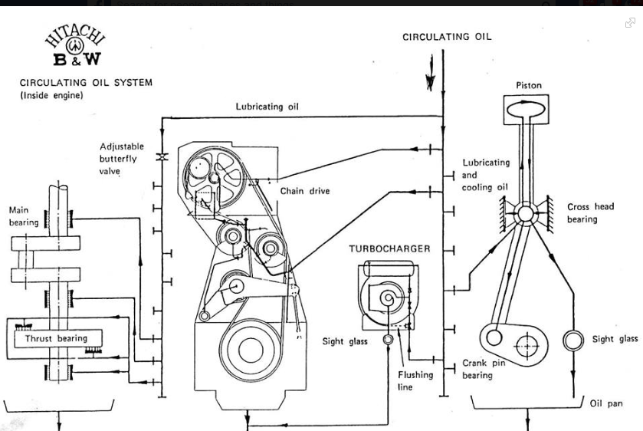

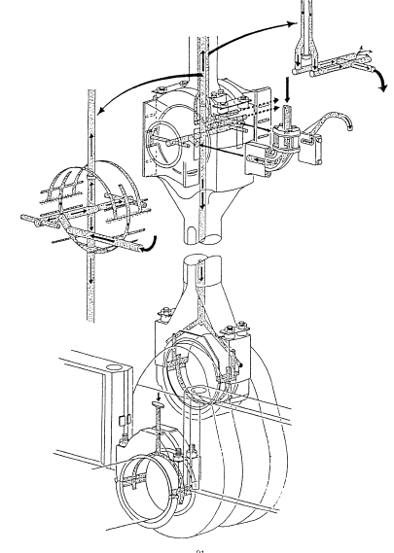

Top of Form

ဆရာသမား အဲ့ဒါက ကျွန်​တော့် တုန်းက ၂ကဒ် တွဲုံးလို့မရဘူး ခနပဲ run တယ်ပီးရင် fault ဖြစ်ပီး ၂ကဒ် ုံးကျသွားပီး slowdown ဖစ်တာ တခု ချင်းစီ လိုက်ထည်ွကြည့်​တော့ master ကအဆင်​​​ြေတယ် slave ကအဆင်မ​ပေဘူး ​လော​လောနဲ့​ေပြာင်းလိုက်လို့ dipswitch မ ​ပေါင်းမိတာ
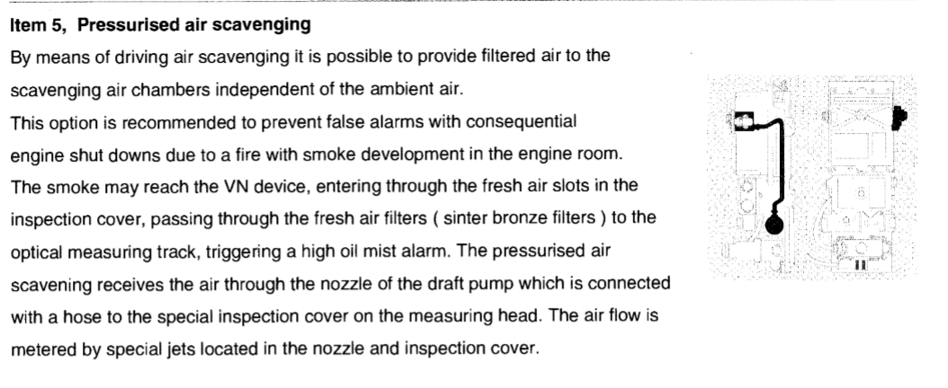
CPU Card အသစ္ဆိုရင္
CPU TOP & CPU ROM မပါဘူး
ကၽြန္ေတာ့္တုန္းက CPU Card အေဟာင္းထဲကေနျဖဳတ္ထည့္ရတာ
Download လုပ္စရာမလိုဘူး
Card အသစ္လာရင္
အေဟာင္းက CPU TOP& ROM ကိုထည့္ၿပီး တန္း Run လို႔ရတယ္
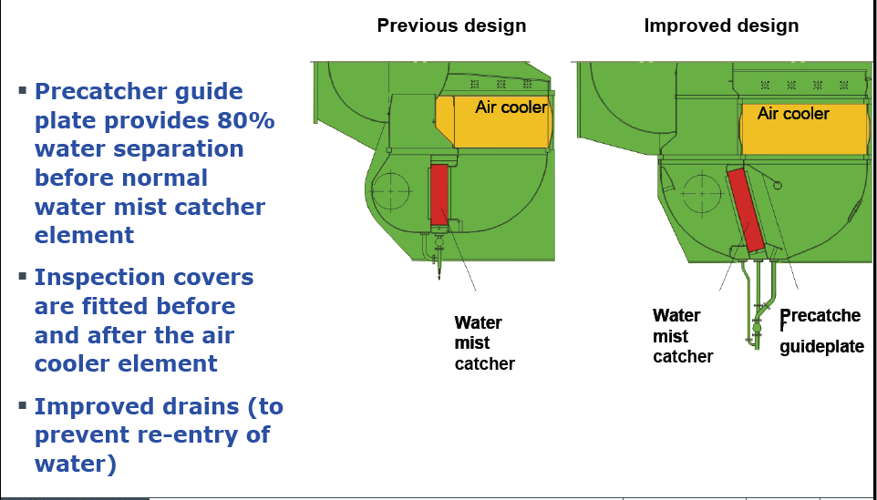
Mitsui Zosen System Research Inc.(MSR )ကုပၼဏီထုတ္EMS -200 III Electronic Governor ႏွင္႔ Control Systems
(၁) ယေန႔ေခတ္ အျပည္ျပည္သြား ကုန္သြယ္သေဘာၤမ်ားတြင္ သေဘာၤ ေမာင္းႏွင္ရန္ အတြက္ တပ္ဆင္အသုံးျပဳ လွ်က္ရွိ သည္႔ Main Engine ၾကီးကုိ စတင္စက္နွဳိး ေမာင္းႏွင္ ခ်ိန္မွစ၍ ဦးတည္ လမ္းေၾကာင္းဆြဲ ထားသည္႔ ဆိပ္ကမ္း တခု မွ တျခားဆိပ္ကမ္း တခု သုိ႔ မရပ္မနား ေတာက္ေလွ်ာက္ ေမာင္းႏွင္ ႏူိင္ရန္ Main Engine Speed (RPM) ကုိ ရာသီဥတု အေျခအေန ႏွင္႔ ပင္လယ္ျပင္ အေျခအေန (Load) ေပၚ မူတည္ ၍ ၾကိဳတင္ ခ်ိန္ညွိ ၍ ေမာင္းႏွင္ၾက ရပါသည္ ။
ထုိသုိ႔ Main Engine အတြက္ေရာ သေဘာၤ အတြက္ ပါ အႏၱရယ္ ကင္းမည္႔ ၾကိဳတင္ ခ်ိန္ညွိ ထားေသာ လည္ ပတ္နွဳန္း (Safe Setting RPM) အတုိင္း တည္ျငိမ္စြာ ေမာင္းႏွင္ ႏူိင္ေစရန္ အတြက္ အင္ဂ်င္ ဆလင္ဒါမ်ား ထဲသုိ႔ ေပးပုိ႔မည္႔ လုိအပ္ေသာ ေလာင္စာဆီ ပမာဏ အတုိး / အေလွ်ာ႔ ကုိ ထိမ္းသိမ္း ခ်ိန္ညွိ ေပးျခင္း လုပ္ငန္းကုိ Governor မွ လုပ္ေဆာင္ ေပးပါသည္ ။
ယခင္ ေခတ္မ်ား က တည္ေဆာက္ခဲ႔ေသာ သေဘာၤမ်ားတြင္ Main Engine ၌ Mechnical Governor ေခၚ Hydraulic နည္းစနစ္ ျဖင္႔ အလုပ္လုပ္ သည္႔ Governor မ်ားကုိ တြင္က်ယ္စြာ တပ္ဆင္အသုံး ျပဳခဲ႔ၾကပါသည္ ။
သုိ႔ေသာ္ ၄င္း Governor အမ်ိဳးအစား မ်ားသည္ Mechnically Linkage မ်ား ျဖင္႔ ဖြဲ႕စည္း တည္ေဆာက္ ထားၾကေသာ ေၾကာင္႔ Load ကုိ အာရုံခံ (Sensing) ရာ တြင္၄င္း ၊ Sensing လုပ္ျပီး သင္႔ေတာ္မည္႔ လုိအပ္ေသာ ေလာင္စာဆီ ပမာဏ ကုိ အင္ဂ်င္ ဆလင္ဒါမ်ားထဲ သုိ႔ ပုိ႔ေဆာင္ေပးရန္ Fuel Injection Pump မ်ားကုိ Control လုပ္ေပးရာတြင္ ၄င္း ၊ တုန္႔ျပန္မွဳ႕ (Response) ေႏွးေကြး ေသာေၾကာင္႔ အင္ဂ်င္တြင္ မလုိလား အပ္ေသာ အက်ိဳးသက္ေရာက္မွဳ႕မ်ား ျဖစ္ေပၚေစျခင္း ၊ ဆီစားႏွဳန္း (Specific Fuel Oil Consumption) ျမင္႔မားေစျခင္း ၊ NOx ႏွင္႔ SOx ကဲ႔သုိ႔ေသာ ေလထု ညစ္ညမ္းမွဳ႕ ျဖစ္ေပၚ ေစမည္႔ Gas မ်ား ထြက္ႏွဳန္းမ်ားျခင္း ၊ အင္ဂ်င္ Over Speed ျဖစ္လွ်င္ Governor မွ Over Speed ျဖစ္ေနေၾကာင္း အာရုံခံ ျပီး အင္ဂ်င္ ရပ္ေစရန္ အခ်ိန္ အနည္းငယ္ ယူရျခင္း ၊ တုန္ျပန္မွဳ႕ ေႏွးေကြး သျဖင္႔ ခ်က္ျခင္း အင္ဂ်င္ရပ္တန္႔ သြားေအာင္ မစြမ္းေဆာင္ႏွဳိင္ျခင္း တုိ႔ေၾကာင္႔ တ စကၠန္႔ ၏ အစိတ္ အပုိင္းအတြင္း အင္ဂ်င္ အစိတ္ အပုိင္းမ်ား ၾကီးမားစြာ ပ်က္စီးေစႏွိဳင္္ျခင္း ၊ ရာသီဥတု ဆုိးရြား ေနခ်ိန္ ႏွင္႔ လွိဳင္းၾကီးေနခ်ိန္ တုိ႔တြင္ Engine RPM မွာ တည္ျငိမ္မွဳ႕ မရွိဘဲ တတ္လုိက္ / က် လုိက္ (Fulctuation) ျဖစ္ေပၚ ေနျခင္း ၊ ထုိကဲ႔သုိ႔ မတည္ျငိမ္ေသာ လည္ပတ္ မွဳ႕ မ်ား ျဖစ္ေပၚလာ ေသာေၾကာင္႔ တခ်ိဳ႕ Unit မ်ားတြင္ Overload ျဖစ္ ေစျခင္း ၊ Over Speed Trip Test ကဲ႔သုိ႔ ေသာ ပုံမွန္ အင္ဂ်င္ ၏ Safety Device စမ္းသပ္ စစ္ေဆးမွဳ႕ မ်ိဳးကုိ သေဘာၤ ေမာင္းႏွင္ ေနခ်ိန္တြင္သာ စမ္းသပ္ႏူိင္ျပီး ရပ္ထား ခ်ိန္တြင္ စိတ္ခ်လက္ခ် စမ္းသပ္ ၍ မရျခင္း ၊ စသည္႔ အားနည္းခ်က္မ်ား နွင္႔ နည္းပညာမ်ား ဖြံ႕ျဖိဳး တုိးတတ္လာျခင္းမ်ား ေၾကာင္႔ ယေန႔ေခတ္ တြင္ Electronic Governor ႏွင္႔ ၄င္းကုိ Control လုပ္ေပးမည္႔ Electronic Governor Control System မ်ား ကုိတပ္ဆင္ အသုံးျပဳလာ ၾကျခင္းျဖစ္ပါသည္ ။
အက်ိဳးသက္ေရာက္မွဳ႕အေနျဖင္႔ ေဖာ္ျပပါ အားနည္းခ်က္မ်ားကုိ အလြယ္တကူ ေက်ာ္လႊားႏူိင္ ခဲ႔ျပီး Engine သည္ ယေန႔ေခတ္ ေရေၾကာင္းသြားလာေရး ဥပေဒမ်ား ၊ နည္းဥပေဒမ်ား တြင္ ျပဌာန္း ေဖာ္ျပထားေသာ စံ ႏွဳန္းမ်ား ႏွင္႔ ကုိက္ညီလာ ခဲ႔သည္႔ အျပင္ သေဘာၤရွိ အင္ဂ်င္နီယာ မွ မိမိ အင္ဂ်င္နွင္႔ ကုိက္ညီမည္႔ Setting မ်ားကုိ လုိအပ္သလုိ ခ်ိန္ညွိျခင္းမ်ား ျပဳလုပ္ႏူိင္၍ ထိမ္းခ်ဳပ္ ေမာင္းႏွင္ လုိေသာ Setting မ်ားအတြင္း အႏၱရယ္ကင္းစြာ ေမာင္းႏွင္ ႏူိင္ျခင္း ၊ သေဘာၤရပ္နား ထားခ်ိန္တြင္ Over Speed Trip Test ကဲ႔ သုိ႔ေသာ Safety Device မ်ား ၊ Engine Protection System မ်ားကုိ Simulation Test (ျဖစ္ ပ်က္ ပုံစံတူ) မ်ား အားျဖင္႔ စိတ္တုိင္းၾက စမ္းသပ္ ႏူိင္ျခင္းမ်ားပင္ ျဖစ္ပါသည္ ။
Main Engine Electronic Governor နွင္႔ Electronic Governor Control System ကုိ မ်ားေသာအားျဖင္႔ သေဘာၤမ်ား တြင္ ဥေရာပျပည္ေထာင္စု မွ တည္ေဆာက္သည္႔ ပုံစံ ႏွင္႔ ဂ်ပန္ႏူိင္ငံ မွ တည္ေဆာက္သည္႔ ပုံစံ မ်ားျဖင္႔ ဒီဇုိင္းမ်ိဳးစုံ ေတြ႔ ႏူိင္ပါ သည္ ။ ယခုတင္ျပမည္႔ Main Engine Electronic Governor နွင္႔ Governor Control System မ်ားသည္ ဂ်ပန္ႏူိင္ငံမွ တည္ေဆာက္ သည္႔ သေဘာၤမ်ား တြင္ အမ်ားဆုံး တပ္ဆင္ အသုံးျပဳေနေသာ Mitsui Zosen System Research Inc.(MSR ) မွ ထုတ္လုပ္ေသာ EMS -200 III Electronic Governor ႏွင္႔ ၄င္း ၏ Control System တုိ႔ျဖင္႔ ပူးတြဲ ဖြဲ႕စည္း တည္ေဆာက္ ထားသည္႔ Remote Control System မွာ Nabtesco Corporation , Marine Control System ကုိ အေျခခံ ၍ တင္ျပ ထားျခင္း ျဖစ္ပါသည္ ။
EMS -200 III Electronic Governor ႏွင္႔ Engine Manoeuvering System Arrangement ကုိ ေအာက္ ေဖာ္ျပပါ ပုံစံျဖင္႔ ေလ႔လာႏူိင္ ပါသည္ ။
(ေအာက္ေဖာ္ျပပါ ပုံမ်ားကုိၾကည္႔ပါ)
Main Engine Electronic Governor System
Main Engine ၏ Electronic Governor ဆုိသည္မွာ Electronic Devices မ်ား ၊ မွက္ဥာဏ္ စနစ္မ်ား (Memory) တုိ႔ျဖင္႔ Electronic Printed Circuit Boad ေပၚတြင္ အတူတကြ ပူးတြဲ တည္ေဆာက္ထားေသာ Computer Processing Unit (CPU) ႏွင္႔ တုိက္ရုိက္ ခ်ိတ္ဆက္ တပ္ဆင္ထားေသာ Electronic စနစ္တခု ျဖစ္ျပီး Digital နည္းပညာ ျဖင္႔ Governor Actuator ကုိ လွည္႔ေပးမည္႔ Electric Motor ကုိ လုိအပ္သည္႔ အခ်ိန္ တြင္ အလုိရွိ သည္႔ ဦးတည္ဘက္ အတုိင္း လည္ပတ္ေစ ရန္ျပဳလုပ္ ထားပါသည္ ။
Electric Motor ကုိ Reduction Gear ခံထားျပီး လည္ပတ္ႏွဳန္း ကုိ ေလ်ာ႔ခ်ကာ Governor Actuator ျဖင္႔ဆက္သြယ္ အသုံးျပဳ ထား ပါသည္ ။
Governor Actuator ၏ Arm ေပၚရွိ Shaft ႏွင္႔ ဆက္သြယ္ ထားေသာ Linkage မ်ား မွတဆင္႔ Fuel Injection Pump တုိ႔ ၏ Rack မ်ားဆီသုိ႔ ဆက္သြယ္ ခ်ိတ္ဆက္ ထားျပီး ေမာ္တာ လည္သည္႔ ဦးတည္ဘက္ ကုိလုိက္၍ Fuel Rack ကုိ ေရွ႕တုိးျခင္း ၊ ေနာက္ဆုတ္ျခင္း ၊ မ်ားျပဳလုပ္ေစ၍ ေလာင္စာဆီ ပမာဏ အနည္း / အမ်ား ကုိျဖစ္ေပၚေစျခင္း ျဖင္႔ Engine Speed
(RPM) ကုိ ထိမ္းသိမ္းေပး၍ Engine ကုိ လည္ပတ္ေစတာ ျဖစ္ပါသည္ ။
Electronic Governor System ၏ အေျခခံသေဘာ ႏွင္႔ အဓိက လုပ္ငန္း မွာ Fuel Lever သုိ႔မဟုတ္ Speed Control Dial မွ Engine အား ၾကိဳတင္ Setting ျပဳလုပ္ထားေသာ RPM Range ႏွင္႔ Load ေပၚမူတည္ ၍ Engine မွ အမွန္တကယ္ ေမာင္းႏွင္ လည္ပတ္ လွ်က္ရွိေသာ Actual RPM တုိ႔ကုိ Fly Wheel တြင္ တပ္ဆင္ထားေသာ Pick Up Sensor မ်ားမွ ေထာက္လွမ္း သိရွိျပီး Electronic Signal အျဖစ္ CPU (Computer Processing Unit) သုိ႔ ပုိ႔ေဆာင္ေပး၍ CPU မွ တဆင္႔ ႏွဳိင္းယွဥ္ တြက္ခ်က္ (Compare and Computerization) မွဳ႕ျဖင္႔ RPM ကြာျခားမွဳ႕ အနည္း အမ်ား ကုိ ရရွိပါသည္ ။
Setting RPM ႏွင္႔ Load ေၾကာင္႔ အမွန္တကယ္ လည္ပတ္ေနေသာ RPM ျခားနားခ်က္ ေပၚ မူတည္ ၍ Governor အား Fuel Injection Pump မ်ားမွ သက္ဆုိင္ရာ ဆလင္ဒါ မ်ားဆီ သုိ႔ ေလာင္စာဆီ ပုိ႔ေဆာင္ေပးမွဳ႕ နည္းေစျခင္း သုိ႔မဟုတ္ မ်ားေစ ျခင္းမ်ား ကုိ ျပဳလုပ္ေစရန္ Command ေပး ျခင္း အားျဖင္႔ လုိအပ္ေသာ Setting RPM Range အတြင္း တည္ျငိမ္စြာ လည္ပတ္ ေစရန္ ထိမ္းေၾကာင္း လုပ္ေဆာင္ ေပးျခင္း ျဖစ္ပါသည္ ။
Main Engine Electronic Governor သည္ Engine အတြက္ အေရးၾကီးေသာ အေျခခံ လုပ္ငန္းမ်ား ျဖစ္သည္႔ လည္ပတ္ႏွဳန္း ထိမ္းသိမ္းေပးျခင္း (RPM Control) ႏွင္႔ အေျခအေန တုိင္း အတြက္ ေလာင္စာဆီ ေပးပုိ႔မွဳ႕ကုိကန္႕သတ္ ထိမ္း သိမ္း ေပးျခင္း (Fuel Limination) တုိ႔ျပင္ ေအာက္ေဖာ္ျပပါ လုပ္ငန္းမ်ားႏွင္႔ အားသာခ်က္ မ်ားကုိလဲ ေဆာင္ရြက္ႏူိင္ ပါသည္ ။
ϖ Governor Control ျပဳလုပ္ေနသည္႔ အေျခအေန အရပ္ရပ္ ကုိ Engine Control Room ရွိ LCD Screen မွ ေန၍ တုိက္ရုိက္ ျမင္ေတြ႔ ေစႏူိင္ျခင္း ၊
ϖ Engine ႏွင္႔ ကုိက္ညီမည္႔ Setting မ်ားႏွင္႔ ၊ Govenor ၏ လုပ္ငန္းမ်ား ကုိ Engine အား အႏၱရယ္ မျဖစ္ေစ ဘဲ လုံေလာက္ေသာ ကာကြယ္ေရး စနစ္ မ်ားျဖင္႔ အလြယ္တကူ အေျပာင္းအလဲ ျပဳလုပ္ႏူိင္ျခင္း ၊
ϖ CPU ၏ ဆုံးျဖတ္ခ်က္ ျဖင္႔ Maximum Fuel Supply ကုိ Control လုပ္ေပးႏူိင္ျခင္း ၊
ϖ Engine ေမာင္းထား ခ်ိန္တြင္ Governor အလုပ္လုပ္ ေနသည္႔ ကာလတေလွ်ာက္လုံး ၌ Governor Output ကုိ Engine Control Room ရွိ LCD Screen မွ ၾကည္႔ရွဳ႕ စစ္ေဆးႏုိင္ျပီး ၊ Engine ရပ္နားထား ခ်ိန္တြင္ Governor Output ႏွင္႔ Governor Fuction Test မ်ားကုိ Engine Control Room ရွိ LCD Screen မွ ေန၍ Simulation Test မ်ားျဖင္႔ စမ္းသပ္ ၊ စစ္ေဆးျခင္း မ်ားျပဳလုပ္ႏူိင္ျခင္း ၊
ϖ Engine Control Room ရွိ LCD Screen ၏ FUEL MODE ကုိ ႏွိပ္ျခင္းျဖင္႔ ဆလင္ဒါ အတြင္း ေလာင္ကြ်မ္းမည္႔ ေလာင္စာဆီ ေပးပုိ႔မွဳ႕ ပမာဏ ကုိ ပုံေသ ျဖစ္ေအာင္ Governor အား Command ေပးႏူိင္ ျခင္း (Constant Amount of Fuel Oil Supply)
ϖ LCD Screen ရွိ DIRECT MODE ကုိ ႏွိပ္ျခင္းျဖင္႔ Fuel Rack မ်ား ကုိ Engine Control Room မွ ေန၍ Control လုပ္ႏူိင္ျခင္း ၊
ϖ ရာသီဥတုဆုိးရြား ေနခ်ိန္ ႏွင္႔ လွိဳင္းၾကီးေနခ်ိန္ တုိ႔ကဲ႔သုိ႔ ပုံမွန္မဟုတ္ သည္႔အေျခအေန မ်ိဳးမ်ားတြင္ Engine
Speed (RPM) ကုိ တုိက္ရုိက္ အက်ိဳးသက္ေရာက္ေစသည္႔ Fuel Rack မ်ားအား တတ္လုိက္ / က် လုိက္ (Fulctuation) မျဖစ္ေစဘဲ တည္ျငိမ္ေအာင္ Control လုပ္ေပးႏူိင္ျခင္း ၊
ϖ Voyage Data Recorder ႏွင္႔ ခ်ိတ္ဆက္ ထားျပီး Main Engine ႏွင္႔ Governor လုပ္ေဆာင္ ခ်က္မ်ားကုိ Record လုပ္ထားႏူိင္ျခင္း ၊
ϖ Governor ကုိေမာင္းႏွင္ ေပးမည္႔ Electric Motor ႏွင္႔ Governor Actuator တုိ႔ကို အလြယ္တကူ ျဖဳတ္ / တပ္ ႏူိင္၍ ျပဳျပင္ထိမ္းသိမ္း မွဳ႕မ်ားကုိ လြယ္ကူစြာ ေဆာင္ရြက္ႏွဳိင္ျခင္း ၊ စသည္တုိ႔ ပင္ျဖစ္ပါသည္ ။
(ဆက္လက္ေဖာ္ျပပါမည္)
Yesterday at 13:46
Main Engine Electronic Governor and Electronic Governor Control Systems မ်ား အေၾကာင္း ။
Mitsui Zosen System Research Inc.(MSR )ကုပၼဏီထုတ္EMS -200 III Electronic Governor ႏွင္႔ Control Systems
(အပုိင္း ၃ ကုိဆက္လက္ဖတ္ရွဳ႕ပါ)
Torque Limiter
Torque Limiter ၏ အဓိက လုပ္ေဆာင္ ေပးမည္႔ Function မွာ Engine Running Speed ႏွင္႔ လုိက္ေလ်ာ ညီေထြ ျဖစ္မည္႔ ေလာင္စာဆီ ပမာဏ ကုိ ကန္႔သတ္ ထိမ္းခ်ဳပ္ေပး ျခင္းျဖင္႔ Engine ၏ လက္ရွိ ထမ္းေဆာင္ ေနေသာ Setting Load အတြင္း တည္ျငိမ္စြာ ရရွိေစျပီး Engine ကုိ Over Load ျဖစ္ျခင္း မွ ကာကြယ္ ေပးပါသည္ ။
ပင္လယ္ေရထဲတြင္ နစ္ေနသည္႔ သေဘာၤ ၏ ကုိယ္ထည္ သည္ အလြန္ၾကာျမင္႔စြာ ေရြ႕လွ်ားမွဳ႕ မရွိျခင္း ၊ ေက်ာက္ခ် ရပ္နားထားခ်ိန္ ၾကာျမင္႔ျခင္း ၊ ေရ ေန သတၱဝါမ်ား တြယ္ကပ္ႏူိင္ျခင္း မရွိေအာင္ သုတ္ထားေသာ သုတ္ေဆးမ်ား (Anti Fouling Paint) အမ်ိဳးအစား မေကာင္း ေသာေၾကာင္႔ သုိ႔မဟုတ္ သုတ္ေဆးမ်ား မရွိေတာ႔ျခင္း ၊ Cathod Protection System ဟု ေခၚ ေသာ လွ်ပ္စစ္ဓါတ္ လႊတ္၍ သေဘာၤ ကုိယ္ထည္ကုိ ကာကြယ္ထားေသာ နည္းစနစ္မ်ား ႏွင္႔ ကရိယာမ်ား မတပ္ဆင္ထားျခင္း ၊ တပ္ဆင္ ထားေသာလည္း စြမ္းေဆာင္ရည္ မေကာင္း ျခင္း ၊ စသည္တုိ႔ေၾကာင္႔ ပင္လယ္ခရုမ်ား ခရင္းမ်ား ႏွင္႔ ပင္လယ္ေရေန သတၱဝါ မ်ား သည္ သေဘာၤ ကုိယ္ထည္ ႏွင္႔ ပန္ကာရြက္မ်ား (Propeller) ၌ လြန္မင္းစြာ တြယ္ကပ္ေနၾကျခင္း ၊ ပန္ကာရြက္မ်ား ႏွင္႔ Propeller Boss တြင္ ငါးဖမ္းပုိက္ ကဲ႔သုိ႔ေသာ ၾကိဳးစ မ်ားတြယ္ျငိ ေန ျခင္း ၊ Engine ႏွင္႔ Propleer တုိ႔ ၏ အခ်ိဳးညီစြာ တြဲဆက္ လုပ္ေဆာင္ေန မွဳ႕ သေဘာတရား ကုိ ေသခ်ာစြာ နားမလည္ဘဲ ေရတိမ္တြင္ (ဥပမာ ျမစ္ေၾကာင္း အတြင္း) Setting အလြန္မ်ား ေသာ Engine Speed ကုိ ေလွ်ာ႔မခ်ဘဲ တတ္မ တဆုံး (Full Rudder Angle) ဆြဲ၍ ေကြ႕ေစျခင္း ၊ စေသာ အေျခအေန အရပ္ရပ္ သည္ Engine Load ကုိ ပုံမွန္အေျခ အေန ထက္ ပုိမ်ားေစျပီး ထုိ ပုံမွန္မဟုတ္သည္႔ ဝန္ပုိ (Abnormal Load) ကုိ ေက်ာ္လြန္ ေအာင္ ပန္ကာရြက္မ်ား (Propeller) က တြန္းရာတြင္ ပုံမွန္အေျခေနထက္ Torque ႏွင္႔ Thrust Force မ်ားစြာ အသုံးျပဳလုိက္ ရေသာေၾကာင္႔ ေဖာ္ျပပါ အေျခအေနမ်ိဳးမ်ားတြင္ Torque Limit Alarm ေပၚလာ ျပီး Engineer ကုိ အခ်က္ ေပး ၍ Torque Limit သည္ Setting Limit ထက္ ေက်ာ္လြန္ေနေၾကာင္း သိေစမွာျဖစ္ပါသည္ ။
EMS -200 III Electronic Governor System တြင္ Torque Limit ကုိ Engineer မွ မိမိ စိတ္တုိင္းၾက Program သြင္း ျပီး Setting မ်ား ကုိ ျပဳျပင္ေျပာင္းလဲ ျခင္းမ်ား မျပဳလုပ္ႏူိင္ပါ ။ Electronic Governor System တည္ေဆာက္သည္႔ ကြ်မ္းက်င္ သူ ပညာရွင္ မ်ားမွ သေဘာၤ ႏွင္႔ တပ္ဆင္ ထားေသာ Engine တုိ႔ ၏ Load မ်ား ၊ Engine Speed ႏွင္႔ လုိက္ေလ်ာညီေထြ ျဖစ္မည္႔ ၾကိဳတင္ တြက္ခ်က္ သတ္မွက္ ထားေသာ Torque ႏွင္႔ Thrust Force မ်ား စသည္ တုိ႔ကုိ စနစ္တက် ေသခ်ာစြာ တြက္ခ်က္၍ Memoey လုပ္ထားကာ ၎ အေျခအေန အတုိင္း မေျပာင္း လဲဘဲ တည္ရွိေနေစရန္ ျဖစ္ပါသည္ ။
(ေအာက္ေဖာ္ျပပါ Totque Limiter ၏ လုပ္ေဆာင္မွဳ႔ အေျချပ Graph ကုိၾကည္႔ပါ)
Chief Limiter
Chief Limiter ၏ Function မွာ ဆလင္ဒါ မ်ားသုိ႔ ေပးပုိ႔မည္႔ ေလာင္စာဆီ ပမာဏသည္ ၾကိဳတင္ ခ်ိန္ဆ ထားေသာ Setting တန္ဘုိး ပမာဏ ထက္မေက်ာ္လြန္ေအာင္ ကန္႔သတ္ ထိမ္းခ်ဳပ္ေစျခင္း ျဖစ္ျပီး Engine ကုိ Over Load မျဖစ္ေအာင္ ကာကြယ္ ေပးပါသည္ ။ Chief Limiter Function မွ ေန၍ Engine ၏ လုိအပ္ခ်က္ ႏွင္႔ ကုိက္ညီမည္႔ ေလာင္စာဆီ ေပးပုိ႔မွဳ႕ ပမာဏ ကုိ အင္ဂ်င္နီယာ မွ စိတ္တုိင္းၾက Program လုပ္ေပး ႏူိင္ပါသည္ ။
Electronic Governor Control System
MSR ၏ EMS -200 III Electronic Governor ႏွင္႔ Engine Manoeuvering System တုိ႔ ၏ Control System ကုိ အဓိက အားျဖင္႔ ေအာက္ပါ System မ်ားႏွင္႔ အတူတကြ ေပါင္းစပ္ ဖြဲ႔စည္း တည္ေဆာက္ထားပါသည္ ။
1) Engine Control System (ECS)
Engine Control System တခုျဖစ္ျပီး Engine Control Room မွ ေန၍ Manual Remote Control ျဖင္႔ Electronic Governor ကုိ လုိအပ္သလုိ ထိမ္းခ်ဳပ္ ေမာင္းႏွင္ ႏူိင္ ျပီး Engine ကုိ စတင္ စက္ႏွဳိးခ်ိန္မွ ေတာက္ေလွ်ာက္ ေမာင္းႏွင္ ေနသည္႔ ကာလ အေတာအတြင္း ထိမ္းခ်ဳပ္ ေမာင္းႏွင္ ႏူိင္သည္႔ စနစ္ (Control System) ျဖစ္ပါသည္ ။
2) Engine Protecting System (EPS)
Engine ၾကီးတခုလုံးအတြက္ Safety System မ်ားျဖစ္ျပီး အေၾကာင္း တစုံတရာေၾကာင္႔ Engine ၾကီးအား အေသးအဖြဲ မွ စ၍ ၾကီးမားေသာ ပ်က္စီးမွဳ႕မ်ိဳးအထိ မျဖစ္ေပၚ မပ်က္စီးေစရန္ ကာကြယ္ ေပးထားေသာ ထိမ္းခ်ဳပ္မွဳ႕စနစ္ (Control System) ျဖစ္ပါသည္ ။
3) Backup Control System (BUCS)
အကယ္၍ Electronic Governor ၏ လွဳပ္ရွားမွဳ႕ မ်ား ကုိ စဥ္ဆက္မျပတ္ ေထာက္လွမ္း သိရွိေစႏူိင္ျပီး ခ်က္ျခင္း တုန္႔ျပန္မွဳ႕ေပးႏူိင္ သည္႔ CPU သည္ ပုံမွန္ အတုိင္း အလုပ္မလုပ္ႏူိင္ ခဲ႕လွ်င္ ေသာ္လည္းေကာင္း (CPU Abnormal) ၊ CPU သုိ႔ ေပးပုိ႔ေသာ ပါဝါ Supply ျပတ္ေတာက္ (Electric Power Failure ) ခဲ႔လွ်င္ေသာ္လည္းေကာင္း ၊ အေၾကာင္း တခုခု ေၾကာင္႔ ECS Power Supply Failure ျဖစ္ေနေၾကာင္း CPU မွ ေထာက္လွမ္း သိရွိခဲ႔ လွ်င္ေသာ္ လည္းေကာင္း ၊ Engine Control Room မွ Backup Control System (BUCS) သည္ အလုိေလွ်ာက္ Engine ကုိ ပုံမွန္ ေမာင္းႏွင္ေနၾက နည္းလမ္းမ်ား အတုိင္း အႏၱရယ္ ကင္းစြာျဖင္႔ ခ်က္ျခင္း အဆက္မျပတ္ ထိမ္းသိမ္း ေမာင္းႏွင္ ေပးမည္႔ ထိမ္းခ်ဳပ္မွဳ႕စနစ္ (Control System) ျဖစ္ပါသည္ ။
4) Engine Governor System (MAG)
Main Engine ၾကီးကုိ Engine Control Room မွ Remote Control System မ်ား အားျဖင္႔ ေသာ္ လည္းေကာင္း ၊ Bridge မွ Remote Control System မ်ား အားျဖင္႔ ေသာ္လည္းေကာင္း စတင္ေမာင္း ႏွင္ ျခင္း ၊ ပုံမွန္အတုိင္း လည္ပတ္ ေမာင္းႏွင္ ေနသည္႔ ကာလ အေတာအတြင္း Load ေပၚမူတည္ ၍ ၾကိဳတင္ ခ်ိန္ညွိ ထားေသာ RPM Range အတြင္း တည္တည္ ျငိမ္ျငိမ္ လည္ပတ္ ေန ေစရန္ လုိအပ္ ေသာ ေလာင္စာဆီ ပမာဏ အနည္း အမ်ားကုိ Fuel Injection Pump မ်ားက သက္ဆုိင္ရာ ဆလင္ဒါ မ်ား ဆီ သုိ႔ အတိအက် ပို႔ေဆာင္ ေပးႏူိင္ရန္ Governor မွ CPU ၏ တြက္ခ်က္မွဳ႕ မ်ား အတုိင္း အတုိး / အေလွ်ာ႔ ကုိ စကၠန္႔ မလပ္ ခ်ိန္ညွိေပး ေနျခင္း ဘဲ ျဖစ္ပါသည္ ။
(ဆက္လက္ေဖာ္ျပပါမည္)
အဆင္ေျပေအာင္ျမင္ၾကပါေစ။

မဂၤလာပါခင္ဗ်ာ....
ညီငယ္လူသစ္မ်ားကိုရည္ၫႊန္းပါတယ္....
.....
Main Engine နဲ႔ပတ္သက္တဲ့ safety devices အေၾကာင္းနဲ႔ protection အေၾကာင္းအေျခခံေလးတင္ျပေပးပါရေစ......
.....
သေဘၤာႀကီးတစ္စီးပင္လယ္ျပင္ကိုျဖတ္သန္းခုတ္ေမာင္းရန္အတြက္ အင္ဂ်င္ကိုတပ္ဆင္ထားပါတယ္......
အင္ဂ်င္ရဲ႕လည္ပတ္မႈအားေၾကာင့္သေဘၤာႀကီးေ႐ွ႕တိုးေနာက္ဆုတ္ျဖစ္စဥ္ေတြကိုေဆာင္ရြက္လို႔ရတဲ့အတြက္သေဘၤာႀကီးရဲ႕ႏွလံုးသားလို႔တင္စားၾကပါတယ္....အကယ္၍အင္ဂ်င္သာမပါခဲ့လွ်င္အသက္မဲ့ေနတဲ့သေဘၤာႀကီးျဖစ္ေနႏိုင္ပါတယ္.......
သေဘၤာႀကီးေရြ႔လ်ားမႈျဖစ္စဥ္အတြက္ တာဝန္ထမ္းေဆာင္ေနရတဲ့ Main Engine သည္ အမ်ိဳးမ်ိဳးေသာဝန္အား(various loads) ေတြ ဆိုးရြားတဲ့ရာသီဥတုဒဏ္(Stresses) ေတြကိုခံရပါတယ္......
Main Engine ေကာင္းမြန္စြာလည္ပတ္ေစေရးအတြက္ ကူညီေထာက္ပ့ံေပးေသာအျခားစက္ပစၥည္းမ်ား ပံုမွန္အလုပ္မလုပ္ျခင္းမ်ိဳးကိုလည္းၾကံဳေတြ႔ရႏိုင္ပါတယ္........
ထုိကဲ့သို႔ပံုမွန္မဟုတ္ေသာအေျခအေနေတြအေနအထားေတြနဲ႔ၾကံဳလာရတဲ့အခါ Main engine ရဲ႕အစိတ္အပိုင္းေတြပ်က္စီးျခင္းျဖစ္ေပၚတတ္ပါတယ္.......
Main Engineရဲ႕အစိတ္အပိုင္းတခ်ိဳ႕ ပ်က္စီးျခင္းမွာ စက္ခန္းအတြင္းတာဝန္ထမ္းေဆာင္ေနေသာလူသားမ်ားကိုလည္းမေတာ္တဆထိခိုက္မႈေတြျဖစ္ႏိုင္သလို သေဘၤာႀကီးတစ္စီးလံုးေရထဲနစ္ျမဳတ္ၿပီး ႀကီးမားတဲ့ဆံု႐ွံုးမႈေတြလည္းျဖစ္ေပၚႏိုင္ပါတယ္......
အဲ့တာေၾကာင့္ Main Engine မွာ ပံုမွန္မဟုတ္တဲ့အေျခအေနေတြျဖစ္ေပၚလာခဲ့ရင္ ႀကိဳတင္သိ႐ွိၿပီး အႏၱရာယ္ကိုေ႐ွာင္႐ွားႏိုင္ရန္ Protection system ေတြ တပ္ဆင္ထားပါတယ္....
......
Main Engine မွာတပ္ဆင္ထားတဲ့ Protection System မ်ားကိုအေျခခံအားျဖင့္ ၄မ်ိဳးခြဲျခားႏိုင္ပါတယ္......
၁. Alarm.
သတ္မွတ္တန္ဖိုးေတြကေနၿပီး engine parameters ေတြေသြဖယ္သြားတဲ့အခါ စက္ခန္းအတြင္းမွာ တာဝန္က်ဝန္ထမ္းကို အသံႏွင့္အခ်က္ျပမီးအားျဖင့္သတိေပးေသာစနစ္တပ္ဆင္ထားပါတယ္....Main Engine နဲ႔ပတ္သက္ၿပီး ႀကိဳတင္သတိေပးတဲ့စနစ္ Alarm ျဖစ္ပါတယ္......
၂. Engine Slow Down
ပထမအဆင့္ျဖစ္တဲ့ Alarm လာၿပီးေနာက္ လံုေလာက္တဲ့ျပင္ဆင္မႈေတြ...တာဆီးမႈေတြ...ျပစ္ခ်က္႐ွာေဖြၿပီးျပဳျပင္မႈေတြကိုအခ်ိန္မွီမလုပ္ေဆာင္ႏိုင္တဲ့အခါ Main Engine ရဲ႕အစိတ္အပို္င္းေတြပ်က္စီးသြားႏိုင္တဲ့အတြက္ အင္ဂ်င္ရဲ႕လည္ပတ္ႏႈန္းကိုအလိုေလွ်ာက္ေလ်ာ့ခ်တဲ့စနစ္ျဖစ္ပါတယ္......
၃. Engine Shut Down
Main Engine မွာျဖစ္ေပၚေနတဲ့ျပသနာဟာ စက္ပစၥည္းကိုပ်က္စီးေစႏိုင္တဲ့အေနအထားကိုအလြန္နီးကပ္စြာေရာက္႐ွိသြားရင္ အလိုေလွ်ာက္ရပ္တန္႔သြားေစမယ့္စနစ္ျဖစ္ပါတယ္...
Main Engine လည္ပတ္ေစရန္ေထာက္ပံ့ေပးတဲ့ Fuel or Air ကိုျဖတ္ေတာက္ေပးလိုက္တာပဲျဖစ္ပါတယ္.....
၄. Starting Interlock
Main Engine ရပ္တန္႔ထားေသာအေနအထားကေနၿပီးလံုးဝလည္ပတ္မႈကုိျပဳလုပ္မရေအာင္တာဆီးထားေသာစနစ္ျဖစ္ပါတယ္....Main Engine လည္ပတ္မႈအတြက္လံုေလာက္ေသာအေျခအေနမ်ား ဆက္စပ္စက္ပစၥည္းမ်ာ....ေထာက္ပ့ံစနစ္မ်ားျပည့္စံုျခင္မ႐ွိေသးပဲ စက္ႏိႈးတဲ့အခါ Engine ပ်က္စီးေစျခင္းျဖစ္ေပၚမႈမွကာကြယ္ရန္စနစ္ျဖစ္ပါတယ္.......
........
အထက္ေဖာ္ျပပါစနစ္မ်ားထဲမွာ Main Engine Slow Down ျဖစ္ေစေသာအေျခခံအခ်က္မ်ားကိုတင္ျပေပးပါမယ္....
1. Lubricating Oil Pressure fall to 1.5 bar
2. Cam Shaft pressure below 2 bar
3. No flow of piston cooling(water/oil)
4. Oil mist detector activated
5. Lubricating oil high temperature > 60'C
6. Piston cooling temperature high > 75'C
7. Jacket water temperature high > 88'C
8. Cylinder exhaust temperature high > 450'C
9. Scavenge air temperature high > 65'C
10. Thrust Block temperature high > 75'C
11. Low flow cylinder lubricating oil
12. Control air low pressure <5.5bar
စတဲ့အေျခခံအခ်က္ေတြျဖစ္ပါတယ္.......
Temperature နဲ႔ pressure တန္ဖိုးမ်ားဟာ maker/type အေပၚမူတည္ၿပီး Manual စာအုပ္ကိုကိုးကားႏိုင္ပါတယ္..........
.....
Main Engine Shut Down ျဖစ္ေစတဲ့အေျခခံအခ်က္ေတြကေတာ့....
1. Lubricating oil pressure very low < 1 bar
2. Cam shaft lubricating oil pressure very low < 1.5 bar
3. Jacket cooling water temperature very high > 95'C
4. Low jacket water pressure < 0.1 bar
5. Non flow of cylinder lubricating oil
6. Thrust block temperature very high > 90'C
7. Turbocharger lubricating oil pressure low < 0.8 bar
8. Over speed of Main Engine ( 107 % of Max. Continuous rating MCR)........
9. Manual Shut down
စတဲ့အေျခခံအခ်က္ေတြျဖစ္ပါတယ္........
Temperature နဲ့ pressure တန္ဖိုးမ်ားကို maker/type အေပၚမူတည္ၿပီး manual စာအုပ္ကို ကိုးကားႏိုင္ပါတယ္........
..........
Starting Interlock နဲ႔ပတ္သက္တဲ့အေျခခံအခ်က္ေတြကေတာ့.....
1. Turning gear engage interlock
2. Auxiliary blower OFF interlock
3. Lubricating oil and other important pump not running interlock
4. Starting air line valve CLOSE interlock
စတဲ့အေျခခံအခ်က္မ်ားပဲျဖစ္ပါတယ္.....
.......
.......
အထက္ေဖာ္ျပပါအခ်က္မ်ားအျပင္ အင္ဂ်င္မွာတပ္ဆင္ထားေသာ Safety Devices မ်ားလည္း႐ွိေနပါေသးတယ္........
လည္းေကာင္းတို႔အထဲမွာ အေျခခံအက်ဆံုး Device မ်ားကို ပံုႏွင့္တကြေဖာ္ျပေပးလိုက္ပါတယ္.....
.....
1. Crank case relief door/valve
2. Scavenge space relief door/valve
3. Starting air line relief valve
4. Cylinder head relief valve
5. Flame trap
6. Oil mist detector
7. Running direction interlock
8. Turning gear interlock
စတဲ့အေျခခံ device ေတြျဖစ္ပါတယ္.......
ပံုမ်ားကိုအမည္ႏွင့္တကြေဖာ္ျပေပးထားပါတယ္.....
............
ယခုဆိုလွ်င္ Main Engine ႏွင့္ပတ္သက္ေသာ Safety device နဲ့ protection မ်ားကိုအနည္းငယ္တီးေခါက္မိၿပီဟုယံုၾကည္ပါတယ္......
လိုအပ္ခ်က္မ်ားလြဲမွားခ်က္မ်ားကိုဝင္ေရာက္ျဖည့္စြက္ေဆြးေႏြးေပးပါရန္ေလးစားစြာေမတၱာရပ္ခံပါတယ္............
...........
...........
ေလးစားစြာျဖင့္
ရန္လင္း
၀၈.၁၀.၂၀၁၆
Main Engine Electronic Governor and Electronic Governor Control Systems မ်ား အေၾကာင္း ။
Mitsui Zosen System Research Inc.(MSR )ကုပၼဏီထုတ္EMS -200 III Electronic Governor ႏွင္႔ Control Systems
(အပုိင္း ၂ ကုိ ဆက္လက္ဖတ္ရွဳ႕ပါရန္)
Main Control Unit or Governor Control Unit
Main Control Unit သုိ႔မဟုတ္ Governor Control Unit ကုိ Engine Control System (ECS) ႏွင္႔ အတူတကြ ေပါင္းစပ္ဖြဲ႔စည္း တည္ေဆာက္ ထားပါသည္ ။ ၄င္းတြင္ PID Controller (P:Proportial , I:Integral , D:Differential) ပါဝင္ပါသည္ ။
Fuel Lever သုိ႔မဟုတ္ Speed Control Dial မွ Starting Air Order ေပးလုိက္ေသာ အခါ Speed Order Signal သည္ PID Controller မွတဆင္႔ Control လုပ္မည္႔ Starting Process မ်ား အတုိင္း အတိအက် လုပ္ေဆာင္ ေစ၍ Engine သည္ ေလအား ျဖင္႔ Time Delay တခုထိ စတင္ လည္ပတ္ျပီး ေနာက္ Fuel Lever သုိ႔မဟုတ္ Speed Control Dial ကုိ အလုိရွိသည္႔ Engine Speed Range သုိ႔ Order ေပးေစေသာ အခါ ထုိ Speed Order Signal သည္ PID Controller သုိ႔ ေရာက္ရွိသည္ ။
PID Controller မွ ခ်က္ျခင္းတုန္႔ျပန္ ၍ Engine Safety နွင္႔ Protection System တုိ႔ ရွိ Setting လုပ္ထားေသာ Fuel Limiting Process မ်ား ၊ RPM Pick Up Sensor မ်ား ႏွင္႔ Servo Panel Unit ရွိ Servo Driver ၏ PID Controller သုိ႔ ဆက္လက္ ေရာက္ရွိေစ ပါသည္ ။
Servo Driver ၏ PID Controller မွ Controlling Process မ်ားအတုိင္း ဆက္လက္ လုပ္ေဆာင္ ျပီးေနာက္ Governor Actuator ကုိ လွည္႔ေပး မည္႔ Servo Motor သုိ႔ ထုိ Speed Order Signal ကုိ ဆက္လက္ ေရာက္ရွိ ေစ သျဖင္႔ Governor Actuator မွ Fuel Injection Pump မ်ား သုိ႔ ေလာင္စာဆီ မ်ားကုိ စတင္ ပုိ႔ လႊတ္ေစရန္ စြမ္းေဆာင္ ေပးျပီး Fuel Injection စတင္ ျဖစ္ေပၚ၍ Engine သည္ အလုိရွိရာ Speed Order အတုိင္း ဆက္တုိက္ လည္ပတ္ ေနမည္ ျဖစ္ပါသည္ ။
Engine စတင္ လည္ပတ္သည္ နွင္႔ တျပိဳင္နက္ အမွန္တကယ္ Engine လည္ပတ္ ေနသည္႔ လည္ပတ္ႏွဳန္း (Actual Engine Speed - RPM) ကုိ RPM Pick Up Sensor မ်ားမွ ေထာက္လွမ္း သိရွိ ၍ Main Control Unit ရွိ PID Controller မွတဆင္႔ CPU သုိ႔ Feed Back Signal မ်ားကုိ ၄င္း ၊ Governor Actuator Position ၏ Feed Back Signal ကုိ Servo Driver ရွိ PID Controller သုိ႔ ၄င္း ၊ ပုိ႔ေဆာင္ ေပး၍ Setting RPM ႏွင္႔ Actual RPM တုိ႔ တထပ္တည္း ျဖစ္ေစရန္ လုပ္ေဆာင္ ေပးပါသည္။
ထုိနည္း အတုိင္း Engine ေမာင္းႏွင္ ေနသည္႔ ကာလ တေလွ်ာက္လုံး ၌ Setting လုပ္ထားသည္႔ Speed Order ကုိ အေျခခံ ၍ Engine ၏ အမွန္တကယ္ လည္ပတ္ႏူန္း (Actual RPM) ကုိ Pick Up Sensor မ်ားမွ အဆက္မျပတ္ ေထာက္လွမ္း ၍ Speed Signal အျဖစ္ထုတ္ လႊတ္ေပးျပီး CPU ႏွင္႔ Servo Driver သုိ႔ ပုိ႔ေဆာင္ ေပးပါသည္ ။
ထုိ႔ေၾကာင္႔ Governor Actuator Position Order သည္ Setting လုပ္ထားသည္႔ လည္ပတ္ႏူန္း (Setting RPM) ႏွင္႔ Engine အမွန္တကယ္ လည္ပတ္ ေနသည္႔ Actual RPM တုိ႔ တထပ္တည္း က်ေစရန္ Governor ၏ Electric Motor ကုိေမာင္း ေပးေစျခင္းျဖင္႔ Actual RPM ကုိ အႏၱရယ္ ကင္းသည္႔ Engine Running Condition အမ်ိဳးမ်ိဳး အတြက္ ၾကိဳတင္ ကန္႔သတ္ထားေသာ ကန္႔သတ္္ခ်က္ ေဘာင္မ်ားအတြင္း မွ တည္ျငိမ္စြာ ရရွိ ေစပါသည္ ။
(ေအာက္တြင္ေဖာ္္ျပထားေသာ ပုံကုိၾကည္႔ပါ)
Servo Panel Unit
Governor Actuator Motor ကုိ ေမာင္းရန္ သုိ႔မဟုတ္ Control လုပ္ရန္ အတြက္ Servo Panel Unit ကုိ Servo Driver ႏွင္႔ အတူတကြ တပ္ဆင္ ထားပါသည္ ။ ၄င္းသည္ Engine ေမာင္းႏွင္ လည္ပတ္ ေနသည္႔ ကာလတေလွ်ာက္ လုံး ၌ Servo Driver ႏွင္႔ Governor Actuator Motor တုိ႔ ၏ Running Condition ကုိလဲ စစ္ေဆး ေပးပါသည္။ Power Supply မွာ AC 440V , 60Hz , 1Φ , Max : 500 VA ျဖစ္ပါသည္ ။
Transformer
သေဘာၤေပၚတြင္ လုပ္ငန္း အမ်ိဳးမ်ိဳး အတြက္ Electric Power ေပးရန္ အသုံးျပဳေနသည္႔ AC Transformer မ်ားျဖင္႔ ဆက္သြယ္ ထားျခင္းမရွိဘဲ သီးျခားဖြဲ႔စည္း တည္ေဆာက္ ထားေသာ Transformer ျဖစ္ျပီး Servo Driver သုိ႔ AC Power ေပးရန္ တပ္ဆင္ထား ပါသည္ ။
Governor Actuator
Governor Actuator တြင္ Drive လုပ္ေပးမည္႔ AC Servo Motor ႏွင္႔အတူ Resolver , Reduction Gear , Fuel Rack မ်ားႏွင္႔ ခ်ိတ္ဆက္ ထားသည္႔ Arm တခုတုိ႔ ပါဝင္ဖြဲ႕စည္းထားသည္ ။
Governor Control မလုပ္ႏူိင္သည္႔ ပုံမွန္ မဟုတ္ေသာ အေျခအေနမ်ိဳးမ်ားတြင္ Arm ရွိ Linkage ကုိ လွည္႔၍ Lock လုပ္ျပီး Governor နွင္႔ Engine ဆက္သြယ္မွဳ႕ ကုိ ျဖတ္ေတာက္ ၍ Engine Side မွ တုိက္ရုိက္ ထိမ္းခ်ဳပ္ ေမာင္းႏွင္ ႏုိင္ရန္ အတြက္ သီးသန္႔ အစီအစဥ္တခု ျပဳလုပ္ ထားပါသည္ ။
RPM Pick Up Sensors
Enging Speed (RPM) ကုိ ေထာက္လွမ္း သိရွိႏူိင္ေစရန္ တစုံလွ်င္ Pick Up Sensor ႏွစ္ခု ပါဝင္သည္႔ Pick Up Sensor ႏွစ္စုံ (စုစုေပါင္း ၄ ခု) ကုိ Engine ၏ Fly Wheel ေဘးနား တြင္ တပ္ဆင္ ထားသည္ ။ ၄င္းတုိ႔ကုိ Engine Control System (ECS) ႏွင္႔ Engine Protection System (EPS) တုိ႔အတြက္လဲ အသုံးျပဳ ပါသည္ ။
P / I Transducer (P : Pressure , I : Intensity)
Pressure Transmitter တခုပင္ ျဖစ္သည္ ။ P / I Transducer သည္ Scavenge Air Pressure Signal ကုိ Electric Current Signal အျဖစ္ ေျပာင္းလဲ ေပး၍ Governor Control Unit သုိ႔ ေပးပို႔ ပါသည္ ။ Scavenge Air Trunk မွ Scavenge Air Pressure ကုိ Pipe တခုျဖင္႔ သြယ္ယူလာျပီး P / I Transducer သုိ႔ ဝင္ေရာက္ ၍ Pressure Signal ကုိရရွိ ေစပါသည္ ။
၄င္းသည္ Scavenge Air Pressure ႏွင္႔ Fuel Supply တုိ႔ အင္ဂ်င္ထဲတြင္ အခ်ိဳးညီစြာ ေလာင္ကြ်မ္း ေစရန္ Scavenge Air Limiter ဆီသုိ႔လည္း Signal ပုိ႔ေဆာင္ ေပးပါသည္ ။ လည္ပတ္ ေနေသာ Engine Speed (RPM) ကုိ လုိက္ ၍ ေပးပုိ႔ေသာ Electric Current Signal မွာ 4 ~ 20 mA အတြင္း ရွိရ ပါမည္ ။
ေပးပုိ႔ေသာ Current Signal ပမာဏ အနည္း အမ်ားကုိ Engine Control Room ရွိ LCD Screen ေပၚရွိ I/O Status Function (Input and Output Function) တြင္ ၾကည္႔ရွဳ႕စစ္ေဆး ျခင္းျဖင္႔ P / I Transducer , Scavenge Air Limiter , Fuel Limiter တုိ႔ ေကာင္းမြန္ မွန္ကန္စြာ လုပ္ေဆာင္ ေနျခင္း ရွိမရွိကုိ သိရွိႏူိင္ပါသည္ ။
Fuel Shut Down (ေလာင္စာဆီ ေပးပုိ႔မွဳ႕ ကုိ ခ်က္ျခင္း ရပ္တန္႔ေစျခင္း)
Fuel Lever သုိ႔မဟုတ္ Speed Control Dial မွ Stop Order ရရွိ ျပီးခ်ိန္ ၌ ၎ ၊ Engine အား အႏၱရယ္ ျဖစ္ေစ ႏူိင္ေသာ ေမာင္းႏွင္ မွဳ႕ သုိ႔မဟုတ္ အေၾကာင္း တခုခုေၾကာင္႔ (ဥပမာ Lub.Oil Low Pressure)Engine Protection ႏွင္႔ Safety System တုိ႔ ၏ ၾကိဳတင္ ခ်ိန္ဆ ထားေသာ Limit Setting မ်ားအတြင္း ေရာက္ရွိ ေနခဲ႔လွ်င္ ေသာ္၎ ၊ Electronic Governor Control System မွ Signal တခု ထုတ္ေပးျပီး Fuel Injection Pump မ်ား ေလာင္စာဆီ ပုိ႔ေပး ေနမွဳ႕ ကုိ ခ်က္ျခင္း ရပ္တန္႔ ေစ၍ Engine ကုိ ခ်က္ျခင္း ရပ္ေစရန္ ျပဳလုပ္ ေပးမွာ ျဖစ္ပါသည္ ။
ထုိသုိ႔ Auto Shut Down ျဖစ္သြားျပီး ေနာက္ Engine ျပန္ႏွဳိး ရန္ Fuel Lever သုိ႔မဟုတ္ Speed Control Dial ကုိ Stop Order သုိ႔ျပန္လည္ ေရာက္ရွိ ေစ မွသာ Governor Actuator သည္ Zero Position မွ Process မ်ား ကုိ တဖန္ ျပန္လည္ စတင္ရန္ အတြက္ အသင္႔ အေနအထား ျဖစ္ေအာင္ စီစဥ္ထားရွိ ပါသည္ ။
Fuel Limiting (ေလာင္စာဆီ ေပးပုိ႔မွဳ႕ ကန္႔သတ္ျခင္း)
Fuel Limiter မ်ားကုိ ေအာက္ပါ အတုိင္း(သုံး) မ်ိဳးခြဲ ျခား၍ Engine သုိ႔ ေလာင္စာဆီ ပုိမုိ ေပးပုိ႔ မွဳ႕ကုိ ကန္႔သတ္ ေပးျခင္းျဖင္႔ Engine ထဲတြင္ အခ်ိဳးညီစြာ ေလာင္ကြ်မ္း ေပါက္ကြဲျပီး Over Load မျဖစ္ေအာင္ ထိမ္းခ်ဳပ္ ေပးပါသည္ ။
ϖ Scavenge Air Limiter
ϖ Torque Limiter
ϖ Chief Limiter တုိ႔ ျဖစ္ပါသည္ ။
Scavenge Air Limiter
Scavenge Air Pressure က်ေနခ်ိန္တြင္ ေလာင္စာဆီ ကုိ ပုိမုိ ေပးသြင္းပါက Engine တြင္ Over Load ျဖစ္ေပၚ မည္႔ လကၡဏာ မ်ားျဖစ္ေသာ မီးခုိးမ်ား မဲ လာျခင္း ၊ Exhaust Temperature မ်ား တတ္ လာျခင္းတို႔ မျဖစ္ေပၚေစရန္ Scavenge Air Limiter က ေလာင္စာဆီ ပုိမုိ ေပးပုိ႔မွဳ႕ ကုိ လက္မခံဘဲ Fuel Supply ကုိ ကန္႔သတ္ ေပးမည္ ျဖစ္ပါသည္။
Engine မွ ရရွိေနေသာ Scavenge Air Pressure ႏွင္႔ အခ်ိဳးညီစြာ ေလာင္ကြ်မ္းႏူိင္မည္႔ ေလာင္စာဆီ ကုိသာ ဆက္လက္ပုိ႔ ေပးေနမွာျဖစ္ သည္႔အတြက္ Engine အား Incompleted Combustion ျဖစ္ျခင္းမွ ကာကြယ္ ေပးပါသည္ ။
၄င္း အေျခအေန အတြင္း Scavenge Air Limiter ကုိ Cancel လုပ္ျခင္းျဖင္႔ ၄င္း ၊ Control Panel ရွိ Increase Limit ကုိ ႏွိပ္ ၍ ၄င္း ၊ ေလာင္စာဆီ ကုိ ပုိမုိ ေပးပုိ႔ ႏူိင္ေသာ္လည္း Engine Protection System ႏွင္႔ Safety Procedures မ်ားကုိ By pass လုပ္ကာ ေမာင္းနွင္ ျခင္းျဖစ္ ေသာေၾကာင္႔ လုံးဝ မလုပ္ေဆာင္ သင္႔ပါ ။
........
Marine Insurance Clause ေတြထဲမွာ Franchise Clause ဆိုတာရွိတတ္ပါတယ္
Franchise ရဲ႕ theme ကို Marine Insurance မွာ Liable Portion as from Insurers လို႔ပဲ အၾကမ္းဖ်င္းဖြင့္ဆိုနိုင္ပါတယ္
Marine Insurance Policy ထဲမွာ Franchise Clause ပါလာတာနဲ႕ Ultimate Limit of Amount တစ္ခုပါ တြဲပါလာတတ္ပါတယ္
ဆိုလိုတာက Insurer ေတြသည္ Clause ထဲမွာ ပါတဲ႔ Amount နဲ႕ညီမ်ွ တဲ႔ Loss မေရာက္မခ်င္း မေလ်ာ္ပါဘူး
ဥပမာ Insurance Policy အရ Franchise Amount မွာ ေဒၚလာ ၂၀၀၀ သတ္မွတ္ရင္ ပ်က္စီးမႈ တန္ဖိုး ေဒၚလာ ၂၀၀၀ မေရာက္မခ်င္း မေလ်ာ္ပါဘူး
ေက်ာ္လာျပီဆိုမွ ေလ်ာ္ပါတယ္
ဒီအခါမွာလည္း Comprising Clause ၂ ခု ထပ္ျဖစ္ပါတယ္
Deductible Franchise နဲ႔ Non-Deductible Franchise Clause တို႔ပါ
Deductible Franchise Clause ျဖစ္ခဲ႕ရင္ ပ်က္စီးမႈ တန္ဖိုး ေဒၚလာ ၂၀၀၀ ေက်ာ္ရင္ စ ေလ်ာ္ပါတယ္
Franchise Vlaue ေဒၚလာ ၂၀၀၀ ကို နူတ္ျပီးမွေလ်ာ္ပါတယ္ ပ်က္စီးမႈတန္ဖိုး ေဒၚလာ ၂၅၀၀ ဆိုရင္ ၂၀၀၀ နူတ္ျပီး ေဒၚလာ ၅၀၀ ပဲေလ်ာ္ပါတယ္
အဲ႔ဒီ Deductible Franchise Clause ကို JENSEN Clause လို႔လည္းေခၚပါေသးတယ္
Non-Deductible Franchise ဆိုရင္ေတာ့ ပ်က္စီးမႈတန္ဖိုး Franchise Vlaue ေက်ာ္လာျပီဆိုရင္ စ ေလ်ာ္ပါျပီ အကုန္ ေပါင္းေလ်ာ္ပါတယ္
ဥပမာ Franchise Vlaue ေဒၚလာဟ၂၀၀၀ သတ္မွတ္ထားရင္ ၂၀၀၀ မေက်ာ္မခ်င္း မေလ်ာ္
Loss Value ၂၀၀၀ ေက်ာ္တာနဲ႔ ၂၀၀၀ + Loss Value ကိုပါေလ်ာ္ပါတယ
Lambda control –
ပံုမွန္အါးၿဖင္႔ေတါ႔ ခ်ိန္စ၇ာမလိုဘူးဆိုပါတယ္။ တကယ္လို႔ lambda ကိုၿဖဳတ္ေဆးတါဘဲၿဖစ္ၿဖစ္။ governor

ၿဖဴတ္တါဘဲၿဖစ္ၿဖစ္ ၿပန္ခ်ိန္၇ပါမယ္။အင္ဂ်င္၇ပ္ထါးတံုးခ်ိန္ပါ။

ေအါက္က pick up & band steel & fuel rack 17 စတဲ႔ ၃ ခုကိုခ်ိန္တါက jet assist အတြက္။

၁-pick up နဲ႔ regulating arm မွာ၇ိွ band steel ၿကား 1 mm အကါြ၇ွိ၇ပါမယ္။

၂-load limit knob ကို တဆံုးထါးပါ။ ၿပီး၇င္ fuel index ကိ္ု ၁၇ ထါးပါ။

၃-ၿပီး၇င္ fig 2 မွာၿပထါးတဲ႔အတိုင္း screw ၄ ကို band steel မွာထိ၇ံုခ်ိန္ပါ( စါအုပ္ထဲေၿပာထါးတါက lambda cylinder ထဲကပစ္စတင္နဲ႔ စပ၇င္ထိ၇ံုဆိုေတါ႔ adjust screw စၿပီး ထိတဲ႔အခ်ိန္ပါဘဲ။
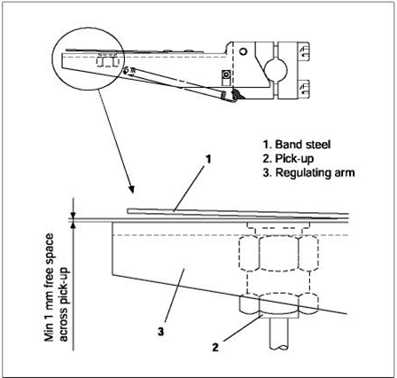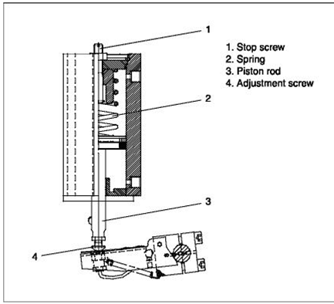
Stop screw adjustment –( ဒါက အင္ဂ်င္ overload မၿဖစ္ေအါင္) charge air လါတဲ႔ပိုက္ကိုၿဖဳတ္ပါ။ (ေအါက္ပိုက္)။ အဲဒီအေပါက္ကေန Working air နဲ႔ piston rod upper position ေ၇ာက္ေအါင္ ေပးပါ။ ၿပီး၇င္ adjust screw ကို( test bed မွာပါတဲ႔ ၁၁၀% load fuel index + 1.5 ) ၇ေအါင္ခ်ိန္ပါ။အဲလိုခ်ိန္၇င္ lambda cylinder နဲ႔အနီးဆံုး fuel pump index တခုကိုၿကည္႔ၿပီးခ်ိန္၇င္လံုေလါက္ပါတယ္။
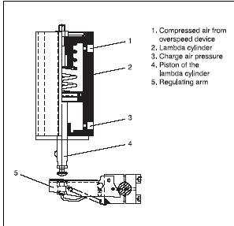
ဒါက overspeed ကိုကါကြယ္တါ ( သူ႔ကေတါ႔ lambda မွာခ်ိန္စ၇ာမလိုပါ)- အင္ဂ်င္ lube oil cooler ဖက္မွာ၇ိွတဲ႔ overspeed device က သူမွာတပ္ထါးတဲ႔ pneumatic valve ေလးကို activate လုပ္၇င္ လါတဲ႔ေလက lambda cylinder ၇ဲ႔ အေပၚဖက္အေပါက္က ၀င္ပါတယ္။ အဲဒါကို fuel rack ေတြကိုဖိခ်လိုက္လို႔ အင္ဂ်င္၇ပ္သါြးပါမယ္။( overspeed setting ေ၇ာက္သြါးခဲ႔၇င္)
အဲဒီ lambda control ဟါ overspeed device ၇ဲ႔ stop cylinder တခုတါ၀န္အၿပင္ ၇ုတ္တ၇က္ load increase လုပ္တဲ႔အခ်ိန္ combustion chamber က complete combustion လုပ္ေပးနိုင္တဲ႔ amount ထက္ပိုၿပီး fuel injection မလုပ္ေအါင္ကါကြယ္ေပးပါတယ္။ အဲဒါကို charge air pressure ေပၚမူတည္ၿပီး fuel index လိုသေလါက္ဘဲေပးနိုင္ေအါင္လုပ္ေပးပါတယ္။(ဒီအတြက္ကေတါ႔ခ်ိန္စ၇ာမလိုပါဘူး။သူဟါသူ စပ၇င္အါးကို charge air နဲ႔ထိနး္ထါးပါတယ္။)
ေနာက္ၿပိး lambda cylinder ၇ဲ႔ adjusting screw လါဖိတဲ႔ steel band ေအါက္ က pick up က turbocharger jet assist ကို control လုပ္ပါတယ္။
ဒါေၿကာင္႔ lambda controller က monentary load increase လုပ္ခ်ိန္ထြက္တတ္တဲ႔ visible smoke ကိုေလ်ာ႔ခ်ပါတယ္။ load ထမ္းတဲ႔ စြမ္းအါးကိုတက္ေစပါတယ္။ exhaust gas way ေတြမွာ fouling ၿဖစ္မွုကိုေလ်ာ႔ခ်ပါတယ္။ အင္ဂ်င္နိဳခ်ိန္မွာ fuel index ကို limit လုပ္ပါတယ္။
Principles for functioning
ပံုမွာၿပထါးတဲ႔အတိုင္း load ၇ုတ္တ၇က္ increase ၿဖစ္ခဲ႔၇င္ governor က fuel index ကိုဆြဲၿမွင္႔ပါလိမ္႔မယ္။ဒါဆို fuel pump rack ေတြကိုလွည္႔တဲ႔ regulating arm ကလည္ပါလိမ္႔မယ္။ ဒါေၿကာင္႔ lambda piston(3) ထိပ္က regulatin arm (1) မွာလါတပ္ထါးတဲ႔ steel band ကိုဖိေတါ႔ switch (2) က electrical circuit ကို close လုပ္ပါတယ္။ အဲဒီလို electrical circuit close ၿဖစ္ေတါ႔ solenoid valve (4) ပြင္႔ပါတယ္။ အဲလို ပြင္႔ေတါ႔ အင္ဂ်င္နိုးတဲ႔ ေလ compressed air နဲ႔ turbocharger blower side က jet assist system ကို supply လုပ္ပါတယ္။ အဲဒီေတါ႔ turbocharger accelerate ၿဖစ္ေတါ႔ charge air pressure တက္လါပါတယ္။ အဲလို charge air pressure တက္လါေတါ႔ lambda cylinder piston ကို အေပၚကိုတြန္းတင္ပါတယ္။ အဲလိုတြန္းတင္လို႔ steel band ကေနကြါ့သြ့ါး၇င္ electrical circuit open ၿဖစ္လို႔ solenoid ပိတ္သြါးေတါ႔ jet assist ကို supply လုပ္တဲ႔ေလကိုပိတ္လိုက္ပါတယ္။ ပံုမွန္အလုပ္လုပ္တဲ႔ jet assist system တခု solenoid ပြင္႔တါက ေန ပိတ္တါထိ 3 – 8 sec ေလါက္အထိေလါက္ဘဲၿကာပါတယ္။ဒါေၿကာင္႔ 10 sec ထက္ၿကာ ၿပီး solenoid valve ပြင္႔ခဲ႔ ၇င္ solenoid power ႕ကိုၿဖတ္ခ်ၿပီး jet assist system fail ဆိုတဲ႔ alarm ေပးပါလိမ္႔မယ္။ ေနာက္ၿပီးမွတ္သါးစ၇ာတခုက jet assist system ဟါ rpm 110 ေက်ာ္မွစၿပီးအလုပ္လုပ္ပါတယ္။ jet assist system malfunction ကေတါ႔ steel band ခ်ိန္တါမွား တါ။ solenoid မပြင္႔တါ စတါေတြၿဖစ္တတ္ပါတယ္။ ေနာက္ၿပီး overspeed device မွာလါတပ္ထါးတဲ႔ pneumatic valve ေလမွာ silencer ေလးပါပါတယ္။မလို၇င္မတပ္ပါနဲ႔။ အဲဒါဂ်ီးပိတ္လို႔ drain မေကါင္း၇င္ lambda cylinder အေပၚမွာေလစုၿပီး fuel regulating arm ကိုဖိထါးသလိုၿဖစ္ၿပိး low load မွာ rpm hunting ၿဖစ္တတ္ပါတယ္။
Jet assist system ကို ABB TURBOCHARGER TPS series မွာလဲေတြ၇တတ္ပါတယ္။ေနာက္ၿပီး KBB T/C HPR & R series ေတြမွာလဲေတြ႔၇တတ္ပါတယ္။သူတို႔ လဲ limited time span တခုအတြင္ impeller ကို compressed air ေက်ြးတါပါဘဲ၊

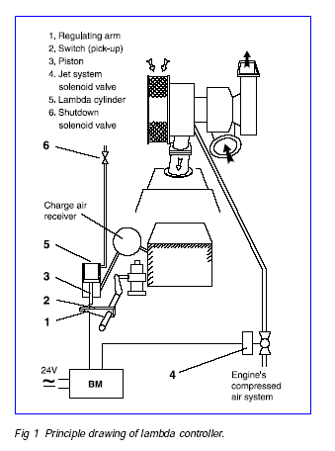

Electrical ဘာေတြ ေလ့လာရမလဲ လို႕ေမးသူမ်ားအတြက္။
*********************************************************
က်ြန္ေတာ္ ဆီ အမ်ား ဆံုး ေမးက်တာ electrical အေန နဲ႕ ဘာေတြ ေလ့လာ ရမလဲဆိုတာပဲ။
အၾကံညာဏ္ေပး ရမယ္ဆိုရင္ အဓိကကေတာ့ electrical basic ေတြ ကို ေၾကညက္ေအာင္ေလ့လာသင့္ပါတယ္။
ဘယ္ပညာရပ္ မဆို Basic , Advance , specialist ဆိုျပီး ရိွပါလိမ့္မယ္။ basic မပိုင္ရင္ေတာ့ ဆက္ျပီးေလ့လာဖို႕ အခက္အခဲ ရိွပါလိမ့္မယ္။
Basic ေလ့လာျပီးရင္ေတာ့ control ပိုင္း ကိုေလ့လာသင့္ပါတယ္ ။ control ပိုင္း နဲ႕ အမ်ားဆံုး လုပ္ က်ရလို႕ပါပဲ ။ အဲဒါနဲ႕ဆက္စပ္ျပီး PLC , HMI , SCADA ေတြ ရဲ႕ အေျခခံ ကိုေလ့လာ လို႕ ရပါတယ္ ။ တခုနဲ႕ တခု ကဆက္စပ္ေနျပီး တခုသိရင္ လြယ္ပါတယ္။
အဲသလိုေလ့လာရင္း နဲ႕မွ မိမိ နဲ႕သက္ဆိုင္တဲ့ subject ကို အထူးျပုေလ့လာ ရင္ အဲဒီ အပိုင္းမွာ က်ြမ္းက်င္ သြားပါလိမ့္မယ္ ။
က်ြန္ေတာ္တို႕ ေလ့လာသင္ယူခဲ့ရတဲ့ basic course ေလးေတြ ကို တင္ေပးလိုက္ပါတယ္။ အဲဒီ basic ေတြ ကို ဘယ္ေလာက္ သိလဲ ေက်ညက္လဲဆိုတာ ကိုယ့္ကို ကိုယ္ ျပန္ေမးၾကည့္ေပါ့။ အကုန္ လံုး detail သိရမယ္ မဆိုလိုေပ မဲ့ ဘာေတြလဲ ဆိုတာ က်ြမ္းက်င္တဲ့ electrical တေယာက္ အေနနဲ႕basic ေလာက္ေတာ့ အားလံုးကို သိရပါမယ္။
ေလ့လာ ဖို႕ အလြယ္ဆံုး အျမန္ဆံုးကေတာ့ အေတြ႕ အၾကံု တကယ္ရိွတဲ့ သူေတြ သင္ တဲ့ စနစ္က်တဲ့ training ေတြ မွာတက္ေရာက္ သင္ရမယ္ဆိုရင္ေတာ့ ျမန္ျမန္ သိသြားမွာပါ။ ဘာလို႕လဲ ဆိုေတာ့ တခ်ဳိ႕ အေၾကာင္း အရာေတြ က မသိ လို႕ခက္ေနတာပါ ။ သိသြားရင္ေတာ့ ဆင့္ကာဆင့္ကာ သိသြားျပီး ထပ္ေလ့လာဖို႕လြယ္သြား လို႕ပါ။ ေလွခါးထစ္တက္သလိုပါပဲ ။
အဲဒါေတြ ေလ့လာ ျပီးသြားရင္ေတာ့ အလုပ္ခြင္ က်ရင္ ဘယ္လို အသံုး၀င္လဲ ဆိုတာ တကယ္ၾကံုရရင္ သိသြားပါလိမ့္မယ္။ အဓိကက က်ြန္ေတာ္တို႕ အတြက္ က အလုပ္ခြင္ပဲေလ ။ ဘယ္ေနရာ ဘယ္ဌာန ျဖစ္ျဖစ္ လုပ္နိုင္စြမ္းရမယ္ေလ။
Electrical ဆိုတာ ဘယ္ေနရာ မွာ ျဖစ္ျဖစ္ အတူတူပါပဲ ။
ELECTRICAL COURSE
ϖ Essential basic electrical and instrument engineering
ϖ Electrical power generation
ϖ Electrical power distribution
ϖ Uninterruptible Power supply & battery
ϖ Electrical Drawings, Diagrams , documentations & electrical specification
ϖ Electrical control, maintenance & testing engineering ( commissioning engineering )
ϖ Electrical project engineering
ϖ Electrical safety engineering
Essential basic electrical and instrument engineering (introduction)
► Electrical AC , DC system
► Electrical law , formula and calculation
► Electrical equipment
► Instrument equipment
► Electrical documents
► Electrical measurement tool
► Electrical safety
Electrical power generation
► AC Generator / turbine ( HV and LV )
► DC generator
► Generator starting system
► Essential and normal power generation
► Generator safety and control system
► Current and voltage transformer
► Solar system
► Wind turbine system
Electrical power distribution
► Distribution , neutral and earthing system ( IT, TT, TNC, TNS )
► Normal, essential, emergency system
► Instrument power distribution system
► Cable
► Cable laying system
► Electrical protection system
► Electrical switch room
► Circuit breaker
► Transformer
► Lighting system
► Electrical socket
► UPS system
► Lightning protection system
► Earthing and bounding system
Uninterruptible Power supply & battery
► AC & DC UPS system
► Battery units
► Charger units
► Inverter units
► Battery maintenance and performance test
Electrical Drawings, Diagrams , documentations & electrical specification
► Electrical symbol ( IEC and BS )
► Wiring diagram
► Schematic diagram
► One line diagram
► Block diagram
► Electrical logic diagram
► P & ID instrument diagram
► Electrical technical and failure report
► Electrical procedure
► Electrical international specification
► Electrical equipment maintenance form
► CMMS computerize maintenance management system
Electrical control, maintenance & testing engineering
► Electrical control system
► PLC , HMI, DCS , PCS control system
► Control equipment Relay, fuse , contactor, timer ,sensors
► Motor, heater ,
► Transducer, CT, PT
► Electrical maintenance procedure
► Electrical equipment test and test sheet
► Electrical pre com and commissioning document
► Electrical punch list procedure
► Megger testing
► CMMS computerize maintenance management system
► Spare part creation
Electrical project engineering
► Basic engineering
► Detail engineering
► Electrical construction and specification
► Project document preparation
► Factory assessment test (FAT )
► Pre-con and commissioning engineering
► Electrical equipment Area, System, unit , tag, classification system
► Project Punch list , memo documentation system
► Hand over electrical system
Electrical safety engineering
► Electrical work permit system
► Electrical isolation and de-isolation system
► Electrical earthing and bounding system
► Electrical safety certificate
► Electrical protection system and equipment
► Electrical safety test and documentation
► Electrical safety equipment and testing
Etc .......

AUTOCHIEF 4 (AC 4) သံုးတဲ႔ MC-C အင္ဂ်င္တလံုးကို BRIDGE ကေန MANOEUVRING လုပ္ေနတံုး BRIDGE PANEL FAIL ALARMလါၿပိး ECR ကို CONTROL TRANSFER ၿဖစ္လါတယ္တဲ႔။ ECR ကေနလုပ္ၿပီး တမိနစ္ေလါက္ၿကာေတါ႔ သူဟါသူ BRIDGE PANEL က RESET ၿဖစ္သြါးသတဲ႔။ အဲဒါဘါေၿကာင္႔လဲ။ဘယ္လိုအၿပစ္၇ွာမလဲ၊ဘါကိုၿပင္၇မလဲ၊
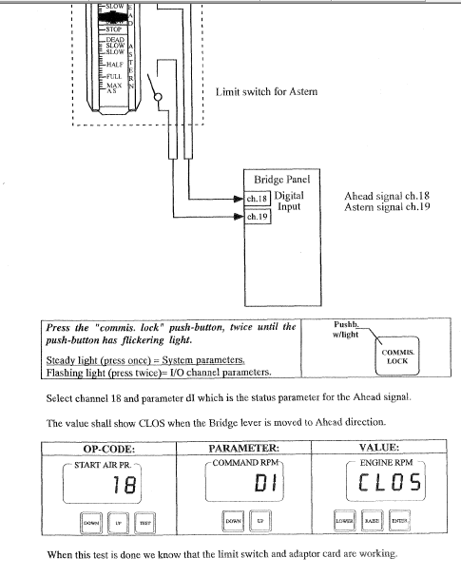

bridge panel lever တံ ေ၇ြ႔တဲ႔ေန၇ာတေလ်ာက္မွာ limit swith ေလးေတြ၇ိွပါတယ္။ stop ကေန ds ahead ကိုသြါး၇င္ ds ahd ေန၇ာမွာ micro limit switch ေလး၇ိွတတ္ပါတယ္။ အဲဒီ micro limit switch ေလးမေကါင္း၇င္ bridge panel fail alarm က stop ကေန ds ahd ကိုေ၇ြ႔ခ်ိန္မွာလါတတ္ပါတယ္။ ecr က manoeuvring လုပ္၇င္၇ပါတယ္။ecr ltu မွာအဲဒီ function မသံုးထါးေပမဲ႔ micro limit switch ကေတါ႔ပါပါတယ္။( ေ၇ွ႔ကလူေတြၿကံုခဲ႔တါကို ေဖါက္သည္ခ် ဆ၇ာၿက၊ီးလုပ္တါပါ။ ကိုယ္ဟါကုိယ္သိတတ္တါမဟုတ္ပါဘူး။ )
တကယ္လို႔ AC 4 သံုးအင္ဂ်င္တခု ၇ပ္တဲ႔အခါ critical rpm ထဲလိုတါထက္ၿကာေန၇င္ဘါကိုစစ္မလဲ၊
တကယ္လို႔ governor zero position and fuel index position ကို program ထဲထည္႔ထါးတါစစ္ပါ။ local မွာ zero ထိဆင္း၇င္ အဲဒါကို zero ေၿပာင္းပါ။( REGULATOR BASIC PARAMETERS –REGULATOR OP CODE 1 BASIC PARAMETER)
ေၿပာင္းနည္းကေတါ႔
၁-DGU – ACTUATOR SIDE CHANGE KEY OPEN
2-REGULATOR – P 99 AND DV-47
3-ACTUATOR – KEY LOCK
4-SHOWING REGULATOR
a-P= OP
b-DV- CODE 0
c-CODE 0 TO CHANGE CODE 1
5-ACTUATOR LOCK – OPEN
6-REGULATOR – PARAMETER 11
7-DV- 13.5
IF NEED CHANGE UP / DOWN AND SAVE PUSH BUTTON( REGULATOR)
8-ACTUATOR KEY LOCK
9-REGULATOR SIDE P 99, DV-0
10- ACTUATOR LOCK
တကယ္လို႔ start signal ေပးလို႔ မနိုး၇င္ ေအါက္ကို signal ေ၇ာက္မေ၇ာက္ op code 66 ကေနစစ္လို႔၇ပါတယ္။
စက္တင္ဘာလ ၂၉ ရက္ေန႔အတြက္ ေငြလဲလွယ္ႏႈန္းထားေတြကေတာ့ အေမရိကန္ ၁ ေဒၚလာကို ၁၂၅၀ က်ပ္၊ ၁ ယူ႐ုိေငြကို ၁၄၀၃ ဒသမ ၂ က်ပ္၊ စင္ကာပူ ၁ ေဒၚလာကို ၉၁၈ ဒသမ ၉၁ က်ပ္၊ မေလးရွား ၁ ရင္းဂစ္ကို ၃၀၃ ဒသမ ၉၁ က်ပ္၊ ထိုင္း ၁ ဘတ္ကို ၃၆ ဒသမ ၁၃ က်ပ္ အသီးသီး ေစ်းေပါက္ပါတယ္။
(ကိုးကား – ျမန္မာႏိုင္ငံေတာ္ဗဟိုဘဏ္)
ျပည္တြင္းေရႊေစ်းကြက္မွာ အကယ္ဒမီေရႊေစ်း တက်ပ္သားကို ၀ယ္ေစ်း ၈၈၅၂၀၀ က်ပ္ျဖစ္ၿပီး ေရာင္းေစ်းကေတာ့ ၈၈၅၄၀၀ က်ပ္ ျဖစ္ပါတယ္။
ကမာၻ႔ေရႊေစ်းကြက္မွာေတာ့ ၁ ေအာင္စကို ၁၃၂၄ ဒသမ ၅၀ ေဒၚလာ ေစ်းေပါက္ပါတယ္။
RTU can't be used in star topology
တစ္ ေန႕ က လႊတ္ ေတာ္ မွာ IMO Convention တစ္ ခု ျဖစ္ သည္႕ OPRC (International Convention on Oil Pollution Preparedness, Response and Co-operation 1990) ကို အ ဖြဲ႕ ဝင္ အ ျဖစ္ လက္ မွတ္ ေရး ထိုး မည္႕ အ ေႀကာင္း သိ ရ ၍ ဝမ္း ေျမာက္ မိ ပါ သည္။ ေရ ေႀကာင္း ပ ညာ ျဖင္႕ အ သက္ ေမြ သူ/ ေမြး မည္႕ သူ လူ ငယ္ မ်ား အ တြက္ က်ြန္ ေတာ္ နား လည္ သ ေရြ႕ ရွင္း ျပ ပါ မည္။
ပင္ လယ္ ျပင္ ေရ ထု ညစ္ ညမ္း မႈ ကာ ကြယ္ ေရး မွာ လူ သား အား လုံး ၏ တာ ဝန္ ျဖစ္ ပါ သည္။ သ ေဘၤာ မ်ား မွ ေရ ထု ညစ္ ညမ္း မႈ ကာ ကြယ္ ရန္ (၂) ဆင္႕ ျပဳ လုပ္ ရန္ IMO မွ အ သိ အ မွတ္ ျပဳ လုပ္ ေဆာင္ ပါ သည္။ ပ ထ မ အ ဆင္႕ မွာ သ ေဘၤာ ေပၚ တြင္ တာ ဝန္ ထမ္း ေဆာင္ သည္႕ သ ေဘၤာ သား မ်ား ႏွင္႕ သက္ ဆိုင္ ပါ သည္ သ ေဘၤာ ေပၚ မွ ဆီ/ ဓါ တု ပ စၥည္း မ်ာ ပင္ လယ္ ထဲ သို႕ မ ေရာက္ ရန္ ကာ ကြယ္ ရန္ ျဖစ္ ပါ သည္ (Contain) လုပ္ ရန္ ျဖစ္ ပါ သည္ သို႕ တြက္ (MARPOL) (International Convention for the Prevention of Pollution from Ships 1973) ျဖင႕ သ ေဘၤာ မ်ား ၏ Operation/ Accidents မ်ား ေႀကာင္႕ ပင္ လယ္ ထဲ သို႕ မ က် ေရာက္ ေစ ရန္ မည္ သို႕ (Contain) လုပ္ ရ မည္ က္ို SOPEP (Shipboard Oil Pollution Emergency Plan) ေရး သား ေဆာင္ ရြက္ ေစ ပါ တယ္။ ပင္ လယ္/ ေရ ျပင္ ထဲ သို႕ ေရာက္ သြား လ်င္ ထိမ္း ခ်ဳပ္ သန္႕ ရွင္း ေရး လုပ္ ရန္ မွာ သ ေဘၤာ သား တို႕ ၏ က်ြမ္း က်င္ မႈ ထက္ ပို လြန္ ပါ သည္ ထို႕ အ တြက္ က်ြမ္း က်င္ သူ မ်ား မွ ထိမ္း ခ်ဳပ္ (Combat) လုပ္ ရန္ လို ပါ သည္ ထို႕ အ ျပင္ ေရ ေႀကာင္း စီး ဆသ္း မႈ (Tidal stream) ေႀကာင္႕ မိ မိ ပိုင္ နက္ ကို ေက်ာ္ လြန္ ေရာက္ ရွိ ႏႈိင္ သ ျဖင္႕ စု ေပါင္း ေဆာင္ ရြက္ (Co-operation) လုပ္ ရန္ လို အပ္ သည္႕ အ တြက္ IMO မွ International Convention on Oil Pollution Preparedness, response and Co-operation 1990 (OPRC 1990) ကို အ တည္ ျပဳ ခဲ႕ ပါ သည္ 2000 တြင္ ေနာက္ ဆက္ တြဲ အ ျဖစ္ HNS( Hazardous and Noxious Substances) ဓါ တု ပစၥည္း မ်ား ပါ ထည္႕ သြင္း ခဲ႕ ပါ သည္။
Contain ႏွင္႕ Combat ကြဲ ျပား ျခား နား ပါ သည္။
Combat လုပ္ ရန္ မွာ နိဳင္ ငံ ရွိ ဆိပမ ကမ္း ( Terminals ) ျဖစ္ ႀက ပါ သည္ ေရး ေပၚ ေင္ ရြက္ ႏႈိင္ ရန္ Contingency Plan မ်ား ရွိ ရ ပါ သည္။ အ ခ်ိဳ႕ ေသာ Terminals မ်ား သည္ စား ရိတ္ စ က ေႀကာင္႕ Combat team ကို မ ခန္႕ ထား ဘဲ အ ထူး ျပဳ ကုမၸဏီ မ်ား သို႕ Outsource လုပ္ ေလ႕ ရွိ ကါ သည္။
ေနာက္ တစ္ ဆင္ မွာ ေလ်ာ္ ေႀက (Compensation) ျဖစ္ ပါ သည္ CLC ျဖစ္ ပါ သည္။
Contain မွ Combat ေနာက္ ဆုံး Compension တို႕ ျဖင္႕ IMO မွ Marine Pollution ကို ကာ ကြယ္ ေန ပါ သည္ ပူး ေပါင္း ေဆာင္ ရြက္ ရန္ မွာ အ ဖြဲ႕ ဝင္ နိဳင္ ငံ မ်ား ၏ တာ ဝန္ ျဖစ္ ပါ သည္။
P & I Insurance
=============
Marine Insurance ကို အၾကမ္းဖ်င္း ၄မ်ိဳးခြဲျခားနိုင္ပါတယ္
1. Hull and Machinery Insurance
2. Liability Insurance
3. P & I Insurance /or/ 3rd Party Liability Insurance
4. Cargo Insurance
စတာေတြပါ
ဒီေနရာမွာ 3rd Party Liability Insurance ကို P & I Clubs ေတြက တာဝန္ယူေလ့ရွိပါတယ္
3 rd Party ဆိုတာကို Norwegian P and I Club ျဖစ္တဲ႔ SKULD က Any Person or party who has a legal or contractual relationship witg the ship , Not inclusive of Ship Owner လို႔ ရွင္းရွင္းလင္းလင္း ဖြင့္ဆိုထားပါတယ္
P and I Club ေတြ စ တင္ေပၚလာတာကေတာ့ သေဘၤာတစ္စီးရဲ႕ Regular Hull Insurance ေတြ မွာ 3/4 Collision Liability Clause /or/ Running Down Clause ဆိုတာရွိပါတယ္ ဒီ Clause အရ Collision ျဖစ္ခဲ႔ရင္ တစ္ဖက္ သေဘၤာရဲ႕ Damage to Hull or Cargo စတာေတြကို ၄ ပံု ၃ ပံု ေလ်ာ္ေပးမယ္လို႔ ဆိုလိုတာပါ က်န္ ၄ ပံု ၁ ပံု ကိုေတာ့ Ship Owner ကပဲ က်ခံေစတာပါ ( Premium တိုးေပးျပီး 4/4 အျပည့္ အေလ်ာ္ လည္း ရ နိုင္ျပီး ပံုမွန္ကေတာ့ 3/4 ပဲေပးပါတယ္ )
အဲ့လိုက်န္တဲ႔ 1/4 ကို ေပးေလ်ာ္နိုင္ေအာင္ စတင္ရင္း P & I Clubs မ်ားေပၚေပါက္ခဲ႔ပါတယ္
P & I ရဲ႕ meaning ကေတာ့ Protection and Indemnity ျဖစ္ျပီး Protection ကေတာ့ Ship Owner ရဲ႕ Collision liability 1/4 ကို ကာကြယ္ေပးတယ္လို႔ ရည္ရြယ္ပါတယ္ Indemnity ကေတာ့ Ship Owner ေတြ ကို Cargo Claim ေတြကေန Indemnify or Compensate လုပ္ေပးမယ္ ဆိုတဲ႔ အဓိပၸါယ္ပါ
P & I Club ေတြက service ေပးတဲ႔ Insurance Class ၂ မ်ိဳးရွိျပီး Class 1 ကေတာ့ Protection and Indemnity Cover ( P & I Cover ) ျဖစ္ပါတယ္
Class 2 ကေတာ့ Freight , Demurrage and Defence လို႔ေခၚတဲ႔ ( FD & D Cover ) ပါ
P & I Coverage ေတြကေတာ့
1. Cargo Claims
2. Cerw Claims
3. 1/4 of Collision Liability
4. Damage Claim to Fixed and Floating Objects
5. Third party claims of injury and death
6. Special Compensation payable by Lloyd Open Form, in Salvage
7. Miscellaneous claims
စ တာေတြပါ
P & I Coverage မျဖစ္တာေတြလည္း ရွိပါတယ္
1. Ad Valorem BL လို႔ေခၚတဲ႕ ကုန္တန္ဖိုးလိုက္ Freight ကိုလိုက္ျမွင့္ေပးရတဲ႔ C.O. Carriage
2. Unjustifiable Deviation
3. Delivery of cargo other than shown in Contract of carriag
4. Delivery if cargo without submission of BL
5. Ante dated / post dated BL
6. Clean BL to Damaged cargo
7. On deck cargo which shown as Underdeck in BL
စ တာေတြပါပဲ
********* ********** ********
Top of Form
အဲ ယား ကြန္‌း အ ‌ေၾကာင္‌း တစ္‌ ‌ေစ့ တစ္‌ ‌ေစာင္‌း အ ဆက္‌
အဲ ယား ကြန္‌း ကုိ Gas ျဖည္‌့ မယ္‌။
ဘယ္‌ က ‌ေန ျဖည္‌့ မွာ လဲ ?
Suction (or) Discharge ?
Suction ဆုိ တာ က စုပ္‌ ယူ တာ လုိ႔ လူ တုိင္‌း သိ ၾက ၿပီး သား ျဖစ္‌ လုိ႔ အ လြယ္‌ တ ကူ မွတ္‌ ရန္‌ လြယ္‌ ကူ‌ ‌ေအာင္‌ Gas ပဲ ျဖည္‌့ မယ္‌ လုိ႔ မွတ္‌ ယူ ပါ။
gas ျဖည္‌့ မယ္‌ ဆုိ လွ်င္‌ လဲ Compressor ကုိ ‌ေမာင္‌း ထား ရ မွာ ျဖစ္‌ ပါ တယ္‌။
လုိ ခ်င္‌ တဲ့ Point ကုိ ‌ေရာက္‌ ‌ေအာင္‌ အ ခ်ိန္‌ ယူ ၿပီး ျဖည္‌့ ရ မွာျဖစ္‌ ပါ တယ္‌။ အ ‌ေရး ႀကီး တာ က ျဖည္‌့ ပံု ျဖည္‌့ နည္‌း လုိ ပါ တယ္‌။ Compressor Cycle မွာ Air Lock မ ျဖစ္‌ ‌ေအာင္‌ gas pipe ‌ေတြ connection လုပ္‌ တဲ့ အ ခ်ိန္‌ မွာ အ ထူး က ရု ျပဳ ရ မွာ ျဖစ္‌ ပါ တယ္‌။ ျဖည္‌့ တင္‌း ‌ေန ၾက သူ မ်ား အ တြက္‌ က ‌ေတာ့ Easy Going ျဖစ္‌ ‌ေပ မယ္‌့ fresher တစ္‌ ‌‌ေယာက္‌ အ တြက္‌ က ‌ေတာ့ လက္‌ တုန္‌ ‌ေန မွာ ‌ေသ ခ်ာ ပါ တယ္‌။ ကုိယ္‌ တိုင္‌ လဲ ျဖစ္‌ ခဲ့ ဘူး ပါ တယ္‌။ လုပ္‌ ‌ေန က် ‌ေတာ့ လဲ ယဥ္‌ ပါး သြား မွာ ‌ပါ။
A/C တစ္‌ လံုး ကုိ Suction Side က ‌ေန Gas ျဖည္‌့ သြင္‌း ‌ေတာ့ မယ္‌ ဆုိ ရင္‌ အ ‌ေရး ႀကီး လုိ အပ္‌ တာ က Ampere Clamp Meter ‌ေလး ပါ။ Compressor motor load ကုိ တြက္‌ ၿပီး Maximum amp ကုိ ‌ေက်ာ္‌ လြန္‌ မ ျဖည္‌့ မိ ဖုိ႔ လုိ အပ္‌ ပါ တယ္‌။
ပုိ ျဖည္‌ ရင္‌ ဘာ ‌ေတြ ဆုိး ၾကဳိး ျဖစ္‌ ႏုိင္‌ လုိ႔ လဲ ဆုိ ရင္‌ Compressor အ တြင္‌း မွာ ရွိ တဲ့ Valve ‌Plate ‌ေတြ piston ring ‌ေတြ က်ဳိး ၿပီး ပ်က္‌ စီး ႏုိင္‌ လုိ႔ ပါ။
Discharge ဆုိ တာ က ထုတ္‌ တယ္‌ လုိ႔ မွတ္‌ ယူ ၿပီး Liquid ပဲ ျဖည္‌့ ပါ။ ‌ေမး စ ရာ ျဖစ္‌ လာ တာ က Liquid ကုိ ဘယ္‌ လုိ ျဖည္‌့ မ လဲ ?
Condenser side က ‌ေန Compressor ကုိ ရပ္‌ ၿပီး Gas bottle ကုိ ‌ေဇာက္‌ ထုိး အ ‌ေန အ ထား ‌ေလး နဲ႔ ျဖည္‌့ ယူ လုိ႔ ရ ပါ တယ္‌။ Psi (or) bar က ‌ေတာ့ depand on Compressor Size of capacity ‌ေပါ ္‌တြင္‌ မူ တည္‌ ၿပီး ျဖည္‌့ လုိ႔ ပါ တယ္‌။ Compressor တုိင္‌း မွာ ျဖည့္‌ ရ မည္‌့ Freron Gas Bottle အ မ်ဳိး အ စား ကုိ တစ္‌ ခါ ထည္‌း စက္‌ ရံု မွ ထုတ ္‌ၿပီး တာနဲ႔ ‌Compressor body name plate မွာ ‌ေရး သား ‌ေဖာ္‌ ျပ ထား တာ ျဖစ္‌ လုိ႔ အလြယ္‌ တ ကူ ကည္‌့ ျမင္‌ ႏုိင္‌ ပါ တယ္‌။ ျဖည္‌့ ရ မဲ့ amount ပ မာ ဏ ကုိ လဲ PSI / Bar / kg per cm3 ျဖင္‌့တစ္‌ ခါ တည္‌း ‌ေဖာ္ ျပ ထား ပါ တယ္‌။
Gas ျဖည္‌့ တယ္‌ ဆုိ တာ ဟာ Leakage ရွိ လုိ႔ ဒါ မွ မ ဟုတ္‌ သက္‌ တမ္‌း ၾကာ လာ လုိ႔ ျဖည္‌့ ရ တာ မ်ဳိး ။ တစ္‌ ခါ တစ္‌ ရံ Split type ‌ေတြ မွာ AC service wash down လုပ္‌ တဲ့ အ ခ်ိန္‌ ‌ေတြ မွာ outdoor unit ‌ေတြ ကုိ ျဖဳတ္‌ တပ္‌ လုပ္‌ တဲ့ အ ခ်ိန္‌ ‌ေတြ မွာ Suction valve တုိ႔ Discharge valve တုိ႔ ကုိ ‌ေသ ခ‌်ာ close မ လုပ္‌ မိ တာ တုိ႔ pump down မ လုပ္‌ မိ တာ မ်ဳိး ‌ေတြ မွာ Gas ယုိ ဆီး မႈ႕ ျဖစ္‌ ပါ တယ္‌။
က်ြန္‌ ‌ေတာ္‌ တုိ႔ တစ္‌ ခ်ဳိ႕ Customer ‌ေတာ္‌ ‌ေတာ္‌ မ်ား မ်ား လက္‌ ခံ ထား တာ က aircond မ ‌ေအး ဘူး ဆုိ လ်ွင္‌ outdoor ကုိ ျဖဴတ္‌ ‌ေစး တာ နဲ႔ gas ျဖည္‌့ ကုိ ျဖည္‌့ ရ မယ္‌ လုိ႔ တစ္‌ ထစ္‌ ခ် ယံု ၾကည္‌ ထား တဲ့ အ ယူ အ ဆ အ လြဲ ‌ေလး ‌ေတြ ကုိ နား လည္‌ ‌ေစ ခ်င္‌ ပါ တယ္‌။ ‌‌ျပင္‌ ပ ရာ သီ ဥ တု အ ပူ ရွိန္‌ တ အား ျမင္‌့ တက္‌ ‌ေန တဲ့ အ ခု လုိ ရာ သီ မ်ဳိး မွာ အဲ ယား ကြန္‌း လဲ ‌ေတာ္‌ ယံု နဲ႔ မ ‌ေအး ႏုိင္‌ ပါ ဘူး။
40 Degree ဆုိ တဲ့ ျပင္‌ ပ ရာ သီ ဥ တု အ ရွိန္‌ ကုိ က်ား ကန္‌ ရုန္‌း ‌ေပး ‌ေန တ့ဲ Compressor ရဲ႕ အ ပူ ခ်ိန္‌ က လဲ ရွိ ‌ေသး တာ မုိ႔ cooling လုပ္‌ ‌ေပး မည္‌့ Condensor အ ‌ေန နဲ႔ one Horse Power တစ္‌ ‌ေကာင္‌ အား ရွိ တဲ့ အဲ ယား ကြန္‌း က ၁၀ ‌ေပ ပတ္‌ လည္‌ အ ခန္‌း က်င္‌းကုိ ‌ေတာ့ ‌ေအး ႏုိင္‌ ‌ေသး ‌ေပ မယ္‌့ ‌ေပ ၂၀ ပတ္‌ လည္‌ အ ခန္‌း အ တြက္‌ က ‌ေတာ့ မ ‌ေအး ႏုိင္‌ ဘူး လုိ႔ ‌ေယ ဘူ ယ် အ ၾကမ္‌း ဖ်င္‌း မွတ္‌ ယူ ႏုိင္‌ ပါ တယ္‌ ခင္‌ ဗ်ာ။
Cooling Load Method ‌ေတြ ကုိ ‌ေတာ့ အင္‌ ဂ်င္‌ မီ ယာ ‌ေတြ အ ‌ေန နဲ႔ ပုိ မုိ နား လည္‌ ႏုိင္‌ မွာ ျဖစ္‌ ပါ တယ္‌။
အ ပူ ခ်ိန္‌ မ မ်ား ဘူး။ ပံု မွန္‌ ပဲ ဆုိ လ်ွင္‌ ‌ေတာ့ စစ္‌ ‌ေဆး ၾကည္‌့ ဖုိ႔ လုိ အပ္‌ ပါ တယ္‌။
ျဖစ္‌ ႏုိင္‌ ‌ေခ် မ်ား တာ ‌ေတြ က ‌ေတာ့
1. Electronic PCB Supply card
2. Temperature Thermostat sensor
3. Expension Valve (or) caplliary tube
4. Dryer Filter
5. If compressor can't run capacitor or motor defected.
6. Evaporator fin dirty
7. Compression stroke ( freezing ice on compressor)
‌ေတြ ပဲ ျဖစ္‌ ပါ တယ္‌။
မွတ္‌ မ ိသ ‌ေလာက္‌ ‌ေလး ပဲ ‌ေရး သား ‌ေဖာ္‌ ျပ ထား ပါ တယ္‌။ က်န္‌ တာ ‌ေတြ ရွိ ရင္‌ လဲ ခြင္‌့ လႊတ္‌ ပါ။
တက္‌ သိ နား လည္‌ တဲ့ ဆ ရာ သ မား မ်ား လဲ ျဖည္‌့ စြြက္‌ ‌ေရး သား ကူ ညီ ပါ ခင္‌ ဗ်ာ။
အ ကုန္‌ မ သိ ‌ေသး ‌ေသာ
‌ေမ တၱာ ျဖင္‌့
TYMM

သေဘ္ာထဲမွာ၊ ေရၿဖည္႔သြင္းၿပီး၊ သြားလာ၊
ခုတ္မာင္းၿခင္းကို၊ 'water ballast' လို႔၊ ေခါါပါတယ္။ သေဘ္ာသြားလာ၊ ခုတ္ေမာင္းမွဳေႀကာင္႔၊ ေပါါေပါက္လာတဲ႔ lateral forces ကို၊ resist အေနနဲ႔ ခုခံမယ္႔၊ movement ရရိွလာေစရန္၊ ေဆာင္ရြက္ၿခင္း ၿဖစ္ပါတယ္။
.
ၿပင္းထန္တဲ႔၊ ေလတိုက္နံွဳး excessively in high winds အႀကား၊ သြားလာခုတ္ေမာင္းေနစဥ္၊ insufficiently ballasted အေနနဲ႔၊ လံုေလာက္စြာ၊ 'ေရ' ၿဖည္႔သြင္းထားၿခင္း 'မရိွ' တဲ႔အခါ၊
tend to tip တနည္းအားၿဖင္႔၊ ‘heel’ ဆိုတဲ႔၊ တိမ္းေစာင္းမွဳ၊ ေပါါေပါက္နိဳင္ၿပီး၊ heel ပမာဏမၽားရာမွ၊ သေဘ္ာတိမ္းေမွာက္မွဳ ‘capsizing’ ၿဖစ္ေပါါနိဳင္ပါတယ္။
.
'ကုန္' မပါရိွပဲ၊ without cargo voyage အၿဖစ္၊ သြားလာတဲ႔အခါ၊ သေဘ္္ာကို၊ upright အေနနဲ႔၊ တည္႔မတ္စြာ၊ ရိွေနေစရန္၊ ေရအနည္းငယ္၊ ၿဖည္႔သြင္းထားတဲ႔၊ ballast အေနအထားၿဖင္႔၊ ခုတ္ေမာင္းႀကၿပီး၊ 'ကုန္' တင္တဲ႔အခါမွာေတာ႔၊ de-ballast အၿဖစ္၊ ၿဖည္႔သြင္းထားတဲ႔၊ 'ေရ' ေတြကို၊ ၿပန္လည္ စြန္႔ထုတ္ပါတယ္။
.
အေစာပိုင္းကာလ၊ 'ရြက္သေဘ္ာ' ဆိုတဲ႔၊ sailboats ေတြမွာ၊ lateral forces ကို၊ ဆန္႔ကၽင္ၿပီး၊ ေရြွ႕လၽွားနိဳင္ရန္၊ 'live ballast' အၿဖစ္၊ ေလတိုက္ရာဖက္မွာ၊ သေဘ္ာသားေတြ ထိုင္ကာ၊ ထိန္းညိွရင္္း၊ heeling moment ရယူခဲ႔ပါတယ္။
.
အဲဒီမွတဆင္႔၊ high density material ေတြၿဖစ္တဲ႔ concrete, iron နဲ႔ lead တို႔ကို၊ သေဘ္ာရဲ႕ keel မွာ၊ တတ္ဆင္ၿပီး၊ heeling moment ကို၊ ထိမ္းေကၽာင္းခဲ႔ႀကသလို၊ hull မွာ၊ ေကၽာက္တုန္းေတြနဲ႔၊ သဲေတြ၊ ထည္႔ၿပီး၊ traditional ballast အၿဖစ္၊ အသံုးၿပဳခဲ႔ႀကပါတယ္။ Fig. (1) မွာ၊ "One of the functions of a yacht's keel is to provide ballast" ဆိုၿပီး၊ ဥပမာအၿဖစ္၊ ေဖာ္ၿပထားပါတယ္။
.
(၁၈၈၀) ခုနွစ္ ကာလေတြအထိ
ေကၽာက္တုန္းေတြနဲ႔၊ သဲေတြကို၊ cargo hold ေတြအတြင္းမွာ၊ ထည္႔ကာ၊ solid ballast materials အၿဖစ္၊ အသံုးၿပဳခဲ႔ႀကတာကို၊ heavy ballast လို႔၊ ေခါါပါတယ္။
.
ေနာက္ပိုင္းကာလေတြမွာေတာ႔၊ သံကိုယ္ထည္ steel-hulled vessels သေဘ္ာေတြ၊ တည္ေဆာက္လာနိဳင္သလို၊ pumping technology နည္းပညာေတြလည္း၊ တိုးတက္လာတာနဲ႔အမၽွ၊ solid ballast materials အစား၊ "ေရ" ထည္႔သြင္းၿခင္းၿဖင္႔၊ water ballast နည္းလမ္းကို၊ ေၿပာင္းလဲ၊ အသံုးၿပဳလာႀကပါတယ္။
.
ballast tanks ေတြရဲ႕၊ အရြယ္အစားနဲ႔ အရည္အတြက္ဟာ၊ သေဘ္ာအမၽိဳးအစား type နဲ႔၊ ပံုသ႑န္ design အေပါါ၊ မူတည္ၿပီး၊ ကြာၿခားသလို၊ တတ္ဆင္ထားတဲ႔ အေနအထား position ဟာလည္း၊ hull stresses ကို၊ ေလၽွာ႔ခၽေပးနိဳင္ရန္၊ လိုအပ္ပါတယ္။
.
stability ရရိွေစရန္၊ သေဘ္ာရဲ႕ ေအာက္ေၿခမွာ၊ double bottom ballast tanks ေတြကို၊ run the length of the vessel အေနနဲ႔၊ ေတာက္ေလၽွာက္တတ္ဆင္ၿပီး၊ hull girder ေတြၿဖင္႔၊ ပိုင္းၿခားကာ၊ တည္ေဆာက္ေလ႔၊ ရိွပါတယ္။
.
ေယဘုယၽအားၿဖင္႔၊ ballast capabilities နဲ႔၊ capacities ဆိုတဲ႔၊ တင္ေဆာင္ထည္႔သြင္းနိဳင္မယ္႔၊ ေရထုထည္၊ ပမာဏဟာ၊ သေဘ္ာ dead weight tonnage ရဲ႕ (25 ~ 30 %) ခန္႔၊ ရိွပါတယ္။
.
သေဘ္ာေတြဟာ၊ တေနရာမွတေနရာသို႔၊ သြားလာ၊ ခုတ္ေမာင္းေနႀကတဲ႔အတြက္၊ ballast နဲ႔ de-ballast ေဆာင္ရြက္ရာမွာ၊ ေဒသတခုမွ၊ ပင္လယ္ေရေတြကို၊ တင္ေဆာင္လာၿပီး၊ အၿခားေဒသတခုမွာ၊ စြန္႔ပစ္ႀကတယ္လို႔၊ ဆိုနိဳင္ပါတယ္။
.
ballast water အၿဖစ္၊ ထည္႔သြင္းထားတဲ႔၊ ပင္လယ္ေရထဲမွာ၊ aquatic species လို႔ေခါါတဲ႔၊ အ႑ဝါဇီဝသက္ရွိ မၽိဳးစိတ္ေတြ၊ အပင္ေတြ၊ ပင္လယ္ေန အေကာင္ငယ္ေတြနဲ႔၊ bacteria ေတြ၊ ပါဝင္လာၿပီး၊ ballast tanks ေတြအတြင္း၊ ရက္သတၱပတ္ေပါင္းမၽားစြာ၊ အသက္ရွင္၊ ေနထိုင္နိဳင္ပါတယ္။
.
အၿခားေဒသတခုမွာ၊ de-ballast အၿဖစ္၊ ပင္လယ္ေရေတြ၊ စြန္႔ထုတ္လိုက္ရာမွာ၊ aquatic species ေတြထဲမွ၊ အႏၱရာယ္ေပးႏုိင္တဲ႔ မၽိဳးစိတ္ေတြဟာ၊ ပင္လယ္ေရနဲ႔၊ အတူ ပါဝင္သြားၿပီး၊ ေဒသခံမၽိဳးစိတ္ေတြ၊အေပါါ၊ လႊမ္းမိုးကာ၊ သဘာ၀ ပတ္၀န္းကၽင္ရဲ႕၊ ေဂဟေဗဒစနစ္ဆိုတဲ႔ ‘ecosystem’ ကို၊ ထိခိုက္ ပၽက္စီးေစတတ္ပါတယ္။ Fig. (2) မွာ၊ "Water ballasting and de-ballasting" ဆိုၿပီး၊ ဥပမာအၿဖစ္၊ ေဖာ္ၿပထားပါတယ္။
.
အၿပည္ၿပည္ဆိုင္ရာ၊ ေရေႀကာင္းအဖြဲ႔အစည္း ‘IMO’ နဲ႔၊ အၿပည္ၿပည္ဆိုင္ရာ၊ ကၽမ္းမာေရးအဖြဲ႔အစည္း ‘WHO’ တို႔ဟာ၊ ‘epidemic disease bacteria’ ဆိုတဲ႔၊ ပင္လယ္ေရမွ တဆင့္၊ လၽွင္ၿမန္စြာ၊ ကူးစက္ၿပန္႔နံွ႔နိဳင္မယ္႔၊ ဘက္တီးရီယားေတြကို၊ ထိန္းခၽဳပ္ရန္၊ နည္းလမ္းေတြကို၊ ရွာေဖြလာႀကပါတယ္။
.
IMO ရဲ႕ MEPC လို႔ေခါါတဲ႔၊ ‘Marine Environment Protection Council’ မွ၊ ‘Ballast Water Management’ ဆိုင္ရာ၊ လမ္းညြွန္ခၽက္ guidelines ေတြကိုလည္း၊ စတင္၊ ၿပဌာန္းခဲ႔ပါတယ္။
.
MEPC ရဲ႕ Ballast Water Management ဆိုင္ရာ၊ လမ္းညြွန္ခၽက္ guidelines ေတြကိုေတြကို၊ resolution အေနနဲ႔ ေလ့လာႀကည္႔တဲ႔အခါ၊ ‘G1’ - Guidelines for sediment reception facilities (resolution MEPC.152 (55)), ‘G2’ - Guidelines for ballast water sampling (resolution MEPC.173 (58)), ‘G3’ - Guidelines for ballast water management equivalent compliance (resolution MEPC.123 (53)), ‘G4’ - Guidelines for ballast water management and development of ballast water management plans (resolution MEPC.127 (53)), ‘G5’ - Guidelines for ballast water reception facilities (resolution MEPC.153 (55)), ‘G6’ - Guidelines for ballast water exchange (resolution MEPC.124 (53)), ‘G7’ - Guidelines for risk assessment under regulation A-4 of the BWM Convention (resolution MEPC.162(56)), ‘G8’ - Guidelines for approval of ballast water management systems (resolution MEPC.174 (58)), ‘G9’ - Procedure for approval of ballast water management systems that make use of Active Substances (resolution MEPC.169 (57)), ‘G10’ - Guidelines for approval and oversight of prototype ballast water treatment technology programmes (resolution MEPC.140 (54)), ‘G11’ - Guidelines for ballast water exchange design and construction standards (resolution MEPC.149 (55)), ‘G12’ - Guidelines on design and construction to facilitate sediment control on ships (resolution MEPC.150 (55)), ‘G13’ - Guidelines for additional measures regarding ballast water management including emergency situations (resolution MEPC.161 (56)), ‘G14’ - Guidelines on designation of areas for ballast water exchange (resolution MEPC.151 (55)) နဲ႔ ‘G15’ - Guidelines for ballast water exchange in the Antarctic treaty area (resolution MEPC.163 (56)) ဆိုၿပီး၊ ေတြ႔ရပါတယ္။
.
(i) - ‘resolution MEPC.173 (58)’ ဆိုတဲ႔၊ Guidelines for ballast water sampling, (ii) - ‘resolution MEPC.123’ (53) ဆိုတဲ႔၊ Guidelines for ballast water management equivalent compliance, (iii) - ‘resolution MEPC.127 (53)’ ဆိုတဲ႔၊ Guidelines for ballast water management and development of ballast water management plans နဲ႔၊ (iv) - ‘resolution MEPC.124 (53)’ ဆိုတဲ႔၊ Guidelines for ballast water exchange တို႔ဟာ၊ ‘Ship Operation Guidelines’ ေတြၿဖစ္ၿပီး၊ သေဘ္ာနဲ႔၊ တိုက္ရိုက္သက္ဆိုင္ပါတယ္။
.
(v) - ‘resolution MEPC.174 (58)’ ဆိုတဲ႔၊ Guidelines for approval of ballast water management systems, (vi) - ‘resolution MEPC.169 (57)’ ဆိုတဲ႔၊ Procedure for approval of ballast water management systems that make use of Active Substances နဲ႔၊ (vii) - ‘resolution MEPC.140 (54)’ ဆိုတဲ႔ Guidelines for approval and oversight of prototype ballast water treatment technology programmes တို႔ကေတာ႔၊ ‘Approval of Ballast Water Management System’ နဲ႔၊ သက္ဆိုင္ပါတယ္။
.
(viii) - ‘resolution MEPC.149 (55)’ ဆိုတဲ႔၊ Guidelines for ballast water exchange design and construction standards နဲ႔၊ (ix) - ‘resolution MEPC.150 (55)’ ဆိုတဲ႔၊ Guidelines on design and construction to facilitate sediment control on ships တို႔ဟာ၊ 'Ship Design Guidelines' ေတြ ၿဖစ္ပါတယ္။
.
(x) - ‘resolution MEPC.162 (56)’ ဆိုတဲ႔၊ Guidelines for risk assessment under regulation A - 4 of the BWM Convention, (xi) - ‘resolution MEPC.161 (56)’ ဆိုတဲ႔၊ Guidelines for additional measures regarding ballast water management including emergency situations, (xii) - ‘resolution MEPC.151 (55)’ ဆိုတဲ႔ Guidelines on designation of areas for ballast water exchange နဲ႔ (xiii) - ‘resolution MEPC.163 (56)’ ဆိုတဲ႔ Guidelines for ballast water exchange in the Antarctic treaty area တို႔ကေတာ႔၊ 'Administration Guidelines' ေတြ၊ ၿဖစ္ပါတယ္။
.
‘Ballast Water Management’ မွာ၊ အဓိကပါဝင္တဲ႔၊ က႑ေတြကေတာ႔၊ ‘BWM methods’ ဆိုတဲ႔၊ ballast water management နည္းလမ္း၊ recording procedure ဆိုတဲ႔႔႔၊ မွတ္တမ္းတင္ၿခင္းနဲ႔၊ training and education ဆိုတဲ႔၊ ေလ့ကၽင္္႔ပညာေပးၿခင္းတို႔ၿဖစ္ပါတယ္။
Fig. (3) မွာ၊ "Ballast Water Management"
ဆိုၿပီး၊ ဥပမာအၿဖစ္၊ ေဖာ္ၿပထားပါတယ္။
.
BWM methods ဆိုတဲ႔၊ ballast water management နည္းလမ္းေတြကို၊ 'D1' - ballast water exchange method နဲ႔ 'D2' - ballast water treatment system ဆိုၿပီး၊ ခြဲၿခားနိဳင္ပါတယ္။
.
Ballast Water Exchange Method ကို၊ အသံုးၿပဳတဲ႔အခါ၊ (a) - sequential method, (b) - flow through method နဲ႔၊ (c) - dilution method ဆိုၿပီး၊ နည္္းလမ္း (၃) ခု၊ ရိွတဲ႔အနက္၊ တခုခုကိို၊ ေရြးခၽယ္ အသံုးၿပဳရမွွာ၊ ၿဖစ္ပါတယ္။
.
(a) - ‘sequential method’ အသံုးၿပဳတဲ႔အခါ၊ ballast water ထည္႔သြင္းးမယ္႔ tank ဟာ၊ empty အေနနဲ႔၊ ေရမရိိွပဲ၊ ခန္းေၿခာက္ ေနရမွာ ၿဖစ္ၿပီး၊ replacement ballast water ကို၊ tank ရဲ႕ 95 % volume metric ပမာဏအထိိ၊ ၿဖည္႔သြင္းရန္ လိုအပ္ပါတယ္။
.
(b) - ‘flow through method’ ကို၊ အသံုးၿပဳတဲ႔အခါ၊ replacement water ကို၊ overflow အေနနဲ႔၊ လၽွံကၽေစတဲ႔ အထိ၊ (၃) ႀကိမ္၊ ေဆာင္ရြက္ရမွာ၊ ၿဖစ္ပါတယ္။ flow through method ကို ‘pump - through method’ လို႔လည္း၊ ေခါါႀကပါတယ္။
.
(c) - ‘dilution method’ မွာတာ႔၊ replacement ballast water ကို၊ tank ရဲ႕၊ အေပါါမွ ၿဖည္႔သြင္းၿပီး၊ tank ရဲ႕ ေအာက္ေၿခမွ၊ ေရၿပန္ ထုတ္ရမွာၿဖစ္ပါတယ္။ ၿဖည္္႔သြင္္းတဲ႔ flow rate နဲ႔ ၿပန္ထုတ္တဲ႔၊ flow rate တို႔၊ တူညီရမွာၿဖစ္သလို၊ tank ထဲမွ၊ ေရ level ဟာလည္း၊ ေၿပာင္းလဲၿခင္းမရိွပဲ၊ tank ရဲ႕ volume metric ပမာဏနဲ႔၊ တူညီတဲ႔၊ replacement ballast water ကို၊ အသြင္းအထုတ္ (၃) ႀကိမ္၊ ေဆာာင္ရြက္ရန္ လိုအပ္ပါတယ္။
.
Ballast Water Management implementation schedule အရ၊ 'D1' ဆိုတဲ႔၊ Ballast Water Exchange Method ကို၊ သေဘ္ာတည္ေဆာက္ရာ ခုနွစ္၊ ‘year of ship built’ နဲ႔၊ ‘ballast capacity’ ပမာဏေအပါါ၊ မူတည္ၿပီး၊ အခၽိန္ကာလတခုအထိ၊ ဆက္လက္အသံုးၿပဳခြင္႔၊ ေပးထားမွာၿဖစ္ၿပီး၊ ေနာက္ပိုင္းမွာေတာ႔၊ 'D2' ဆိုတဲ႔၊ Ballast Water Treatment System ကိုသာ၊ တတ္ဆင္အသံုးၿပဳရေတာ႔မွာၿဖစ္ပါတယ္။
Fig. (4) မွာ၊ "Ballast Water Management implementation schedule" ဆိုၿပီး၊ ဥပမာအၿဖစ္၊ ေဖာ္ၿပထားပါတယ္။
.
(၂၀၁၂) ခုနွစ္ေနာက္ပိုင္း၊ တည္ေဆာက္တဲ႔၊ သေဘ္ာေတြမွာေတာ႔၊ 'D1' ဆိုတဲ႔၊ Ballast Water Exchange Method အသံုးၿပဳခြင္႔မေပးေတာ႔ပဲ၊ Ballast Water Treatment System ကိုသာ၊ တတ္ဆင္ရန္၊ ၿပဌာန္းထားပါတယ္။
.
Ballast Water Treatment System ကို၊ (i) - Mechanical/ gas - based treatment system, (ii) - Physical treatment system နဲ႔၊ (iii) - Chemical treatment system ဆိုၿပီး၊ ခြဲၿခားနိဳင္ပါတယ္။
.
(i) - Mechanical/ gas - based treatment system မွာ၊ filtration, separation, hydro-clone နဲ႔၊ carbonation နည္းလမ္းေတြကို၊ အသံုးၿပဳႀကပါတယ္။ Fig. (5) မွာ၊ "Ballast water treatment " ဆိုၿပီး၊ ဥပမာအၿဖစ္၊ ေဖာ္ၿပထားပါတယ္။
.
(ii) - Physical treatment system မွာ၊ Thermal, Ultraviolet irradiation, Ultrasound နဲ႔ Electrolysis နည္းလမ္းေတြကို၊ အသံုးၿပဳႀကပါတယ္။
.
(iii) - Chemical treatment system မွာေတာ႔၊ Oxidants, Biocides, De-oxygenation နဲ႔ Electronically generated copper and silver နည္းလမ္းေတြကို၊ အသံုးၿပဳႀကပါတယ္။ Mechanical/ gas - based treatment system ဟာ၊ primary treatment system ၿဖစ္ၿပီး၊ Physical treatment system နဲ႔၊ Chemical treatment system တို႔ကေတာ႔၊ secondary treatment system ေတြၿဖစ္ပါတယ္။
.
ballast water treatment system တတ္ဆင္ရန္၊ administration လို႔ေခါါတဲ႔၊ flag state သို႔မဟုတ္၊ classification society သို႔၊ ေလၽွာက္ထားတဲ႔အခါ၊ Type Approval Certificate, Approved Ballast Water Management Plan, Approved ship-specific Operation and Technical manuals နဲ႔၊ Confirmation that electronic and control of BWT system have been typed tested – issued by Admin or test lab စတဲ႔၊ စာရြက္စာတမ္းေတြ၊ လိုအပ္ပါတယ္။
.
BWM survey ကိုေဆာင္ရြက္ရာမွာ၊ Ballast water record book, Equipment manuals နဲ႔၊ Installation specification and commissioning procedures အစရိွတဲ႔၊ စာရြက္စာတမ္းေတြ၊ လိုအပ္ပါတယ္။
.
Ballast Water Management (BWM) Convention အရ၊ သေဘာ္ေတြမွာ၊ Administration ရဲ႕၊ အသိအမွတ္ၿပဳ Ballast Water Management Plan, Ballast Water Record Book, Ballast water exchange (Regulation D-1) သို႔မဟုတ္၊ ballast water treatment system (Regulation D-2) နဲ႔ International Ballast Water Management Certificate တို႔၊၊ ပါရိွရမွာ၊ ၿဖစ္ပါတယ္။
.
1997 International Maritime Organization (IMO) ballast water management Guidelines A.868 (20)’ အရ၊ ‘Ballast Water Management’ ကို၊ အၿပည္႔အဝလိုက္နာၿပီး၊ ေဆာင္ရြက္ရာမွာ၊ ballast draft အထိ၊ ေရၿဖည္႔သြင္းရတဲ႔အတြက္၊ additional weight အေနနဲ႔ သေဘ္ာရဲ႕၊ buoyancy ကၽဆင္းသြားပါတယ္။
.
အရြယ္အစားႀကီးမားတဲ႔ VLCC ဆိုတဲ႔၊ very large crude carrier ေရနံတင္သေဘ္ာႀကီးေတြမွာ၊ unloaded transit condition အေနနဲ႔၊ သြားလာခုတ္ေမာင္းတဲ႔အခါ၊ propeller ကို၊ fully submerged အေနနဲ႔၊ ေရထဲမွာ၊ နစ္ၿမဳတ္ေနေစရန္၊ forward draft နဲ႔၊ ခၽိန္ဆၿပီး၊ ballast water ၿဖည္႔႔သြင္းရပါတယ္။
.
တနည္းအားၿဖင္႔၊ bottom slamming ေႀကာင္႔ေပါါေပါက္လာမယ္႔၊ hull bending moments ကို၊ ေလၽွာင္လြွဲနိဳင္ရန္၊ ballast water ၿဖည္႔႔သြင္းၿခင္းလည္း၊ ၿဖစ္ပါတယ္။
.
transverse stability ရရိွေစရန္၊ ေရၿဖည္႔သြင္းထားၿခင္းေႀကာင္႔၊ လွဳပ္ရွားကပ္ခြာသြားလာနိဳင္စြမ္း manoeuvrability ကၽဆင္းသြားပါတယ္။ during cargo operations ဆိုတဲ႔၊ ကုန္တင္ေနစဥ္မွာလည္း၊ trim နဲ႔ heel တို႔၊ ညီမၽွေနေစရန္၊ ballast water အသြင္းအထုတ္ကို၊ ေဆာင္ရြက္ရပါတယ္။
.
ballast နဲ႔ de-ballast တို႔ကိုု၊ အခၽိန္ႀကာၿမင္႔စြြာ၊ ေဆာင္ရြက္ရတဲ႔႔ အတြက္၊ ေလာင္စာသံုးစြဲမွဳ fuel consumption ပမာဏလည္း၊ ၿမင္႔တက္လာပါတယ္။
.
ballast water treatment system တတ္ဆင္ရာမွာ၊ ကနဦးကုန္ကၽစားရိတ္ initial installation coast ပမာဏ ႀကီးမား သလို၊ ေနာက္ပိုင္းမွာ filters, ultraviolet irradiation, chemical biocides အစရိွတဲ႔႔၊ sterilization equipment ေတြအတြက္၊ အသံုးၿပဳမယ္႔၊ ကုန္ကၽစားရိတ္ဟာလည္း၊ ၿမင္႔မားပါတယ္။
.
ဒီ႔အတြက္ ballast water treatment system အသံုးၿပဳစရာ မလိုတဲ႔၊ 'Non-ballast Ship' သေဘ္ာေတြကို၊ တည္ေဆာက္ရန္ စဥ္းစားလာႀကပါတယ္။ Fig. (6) မွာ၊ "Non-ballast ship" ဆိုၿပီး၊ ဥပမာအၿဖစ္၊ ေဖာ္ၿပထားပါတယ္။
.
non-ballast ship သေဘ္ာရဲ႕၊ waterline ေအာက္မွာ၊ သေဘ္ာဦး bow မွ၊ ပဲ႔ပိုင္း stern အထိ၊ ေတာက္ေလၽွာက္ ရွည္လၽွားတဲ႔၊ trunks ထည္႔သြင္္း ထားၿပီး၊ local seawater ကို၊ constant flow ၿဖင္႔၊ အဆက္မၿပတ္၊ စီးဆင္းေစၿခင္းၿဖင္႔၊ သြားလာခုတ္ေမာင္းေနစဥ္၊ ေပါါေပါက္လာမယ္႔၊ ‘potential hauling’ အား၊ ေလၽွာ႔ခၽယူပါတယ္။
.
non-ballast ship ဆိုတဲ႔၊ ballast free ships သေဘ္ာေတြကို၊ ballast trunks, hull shape, CFD tools, propulsion, trim and heel နဲ႔၊ cargo segregation ဆိုတဲ႔၊ အဓိက features အခၽက္အလက္ေတြကို၊ အေၿခခံၿပီး၊ တည္ေဆာက္ထား ပါတယ္။
.
ballast tank ေတြအစား၊ ထည္႔သြင္းတည္ေဆာက္ထားတဲ႔၊ ballast trunks ဟာ၊ longitudinal structural ballast trunks ပံုသ႑န္ရိွၿပီး၊ centre tank (၁) ခု၊ intermediate tanks (၂) ခုနဲ႔၊ side tank (၂) ခု၊ ပါဝင္ပါတယ္။ side tank (၂) ခု ကေတာ႔၊ cargo hold ရဲ႕ ေဘးမွာ၊ ရိွေနပါတယ္။
.
ballast trunks အတြင္းသို႔၊ seawater ဝင္ေရာက္မယ္႔၊ intake plenum လို႔ေခါါါတဲ႔၊ positive pressure inlet chamber နဲ႔၊ seawater ထြက္သြားမယ္႔၊ discharge plenum လို႔ေခါါါတဲ႔၊ positive pressure outlet chamber တိုု႔ဟာ၊ သေဘ္ာရဲ႕ bow နဲ႔၊ stern မွာ၊ တည္ရိွေနပါတယ္။
.
ballast trunks ဟာ swamped တနည္းအားၿဖင္႔၊ overwhelm အေနနဲ႔၊ ေရလြွမ္းေနတဲ႔အတြက္၊ ship’s buoyancy ကို၊ diminish အၿဖစ္၊ ေလၽွာ႔ခၽေပးနိဳင္ ပါတယ္။
.
ballast free ships သေဘ္ာေတြရဲ႕၊ ကိုယ္ထည္ hull ကို၊ V shape ပံုသ႑န္၊ တည္ေဆာက္ထားတဲ႔အတြက္၊ hull resistance ကၽဆင္းသြားၿပီး၊ fully loaded နဲ႔၊ unloaded အေၿခအေနေတြမွာ၊ propeller ဟာ၊ optimizes အေနနဲ၊႔ စြမ္းရည္တက္လာပါတယ္။ CFD tools လို႔ေခါါတဲ႔၊ 'Computational Fluid Dynamic' နည္းလမ္းေတြကို၊ အသံုးၿပဳကာ၊ တြက္ခၽက္တည္ေဆာက္လာတဲ႔အတြက္၊ သေဘ္ာရဲ႕၊ bow နဲ႔၊ stern area ေတြမွာ ေပါါေပါက္လာမယ္႔၊ pressure fields ေတြကို၊ ပိုမို၊ ေလၽွာ႔ခၽလာနိဳင္ပါတယ္။
.
propulsion အေနနဲ႔၊ twin screw optimum diameter propellers ေတြကို၊ တတ္ဆင္အသံုးၿပဳထားပါတယ္။ ဒါ႔အၿပင္၊ longitudinal bulkheads ေတြကိုသာ၊ အသံုးၿပဳထားတဲ႔အတြက္၊ longitudinal centre line တဝိုက္မွာ၊ moment equilibrium ၿဖစ္ေပါါေနၿပီး၊ cargo operations ေဆာင္ရြက္စဥ္၊ trims ေၿပာင္းလဲမွဳကို၊ ထိန္းသိမ္းေပးနိဳင္ပါတယ္။
.
cargo segregation မွာ၊ local sea water ကိုသာ၊ အသံုးၿပဳၿပီး၊ 1 : 55 %, 2 : 25 % နဲ႔၊ 3 : 20 % သို႔မဟုတ္၊ 1 : 55 %, 2 : 22.5 % နဲ႔၊ 3 : 22.5 % ratio ၿဖင္႔၊ ေရအသြင္းအထုတ္ ballasting ေဆာင္ရြက္နိဳင္ပါတယ္။

လတိုင္းမင္း Company ကထုပ္ေပးရင္။မင္းBank account ထဲမွာ ပိုက္ဆံလတိုင္းရွိရမွာေပါ႕တဲ႔
အေကာင္းဆံုးကေတာ႔။ေငြအဝင္ကိုမင္းBank ထဲထည့္ျပီး။ ေနာက္ပိုင္းမင္းမိန္းမ Bank ထဲကိုေျပာင္းထည့္
ငါလုပ္ေနတာကိုေျပာမယ္။ငါ႔ Bank acc ကိုေငြဝင္လာျပီဆိုရင္။ငါ႕သမီးက သူ႔အေမ Account ထဲကို တေသာင္းခ်က္ျခင္းလႊဲလိုက္တယ္။ငါ႔accont ထဲမွာ ၅၀၀-၁၀၀၀ ေလာက္ဘဲထာျပီးက်န္တာသူ႔အေမ account ထဲ အကုန္လႊဲထားတယ္
ငါ႔Bank card နဲ႔ i banking တုတ္ကင္ေလးကို ငါ႔သမီးကိုေပးထားခဲ႔တယ္
OCBC ကရ- မရမသိဘူး
POSB ကေတာ့ ငါအခုလုပ္ေနတာ

တိုင္ပင္ျပီးလုပ္ေလ။ကိုယ္ေတာ႔ ရတာ ၂လ ရွိျပီ
မိန္းမလဲေပ်ာ္ေနတယ္။Pennesula သြားစရာမလိုဘဲေစာေစာရတာကို။မင္းBank card အိမ္မွာေပးခဲ႔လား?။ဒါမွမဟုတ္ i banking အိမ္မွာလုပ္ထားတယ္မို႔လား?
i banking တုတ္ကင္ေလးကအိမ္မွာထားခဲ႔ရတယ္ေလ
သေဘၤာသားေတာ္ေတာ္မ်ားမ်ားက ေငြကို အဝင္မွာ မိန္းမ bank account ထဲဘဲထားႀကတယ္။ သေဘၤာသားBank account ထဲမွာ ေငြဝင္လာတာလံုးဝမရွိေတာ႔။သေဘၤာသားသေဘၤာလိုက္ျပီးပိုက္ဆံရတယ္ဆိုတာဘယ္ Bank ကမွမယံုဘူး
မိန္းမ အမည္ဆိုရင္ ေငြလႊဲတာဘဲရျပီး အျခားအျမတ္ထုတ္စရာ သိပ္ရမွာမဟုတ္ဘူး
သေဘၤာသားေတာ္ေတာ္မ်ားမ်ားက ေငြကို အဝင္မွာ မိန္းမ bank account ထဲဘဲထားႀကတယ္။ သေဘၤာသားBank account ထဲမွာ ေငြဝင္လာတာလံုးဝမရွိေတာ႔။သေဘၤာသားသေဘၤာလိုက္ျပီးပိုက္ဆံရတယ္ဆိုတာဘယ္ Bank ကမွမယံုဘူး
Payslip ျပလဲမယံုဘူး။တခုေတာ႔ Bank ကေမးတယ္။ေငြသားလတိုင္းထုပ္ေပးလားတဲ႔
i bank လဲ၇ိွတယ္
လတိုင္းမင္း Company ကထုပ္ေပးရင္။မင္းBank account ထဲမွာ ပိုက္ဆံလတိုင္းရွိရမွာေပါ႕တဲ႔
လတိုင္းမင္း Company ကထုပ္ေပးရင္။မင္းBank account ထဲမွာ ပိုက္ဆံလတိုင္းရွိရမွာေပါ႕တဲ႔
အေကာင္းဆံုးကေတာ႔။ေငြအဝင္ကိုမင္းBank ထဲထည့္ျပီး။ ေနာက္ပိုင္းမင္းမိန္းမ Bank ထဲကိုေျပာင္းထည့္

.
('SECAs' ေနရာေဒသသို႔၊ သေဘ္ာ၊ ဝင္ေရာက္တဲ႔အခါ၊
ႀကိဳတင္၊ ေဆာင္ရြက္ရမယ္႔၊ အခၽက္ေတြကို၊
oral ေမးခြန္းမွာ၊ ထည္႔သြင္း၊ ေမးႀကပါတယ္။
.
ေၿဖဆိုသူမွ၊ မိမိအေတြ႔အႀကံဳအရ၊
ေၿဖဆိုႀကသလို၊ စစ္ေမးသူမွလည္း၊
မိမိအေတြ႔အႀကံဳအရ၊ ေမးၿမန္းပါလိမ္႔မယ္။
.
'SECAs' ေနရာေဒသအတြက္၊ ႀကိဳတင္၊
ေဆာင္ရြက္ရမယ္႔၊ pre-arrival ဆိုင္ရာ
အခၽက္အလက္ေတြကို၊ သက္ဆိုင္ရာ၊
သေဘ္ာကုမၼဏီေတြရဲ႕၊ SMM ဆိုတဲ႔၊
"Safety Management Manual" မွာ၊
SECAs pre-arrival check list အၿဖစ္၊
ေရးသားၿပဌာန္းထားသလို၊ ထည္႔သြင္း၊
ေရးသားထားမယ္႔၊ အခၽက္အလက္တခၽိဳ႕ဟာ၊
သေဘ္ာကုမၼဏီ၊ တခုၿခင္းအလိုက္၊
ကြဲၿပားမွဳအနည္းငယ္၊ ရိွနိဳင္ပါတယ္။
.
ဒါ႔အၿပင္၊ တတ္ဆင္အသံုးၿပဳထားတဲ႔၊
engines ေတြရဲ႕၊ အမၽိဳးအစားအလိုက္၊
ထုတ္လုပ္သူ makers ေတြရဲ႕၊
manufacturer's guideline ေတြအေပါါ၊
မူတည္ၿပီး၊ သေဘ္ာတစီးနဲ႔ တစီး၊
အနည္းငယ္၊ ကြဲၿပားမွဳလည္း၊ ရိွတတ္ပါတယ္။
.
ဒီ post ေလးကေတာ႔၊ 'SECAs' ေနရာေဒသသို႔၊
သေဘ္ာ၊ ဝင္ေရာက္တဲ႔အခါ၊ ႀကိဳတင္၊
ေဆာင္ရြက္ရမယ္႔၊ pre-arrival ဆိုင္ရာ၊
အခၽက္အလက္ေတြကို၊ ဥပမာအၿဖစ္သာ၊
ေရးသားေဖာ္ၿပထားတဲ႔၊ post ေလး၊
ၿဖစ္ပါတယ္။)
.
Reference and credit to : "Air Pollution and Greenhouse Gas Emissions" : International Maritime Organization (IMO), retrieved 4 May 2014., "Special Areas under MARPOL" : International Maritime Organization., retrieved 4 May 2014, "New rules to reduce emissions from ships enter into force" : International Maritime Organization., retrieved 4 May 2014., "Prevention of Air Pollution from Ships" : International Maritime Organization (IMO), retrieved 4 May 2014., Sulphur Emission Control Area (SECA) - Entry Guide : www.ecmeurope.net,
“The Lubricant Contribution to Future Low Emission Engine Design” : Diesel Particulate and NOx Emissions Course (University of Leeds), by Boschert, T., Ann Arbor, October, 2002.
.
Remark : All references and images herein this pages are for use of educational purpose only. The owner of this pages is not responsible for the consequences in case of violation to copyright, trademark, patent or other intellectual property rights of any third party.............
.
Sulphur Emission Control Areas (SECAs)
သို႔မဟုတ္၊ Emission Control Areas (ECAs)
ဆိုတာကေတာ႔၊ သေဘ္ာေတြရဲ႕၊ main engine,
auxiliary engines ေတြနဲ႔၊ boilers ေတြကို၊
ေလာင္စာဆီ fuel oil အသံုးၿပဳ၊
ေမာင္းနွင္ၿခင္းေႀကာင္႔၊ ေပါါထြက္လာမယ္႔၊
'airborne emissions' တနည္းအားၿဖင္႔၊
sulfur oxides (SOx), nitrogen oxides
(NOx) တို႔၊ အပါအဝင္၊ volatile organic
compounds (VOC) ေတြနဲ႔၊ ozone
depleting substances (ODS) ေတြ၊
ထုတ္လြွင္႔မွဳအား၊ ေလၽွာ႔ခၽရန္၊
သတ္မွတ္ထားတဲ႔၊ ေနရာေဒသ၊
ဧရိယာေတြ၊ ၿဖစ္ပါတယ္။
.
SECAs သို႔မဟုတ္၊ ECAs ေနရာေဒသ၊
ဧရိယာေတြကို၊ 1997 MARPOL Protocol ရဲ႕၊
Annex VI ၿဖင္႔၊ သတ္မွတ္ခဲ႔ပါတယ္။
.
1997 MARPOL Protocol ရဲ႕၊ Annex VI မွာ၊
emission နဲ႔၊ fuel quality requirements ဆိုတဲ႔၊
က႑ (၂) ခု၊ ပါရိွၿပီး၊ ေလထုညစ္ညမ္းမွဳ၊
ၿဖစ္ေပါါေစမယ္႔၊ 'airborne emissions'
ေလၽွာ႔ခၽၿခင္းအား၊ (၂၀၀၅) ခုနွစ္၊ ေမလမွာ၊
စတင္၊ ကၽင္႔သံုးေစခဲ႔ပါတယ္။
.
SECAs ေနရာေဒသ၊ ဧရိယာေတြအတြင္း၊
အသံုးၿပဳမယ္႔၊ ေလာင္စာဆီ fuel oil ရဲ႕၊
sulphur limits ကန္႔သတ္ခၽက္အၿဖစ္၊
'weight' ကို၊ အေၿခခံထားတဲ႔၊
(i) - (၂၀၁၀) ခုနွစ္၊ ဇူလိုင္လ (၁) ရက္ေန႔၊
မတိုင္မီွ၊ 1. 50 % m/m ပမာဏ၊ အခၽိဳးအစား၊
(ii) - (၂၀၁၀) ခုနွစ္၊ ဇူလိုင္လ၊ (၁) ရက္ေန႔မွ၊
(၂၀၁၅) ခုနွစ္၊ ဇန္နဝါရီလ၊ (၁) ရက္ေန႔၊
မတိုင္မီွအထိ၊ 1. 00 % m/ m ပမာဏ၊
အခၽိဳးအစားနဲ႔၊ (iii) - (၂၀၁၅) ခုနွစ္၊ ဇန္နဝါရီလ၊
(၁) ရက္ေန႔၊ ေနာက္ပိုင္းမွာေတာ႔၊
0. 10 % m/ m ပမာဏ၊ အခၽိဳးအစား၊
ဆိုၿပီး၊ သတ္မွတ္ခဲ႔ပါတယ္။
.
MARPOL Protocol ရဲ႕၊ Annex VI ဆိုတဲ႔၊
"Prevention of air pollution by ships" အရ၊
Baltic Sea ကို၊ SECAs ေနရာေဒသ၊ အၿဖစ္၊
စတင္၊ သတ္မွတ္ခဲ႔ၿပီး၊ ေနာက္ပိုင္းမွာေတာ႔၊
North Sea ကို၊ ထည္႔သြင္းခဲ႔သလို၊
အေမရိကန္နိဳင္ငံရဲ႕၊ အစိတ္အပိုင္း၊
အမၽားစုပါဝင္တဲ႔၊ North American ECA နဲ႔၊
United States Caribbean Sea ECA တို႔ကိုလည္း၊ ထပ္မံ၊ ၿဖည္႔စြက္ခဲ႔ပါတယ္။
.
SECAs ေနရာေဒသေတြနဲ႔၊ အကၽံဳးမဝင္တဲ႔၊
other sea areas ေတြအတြင္း၊ အသံုးၿပဳမယ္႔၊
ေလာင္စာဆီ fuel oil ရဲ႕၊ sulphur limits
ကန္႔သတ္ခၽက္ကိုေတာ႔၊
(i) - (၂၀၁၂) ခုနွစ္၊ ဇန္နဝါရီလ၊ (၁) ရက္ေန႔၊
မတိုင္မီွ၊ 4. 50 % m/m ပမာဏ၊ အခၽိဳးအစား၊
(ii) - (၂၀၁၂) ခုနွစ္၊ ဇန္နဝါရီလ၊ (၁) ရက္ေန႔မွ၊
(၂၀၂၀) ခုနွစ္၊ ဇန္နဝါရီလ၊ (၁) ရက္ေန႔၊ အထိ၊
3. 50 % ပမာဏ၊ အခၽိဳးအစားနဲ႔၊
(iii) - (၂၀၂၀) ခုနွစ္၊ ဇန္နဝါရီလ၊ (၁) ရက္ေန႔၊
ေနာက္ပိုင္းမွာေတာ႔၊ 0. 50 % m/ m ပမာဏ၊
အခၽိဳးအစား၊ ဆိုၿပီး၊ သတ္မွတ္ထားပါတယ္။
.
မူလက၊ Sulphur Emission Control
Areas (SECAs) ေနရာေဒသ၊ ဧရိယာေတြအၿဖစ္၊
သတ္မွတ္ခဲ႔ေပမယ္႔၊ nitrogen oxide emission
ကိုပါ၊ ထည္႔သြင္းခဲ႔ၿပီး၊ အေမရိကန္နိဳင္ငံရဲ႕၊
အစိတ္အပိုင္း၊ အမၽားစုပါဝင္တဲ႔၊
North American ECA နဲ႔၊ United States
Caribbean Sea ECA တို႔ကို၊ Nitrogen
Oxide Emission Control Areas
(NECAs) အၿဖစ္၊ သတ္မွတ္ခဲ႔ပါတယ္။
.
Fig. (1) မွာ၊ ECAs ေနရာေဒသ၊ ဧရိယာေတြကို၊ ဥပမာအၿဖစ္၊ ေဖာ္ၿပထားပါတယ္။
.
သေဘ္ာေတြရဲ႕၊ main engine, auxiliary
engines ေတြနဲ႔၊ boilers ေတြကို၊
ေလာင္စာဆီ fuel oil အသံုးၿပဳ၊၊
ေမာင္းနွင္ၿခင္းေႀကာင္႔၊ ေပါါထြက္လာတဲ႔၊
nitrogen oxides (NOx), sulfur oxides
(SOx), particulate matter (PM) လို႔ေခါါတဲ႔၊
soot သို႔မဟုတ္ carbon monoxide
(CO) တို႔၊ အပါအဝင္၊ incineration ေႀကာင္႔၊ ထြက္ေပါါလာမယ္႔၊ volatile hydrocarbons ဆိုတဲ႔၊ volatile organic compounds (VOC) ေတြနဲ႔၊ air conditioning and refrigeration systems နဲ႔၊ fire extinguishing
system ေတြမွာ၊ အသံုးၿပဳထားတဲ႔၊
ozone depleting substances
(ODS) ေတြေႀကာင္႔၊ air pollution
ၿဖစ္ေပါါရပါတယ္။
.
'CFCs' ဆိုတဲ႔၊ Chloro-Fluoro Carbons
ဓါတ္ေငြ႔ေတြနဲ႔၊ 'halon' ဓါတ္ေငြ႔တို႔ဟာ၊
ozone depleting substances ေတြ၊
ၿဖစ္ႀကပါတယ္။
.
'ေလထုညစ္ညမ္းမွဳ' air pollution
ၿဖစ္ေပါါေစတဲ႔၊ NOx ထြက္ေပါါရာ၊
primary sources ေတြကို၊ thermal NOx,
fuel NOx နဲ႔၊ prompt NOx ဆိုၿပီး၊
ခြဲၿခားနိဳင္ပါတယ္။
.
(i) - thermal NOx ဟာ၊ high temperature
oxidation ေႀကာင္႔ၿဖစ္ေပါါပါတယ္။
hydrocarbon molecules ေတြဟာ၊
carboxylic acids အၿဖစ္၊ converted အေနနဲ႔၊
အသြင္ကူးေၿပာင္းသြားၿခင္းကို၊
'oxidation' လို႔ေခါါပါတယ္။
.
(ii) - fuel NOx ကေတာ႔၊ ေလာင္စာေတြရဲ႕၊
မီးေလာင္ေပါက္ကြဲမွဳ combustion ေႀကာင္႔၊
ေပါါေပါက္လာသလို၊ fuel NOx ဟာ၊
NOx ထြက္ေပါါမယ္႔၊ အဓိက၊
major source ၿဖစ္ပါတယ္။
.
(iii) - prompt Nox ကေတာ႔၊ ေလာင္စာေတြရဲ႕၊
မီးေလာင္ေပါက္ကြဲမွဳအစ၊ တနည္းအားၿဖင္႔၊
combustion ရဲ႕ earliest stage မွာ၊
ၿဖစ္ေပါါပါတယ္။
.
"Sulphur Emission Control Area (SECAs)
Entry Guide"
.
MARPOL - Annex VI : Regulation (14) အရ၊
Sulphur Emission Control Areas (SECAs)
ေနရာေဒသ၊ ဧရိယာေတြမွာ၊ sulphur 0. 10 %,
fuel oil ေလာင္စာဆီကိုသာ၊ အသံုးၿပဳရမွာ၊
ၿဖစ္ပါတယ္။
.
'SECAs' ေနရာေဒသ၊ ဧရိယာေတြသို႔၊
သေဘ္ာ၊ မေရာက္ရိွမီွ၊ sulphur 0. 10 %
fuel oil ေလာင္စာဆီကို၊ bunker fuel အၿဖစ္၊
သိုေလွာင္ထားရမွာၿဖစ္သလို၊
'SECAs' ေနရာေဒသ၊ ဧရိယာေတြမွာ၊
သေဘ္ာရိွေနစဥ္၊ ကာလေတြအတြင္း၊
အသံုးၿပဳရန္၊ လံုေလာက္တဲ႔၊ ပမာဏၿဖင္႔၊
သိုေလွာင္ထားရမွာလည္း၊ ၿဖစ္ပါတယ္။
.
သေဘာ္ပိုင္ရွင္၊ ship's owners၊ သေဘာ္ကို၊
စီမံခန္႔ခြဲေနသူ၊ ship's managers ေတြနဲ႔၊
သေဘာ္ဌားရမ္း၊ အသံုးၿပဳသူ၊ ship's
charterers ေတြဟာ၊ 'ISO 8217
specifications' အရ၊ သတ္မွတ္ထားတဲ႔၊
အရည္အေသြးအတိုင္း၊ sulphur 0. 10 %
fuel oil ေလာင္စာဆီကို၊ bunker fuel အၿဖစ္၊
ေပးသြင္းရန္၊ လိုအပ္သလို၊ သေဘ္ာဌားရမ္းမွဳ၊
စာခၽဳပ္ charter-party clauses ေရးသားရာမွာ၊
MARPOL - Appendix : VI ရဲ႕၊
requirements ေတြကိုလည္း၊
ထည္႔သြင္းထားရန္၊ လိုအပ္ပါတယ္။
.
bunker fuel အၿဖစ္၊ sulphur 0. 10 % fuel oil
ေလာင္စာဆီ၊ လက္ခံရယူတဲ႔အခါ၊ 'ဆီနမူနာ'၊
bunker sampling နဲ႔၊ BDN လို႔ေခါါတဲ႔၊
bunker delivery note တို႔ကို၊ သက္ေသခံ၊
အေထာက္အထား၊ evidence အေနနဲ႔၊
ရယူ၊ သိမ္းဆည္းထားရမွာၿဖစ္ပါတယ္။
.
'ဆီနမူနာ' ရယူၿခင္းကို၊ MARPOL - Annex VI
bunker sampling guidelines အတိုင္း၊
လိုက္နာေဆာင္ရြက္ရမွာ၊ ၿဖစ္သလို၊
BDN မွာ၊ ေရးသြင္းေဖာ္ၿပထားတဲ႔၊
အခၽက္၊ အလက္ေတြဟာ၊ MARPOL -
Annex VI : Appendix (V) မွာ၊
ေဖာ္ၿပထားတဲ႔၊ အခၽက္၊ အလက္ေတြနဲ႔၊
ကိုက္ညီရန္လိုအပ္ပါတယ္။
.
sulphur 0. 10 % fuel oil ေလာင္စာဆီ၊
ေၿပာင္းလဲအသံုးၿပဳတဲ႔၊ fuel change over
process ကို၊ engine room log book မွာ၊
မွတ္တမ္း record အၿဖစ္၊ ေရးသားတဲ႔အခါ၊
bunker tanks ေတြအတြင္းမွာ၊ ရိွေနမယ္႔၊
ေလာင္စာဆီ၊ tonnage ပမာဏ၊ အခၽိန္၊
ေန႔ရက္တို႔သာမက၊ သေဘ္ာတည္ရိွေနတဲ႔၊
position လတၱီတြတ္၊ ေလာင္ဂၽီကၽဳေတြကိုပါ၊
ထည္႔သြင္းေဖာ္ၿပရန္၊ လိုအပ္ပါတယ္။
.
အကယ္၍၊ fuel oil daily tank သို႔မဟုတ္၊
fuel oil service tank (၂) ခု၊ ထည္႔သြင္း၊
တည္ေဆာက္ထားတဲ႔၊ သေဘ္ာၿဖစ္ပါက၊
tank တခုမွာ၊ low sulpher HFO ဆိုတဲ႔၊
sulphur 0. 10 % fuel oil ေလာင္စာဆီ၊
ၿဖည္႔သြင္းၿပီး၊ အၿခား tank တခုမွာေတာ႔၊
high sulpher HFO ထည္႔သြင္းကာ၊
low sulpher HFO နဲ႔၊ high sulpher HFO တို႔၊
ေရာေနွာမသြားေစရန္၊ isolation အၿဖစ္၊
ေဆာင္ရြက္ထားရမယ္႔အၿပင္၊ engines ေတြနဲ႔၊
ဆက္သြယ္ထားတဲ႔၊ fuel oil feeding
lines ေတြကိုလည္း၊ low sulpher HFO ၿဖင္႔၊
flushing အၿဖစ္၊ သန္႔စင္ေဆးေကၽာထားရန္၊
လိုအပ္ပါတယ္။
.
fuel oil daily tank သို႔မဟုတ္၊ fuel oil
service tank (၁) ခုသာ၊ ထည္႔သြင္း၊
တည္ေဆာက္ထားတဲ႔၊ သေဘ္ာၿဖစ္ပါက၊
flushing အၿဖစ္၊ သန္႔စင္ေဆးေကၽာရာမွာ၊
အခၽိန္အတိုင္းအတာ၊ ပိုမို၊ ႀကာၿမင္႔နိဳင္ပါတယ္။
.
(i) - HFO settling tank အတြင္းမွ၊
high sulpher HFO ေလာင္စာဆီေတြကို၊
empty အၿဖစ္၊ အၿမန္ဆံုး၊ ရွင္းလင္းထားရမွာ၊
ၿဖစ္ပါတယ္။
.
(ii) - setting tanks နဲ႔ ဆက္သြယ္ထားတဲ႔၊
pipe lines ေတြနဲ႔၊ settling tank တို႔ကို၊
low sulpher HFO အသံုးၿပဳကာ၊
flushing အၿဖစ္၊ သန္႔စင္ေဆးေကၽာၿပီး၊
settling tanks အတြင္းမွာ၊ low sulpher
HFO ေလာင္စာဆီ၊ ထည္႔သြင္း၊
သိုေလွာင္ထားရမွာ၊ ၿဖစ္ပါတယ္။
.
(iii) - fuel oil daily tank သို႔မဟုတ္၊
fuel oil service tank အတြင္းမွ၊ high
sulpher HFO ေလာင္စာဆီေတြကိုလည္း၊
empty အၿဖစ္၊ အၿမန္ဆံုး၊ ရွင္းလင္းထားရမွာ၊
ၿဖစ္ပါတယ္။
.
(iv) - fuel oil daily tank သို႔မဟုတ္၊
fuel oil service tank နဲ႔ ဆက္သြယ္ထားတဲ႔၊
pipe lines ေတြနဲ႔၊ daily/ service tank တို႔ကို၊
low sulpher HFO အသံုးၿပဳကာ၊
flushing အၿဖစ္၊ သန္႔စင္ေဆးေကၽာၿပီး၊
setting tanks မွတဆင္႔၊
daily/ service tanks အတြင္းသို႔၊
low sulpher HFO ေလာင္စာဆီ၊
ထည္႔သြင္း၊ သိုေလွာင္ထားရမွာ၊ ၿဖစ္ပါတယ္။
.
(v) - settling tanks အတြင္းမွာ၊ low sulpher
HFO ေလာင္စာဆီ၊ ၿပန္လည္ထည္႔သြင္း၊
သိုေလွာင္ထားရမွာ၊ ၿဖစ္သလို၊ engines ေတြနဲ႔၊
ဆက္သြယ္ထားတဲ႔၊ fuel oil feeding
lines ေတြကိုလည္း၊ low sulpher HFO ၿဖင္႔၊
flushing အၿဖစ္၊ သန္႔စင္ေဆးေကၽာထားရန္၊
လိုအပ္ပါတယ္။
.
fuel change over process ေဆာင္ရြက္ရာမွာ၊
fuel oil daily tank သို႔မဟုတ္၊
fuel oil service tank (၂) ခု၊ ထည္႔သြင္း၊
တည္ေဆာက္ထားတဲ႔၊ သေဘ္ာၿဖစ္ပါက၊
အခၽိန္ (၁၂) နာရီခန္႔၊ ႀကာၿမင္႔တတ္ၿပီး၊
အကယ္၍၊ fuel oil daily tank သို႔မဟုတ္၊
fuel oil service tank (၁) ခုသာ၊
ထည္႔သြင္း၊ တည္ေဆာက္ထားတဲ႔၊
သေဘ္ာၿဖစ္ပါက၊ အခၽိန္ (၄၈) နာရီခန္႔၊
ႀကာၿမင္႔တတ္တာ၊ ေတြ႔ရပါတယ္။
.
'SECAs' ေနရာေဒသ၊ ဧရိယာေတြသို႔၊
သေဘ္ာ၊ စတင္၊ ေရာက္ရိွတာနဲ႔၊
low sulpher fuel oil ေလာင္စာဆီ၊
စတင္အသံုးၿပဳရမွာ၊ ၿဖစ္သလို၊
engine room log book မွာ၊
မွတ္တမ္း record အၿဖစ္၊ ေရးသားတဲ႔အခါ၊
bunker tanks ေတြအတြင္းမွာ၊ ရိွေနမယ္႔၊
ေလာင္စာဆီ၊ tonnage ပမာဏ၊ အခၽိန္၊
ေန႔၊ ရက္တို႔သာမက၊ သေဘ္ာတည္ရိွေနတဲ႔၊
position လတၱီတြတ္၊ ေလာင္ဂၽီကၽဳေတြကိုပါ၊
ထည္႔သြင္းေဖာ္ၿပရန္၊ လိုအပ္ပါတယ္။
.
'SECAs' ေနရာေဒသ၊ ဧရိယာအတြင္း၊
သေဘ္ာရိွေနစဥ္၊ ကာလေတြအပါအဝင္၊
'SECAs' ေနရာေဒသမွ၊ သေဘ္ာ၊
ထြက္ခြာသြားတဲ႔အထိ၊ bunker tanks ေတြ၊
အတြင္းမွာ၊ ရိွေနမယ္႔၊ ေလာင္စာဆီ၊
tonnage ပမာဏကို၊ daily record အၿဖစ္၊
မွတ္တမ္း၊ ေရးသားထားရမွာ၊ ၿဖစ္တယ္။
.
'SECAs' ေနရာေဒသမွ၊ သေဘ္ာ၊
ထြက္ခြာ၊ သြားတဲ႔အခါမွာလည္း၊
bunker tanks ေတြအတြင္းမွာ၊ ရိွေနမယ္႔၊
ေလာင္စာဆီ၊ tonnage ပမာဏ၊ အခၽိန္၊
ေန႔၊ ရက္တို႔သာမက၊ သေဘ္ာတည္ရိွေနတဲ႔၊
position လတၱီတြတ္၊ ေလာင္ဂၽီကၽဳေတြကိုပါ၊
engine room log book မွာ၊
မွတ္တမ္း record အၿဖစ္၊ ေရးသားရန္၊
လိုအပ္ပါတယ္။
.
ဒါ႔အၿပင္၊ 'SECAs' ေနရာေဒသ၊ ဧရိယာေတြသို႔၊
သေဘ္ာ၊ မေရာက္ရိွမီွ၊ main engine နဲ႔,
auxiliary engines ေတြအတြက္၊
အသံုးၿပဳထားတဲ႔၊ cylinder lubricating oil နဲ႔၊
system lubricating oil တို႔ရဲ႕၊
TBN လို႔ေခါါတဲ႔၊ total base number ကိုလည္း၊
lubricating oil analysis reports ေတြမွ၊
တဆင္႔၊ ႀကိဳတင္၊ စစ္ေဆးထားသင္႔ပါတယ္။
.
ေလာင္စာဆီ fuel oil အတြင္း၊ ေရာေနွာ၊
ပါဝင္ေနတဲ႔၊ sulpher ဟာ၊ engine ေတြရဲ႕၊
combustion ေႀကာင္႔၊ trace impurities အၿဖစ္၊
lubricating oil ေတြနဲ႔၊ ေရာေနွာသြားရာမွ၊
TNB ပမာဏကို၊ ကၽဆင္းေစတတ္ပါတယ္။
.
အလားတူ၊ lubricating oil ေတြကို၊
အသစ္လဲလွယ္ၿခင္းမရိွပဲ၊ ကာလႀကာရွည္စြာ၊
အသံုးၿပဳခဲ႔ၿခင္းေႀကာင္႔၊ oxidation မွတဆင္႔၊
weak organic acids ေတြနဲ႔၊ strong
inorganic acids ေတြ၊ ဖြဲ႔တည္လာၿပီး၊
TNB ပမာဏကို၊ ကၽဆင္းေစတတ္ပါတယ္။
.
TNB ပမာဏ၊ ကၽဆင္းေနတဲ႔၊
lubricating oil ေတြ၊ အသံုးၿပဳတဲ႔အခါ၊
engines ေတြရဲ႕၊ combustion process မွ၊
တဆင္႔၊ 'airborne emissions' တနည္းအားၿဖင္႔၊
sulfur oxides (SOx) ထုတ္လြွင္႔မွဳ၊လည္း၊
ေပါါေပါက္လာနိဳင္ပါတယ္။
Top of Form
Bottom of Form

ဖင္လန္ကစက္တင္ဘာလလယ္မွာ BWMC ကုိလက္မွတ္ထုိးမယ္။
လက္မွတ္ထုိးသတ္မွတ္သေဘာၤတန္ခ်ိန္ျပည့္သြားမွာျဖစ္တဲ႔အတြက္မၾကာခင္ BWMC အသက္ဝင္ေတာ့မွာျဖစ္ပါတယ္။
BWM အတြက္လုပ္ရမဲ႔အလုပ္ေတြ စာရြက္စာတန္းေတြ in house training-ISM procedure- စစ္ေဆးေရးေတြ-ပစၥည္းပစၥယေတြ- type approval ေတြအစရွိသည္မ် ားအတြက္ျပင္ဆင္ရေတာ့မည္ျဖစ္သည္။

အခြံမာေရသတၱဝါ barnacles,
ပင္လယ္ေရညိွ၊ ေရေမွာ္ algae နဲ႔၊
အခြံေပၽာ႔ေရသတၱဝါ molluscs ဆိုတဲ႔၊
အဏ႖ဝါဇီဝသက္ရိွေတြဟာ၊
‘fouling organisms’ အၿဖစ္၊
သေဘ္ာရဲ႕၊ ကိုယ္ထည္ hull မွာ၊
တြယ္ကပ္ၿငိတြယ္ေနၿခင္း၊ 'မရိွ' မွသာ၊
ေရထဲမွာ၊ travel faster အေနနဲ႔၊
သေဘ္ာလၽွင္ၿမန္စြာ၊ သြားလာနိုင္ၿပီး၊
‘ေလာင္စာ’ အသံုးၿပဳရာမွာလည္း၊
less fuel အေနနဲ႔ ေလၽွာ႔နည္း၊
ကၽဆင္းနိဳင္မွာ၊ ၿဖစ္ပါတယ္။
.
ေရနဲ႔၊ ထိေတြ႔ေနမယ္႔၊ သေဘ္ာရဲ႕၊
ကိုယ္ထည္ hull မွာ၊ အဏ႖ဝါအဏုဇီဝ၊
သက္ရိွေတြ၊ တြယ္ကပ္၊ ၿငိတြယ္ေနၿခင္းကို၊
anti-fouling paint system အသံုးၿပဳၿပီး၊
မတားဆီးနိဳင္ခဲ႔လၽွင္၊ (၆) လတာ၊
ကာလအတြင္း၊ (၁) စတုရန္းမီတာမွာ၊
(၁၅၀) ကီလိုဂရမ္နံွဳးၿဖင္႔၊ fouling ေတြ၊
ကပ္ၿငိ၊ ပြားမၽားလာနိဳင္ပါတယ္။
.
အရြယ္အစား၊ ႀကီးမားၿပီး၊ ေရနဲ႔၊
ထိေတြ႔ေနမယ္႔ underwater areas ပမာဏ၊
စတုရန္းမီတာ (၄၀, ၀၀၀) ရိွတဲ႔၊
ေရနံစိမ္းတင္ crude oil carrier
သေဘ္ာတစီးမွာ၊ anti-fouling paint
system ကို၊ အသံုးမၿပဳခဲ႔လၽွင္၊
(၆) လအတြင္း၊ တန္ (၆, ၀၀၀) ခန္႔ရိွတဲ႔၊
fouling ေတြ၊ ကပ္ၿငိနိဳင္တာ၊ ေတြ႔ရပါတယ္။
.
ေသးငယ္တဲ႔၊ ပမာဏၿဖင္႔၊ fouling ေတြ၊
စတင္၊ ကပ္ၿငိတာနဲ႔၊ ေလာင္စာ၊ သံုးစြဲမွဳနံွဳးထား၊
fuel consumption ဟာ၊ (၄၀) % အထိ၊
ပိုမို၊ ၿမင္႔တက္သြားနိဳင္ပါတယ္။
.
တဆက္တည္းမွာ၊ resistance to
movement အၿဖစ္၊ သေဘ္ာ သြားလာ၊
ခုတ္ေမာင္းနံွဳးကိုလည္း၊ (၅၀) % အထိ၊
ကၽဆင္းသြားေစနိဳင္ပါတယ္။
.
ထိေရာက္မွဳရိွမယ္႔၊ effective anti-fouling
paint system ကို၊ အသံုးၿပဳတဲ႔အခါ၊
သေဘ္ာ၊ သြားလာ၊ ခုတ္ေမာင္းနံွဳးဟာ၊
တသမတ္တည္း၊ ရိွေနမွာၿဖစ္သလို၊
ေလာင္စာသံုးစြဲမွဳ၊ နံွဳးထားကိုလည္း၊
အနည္းဆံုး၊ အေၿခအေနမွာ၊
ထိန္းသိမ္းထားနိဳင္ပါတယ္။
.
အေစာပိုင္း၊ ကာလေတြမွာ၊
သေဘ္ာ hull ရဲ႕၊ သုတ္ေဆးအလြွာ ဆိုတဲ႔၊
paint coating မွာ၊ anti-fouling paint
system အၿဖစ္၊ 'biocide' လို႔ ေခါါတဲ႔၊
ဓါတုၿဒပ္ေနွာ ‘chemical substance’ ေတြကို၊
ေရာစပ္၊ အသံုးၿပဳလာႀကပါတယ္။
.
ထံုး lime, အာဆင္းနစ္ၿဒပ္ေနွာ later
arsenical ေတြနဲ႔၊ မာကၽဴရီၿဒပ္ေပါင္း
mercurial compounds ေတြကို၊
'biocide' အၿဖစ္၊ အသံုးၿပဳၿပီး၊
'အဏ႖ဝါဇီဝသက္ရိွ' ဆိုတဲ႔၊
marine growth ေတြ၊ တြယ္ကပ္၊
ၿငိတြယ္ၿခင္းမွ၊ ကာကြယ္ခဲ႔ႀကပါတယ္။
.
ေယဘုယၽအေနနဲ႔၊ anti-fouling paint
system အတြင္းမွ၊ biocides ေတြဟာ၊
ေရထဲမွာ၊ freely leaches အၿဖစ္၊
အလြယ္တကူ၊ စိမ္႔ဝင္၊ ေရာေနွာနိဳင္ပါတယ္။
.
အစပိုင္းမွာ၊ initial release အၿဖစ္၊
လၽွင္ၿမန္စြာ၊ စိမ္႔ဝင္ၿပီး၊ ေနာက္ပိုင္းမွာေတာ႔၊
တၿဖည္းၿဖည္းေနွးသြားကာ၊ အခၽိန္ကာလ၊
ႀကာၿမင္႔လာတာနဲ႔အမၽွ၊ anti-fouling paint
system အတြင္းမွ၊ biocides ေတြလည္း၊
ကုန္ခမ္း၊ သြားပါတယ္။
.
သေဘ္ာေတြရဲ႕၊ hull အတြက္၊ သံုးစြဲခဲ႔တဲ႔၊
'anti-fouling paint system time line' ကို၊
ၿပန္ႀကည္႔တဲ႔အခါ၊ (၁၉၀၀) ခုနွစ္မွ၊
(၁၉၆၀) ခုနွစ္အထိ၊ 'resin' လို႔ေခါါၿပီး၊
သစ္ပင္ေတြ၊ မွတဆင္႔၊ ထုတ္ယူရရိွလာတဲ႔၊
သစ္ေစး 'hydrocarbon secretion' ေတြနဲ႔၊
'pitch' လို႔ေခါါတဲ႔ ေရနံေခၽးတို႔ကို၊
anti-fouling agent အၿဖစ္၊
ေရာစပ္၊ အသံုးၿပဳခဲ႔ႀကပါတယ္။
.
စနစ္တကၽ၊ ေလ့လာေစာင္႔ႀကည္႔မွဳ
measures taken မေဆာင္ရြက္ခဲ႔တဲ႔အတြက္၊
environmental impacts အေနနဲ႔၊
သဘာဝပတ္ဝန္ကၽင္၊ ထိခိုက္မွဳကို၊
မေဖာ္ၿပနိဳင္ခဲ႔တာ၊ ေတြ႔ရပါတယ္။
.
(၁၉၆၀) ခုနွစ္မွာ၊ 'biocide' အၿဖစ္၊
mercury oxide နဲ႔၊
arsenic halogen compounds ေတြ၊
ပါဝင္တဲ႔၊ 'copper-based
paints' ေတြကုိ၊ အသံုးၿပဳခဲ႔ၿပီး၊
'long-life anti-fouling paint
system' အၿဖစ္၊ အခၽိန္ကာလ၊
(၂၄) လခန္႔အထိ၊ ခံနိဳင္ရည္၊
သက္တမ္း၊ ရိွပါတယ္။
.
(၁၉၆၀) ခုနွစ္အလြန္၊ ကာလေတြမွာေတာ႔၊
ဓါတုကုန္ထုတ္ဆိုင္ရာ chemicals industry
နည္းပညာေတြ၊ တိုးတက္၊ လာတာနဲ႔အမၽွ၊
သတၱဳၿဒပ္ေပါင္း metallic compounds ေတြကို၊
အေၿခခံကာ၊ ထိေရာက္မွဳ efficacious ရိွၿပီး၊
cost-effective အေနနဲ႔၊ ေစၽးနံွဳးလည္း၊
သက္သာမယ္႔၊ "DDT" လို႔ေခါါါတဲ႔၊
dichloro dithenyl trichloroethane ေတြကို၊
'biocide' အၿဖစ္၊ anti-fouling paint
system မွာ၊ 'biocide' အၿဖစ္၊ ထည္႔သြင္း၊
အသံုးၿပဳလာခဲ႔ ႀကပါတယ္။
.
ဒါ႔အၿပင္ (၁၉၇၀) ခုနွစ္မွ၊ စၿပီး၊
anti-fouling paints ထုတ္လုပ္ရာမွာ၊
"TBT" လို႔ေခါါါတဲ႔၊ ‘tributylin
compounds’ ေတြကို၊ 'biocide' အၿဖစ္၊
တြင္တြင္ကၽယ္ကၽယ္၊ အသံုးၿပဳခဲ႔ႀကပါတယ္။
.
tributylin compound ေတြဟာ၊
‘organotin compounds’ တနည္းအားၿဖင္႔႔၊
‘stannanes’ လို႔ေခါါတဲ႔၊ 'သံၿဖဴ' tin နဲ႔၊
ေရာစပ္ထားတဲ႔၊ 'ဟိုက္ၿဒိဳကာဘြန္' အုပ္္စုဝင္၊
tin with hydrocarbon substituents
ၿဒပ္ေပါင္းေတြ၊ ၿဖစ္ပါတယ္။
.
အလားတူ၊ (၁၉၇၀) ခုနွစ္မွာ၊
free association TBT - based anti-fouling
paints ေတြကို၊ self-polishing anti-fouling
paint system အၿဖစ္၊ စတင္၊
အသံုးၿပဳလာခဲ႔ႀကပါတယ္။
.
သေဘ္ာေမာင္းနွင္တဲ႔အခါ၊ seawater နဲ႔၊
သုတ္ေဆးအလြွာ၊ paint layer တို႔၊
ပြတ္တိုက္တိုင္း၊ anti-fouling toxin ေတြ၊
ထုတ္လြွင္႔ၿပီး၊ ‘fouling organisms’
ကပ္ၿငိၿခင္းမွ၊ တားဆီးေပးပါတယ္။
.
သုတ္ေဆးရဲ႕၊ အလြွာတိုင္းမွာ၊
layer by layer အေနနဲ႔၊ အထပ္လိုက္၊
တည္ရိွကာ၊ anti-fouling toxin ေတြကို၊
ထုတ္လြွင္႔ၿခင္း၊ ၿဖစ္ၿပီး၊ အခၽိန္ကာလ၊
(၅) နွစ္ခန္႔အထိ၊ ခံနိဳင္ရည္၊ သက္တမ္း၊
ရိွတာကို၊ ေတြ႔ရပါတယ္။
.
(၁၉၈၀) ခုနွစ္ ေနာက္ပိုင္း၊ ကာလေတြမွာ၊
self -polishing co-polymer TBT based
anti-fouling paint system ကိုလည္း၊
အသံုးၿပဳခဲ႔ပါတယ္။
.
self-polishing paints ေတြဟာ၊
‘polymer base organotin compounds’ ေတြ၊
ၿဖစ္သလို၊ biocide ရဲ႕ အလြယ္တကူ၊
စိမ္႔ဝင္၊ ၿပိဳကြဲမွဳကိုလည္း၊ ထိန္းသိမ္း၊
ေပးထားနိဳင္တာ၊ ေတြ႔ရပါတယ္။
.
တနည္းအားၿဖင္႔၊ သုတ္ေဆးရဲ႕၊
surface layer အေပါါ၊ seawater reaction သက္ေရာက္မွသာ၊ ေရထုအတြင္း၊
biocide စိမ္႔ဝင္မွဳ၊ ၿဖစ္ေပါါတယ္လို႔၊
ဆိုနိဳင္ပါတယ္။
.
သုတ္ေဆးအလြွာ၊ paint layer တခုနဲ႔၊
အတူ၊ biocide ဟာ၊ leaches အေနနဲ႔၊
စိမ္႔ဝင္ကုန္ခမ္းသြားၿပီး၊ ေနာက္ထပ္၊
သုတ္ေဆးအလြွာ၊ အလြွာတခုမွာေတာ႔၊
biocides ဟာ၊ anti-fouling agent အၿဖစ္၊
ဆက္လက္၊ တည္ရိွေနမွာၿဖစ္ပါတယ္။
.
biocide ရဲ႕၊ leaching rate နံွဳးထားဟာ၊
သုတ္ေဆးရဲ႕၊ သက္တမ္းအတိုင္း၊
ဆက္လက္တည္ရိွေနမွာၿဖစ္သလို၊
အခၽိန္ကာလအားၿဖင္႔၊ လေပါင္း၊
(၆၀) ခန္႔အထိ၊ သက္တမ္းရိွေနနိဳင္ပါတယ္။
.
'သတၱဳဳၿဒပ္ေပါင္း' ဆိုတဲ႔၊
metallic compounds တမိၽဳးၿဖစ္တဲ႔၊
‘TBT’ ကို၊ ‘organotin compounds’ အေနနဲ႔၊
anti-fouling paints သုတ္ေဆးေတြမွာ၊
ထည္႔သြင္း၊ အသံုးၿပဳၿခင္းေႀကာင္႔၊
'ေရနဲ႔ ထိေတြ႔မွဳ persist'၊ 'ေရထဲမွာ၊
ေပၽာ္ဝင္ၿပိဳကြဲမွဳ sediments' တို႔မွတဆင္႔၊
ေရေန၊ သက္ရိွသတၱဝါ sea-life ေတြအေပါါ၊
အသက္ဆံုးရံွဳးေစၿခင္း killing နဲ႔၊ စားေသာက္ေနထိုင္မွဳဘဝ၊ ေၿပာင္းလဲေစၿခင္း၊
life style and food changes အစရိွတဲ႔၊
သဘာဝပတ္ဝန္းကၽင္၊ ထိခိုက္ပၽက္စီး၊ ယိုယြင္းမွဳေတြ၊ ေပါါေပါက္လာနိဳင္တာကို၊
သုေသသနၿပဳခၽက္ေတြအရ၊
ေတြ႔ရိွ၊ သိၿမင္၊ လာခဲ႔ႀကပါတယ္။
.
ဥပမာ၊ ကမာေကာင္ oysters ေတြရဲ႕၊
အခြံပံုသ႑န္ပၽက္ယြင္းမွဳ
shell deformations ေတြ၊
ေပါါေပါက္လာၿခင္း၊ whelks လို႔ေခါါတဲ႔၊
ပင္လယ္ခရုေတြမွာ၊ လိင္ေၿပာင္းလဲမွဳ၊
imposex ေတြၿဖစ္ေပါါလာၿခင္း၊
immune response လို႔ေခါါတဲ႔၊
ခုခံအားစနစ္ေတြ၊ ေၿပာင္းလဲ၊
သြားၿခင္းတို႔အၿပင္၊ ေရေနသက္ရိွ၊
marine species ေတြရဲ႕၊ အာရံုေႀကာစနစ္၊
အဆိပ္သင္႔မွဳ ‘neurotoxic’ နဲ႔၊
မၽိဳးရိုးဗီဇ၊ ပၽက္စီးယိုယြင္းမွဳ၊
‘genetic affects’ တို႔ဟာ၊ TBT လို႔ေခါါါတဲ႔၊
‘tributylin’ compound ေတြ၊
အသံုးၿပဳထားတဲ႔ anti-fouling
သုတ္ေဆးေတြေႀကာင္႔၊
ေပါါေပါက္လာၿခင္း၊ ၿဖစ္ပါတယ္။
.
အလားတူ၊ အဂ္လန္ကမ္းေၿခ၊
'english coastal waters'
တေလၽွာက္မွ၊ ပင္လယ္ခရု whelks ေတြမွာ၊
လိင္ေၿပာင္းလဲမွဳ imposex ၿဖစ္ေပါါလာၿခင္း၊
ေတြ႔ရိွခဲ႔ႀကသလို၊ နိဳင္ငံေတာ္ေတာ္မၽားမၽားမွ၊
အလၽွား (၂၅) မီတာေအာက္၊ သေဘ္ာေတြရဲ႕၊
anti-fouling paints ေတြမွာ၊
TBT ထည္႔သြင္း၊ အသံုးၿပဳမွဳကို၊
စတင္၊ တားဆီးခဲ႔ပါတယ္။
.
တဆက္တည္းမွာ၊ ကမာေကာင္
oysters ေတြရဲ႕၊ အခြံမွာ၊
ပံုသ႑န္ပၽက္ယြင္းမွဳ
shell deformations ေတြ၊
ေပါါေပါက္လာၿခင္းကို၊ ၿပင္သစ္နိဳင္ငံမွာ၊
ေတြ႔ရိွခဲ႔ၿပီး၊ TBT ရဲ႕၊ ေဘးထြက္ဆိုးကၽိဳး၊
side-effects အၿဖစ္၊ ပိုမို၊
သံသယရွိလာခဲ႔ပါတယ္။
.
fungicide, bactericide, insecticide နဲ႔၊
wood preservative ေတြကို၊
biocide အၿဖစ္၊ အသံုးၿပဳရာမွာ၊
aquatic organism ေတြၿဖစ္တဲ႔၊
microalgae, molluscs, crustaceans နဲ႔၊
ငါး၊ အစရိွတဲ႔ ေရေနသတၱဝါေတြ၊
ထိခိုက္ေပမယ္႔၊ TBT biocide ဟာ၊
ထိခိုက္မွဳ၊ အမၽားဆံုး၊ ၿဖစ္ေပါါေစတဲ႔၊
‘most toxic substance’ ၿဖစ္ပါတယ္။
.
TBT ကို၊ biocide အၿဖစ္၊
'self-polishing paints' ေတြမွာ၊
စတင္၊ အသံုးၿပဳကတည္းက၊ ေရထုအတြင္း၊
contamination အေနနဲ႔၊ ေရာေနွာ၊
ပါဝင္မွဳ၊ ၿဖစ္ေပါါမယ္႔၊ ပမာဏကို၊
ေစာင္႔ႀကည္႔၊ ေလ့လာခဲ႔ႀကပါတယ္။
.
TBT accumulation ဟာ၊ ေရထုအတြင္း၊
ေပၽာ္ဝင္မွဳမရိွပဲ၊ ငါးအပါအဝင္၊
ေရေန၊ နိဳ႕တိုက္သတၱဝါ၊ mammals ေတြထံသို႔၊ တိုက္ရိုက္၊ ေရာက္ရိွသြားေႀကာင္း၊
ေနာက္ပိုင္းမွသာ၊ ေတြ႔ရိွခဲ႔ႀကပါတယ္။
.
ေရေန၊ သက္ရိွေတြကို၊ စားသံုးတဲ႔၊
လူသားေတြမွာလည္း၊ အာရံုေႀကာစနစ္၊
အဆိပ္သင္႔မွဳနဲ႔၊ မၽိဳးရိုးဗီဇဆိုင္ရာ၊
ခၽိဳ႕ယြင္းယိုယြင္းမွဳေတြဟာ၊ ေရာဂါ၊
တမၽိဳးအေနနဲ႔၊ ကူးစက္ၿခင္းအၿဖစ္၊
ေတြ႔ရိွလာႀကပါတယ္။
.
TBT ဟာ၊ ေရထဲမွာ၊ အလင္းေရာင္၊
သက္ေရာက္မွဳ influence of
light ၿဖစ္ေပါါတဲ႔အခါ၊
‘photolysis’ အေနနဲ႔၊
အလြယ္တကူ၊ ၿပိဳကြဲသြားနိဳင္ပါတယ္။
.
ၿပိဳကြဲသြားတဲ၊႔ TBT compounds ေတြဟာ၊
ေရထဲမွ၊ အဏုဇီဝ micro-organisms ေတြ၊
အေပါါ၊ ဇီဝအသြင္ေၿပာင္းလဲမွဳ၊
‘biodegradation’ ၿဖစ္ေပါါေစၿပီး၊
less toxic di-butyltin နဲ႔၊
mono-butyltin ၿဒပ္ေပါင္းအၿဖစ္၊
တည္ရိွေနေစပါတယ္။
.
‘biodegradation’ ၿဖစ္ေပါါေနတဲ႔၊
အဏုဇီဝေတြမွ၊ တဆင္႔၊
decomposition အေနနဲ၊႔ စုပံုကာ၊
sediment ဆိုတဲ႔၊ အနည္အနွစ္ေတြ၊
ၿဖစ္ေပါါလာပါတယ္။
.
oxygen လံုေလာက္စြာ၊ ရရိွနိဳင္တဲ႔၊
ေရေအာက္ေနရာေတြမွာ၊
‘heavily sedimented bottoms’ အေနနဲ႔၊
စုပံု၊ ဖြဲ႔တည္ေနၿပီး၊ နွစ္ေပါင္းမၽားစြာ၊
တည္ရိွ၊ ေနနိဳင္ပါတယ္။
.
(၁၉၈၈) ခုနွစ္မွာ၊ MEPC လို႔ေခါါတဲ႔၊
IMO ရဲ႕၊ ‘Marine Environment Protection
Committee’ မွ၊ အသံုးၿပဳထားတဲ႔၊
anti-fouling paints ေတြနဲ႔၊
ပက္သက္ၿပီး၊ သေဘ္ာသြားလာ၊ ခုတ္ေမာင္းရာမွာ၊ ေဘးအနၱရာယ္ကင္းရွင္းေရး၊
safety of shipping နဲ႔၊ ေရၿပင္ညစ္ညမ္းမွဳ၊
ကာကြယ္တားဆီးရး prevention of marine
pollution အတြက္၊ အေလးအနက္ထားကာ၊
ေဆြးလာခဲ႔ႀကပါတယ္။
.
(၁၉၉၀) ခုနွစ္မွာေတာ႔၊ anti-fouling
paints ေတြမွာ၊ ပါဝင္ေနတဲ႔၊
'TBT' ပမာဏအား၊ စတင္၊ တိုင္းတာခဲ႔ၿပီး၊
သဘာဝ၊ ပါတ္ဝန္းကၽင္ဆိုင္ရာ၊
အေရးႀကီး၊ အခၽက္အလက္၊
environmental issues အေနနဲ႔၊
anti-fouling systems ေတြကို၊
ေစာင္႔ႀကည္႔၊ ေလ့လာခဲ႔ပါတယ္။
.
IMO Resolution MEPC 46 (30)’ ကို၊
စတင္ကၽင္႔သံုးခဲ႔ၿပီး၊ Japan, New Zealand နဲ႔၊
Australia နိဳင္ငံေတြမွာ၊ anti-fouling
paints ေတြအတြင္း၊ TBT ထည္႔သြင္း၊
အသံုးၿပဳမွဳအား၊ စတင္တားဆီးခဲ႔ပါတယ္။
.
TBT ေႀကာင္႔၊ dog whelks ေတြမွာ၊
imposex ၿဖစ္ေပါါလာၿခင္းကို၊
ထပ္မံေတြ႔ရိွခဲ႔ႀကၿပီး၊ United States, Canada,
Sweden နဲ႔ Netherlands နိဳင္ငံေတြမွာ၊
TBT ထည္႔သြင္းအသံုးၿပဳမွဳ၊ ေလၽွာ႔ခၽေရးဆိုင္ရာ၊
TBT release rate restrictions ေတြကို၊
ထုတ္ၿပန္ သတ္မွတ္ခဲ႔ပါတယ္။
.
(၁၉၉၅) ခုနွစ္မွာေတာ႔ IMO ဟာ၊
harmful effects of anti-fouling paints ဆိုတဲ႔၊
MEPC working group ကိုဖြဲ႔စည္းခဲ႔ၿပီး၊
(၁၉၉၇) ခုနွစ္မွာေတာ႔ ဂၽပန္နိဳင္ငံဟာ၊
TBT-based anti-fouling paints ထုတ္လုပ္မွဳအား၊
လံုးဝတားၿမစ္ ရပ္ဆိုင္းခဲ႔ပါတယ္။
.
(၁၉၉၉) ခုနွစ္၊ နိဳဝင္ဘာလမွာ၊
harmful effects အေနနဲ႔၊
ေဘးထြက္၊ ဆိုးကၽိဳးအနၱရာယ္၊ ၿဖစ္ေပါါနိဳင္တဲ႔၊
anti-fouling paints ေတြနဲ႔၊ ပက္သက္ၿပီး၊
assembly resolution အၿဖစ္၊
စုေဝး၊ ေဆြးေနြးခဲ႔႔ႀကပါတယ္။
.
(၁၉၉၈) ခုနွစ္မွာ IMO ဟာ၊
‘MEPC draft mandatory regulations’ ကို၊
ၿပဌာန္းခဲ႔ၿပီး၊ အခၽိန္ကာလအပိုင္းအၿခား၊
time scale တခု၊ သတ္မွတ္ကာ၊
anti-fouling paint အတြင္း၊
"organotins" ထည္႔သြင္းအသံုးၿပဳမွဳအား၊
ရပ္ဆိုင္းရန္၊ သေဘာတူခဲ႔ႀကသလို၊
(၁၉၉၉) ခုနွစ္မွာေတာ႔၊ IMO 21st Assembly မွ၊
biocides ထည္႔သြင္းအသံုးၿပဳမွဳ၊ ရပ္ဆိုင္းရန္၊
အခၽိန္ကာလ၊ နွစ္အပိုင္းအၿခားကို၊
သတ္မွတ္ခဲ႔ပါတယ္။
.
(၂၀၀၁) ခုနွစ္၊ ေအာက္တိုဘာလ၊ မွာေတာ႔၊
'International Convention on the
Control of Harmful Anti-fouling
Systems on Ships' ဆိုတဲ႔၊
အၿပည္ၿပည္ဆိုင္ရာ၊ သေဘာတူညီခၽက္အရ၊
anti-fouling systems မွာ၊
ေဘးထြက္၊ ဆိုးကၽိဳးအနၱရာယ္၊ ၿဖစ္ေပါါနိဳင္တဲ႔၊
‘harmful substances’ ေတြကို၊
ထည္႔သြင္း၊ အသံုးၿပဳမွဳမွ၊ တားဆီးရန္၊
နည္းပေဒ regulation ကို၊ ၿပဌာန္းခဲ႔ပါတယ္။
.
အၿပည္ၿပည္ဆိုင္ရာ၊ ေရေႀကာင္းအဖြဲ႔အစည္း၊
IMO အဖြဲ႔ဝင္နိဳင္ငံအားလံုးဟာ၊
(၂၀၀၈) ခုနွစ္၊ ဇန္နဝါရီလ (၁) ရက္ေန႔မွ၊
စတင္ၿပီး၊ 'International Convention on the
Control of Harmful Anti-fouling Systems
on Ships' ဆိုတဲ႔ နည္းဥပေဒကို၊
အၿပည္႔အဝလိုက္နာရန္၊ လိုအပ္ပါတယ္။
.
(၂၀၀၁) ခုနွစ္မွာ ‘International Convention on
the Control of Harmful Anti-fouling Systems on Ships 2003 Date for prohibiting application of organotin' ဆိုတဲ႔ အၿပည္ၿပည္ဆိုင္ရာ၊ diplomatic conference ကို၊ ကၽင္းပခဲ႔ပါတယ္။
.
(၂၀၀၃) ခုနွစ္မွ (၂၀၀၈) ခုနွစ္အတြင္း၊
prohibiting application ကာလအၿဖစ္၊
ယာယီအသံုးၿပဳခြင္႔ ေပးထားခဲ႔ၿပီး၊
(၂၀၀၈) ခုနွစ္မွာေတာ႔၊
anti-fouling systems အတြင္း၊
TBT biocides ထည္႔သြင္း၊ အသံုးၿပဳမွဳအား၊
လံုးဝ၊ ရပ္ဆိုင္းေစခဲ႔ပါတယ္။
.
"Alternative anti-fouling paint systems"
.
‘harmful substances’ ေတြကို၊
ထည္႔သြင္း၊ အသံုးၿပဳမွဳမွ၊ တားဆီးထားတဲ႔၊
နည္းပေဒ regulation အရ၊
effective anti-fouling system ရရိွေစရန္၊
'biocide' လို႔ ေခါါၿပီး၊ harmless အေနနဲ႔၊
ေဘးအနၱရာယ္၊ ကင္းေဝးေစမယ္႔၊
ဓါတုၿဒပ္ေနွာ၊ ‘chemical substance’ ေတြကို၊
ေရာစပ္၊ အသံုးၿပဳလာႀကပါတယ္။
.
ေရာစပ္၊ အသံုးၿပဳထားတဲ႔ 'biocide' ဟာ၊
(i) - ေရရွည္၊ အသံုးခံၿခင္း၊ ဆိုတဲ႔၊
broad spectrum activity,
(ii) - အဆိပ္အေတာက္ၿဖစ္ေပါါမွဳ၊
နည္းပါးၿခင္း၊ ဆိုတဲ႔၊ low mammalian toxicity,
(iii) - ေရထဲမွာ အလြယ္တကူ၊
မေပၽာ္ဝင္နိဳင္ၿခင္း၊ ဆိုတဲ႔၊
low water solubility,
(iv) - ေရေနသက္ရိွေတြရဲ႕၊
အစားအေသာက္ထဲမွာ၊ ဇီဝၿဖစ္တည္၊
ေရာေနွာမွဳ၊ မေပါါေပါက္နိဳင္ၿခင္း၊ ဆိုတဲ႔၊
no bio-accumulation in the food chain,
(v) - သဘာဝပါတ္ဝန္းကၽင္နဲ႔၊
ဆန္႔ကၽင္မွဳ၊ မၿဖစ္ေပါါၿခင္း၊ ဆိုတဲ႔၊
not persistent in the environment,
(vi) - သုတ္ေဆးထုတ္လုပ္ရာမွာ၊
အသံုးၿပဳထားတဲ႔၊ ကုန္ႀကမ္းေတြနဲ႔၊
အလြယ္တကူ ေရာစပ္နိဳင္ၿခင္း၊ ဆိုတဲ႔၊
compatible with paint raw materials နဲ႔၊
(vii) - ေစၽးနံွဳးအရ သက္သာၿပီး၊
စြမ္းေဆာင္ရည္ေကာင္းမြန္ၿခင္း ဆိုတဲ႔၊
favorable price/ performance အစရိွတဲ႔၊
ဂုဏ္သတၱိေတြ၊ ရိွရန္၊ လိုအပ္ပါတယ္။
.
(၁၉၉၀) ခုနွစ္ အေစာပိုင္းကာလေတြ၊
ကတည္းက၊ အရြယ္အစားေသးငယ္တဲ၊႔
သေဘ္ာေတြရဲ႕၊ anti-fouling paint အၿဖစ္၊
'non-stick coating paints' ေတြကို၊
စတင္၊ အသံုးၿပဳလာႀကသလို၊
TBT biocides ထည္႔သြင္း၊
အသံုးၿပဳထားၿခင္း၊ မရိွတဲ႔၊
tin-free alternatives
anti-fouling paints
အမၽိဳးအစားေပါင္း၊ မၽားစြာလည္း၊
ေပါါေပါက္လာတာ၊ ေတြ႔ရပါတယ္။
.
‘TBT organotin compounds’ ကို၊
biocides အၿဖစ္၊ အသံုးၿပဳထားၿခင္း၊ မရိွတဲ႔၊
‘alternative organotin compounds’ ေတြကို၊
(၁၉၉၀) ခုနွစ္ခန္႔မွာ၊ ဂၽပန္နိဳင္ငံမွ၊
non-aluminium hulls သေဘ္ာေတြမွာ၊
စတင္၊ အသံုးၿပဳခဲ႔တာလည္း၊ ၿဖစ္ပါတယ္။
.
တနည္းအားၿဖင္႔၊ anti-fouling paint
systems မွာ၊ biocides အၿဖစ္၊
TBT organotin compounds ထည္႔သြင္း၊
အသံုးၿပဳမွဳကို၊ လံုးဝတားဆီးရန္၊
မဆံုးၿဖတ္မီွ၊ ကတည္းက၊
TBT free anti-fouling paint system
သုတ္ေဆးေတြကို၊ နိဳင္ငံအခၽိဳ႕မွာ၊
စတင္၊ အသံုးၿပဳလာႀကတယ္လို႔၊
ဆိုနိဳင္ပါတယ္။
.
‘TBT organotin compounds’
ထည္႔သြင္း၊ အသံုးၿပဳမွဳကို၊ လံုးဝ၊
အသံုးမၿပဳရန္၊ တားဆီးမယ္႔ ကာလ၊
မတိုင္မီွ၊ TBT free anti-fouling
system ေတြရဲ႕၊ ထုတ္လုပ္မွဳနည္းပညာနဲ႔၊
အရည္အေသြးေတြ၊ တိုးတက္လာသလို၊
ေစၽးနံွဳးအရလည္း သက္သာ၊
ကၽဆင္းလာခဲ႔ပါတယ္။
.
TBT free anti-fouling systems အတြက္၊
ေရထဲမွာ၊ ေပၽာ္ဝင္သြားနိဳင္မယ္႔၊
seawater soluble matrices ေတြကို၊
‘tin-free biologically active
ingredients’ ေတြအၿဖစ္၊ အသံုးၿပဳထားပါတယ္။
.
biocides ေတြဟာ၊ chemically bonded အၿဖစ္၊
ဖြဲ႔စည္းေနၿခင္း၊ မရိွပဲ၊ 'matrix' အေနနဲ႔သာ၊
အလၽွားလိုက္နဲ႔၊ ေဒါင္လိုက္၊ အေနအထားၿဖင္႔၊
ကၽယ္ၿပန္႔စြာ၊ ေနရာယူ၊ ဖြဲ႔စည္းထားတာ၊
ၿဖစ္ပါတယ္။
.
အခၽိန္ကာလ၊ ႀကာၿမင္႔လာတိုင္း၊ ေရနဲ႔၊
သုတ္ေဆးတို႔၊ ထိေတြ႔မွဳေႀကာင္႔၊
seawater/ paint interface အတြင္းမွာ၊
biocide ဟာ၊ controlled rate နံွဳးထား၊
တခုၿဖင္႔၊ ေပၽာ္ဝင္၊ ၿပိဳကြဲသြားပါတယ္။
.
matrix dissolves အၿဖစ္၊ ေပၽာ္ဝင္သြားတိုင္း၊
ေဆးသားအလြွာ paint layer မွာ၊
biocide အသစ္ေတြ၊ ထပ္မံ၊
ေပါါေပါက္လာမွာ၊ ၿဖစ္ပါတယ္။
.
hull fouling ကိုသာ၊ မထိမ္းသိမ္းနိဳင္ခဲ႔လၽွင္၊
သေဘ္ာရဲ႕၊ ကိုယ္ထည္ hull မွာ၊
potential corrosion ေတြ၊
ေပါါေပါက္လာမွာ ၿဖစ္ပါတယ္။
.
အခၽိန္၊ (၂) နွစ္ခြဲနဲ႔၊ (၃) နွစ္၊ ကာလတိုင္းမွာ၊
သေဘ္ာကို ပံုမွန္ dry-docking တင္ကာ၊
ေဆးသားအသစ္၊ သုတ္ၿခင္းၿဖင္႔၊
‘potential corrosion’ ၿဖစ္ေပါါလာနိဳင္မွဳကို၊
တာဆီးရာမွာ၊ ‘TBT free anti-fouling paint
system’ ဆိုတဲ႔၊ alternative anti-fouling
paint system အၿပင္၊ ‘anti-corrosive paint
system’ ကို၊ အေပါါယံအလြွာအၿဖစ္၊
ထည္႔သြင္း၊ အသံုးၿပဳလာႀကပါတယ္။
.
alternative anti-fouling paint systems ကို၊
‘organotin-free system’ လို႔လည္း၊
ေခါါနိဳင္ပါတယ္။
.
အခၽိဳ႕ alternative anti-fouling paint system
ေတြဟာ၊ co-polymer system anti-fouling
paint တနည္းအားၿဖင္႔ TBT အသံုးၿပဳထားတဲ႔၊
organotin-based systems ကဲ႔သို႔၊ သက္တမ္း၊
(၅) နွစ္ခန္႔အထိ၊ ထိေရာက္စြာ၊ အသံုးၿပဳနိဳင္တာ၊
ေတြ႔ရပါတယ္။
.
alternative anti-fouling paint system
ေတြကေတာ႔ (i) - copper-based
anti-fouling paints, (ii) - tin-free
anti-fouling paints, (iii) - non-stick coatings,
(iv) - natural resistance - natural
biocides နဲ႔၊ (v) - prickly coatings ဆိုတဲ႔၊
သုတ္ေဆးေတြနဲ႔ (vi) - hull cleaning အပါအဝင္၊ (vii) - electricity ဆိုတဲ႔၊ သေဘ္ာကိုယ္ထည္နဲ႔၊ ေရထုႀကားမွာ၊ လၽွပ္စီးမွဳၿဖစ္ေပါါေစၿခင္း၊ တို႔လည္း ပါဝင္ပါတယ္။
.
alternative anti-fouling paint
system ေတြကို၊ အသံုးၿပဳေပမယ္႔၊
alternative biocides ေတြေႀကာင္႔၊
ေပါါေပါက္လာမယ္႔၊ unknown
environmental risks ေတြနဲ႔၊ boicides ရဲ႕၊
ဇီဝကမၼၿဖစ္ေပါါမွဳ metabolites ကိုလည္း၊
ေစာင္႔ႀကည္႔၊ ေလ့လာရန္၊ လိုအပ္ပါတယ္။
.
(i) - ‘copper-based anti-fouling
paints’ ေတြကို၊ TBT အသံုးၿပဳထားတဲ႔၊
‘anti-fouling paints’ ေတြနဲ႔၊
နိွဳင္းယွဥ္ႀကည္႔လၽွင္၊ ‘aquatic
environment’ မွာ၊ အဆိပ္အေတာက္၊
ၿဖစ္ေပါါမွဳ နည္းပါးတဲ႔၊ less toxic
compounds ၿဖစ္ေပမယ္႔၊ ‘marine
fauna’ လို႔ေခါါတဲ႔၊ ေရေနအဏုဇီဝ၊
သက္ရိွသတၱဝါေတြနဲ၊႔ အပင္ေတြကို၊
ထိခိုက္ပၽက္စီးေစတဲ႔အတြက္၊
အသံုးၿပဳမွဳအား၊ လံုးဝ၊ ရပ္ဆိုင္းခဲ႔ၿပီ
၊ၿဖစ္ပါတယ္။
.
(ii) - 'tin-free anti-fouling
paints' ေတြဟာ၊ သဘာဝ၊ ပါတ္ဝန္းကၽင္ကို၊
မထိခိုက္ေစေပမယ္႔၊ (၆) လခန္႔၊
ႀကာလာတဲ႔အခါ၊ fouling ေတြ၊ စတင္၊
တြယ္ကပ္၊ လာတတ္တဲ႔အတြက္၊
အခၽိန္ကာလ၊ (၂) နွစ္ခြဲနဲ႔၊ (၃) နွစ္၊
ကာလတိုင္းမွာ၊ သေဘ္ာကို၊ ပံုမွန္၊
dry-docking တင္ကာ၊ ေဆးသား၊
အသစ္သုတ္ရန္၊ လိုအပ္ပါတယ္။
.
(iii) - ‘non-stick coatings’ ကိုေတာ႔၊
minimum speed 30 knots နဲ႔၊ အထက္၊ ၿမန္နံွဳးၿမင္႔တဲ႔၊ ေရယာဥ္ေတြမွာသာ၊ အသံုးၿပဳရန္၊
သင္႔ေလၽွာ္ပါတယ္။
.
သေဘ္ာရဲ႕ hull ဟာ၊ ေၿပာင္ေခၽာေနတဲ႔၊
‘extremely slippery surface’ အၿဖစ္
ရိွေနၿပီး၊ fouling ေတြ၊ အလြယ္တကူ၊
ကပ္ၿငိၿခင္း၊ မရိွနိဳင္ေပမယ္႔၊ ေဆးသြားလြွာ၊
ပၽက္စီးမွဳ coating damage ၿဖစ္ေပါါခဲ႔လၽွင္၊ ၿပဳၿပင္ရန္ခက္ခဲတာ၊ ေတြ႔ရပါတယ္။
.
(iv) - natural resistance - natural
biocides အၿဖစ္၊ natural compounds ေတြကို၊
အသံုးၿပဳထားသလို၊ သက္ရိွဇီဝကမၼၿဖစ္စဥ္၊
ရရိွေစရန္၊ ‘active metabolites’ ေတြၿဖစ္တဲ႔၊
ceratinamine နဲ႔ mauritiamine ေတြကို၊
biocide အၿဖစ္၊ အခၽိဳးကၽ၊ ခၽိန္ညိွေစရန္၊
ထည္႔သြင္းထားပါတယ္။
.
သေဘ္ာရဲ႕၊ hull မွာ၊ natural resistance ၊
တနည္းအားၿဖင္၊႔ natural biocides ၿဖစ္ေပါါေစၿပီး၊ corals ဆိုတဲ႔၊ သနၱာေကၽာက္ေတြနဲ႔၊ sponges ဆိုတဲ႔၊ ပင္လယ္ေရၿမွဳတ္ေတြကဲ႔သို႔၊
‘fouling’ ကပ္တြယ္မွဳကို၊ သဘာဝအေလၽွာက္၊
တားဆီးနိဳင္ပါတယ္။
.
synthesized first phase of fouling's
growth အေနနဲ႔၊ အဏုဇီဝေတြ၊ စတင္၊
တြယ္ကပ္စဥ္မွာ၊ natural resistance အၿဖစ္၊
'enzymes' ေတြ၊ ထုတ္ေပးၿပီး၊
သဘာဝအေလၽွာက္၊ natural biocides ေပါါေပါက္ေစၿခင္းလည္း၊
ၿဖစ္ပါတယ္။
.
natural biocides ၿဖစ္ေပါါမွဳမွတဆင္႔၊
သဘာဝအေလၽွာက္၊ တားဆီးၿခင္းကို၊
'hydrophilic coating' လို႔၊ ေခါါပါတယ္။
.
‘hydrophilic materials’ ေတြဟာ၊
‘hydrophobic materials’ သို႔မဟုတ္၊
water repelling substances ေတြလည္း၊
ၿဖစ္ႀကပါတယ္။
.
တနည္းအားၿဖင္႔၊ ေရနဲ႔၊ သဟဇာတၿဖစ္မယ္႔၊
‘water loving materials’ ေတြၿဖစ္တဲ႔၊
silicone နဲ႔၊ wax တို႔ကို၊ အသံုးၿပဳထားတယ္လို႔၊
ဆိုနိဳင္ပါတယ္။
.
(v) - microscopic prickles' ေတြ၊
အသံုးၿပဳထားတဲ႔၊ coatings ေတြကို၊
alternative anti-fouling paint system အၿဖစ္၊
အစားထိုး၊ သံုးစြဲလာတာကိုလည္း၊
ေတြ႔ရပါတယ္။
.
prickles ေတြ၊ ထည္႔သြင္းထားမယ္႔၊
ေနရာပမာဏ၊ length and distribution
အေပါါ၊ မူတည္ၿပီး၊ ထိေရာက္မွဳ၊
ကြာၿခားတတ္သလို၊ သေဘ္ာသြားလာ၊
ခုတ္ေမာင္းရာမွာ၊ hull resistance လည္း၊
ၿဖစ္ေပါါတတ္တဲ႔အတြက္၊ realistic option
တခုအေနနဲ႔၊ ဆက္လက္သုေသသန၊
ၿပဳေနဆဲ၊ ၿဖစ္ပါတယ္။
.
(vi) - ဒါ႔အၿပင္၊ rotating brushes ေတြနဲ႔၊
high-pressure hoses ေတြ၊ အသံုးၿပဳကာ၊
သေဘ္ာရဲ႕၊ hull ကို၊ ေရထဲမွာ၊ အခၽိန္မွန္၊
‘periodic hull cleaning’ ေဆာင္ရြက္ၿပီး၊
marine organisms ေတြ၊ ခြာခၽၿခင္းကိုလည္း၊
alternative anti-fouling paint
system အၿဖစ္၊ သတ္မွတ္နိဳင္ပါတယ္။
.
(vii) - hull နဲ႔ sea water တို႔၊ အႀကားမွာ၊
ေပါါေပါက္လာမယ္႔ electrical charge မွ၊
တဆင္႔၊ unleashes chemical process
အေနနဲ႔၊ fouling ၿဖစ္ေပါါမွဳ၊ တားဆီး၊
ကာကြယ္တဲ႔၊ နည္းလမ္းကိုလည္း၊
alternative anti-fouling systems အၿဖစ္၊
သတ္မွတ္နိဳင္ပါတယ္။
.
လၽွပ္စစ္ဓါတ္ electricity ကို၊ အသံုးၿပဳထားတဲ႔၊
anti-fouling systems နည္းလမ္းဟာ၊
tin-free paint ေတြ၊ အသံုးၿပဳၿခင္းထက္၊
ပိုမိုထိေရာက္ေပမယ္႔၊ ကနဦးတတ္ဆင္မွဳ ၊
ကုန္ကၽစားရိတ္ initial installation cost
ၿမင္႔မားသလို၊ အလြယ္တကူ၊ ပၽက္စီးခၽိဳ႕ယြင္းမွဳ
easily damaged ၿဖစ္ေပါါနိဳင္ၿပီး၊
corrosion နဲ႔၊ energy consumption
ၿမင္႔တက္လာမွဳေတြလည္း၊ ရိွတတ္တာ၊
ေတြ႔ရပါတယ္။
.

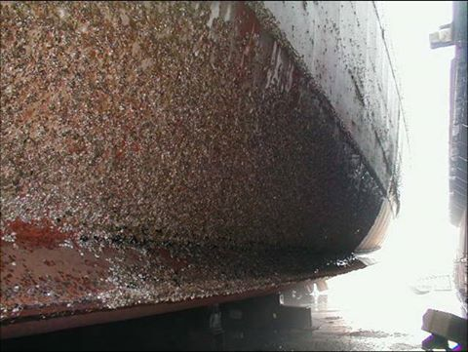

အေထြေထြအျပားျပား ကဲြျပားလွတဲ့ ေမာ္တာေတြအတြက္ အေတာ္စံုလင္ေကာင္းမြန္တဲ့ ဗဟုသုတေတြျပည့္ဝပါဝင္တဲ့ စာစုတစ္ခုပါခင္ဗ်ား။
PLC ကေတာာ့ Control ရည္ရြယ္ခ်က္မ်ားအတြက္ အစားထိုးေပးၿပီး Solid State devices မ်ား Thyristors မ်ားကို Power Electronic switching ကရိယာမ်ားအျဖစ္ သံုးစဲြကာ လိုအပ္တဲ့ Frequencies နဲ႔ Voltages ထုတ္ေပးတဲ့ Motor Speed drives နဲ႔ VFD drive မ်ားသံုးတဲ့အခါမွာ Main Magnetic contactor မ်ားကို ဖယ္႐ွားထားလို႔ လည္း ရပါတယ္ခင္ဗ်ား။ တန္ဘိုးသက္သာတဲ့
Soft Starter အဆင့္သာ သံုးစဲြတဲ့အခါမ်ိဳးမွာ ႏိႈးအဆင့္ေက်ာ္လြန္ၿပီးေနာက္ပိုင္း ဆက္လက္ေမာင္းႏွင္သြားဖို႔ bypass Magnetic Contractor မ်ား ျဖင့္လဲႊေျပာင္းယူေနၾကတာျဖစ္ပါတယ္။
အခ်ိဳ႕ Soft Starter မ်ားဟာ အခ်က္အလက္မတူညီတဲ့ ေမာ္တာငါးလံုးရဲ႕ လိုအပ္ခ်က္မ်ားကို မွတ္ဥာဏ္ Parameters setting မွာမွတ္သားထားၿပီး လိုအပ္တဲ့တစ္လံုးစီကို အဆင္ေျပမွန္ကန္စြာေရြးခ်ယ္ႏိႈးေပးသြားႏိုင္ၾကပါတယ္။
ဒါေပမယ့္ အဲဒီေလာက္ စံုစံုလင္လင္ အသံုးခ်ခ်င္တဲ့ အလုပ္႐ွင္ေတြ သိပ္မေတြ႔ခဲ့ရပါဘူး။
PMS system အ​ေၾကာင္​း​ေသ​ေခ်ာခ်ာ​ေ၇းတာ​ေလးမ်ား​ေတြ႔၇င္​အလင္​းျပ​ေပးပါဦး။မ်ား​ ေသာအားျဖင္​့ကာကုလ အ​ေျချုပုၿပီး အကဲဒမစ္​ဆန္​ဆန္​ဘဲ​ေ၇းထားၾကတာမ်ား​ေတာ့math s အားနဲ​ေတာ့ဖတ္​မႏိုင္​ဘူးျဖစ္​​ေနလို႔ပါ
Nay Myo Aung PMS စနစ္သံုးထားတဲ့ MSB Drawing နဲ႔ Operation manual မွာ စတင္ေလ့လာပါခင္ဗ်ား။
PLC အထဲမွာကေတာ့ Kilowatts တန္ဘိုးေတြ ဖတ္ယူကာ ေပါင္းတာႏိႈင္းယွဥ္တာေတြနဲ႔ Standby Generator သတ္မွတ္ခ်က္ အဆင့္တိုးတာ ေလ်ွာ့တာေတြ ေရးေပးရတာပါ။
အခုေနာက္ပိုင္း Engine controller ေတြက PLC ထပ္မံပူးတဲြရန္မလိုပဲ PMS အတြက္ လိုအပ္ခ်က္ေတြ ခ်ိန္ညႇိယူလို႔ရၾကပါတယ္။
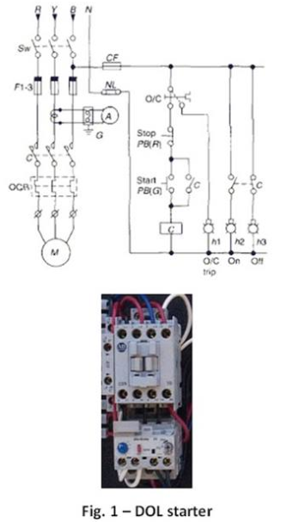
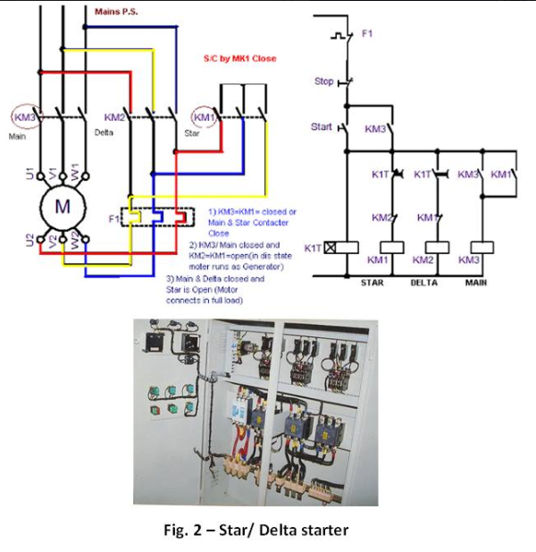
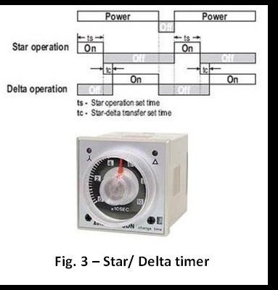
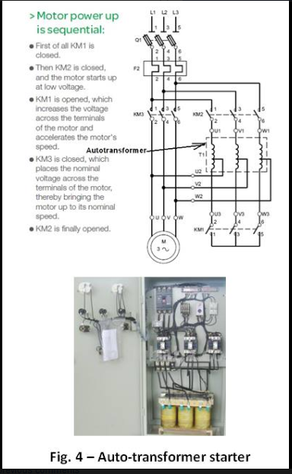
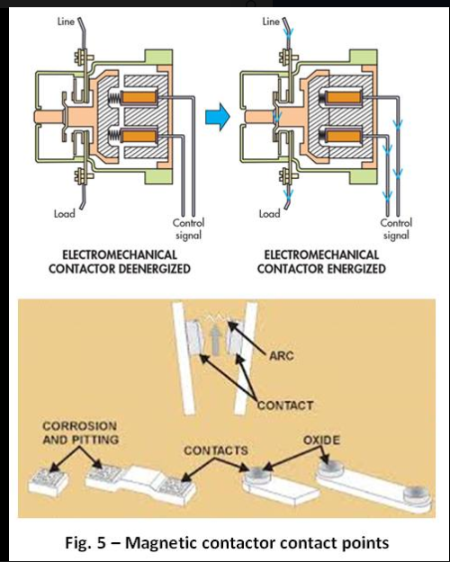
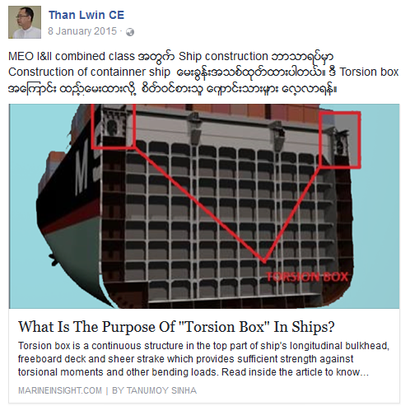
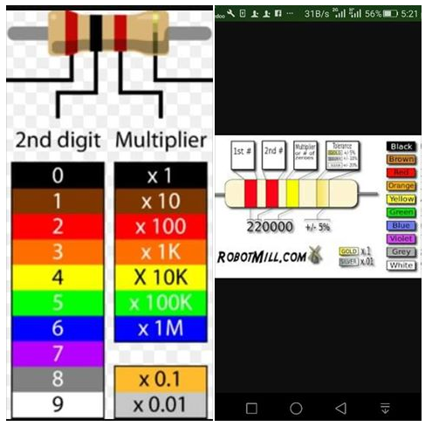
၂၀၁၂ ေမလဆန္းကေပါ့ ဆမ္ဘာဝမ္း သေဘၤာက်င္းမွာ ေရာက္ေနတဲ့ သြန္းေမရီဆိုတဲ့ သေဘၤာတစင္းကို ဂ်င္နေရတာမ်ားနဲ့ Power Manangement အပိုင္းမ်ား စစ္ေဆးျပဳျပင္ေပးဖို႔. နာမည္ေက်ာ္ CYCLECTရဲ႕ APPLY AUTOMATION က စြမ္းရည္ျပည့္ အင္ဂ်င္နီယာမ်ား အဖဲြ႕လိုက္ခ်ီတက္ခဲ့ရပါတယ္။
အဓိက ျပႆနာက အမွတ္ ၂ ဂ်င္နေရတာနဲ႔ ပူးတဲြေမာင္းထားတဲ့အခ်ိန္ေတြမွာ PMS စနစ္ဟာ မေခ်ာေမြ႔ပဲ မထင္မွတ္တဲ့ျပႆနာေတြ ေပးေနတာေၾကာင့္ျဖစ္ပါတယ္။
သူတို႔ ျပႆနာက ၾကာ႐ွည္ေနၿပီျဖစ္ၿပီး ကြၽန္ေတာ္တို႔ရဲ႕ ေ႐ွ႕မွာ အျခားသူမ်ားႀကိဳးပမ္းၾကည့္ခဲ့ၾကပါၿပီ။
ကြၽန္ေတာ္တို႔အဖဲြ႔လဲ ထံုးစံအတိုင္း လိုအပ္တာေတြ စစ္ေဆးၿပီး AVR Setting မ်ားခ်ိန္ညႇိစမ္းသပ္ၾကပါတယ္။
Oo ဆိုရင္လည္း သူ႔ကိုယ္လံုးေလး ဝင္လို႔ရတဲ့ Terminal Box အထဲထိ ဝင္ၿပီး SIEMEN ႏွစ္ကဒ္တဲြ AVR မွာ Droop တန္ဘိုး Gain တန္ဘိုးေတြ စိတ္တိုင္းက် ရသည္အထိ အႏုစိတ္ခ်ိန္ညႇိေပးခဲ့ပါတယ္။
ဂ်င္နေရတာေတြရဲ႕ Response စိတ္တိုင္းက် ရေပမယ့္ ထူးျခားေကာင္းမြန္လာတာေတြ႐ွိေပမယ့္၊ Power Manangement System မွာ စိတ္တိုင္းက်မရေသးပါဘူး။
အဲဒီ သေဘၤာမွာက DEIF PPU နဲ႔ OMORN PLC တဲြဖက္ၿပီး PMS တည္ေဆာက္ထားတာျဖစ္ပါတယ္။
DEIF အတြက္ Program ႐ွာေဖြၿပီး Down Load ယူရတဲ့အျပင္ Communication Cable ကို ကိုယ္တိုင္ ဖန္တီးခဲ့ရပါတယ္။
OMRON အတြက္ CX programmer Software နဲ႔ Programming cable ကို Project ဌာနက ငွါးယူခဲ့ရပါတယ္။
PMS maker ရဲ႕ မူရင္း Parameter Setting ေတြကို ဂ်င္နေရတာတစ္ခုစီက upload ယူၿပီးအထပ္ထပ္ ႏိႈင္းယွဥ္ၾကည့္ရပါတယ္။
PLC အထဲက Ladder diagram program ကိုလည္း ဆဲြယူစစ္ေဆးခဲ့ရျပန္ပါတယ္။ တစ္ရက္ႏွစ္ရက္ စမ္းသပ္ခြင့္ရခ်ိန္ေတြမွာ
ကိုယ္ေတြ သိသေလာက္ အျပစ္အနာအဆာမေတြ႔မိပါဘူးခင္ဗ်ား။
ေနာက္ဆံုးတစ္ရက္မွာေတာ့ တာဝန္ကိုယ္စီ ခဲြေဝစစ္ေဆးစမ္းသပ္ၾကရင္း Online monitoring test လုပ္ထားတဲ့လုပ္ထားလိုက္ၾကည့္ေနတဲ့ ကြၽန္ေတာ့္ Laptop မွာ
ထူးျခားခ်က္တစ္ခုေတြ႔လိုက္ရပါတယ္။
Gen ေတြ Synchronization လုပ္ထားၿပီး PMS ON ထားတဲ့အခ်ိန္ Load Sharing တန္ဘိုးအပိုင္းေတြကို စစ္ေဆးေနတာဆိုေတာ့ Gen#2 ရဲ႕ Kilowatts transducer က Analog value ကို လံုးဝမယူဘူးမသိဘူး ျဖစ္ေနတာ ေတြ႔လိုက္ရတာပါ။
ဆက္လက္စစ္ေဆးေတာ့မွ PANEL Meter ေပၚမွာေတာ့ အ႐ွိအတိုင္း အမွန္အတိုင္း ျပတယ္ဗ်ာ။ PLC အထဲကိုေပးေတာ့မွ Analog Input modules မွာ ႀကိဳးအဝင္ယူတာ တစ္ေခ်ာင္းက်န္ေနတာေၾကာင့္ဆိုတာ သြားေတြ႔ပါတယ္ခင္ဗ်ား။
ဆိုေတာ့ကာ သေဘၤာတည္ေဆာက္စဥ္ကတည္းက အမွတ္ႏွစ္ဂ်င္နေရတာအတြက္ဆက္သြယ္ရာမွာ မွားယြင္းက်န္ရစ္ခဲ့ပံုရတဲ့ျပႆနာပါ။
အမွားအယြင္းျပႆနာကို ေတြ႔လို႔ေျဖ႐ွင္းလိုက္တာနဲ႔ PMS အပိုင္းဟာလည္း စင္းလံုးေခ်ာ ေကာင္းမြန္သြားပါေတာ့တယ္။
Load depended Start/ Stop system တို႔ Heavy consumer Request တို႔ Auto Load sharing တိ့ု အဲတာေတြ အားလံုးအဆင္ေျပသြားတာျဖစ္ပါတယ္။
တကၠနက္႐ွင္ တစ္ဦးရဲ႕ မေတာ္တဆ ဝါယာႀကိဳူသြယ္ အမွားေလးတစ္ခုဟာ ႏွစ္ေတြအၾကာႀကီး ကြၽန္ေတာ္တို႔ အင္ဂ်င္နီယာမ်ားစြာရဲ႕ေ႐ွ႕ေမွာက္မွာ ကိုယ္ေယာင္ေဖ်ာက္ကာေနသြားဖူးတယ္ဆိုတဲ့ အေၾကာင္းနဲ႔
ကိုယ္တိုင္ Commissioning Engineer ဘဝမွာေတာ့ ကိုယ့္ကုမဏၰီရဲ႕ Design ပံုေတြ Flow Chat ေတြအတိုင္း တိတိက်က် ဆက္သြယ္တပ္ဆင္ထားျခင္း႐ွိမ႐ွိ အလုပ္တာဝန္ေတြ တိတိက်က် ထမ္းေဆာင္ျခင္း႐ွိမ႐ွိ
တုိ႔ကို ေစ့ေစ့စပ္စပ္ စစ္ေဆးလက္လဲႊေပးခဲ့ပါတယ္ဆိုတဲ့ အေၾကာင္း ျပန္ေျပာင္းေျပာျပလိုတာျဖစ္ပါတယ္။
PMS စနစ္ နဲ႔ Operation အပိုင္းစူးစိုက္ေလ့လာေနသူမ်ားကို အေသးစိတ္ မွတ္တမ္း တခ်ိဳ႕ကို ျပသျဖစ္ပါတယ္ခင္ဗ်ား။

ညီညီေထြး (Chief Engineer)
စက္ပစၥည္းမ်ား၏ေမာင္းႏွင္လည္ပါတ္ေနေသာရွဳေထာင့္မွၾကည့္လွ်င္ မည္သည့္အမ်ဳိးအစားဘယ္ရင္မ်ားကုိမဆုိ တပ္ဆင္သုံးစြဲထားသည္ျဖစ္ေစ၊ ထုိစက္ပစၥည္းမ်ား၏လည္ပါတ္မွဳစြမ္းအား ေကာင္းက်ဳိးဆုိးျပစ္တုိ႔အေပၚ အလြန္ၾသဇာသက္ေရာက္မွဳရွိေနသည့္ သင့္တင့္ေလွ်ာက္ပါတ္ေသာ အေၾကာင္းအခ်က္မ်ားရွိေနမည္ျဖစ္ပါသည္။ သေဘၤာတြင္ဆုံးရွဳံးမွဳၾကီးမားစြာျဖစ္ေပၚလာနုိင္ေသာအခုိက္အတန္႔တြင္ အဓိကအေၾကာင္းအရာတခုျဖစ္သည့္ စက္ပစၥည္းမ်ားပ်က္စီးျခင္း (machinery breakdown) ကဲ့သုိ႔ အျခားေသာ ဆက္စပ္ ပါတ္သက္ေနသမွ်သည္ ဒုတိယအခ်က္အေနႏွင့္ျဖစ္ေပၚလာမည္ျဖစ္ျပီး ဆုံးရွဳံးမွဳပမာဏေပၚမူတည္၍ ေနာက္ဆက္တြဲျပႆနာမ်ား သီးျခားေပၚထြက္လာေစပါသည္။
ဤတြင္ လႊမ္းမုိးမွဳအေၾကာင္းအရာသည္ ဘယ္ရင္ဒီဇုိင္း ႏွင့္ ေယဘူယ်အားျဖင့္ ၀န္အား (load) သက္ေရာက္မွဳရွိေသာ ဘယ္ရင္ဒီဇုိင္း တုိ႔ျဖစ္၍ ၎တုိ႔သည္ ေရွးရုိးဆန္ဆန္လႊမ္းမုိးလွ်က္ရွိေသာ အေၾကာင္းတရားမ်ားျဖစ္ၾကပါသည္။ သုိ႔ပါလွ်က္ လြန္ခဲ့ေသာႏွစ္အနည္းငယ္အတြင္း သေဘၤာလုပ္ငန္းသုံးဒီဇယ္အင္ဂ်င္မ်ား၏ စက္ေမာင္းႏွင္မွဳဆုိင္ရာျပႆနာအမ်ားစုမွာ အသုံးျပဳေသာ ဘယ္ရင္မ်ားတြင္ျဖစ္ေပၚခဲ့ေသာ ျပႆနာမ်ားျဖစ္ေၾကာင္းကုိလဲေတြ႔ရွိေနရပါသည္။ Residual fuel သုံးစြဲထားေသာ ယခင္ေခတ္သုံး crosshead type marine diesel engines မ်ားတြင္ crankshaft corrosion (အထူးသျဖင့္ electro-chemical corrosion) ျဖစ္ေပၚျခင္း ၊ ဘယ္ရင္သတၱဳသြန္းေလာင္းအတတ္ပညာမဖြံျဖိဳးျခင္းေၾကာင့္ မာေက်ာေသာ ဘယ္ရင္မ်ားသုံးစြဲျခင္း (white metal hardening) သုိ႔မဟုတ္ steam turbine မ်ားတြင္ (ဓါတ္ျပဳျခင္းေၾကာင့္) သတၱဳေအာက္ဆုိဒ္မ်ားျဖစ္ေပးလာျခင္း (oxide formation) ၊ တာဘုိင္တြင္ အဖိခံဘယ္ရင္ပ်က္စီးျခင္း (turbine thrust bearing failure) ႏွင့္ သီးျခားျဖစ္ေသာအေၾကာင္းအရာမွာ 4 stroke trunk type diesel engine တြင္ piston ၏ မီးစုန္း-ေၾကးနီသတၱဳစပ္ gudgeon pin bearing တုိက္စားခံရျခင္း (phosphor-bronze gedgeon pin bearing failure) တုိ႔ျဖစ္ေၾကာင္း ေတြ႔ရွိရပါသည္။
သေဘၤာလုပ္ငန္းသုံး ဒီဇယ္အင္ဂ်င္ဒီဇုိင္းမ်ား တုိးတက္ဖြံ႔ျဖိဳးလာျခင္းေၾကာင့္ ဘယ္ရင္သတတၱဳပုံေလာင္းအတတ္ပညာသည္ လည္း တုိးတတ္ဖြံ႔ျဖိဳးလာျပီး ေခ်ာဆီေပးပုိ႔မွဳစံနစ္တြင္ ေခ်ာဆီကုိေကာင္းစြာကုိင္တြယ္ထိန္းသိမ္းသင့္သည့္ အေၾကာင္းအရာမ်ားကုိက်ယ္ျပန္႔စြာသတိျပဳမိေစျခင္း ၊ ပုိ၍သတိျပဳရမည့္ အနည္းဆုံးဟုမဆုိနုိင္သည့္ စဦးႏွင့္ေနာက္ဆုံး ေခ်ာဆီသန္႔ရွင္းေရးနည္းစံနစ္မ်ား ၊ အထူးတီထြင္ထုတ္လုပ္ထားေသာ ေခ်ာဆီမ်ား၏ တုိးတတ္ဖြ႔ံျဖိဳးလာမွဳမ်ား စသည္တုိ႔ျဖင့္ ဘယ္ရင္မ်ားတြင္ျဖစ္ေပၚလာနုိင္ေသာျပႆနာမ်ားကုိ တဖက္တလမ္းမွ ေျဖရွင္းယူရမည္ျဖစ္ပါသည္။
ယခုေခတ္တြင္ သေဘၤာလုပ္ငန္းသုံးဒီဇယ္အင္ဂ်င္မ်ား၌ shell type ဘယ္ရင္မ်ားကုိ အမ်ားဆုံးအသုံးျပဳလာသည္ျဖစ္၍ main bearings မ်ား ႏွင့္ bottom end bearings မ်ား၏ ဒီဇုိင္းပုံစံျပန္လည္ျပဳျပင္ျခင္း၊ အဆင့္ျမင့္သတၱဳပုံေလာင္းျခင္း ၊ ဘယ္ရင္အထုိင္မ်ား ပုိမုိေကာင္းမြန္လာျခင္း ၊ မသင့္ေလ်ာ္ေသာ oil groove ပုံစံကုိျပဳျပင္ျခင္း ၊ filter တခုခ်င္းတပ္ဆင္ျခင္း ၊ စသည္တုိ႔ စုေပါင္းပါ၀င္ေနေသာ thick shell bearings မွ thin shell bearings မ်ားႏွင့္ အစားထုိးေျပာင္းလဲယူျခင္း စသည့္ ထင္ရွားေသာ အခ်က္မ်ားကုိ ေျပာင္းလဲလာခဲ့ၾကျပီျဖစ္ပါသည္။
ေဖာ္ျပထားေသာပုံတြင္ journal bearing တစ္ခုကုိ တင္ျပထားပါသည္။ မွ်ားထုိးတင္ျပထားေသာ အခ်က္အလက္မ်ားမွာ ဘယ္ရင္တခုႏွင့္တခု တထပ္တည္းတူညီမည္မဟုတ္ပါ။
ဘယ္ရင္မ်ား၏စြမ္းေဆာင္နုိင္ရည္ႏွင့္ လည္ပါတ္စဥ္ပ်က္စီးမွဳမ်ား (Bearing performance and operating failure)
*****
Thin shell bearings မ်ားႏွင့္ ေပ်ာ့ေျပာင္းေသာ သတၱဳစပ္ဘယ္ရင္မ်ား အသုံးျပဳစဥ္ ~-
a) ဒီဇုိင္းပုံစံမေကာင္းျခင္း
b) မသင့္ေလွ်ာ္ေသာ သတၱဳမ်ားသုံးစြဲျခင္း
c) စဦးတပ္ခုိက္ သုိ႔မဟုတ္ ျပဳျပင္ထိန္းသိမ္းေရးလုပ္စဥ္အခုိက္အတန္႔တြင္ ထိခုိက္ျခင္း
d) ဘယ္ရင္ေပၚသုိ႔သက္ေရာက္ေသာ ၀န္အား (load) အလြန္မ်ားျပားျခင္း
e) ေခ်ာဆီအပူခ်ိန္ ၊ ေခ်ာဆီအမ်ဳိးအစားႏွင့္ ဘယ္ရင္သုိ႔ေပးပုိ႔ေသာ ေခ်ာဆီ ပမဏ အနည္း ၊ အမ်ား ၊
f) ေခ်ာဆီ၏သန္႔ရွင္းမွဳအဆင့္
g) ေခ်ာဆီအတြင္း အညစ္အေၾကးႏွင့္အမွဳိက္သရုိက္မ်ားပါ၀င္မွဳအေျခအေန
h) ေခ်ာဆီတြင္ အျခားအရည္မ်ား၀င္ေရာက္ေရာေႏွာေနျခင္း
စသည့္အခ်က္မ်ားေပၚမူတည္၍ ကြဲျပားျခားနားေသာ ပ်က္စီးမွဳအခ်ဳိ႕ကုိ ေတြ႔ရွိလာရပါသည္။
ဘယ္ရင္ပ်က္စီးမွဳအမ်ားဆုံးအေၾကာင္းအရာမ်ားမွာ ~~
1) ကာလၾကာရွည္အသုံးျပဳထားျခင္းေၾကာင့္ ေညာင္း၍ပ်က္စီးျခင္း (Fatigue)
2) ပြတ္တုိက္ျခင္းေၾကာင့္ပ်က္စီးျခင္း (Wiping)
3) တုိက္စားခံရျခင္း (Corrosion)
4) ဘယ္ရင္ေနာက္ဖက္ျခမ္းေနရာႏွင့္ အထုိင္ၾကားေခ်ာင္၍ တုိက္စားခံရျခင္းမွတဆင့္ပ်က္စီးျခင္း (Fretting corrosion)
5) ပြန္းစားျခင္း (Wear)
6) လွ်ပ္စစ္ဓါတ္ျပဳမွဳေၾကာင့္ ပ်က္စီးျခင္း (Electrical damage) (Electro-chemical corrosion)
7) အေခါင္းေပါက္အျဖစ္တုိက္စားခံရ၍ ပ်က္စီးျခင္း (Cavitation erosion)
တုိ႔ျဖစ္ၾကပါသည္။
ရႊင္လန္းပါေစ။

Marine Insight လို႔ ၾကားလိုက္တာနဲ႔ ေရေၾကာင္းေလာက က လူတိုင္းၾကားဖူးၿပီးသားျဖစ္မွာပါ။
စာအုပ္ေတြေရာ၊ သတင္းေတြေရာ၊ ဗဟုသုတရစရာေတြေရာ တင္ေပးေနတဲ့ website တစ္ခုျဖစ္ပါတယ္။
အခု #MarineInsight ရဲ႕ pinned post အျဖစ္ရွိေနတဲ့
"3 important calculations Every Marine Engineer MUST know on ships" (သေဘၤာအင္ဂ်င္နီယာတိုင္း သိကိုသိထားရမယ့္ တြက္ခ်က္မႈ သံုးခုဆိုပါေတာ့)။
⚓️
ဖတ္ေနရင္းနဲ႔ ကိုယ္ကိုယ္တိုင္ သိသလိုလိုနဲ႔ မသိတာေတြ၊ မေသခ်ာ မေရရာတဲ့ အသိေတြကိုလည္း ေတြ႕လိုက္ရတယ္။ ဒါနဲ႔ ပဲ မဖတ္ရေသးတဲ့သူေတြလည္း လြယ္လြယ္ကူကူ ဖတ္လို႔ရေအာင္ ကိုယ့္ဘာသာကိုယ္လည္း ျပန္ျပန္ဖတ္ေနလို႔ရေအာင္ ဘာသာျပန္ထားလိုက္တယ္။
--
--
အင္ဂ်င္ခန္းမွာ temperature ေတြ, pressure ေတြ, level ေတြသိဖို႔တပ္ထားတဲ့ instruments ေတြ အမ်ားႀကီးပဲ။ ဒါေပမဲ့ တိုက္႐ိုက္ ဖတ္လို႔မရတဲ့ တစ္ခ်ိဳ႕ parameter ေတြရွိေနေသးတယ္ဆိုတာမေမ့ပါနဲ႔။
ဒါေတြအတြက္ #Engineer ဆိုတဲ့သူေတြ မသိမျဖစ္သိကိုသိေနရမယ့္ Formula ေတြရွိေနတယ္...Without fail ပါ။
1. Bunker Calculation
Bunker ဆိုတာ Marine Engineer နဲ႔ သက္တမ္းတစ္ေလွ်ာက္လံုးလည္ပင္းဖက္သြားရမယ့္ term ပါ။ Fuel Oil (FO) ေပါ့ တစ္နည္းအားျဖင့္။ ေနာက္တစ္မ်ိဳးထပ္ေျပာပါဆိုရင္ အင္ဂ်င္ run ဖို႔ အတြက္ ဆီၾကမ္း။
Same weight (အေလးခ်ိန္တူေနေပမယ့္) different temperature (အပူခ်ိန္ ကြာျခားတာ) နဲ႔ volume (ထုထည္) ကြာျခားတတ္တဲ့ FO (bunker) ကို ....မွာရင္ ပဲ ျဖစ္ျဖစ္..တိုင္းတာရင္ပဲျဖစ္ျဖစ္ Weight (အေလးခ်ိန္) ကိုပဲသံုးၿပီးမွာရပါတယ္။ တိုင္းရပါတယ္။ Weight ကို တစ္နည္းအားျဖင့္ calculation ပိုင္းမွာ Mass ေပါ့။
မ်ားေသာအားျဖင့္ Fourth Engineer (ဒါမွမဟုတ္) Third Engineer က bunkering (Bunker ယူတဲ့ ေနရာမွာ) အခရာက်ေတာ့ ေအာက္က အခ်က္အလက္ေတြကို ေသခ်ာ သိေအာင္လုပ္ထားသင့္ပါတယ္။ လုပ္ထားရပါမယ္။
Bunker ယူမယ့္ တန္ခ်ိန္ ပမာဏကို သတ္မွတ္လိုက္ၿပီဆိုတာနဲ႔ bunker plan ဆြဲဖို႔ လက္က်န္ Tanks ေတြကို ဘယ္ေလာက္က်န္တယ္ sounding တိုင္းရမယ္။ ဘယ္ Tank ေတြကို အရင္ဆံုးျဖည့္မယ္။ ဘယ္ tank ၿပီး ဘယ္ tank ဆိုတာ ဆံုးျဖတ္ထားရပါမယ္။
ေနာက္တစ္ခုက Temperature ဘယ္ေလာက္ရွိေနတယ္။ အဲ့ဒီ့ Temperature မွာရွိေနတဲ့ bunker FO ရဲ႕ Density ကို သိထားရပါမယ္။ ဒါမွ Mass ဘယ္ေလာက္ tank ထဲ ဝင္မယ္ Volume ဘယ္ေလာက္ထိရွိသြားမယ္ မွန္းဆႏိုင္မွာပါ။ (ဒါကို ေအာက္ကDensity တြက္တာနဲ႔ တြဲဖတ္လိုက္ရင္ ပိုရွင္းသြားမွာပါ။)
ဒါ့အတြက္ ပထမဆံုး ပံုေသနည္းကေတာ့
Mass= Volume x Density
ဒီ ပံုေသနည္းအတြက္ same temperature ျဖစ္ဖို႔ေတာ့ သတိထားပါ။
ယူၿပီးခ်ိန္မွာ တြက္ခ်က္ဖို႔အတြက္ temperature ျပန္တိုင္းရမယ္။ Ullage sounding တိုင္းရမယ္။ DO လိုမ်ိဳးအတြက္ sounding paste သံုးသင့္တယ္။ Trim/List ၾကည့္မယ္။ ဒီကေန Volume ရမယ္။
Density at 15'C ဟာ Bunker ယူတိုင္းမွာ supplier က ေပးတဲ့ density with reference temperature ပါ။ ဒီကေန လက္ရွိ temperature မွာရွိေနတဲ့ Density ကို ျပန္တြက္ရပါတယ္။ ေတာ္ေတာ္မ်ားမ်ားသေဘၤာေတြမွာ ဒီ့အတြက္ software ရွိၿပီးသားပါ။ ဒါေပမဲ့ မရွိတဲ့သေဘၤာေတြမွာ ကိုယ္တိုင္တြက္ရပါလိမ့္မယ္။
ဒီ့အတြက္ Formula က
Temperature Corrected Density is:
= (Density of Fuel Oil @ 15⁰C) x [1- {(T-15) x 0.00064}]
ဒါဆို Density ရၿပီ။
ဒီကေန
Mass = Volume x Density နဲ႔တြက္လိုက္ရင္ Bunker Calculation ၿပီးၿပီ။
2. Specific Fuel Oil Consumption (SFOC)
ဆီစားႏႈန္းေပါ့။ Engine ရဲ႕ အေျခအေနကို SFOC နဲ႔ ပဲ check လုပ္တာ မ်ားတယ္။
သူ႔ရဲ႕ ပံုေသနည္းက
SFOC (g/kwh) = Mass of fuel consumed per hour / Power developed in KW
Fine weather မွာပဲတိုင္းတယ္ တိက်မႈရွိေအာင္ေပါ့။
Mass of fuel consumed ကေတာ့ HFO service tank ရဲ႕ 1 hr consumption volume ကို ဟိုးအေပၚက Mass ျပန္တြက္တဲ့ formula နဲ႔ပဲ တြက္ယူတယ္။
Power developed in KW ကေတာ့ Digital indicator မွာဖတ္တယ္။
3. Percentage of Slip
Engine က လည္ပတ္ေနတဲ့ speed နဲ႔ သေဘၤာအမွန္တကယ္ရၿပီး သြားေနတဲ့ speed ၾကားက difference က Slip ပါ။ percentage နဲ႔ တြက္ခ်က္တယ္။ Engine Slip ကို ေန႔စဥ္တြက္ခ်က္ၿပီး log book မွာထည့္ရတယ္။
သူ႔ရဲ႕ ပံုေသနည္းကေတာ့ ႐ိုးရွင္းပါတယ္။
Percentage of Slip = (Engine Distance - Observed Distance) x 100%/ Engine Distance
Observed distance (in nautical mile) ကေတာ့ Noon to Noon သြားခဲ့တဲ့ distance ကို ship's log က ယူပါတယ္။ (Bridge ကိုေတာင္းရပါလိမ့္မယ္။)
Engine Distance ကေတာ့ ..Noon to Noon သြားခဲ့ တဲ့ Revolution ကို revolution counter က ရပါတယ္။ ဒါကို Pitch နဲ႔ ေျမႇာက္တယ္။ Pitch ဆိုတာကေတာ့ အင္ဂ်င္ ရဲ႕ Manufacture (Maker ေပါ့) က ေပးၿပီးသားပါ။ Unit က metre နဲ႔ ျပတယ္။ ဒါကို Nautical mile ေျပာင္းဖို႔မေမ့ပါနဲ႔။ (1 Nautical mile = 1800 metre)
BOE Exam မ်ားမွာ ေမးခြန္းတုိအျဖစ္ ေမးေလ့ရွိတဲ႔ ေခ်ာဆီစနစ္မ်ားအေၾကာင္း ဗဟုသုတေပါ့။
ေခ်ာဆီစံနစ္ကုိ အမ်ဳိးအစားခြဲျခားျခင္း (Lubrication classifications)
****
ညီညီေထြး (Chief Engineer)
ေမာင္းႏွင္လည္ပါတ္လွ်က္ရွိေသာ သုိ႔မဟုတ္ ေရြ႕လွ်ားလွ်က္ရွိေသာစက္ပစၥည္းမ်ားတြင္ ပြတ္မွဳအား (friction) ေၾကာင့္ ခုခံမွဳ (resistance) တုိးလာျပီး အဆုိပါစက္ပစၥည္းမ်ား၏ ေရြ႕လွ်ားမွဳကုိ ၾကီးစြာေသာအတားအဆီးတခုအျဖစ္ေရာက္ရွိေစပါသည္။ ထုိ႔ေၾကာင့္ ေရြ႕လွ်ား လည္ပါတ္ေနေသာ စက္ပစၥည္းအစိတ္အပုိင္းမ်ားၾကားတြင္ ခုခံမွဳနည္းပါးသြားေစရန္အတြက္၎၊ စက္ပစၥည္းအစိတ္အပို္င္းမ်ား ေခ်ာေမြ႔စြာ လည္ပါတ္ျခင္း ၊ ေရြ႕လွ်ားျခင္းရရွိေစရန္အတြက္၎ ၊ ပြတ္မွဳအားကုိ အနည္းဆုံးအေျခအေနထိ ေလွ်ာ့ခ်နုိင္ရန္ သင့္ေတာ္ေသာ ေခ်ာဆီေပးပုိ႔မွဳစံနစ္မ်ား၊ လုိအပ္ေသာ ေခ်ာဆီပမာဏမ်ားကုိ ေထာက္ပံ့ပုိ႔ေဆာင္ေပးျခင္းနည္းစံနစ္မ်ားကုိ အသုံးခ်ျခင္းျဖင့္ စက္ပစၥည္းမ်ားတြင္ ပြတ္မွဳအားေလွ်ာ့နည္းသြားရျပီး စက္ပစၥည္းအစိတ္အပုိင္းမ်ား၏ သက္တမ္း ႏွင့္ စြမ္းေဆာင္ရည္သည္လည္း ပုိမုိတုိးတက္လာရပါသည္။ ေခ်ာဆီေပးပုိ႔မွဳစံနစ္မ်ားတြင္ မရွိမျဖစ္ အမ်ဳိးအစားမ်ားျဖစ္ေသာ ေခ်ာဆီေပးပုိ႔မွဳစံနစ္မ်ားမွာေအာက္ပါအတုိင္းျဖစ္သည္။
1) Hydrodynamic or Full fluid film lubrication
2) Hydrostatic lubrication
3) Boundary lubrication or thin film lubrication
4) Partial full fluid flim lubrication
5) Elastohydrodynamic lubrication
တုိ႔ျဖစ္ၾကပါသည္။
Hydrodynamic or Full fluid film lubrication
****
ပုံစံအားျဖင့္ ဤအမ်ဳိးအစားတြင္ bearing ေပၚ၌ လည္ပါတ္ေနေသာ shaft တစ္ေခ်ာင္းကုိ ေခ်ာဆီထုျဖင့္ေထာက္မထားျခင္းျဖင့္ မ်က္ႏွာျပင္ႏွစ္ခုၾကား ထိစပ္ေနေသာေနရာ၌ ပြတ္မွဳအားေလွ်ာ့နည္းေစျခင္းျဖစ္ပါသည္။ ပြတ္တုိက္ခံေနရသည့္ ေအာက္ခံမ်က္ႏွာျပင္ ႏွင့္ လည္ပါတ္ေနေသာ အစိတ္အပုိင္း၏မ်က္ႏွာျပင္တုိ႔ကုိ ဖိအားတခုျဖင့္ အဆက္မျပတ္ေပးပုိ႔လွ်က္ရွိသည့္ မျပိဳကြဲနုိင္ေသာ ေခ်ာဆီထုအလႊာ သုိ႔မဟုတ္ ေခ်ာဆီခ်ပ္ျပားအားျဖင့္ အျပည့္အ၀ ခြဲျခားထားလုိက္ျပီး ၎မ်က္ႏွာျပင္မ်ား ေပၚတြင္ ေခ်ာဆီအလႊာပါးတခုကုိ အမွန္တကယ္တည္ရွိေနေစရန္ ျပဳလုပ္ေပးျခင္းျဖင့္ ပြတ္မွဳအားကုိေလွ်ာ့ခ်ျခင္းျဖစ္ပါသည္။
၀န္အား (load) သုိ႔မဟုတ္ လည္ပါတ္ေနေသာ အစိတ္အပုိင္းမွ ထမ္းရြက္ေနရေသာ ၀န္အား (load) ႏွင့္ ပုိ၍အဆင္ေျပမွဳရွိသည့္ bearing ၏ ဖိအားသည္ အလြန္အေရးၾကီးသည္ျဖစ္၍ အကယ္၍ အလြန္မ်ားလြန္းေသာ ၀န္အား (load) သည္ ေခ်ာဆီထုအလႊာတည္ေဆာက္ေပးရန္ စြမ္းေဆာင္နုိင္မည္မဟုတ္ပါ။ သေဘၤာလုပ္ငန္းသုံးဒီဇယ္အင္ဂ်င္မ်ားတြင္ bearing ဖိအားသည္ အၾကမ္းအားျဖင့္ main bearing မ်ားအတြက္ 56 ~ 105 kg/cm2 ခန္႔ ၊ connecting rod bearing (bottom end bearing) မ်ားအတြက္ 70 ~ 140 kg/cm2 ခန္႔ ႏွင့္ crosshead bearing (gudgeon pin bearing) 169 kg/cm2 ထက္ပုိသည့္ bearing ၏ ဖိအားမ်ားျပားလာျခင္းတုိ႔ကဲ့သုိ႔ ခက္ခဲေသာျပႆနာမ်ား ရွိေနျပီး ဤအခ်က္ကုိ steam turbine bearing မ်ားတြင္ အမ်ားဆုံးအသုံးျပဳေနေသာ bearing မ်ားရွိ bearing ဖိအား 7 ~ 17.5 kg/cm2 ခန္႔ ႏွင့္နုိင္းယွဥ္ၾကည့္ပါက ထင္ရွားစြာ ေတြ႔ျမင္နုိင္မည္ျဖစ္ပါသည္။
ထုိ႔အျပင္ shaft သုိ႔မဟုတ္ journal ၏ လည္ပါတ္နဳန္း (speed) သည္လည္း ေနာက္ထပ္ အေရးၾကီးေသာ အေၾကာင္းအရာတစ္ခု ျဖစ္ျပီး ဤအခ်က္ကုိအင္ဂ်င္တည္ေဆာက္ပုံဒီဇုိင္းအားျဖင့္ ထိန္းခ်ဳပ္နုိင္၍ လည္ပါတ္နဳန္းနည္းပါးေသာ slow speed အင္ဂ်င္မ်ားတြင္ ေခ်ာဆီထုအလႊာရရွိေအာင္ တည္ေဆာက္ယူျခင္းသည္ slow speed engine မ်ားအတြက္ ေက်ာ္ၾကားလွေသာ အေျခအေနတရပ္အျဖစ္ စြမ္းေဆာင္ေပးနုိင္ပါသည္။ ေခ်ာဆီ၏ေစးပ်စ္မွဳ (viscosity of lubricant) သည္လည္း ေခ်ာဆီထု အလႊာ တည္ေဆက္မွဳတြင္ ေထာက္ကူေပးသည့္ အျခားေသာအေၾကာင္းအခ်က္တစ္ခုျဖစ္ပါသည္။ သုိ႔ရာတြင္ ဤအခ်က္သည္ ကန္႔သတ္ထားေသာ ေခ်ာဆီေစးပ်စ္မွဳ ျမင့္မားျခင္းအေျခအေန၌သာျဖစ္ပါသည္။ အဘယ့္ေၾကာင့္ဆုိေသာ အလြန္မ်ားျပားေသာ ထုထည္ရွိသည့္ ေခ်ာဆီႏွင့္ေစးပ်စ္မွဳသည္ ေခ်ာဆီကုိ ျပန္လည္အေအးခံရာ၌ အခက္အခဲရွိေသာေၾကာင့္ျဖစ္ပါသည္။
လည္ပါတ္ေနေသာ စက္ပစၥည္းအစိတ္အပုိင္းတစ္ခုအတြက္ ေခ်ာဆီထုအလႊာ ျဖစ္တည္မွဳဆုိသည္မွာ အဆုိပါအစိတ္အပုိင္းရွိ bearing clearance သည္ အထူးအေရးၾကီးေသာ အခ်က္တစ္ခုျဖစ္ျပီး ၎ကုိ အထူးဂရုစုိက္စြာ ထိန္းသိမ္းမွဳေပးရမည္ျဖစ္ပါ သည္။ အကယ္၍ bearing clearance သည္ အတန္အသင့္ မ်ားေနပါက ဗဟုိခ်က္လြဲေနေသာ bearing ႏွင့္ journal တုိ႔ၾကားေနရာလပ္သည္ က်ယ္ျပန္႔လာျပီး ေခ်ာဆီထုအလႊာအျဖစ္စုစည္းမွဳေနရာေကာင္းစြာရရွိေစကာ ထုိေခ်ာဆီထုအလႊာျဖင့္ ၀န္အား (load) ေထာက္မေပးနုိင္သည့္ေနရာ က်ယ္ျပန္႔စြာရရွိနုိင္ေစပါသည္။ သုိ႔ေသာ္ အလြန္မ်ားလြန္းေသာ bearing clearance ေၾကာင့္ bearing ေပၚသုိ႔ပုိ႔ေဆာင္ေပးထားထားသည့္ ေခ်ာဆီသည္ bearing မွတဆင့္ ယုိစီးထြက္မွဳမ်ားကုိျဖစ္ေပၚနုိင္ေစျပီး ေခ်ာဆီ၏ဖိအားျဖင့္ bearing မွ ၀န္အား (load) သယ္ေဆာင္ထားနုိင္မွဳကုိ ေလွ်ာ့နည္းက်ဆင္းလာနုိင္ေစပါသည္။ ထုိ႔အတူ အလြန္နည္းပါးေသာ bearing clearance ရွိေနပါက ေခ်ာဆီအလႊာအျဖစ္စုစည္းမွဳေနရာေကာင္းစြာ မရရွိနုိင္ေတာ့ပဲ ပြတ္မွဳအားမ်ားလာျခင္း ၊ ေခ်ာဆီအပူခ်ိန္ျမင့္တက္ျခင္း ၊ bearing တြင္ ပြန္းစားခံရမွဳ မ်ားလာျခင္း ၊ ထုိမွတဆင့္ အျခားျပႆနာအမ်ားအျပားဆီသုိ႔ ဦးတည္ျဖစ္ေပၚေစနုိင္ပါသည္။
ထုိ႔အတူ စက္ပစၥည္းအစိတ္အပုိင္းတြင္ သုံးစြဲထားေသာ bearing ၏ အလွ်ား (length) သည္လည္း အထူးဂရုျပဳရမည့္ အေၾကာင္းအရာတရပ္ျဖစ္ပါသည္။ ရွည္လွ်ားေသာ bearing သည္ ၀န္အား (load) သယ္ေဆာင္ထားနုိင္ျခင္းတြင္ ထိေရာက္စြာ အက်ဳိးရွိေၾကာင္း သံသယရွိရန္မလုိပါ။
ဥပမာ-Main bearing lubrication
Boundary lubrication or thin film lubrication
****
စက္ပစၥည္းအစိတ္အပုိင္းမ်ား လွဳပ္ရွားလည္ပါတ္ေနေသာအေျခအေနတြင္ အထူးသျဖင့္ ေလွ်ာထုိးေရြ႕လွ်ားေနသည့္ အစိတ္အပုိင္းႏွင့္ ထိစပ္ေနသည့္ အစိတ္အပုိင္းအသီးသီးၾကားတြင္ ေခ်ာဆီထုအလႊာ သုိ႔မဟုတ္ ေခ်ာဆီခ်ပ္ျပားတုိ႔ျဖင့္ အျပည့္အ၀ ခြဲျခားေပးရန္ မည္သုိ႔မွ်မျဖစ္ႏုိင္ပါ။ အေတြ႔အၾကံဳမ်ားအရ ဤအခ်က္သည္ bearing design ႏွင့္ oil technology တြင္ အဓိကျပႆနာၾကီးတရပ္ျဖစ္ေနပါသည္။ ဤသုိ႔ေသာအေျခအေနမ်ဳိးတြင္ ထိစပ္ေနေသာအစိတ္အပုိင္းတုိ႔၏မ်က္ႏွာျပင္မ်ားၾကားတြင္ လွဳပ္ရွားမွဳမ်ားျပားျခင္း ၊ ပြတ္မွဳအားႏွင့္ သတၱဳအခ်င္းခ်င္းထိေတြ႔ျခင္းတုိ႔ေၾကာင့္ လွ်င္ျမန္စြာ ပ်က္စီးသြားေစနုိင္သည့္အတြက္ ေခ်ာဆီကုိ အစိတ္အပိုင္းမ်ား၏ထိစပ္ေနေသာ လွဳပ္ရွားမွဳရွိနုိင္သည့္ ေနရာမ်ားေပၚသုိ႔ ေပးပုိ႔ျခင္းျဖင့္ မ်က္ႏွာျပင္ႏွစ္ခုၾကားရွိ ပြတ္မွဳအားကုိ ေလွ်ာ့ခ်ေပးနုိင္ပါသည္။
ဥပမာ-Guide shoe lubrication
ရႊင္လန္းပါေစ။
ပုံစာမ်ား။
ပုံ-၁။ Hydrodynamic or Full fluid film lubrication
ပုံ-၂။ Boundary lubrication or thin film lubrication
ကုိးကား။
Marine Diesel Lubrication by G.H. Clark, Ch Eng. MI Mar E. Burmah-Castrol publication

မေကာင္းတဲ႔သတင္းေတြတင္တာမ် ားလာလုိ႔
ဒါေလးေရးၾကည့္လုိက္တယ္။
Offshore မွာေျပာေလ့ရွိတဲ႔-
" HSE Bridging Document ဆုိတာ"
Maker : Danfoss
Refrigerant : R404 a , R507
Temperature range : -40 C' /+10C' (-40 F' /+50F')
Orific No : 01
Max Working Pressure : 500 psi (35.1535 Kgf/cm2)
တုိင္ေတနီယမ္သတၱဳစပ္ျဖင့္ျပဳလုပ္ထားေသာ ပလိပ္ျပားခ်ပ္မ်ားႏွင့္ တည္ေဆာက္ထားသည့္ အလုံပိတ္ေပါင္းခံေရခ်ဳိခ်က္စက္တြင္အမ်ဳိးအစားႏွစ္မ်ဳိးရွိပါသည္။ တစ္မ်ဳိးမွာ တာဘုိင္စြမ္းအင္သုံးသေဘၤာမ်ားအတြက္ steam energy ေထာက္ပံ့ေပးထားေသာ ဘိြဳင္လာ၏ condensate (ေရခ်ဳိ) ျဖင့္ ေရခ်က္စက္၏ အေအးခံ ကြန္ဒင္ဆာကုိ အေအးေပးကာ ကြန္ဒင္ဆာထဲမွ ျဖတ္သန္းသြားသည့္ vapor တုိ႔ကုိ heat exchange နည္းလမ္းျဖင့္သိပ္သည္းသြားေစျပီး distilled water အျဖစ္ စုေဆာင္းယူေသာ အမ်ဳိးအစား ႏွင့္ ေနာက္တမ်ဳိးမွာ ေရခ်က္စက္၏ အေအးခံ ကြန္ဒင္ဆာကုိ sea water ျဖင့္ အေအးေပး၍ ကြန္ဒင္ဆာထဲမွ ျဖတ္သန္းသြားသည့္ vapor မ်ားကုိ သိပ္သည္းေစျပီး distilled water အျဖစ္ စုေဆာင္းယူေသာ အမ်ဳိးအစားတုိ႔ျဖစ္ပါသည္။
ထုိ့ေၾကာင့္ ပလိပ္ျပားခ်ပ္မ်ားႏွင့္ တည္ေဆာက္ထားသည့္ အလုံပိတ္ေပါင္းခံ ေရခ်ဳိခ်က္စက္၏ အေအးခံစံနစ္တြင္ ~
(၁) ေရခ်ဳိ (ဘိြဳင္လာမွ condensate) အသုံးျပဳသည့္ အမ်ဳိးအစား ႏွင့္
(၂) sea water အသုံးျပဳသည့္အမ်ဳိးအစား
ဟူ၍ ႏွစ္မ်ဳိးရွိေၾကာင္း သိရွိနုိင္ပါသည္။ feed water ျဖစ္ေသာ sea water ကုိ ေရခ်ဳိခ်က္စက္သုိ႔ ပန္႔ ျဖင့္ေပးပုိ႔၍ evaporator သုိ႔ေရာက္ရွိလာပါသည္။ evaporator ထဲတြင္ air ejector အားျဖင့္ vacuum ရယူ ဖန္တီးထားျပီး steam ျဖင့္ sea water အေငြ႔ျပန္နုိင္သည့္ အပူခ်ိန္ေရာက္ သည္အထိ အပူေပးေစပါသည္။
ပင္လယ္ေရကုိ အပူေပးျခင္းျဖင့္ အေငြ႔ျပန္လာေသာ vapor မ်ားသည္ ဆားဓါတ္ပါ၀င္မွဳကုိ စုပ္ယူထားနုိင္သည့္ demister ကုိ ျဖတ္သန္းျပီး အေအးခံကြန္ဒင္ဆာသုိ႔ ေရာက္ရွိ အေအးခံ၍သိပ္သည္းေစကာ distilled water အျဖစ္ စုေဆာင္းယူပါသည္။ ကြန္ဒင္ဆာကုိ ဘိြဳင္လာ၏ main condensate line မွတဆင့္ ပုိက္တစ္ခု ခြဲထုပ္ကာ ထုိေရျဖင့္ အေအးေပးျခင္းျပဳလုပ္ပါသည္။ အျခားအမ်ဳိးအစားတခုမွာ sea water pump မွေထာက္ပ့ံေပးပုိ႔ေသာ ပင္လယ္ေရကုိ ကြန္ဒင္ဆာတြင္ အေအးေပးေသာ sea water cooling အမ်ဳိးအစားကုိလည္းအခ်ဳိ႕သေဘၤာမ်ားတြင္ တပ္ဆင္အသုံးျပဳပါသည္။ ခ်က္လုပ္ ရရွိေသာ distilled water ကုိ distilled water pump ျဖင့္ ေသာက္ေရ ႏွင့္ သုံးေရ သုိေလွာင္ကန္ အသီးသီးသုိ႔ပုိ႔ ေဆာင္ေပးပါသည္။
ေအာက္တြင္ေဖာ္ျပထားေသာပုံတြင္ Air ejector သည္ sea water pump မွ ေထာက္ပံ့ေပးပုိ႔လာေသာ pressure ျဖင့့္္ ေရခ်ဳိခ်က္စက္၏ အလုံပိတ္ ေပါင္းခံအုိးထဲတြင္ ေလဟာနယ္ (vacuum) အျဖစ္ရယူ ဖန္တီးထားျပီး ေထာက္ပံ့ေပးေသာ sea water မ်ား ႏွင့္ evaporator မွ ျပန္ထြက္လာေသာ brine တုိ႔ကုိ air ejector အသုံးျပဳ၍ပင္ သေဘၤာျပင္ပသုိ႔စြန္႔ထုပ္ပါသည္။ Evaporator အတြင္းဖိအားကုိမူ control panel မွ အီလက္ထရြန္းနစ္ နည္းပညာမ်ားအသုံးျပဳ၍ အလုိေလွ်ာက္ ခ်ိန္ညွိ ထိန္းခ်ဳပ္ေပးပါသည္။
Salinity indicator စံနစ္ကုိ distilled water စုေဆာင္းရယူျခင္းမွ storage tanks မ်ားအထိ ျဖန္႔ေ၀ တည္ေဆာက္ထားပါသည္။ ဆားဓါတ္ပါ၀င္မွဳကုိ မူလခ်ိန္ညိွထားရာအမွတ္ျဖစ္ေသာ 4 ppm ထက္ ပုိမ်ားလာေၾကာင္းတုိင္းတာ သိရွိပါက သတိေပးစံနစ္ (alarm system) တပ္ဆင္ထားျပီး တခ်ိန္တည္းမွာပင္ storage tanks မ်ားသုိ႔ ပုိ႔ေပးေသာ distilled water pipe line ရွိ solenoid valve ကုိ ဖြင့္ေပးကာ ဆားဓါတ္ပါ၀င္မွဳမ်ားျပားေနသည့္ distilled water မ်ားကုိ evaporator သုိ႔ တဖန္ျပန္လည္ ၀င္ေရာက္ေစ၍ evaporation ထပ္မံ ျပဳလုပ္ေပးပါသည္။ မာေက်ာေသာ ခ်ဳိးတက္မွဳမ်ားကုိ အနည္းဆုံးသုိ႔ ေလွ်ာ့ခ်၍ ကာကြယ္မွဳေပးနုိင္ရန္ ဓါတုေဆး ထည့္သြင္းကန္ (chemical injection tank) ကုိတည္ေဆာက္ထားျပီး feed water ထဲသုိ႔ ခ်ဳိးမတက္ ေဆးရည္ (scale inhibator solution) ကုိ အေသးစားဓါတုေဆးထည့္ပန္႔ (chemical dosing pump) အားျဖင့္ ေရခ်ဳိခ်က္စက္ ေမာင္းႏွင္ထား စဥ္တေလွ်ာက္လုံးအဆက္မျပတ္ ထည့္သြင္းေပးပါသည္။
(ပုံတြင္ေဖာ္ျပထားေသာ) Plate type distilling plant (for turbine ships မ်ားတြင္တပ္ဆင္ထားေသာ) ေရခ်ဳိခ်က္စက္ ေမာင္းႏွင္ပုံအဆင့္ဆင့္
*****
(က) ejector steam pressure ကုိ 1.1 MpaG တြင္ ခ်ိန္ညွိပါ။
(ခ) brine pressure ကုိ 0.15 MpaG တြင္ control valve အသုံးျပဳ၍ ခ်ိန္ညွိပါ။
(ဂ) feed water သည္ heater pressure ႏွင့္ လုိက္ေလ်ွာညီေထြမွဳမရွိပဲ over heated ျဖစ္ေနပါက ဘိြဳင္လာမွ Desuperheat ခ်ထားသည့္ valve ကုိ ဖြင့္ ေပးနုိင္ပါသည္။
(ဃ) ရပ္တန္႔ရန္မွာ ေရခ်ဳိခ်က္စက္ကုိ အျပည့္အ၀ မရပ္တန္႔မွီ feed water control valve ကုိ ပိတ္၍ အပူခ်ိန္က်ဆင္းသြားျပီး မွ cooling seawater inlet valve ကုိ ပိတ္ ပါ။ ထုိ႔ေနာက္ brine pump (သုိ႔မဟုတ္) water ejector ကုိ ရပ္ပါ။
ရႊင္လန္းပါေစ။
ပုံစာမ်ား။
ပုံ- ၁။ Cross-section of NIREX distilling plant chamber
ပုံ-၂။ Alfa-lava plate type fresh water generator

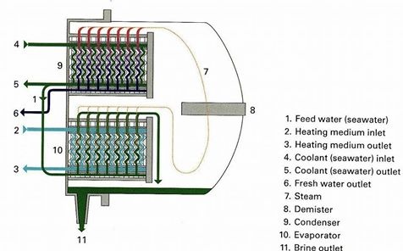

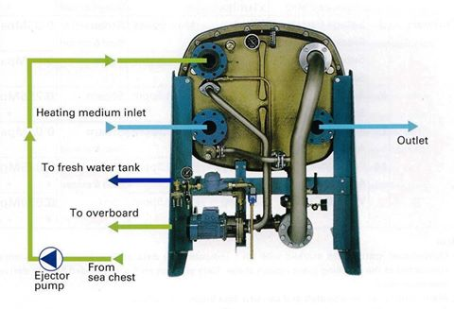

Top of Form

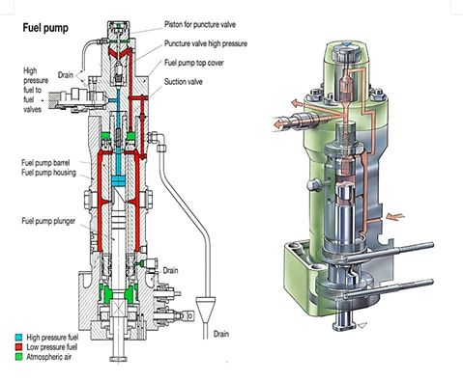

Top of Form

Bottom of Form
Bottom of Form

Offshore Project တစ္ခုကုိ contractor/company ေတြပူးေပါင္းလုပ္ကုိင္တဲ႔အခါေရးဆြဲဲရန္လုိအပ္ေသာ "document- manual "တစ္ခု ျဖစ္ပါတယ္။
ဥပမာပေရာဂ်က္မွာ-
Accommodation Work Barge-AWB
Anchor Handling Tug Supply- AHTS
Seismics vessel
Geotechnical vessel
Platform Supply vessel-PSV
Crew Boat တုိ႔ပါဝင္လုပ္တယ္ဆုိပါစုိ႔-
ကုမၼဏီမတူ၊သဘာဝမတူတဲ႔သေဘာၤမ် ား
ပါဝင္တဲ႔အတြက္ Safety Management Manual
မ် ားဟာလည္းမတူညီဘဲကြဲျပားေနမွာျဖစ္ပါတယ္။
ထုိ႔အျပင္တစ္စီးႏွင့္တစ္စီးရွိတဲ႔ facility ကလဲတူမွာမဟုတ္ပါ။
ဥပမာ- Medic ပါတဲ႔သေဘာၤရွိသလုိအခ်ိ ဳ႕ ဆရာဝန္ပါႏုိင္တယ္။
Helicopter Pad ပါတဲ႔သေဘာၤရွိႏုိင္သလုိ FRB ပါတဲ႔ သေဘာၤလဲရွိႏုိင္ပါတယ္။
အခ်ိဳ ဳ ႕ chemical ျဖန္းႏုိင္တဲ႔ spray boom ပါႏုိင္တယ္။
အကယ္၍မ် ားပေရာဂ်က္ကာလတြင္း သေဘာၤတစီးစီးကေသာ္၎ Oil platform ကေသာ္၎ ဆီယုိထြက္မႈျဖစ္ျခင္း manover board ျဖစ္ျခင္း၊ဒါမွမဟုတ္ explosion အစရွိသည္မ် ား ျဖစ္ခဲ႔ရင္ပူေပါင္းေဆာင္ရြက္ႏုိင္ရန္အတြက္ေရးဆြဲေသာ document-manual ျဖစ္ပါတယ္။
HSE-BD ေရးဆြဲရန္အတြက္သေဘာၤမ် ားႏွင့္ platform မွာရွိတဲ႔ SMM ႏွင့္ facility ေတြကုိ ပေရာဂ်က္ကုိဦးေဆာင္မဲ႔
တင္ဒါေအာင္ေသာ Company ကုိတင္ျပရပါတယ္။
ျပီးေနာက္အဆုိပါ Company ရဲ႕ HSE ဌာနက document ကုိေရးဆြဲပါတယ္။
အားလုံးျပင္ဆင္ျခင္းညွိႏႈိင္းျခင္းမ် ားျပဳ လုပ္ျပီးစီးေသာအခါ approved document ထြက္လာျပီးသေဘာတူလက္မွတ္ထုိးရပါတယ္။HSE-BD ကုိျဖန္႔ေဝျခင္းျပဳပါတယ္။
ျပီးေနာက္ ပေရာဂ်က္ရဲ႕ Offshore site အၾကီးအကဲကုိသတ္မွတ္ပါတယ္။
အဆုိပါအၾကီးအကဲကုိ Client Site Representative- (CSR) လုိ႔အတုိေခၚပါတယ္။
သူဟာ project တခုလုံးရဲ႕ ဘတ္ဂ်က္- ေန႔စဥ္တာဝန္ဝတၲရား- ေနထုိင္မေကာင္းထိခုိက္ဒဏ္ရာရမႈ-သေဘာၤသားအေျပာင္းအလြဲ- provision supply timing- crew boat services-အေထြေထြကိစၥမ်ားကုိတာဝန္ရွိပါတယ္။
ၾသဇာအာဏာပါဝါရွိပါတယ္။
သက္ဆုိင္ရာ Company မ် ားရဲ႕ Superintendent / Manager မ် ားကလည္းမိမိတုိ႔သေဘာၤမ် ားကုိ HSE-BD အေၾကာင္းညြန္ၾကားျခင္းေလ့က်င့္ျခင္း
သင္ၾကားေပးျခင္းလုပ္ေပးရပါတယ္။
သုိ႔မွသာလုပ္ငန္းစတာႏွင့္တျပိဳင္နက္-
ဆက္သြယ္ရန္ Telephone ကဘယ္သူေတြပါတယ္။
ဘာကိစၥျဖစ္ပါကမည္သူကုိဆက္သြယ္မည္။
Crew boat service ကဘယ္ေန႔ဘယ္အခ်ိန္ရမည္။ ဘယ္ကုိေခၚမည္။
ေနမေကာင္းျဖစ္ကဘာလုပ္မည္။
တခါတရံ စုေပါင္း joint emergency drill ကုိသတ္မွတ္ schedule အတုိင္းလုပ္ေဆာင္ၾကပါသည္။
အခ် ဳပ္ဆုိရေသာ္အင္မတန္ထိေရာက္အသုံးဝင္တဲ႔ document တစ္ခုျဖစ္ပါတယ္။
Project တစ္ခုႏွင့္တစ္ခု document လုံးဝမတူညီႏုိင္သလုိအေခၚအေဝၚလည္းကြဲျပားႏုိင္ပါတယ္။
ပုံ (၁) HSE-BD မ်က္ႏွာဖုံး
ပုံ (၂) Content
ပုံ (၃) Communication chart
~~~~~~
မွတ္ခ်က္။
HSE-BD သည္ သေဘာၤရဲ႕မူလ Safety Management System ကုိလြမ္းမုိးသေယာင္ရွိပါသည္။
လက္ေတြ႔မွာHSE-BD သည္လည္း safety science
ကုိအေျခခံ၍ ပူးေပါင္းေရးဆြဲထားေသာ document ျဖစ္ေသာေၾကာင့္လက္မခံႏုိင္စရာမရွိပါ။
အမ် ားနဲ႔စုလုပ္ရေသာအလုပ္ျဖစ္တဲ႔အတြက္
co-operarion ေကာင္းမွသတ္မွတ္ရက္အတြင္းပေရာဂ်က္ျပီးစီးႏုိင္မွာျဖစ္ပါတယ္။ Team work အေရးၾကီးပါတယ္။
မိမိသေဘာၤရဲ႕ SMS ဆုိင္ရာ annual internal audit ႏွင့္ external audit ကိစၥမ် ား ႏွင့္ပတ္သက္ေသာ drill schedule / check lists/ forms/PTW system မ် ားကုိေတာ့အဆင္ေျပေစရန္ညွိႏူိင္းေရးသားေဆာင္
ရြက္ရပါတယ္။

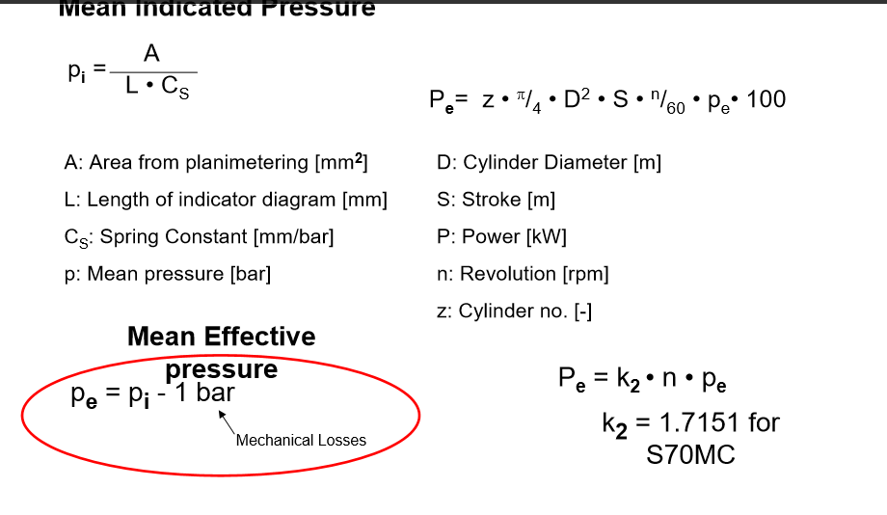
Ballast Water Tank မ်ားကုိ Gravity Filling / Discharging ျပဳလုပ္ျခင္း
+++++++++
ညီညီေထြး (Chief Engineer)
မည္သည့္အမ်ဳိးအစားသေဘၤာမ်ားမွာမဆုိ ကုန္တင္ထားစဥ္ (laden) အေျခအေနမွာ သေဘၤာရဲ့ displacement ေၾကာင့္ ဟန္ခ်က္ (stability) ရရွိနုိင္ေပမဲ့ ကုန္မတင္ထားတဲ့ အေျခအေနမွာေတာ့ သေဘၤာအတြက္လုိအပ္တဲ့ propulsion power ၊ ဟန္ခ်က္ (stability) နဲ႔ ကုိယ္ထည္ပုိင္းဆုိင္ရာမွာ sagging ၊ hogging ဒါဏ္အားမ်ား (Stress) မျဖစ္ေပၚေစဖုိ႔ ballast water tanks (BWT) မ်ားကုိ ေရျဖည့္ျခင္းလုပ္ငန္းမ်ား ေဆာင္ရြက္ထားရေလ့ရွိပါတယ္။ ဒီလုပ္ငန္းကုိ သေဘၤာမ်ားမွာ ေရသြင္းျခင္း (ballasting) နဲ႔ ေရထုတ္ျခင္း (de-ballasting) လုိ႔ေခၚျပီး စံနစ္တက်လုပ္ေဆာင္နုိင္ဖုိ႔ သေဘၤာကုမၸဏီရဲ့ SMS manual ထဲမွာ ballasting ၊ de-ballasting procedures မ်ားကုိလဲ ထည့္သြင္းေဖာ္ျပထားပါတယ္။
အထူးသျဖင့္ bulk carrier သေဘၤာမ်ား နဲ႔ super tanker မ်ားမွာ သေဘၤာအလွ်ားရွည္တဲ့အျပင္ cargo hold မ်ား ၊ cargo tanks မ်ားကလဲ ၾကီးမားၾကတာေၾကာင့္ stability မေကာင္းတဲ့ ကုန္တင္ထားမွဳမ်ဳိးနဲ႔ ကုန္မပါတဲ့အေျခအေနမ်ဳိးမွာ သေဘၤာခါးက်ဳိးနုိင္ဖုိ႔ အလားအလာ အလြန္မ်ားျပားပါတယ္။ ဒါ့ေၾကာင့္ bulk carrier သေဘၤာမ်ား နဲ႔ super tanker မ်ားမွာ ballasting ၊ de-ballasting လုပ္ငန္းစဥ္ဟာ မရွိမျဖစ္ အေရးၾကီးတဲ့ သေဘၤာလုပ္ငန္းဆုိင္ရာကိစၥျဖစ္တဲ့အျပင္ မွန္ကန္တဲ့ ballasting ၊ de-ballasting procedures ဆုိတာ deck department နဲ႔ engine department တုိ႔ရဲ့ ပူးတြဲလုပ္ေဆာင္ရတဲ့ co-operative လဲရွိျပီး team work ေကာင္းရတဲ့ လုပ္ငန္းစဥ္လဲျဖစ္ပါတယ္။
(အျခားေသာ container သေဘၤာမ်ား ၊ Car Carrier မ်ား ၊ General Cargo (G.C) သေဘၤာမ်ား မွာလဲ ballasting ၊ de-ballasting လုပ္ငန္းစဥ္ဟာ အေရးၾကီးလုပ္ငန္းပါပဲ။)
သေဘၤာတစ္စီးမွာ ဟန္ခ်က္ (stability) အေရးၾကီးတာျဖစ္လုိ႔ ballast tanks မ်ားတည္ေဆာက္ထားရာမွာ double bottom tanks (DBT) မ်ားအျဖစ္တည္ေဆာက္ထားရပါတယ္။ ၾကီးမားတဲ့ bulk carrier သေဘၤာမ်ားမွာေတာ့ stability ေကာင္းေကာင္း ကစားနုိင္ဖုိ႔ top side tanks (TST) မ်ားကုိပါ double bottom tanks မ်ားနဲ႔ တြဲရက္ျဖစ္ေစ ၊ double bottom tanks မ်ားရဲ့ အေပၚလုိင္း ၊ Port and Starboard ship’s side ေတြမွာျဖစ္ေစ တည္ေဆာက္ထားၾကရပါတယ္။ ထုိ႔အတူ tanker သေဘၤာမ်ားမွာေတာ့ double hull လုပ္ထားျပီး top side tanks (TST) မ်ားပါ တည္ေဆာက္ထားၾကပါတယ္။ သေဘၤာမ်ားရဲ့ ballasting ၊ de-ballasting procedures အရ မွန္ကန္တဲ့ ballasting ၊ de-ballasting လုပ္ဖုိ႔ ~~
1. Gravity flow နည္း
2. Ballast Pump အသုံးျပဳတဲ႔နည္း နဲ႔
3. Ejector Pump အသုံးျပဳတဲ႔နည္း
တုိ႔ကုိ အစီအစဥ္အတုိင္း လုပ္သြားရတာျဖစ္ပါတယ္။
Gravity flow နည္း
သေဘၤာတစ္စီးဟာ ကုန္မပါပဲ ballast water tanks မ်ားထဲမွာ ballast water မ်ားျဖည့္သြင္းထားျပီး ကုန္တင္ဖုိ႔ ဆိပ္ကမ္းတခုကုိ ေရာက္လာတဲ့အခါမွာ သေဘၤာဟာ ကုန္မရွိတဲ့ အတြက္ ေရစူး (draft) နည္းေနေတာ့ ဆိပ္ကမ္းေရရဲ့ water level ထက္ top side tanks (TST) မ်ား ၊ ballast water tanks မ်ားထဲက ballast water level က ပုိျမင့္ေနပါတယ္။ ဒီအခါမွာ Gravity flow နည္းနဲ႔ ေဖာက္ခ်လုိ႔ ရျပီျဖစ္ပါတယ္။ တခ်ဳိ႕သေဘၤာမ်ားမွာ top side tanks (TST) မ်ားရဲ့ overboard valve ေတြက ေရထဲမွာ နစ္ျမဳပ္မေနေတာ့ပဲ water level အေပၚ ေလထဲမွာ ေပၚေနျပီျဖစ္လုိ႔ top side tanks (TST) မ်ားထဲမွာ ျဖည့္ထား ခဲ့တဲ့ ballast water မ်ားကုိ စက္ပစၥည္းကိရိယာ အကူအညီ ဘာမွမလုိပဲ Gravity flow နည္းနဲ႔ ေဖာက္ခ်လုိ႔ရတာျဖစ္ပါတယ္။ ဒီလုိပဲ ballast water tanks (BWT) မ်ားထဲမွ ballast water ေတြကုိလဲ overboard valve ဖြင့္ျပီး Gravity flow နည္းနဲ႔ ေဖာက္ခ်ဖုိ႔အဆင္ေျပတာျဖစ္ပါတယ္။ Gravity flow နည္းနဲ႔ ေဖါက္ခ်ရတဲ့ overboard valve ေတြကေတာ့ manual butterfly valve ၊ hydraulic operated butterfly valve ၊ electric motor driven butterfly valve စသျဖင့္ အမ်ဳိးအစား မ်ားစြာတပ္ဆင္ထားေလ့ရွိၾကပါတယ္။ (ပံုတြင္ၾကည့္ပါ)
Gravity flow နည္းနဲ႔ေဖာက္ခ်တဲ႔အတြက္ အက်ဳိးေက်းဇူးမ်ားရရွိေစတာကေတာ့ ~~
(က) ballast pump မသုံးတဲ့အတြက္ electrical power သုံးစြဲမွဳ ေလွ်ာ့နည္းတယ္။
(ခ) ကုန္တင္ေနတဲ့ နဳန္းနဲ႔ ညီမွ်တဲ့ de-ballasting လုပ္ငန္းကုိ Gravity flow နည္းနဲ႔ ေကာင္းစြာထိန္းခ်ဳပ္နုိင္တယ္။
(ဂ) ကုန္တင္ေနတဲ့လုပ္ငန္းကုိ de-ballasting လုပ္ငန္းေၾကာင့္ အလုပ္ရွဳပ္မေနေစတဲ့အတြက္ Cargo operation ကုိ အရာရွိေတြက ဖိဖိစီစီး လုပ္နုိင္တယ္။
(ဃ) de-ballasting လုပ္ေနတဲ့ နဳန္းဟာ သေဘၤာရဲ့ stability ကုိထိခုိက္မွဳမရွိေအာင္ ေကာင္းေကာင္း ကစားျပီး ထိန္းခ်ဳပ္ထားလုိ႔ရတယ္။
ဆိပ္ကမ္းေရရဲ့ water level နဲ႔ ballast water tanks (BWT) မ်ားထဲက water level ညီသြားတဲ့အခါမွာေတာ့ Gravity flow နည္းနဲ႔ ေရထုတ္လုိ႔မရေတာ့ပါဘူး။ ဒီအခါမွာ ballast pump အသုံးျပဳျပီး ေရထုတ္ျခင္းလုပ္ငန္း (de-ballasting) ကုိဆက္လက္ ေဆာင္ရြက္ၾကရမွာျဖစ္ပါတယ္။
ကုန္တင္ထားတဲ့သေဘၤာမွာေတာ့ ballast water ျဖည့္သြင္းထားေလ့မရွိသေလာက္ပါပဲ။ ကုန္တင္ထားတဲ့အတြက္ draft က မ်ားေနျပီး ဆိပ္ကမ္းေရရဲ့ water level ေအာက္ကုိ ballast water tanks (BWT) ေတြက ေရာက္ေနေတာ့ သေဘၤာဟာ ဆိပ္ကမ္းေရာက္လုိ႔ ကုန္ခ်ေနခ်ိန္မွာ ballast water tanks (BWT) မ်ားထဲကုိ ပထမဆုံး Gravity flow နည္းနဲ႔ စတင္ေရျဖည့္ရပါ တယ္။ ဒီလုိနဲ႔ ballast water tanks (BWT) ေတြထဲကုိ ေရေတြေရာက္လာျပီး tanks မ်ားထဲက ballast water level နဲ႔ ဆိပ္ကမ္း ေရရဲ့ water level တူညီသြားတဲ့အခါမွာ ေရသြင္းလုိ႔ မရေတာ့ပါဘူး။ ဒီအခါမွာ လုိအပ္လုိ႔ေရထပ္ျဖည့္မယ္ဆုိရင္ ballast pump အသုံးျပဳျပီး ေရသြင္းျခင္းလုပ္ငန္း (ballasting) ကုိဆက္လက္ ေဆာင္ရြက္ၾကရမွာျဖစ္ပါတယ္။ ballast pump အသုံးျပဳျပီး ေရသြင္း ျခင္းလုပ္ငန္း (ballasting) လုပ္ငန္းအေၾကာင္းနဲ႔ ejector pump အသုံးျပဳျပီး stripping လုပ္တဲ့လုပ္ငန္းအေၾကာင္းကုိလည္း ဆက္ျပီးေရးပါအုံးမယ္။
ပုံစားမ်ား။
ပုံ-၁။ Water Head Pressure
ပုံ-၂။ Ballast Tank
ပုံ-၃။ Cargo မပါေသာသေဘၤာတစ္စီး Ballast Tank ထဲတြင္ ေရျဖည့္ထားပုံ။
ပုံ-၄။ Ballast Tank ထဲမွ ေရမ်ားကုိ Gravity Flow နည္းျဖင့္ေရထုတ္ေနပုံ
ပုံ-၅။ Gravity Flow နည္းျဖင့္ေရထုတ္ရန္ Ballast Tank Piping System
Russia Marine Engineering Forumကေနdownloadဆြဲထားတဲ့ Lloyd's Register Rulefinder 2015- Version 9.24ပါ File sizeႀကီးလို႔ Zip Fileနဲ႔တင္ထားေပးပါတယ္ Zip Fileျဖည့္ရင္ Password က mgmg ပါခင္ဗ်ာ
အင္ဂ်င္၏စြမ္းအားစီမံခန္႔ခြဲမွဳစံနဳန္း (Power management standard)
ေၾကာ္ျငာမဟုတ္ရပါ၊အသံုးတည့္မွာပါ၊တစ္လံုးဝယ္လိုက္ပါတယ္။သယ္ရျပဳရလည္းအရမ္းလြယ္ကူပါတယ္။အိမ္မွာလည္းအသံုးတည့္မယ့္ပစၥည္းပါ။အခုဆင္းလာတဲ့သေဘ္ာမွာဘြိဳင္လာsmoke tubeေတြေပါက္တဲ့အေတြ႔အၾကံဳအရကိုယ့္အင္ဒိုfitterရဲ႕အရည္အခ်င္းကိုလည္းမခ်င့္မရဲျဖစ္ရပါတယ္။ကိုယ္ကလည္းprofessionalလိုမေဆာ္တတ္ေတာ့အားမလိုအားမရျဖစ္ရပါတယ္။shore repairမရႏိုင္တဲ့ေနရာမွာျဖစ္ေတာ့ကိုယ္အားကိုယ္ကိုးtemporary repairလုပ္ရပါတယ္။ကိုယ့္လက္ကိုယ္ေသြးဖို႔ရယ္အိမ္မွာလိုတာလုပ္ဖို႔ရယ္စက္တစ္လံုးဝယ္လိုက္ပါတယ္။ အိမ္အေရာက္ပို႔ေပးၿပီးပို႔ခမယူတဲ့ Toe Electric ကိုေက်းဇူးပါ။အလ်ွင္းသင့္ရင္boiler smoke tube temporary repair လုပ္ခဲ့ရတဲ့အေၾကာင္းေလးေရးတင္ပါဦးမယ္ခင္ဗ်ာ။ စကားမစပ္ရန္ကင္းၿမိဳ႕နယ္နဲ႔မနီးမေဝးက welding and lathe machine training center ေကာင္းေကာင္းေလးမ်ားေတြ႔ရင္လည္းလမ္းၫႊန္ေပးၾကပါခင္ဗ်ာ။
Bow Thruster Cntrol System အတြက္ SIEMENS LOGO PLC နဲ႔ေရးထား ဆင္ထားတာပါ။
ေမာ္တာကို VFD နဲ႔ေမာင္းပါတယ္ BT သက္သက္ သီးျခားေမာင္ႏွင္ႏိုင္သလို
မိန္းအင္ဂ်င္၂လံုးရဲ႕ CPP System ကလည္း အလို႐ွိလွ်င္ BT ကို ဝင္ေရာက္ပူးေပါင္းထိန္းခ်ဳပ္ႏိုင္ပါတယ္။
JOY-STICKေလး တစ္ခု ကစားေပးယံုနဲ႔ CPP ရဲ႕လိုအပ္ခ်က္ကို ကြၽန္ေတာ္တို႔ VFD က တိုး/ေလွ်ာ့ ၊ ေ႐ွ႕လည္/ေနာက္လည္ လုပ္ၿပီး ျဖည့္ဆည္းေပးႏိုင္ပါတယ္ခင္ဗ်ာ။

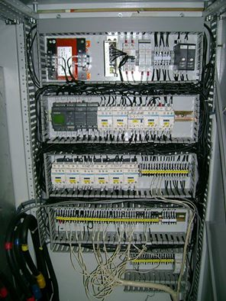
Soft Starter နဲ႔ႏိႈးတဲ့ BT Motor
Starting period မွာ over current နဲ႔ Start fail ျဖစ္ျဖစ္ေနေတာ့ ဆိပ္ကမ္းအကပ္အခြါလုပ္တိုင္း တက္ဘုတ္တစ္စင္း အပိုထပ္ငွါးေနရတယ္တဲ့ခင္ဗ်ာ။
Motor အပိုင္း Thyristors အပိုင္းနဲ႔ Main wire ေတြပံုမွန္ပါပဲ။ PLC လည္း ျပႆနာမ႐ွိပါ။
ဗူးသီးငါးေပါင္းေၾကာ္စာနဲ႔ ေရးထားတဲ့ controller PCB က over current Setting လဲြသိေနတာျဖစ္ပါတယ္။
ခ်ိန္ညႇိလို႔လည္းမရေတာ့တာေၾကာင့္ အပိုပစၥည္းမွာယူဖို႔ မွတ္ခ်က္ျပဳခဲ့ၿပီး က်န္တာေတြအကုန္ေကာင္းေၾကာင္း ျပသဖို႔ current sensing ေပးေနတဲ့ CT ကို ၈ စကၠန္႔ Bypass လုပ္ကာ ႏိႈးၿပီး ယာယီေမာင္းၾကည့္ခဲ့ပါတယ္။
ႏိႈးလို႔ရ ေမာင္းလို႔ရ သံုးလို႔ ဆင္ေျပေပမယ့္ အဲလိုလုပ္ခြင့္မ႐ွိတာမို႔ Bypass လုပ္ေပးတဲ့ Timer ျပန္ျဖဳတ္ကာ အလားတူ လုပ္လိုကလုပ္ဖို႔ေလာက္သာ ေရႊျမန္မာျခင္း အၾကံေပးခဲ့ပါတယ္။

Main Engine မွထုတ္လုပ္ေပးေသာစြမ္းအားကုိ စီမံခန္႔ခြဲျခင္း (Main Engine output power management)
********
ညီညီေထြး (Chief Engineer)
Thermal Load
****
ဆီ ႏွင့္ ေလ တုိ႔ အခ်ဳိးက်ေတြ႔ဆုံ၍ မီးေလာင္ေပါက္ကြဲျခင္းေၾကာင့္ combustion chamber ၏ မ်က္ႏွာျပင္ေပၚသုိ႔ ေရာက္ရွိ လာေသာ combustion heat မွ အပူစြမ္းအင္အစိတ္အပုိင္းအခ်ဳိ႕ကုိ အပူစြမ္းအင္ဆုံးရွဳံးမွဳ (thermal loss) ဟုေခၚ၍ ၎တုိ႔သည္ စက္စၥည္းအစိတ္အပုိင္းမ်ား အထူးသျဖင့္အင္ဂ်င္ဆလင္ဒါမ်ား၏မ်က္ႏွာျပင္ေပၚတြင္ အပူခ်ိန္ျမင့္တက္လာျခင္း မွတဆင့္ အပူေၾကာင့္ျဖစ္ေပၚလာေသာပ်က္စီးမွဳမ်ား (thermal damage) ကုိျဖစ္ေပၚေစပါသည္။ ထုိအခ်က္ေၾကာင့္ combustion chamber ပါတ္၀န္းက်င္တြင္လက္ခံရရွိခဲ့ေသာ fuel တြင္ပါ၀င္ေနသည့္ အပူစြမ္းအင္ပမာဏ (Calorific Value) ကုိ နည္းပညာပုိင္းအရ thermal load ဟု ရည္ညႊန္းရမည္ျဖစ္ပါသည္။
မည္သုိ႔ဆုိေစ M.A.N B&W ၊ Sulzer ၊ Mitsubishi UEC အစရွိေသာ အင္ဂ်င္ထုတ္လုပ္သူအသီးသီးမွ ကုိယ္တုိင္ၾကံဳေတြ႔ခဲ႔ရ ေသာ အေတြ႔အၾကံဳမ်ားအားျဖင့္ အတည္ျပဳေပးနုိင္သည္မွာ Main Engine တစ္လုံး၏ တကယ့္လက္ေတြ႔ေမာင္းႏွင္မွဳတြင္ thermal load သည္ mean effective pressure - Pe ႏွင့္ လုံး၀နီးကပ္စြာ အခ်ဳိးက်လွ်က္ရွိျပီး mean effective pressure - Pe/100% Pe ျဖစ္ေသာ ထုိအခ်ဳိးသည္ thermal load ကုိျပဆုိျခင္းပင္ျဖစ္ပါသည္။
ေအာက္တြင္ေဖာ္ျပထားေသာပုံမွာ အင္ဂ်င္ထုတ္လုပ္သူအသီးသီး၏ load limit ဆုိင္ရာတိက်စြာတုိင္းထြာခ်က္မ်ားမွ 85% Maximum Continuous Rating - MCR ႏွင့္ 90% of thermal load (90% of break mean effective pressure - Pe) တုိ႔၏ဆုံခ်က္ကုိေဖာ္ျပထားေသာ load diagram ျဖစ္ပါသည္။
ေယဘူယ်အားျဖင့္ ဤ load diagram ႏွင့္ load limit ဆုိင္ရာအေၾကာင္းအရာသည္ main engine ကုိ Fixed Pitch Propeller - FPP ႏွင့္ တုိက္ရုိက္ဆက္သြယ္ထားေသာ ပုံမွန္သေဘၤာမ်ားအတြက္ တိက်ေသာအေျခအေနအရပ္ရပ္၌ အင္ဂ်င္ကုိတည္ေဆာက္ထားသည့္ စက္ပစၥည္းအစိတ္အပုိင္းမ်ားရွိ စက္မွဳပုိင္းဆုိင္ရာၾကံ့ခုိင္မွဳ (mechanical strength) ႏွင့္ combustion condition ေပၚသုိ႔သက္ေရာက္ေနသည့္ thermal load တုိ႔ကုိ အေျခခံတြက္ခ်က္ထားျခင္းျဖစ္ျပီး ဒီဇယ္အင္ဂ်င္တစ္လုံး၏အျမင့္ဆုံးထုတ္လုပ္ေပးႏုိင္ေသာ စြမ္းအားအမွတ္ (upper limit of output of a diesel engine) ျဖစ္ပါသည္။ လက္ေတြ႕နယ္ပါယ္တြင္မူ ေမာင္းႏွင္လည္ပါတ္ေနေသာ အခ်က္အလက္မ်ား (operating parameters) အားလုံးတုိ႔ကုိ propeller ႏွင့္ (တနည္းအားျဖင့္ propeller law ႏွင့္) ဆက္စပ္ တြက္ခ်က္ရန္ လုိအပ္ပါသည္။
Fixed Pitch Propeller - FPP တပ္ဆင္ထားေသာသေဘၤာမ်ားအတြက္ ေရစူးမ်ားျခင္း (deeper draft) ၊ ကုိယ္ထည္ပုိင္းခ်ဳိ႕ယြင္း အားနည္းျခင္း (fouled hull) ၊ ကုိယ္ထည္ပုိင္းပ်က္စီးျခင္း (deteriorated hull) ၊ ရာသီဥတုဆုိးရြား ျခင္း (heavier weather) စသည့္ အခ်က္မ်ားေၾကာင့္ သေဘၤာသည္ ပုံမွန္ေမာင္းႏွင္ေနက်အလွ်င္ (speed) ရရွိနုိင္ရန္ သုိ႔မဟုတ္ ပုံမွန္ေမာင္းႏွင္ေနက်အလွ်င္တြင္ အင္ဂ်င္၌လည္ပါတ္ေသာအင္အား (torque) ပုိမုိရရွိရန္အလုိ႔ငွာ အင္ဂ်င္မွစြမ္းအားပုိမုိထုတ္လုပ္ေပးရန္လုိအပ္လာပါသည္။ ထုိအခါ တုိးလာေသာ အင္ဂ်င္လည္ပါတ္အား (torque) သည္ အင္ဂ်င္တပါတ္လည္တုိင္းအတြက္ ဆီပုိ႔လႊတ္မွဳ (fuel injection per revolution) တုိးလာေစျခင္းကုိ ျဖစ္ေပၚေစပါသည္။ ဆီပုိ႔လႊတ္မွဳ (fuel injection per revolution) တုိးလာျခင္းေၾကာင့္ အျခားတဖက္တြင္ အင္ဂ်င္ဆလင္ဒါမ်ား၌ mean effective pressure - Pe တုိးလာျခင္းလည္းျဖစ္ေပၚလာရျပီး “Torque-rich operation” ဟုေခၚပါသည္။ ထုိအခါ ကုိယ္ထည္ပုိင္းတြင္ ခုခံမွဳမ်ားတုိးပြားလာရပါသည္။ ထုိ႔ေၾကာင့္ mean effective pressure အလြန္အကၽြံမ်ားျပားေနျခင္းမွ ေရွာင္လႊဲနုိင္ရန္ႏွင့္ သက္ေရာက္မွဳရွိေနေသာ thermal load မ်ားမွ သက္သာရာ ရေစရန္ အင္ဂ်င္၏ထုတ္လုပ္မွဳစြမ္းအား (output power) ကုိ ေလွ်ာ့ခ်ရပါသည္။ ထုိ႔ေၾကာင့္ အင္ဂ်င္သည္ လုံျခံဳစိတ္ခ်ရေသာ အသုံးခ်မွဳႏွင့္ တပ္ဆင္ထားေသာ စက္ပစၥည္းအစိတ္အပုိင္းအသီးသီးတုိ႔၏ ၾကံ့ခုိင္မွဳမ်ားအတြင္းရွိ rated output ျဖင့္ ေမာင္းႏွင္လည္ပါတ္ေနရျပီး ဤုသုိ႔ ေမာင္းႏွင္လည္ပါတ္ေနျခင္းကုိ maximum limit ဟု မေျပာႏုိင္ပါ။
Engine speed ၊ power output ၊ mean effective pressure ၊ torque ႏွင့္ operating parameters ကဲ့သုိ႔ေသာ အင္ဂ်င္ေမာင္းႏွင္မွဳဆုိင္ရာ အေျခခံအခ်က္မ်ားကုိမူတည္၍ ခ်ိန္ညွိထားျခင္းေၾကာင့္ ခြင့္ျပဳနုိင္ေသာ continuous engine operation အတြင္း၌သာ အင္ဂ်င္၏ operating point ဟု အစဥ္အျမဲ နားလည္သေဘာေပါက္ခဲ့လွ်င္ ထုိ operating point ၏ ျပင္ပအေျခအေနတြင္၎ ၊ ဒီဇုိင္းထုတ္ထားေသာ အေျခအေနတြင္၎ အင္ဂ်င္ေမာင္းႏွင္ျခင္းကုိ ကာကြယ္နုိင္မည္ျဖစ္ပါ သည္။
သုိ႔ေသာ္ သေဘၤာလုပ္ငန္းစီးပြားေရးတြင္ သေဘၤာမ်ားကုိ အတင္းအက်ပ္ ဖိအားေပးကာ ခြင့္ျပဳနုိင္ေသာ continuous engine operation စည္း၏ အျပင္ဖက္တြင္ သေဘၤာေမာင္းႏွင္ေစျခင္းျဖစ္စဥ္မ်ားလဲ (တခါတရံ) ရွိေကာင္းရွိနုိင္မည္ျဖစ္ပါ သည္။ မည္သုိ႔ဆုိေစ ၊ ထုိကဲ့သုိ႔ သေဘၤာမ်ားကုိ အေျခအေနအခ်ိန္အခါအရ ေတာင္းဆုိမွဳမ်ားရွိလာခဲ့သည္ရွိေသာ္ အစဥ္အျမဲ သတိျပဳေနရမည္မွာ operating point ကုိ ဆုတ္ကုိင္ထားျပီး ဆက္စပ္ေနေသာ operating parameters မ်ားကုိ တင္းက်ပ္စြာေစာင့္က်ပ္ ၾကည့္ရွဳျခင္းျဖင့္ main engine output power ကုိ ေကာင္းစြာထိန္းခ်ဳပ္ထားနုိင္ကာ တည္ျငိမ္ေသာ လုပ္ငန္းစြမ္းေဆာင္ရည္လည္းရရွိနုိင္မည့္ အင္ဂ်င္၏စြမ္းအားစီမံခန္႔ခြဲမွဳစံနဳန္းမ်ား (power management standard) ကုိၾကိဳတင္ ေလ့လာသတ္မွတ္ထားျခင္းပင္ျဖစ္ပါသည္။
အင္ဂ်င္၏စြမ္းအားစီမံခန္႔ခြဲမွဳစံနဳန္း (Power management standard)
*****
သေဘၤာကုပၼဏီတုိင္းႏွင့္ အင္ဂ်င္ထုတ္လုပ္သူတုိင္းသည္ အင္ဂ်င္၏စြမ္းအားစီမံခန္႔ခြဲမွဳစံနဳန္း (power management standard) ကုိ ပုံမွန္အားျဖင့္ 85% MCR ႏွင့္ 90% thermal load - Pe တုိ႔ကုိ ဒီဇယ္အင္ဂ်င္တစ္လုံး၏ အျမင့္ဆုံးထုတ္လုပ္ ေပးႏုိင္ေသာ စြမ္းအားအမွတ္ (upper limit of output of a diesel engine) ဟု သတ္မွတ္ပါသည္။ Continuous operation တခုအတြက္ အဆုိပါ အျမင့္ဆုံးအမွတ္တန္ဖိုးကုိ ကုန္က်စရိတ္ေလွ်ာ့ခ်နုိင္မွဳ (economy) ၊ အင္ဂ်င္ၾကံ့ခုိင္ေရး လုပ္ေဆာင္နုိင္မွဳ (maintenance of the engine) ၊ စက္ပစၥည္းအစိတ္အပုိင္းမ်ားရွိ စက္မွဳပုိင္းဆုိင္ရာၾကံ့ခုိင္မွဳ (mechanical strength) ၊ ဘယ္ရင္မ်ား တည္ေဆာက္ပုံ (bearing structure) ၊ combustion chamber အတြင္း mean effective pressure ႏွင့္ scavenging air ရရွိမွဳေၾကာင့္ thermal load ကုိ တားဆီးနုိင္မွဳ စသည့္အခ်က္မ်ားျဖင့္ တြက္ခ်က္ တုိင္းတာနုိင္ပါသည္။
ဒီဇယ္အင္ဂ်င္တစ္လုံး၏ အျမင့္ဆုံးထုတ္လုပ္ ေပးႏုိင္ေသာ စြမ္းအားအမွတ္ (upper limit of output of a diesel engine) အျဖစ္ 85% MCR ႏွင့္ 90% thermal load - Pe တုိ႔ကုိ သတ္မွတ္ထားရျခင္း၏ ရည္ရြယ္ခ်က္မွာ combustion chamber ၏ စက္ပစၥည္းအစိတ္အပုိင္းမ်ားပ်က္စီးျခင္းမွ ကာကြယ္ရန္ႏွင့္ အင္ဂ်င္၏စြမ္းေဆာင္ရည္ထိန္းသိမ္းေပးျခင္းျဖင့္ ကာလ ၾကာရွည္စြာ အသုံးျပဳနုိင္ရန္ျဖစ္ပါသည္။ ထုိရည္မွန္းခ်က္ရွိသည့္အတုိင္း စီးပြားေရးက႑၌ ကုန္က်စရိတ္ေလွ်ာ့ခ်နုိင္မွဳႏွင့္ အင္ဂ်င္ၾကံ့ခုိင္ေရးရွဳေထာင့္မွ ဆလင္ဒါအသီးသီးတြင္ ထြက္ေပၚလာေသာ စြမ္းအားမ်ားတေလွ်ာက္ မညီမွ်မွဳ (imbalance) အနည္းဆုံးနွင့္ စြမ္းေဆာင္ရည္ေကာင္းမြန္မွဳအရွိဆုံးျဖစ္သည့္ မွန္ကန္ေသာ sea margin မ်ား ခ်ိန္ညွိထားသင့္ပါသည္။ ထုိ႔ေၾကာင့္ output power 15% margin ႏွင့္ thermal load 10% margin တုိ႔ကုိ သတ္မွတ္ေပးထားျခင္းျဖစ္ပါသည္။
(ဆက္လက္ေဖာ္ျပပါမည္။)
ရႊင္လန္းပါေစ။
ကုိးကား။
Standard for Diesel Engine Power Management, Mitsui OSK Lines, Tokyo, Japan.
ISO Ref. No.: ISOMRE-SI-00/007, ISM Ref. No.: 2-4001-00009

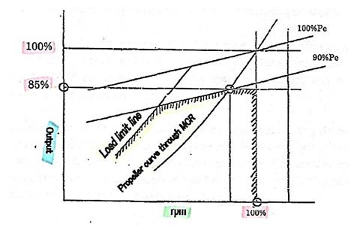

Top of Form

Bottom of Form
******
ညီညီေထြး (Chief Engineer)
Fixed Pitch Propeller - FPP တပ္ဆင္ထားေသာသေဘၤာမ်ားအတြက္ ေရစူးမ်ားျခင္း (deeper draft) ၊ ကုိယ္ထည္ပုိင္း ခ်ဳိ႕ယြင္း အားနည္းျခင္း (fouled hull) ၊ ကုိယ္ထည္ပုိင္းပ်က္စီးျခင္း (deteriorated hull) ၊ ရာသီဥတုဆုိးရြား ျခင္း (heavier weather) စသည့္ အခ်က္မ်ားေၾကာင့္ သေဘၤာသည္ ပုံမွန္ေမာင္းႏွင္ေနက်အလွ်င္ (speed) ရရွိနုိင္ရန္ သုိ႔မဟုတ္ ပုံမွန္ေမာင္းႏွင္ေနက်အလွ်င္တြင္ အင္ဂ်င္၌လည္ပါတ္ေသာအင္အား (torque) ပုိမုိရရွိရန္အလုိ႔ငွာ အင္ဂ်င္မွ စြမ္းအားပုိမုိထုတ္လုပ္ေပးရန္လုိအပ္လာပါသည္။ ထုိအခါ တုိးလာေသာ အင္ဂ်င္လည္ပါတ္အား (torque) သည္ အင္ဂ်င္ တပါတ္လည္တုိင္းအတြက္ ဆီပုိ႔လႊတ္မွဳ (fuel injection per revolution) တုိးလာေစျခင္းကုိ ျဖစ္ေပၚေစပါသည္။ ဆီပုိ႔လႊတ္မွဳ (fuel injection per revolution) တုိးလာျခင္းေၾကာင့္ အျခားတဖက္တြင္ အင္ဂ်င္ဆလင္ဒါမ်ား၌ mean effective pressure - Pe တုိးလာျခင္းလည္းျဖစ္ေပၚလာရျပီး “Torque-rich operation” ဟုေခၚပါသည္။ ထုိအခါ ကုိယ္ထည္ပုိင္းတြင္ ခုခံမွဳမ်ားတုိးပြားလာရပါသည္။ ထုိ႔ေၾကာင့္ mean effective pressure အလြန္အကၽြံမ်ားျပားေနျခင္းမွ ေရွာင္လႊဲနုိင္ရန္ႏွင့္ သက္ေရာက္မွဳရွိေနေသာ thermal load မ်ားမွ သက္သာရာ ရေစရန္ အင္ဂ်င္၏ထုတ္လုပ္မွဳစြမ္းအား (output power) ကုိ ေလွ်ာ့ခ်ရပါသည္။ ထုိ႔ေၾကာင့္ အင္ဂ်င္သည္ လုံျခံဳစိတ္ခ်ရေသာ အသုံးခ်မွဳႏွင့္ တပ္ဆင္ထားေသာ စက္ပစၥည္းအစိတ္အပုိင္းအသီးသီးတုိ႔၏ ၾကံ့ခုိင္မွဳမ်ားအတြင္းရွိ rated output ျဖင့္ ေမာင္းႏွင္လည္ပါတ္ေနရျပီး ဤုသုိ႔ ေမာင္းႏွင္လည္ပါတ္ေနျခင္းကုိ maximum limit ဟု မေျပာႏုိင္ပါ။ ဆုိလုိသည္မွာ သေဘၤာတစီးသည္ သေဘၤာ၏သက္တမ္း ၊ ကုိယ္ထည္ပုိင္းၾကံ့ခုိင္မွဳ ၊ ေရစူး ၊ ရာသီဥတုအေျခအေန ၊ main engine ၾကံ့ခုိင္မွဳႏွင့္စြမ္းေဆာင္ရည္ ၊ propeller ၏ ၾကံ့ခို္င္ မွဳႏွင့္စြမ္းအား စသည္တုိ႔ေပၚမူတည္ကာ တပ္ဆင္ထားေသာ main engine ၏ တမိနစ္လည္ပါတ္နဳန္း (revolution per minutes-rpm) ႏွင့္ စြမ္းအား (output power) တုိ႔ကုိ propeller ႏွင့္ဆက္စပ္၍ main engine ၏အျမင့္ဆုံးထုတ္လုပ္ ေပးႏုိင္ေသာ စြမ္းအားအမွတ္ (upper limit of output of a diesel engine) 85% MCR ႏွင့္ 90% thermal load - Pe ေအာက္ အဆင္ေျပလုိက္ေလွ်ာညီေထြျဖစ္မည့္ လည္ပါတ္နဳန္းႏွင့္ စြမ္းအားတုိ႔ျဖင့္ သေဘၤာကုိ လုိရာခရီးသုိ႔ ေရာက္ရွိနုိင္ရန္ ေမာင္းႏွင္လည္ပါတ္ရျခင္းျဖစ္ျခင္းေၾကာင့္ တကယ့္လက္ေတြ႔တြင္ေမာင္းႏွင္လည္ပါတ္ေနေသာ အေျခအေနကုိ ထုိအင္ဂ်င္အတြက္ operating point ဟု သတ္မွတ္ရမည္ျဖစ္ပါသည္။
သေဘၤာကုပၼဏီတုိင္းႏွင့္ အင္ဂ်င္ထုတ္လုပ္သူတုိင္းသည္ အင္ဂ်င္၏စြမ္းအားစီမံခန္႔ခြဲမွဳစံနဳန္း (power management standard) ကုိ ပုံမွန္အားျဖင့္ 85% MCR ႏွင့္ 90% thermal load - Pe တုိ႔ကုိ ဒီဇယ္အင္ဂ်င္တစ္လုံး၏ အျမင့္ဆုံးထုတ္လုပ္ ေပးႏုိင္ေသာ စြမ္းအားအမွတ္ (upper limit of output of a diesel engine) ဟု သတ္မွတ္ပါသည္။ Continuous operation တခုအတြက္ အဆုိပါ အျမင့္ဆုံးအမွတ္တန္ဖိုးကုိ ကုန္က်စရိတ္ေလွ်ာ့ခ်နုိင္မွဳ (economy) ၊ အင္ဂ်င္ၾကံ့ခုိင္ေရး လုပ္ေဆာင္နုိင္မွဳ (maintenance of the engine) ၊ စက္ပစၥည္းအစိတ္အပုိင္းမ်ားရွိ စက္မွဳပုိင္းဆုိင္ရာ ၾကံ့ခုိင္မွဳ (mechanical strength) ၊ ဘယ္ရင္မ်ား တည္ေဆာက္ပုံ (bearing structure) ၊ combustion chamber အတြင္း mean effective pressure ႏွင့္ scavenging air ရရွိမွဳေၾကာင့္ thermal load ကုိ တားဆီးနုိင္မွဳ စသည့္အခ်က္မ်ားျဖင့္ တြက္ခ်က္ တုိင္းတာနုိင္ပါသည္။
ဒီဇယ္အင္ဂ်င္တစ္လုံး၏ အျမင့္ဆုံးထုတ္လုပ္ ေပးႏုိင္ေသာ စြမ္းအားအမွတ္ (upper limit of output of a diesel engine) အျဖစ္ 85% MCR ႏွင့္ 90% thermal load - Pe တုိ႔ကုိ သတ္မွတ္ထားရျခင္း၏ ရည္ရြယ္ခ်က္မွာ combustion chamber ၏ စက္ပစၥည္းအစိတ္အပုိင္းမ်ားပ်က္စီးျခင္းမွ ကာကြယ္ရန္ႏွင့္ အင္ဂ်င္၏စြမ္းေဆာင္ရည္ထိန္းသိမ္းေပးျခင္းျဖင့္ ကာလ ၾကာရွည္စြာ အသုံးျပဳနုိင္ရန္ျဖစ္ပါသည္။ ထုိရည္မွန္းခ်က္ရွိသည့္အတုိင္း စီးပြားေရးက႑၌ ကုန္က်စရိတ္ေလွ်ာ့ခ် နုိင္မွဳႏွင့္ အင္ဂ်င္ၾကံ့ခုိင္ေရးရွဳေထာင့္မွ ဆလင္ဒါအသီးသီးတြင္ ထြက္ေပၚလာေသာ စြမ္းအားမ်ားတေလွ်ာက္ မညီမွ်မွဳ (imbalance) အနည္းဆုံးနွင့္ စြမ္းေဆာင္ရည္ေကာင္းမြန္မွဳအရွိဆုံးျဖစ္သည့္ မွန္ကန္ေသာ sea margin မ်ား ခ်ိန္ညွိထား သင့္ပါသည္။ ထုိ႔ေၾကာင့္ output power 15% margin ႏွင့္ thermal load 10% margin တုိ႔ကုိ သတ္မွတ္ေပးထားျခင္း ျဖစ္ပါသည္။
သုိ႔ေသာ္ main engine ၏အျမင့္ဆုံးထုတ္လုပ္ ေပးႏုိင္ေသာ စြမ္းအားအမွတ္ (upper limit of output of a diesel engine) 85% MCR ႏွင့္ 90% thermal load – Pe သည္ အင္ဂ်င္ထုတ္လုပ္သူအသီးသီးမွ ေထာက္ခံအတည္ျပဳထားျခင္း ျဖစ္ေသာ္လည္း ေအာက္ပါျပႆနာရပ္မ်ားမွာလက္ေတြ႔အေျခအေနတြင္ မ်ားစြာျဖစ္ပြားလွ်က္ရွိေနသည္ကုိ ေတြ႔ရွိရပါသည္။
1) Thermal load စီမံခန္႔ခြဲမွဳ (Management of thermal load)
2) အင္ဂ်င္စြမ္းအားျမင့္မားလြန္းမွဳ (Higher engine output power)
3) Cylinders မ်ားအခ်င္းခ်င္းအၾကားတြင္ အထြက္စြမ္းအားမညီမွ်မွဳ (Imbalance of output among cylinders)
စသည္တုိ႔ျဖစ္ၾကပါသည္။
1) Thermal load စီမံခန္႔ခြဲမွဳ (Management of thermal load)
*****
အင္ဂ်င္မွထုတ္လုပ္ေပးေသာစြမ္းအား (output power of the engine) ထိန္းခ်ဳပ္ျခင္းကုိ thermal load အတြက္ ေဖာ္ျပခ်က္အညႊန္း (indicator) အျဖစ္ ဆုံးျဖတ္သတ္မွတ္ရန္လုိအပ္ပါသည္။ Main engine ၏ pistons ႏွင့္ liners မ်ားတြင္ ျဖစ္ပြားခဲ့သမွ်ေသာ ျပႆနာအမ်ားအျပားသည္ output power ထိန္းခ်ဳပ္ျခင္းသက္သက္မွထြက္ေပၚလာေသာ ရလဒ္မ်ား ျဖစ္ၾက၍ သေဘၤာမ်ားတြင္ 85% MCR output စည္းမ်ဥ္းကုိထိန္းသိမ္းေဆာင္ရြက္ၾကေသာ္လည္း thermal load အတြက္ ကုိမူ အလြန္အားနည္းေသာေဆာင္ရြက္ခ်က္မ်ားကုိသာျပဳလုပ္ခဲ့ၾကျခင္းျဖစ္ေၾကာင္းေတြ႔ရေလ့ရွိပါသည္။
Propeller ၏တြန္းအားတြင္ ခုခံမွဳတုိးပြားလာျခင္း (an increase propulsive resistance) ေၾကာင့္ အင္ဂ်င္၏ လည္ပါတ္နဳန္းေလွ်ာ့ခ်ရစဥ္ တူညီေသာ output power ရရွိေအာင္ထိန္းခ်ဳပ္ထားနုိင္ရန္ အင္ဂ်င္ တပါတ္လည္တုိင္းအတြက္ ဆီပုိ႔လႊတ္မွဳနဳန္း (fuel feed rate per revolution) တုိးေပးရန္ (increase fuel index) လုိအပ္ပါသည္။ ထုိ႔ေၾကာင့္ combustion chamber ေပၚတြင္ thermal load မ်ား တုိးလာျပီး အျခားတဖက္တြင္လည္း အင္ဂ်င္သည္ torque-rich မ်ားျပားလာျခင္း အေျခအေနသုိ႔ေရာက္ရွိလာရပါသည္။ thermal load မ်ား တုိးပြားလာျခင္းသည္ combustion chamber ၏ အစိတ္အပုိင္းအသီးသီးတြင္ အပူခ်ိန္တုိးပြားလာျခင္းကုိျဖစ္ေပၚေစျပီး အပူေၾကာင့္ပ်က္စီးမွဳမ်ား (thermal damage) ပုိမုိ ျဖစ္ေပၚေစရန္ အခြင့္အလမ္းေကာင္းျဖစ္ေပၚေစကာ အင္ဂ်င္ႏွင့္သက္ဆုိင္ရာအစိတ္အပုိင္းမ်ား၏သက္တမ္းကုိ တုိေတာင္း သြားေစသည့္ ရလဒ္ဆုိးမ်ားျဖစ္ေပၚေစပါေတာ့သည္။
တြက္ခ်က္မွဳရလဒ္မ်ားအရ engine load ႏွင့္ thermal load တုိ႔တြင္ 5% ၀န္းက်င္ကြာျခားခ်က္သည္ thermal load စီမံခန္႔ခြဲမွဳတြင္ အေကာင္းဆုံးအေျခအေနျဖစ္ျပီး 10~12% ၀န္းက်င္ကြာျခားခ်က္သည္ လက္ခံနုိင္ေသာ ကြာျခားခ်က္ ျဖစ္ပါသည္။
2) အင္ဂ်င္စြမ္းအားျမင့္မားလြန္းမွဳ (Higher engine output power)
*****
Main Engine ၏လုိက္ေလွ်ာညီေထြျဖစ္မွဳ ရွဳေထာင့္မွၾကည့္လွ်င္ Alpha lubrication system တပ္ဆင္ထားေသာ ေခတ္မွီသေဘၤာမ်ားတြင္မူ cylinder oil feed rate ကုိ ဆီသုံးစြဲမွဳ (cylinder oil consumption) အနည္းဆုံးႏွင့္ liner တြင္ ပြန္းစားမွဳ (weardown) အနည္းဆုံးျဖစ္ေသာအက်ဳိးျဖစ္ထြန္းမွဳအရွိဆုံး optimum condition ကုိရရွိနုိင္ေသာ္လည္းအင္ဂ်င္ အဟာင္းမ်ားႏွင့္ mechanical lubricator စံနစ္ တပ္ဆင္ထားေသာ သေဘၤာမ်ားတြင္မူ cylinder oil feed rate သည္ သက္တမ္းအုိမင္းမွဳအလုိက္ ၁.၅ ဆ မွ ၂ ဆ ထိ ပုိမုိ ရရွိရန္လုိအပ္ပါသည္။ ထုိအေျခအေနကုိၾကည့္လွ်င္ပင္ အင္ဂ်င္ေဟာင္း မ်ား၌ cylinder oil feed rate ျမင့္မားမွဳကုိေတြ႔ ရွိနုိင္မည္ျဖစ္ျပီး output power မ်ားမ်ားႏွင့္ load diagram ေပၚရွိ 85% MCR output စည္းမ်ဥ္းအနီးသုိ႔ ေရာက္လာေလ piston ႏွင့္ piston rings မ်ားေပၚတြင္ ပုံသ႑န္မမွန္ေသာ ပြန္းစားျခင္း သုိ႔မဟုတ္ က်ဳိးျခင္း စသည့္ ျပႆနာမ်ားသည္၎ ၊ နက္ရွဳိင္းေသာ ပြန္းရာျခစ္ရာမ်ားသည္ liner တြင္၎ ပုိမုိတုိးပြားစြာ ျဖစ္ေပၚလာၾကသည္ကုိေတြ႔ရပါသည္။
ေခတ္မွီအင္ဂ်င္မ်ားကုိေလ့လာၾကည့္လွ်င္ piston rings မ်ားေပၚတြင္ combustion process မွ ဖိအားမ်ားတုိးလာ ျခင္းသည္ ျမင့္မားေသာ Pme ႏွင့္ Pmax တုိ႔ကုိရရွိေစျပီး long stroke မ်ားျဖင့္ထုတ္လုပ္ေပးေသာ pistons speed သည္ လည္း တုိးလာရ၍ cylinder lubrication လုိအပ္ခ်က္သည္လည္း တုိးလာရပါသည္။ ဤျဖစ္စဥ္တြင္ cylinder liner ၊ piston ၊ piston rings စသည္တုိ႔အပါအ၀င္ main engine ႏွင့္ဆက္စပ္ေနေသာ စက္ပစၥည္းအစိတ္အပုိင္းမ်ားအတြက္ သတၱဳႏွင့္ သတၱဳပုံေလာင္းျခင္းနည္းပညာရပ္မ်ား ၊ စက္ပစၥည္းအစိတ္အပုိင္းမ်ား၏ ပုံသ႑န္ႏွင့္ ဒီဇုိင္းပုံစံတုိ႔ကုိ ပုိမုိတုိးတက္ေအာင္ ျပဳျပင္ယူရမည္ျဖစ္ေသာေၾကာင့္ combustion chamber အတြင္းမ်က္ႏွာျပင္ႏွင့္ အစိတ္အပုိင္းမ်ားရွိအပူခ်ိန္ကုိ ပုံမွန္ ေစာင့္ၾကပ္ၾကည့္ရွဳ ထိန္းသိမ္းျခင္းျဖင့္သာ main engine ၏စက္မွဳပုိင္းဆုိင္ရာျပႆနာရပ္မ်ားကုိ ထပ္မံမျဖစ္ေပၚေစရန္ ကာကြယ္တာဆီး နုိင္မည္ျဖစ္ပါသည္။
3) Cylinders မ်ားအခ်င္းခ်င္းအၾကားတြင္ အထြက္စြမ္းအားမညီမွ်မွဳ (Imbalance of output among cylinders)
*****
သမားရုိးက် main engine မ်ားတြင္ fuel injection pump ေပၚရွိ link တပ္ဆင္ထားျခင္းအားျဖင့္ indicator card (power card) မ်ားဆြဲနုိင္သည့္ အတြက္ ဥပမာအားျဖင့္ ေလာင္စာဆီ (fuel oil) ေပးပုိ႔မွဳ မမွန္ျခင္းႏွင့္ ေလာင္စာဆီ (fuel oil) ေပးပုိ႔မွဳ စံနစ္တြင္ျပႆနာမ်ားကာလၾကာရွည္ျဖစ္ပြားေနျခင္းမွတဆင့္ဆလင္ဒါမ်ားကြဲျခင္း စသည့္အျဖစ္အပ်က္မ်ား ေၾကာင့္ ဆလင္ဒါမ်ားၾကားတြင္ စြမ္းအားထုတ္လုပ္မွဳ မညီမွ်ျဖစ္ေနျခင္းမ်ားကုိ အင္ဂ်င္နီယာမွ ခ်က္ျခင္းသိရွိနုိင္ေသာ္လည္း ေခတ္မွီသေဘၤာမ်ားတြင္မူ indicator card (power card) မ်ားကုိမဆြဲနုိင္ေတာ့ပဲ (သေဘၤာပုိင္ရွင္အခ်ဳိ႕တုိ႔မွာ main engine power card မ်ားသာမက သက္ဆုိင္ရာအခ်က္အလက္မ်ားကုိပါ သိရွိနုိင္သည့္ computer စံနစ္သုံး electronic device ကုိ ေထာက္ပ့ံေပးထားေလ့ရွိပါသည္။) Pmax ဆြဲရုံ ၊ draw card ဆြဲ၍ Pcomp ၾကည့္နုိင္ရုံေလာက္သာရွိသည့္အတြက္ ဆလင္ဒါမ်ားၾကားတြင္ စြမ္းအားထုတ္လုပ္မွဳ မညီမွ်ျဖစ္ေနျခင္းမ်ားကုိ အင္ဂ်င္နီယာမွ ခ်က္ျခင္းမသိရွိနုိင္ျခင္း ၊ ထုိအေျခ အေနအတုိင္း ကာလၾကာရွည္ထိန္းသိမ္းထားသကဲ့သုိ႔ျဖစ္ေနရျခင္းမ်ား ျဖစ္ေလ့ရွိၾကပါသည္။
အထက္တြင္ေဖာ္ျပခဲ့ေသာ တခုတည္း သုိ႔မဟုတ္ ေပါင္းစုထားေသာ ျပႆနာအ်မားအျပားသည္ လက္ေတြ႔ အင္ဂ်င္ေမာင္းႏွင္လည္ပါတ္ရာတြင္ေတြ႔ၾကံဳေနရေသာ ျဖစ္ရပ္မ်ားျဖစ္ၾကျပီး အထူးသျဖင့္ေအာက္ပါအေၾကာင္းမ်ားေၾကာင့္ ျဖစ္ရေလ့ရွိေၾကာင္းေတြ႔ရွိရပါသည္။
a) piston rings ႏွင့္ liner တြင္ ပုံသ႑န္မမွန္ေသာ ပြန္းစား တုိက္စားမွဳခံေနရျခင္း။
ဤအေျခအေနကုိ combustion chamber တြင္သက္ေရာက္ေနေသာ thermal load ကုိ တုိင္းတာယူ၍ 85% MCR ၌ Pmax ကုိ 13% ခန္႔ေလွ်ာ့ခ်ေစျပီး jacket cooling water temperature ကုိ 10˚C ခန္႔ ႏွိမ့္ထားျခင္းကဲ့သုိ႔ ယာယီအားျဖင့္ ေလွ်ာ့ခ်နုိင္ေၾကာင္း အင္ဂ်င္ထုတ္လုပ္သူမ်ားမွ ေထာက္ခံအတည္ျပဳေပးထားပါသည္။
b) Cylinder liner မ်က္ႏွာျပင္တြင္ ပြန္းရာျခစ္ရာမ်ားျဖစ္ေပၚမွဳကုိ ျပန္လည္တုန္႔ျပန္ရန္ အင္ဂ်င္၏ ေလာင္စာဆီ (fuel oil) ေပးပုိ႔မွဳစံနစ္ကုိ ပုိမုိေခတ္မွီေအာင္ျပဳျပင္ျခင္း။
MCR ၌ shop trial ျပဳလုပ္စဥ္ piston crown အတြင္းရွိ piston cooling oil ေပးပုိ႔ရာ အေခါင္းေပါက္မ်ား အပူခ်ိန္ သည္ 270˚C ခန္႔ရွိ၍ ၎သည္ lubricating oil ၏အပူဆုိင္ရာတည္ျငိမ္မွဳအမွတ္အထက္သုိ႔ေရာက္ရွိေနျပီး မွတ္ တမ္းမ်ားအရ NCR တြင္မူသင့္တင့္ေသာအဆင့္အတြင္းရရွိေၾကာင္းေတြ႔ရပါသည္။ သုိ႔ရာတြင္ NCR ႏွင့္တကယ့္ လက္ေတြ႔ေမာင္းႏွင္မွဳတြင္ အင္ဂ်င္သက္တမ္းၾကာျမင့္မွဳ ၊ ေလာင္စာဆီအရည္အေသြးညံ့ဖ်င္းမွဳ သုိ႔မဟုတ္ ေလာင္စာဆီေပးသြင္းမွဳစံနစ္ (fuel injection system) ခ်ဳိ႕ယြင္းမွဳ စသည့္ သီးျခားအခ်က္အလက္မ်ားစြာေၾကာင့္ အဆုိပါအပူခ်ိန္သည္ shop trial MCR အဆင့္နီးပါးထိ ေရာက္လာေၾကာင္းေတြ႔ရွိရပါသည္။ အက်ဳိးဆက္အေနျဖင့္ piston crown အတြင္းရွိ piston cooling ေပးသြင္းရာ အေခါင္းေပါက္မ်ားတြင္ ေခ်ာဆီဂ်ဳိးမ်ား (scale of lube oil) ၾကီးမားစြာတြယ္ကပ္၍ high temperature corrosion မ်ား ၊ သတ္မွတ္ထားေသာ piston cooling oil temperature မရရွိျခင္းမ်ား ႏွင့္ piston crown ကြဲျခင္းမ်ား စသည္တုိ႔ ျဖစ္ေပၚလာေလ့ရွိပါသည္။
c) Shore power plant မ်ားရွိ generator engine မ်ားတြင္ 90% MCR သုိ႔မဟုတ္ ထုိ႔ထက္ပုိ၍ ေမာင္းႏွင္လည္ ပါတ္ရန္ ဖိအားေပးလာေသာ အေျခအေနတခုတြင္ ေလ့လာခ်က္အရ စတင္ေမာင္းႏွင္ခ်ိန္မွ နာရီ 3000 မွ 4000 အၾကာတြင္ liners မ်ား၌ ခပ္ၾကမ္းၾကမ္း ပြန္းစားမွဳမ်ားျဖစ္ေပၚလာေၾကာင္းေတြ႔ရွိရပါသည္။ အေၾကာင္းမွာ carbon deposits မ်ား piston crown ေပၚတြင္ စုပုံလာျခင္းေၾကာင့္ျဖစ္ေၾကာင္းႏွင့္ overhaul လုပ္ရန္ ျဖဳတ္ခ်လုိက္သည့္ အခါတြင္ top piston ring ႏွင့္ second piston rings တုိ႔တြင္ overheating လကၡဏာမ်ားကုိေတြ႔ရပါသည္။
d) Temperature record မ်ားအရ အင္ဂ်င္၏ဆလင္ဒါသည္ ပြန္းစားတုိက္စားမွဳအခ်ဳိ႕ကုိခံရေလ့ရွိျပီး top piston ring သည္ TDC သုိ႔ ေရာက္ရွိေသာအခါ ဆလင္ဒါ မ်က္ႏွာျပင္ေပၚရွိအျမင့္ဆုံးအပူခ်ိန္သည္ 260˚C ရွိ၍ ၎သည္ အလြန္ဆုိးရြားျပင္းထန္ေသာ cylinder oil အေျခအေနမ်ားကုိလည္းေဖာ္ျပေနျခင္းျဖစ္ကာ ေခ်ာဆီ (lubricant) ၏ စြမ္းေဆာင္နုိင္ရည္ကုိ ဂရုစုိက္ကုိင္တြယ္ ထိန္းသိမ္းေပးရမည္ျဖစ္ပါသည္။
ရႊင္လန္းပါေစ။
ကုိးကား။
Standard for Diesel Engine Power Management, Mitsui OSK Lines, Tokyo, Japan.
ISO Ref. No.: ISOMRE-SI-00/007, ISM Ref. No.: 2-4001-00009

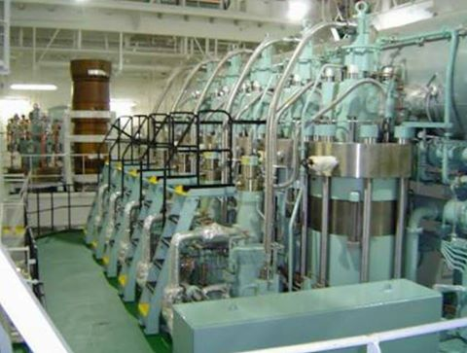

Top of Form
Bottom of Form

IN standard conventional
safety valves ေတြနဲ႔၊ ASME standard
conventional safety valves ေတြမွာ၊
ထည္႔သြင္းတတ္ဆင္ထားတဲ႔၊
principal elements ေတြ၊ တူညီေပမယ္႔၊
design ပိုင္းအရ၊ အနည္းငယ္၊ ကြဲလြဲမွဳ၊
ရိွတာကိုလည္းေတြ႔ရပါတယ္။
.
DIN standard valve ေတြရဲ႕၊
design ဟာ၊ ရိုးရွင္းၿပီး၊ fixed skirt သို႔မဟုတ္၊
hood လို႔ေခါါတဲ႔၊ ပံုသ႑န္မၽိဳး၊
တည္ေဆာက္ထားပါတယ္။
.
ASME Standard valves ေတြရဲ႕၊
design ကေတာ႔၊ အနည္းငယ္ရွဳပ္ေထြးၿပီး၊
adjustable blow-down ring နဲ႔၊
fine-tune adjustable blow-down rings ေတြကို၊ ထည္႔သြင္း တတ္ဆင္ထားပါတယ္။
.
blow-down value အတိအကၽရရိွေစရန္၊
adjustable blow-down ring ထည္႔သြင္း၊
တတ္ဆင္ထားၿခင္းၿဖစ္သလို၊
over pressure ကို၊ အတိအကၽ၊
တိုင္းတာနိဳင္ရန္၊ fine-tune adjustable blow-down rings တတ္ဆင္ထားၿခင္းလည္း၊ ၿဖစ္ပါတယ္။
.
orifice area ရဲ႕၊ ပမာဏဟာ၊ valve ရဲ႕၊
inlet နဲ႔ outlet connection အရြယ္အစား၊
valve center line dimension နဲ႔၊
face dimensions အရြယ္အစားတို႔အေပါါ၊
မူတည္ပါတယ္။
.
European origin conventional
safety valves ေတြမွာ၊ valve ေတြရဲ႕၊
nominal size ၿခင္း၊ တူညီႀကေပမယ္႔၊
dimensions ေတြ၊ ကြဲၿပားမွဳေႀကာင္႔၊
orifice area ေတြ၊ မတူညီတာကိုေတြ႔ရပါတယ္။
valve body မွာ၊ ေရးသားေဖာ္ၿပထားတဲ႔၊
သေက္တကိုဖတ္ၿပီး inlet နဲ႔ out let ကို၊
အတိအကၽေၿပာနိဳင္ေပမယ္႔၊
orifice size ကိုေတာ႔၊ အတိအကၽ၊
ေၿပာဆိုနိဳင္ရန္၊ ခက္ခဲပါတယ္။
.
ASME standard conventional
safety valves ေတြမွာေတာ႔၊
center line to face dimensions ေတြနဲ႔၊
orifice sizes ေတြကို၊ API Recommended
Practice - 526 အရ၊ သတ္မွတ္ထားတဲ႔အတိုင္း၊
အတိအကၽ၊ ထုတ္လုပ္ထားတာ၊ ေတြ႔ရပါတယ္။
ဥပမာ 2 J 3 ရယ္လို႔၊ valve body မွာ၊
ေရးသားထားလွၽင္၊ inlet ဟာ 2",
orifice ဟာ၊ standard 'J' size နဲ႔၊
outlet ဟာ၊ 3" ဆိုၿပီး၊ အလြယ္တကူ၊
သိနိဳင္ပါတယ္။
.
safety valves အမၽိဳးအစားေတြ၊
ကြဲၿပားႀကေပမယ္႔၊ basic operation အေနနဲ႔ကေတာ၊႔ "Lifting" နဲ႔၊ "Re-seating" ဆိုၿပီး၊ (၂) မၽိဳးသာ၊ ရိွပါတယ္။
.
"Lifting" - inlet static pressure ၿမင္႔တက္လာၿပီး၊ safety valve ရဲ႕၊ set pressure ပမာဏအထက္သို႔၊ ေရာက္ရိွလာတဲ႔အခါ၊ seat ေပါါမွ disc ဟာ၊ 'ႀကြ' လာသလို၊ အေပါါမွ၊ ဖိထားတဲ႔၊ spring compression force လည္း
increase အေနနဲ႔၊ 'ၿမင္႔' တက္လာပါတယ္။
.
inlet static pressure ၊ ဆက္ၿပီး၊ 'ၿမင္႔' တက္မွသာ၊ disc ကို၊ lift အေနနဲ႔၊ 'အေပါါ' သို႔၊ တြန္းတင္ၿပီး၊ fluid ဟာ၊ significant flow အၿဖစ္၊ valve မွ၊ ထြက္သြားနိဳင္မွာၿဖစ္ပါတယ္။ တနည္းအားၿဖင္႔၊ additional pressure အေနနဲ႔၊ ထပ္တိုးရန္၊ လိုအပ္ၿပီး၊ valve ဟာ၊ rated capacity အရ၊ discharge ၿပဳလုပ္မွာၿဖစ္ပါတယ္။
additional pressure ကို၊ over-pressure လို႔၊
ေခါါပါတယ္။
.
particular application ေတြအရ၊
over-pressure ကို၊ compressed air နဲ႔၊
steam အပါအဝင္၊ compressible fluids
media ေတြအတြက္၊ ( 3 % ~ 10 % ) နဲ႔၊
in-compressible liquids media ေတြအတြက္၊
( 10 % ~ 25 % ) သတ္မွတ္ထားပါတယ္။
.
ေသးငယ္တဲ႔ small over-pressure ပမာဏေႀကာင္႔၊ valve ဟာ၊ full opening force နဲ႔အတူ၊ rapid opening action ကိုပါ၊ ေဆာင္ရြက္ေစရန္၊ disc arrangement အေပါါ၊ မူတည္ေနပါတယ္။ shroud တနည္းအားၿဖင္႔၊ control chamber သို႔မဟုတ္၊
huddling chamber, skirt တို႔နဲ႔၊ disc ရဲ႕၊
arrangement ဟာ၊ အေရးႀကီးပါတယ္။
.
Fig. (1) မွာ၊ Typical disc and shroud arrangement used on rapid opening safety valve ဆိုၿပီး၊ ဥပမာအၿဖစ္၊ ေဖာ္ၿပထားပါတယ္။
.
valve ရဲ႕၊ chamber အတြင္းရိွ၊ fluid media ရဲ႕၊
pressure ဟာ၊ shroud ကဲ႔သို႔၊
exposed area အေပါါ၊ တိုက္ရိုက္၊
သက္ေရာက္ေနပါတယ္။
.
(F = P x A) ဆိုတဲ႔၊ ပံုေသနည္းအရ၊ fluid ရဲ႕၊
pressure (P) ဟာ၊ တိုက္ရိုက္၊ ထိေတြ႔ေနတဲ႔၊
exposed area (A) အေပါါမူတည္ၿပီး၊
lifting force (F) အၿဖစ္၊ proportionally
တိုက္ရိုက္အခၽိဳးနဲ႔၊ ၿမင္႔တက္လာပါတယ္။
.
safety valve 'ပြင္႔' သြားေစမယ္႔၊
opening force အၿဖစ္၊
incremental increase အေနနဲ႔၊
တိုိိးသထက္၊ တိုးလာတာလည္း၊ ၿဖစ္ပါတယ္။
.
အဲဒီအခၽိန္မွာ၊ အေပါါမွ၊ 'ဖိ' ထားတဲ႔၊
spring compression force ဟာလည္း၊
'ၿမင္႔' တက္လာပါတယ္။ ေအာက္မွ 'တြန္း' ေနတဲ႔၊
opening force ဟာ၊ အေပါါမွ၊ 'ဖိ' ထားတဲ႔၊
spring compression force ထက္၊ 'ပို' သြားတဲ႔အခါ၊ disc ဟာ၊ rapid opening action ၿဖင္႔၊ ရုတ္တရက္၊ 'ပြင္႔' သြားပါေတာ႔တယ္။
.
တခၽိန္တည္းမွာပဲ၊ shroud ဟာ၊ fluid flow ကို၊
reverses direction ၿဖင္႔၊ reaction force တခု၊
ၿဖစ္ေပါါလာေစၿပီး၊ opening force သို႔မဟုတ္၊
lift အား၊ enhance အေနနဲ႔၊ ထပ္မံတိုးၿမင္႔လိုက္ပါတယ္။
.
incremental increase opening force နဲ႔၊
shroud ေႀကာင္႔ရရိွလာတဲ႔ reaction force (၂) ခုေပါင္း၊ ပမာဏေႀကာင္႔၊ ေသးငယ္တဲ႔ over pressure limit မွာ၊ designed lift ကို၊ ရရိွလာပါတယ္။
.
Fig. (2) မွာ၊ Opening force and Shroud's
reverse direction reaction force ဆိုၿပီး၊
ဥပမာအၿဖစ္၊ ေဖာ္ၿပထားပါတယ္။
.
compressible fluid media ေတြရဲ႕၊ ရုတ္တရက္၊
ရုန္းကန္ထြက္နိဳင္တဲ႔ rapid expansion ဆိုင္ရာ၊
ရုပ္ဂုဏ္သတၱိေႀကာင္႔၊ lower pressure area အေပါါ၊ ကၽေရာက္ေနတဲ႔၊ fluid volume ပမာဏ၊
ႀကီးမားလာတဲ႔အခါ၊ rapid action ရရိွတာလည္း၊
ၿဖစ္ပါတယ္။
.
in-compressible liquid media ေတြမွာေတာ႔၊
တၿဖည္းၿဖည္း၊ ၿမင္႔တက္လာမယ္႔၊
proportional increase နံွဳးဟာ၊
ေနွးေကြးတဲ႔အတြက္၊ over-pressure limit ၊
ပိုမိုမၽားၿပားပါတယ္။
.
"Re-seating" - pressure ဟာ၊ ပံုမွန္၊
normal operating conditions သို႔၊
ေရာက္သြားတာနဲ႔၊ valve လည္း၊ ၿပန္လည္၊
'ပိတ္' သြားရမွာ၊ ၿဖစ္ပါတယ္။ ဒါေပမယ္႔၊ valve ရဲ႕၊
disc area နဲ႔၊ fluid media တို႔၊ တိုက္ရိုက္၊
ထိေတြ႔ေနေသးတဲ႔အတြက္၊ နဂိုမူလ၊
original set pressure ရဲ႕၊ ေအာက္ပမာဏသို႔၊
ေရာက္ရိွမွသာ၊ valve disc ဟာ၊ seat အေပါါ၊
ၿပန္ 'ထိုင္' မွာ၊ ၿဖစ္ပါတယ္။
.
valve disc ၿပန္ 'ထိုင္' မယ္႔၊ original set pressure ရဲ႕၊ ေအာက္ပမာဏ၊ အမွတ္ကို၊ re-seating pressure လို႔၊ ေခါါပါတယ္။
.
set pressure နဲ႔ re-seating pressure တို႔အႀကား၊ valve disc ဟာ၊ seat အေပါါ၊ မ 'ထိုင္' ေသးတဲ႔၊ အေၿခအေနကို၊ 'blow-down' condition အၿဖစ္၊ သတ္မွတ္ပါတယ္။ တနည္းအားၿဖင္႔ set pressure နဲ႔၊
re-seating pressure တို႔ၿခားနားခၽက္ဟာ၊
'blow-down' pressure လည္း၊ ၿဖစ္ပါတယ္။
.
Fig. (3) မွာ၊ Relationship between
pressure and lift for a typical safety valve ဆိုၿပီး၊ ဥပမာအၿဖစ္၊ ေဖာ္ၿပထားပါတယ္။
.
'blow-down' pressure ကို၊ set pressure ၿဖင္႔၊
နိွဳင္းယွဥ္ေဖာ္ၿပပါတယ္။ compressible fluids ေတြရဲ႕၊ 'blow-down' pressure ဟာ၊ set pressure ရဲ႕၊ ( 10 %) ပမာဏခန္႔ရိွၿပီး၊ in-compressible liquids ေတြရဲ႕၊ 'blow-down' pressure ကေတာ႔၊ set pressure ရဲ႕၊ ( 20 %) ပမာဏခန္႔၊ ရိွပါတယ္။
.
blow-down pressure ဟာ၊ potentially hazardous situation သို႔၊ ေရာက္ရိွလာတဲ႔အခါ၊ shroud မွာ၊ rapid opening နဲ႔၊ small blow-down action တို႔၊
ၿဖစ္ေပါါလာပါတယ္။ တနည္းအားၿဖင္႔၊
over-pressure ကို၊ အၿမန္ဆံုးေလၽွာ႔ခၽေပးၿခင္း၊
excessive quantities pressure ကို၊
pressurized vessel အတြင္း၊ ထိမ္းသိမ္းေပးထားၿခင္းနဲ႔၊
valve disc ရုတ္တရက္၊ ၿပန္ 'ႀကြ' ကာ၊
lift ထပ္မံ၊ မၿဖစ္ေပါါေစရန္၊ ထိမ္းသိမ္းေပးထားၿခင္းတို႔ကို၊
ေဆာင္ရြက္ေပးၿခင္းလည္း၊ ၿဖစ္ပါတယ္။
.
ASME Standard safety valves ေတြမွာ၊
over-pressure နဲ႔ blow-down
requirements တို႔အတြက္၊
lower blow-down (nozzle) ring ကို၊ မရိွမၿဖစ္၊ ထည္႔သြင္းတတ္ဆင္ထားပါတယ္။
upper blow down ring ကေတာ႔၊
huddling chamber အတြက္ၿဖစ္ၿပီး၊
factory set ၿဖင္႔၊ ႀကိဳတင္၊ ခၽိန္ညိွထားပါတယ္။
.
Fig. (4) မွာ၊ Blow-down rings on an ASME type safety valve ဆိုၿပီး၊ ဥပမာအၿဖစ္၊ ေဖာ္ၿပထားပါတယ္။
.
lower blow-down ring ဟာ၊ appropriate code
performance requirements ေတြအရ၊
ႀကိဳတင္၊ ခၽိန္ညိွထားတဲ႔၊ factory set ၿဖစ္ေပမယ္႔၊
လိုအပ္သလို၊ ထပ္မံကာ၊ adjust အေနနဲ႔၊
ၿပဳလုပ္နိဳင္ပါတယ္။
.
lower blow-down ring ကို၊ top position အထိ၊
ထပ္မံကာ၊ adjust အေနနဲ႔၊ ခၽိန္ညိွႀကည္႔လၽွင္၊
huddling chamber area အရြယ္အစား၊
ႀကီးမားသြားတဲ႔အတြက္၊ over-pressure value အား၊ minimizing value အထိ၊ ရရိွနိဳင္သလို၊
valve disc ၿပန္ 'ထိုင္' ရန္၊ အခၽိန္အတိုင္းအတာ၊ ပို 'ႀကာ' တာကိုလည္း၊ ေတြ႔ရပါတယ္။
.
တခါ lower blow-down ring ကို၊
lower position အေနနဲ႔၊ adjust ၿပဳလုပ္ႀကည္႔လၽွင္၊
over-pressure value ပမာဏကို၊
တိုးၿမင္႔နိဳင္ၿပီး၊ blow-down value အား၊
ေလၽွာ႔ခၽနိဳင္ပါတယ္။ Fig. (5) မွာ၊
boiler နဲ႔ pressure vessel ေတြအတြက္၊
အသံုးမၽားတဲ႔ safety valve standard အခၽိဳ႕ကို၊
ေဖာ္ၿပထားပါတယ္။
(WIN MART Eletrical control ၏ post ကုိမ်ွေဝျခင္းပါ
မူရင္းpost ပုိင္႐ွင္ကုိcreditေပးပါသည္ခမ်ာ)
Star - Delta ေျပာင္းဖို႕ delay timer ကို ဘယ္ႏွစ္ စကၠန္႕ေလာက္ထားရင္ သင့္ေတာ္မလဲဲ ?
ေရနံတင္သေဘ္ာေတြဟာ၊ ဟိုက္ဒရိုကာဘြန္ကုိ၊
အေၿခခံထားတဲ႔ ေရနံစိမ္း crude oil မွ၊
octane spirits ေတြၿဖစ္တဲ႔၊ ေရနံထြက္ပစၥည္း petroleum products ေတြအထိ၊
သယ္ေဆာင္ၿပီး၊ တေနရာမွ၊ အၿခား တေနရာသို႔၊
ပို႔ေဆာင္ေပးႀကပါတယ္။
.
ၿပင္ပေလထုအတြင္းမွ၊ ေအာက္စီဂၽင္ဓါတ္ေငြ႔နဲ႔၊ ဟိုက္ဒရိုကာဘြန္ဓါတ္ေငြ႔ေတြ၊ ေပါင္းစပ္သြားရာမွ၊
အလိုအေလၽွာက္ မီးေလာင္ေပါက္ကြဲမွဳ၊
explosion ၿဖစ္ေပါါတတ္ပါတယ္။
.
မီးေလာင္ေပါက္ကြဲေစတတ္တဲ႔၊
ဟိုက္ဒရိုကာဘြန္ အေၿခခံ၊ ေရနံနဲ႔၊
ေရနံထြက္ပစၥည္း petroleum products ေတြကို၊
ေရနံတင္သေဘ္ာရဲ႕ tanks ေတြ၊ အတြင္းသို႔၊
ေပးသြင္းၿခင္း၊ သိုေလွာင္ၿခင္း၊ ၿဖန္႔ၿဖဴးၿခင္း၊
ကိစၥေတြမွာ၊ သတိထားေဆာင္ရြက္ရန္၊
လိုအပ္ပါတယ္။
.
ေရနံတင္သေဘ္ာရဲ႕၊ cargo tanks ေတြအတြင္း၊ မီးေလာင္ေပါက္ကြဲေစတတ္တဲ႔၊
ေအာက္စီဂၽင္ဓါတ္ေငြ႔နဲ႔ ဟိုက္ဒရိုကာဘြန္ဓါတ္ေငြ႔ေတြ၊
ရိွေနၿပီး၊ flammable range ဆိုတဲ႔၊
ေအာက္စီဂၽင္ဓါတ္ေငြ႔နဲ႔ ဟိုက္ဒရိုကာဘြန္ဓါတ္ေငြ႔ေတြရဲ႕၊
ပါဝင္မွဳ အခၽိဳးအစားၿဖင္႔၊ သတ္မွတ္ပါတယ္။
.
ဒါေပမယ္႔ cargo tanks ေတြအတြင္းမွ၊
ဟိုက္ဒရိုကာဘြန္ဓါတ္ေငြ႔ ပါဝင္မွဳအခၽိဳးအစားဟာ၊
အနည္းဆံုး minimum ပမာဏေအာက္မွာသာ၊
ရိွေနခဲ႔လၽွင္၊ ၿပင္ပေလထုအတြင္းမွ၊
ေအာက္စီဂၽင္ဓါတ္ေငြ႔နဲ႔ ေပါင္းစပ္တဲ႔အခါ၊
မီးေလာင္ေပါက္ကြဲမွဳ၊ မၿဖစ္ေပါါနိဳင္သလို၊
အမၽားဆံုး maximum ပမာဏအထက္မွာ၊
ရိွေနခဲ႔လၽွင္လည္း၊ မီးမေလာင္နိဳင္တာေတြ႔ရၿပီး၊
'lower flammable limit' နဲ႔၊
'upper flammable limit' ရယ္လို႔ ေခါါဆိုႀကပါတယ္။
.
flammable limit န႔ဲ upper flammable limit ေတြကို၊ ေယဘုယၽအားၿဖင္႔ (၁) % မွ (၁၀) % အတြင္း၊ သတ္မွတ္ႀကပါတယ္။ Fig. (1) မွာ၊ ဥပမာအၿဖစ္၊ Flammable Triangle ကို၊ ေဖာ္ၿပထားပါတယ္။
.
graph ရဲ႕၊ ညာဖက္ line "AB" ဟာ၊ tank ထဲမွာ၊
ရိွေနမယ္႔၊ ေအာက္စီဂၽင္ဓါတ္ေငြ႔၊ ပါဝင္မွဳရာခိုင္နွံဳးနဲ႔၊ ဟိုက္ဒရိုကာဘြန္ဓါတ္ေငြ႔ ပါဝင္မွဳရာခိုင္နံွဳးတို႔ရဲ႕၊ ဆက္စပ္မွဳၿဖစ္ပါတယ္။ အမဲေရာင္ triangle ရဲ႕ ညာဖက္မွာရိွေနတဲ႔ အပိုင္းကို၊ "deadly triangle" လို႔၊ ေခါါပါတယ္။
.
အမွတ္ "A" အစၿပဳတ႔ဲ ညာဖက္မွ၊ ေဒါင္လိုက္လိုင္းကို၊
ႀကည္႔လၽွင္၊ "C" နဲ႔ "D" ဆိုတဲ႔ lower flammable
limit နဲ႔၊ upper flammable limit အမွတ္ေတြကို၊
ေတြ႔ရမွာ၊ ၿဖစ္ပါတယ္။ အမွတ္ "C" နဲ႔ "D" အႀကား၊
ေနရာကေတာ႔၊ 'flammable range' ၿဖစ္ပါတယ္။
.
အမွတ္ "C" ရဲ႕ေအာက္ဖက္ဟာ၊ 'lower flammable range' ၿဖစ္ၿပီး၊ အမွတ္ "D" ရဲ႕အထက္ကေတာ႔၊ 'upper flammable range' ၿဖစ္ပါတယ္။
.
inert gas ကို၊ cargo tank အတြင္းသု႔ိ၊
ေပးသြင္းၿခင္း၊ ေလၽွာ႔ထုတ္ၿခင္းတို႔ၿဖင္႔၊
tank ရဲ႕၊ atmosphere အတြင္းမွ၊
flammable range ကို၊ အတိုးအေလၽွာ႔၊
ၿပဳလုပ္နိုင္ပါတယ္။ inert gas ဟာ၊
ေအာက္စီဂၽင္ပါဝင္မွဳပမာဏ၊ ေလၽွာ႔ခၽထားတဲ႔၊
"flue gas" ၿဖစ္ပါတယ္။
.
ေရနံတင္သေဘ္ာေတြမွာ၊ inert gas ကို၊
boiler သို႔မဟုတ္ gas turbine ေတြ လည္ပတ္ရာမွ၊ ထြက္ရိွလာတဲ႔ exhaust gas ေတြမွတဆင္႔၊ ထုတ္ယူပါတယ္။ ဒါ႔အၿပင္ သီးၿခား၊ inert gas generator ေတြ၊ တတ္ဆင္ၿပီး၊
ထုတ္ယူနိုင္ပါတယ္။
.
"inert gas" ကို၊ ေရနံတင္သေဘ္ာရဲ႕၊
cargo tank အတြင္း၊ ၿဖည္႔သြင္းလိုက္တဲ႔အခါ၊
inert gas ပမာဏ၊ ၿမင္႔တက္လာသည္နွင္႔အမၽွ၊
flammable range လည္း၊ ကၽဆင္းသြားပါတယ္။
.
graph မွာ၊ lower flammable range ရဲ႕၊
limit "C" အမွတ္ဟာ၊ "E" ဆိုတဲ႔ အမွတ္အထိ၊
ကၽဆင္းသြားသလို၊ upper Lower flammable
range ရဲ႕၊ limit "D" အမွတ္ဟာလည္း၊
"E" ဆိုတဲ႔အမွတ္အထိ၊ ကၽဆင္းသြားတာ၊
ေတြ႔ရမွာၿဖစ္ပါတယ္။
.
AF", "AG", "AE" နဲ႔ "FH" အစရိွတဲ႔၊
line ေတြကေတာ႔၊ inert gas ေပးသြင္းတဲ႔အခါ၊
ဟိုက္ဒရိုကာဘြန္၊ ပါဝင္မွဳပမာဏ ၿမင္႔တက္လာၿခင္းနဲ႔၊
ကၽဆင္းသြားၿခင္း၊ အေၿခအေနေတြကို၊
ေဖာ္ၿပထား႔တာၿဖစ္ပါတယ္။
.
inert gas ကို၊ 'ေပးသြင္း' ၿခင္းၿဖင္႔၊
cargo tank အတြင္းမွ၊ ဓါတ္ေငြ႔ေတြရဲ႕၊
အခၽိဳးအဆဟာ၊ "F" အမွတ္မွာ၊ ရိွေနခဲ႔လၽွင္၊
ေဘးအနၱရာယ္အကင္းအရွင္းဆံုး၊
အေၿခအေနအၿဖစ္၊ သတ္မွတ္နိဳင္ပါတယ္။
.
အကယ္၍ inert gas ကို၊ cargo tank အတြင္းမွ၊
'ေလၽွာ႔ထုတ္' လိုက္လၽွင္၊ "FA" ဆိုတဲ႔ line ဟာ၊
"A" အမွတ္သို႔၊ 'ကၽဆင္း' သြားမွာၿဖစ္ၿပီး၊
မီးေလာင္ေပါက္ကြဲမွဳ၊ အနၱရာယ္နဲ႔လည္း၊
နီးကပ္လာနိုင္ပါတယ္။
.
graph မွ၊ အမဲေရာင္ triangle ရဲ႕၊
ဘယ္ဘက္ အစိတ္အပိုင္းကို၊ မၿဖတ္သန္းေစပဲ၊
"F" အမွတ္မွတဆင္႔ "H" အမွတ္ကိုသာ၊
ၿဖတ္သန္းကာ၊ inert gas ေလၽွာ႔ထုတ္ၿခင္းၿဖင္႔၊
မီးေလာင္ေပါက္ကြဲမဳွအနၱရာယ္မွ၊
ကင္းေဝးေစမွာ၊ ၿဖစ္ပါတယ္။
.
cargo tank အတြင္းရိွ၊ atmosphere မွာ၊
positive pressure ရရိွေစရန္၊
inert gas ၿဖည္႔သြင္းၿခင္းကိုေတာ႔၊
'topping-up' လို႔ေခါါပါတယ္။ inert gas ၿဖည္႔သြင္းတဲ႔၊
နည္းလမ္း (၂) ခုရိွၿပီး၊ "dilution technique" နဲ႔၊
"displacement technique" လို႔ေခါါပါတယ္။
Fig. (2) မွာ၊ ဥပမာအၿဖစ္၊ "dilution technique" နဲ႔၊ "displacement technique" တို႔ကို၊
ေဖာ္ၿပထားပါတယ္။
.
"dilution technique" - cargo tank ရဲ႕၊
မူူလ atmosphere အတြင္းမွာ၊ ရိွေနတဲ႔ gas ေတြနဲ႔၊ ၿဖည္႔သြင္းလိုက္တဲ႔ inert gas ေတြ၊ ညီညြတ္မၽွတစြာ၊ ေရာစပ္သြားမွသာ၊ flammable limit ကို၊ ထိန္းခၽဳပ္နိုင္မွာၿဖစ္ပါတယ္။
.
အားေကာင္းတဲ႔ blower ေတြအသံုးၿပဳၿပီး၊
inert gas ေတြကို tank အတြင္းသို႔၊
high velocity အလံုးအရင္းၿဖင္႔၊
tank ေအာက္ေၿခအထိ၊ ေရာက္ရိွသြားေစရန္၊
ေပးသြင္းၿခင္းကို "dilution technique" လို႔၊
ေခါါပါတယ္။
.
dilution technique ကို၊ inert gas ေတြ၊
ေပးသြင္းၿခင္းဆိုတဲ႔ 'inerting' အၿပင္၊
gas-freeing နဲ႔ purging ကိစၥေတြအတြက္ပါ၊
အသံုးၿပဳႀကပါတယ္။
.
'gas free' ဆိုတာကေတာ႔၊ tank အတြင္းမွာ၊
normal atmospheric conditions အၿဖစ္၊
ရိွေနေစရန္၊ တနည္းအားၿဖင္႔ tank အတြင္းရိွ၊
၊atmosphere မွာ၊ ေအာက္စီဂၽင္ပါဝင္မွဳ၊
(၂၁) % သာ၊ ရိွေနေစရန္ေဆာင္ရြက္ၿခင္း ၿဖစ္ပါတယ္။
.
ဲ'purging' ကေတာ႔၊ tank အတြင္း၊ ၿဖည္႔သြင္းထားတဲ႔၊ ေအာက္စီဂၽင္ ပါဝင္မွဳ ပမာဏကို၊ (၈) % ေအာက္သို႔၊
ေရာက္ရိွသြားေစရန္၊ ေဆာင္ရြက္ၿခင္းၿဖစ္ပါတယ္။
.
dilution technique မွာ၊ inert gas ကို၊
cargo tank ရဲ႕ ေအာက္ေၿခပိုင္း bottom side မွ၊
ေပးသြင္းၿပီး vent line ကိုေတာ႔၊ tank အေပါါမွာ၊
တတ္ဆင္ထားပါတယ္။ main deck မွာရိွတဲ႔၊
main inert gas line မွတဆင္႔၊ ဝင္ေရာက္လာမယ္႔၊ inert gas ကို၊ tank ရဲ႕ cargo line အတြင္းသို႔၊ non-return valve ေတြ 'ခံ' ၿပီး ေပးသြင္းပါတယ္။
.
ဒါ႔အၿပင္ inert gas တြန္းပို႔ေပးသြင္းမယ္႔ blower အၿပင္၊ သီးၿခား gas freeing blower ေတြကိုလည္း၊ cargo tank ေတြမွာ တတ္ဆင္ထားေလ့ရိွပါတယ္။
tank မွထြက္လာမယ္႔ exhaust gas ေတြကို၊
tank တခုစီအတြက္ သီးၿခားတတ္ဆင္ထားတဲ႔၊
vent stack ေတြမွတဆင္႔၊ ၿပင္ပ outside atmosphere သို႔၊ ထုတ္ေပးပါတယ္။
.
တခါတရံ tank ေတြမွာ၊ isolating valve ေတြခံၿပီး၊
main common line ရဲ႕ mast riser မွာ၊
တတ္ဆင္ထားတဲ႔၊ main vent ေတြမွတဆင္႔၊
ၿပင္ပ outside atmosphere သို႔ထုတ္ေပးပါတယ္။
.
"displacement technique" - inert gas ကို၊
cargo tank ရဲ႕ အေပါါဖက္၊ top side မွ၊
ေပးသြင္းပါတယ္။ ၿပင္ပ outside atmosphere သို႔၊ tank မွထြက္လာမယ္႔ exhaust gas ေတြကို၊
ၿပင္ပ outside atmosphere သို႔၊ ထုတ္ေပးရန္၊
tank ရဲ႕ေအာက္ေၿခ၊ bottom အထိ၊
vent line ၿမွဳတ္နံွကာ၊ တတ္ဆင္ထားပါတယ္။
.
"dilution technique" နဲ႔ "displacement
technique" တို႔မွာ air vent line နဲ႔၊
cargo tank ေတြကို၊ ဆက္သြယ္ထားတဲ႔၊
isolating valve ေတြဟာ၊ အၿမဲတမ္းအဖြင္႔၊
normally open အေနအထားမွာ၊ ရိွေနေစရန္၊
'positive inter-lock arrangements' ေတြ၊
တတ္ဆင္ထားရန္လိုအပ္ပါတယ္။
.
"Inert gas plant" တခုမွာ ပါဝင္တဲ႔၊
အစိတ္အပိုင္းေတြကေတာ႔ (i) exhaust gases source, (ii) inert gas isolating valve, (iii) scrubbing tower, (iv) demister, (v) gas blower, (vi) I.G pressure regulating valve, (vii) Deck seal, (viii) mechanical non return valve, (ix) deck isolating valve, (x) pressure & vacuum (PV) breaker, (xi) cargo tank isolating valves နဲ႔၊ (xii) mast riser တို႔ၿဖစ္ပါတယ္။ Fig. (3) မွာ၊ ဥပမာအၿဖစ္၊ inert gas plant ကို၊ ေဖာ္ၿပထားပါတယ္။
.
(i) exhaust gases source ဟာ၊ inert gas အၿဖစ္၊ ေၿပာင္းလဲအသံုးခၽမယ္႔ flue gas ကို၊
ထုတ္ေပးမယ္႔ အစိတ္အပိုင္းၿဖစ္ပါတယ္။
.
(ii) inert gas isolating valve ကေတာ႔ system ကို၊ အသံုးၿပဳတဲ႔အခါ၊ ဖြင္႔ေပးထားၿပီး၊ အသံုးမၿပဳတဲ႔အခါ၊ ပိတ္ထားၿခင္းၿဖင္႔၊ မီးခိုးေခါင္းတိုင္ funnel မွ၊ အၿပင္ေလထု outside atmosphere သ႔ုိ၊ exhaust gas စြန္႔ထုတ္ၿခင္းကို၊ ေဆာင္ရြက္ေပးပါတယ္။
.
(iii) scrubbing tower သို႔မဟုတ္ scrubber unit ရဲ႕၊ ေအာက္ေၿခမွ၊ ကေန၊ flue gas ေတြကို၊
ဝင္ေရာက္ေစပါတယ္။ ေရေတြ တၿဖန္းၿဖန္းကၽေနတဲ႔၊ baffle plate ေတြကို၊ ၿဖတ္သန္းၿခင္းၿဖင္႔၊ flue gas ေတြဟာ၊ အပူခၽိန္ကၽဆင္းသြားပါတယ္။
ဒါ႔အၿပင္ ဆာလဖာဒိုင္ေအာက္ဆိုဒ္ ပါဝင္မွဳကို၊
(၉၀) % အထိ ေလၽွာ႔ခၽေပး လိုက္တာေႀကာင္႔၊
flue gas ေတြထဲမွာ၊ ပါဝင္ေနတဲ႔၊ soot ေတြလည္း၊
ကုန္စင္သြားပါတယ္။
.
(iv) demister ကို၊ polypropylene ၿဖင္႔ ၿပဳလုပ္ထားၿပီး၊ scrubber unit မွ ထြက္ရိွလာတဲ႔ gas ေတြအတြင္း၊ ေရာေနွာပါဝင္ေနတဲ႔၊ ေရ နဲ႔ ေရခိုးေရေငြ႔ေတြကို၊ စုတ္ယူဖယ္ရွားေပးပါတယ္။
.
(v) gas blower ေတြကို၊ steam driven
turbine blower နဲ႔ electrically driven blower ရယ္လို႔၊ (၂) မၽိဳးေတြ႔ရပါတယ္။ ေရနံတင္ သေဘ္ာႀကီးေတြမွာ၊ steam driven turbine blower ေတြ၊ အသံုးၿပဳၿပီး ေရနံတင္သေဘ္ာ အေသးေတြမွာေတာ႔၊ electrically driven blower ေတြကို၊ အသံုးၿပဳပါတယ္။
.
(vi) I.G pressure regulating valve ကို၊ blower ရဲ႕၊ အထြက္ discharge line မွာ၊ တတ္ဆင္ထားပါတယ္။ ေရနံနဲ႔ ေရနံထြက္၊ ကုန္ပစၥည္းေတြရဲ႕ ဂုဏ္သတၲိေတြအေပါါ၊
မူတည္ၿပီး၊ cargo tank ရဲ႕ atmospheric pressure ေၿပာင္းလဲတတ္ပါတယ္။ pressure ၿမင္႔တက္လာတဲ႔အခါ၊ ေလၽွာ႔ခၽရန္နဲ႔၊ blower fan မွာ၊ over heat မၿဖစ္ေပါါေစရန္၊ pressure regulating valve မွေဆာင္ရြက္ေပးပါတယ္။
.
တနည္းအားၿဖင္႔ ပိုလၽံွေနတဲ႔ excess gas ေတြကို၊
re-circulate ၿပဳလုပ္ရန္၊ scrubber unit သို႔၊
ၿပန္လည္ ေပးပို႔ၿခင္းလည္းၿဖစ္ပါတယ္။
.
(vii) deck seal ကေတာ႔၊ inert gas ေတြ၊
blower ဖက္သို႔ back flow အၿဖစ္၊
ၿပန္လည္စီးဆင္းမသြားေစရန္၊ တားဆီးေပးပါတယ္။ မၽားေသာအားၿဖင္႔ wet type deck seals ေတြ၊ အသံုးၿပဳႀကၿပီး၊ demister ကိုပါ၊
ထည္႔သြင္းတတ္ဆင္ထားေလ့ရိွႀကပါတယ္။
.
(viii) mechanical non return valve ကို၊
deck seal unit ရဲ႕အထြက္ line မွာ၊ တတ္ဆင္ထားၿပီး၊ inert gas ေတြ၊ blower ဖက္သို႔၊ ၿပန္လည္၊ စီးဆင္းမသြားေစရန္၊ ထပ္မံတားဆီးေပးပါတယ္။
.
(ix) အကယ္၍၊ အေႀကာင္းတခုခုေႀကာင္႔၊
engine room မွ၊ inert gas isolating valve ဟာ၊
operate မၿပဳလုပ္နိဳင္ခဲ႔လၽွင္၊ system ရပ္ထားနိဳင္ရန္၊ deck isolating valve ကုိ၊ အရံအၿဖစ္၊ တတ္ဆင္ထားပါတယ္။
.
(x) pressure & vacuum (PV) breaker ဆိုတဲ႔၊
PV valve ေတြဟာ၊ cargo tank ေတြအတြင္း၊
under pressurization နဲ႔ over pressurization
အေၿခအေန မၿဖစ္ေပါါေစရန္၊ ထိန္းညွိေပးပါတယ္။
flame trap ေတြ တတ္ဆင္ထားတဲ႔အတြက္၊
အေႀကာင္းတစံုတခုေႀကာင္႔ ignite ၿဖစ္ခဲ႔ရင္လည္း၊
မီး မေလာင္ေစရန္တားဆီးေပးပါတယ္။
.
(xi) cargo tank isolating valves ေတြကို၊
tank တိုင္းမွာ တတ္ဆင္ထားၿပီး၊
inert gas ထည္႔သြင္းၿခင္းနဲ႔၊ သိုေလွာင္ၿခင္းတို႔အတြက္၊
အသံုးၿပဳပါတယ္။
.
(xii) Mast riser ကေတာ႔ ကုန္တင္ေနစဥ္၊
tank ေတြထဲမွာ၊ pressurization မၿဖစ္ေပါါေစရန္နဲ႔၊ ၿဖည္႔သြင္းထားတဲ႔ inert gas ရဲ႕ positive pressure အား၊ ထိမ္းသိမ္းေပးၿခင္းတို႔ကို၊ ေဆာင္ရြက္ေပးပါတယ္။
ဒီေမးခြန္းက အလြန္လည္း အေမးမ်ားျပီး တိတိက်က်လည္း ေျဖရခက္တဲ့ ေမးခြန္းတစ္ခုပါ.... basic factors (eg. Starting torque, system voltage stability) ေတြေပၚမူတည္ျပီး အမ်ားၾကီး ေျပာင္းလဲႏိုင္ပါတယ္။ တိတိက်က်တြက္ဖို႕ေတာ့ ခက္ပါတယ္။
လြယ္လြယ္ကူကူတြက္လို႕ ရတဲ့ ေအာက္က (၂) နည္းကို စမ္းၾကည့္ပါ။
(၁) Ampere method
Clamp meter တစ္ခုကို star-delta starter အ၀င္ၾကိဳးတစ္ခုမွာ ခြထားျပီး ေမာ္တာကို Star နဲ႕ႏွိဳးပါ။ Zero မွ Until Peak Value Ampere ထိ တက္တဲ့ အခ်ိန္ကို Stop watch တစ္ခုနဲ႕ မွတ္သားပါ။ အဲတာ dalay timeပါ။
(၂) Speed method
Tachometer (RPM meter) တစ္ခုရွိရင္ရပါျပီ။ ေလဆာသံုးပီးတိုင္းတဲ့ မီတာေလးေတြ ေစ်းကြက္ထဲဲမွာ ၃ ေသာင္း၀န္းက်င္ပဲရွိပါတယ္။ ေမာ္တာရဲ႕ rated speed eg. 1480 ထားပါစို႕။ ေမာ္တာကို Star နဲ႕ စႏွိဳးတဲ့အခ်ိန္က စျပီးမွတ္ပါ။ 80% ျဖစ္တဲ့ 1184 rpm ၀န္းက်င္ ေရာက္တဲ့ အခ်ိန္က Star-Delta delay time ပါ။
စက္ရံုေတြမွာေတာ့ ေမာ္တာအသံေျပာင္းသြားတဲ့ အခ်ိန္ကိုမွတ္ျပီး delay time ကို ထားၾကတာမ်ားပါတယ္။ ဘယ္သူမွလည္း တိုင္းမေနပါဘူး။ အလုပ္ျဖစ္ေနၾကတာပါပဲ....စနစ္တက်ေလးဆိုရင္ေတာ့ ေမာ္တာကြိဳင္ေတြ အနာသက္သာမယ္... ခလုတ္ေတြ အပ်က္သက္သာပါမယ္...
ကၽြန္ေတာ္သိသေလာက္ပါေနာ္... မွားတာေလးေတြရွိရင္လည္း ေထာက္ျပေပးၾကပါ....
ေလးစားလွ်က္..
လြန္ခဲ႔တဲ႔ နွစ္ေပါင္း (၂၀, ၀၀) ေကၽာ္၊
ကာလကတည္းက၊ တရုပ္လူမၽိဳးေတြဟာ၊
cauldrons လို႔ေခါါတဲ႔၊ သတၱဳအိုးေတြရဲ႕အဖံုးမွာ၊
hinged lids ေတြ၊ ထည္႔သြင္းတတ္ဆင္ၿပီး၊
အစားအေသာက္၊ ခၽက္ၿပဳတ္ခဲ႔တဲ႔၊
အေထာက္အထားေတြ၊ ေတြ႔ရိွခဲ႔ႀကတဲ႔အတြက္၊
hinged lids ေတြကို၊ safety valves ေတြရဲ႕၊
အစရယ္လို႔၊ ဆိုနိဳင္ပါတယ္။
.
(၁၄) ရာစုခန္႔မွာေတာ႔၊ ဥေရာပမွ၊
ဓါတုေဗဒ ပညာရွင္ေတြဟာ၊
pressurized vessels ေတြမွာ၊
conical plugs ေတြနဲ႔၊ compressed spring ေတြ၊ တတ္ဆင္ၿပီး၊ safety valve အၿဖစ္၊
စတင္၊ အသံုးၿပဳခဲ႔ႀကပါတယ္။
.
(၁၉) ရာစုအစမွာ၊ သေဘ္ာ boiler ေတြနဲ႔၊
မီးရထားစက္ေခါင္း၊ boiler ေတြမွာ၊
faulty safety devices ေတြေႀကာင္႔၊
explosion ေတြ၊ မႀကာခဏ၊ ေပါါေပါက္ခဲ႔ရာမွ၊
safety relief valves ေတြနဲ႔၊ ပက္သက္ၿပီး၊
အာရံုစိုက္ကာ၊ တီထြင္မွဳေတြ၊ ၿပဳလုပ္ခဲ႔ပါတယ္။
.
(၁၈၄၈) ခုနွစ္မွာ၊ 'Charles Retchie' ဆိုသူမွ၊
valve accumulation chamber ရဲ႕၊
compression surface မွတဆင္႔၊
narrow over pressure margin အတြင္းမွာ၊
ခၽက္ၿခင္း 'ပြင္႔' နိဳင္မယ္႔၊ safety valve ကို၊
တီထြင္နိဳင္ခဲ႔ပါတယ္။
.
အဲဒီမွတဆင္႔၊ safety valve သို႔မဟုတ္၊
safety relief valve တီထြင္ထုတ္လုပ္မွဳ၊
တိုးတက္လာခဲ႔ၿပီး၊ ယေန႔ေခါါတ္မွာေတာ႔၊
safety valves ေတြဟာ၊ boiler နဲ႔၊
air vessel ကဲ႔သို႔၊ အလံုပိတ္၊
pressurized vessel ေတြမွာ၊
over pressurized ေႀကာင္႔၊ ၿဖစ္ေပါါလာမယ္႔၊
explosion ကို၊ ကာကြယ္ရန္၊ မၿဖစ္မေန၊
ထည္႔သြင္း၊ တတ္ဆင္ရတဲ႔ safety device တခု၊
ၿဖစ္လာတာ၊ ေတြ႔ရပါတယ္။
.
over pressurized ၿဖစ္ေပါါမွဳကို၊ အလိုအေလၽွာက္၊
ေလၽွာ႔ခၽေပးမယ္႔၊ safety devices ေတြနဲ႔၊
ပက္သက္ၿပီး၊ သတ္မွတ္ထားတဲ႔၊ အေခါါအေဝါါ၊
အသံုးအနံွဳးေတြဟာလည္း၊ စိတ္ဝင္စားဖြယ္၊
ေကာင္းပါတယ္။
.
Europe အေခါါ အေဝါါအရ၊ 'safety valve' ဟာ၊
US အေခါါအေဝါါမွာ၊ 'safety relief valve' သို႔မဟုတ္၊ 'pressure relief valve' ၿဖစ္ပါတယ္။
တခါ US အေခါါအေဝါါအရ၊ 'safety valve' ဆိုတဲ႔၊
အသံုးအနံွဳးဟာ၊ Europe အေခါါအေဝါါမွာ၊
full-lift type safety valve ကို၊ ဆိုလိုတာၿဖစ္ပါတယ္။
.
'European standard EN ISO 4126-1' အရ၊
"Safety valve" ကို၊ pressurized vessel မွာ၊
မူလသတ္မွတ္ထားတဲ႔၊ safe pressure ထက္၊
ေကၽာ္လြန္တဲ႔အခါ၊ ၿပင္ပအေထာက္အကူမပါပဲ၊
အလိုအေလၽွာက္၊ self activated opening
အေနအထားၿဖင္႔႔၊ 'ပြင္႔' ကာ၊ pressure ကို၊
ေလၽွာ႔ခၽၿပီး၊ normal pressure သို႔၊
ၿပန္လည္ေရာက္ရိွ၊ သြားတဲ႔အခါမွာေတာ႔၊
အလိုအေလၽွာက္၊ self activated closing
အေနအထားၿဖင္႔႔၊ 'ပိတ္' သြားမယ္႔၊
valve ဆိုကာ၊ သတ္မွတ္ထားပါတယ္။
.
US ရဲ႕၊ ASME / ANSI PTC25.3 standards အရ၊ "Safety valve" ကို၊ (i) - pressure relief valve, (ii) - safety valve, (iii) relief valve နဲ႔၊
(iv) - safety relief valve ဆိုၿပီး၊ ခြဲၿခား၊ သတ္မွတ္ထားပါတယ္။
.
(i) - "pressure relief valve" - safety valves,
relief valves နဲ႔ safety relief valves ေတြကို၊
စုေပါင္းေခါါေဝါါ၊ သံုးစြဲတဲ႔၊ အသံုးအနံွဳးၿဖစ္ပါတယ္။
.
pressure relief valve ဟာ၊ spring-loaded
valve ၿဖစ္သလို၊ excess pressure သို႔၊
ေရာက္ရိွစဥ္၊ အလိုအေလၽွာက္၊ 'ပြင္႔' ကာ၊
normal pressure condition မွာေတာ႔၊
အလိုအေလၽွာက္၊ ၿပန္ 'ပိတ္' မယ္႔၊
valve လည္း၊ ၿဖစ္ပါတယ္။
.
rapid-opening လို႔ေခါါတဲ႔၊ 'pop' action နဲ႔၊
ရုတ္တရက္၊ အလိုအေလၽွာက္၊
'ပြင္႔' နိဳင္သလို၊ တၿဖည္းၿဖည္း၊ ၿမင္႔တက္လာတဲ႔၊
proportional increase pressure ရဲ႕၊
opening pressure ကို၊ ေကၽာ္လြန္သြားတဲ႔အခါ၊
proportional increase over
opening pressure action ၿဖင္႔လည္း၊
တၿဖည္းၿဖည္း၊ အလိုအေလၽွာက္၊ 'ပြင္႔' မယ္႔၊
valve အမၽိဳးအစားေတြ၊ ၿဖစ္ၿပီး၊ compressible နဲ႔၊
in-compressible fluids ေတြအတြက္၊
အသံုးၿပဳႀကပါတယ္။
.
(ii) - "safety valve" - pressure relief valve ၿဖစ္ၿပီး၊ inlet static pressure ၿဖင္႔၊ အလုပ္လုပ္ကာ၊ rapid opening သို႔မဟုတ္ pop action နဲ႔၊ ရုတ္တရက္၊ အလိုအေလၽွာက္၊ 'ပြင္႔' ပါတယ္။ steam နဲ႔၊ air services application ေတြ၊ တနည္းအားၿဖင္႔၊ compressible gases media ေတြမွာ၊
အသံုးၿပဳသလို၊ process applications ေတြ၊
အတြက္လည္း၊ အသံုးၿပဳႀကပါတယ္။
.
(iii) - "relief valve" - inlet static pressure ဟာ၊
proportional increase ၿဖင္႔၊ တၿဖည္းၿဖည္း၊
ၿမင္႔တက္လာၿပီး၊ opening pressure ထက္၊
ေကၽာ္လြန္တဲ႔အခါ၊ proportional increase over
opening pressure action နဲ႔၊ တၿဖည္းၿဖည္း၊
အလိုအေလၽွာက္၊ 'ပြင္႔' သြားမယ္႔၊ safety device အၿဖစ္၊ သတ္မွတ္နိဳင္ပါတယ္။ capacities နဲ႔၊
thermal expansion duty နည္းပါးတဲ႔၊
liquid systems ေတြ၊ တနည္းအားၿဖင္၊႔
in-compressible fluids media ေတြအတြက္၊
အသံုးၿပဳသလို၊ pumped systems ေတြမွာလည္း၊
pressure over-spill protection devices ေတြအၿဖစ္၊ အသံုးၿပဳပါတယ္။
.
(iv) - safety relief valve - liquid or
in-compressible fluid system မွာ၊
pressure ဟာ proportional
increase ၿဖင္႔၊ တၿဖည္းၿဖည္း၊ ၿမင္႔တက္လာၿပီး၊
opening pressure ထက္၊ ေကၽာ္လြန္တဲ႔အခါ၊
proportional increase over opening
pressure action နဲ႔၊ တၿဖည္းၿဖည္း၊
အလိုအေလၽွာက္၊ 'ပြင္႔' သြားမယ္႔၊ valve ၿဖစ္ၿပီး၊
compressible gas system မွာ၊
တတ္ဆင္အသံုးၿပဳတဲ႔အခါ၊ safety valve ကဲ႔သို႔၊
rapid opening သို႔မဟုတ္ pop action ၿဖင္႔၊
ရုတ္တရက္၊ အလိုအေလၽွာက္၊ 'ပြင္႔' မွာၿဖစ္ပါတယ္။
.
ASME / ANSI Standard အသံုးအနံဳး၊
အေခါါအေဝါါေတြအရ၊ 'safety valve' ဟာ၊
inlet static pressure ၿဖင္႔၊ အလုပ္လုပ္ကာ၊
rapid opening သို႔မဟုတ္ pop action နဲ႔၊
ရုတ္တရက္၊ အလိုအေလၽွာက္၊ 'ပြင္႔' တဲ႔၊
valve လို႔၊ သတ္မွတ္နိဳင္ၿပီး၊
compressible gases media ေတြအတြက္၊
အသံုးၿပဳပါတယ္။
.
'relief valve' ကိုေတာ႔၊ proportional increase over opening pressure action ၿဖင္႔၊ အလုပ္လုပ္ကာ၊ တၿဖည္းၿဖည္း၊ အလိုအေလၽွာက္၊ 'ပြင္႔' မယ္႔၊ valve လို႔၊ သတ္မွတ္နိဳင္ၿပီး၊
in-compressible fluids media ေတြအတြက္၊
အသံုးၿပဳပါတယ္။
.
safety valve ရဲ႕ rapid opening သို႔မဟုတ္၊
ရုတ္တရက္၊ အလိုအေလၽွာက္၊ 'ပြင္႔' မယ္႔၊
pop action နဲ႔၊ relief valve ရဲ႕၊ တၿဖည္းၿဖည္း၊
အလိုအေလၽွာက္၊ 'ပြင္႔' မယ္႔၊ proportional increase over opening pressure action (၂) မၽိဳး၊ ေပါင္းစပ္ထားတဲ႔၊ valve ကိုေတာ႔၊
'safety relief valve' လို႔၊ ေခါါပါတယ္။
.
spring loaded safety valve ေတြဟာ၊
'standard' တနည္းအားၿဖင္႔၊ 'conventional' အေနနဲ႔၊ အသံုးမၽားတဲ႔၊ safety valve ေတြၿဖစ္ၿပီး၊
self-acting device မွတဆင္႔၊
over pressure protection ကို၊
ေဆာင္ရြက္ေပးပါတယ္။
Fig. (1) မွာ၊ အသံုးမၽားတဲ႔၊
Typical spring loaded safety valve ကို၊
ဥပမာအၿဖစ္၊ ေဖာ္ၿပထားပါတယ္။
.
right angle pattern valve body ပံုသ႑န္၊
တည္ေဆာက္ထားၿပီး၊ basic elements ေတြအၿဖစ္၊
valve inlet connection သို႔မဟုတ္၊
nozzle တို႔၊ ပါဝင္ၿပီး၊
pressure-containing system နဲ႔အတူ၊
တတ္ဆင္ထားပါတယ္။
.
discharge piping system အေပါါမူတည္ၿပီး၊
out let connection ကို၊ flange သို႔မဟုတ္၊
screwed connection အၿဖစ္၊ ေတြ႔နိဳင္ပါတယ္။
.
compressed air systems အတြက္၊
အသံုးၿပဳမယ္႔၊ safety valve ေတြမွာေတာ႔၊
outlet connection မပါရိွပဲ၊
over pressured fluid ကို၊ atmosphere အတြင္းသို႔၊ directly vented အေနနဲ႔၊ release အၿဖစ္၊ စြန္႔ထုတ္ပါတယ္။
.
safety valve ေတြရဲ႕၊ valve inlet လို႔ေခါါတဲ႔၊
approach channel ကို၊ full-nozzle နဲ႔၊
semi-nozzle type ဆိုၿပီး၊ ခြဲၿခားထားပါတယ္။
Fig. (2) မွာ၊ Full-nozzle safety valve &
Semi-nozzle safety valve ဆိုၿပီး၊
ဥပမာအၿဖစ္၊ ေဖာ္ၿပထားပါတယ္။
.
full-nozzle type valve inlet ကို၊
''wetted' inlet tract form ပံုသ႑န္၊
တည္ေဆာက္ထားၿပီး၊ corrosive fluid
applications ေတြမွာ၊ အသံုးၿပဳပါတယ္။
semi-nozzle type မွာ၊ valve seat လို႔ေခါါတဲ႔၊
valve body seating ring ကို၊ ထည္႔သြင္း၊
တတ္ဆင္ထားပါတယ္။
safety valve ယိုစိမ္႔မွဳ leakage ၿဖစ္ေပါါတဲ႔အခါ၊
full nozzle type ေတြကဲ႔သို႔လို၊ valve တခုလံုး၊
လဲလွယ္ရန္၊ မလိုအပ္သလို၊ valve seat ကိုသာ၊
အလြယ္တကူ၊ အစားထိုး၊ လဲလွယ္နိဳင္ပါတယ္။
.
safety valve ေတြမွာ၊ carbon steel ၿဖင္႔၊
ၿပဳလုပ္ထားတဲ႔၊ spring ကို၊ bonnet လို႔ေခါါတဲ႔၊
spring housing arrangement အတြင္း၊
တတ္ဆင္ထားပါတယ္။ spring မွ၊ nozzle seat အေပါါမွာရိွတဲ႔၊ disc ကို closing force ၿဖင္႔၊ "ဖိ" ထားပါတယ္။
.
rapid opening လို႔ေခါါတဲ႔၊ ရုတ္တရက္၊ ခၽက္ၿခင္း၊
'ပြင္႔' မယ္႔၊pop type safety valve ေတြမွာ၊
valve disc အတြက္၊ shroud ပါဝင္ပါတယ္။
pressure 'ၿမင္႔တက္' လာတဲ႔အခါ၊
shroud ဟာ၊ disc holder သို႔မဟုတ္၊
huddling chamber မွတဆင္႔၊
rapid opening action ၿဖစ္ေပါါေစၿပီး၊
disc ကို "တြန္း" တင္လိုက္မွာၿဖစ္ပါတယ္။
spring ရဲ႕ closing force လို႔ေခါါတဲ႔၊
compression force ကို၊ spring adjuster ၿဖင္႔၊
အတိုးအေလၽွာ႔၊ ၿပဳလုပ္နိဳင္ပါတယ္။
.
safety valve ရဲ႕ ၊discharge capacity နဲ႔၊
ပက္သက္ၿပီး၊ design ကို၊ တြက္ယူတဲ႔အခါ၊
flow သို႔မဟုတ္ bore area, curtain area နဲ႔၊
discharge area လို႔ေခါါတဲ႔၊ orifice area အစရိွတဲ႔၊ အခၽက္ (၃) ခၽက္ကို၊ အေၿခခံပါတယ္။
.
'flow area' ဟာ၊ inlet နဲ႔ valve seat အႀကားရိွ၊
minimum cross-sectional area ၿဖစ္ပါတယ္။
'd' ဟာ 'flow area' ရဲ႕ diameter ၿဖစ္ပါတယ္။
Fig. (3) မွာ၊ 'flow area' နဲ႔ 'curtain area' တို႔၊
တြက္ယူပံုကို၊ ဥပမာအၿဖစ္၊ ေဖာ္ၿပထားပါတယ္။
.
valve seat အေပါါမွ၊ disc ဟာ၊ အေပါါါဖက္သို႔၊
ႀကြတက္သြားရာမွ၊ ေပါါေပါက္လာမယ္႔၊
cylindrical သို႔မဟုတ္ conical discharge
opening area ကို၊ 'curtain area' လို႔ေခါါၿပီး၊
'd1' ဟာ curtain area ရဲ႕၊ diameter ၿဖစ္ပါတယ္။
.
valve အတြင္းမွ၊ fluid ၿဖတ္သန္းစီးဆင္းသြားမယ္႔၊
area ဟာ၊ discharge area ၿဖစ္ၿပီး၊ flow နဲ႔၊
curtain area တို႔ရဲ႕၊ အရြယ္အစားထက္၊
ပိုမို၊ ေသးငယ္ပါတယ္။ valve ရဲ႕ discharge capacity ၊ေကာင္းမြန္ေစရန္၊ curtain area ၊ မထည္႔သြင္းပဲ၊
flow area ကိုသာ၊ အဓိကထားကာ၊
တည္ေဆာက္ထားတဲ႔ safety valve ေတြကို၊
full lift safety valve လို႔ေခါါပါတယ္။
.
full lift safety valves ေတြဟာ၊ low lift နဲ႔၊
high lift valves ေတြထက္၊ discharge capacity၊
ပိုမိုေကာင္းမြန္ပါတယ္။
ဘယ္ရင္ဒီဇုိင္းႏွင့္လည္ပါတ္စဥ္ျပႆနာမ်ား (Bearing design and operating problems)
*****
ညီညီေထြး (Chief Engineer)
စက္ပစၥည္းမ်ား၏ေမာင္းႏွင္လည္ပါတ္ေနေသာရွဳေထာင့္မွၾကည့္လွ်င္ မည္သည့္အမ်ဳိးအစားဘယ္ရင္မ်ားကုိမဆုိ တပ္ဆင္သုံးစြဲထားသည္ျဖစ္ေစ၊ ထုိစက္ပစၥည္းမ်ား၏လည္ပါတ္မွဳစြမ္းအား ေကာင္းက်ဳိးဆုိးျပစ္တုိ႔အေပၚ အလြန္ၾသဇာသက္ေရာက္မွဳရွိေနသည့္ သင့္တင့္ေလွ်ာက္ပါတ္ေသာ အေၾကာင္းအခ်က္မ်ားရွိေနမည္ျဖစ္ပါသည္။ သေဘၤာတြင္ဆုံးရွဳံးမွဳၾကီးမားစြာျဖစ္ေပၚလာနုိင္ေသာအခုိက္အတန္႔တြင္ အဓိကအေၾကာင္းအရာတခုျဖစ္သည့္ စက္ပစၥည္းမ်ားပ်က္စီးျခင္း (machinery breakdown) ကဲ့သုိ႔ အျခားေသာ ဆက္စပ္ ပါတ္သက္ေနသမွ်သည္ ဒုတိယအခ်က္အေနႏွင့္ျဖစ္ေပၚလာမည္ျဖစ္ျပီး ဆုံးရွဳံးမွဳပမာဏေပၚမူတည္၍ ေနာက္ဆက္တြဲျပႆနာမ်ား သီးျခားေပၚထြက္လာေစပါသည္။
ဤတြင္ လႊမ္းမုိးမွဳအေၾကာင္းအရာသည္ ဘယ္ရင္ဒီဇုိင္း ႏွင့္ ေယဘူယ်အားျဖင့္ ၀န္အား (load) သက္ေရာက္မွဳရွိေသာ ဘယ္ရင္ဒီဇုိင္း တုိ႔ျဖစ္၍ ၎တုိ႔သည္ ေရွးရုိးဆန္ဆန္လႊမ္းမုိးလွ်က္ရွိေသာ အေၾကာင္းတရားမ်ားျဖစ္ၾကပါသည္။ သုိ႔ပါလွ်က္ လြန္ခဲ့ေသာႏွစ္အနည္းငယ္အတြင္း သေဘၤာလုပ္ငန္းသုံးဒီဇယ္အင္ဂ်င္မ်ား၏ စက္ေမာင္းႏွင္မွဳဆုိင္ရာျပႆနာအမ်ားစုမွာ အသုံးျပဳေသာ ဘယ္ရင္မ်ားတြင္ျဖစ္ေပၚခဲ့ေသာ ျပႆနာမ်ားျဖစ္ေၾကာင္းကုိလဲေတြ႔ရွိေနရပါသည္။ Residual fuel သုံးစြဲထားေသာ ယခင္ေခတ္သုံး crosshead type marine diesel engines မ်ားတြင္ crankshaft corrosion (အထူးသျဖင့္ electro-chemical corrosion) ျဖစ္ေပၚျခင္း ၊ ဘယ္ရင္သတၱဳသြန္းေလာင္းအတတ္ပညာမဖြံျဖိဳးျခင္းေၾကာင့္ မာေက်ာေသာ ဘယ္ရင္မ်ားသုံးစြဲျခင္း (white metal hardening) သုိ႔မဟုတ္ steam turbine မ်ားတြင္ (ဓါတ္ျပဳျခင္းေၾကာင့္) သတၱဳေအာက္ဆုိဒ္မ်ားျဖစ္ေပးလာျခင္း (oxide formation) ၊ တာဘုိင္တြင္ အဖိခံဘယ္ရင္ပ်က္စီးျခင္း (turbine thrust bearing failure) ႏွင့္ သီးျခားျဖစ္ေသာအေၾကာင္းအရာမွာ 4 stroke trunk type diesel engine တြင္ piston ၏ မီးစုန္း-ေၾကးနီသတၱဳစပ္ gudgeon pin bearing တုိက္စားခံရျခင္း (phosphor-bronze gedgeon pin bearing failure) တုိ႔ျဖစ္ေၾကာင္း ေတြ႔ရွိရပါသည္။
သေဘၤာလုပ္ငန္းသုံး ဒီဇယ္အင္ဂ်င္ဒီဇုိင္းမ်ား တုိးတက္ဖြံ႔ျဖိဳးလာျခင္းေၾကာင့္ ဘယ္ရင္သတတၱဳပုံေလာင္းအတတ္ပညာသည္ လည္း တုိးတတ္ဖြံ႔ျဖိဳးလာျပီး ေခ်ာဆီေပးပုိ႔မွဳစံနစ္တြင္ ေခ်ာဆီကုိေကာင္းစြာကုိင္တြယ္ထိန္းသိမ္းသင့္သည့္ အေၾကာင္းအရာမ်ားကုိက်ယ္ျပန္႔စြာသတိျပဳမိေစျခင္း ၊ ပုိ၍သတိျပဳရမည့္ အနည္းဆုံးဟုမဆုိနုိင္သည့္ စဦးႏွင့္ေနာက္ဆုံး ေခ်ာဆီသန္႔ရွင္းေရးနည္းစံနစ္မ်ား ၊ အထူးတီထြင္ထုတ္လုပ္ထားေသာ ေခ်ာဆီမ်ား၏ တုိးတတ္ဖြ႔ံျဖိဳးလာမွဳမ်ား စသည္တုိ႔ျဖင့္ ဘယ္ရင္မ်ားတြင္ျဖစ္ေပၚလာနုိင္ေသာျပႆနာမ်ားကုိ တဖက္တလမ္းမွ ေျဖရွင္းယူရမည္ျဖစ္ပါသည္။
ယခုေခတ္တြင္ သေဘၤာလုပ္ငန္းသုံးဒီဇယ္အင္ဂ်င္မ်ား၌ shell type ဘယ္ရင္မ်ားကုိ အမ်ားဆုံးအသုံးျပဳလာသည္ျဖစ္၍ main bearings မ်ား ႏွင့္ bottom end bearings မ်ား၏ ဒီဇုိင္းပုံစံျပန္လည္ျပဳျပင္ျခင္း၊ အဆင့္ျမင့္သတၱဳပုံေလာင္းျခင္း ၊ ဘယ္ရင္အထုိင္မ်ား ပုိမုိေကာင္းမြန္လာျခင္း ၊ မသင့္ေလ်ာ္ေသာ oil groove ပုံစံကုိျပဳျပင္ျခင္း ၊ filter တခုခ်င္းတပ္ဆင္ျခင္း ၊ စသည္တုိ႔ စုေပါင္းပါ၀င္ေနေသာ thick shell bearings မွ thin shell bearings မ်ားႏွင့္ အစားထုိးေျပာင္းလဲယူျခင္း စသည့္ ထင္ရွားေသာ အခ်က္မ်ားကုိ ေျပာင္းလဲလာခဲ့ၾကျပီျဖစ္ပါသည္။
ေဖာ္ျပထားေသာပုံတြင္ journal bearing တစ္ခုကုိ တင္ျပထားပါသည္။ မွ်ားထုိးတင္ျပထားေသာ အခ်က္အလက္မ်ားမွာ ဘယ္ရင္တခုႏွင့္တခု တထပ္တည္းတူညီမည္မဟုတ္ပါ။
ဘယ္ရင္မ်ား၏စြမ္းေဆာင္နုိင္ရည္ႏွင့္ လည္ပါတ္စဥ္ပ်က္စီးမွဳမ်ား (Bearing performance and operating failure)
*****
Thin shell bearings မ်ားႏွင့္ ေပ်ာ့ေျပာင္းေသာ သတၱဳစပ္ဘယ္ရင္မ်ား အသုံးျပဳစဥ္ ~-
a) ဒီဇုိင္းပုံစံမေကာင္းျခင္း
b) မသင့္ေလွ်ာ္ေသာ သတၱဳမ်ားသုံးစြဲျခင္း
c) စဦးတပ္ခုိက္ သုိ႔မဟုတ္ ျပဳျပင္ထိန္းသိမ္းေရးလုပ္စဥ္အခုိက္အတန္႔တြင္ ထိခုိက္ျခင္း
d) ဘယ္ရင္ေပၚသုိ႔သက္ေရာက္ေသာ ၀န္အား (load) အလြန္မ်ားျပားျခင္း
e) ေခ်ာဆီအပူခ်ိန္ ၊ ေခ်ာဆီအမ်ဳိးအစားႏွင့္ ဘယ္ရင္သုိ႔ေပးပုိ႔ေသာ ေခ်ာဆီ ပမဏ အနည္း ၊ အမ်ား ၊
f) ေခ်ာဆီ၏သန္႔ရွင္းမွဳအဆင့္
g) ေခ်ာဆီအတြင္း အညစ္အေၾကးႏွင့္အမွဳိက္သရုိက္မ်ားပါ၀င္မွဳအေျခအေန
h) ေခ်ာဆီတြင္ အျခားအရည္မ်ား၀င္ေရာက္ေရာေႏွာေနျခင္း
စသည့္အခ်က္မ်ားေပၚမူတည္၍ ကြဲျပားျခားနားေသာ ပ်က္စီးမွဳအခ်ဳိ႕ကုိ ေတြ႔ရွိလာရပါသည္။
ဘယ္ရင္ပ်က္စီးမွဳအမ်ားဆုံးအေၾကာင္းအရာမ်ားမွာ ~~
1) ကာလၾကာရွည္အသုံးျပဳထားျခင္းေၾကာင့္ ေညာင္း၍ပ်က္စီးျခင္း (Fatigue)
2) ပြတ္တုိက္ျခင္းေၾကာင့္ပ်က္စီးျခင္း (Wiping)
3) တုိက္စားခံရျခင္း (Corrosion)
4) ဘယ္ရင္ေနာက္ဖက္ျခမ္းေနရာႏွင့္ အထုိင္ၾကားေခ်ာင္၍ တုိက္စားခံရျခင္းမွတဆင့္ပ်က္စီးျခင္း (Fretting corrosion)
5) ပြန္းစားျခင္း (Wear)
6) လွ်ပ္စစ္ဓါတ္ျပဳမွဳေၾကာင့္ ပ်က္စီးျခင္း (Electrical damage) (Electro-chemical corrosion)
7) အေခါင္းေပါက္အျဖစ္တုိက္စားခံရ၍ ပ်က္စီးျခင္း (Cavitation erosion)
တုိ႔ျဖစ္ၾကပါသည္။
ရႊင္လန္းပါေစ။
ကုိးကား။

ဒီ ေန႕ Commercial Survey/ Inspection အ ေႀကာင္း ေဆြး ေႏြး ရန္ ျဖစ္ ေသာ္ လည္း ႀကား ျဖတ္ ေမး လြန္း ေလး တစ္ ခု ေႀကာင္႕ ခု မွ ေဆံ ေႏြး ျဖစ္ ပါ တယ္။
Classification Societies ေတြ ဟာ Insurance အ တြက္ Class ထဲ ဝင္ ႏႈိင္ ရန္ အ ဓိ က အား ျဖင္႕ Hardware ျဖစ္ တဲ႕ Hull and Machinery ကို စစ္ ျပီး Class certificate ထုတ္ ေပး ပါ တယ္။
Marine Insurance ရဲ႕ အ စ ဟာ Indemnity ဆို တဲ႕ ပ်က္ စီး ဆုံး ရႈံး မႈ ေတြ ကို ေလ်ာ္ ေပး တာ ပါ။ ေလ်ာ္ ေပး တဲ႕ ခါ မွာ လဲ အ ပ်က္ အ စီး ကို စစ္ ေဆး ရ ပါ တယ္ ဒါ ကို Hull and Machinery damage survey လုပ္ ျပီး မွ ေလ်ာ္ ေပး တာ ပါ။ Marine Insurance ဟာ indemnity ဆို တဲ႕ အ ပ်က္ အ စီး ေတြ ေလ်ာ္ ရာ မွာ အာ မ ခံ ကို အ ေလာင္း အ စား လို မ က်င္႕ သုံး ႏႈိင္ ေအာင္ Subrogation ဆို တဲ႕ အ ခ်က္ ထည္႕ ထား ပါ တယ္ အဲ ဒါ ဟာ အာ မ ခံ ဘယ္ ႏွစ္ ခု ဘဲ ထား ထား အာ မ ခံ တန္ ဖိုး ဘဲ ရ မွာ ပါ။ (Insuramce အ ေႀကာင္း အ ေသး စိပ္ မ ေဆြး ေႏြး လို ပါ က်ြန္ ေတာ႕ ထက္ တတ္ က်ြမ္း သူ မ်ား ကို ဖိတ္ ေခၚ ပါ တယ္) ေနာက္ တစ္ ခု က Marine Insurance မွာ Total loss အ လုံး စုံ ဆုံး ရႈံး မႈ မွာ 3/4 Running down Clause အ ရ ၇၅% ဘဲ အ ေလ်ာ္ ရ လို႕ သ ေဘၤာ ပိုင္ ရွင္ ေတြ က စု ျပီး က်န္ 1/4 ရ ႏႈိင္ ႀငံ ေင္ ပါ တယ္။ တ ဆက္ ထဲ Indemnity တင္ မ က
Insurance ထဲ မွာ မ ပါ တဲ႕ အ ရာ ေတြ ကို ပါ ကာ ကြယ္ ရ ႏႈိင္ ဖို႕ Protrction လုပ္ တဲ႕ အ ေန နဲ႕ Protectipn & Indnity ( P & I ) ဆို တဲ႕ Clubs ေတြ ဖြဲ႕ စည္း လုပ္ ေဆာင္ ႀက ပါ တယ္။ အ ဖြဲ႕ အ စည္း ေတြ က အ မ်ား ႀကီး ပါ။ ထင္ ရွား တဲ႕ အ ဖြဲ႕ ေတြ ဟာ UK P& I, Standard, West of England, GARD, Swedish စ သည္ ျဖင္႕ ရွိ ႀက ပါ တယ္။ အ ဖြဲ႕ ဝင္ အ ျဖစ္ လက္ ခံ ႏႈိင္ ဖို႕ Club entry နဲ သက္ တမ္း တိုး Annual inspections ေတြ လုပ္ ရ ပါ တယ္။ P & I ဟာ Marine Insurance ထဲ မွာ cover မ ျဖစ္ တဲ႕ အ ထူး သ ျဖင္႕ ကုန္ ပ စၥည္း ပ်က္ စီး မႈ cargo damage survey ေတြ လဲ လုပ္ ပါ တယ္။ P & I clubs ရဲ႕ Survey/ Inspections ေတြ ရဲ႕ ထူး ျခား ခ်က္ ဟာ Jardware ေရာ Software ပါ စစ္ ပါ တယ္။
Crew qualofication, chart corrections, passage planning စ သည္ ျဖင္႕ ပါ။
repotrs ေတြ ရွိ ပါ တယ္ file size ႀကီး လို႕ ရယ္ သ ေဘၤာ နံ မယ္ ပါ လိုႈ ရယ္ မ တင္ ကို နား လည္ ေပး ပါ။
က်ြန္ ေတာ႕ မိတ္ ေဆြ ပို႕ ေပး လို႕ က်ြန္ ေ႕ ဆီ မွာ Rulr Fonder 9.26 တ ေန႕ က ဘဲ ေရာက္ ပါ တယ္။ ခု တ ေလာ သင္ တန္း ေတြ မ ရွိ နဲ႕ PGI မ ေရာက္ ျဖစ္ ပါ လိူ ျခင္ ရင္ ေတာ႕ က်ြန္ ေတာ႕ က်ြန္ ေ႕ အိမ္ မ လာ ကူး ႏႈိင္ ပါ တယ္။္
လြန္ခဲ႔တဲ႔၊ (၂) ပတ္ခန္႔က၊ လက္ရိွ၊
တာဝန္ယူထားတဲ႔၊ သေဘ္ာတစီးမွာ၊
shunt excitation method အသံုးၿပဳထားတဲ႔၊
alternator အေပါါ၊ ၿမင္႔မားတဲ႔၊
high over load တနည္းအားၿဖင္႔၊
load impact လို႔ေခါါတဲ႔၊ capacity ၿမင္႔မားတဲ႔၊
motors ေတြ၊ အႀကိမ္ေပါင္းမၽားစြာ၊
ရုတ္တရက္၊ 'စုၿပံဳ' ကာ၊
'စတင္' လည္ပတ္ၿခင္းေႀကာင္႔၊
stator winding မွာ၊ short circuit ၿဖစ္ေပါါၿပီး၊
ပၽက္စီးသြားတာကို၊ သတိရမိသလို၊
PMG excitation အေႀကာင္း၊ ေၿပာၿပပါလို႔၊
ေၿပာလာသမို႔၊ post ေလးတခုအၿဖစ္၊
တင္လိုက္ပါတယ္။)
.
Reference and image credit to : EMERSON Industrial Automation, patented by "Leroy-Somer", M. T Seger's No. (1) Alternator damaged condition (14/ 08/ 2016).
.
Remark : All references and images herein this pages are for use of educational purpose only. The owner of this pages is not responsible for the consequences in case of violation to copyright, trademark, patent or other intellectual property rights of any third party.............
.
generator သို႔မဟုတ္၊ alternator လို႔ေခါါတဲ႔၊
လၽွပ္စစ္ဓါတ္အား၊ ထုတ္ေပးမယ္႔၊
'electrical machines' ေတြမွ၊
rated AC output voltage ရရိွေစရန္၊
'ညိွဳ႕ဓါတ္အား' ဆိုတဲ႔၊
excitation voltage တန္ဘိုးတခု၊
ေပးသြင္းရန္၊ လိုအပ္ပါတယ္။
.
brush-less generator သို႔မဟုတ္၊
brush-less alternator ေတြကို၊
excitation voltage ေပးသြင္းတဲ႔အခါ၊
(i) - shunt excitation method,
(ii) - PMG excitation ဆိုတဲ႔၊
'permanent magnet generator
excitation method' နဲ႔၊
(iii) - AREP excitation ဆိုတဲ႔၊
auxiliary winding regulating
excitation principle method တို႔ကို၊
အသံုးၿပဳႀကပါတယ္။
.
(i) - "Shunt excitation method"
.
AVR အတြက္၊ power supply voltage ကို၊
alternator ရဲ႕၊ output terminal မွ၊
"shunt" အၿဖစ္၊ တိုက္ရိုက္ဆက္သြယ္၊
ရယူထားပါတယ္။
.
Fig. (1) မွာ၊ "Shunt Excitation" ဆိုၿပီး၊
ဥပမာအၿဖစ္၊ ေဖာ္ၿပထားပါတယ္။
.
AVR အတြက္၊ reference voltage ကိုလည္း၊
shunt terminal မွသာ၊ ရယူထားပါတယ္။
.
AVR ဟာ၊ alternator ရဲ႕၊
rated AC output voltage ပမာဏအေပါါ၊
မူတည္ၿပီး၊ regulating အေနနဲ႔၊
အတိုးအေလၽွာ႔ၿပဳလုပ္ၿပီး၊ 'ညိွဳ႕ဓါတ္အား' ဆိုတဲ႔၊
excitation voltage တန္ဘိုးတခုကို၊
main rotor winding သို႔၊ feed အၿဖစ္၊
ၿပန္လည္၊ ေပးသြင္းပါတယ္။
.
'shunt excitation method' ဟာ၊
အႀကိမ္ေပါင္းမၽားစြာ၊ ရုတ္တရက္၊ သက္ေရာက္လာမယ္႔၊ ၿမင္႔မားတဲ႔၊ high over load ကို၊ ခံနိဳင္ရည္၊ မရိွသလို၊ တနည္းအားၿဖင္႔၊
short circuit ေပါါေပါက္မွဳကိုလည္း၊
တားဆီးနိဳင္စြမ္း၊ မရိွတာ၊ ေတြ႔ရပါတယ္။
.
(ii) - "PMG excitation method"
.
alternator ရဲ႕ output terminal မွာ၊
"shunt" အၿဖစ္၊ ဆက္သြယ္ထားၿပီး၊
AVR အတြက္၊ reference voltage ကို၊
shunt terminal မွ၊ ရယူပါတယ္။
.
AVR ရဲ႕၊ power supply voltage ကိုေတာ႔၊
PMG ဆိုတဲ႔ permanent magnet
generator မွ၊ ရယူပါတယ္။
.
Fig. (2) မွာ၊ "PMG Excitation" ဆိုၿပီး၊
ဥပမာအၿဖစ္၊ ေဖာ္ၿပထားပါတယ္။
.
'PMG' ဆိုတဲ႔ permanent magnet
generator ကို၊ alternator ရဲ႕၊ အဆံုး၊
rotor shaft အေပါါမွာ၊
shaft extension အေနနဲ႔၊
sleeve fitting အၿဖစ္၊ တတ္ဆင္ထားပါတယ္။
.
PMG ကို၊ main stator winding နဲ႔၊
ဆက္သြယ္ထားၿခင္း၊ မရိွသလို၊
rotor shaft စတင္၊ လည္ပတ္တာနဲ႔၊
PMG မွ၊ constant voltage တန္ဘိုးတခု၊
ထုတ္ေပးၿပီး၊ AVR ရဲ႕၊ power supply
voltage အၿဖစ္၊ ေပးသြင္းမွာ၊ ၿဖစ္ပါတယ္။
.
AVR ဟာ၊ power supply voltage ကို၊
သီးၿခား၊ independent အေနနဲ႔၊
ရယူထားတယ္လို႔၊ ဆိုနိဳင္ပါတယ္။
.
generator သို႔မဟုတ္၊ alternator ရဲ႕၊
rated AC output voltage ပမာဏအေပါါ၊
မူတည္ၿပီး၊ AVR သို႔၊ ဝင္ေရာက္လာမယ္႔၊
reference voltage တနည္းအားၿဖင္႔၊
sensing voltage ေၿပာင္းလဲမွဳတိုင္းမွာ၊
AVR ဟာ၊ regulating အေနနဲ႔၊
ပိုမိုလၽွင္ၿမန္စြာ၊ အတိုးအေလၽွာ႔၊
ၿပဳလုပ္လာနိဳင္ၿပီး၊ 'ညိွဳ႕ဓါတ္အား' ဆိုတဲ႔၊
excitation voltage တန္ဘိုးတခုကို၊
main rotor winding သို႔၊ feed အၿဖစ္၊
တိကၽ၊ ထိေရာက္စြာ၊ ၿပန္လည္၊
ေပးသြင္းပါတယ္။
.
'PMG excitation method' ဟာ၊
ရုတ္တရက္၊ သက္ေရာက္လာမယ္႔၊
ၿမင္႔မားတဲ႔၊ high over load တနည္းအားၿဖင္႔၊
load impact လို႔ေခါါတဲ႔၊
capacity ၿမင္႔မားတဲ႔၊ motors ေတြ၊
ရုတ္တရက္၊ 'စတင္' လည္ပတ္ၿခင္းကို၊
ခံနိဳင္ရည္ရိွတာ၊ ေတြ႔ရပါတယ္။
.
တနည္းအားၿဖင္႔၊ generator သို႔မဟုတ္၊
alternator မွာ၊ short circuit မၿဖစ္ေပါါေစရန္၊
excitation voltage ကို၊ intrinsic အေနနဲ႔၊
ရုတ္တရက္၊ အလၽွင္အၿမန္ေပးသြင္းၿပီး၊
voltage built-up ၿပဳလုပ္နိဳင္တယ္လို႔၊
ဆိုနိဳင္ပါတယ္။
.
(iii) - "AREP excitation method"
.
AVR အတြက္၊ power supply voltage ကို၊
main stator housing မွာ၊ သီးၿခားရိွေနတဲ႔၊
independent auxiliary winding (၂) ခုမွ၊
ရယူပါတယ္။
.
ပထမ independent auxiliary winding မွ၊
ရရိွလာတဲ႔၊ voltage တန္ဘိုး၊ ပမာဏဟာ၊
alternator ရဲ႕၊ output voltage ပမာဏၿဖင္႔၊
proportionally အေနနဲ႔၊ တိုက္ရိုက္၊
အခၽိဳးကၽစြာ၊ AVR သို႔၊ စီးဆင္းပါတယ္။
.
တနည္းအားၿဖင္႔၊ 'shunt characteristic' နဲ႔၊
စီးဆင္းတယ္လို႔၊ ဆိုနိဳင္ပါတယ္။
.
ဒုတိယ၊ independent auxiliary winding မွ၊
ရရိွလာတဲ႔၊ voltage တန္ဘိုး၊ ပမာဏဟာ၊
alternator အေပါါ၊ သက္ေရာက္လာတဲ႔၊
load ေႀကာင္႔၊ ေပါါေပါက္လာတဲ႔၊
out put current ပမာဏၿဖင္႔၊
proportionally အေနနဲ႔၊ တိုက္ရိုက္၊
အခၽိဳးကၽစြာ၊ AVR သို႔၊ စီးဆင္းပါတယ္။
.
တနည္းအားၿဖင္႔၊ 'compound characteristic'
သို႔မဟုတ္၊ booster effect နဲ႔၊ စီးဆင္းတယ္လို႔၊
ဆိုနိဳင္ပါတယ္။
.
'shunt characteristic' ၿဖင္႔၊ စီးဆင္းတဲ႔၊
output voltage ပမာဏနဲ႔၊
'compound characteristic' ၿဖင္႔၊ စီးဆင္းတဲ႔၊
output voltage ပမာဏတို႔ရဲ႕၊
'resulting phase-to-phase voltage' ပမာဏဟာ၊ AVR အတြက္၊ power supply voltage လည္း၊ ၿဖစ္ပါတယ္။
.
Fig. (3) မွာ၊ "AREP Excitation" ဆိုၿပီး၊
ဥပမာအၿဖစ္၊ ေဖာ္ၿပထားပါတယ္။
.
AVR ဟာ၊ reference voltage တနည္းအားၿဖင္႔၊
voltage seining နဲ႔၊ သီးၿခား၊
independent အၿဖစ္၊ ရိွေနပါတယ္။
.
resulting phase-to-phase
voltage တန္ဘိုးၿဖင္႔သာ၊
regulating အေနနဲ႔၊ အတိုးအေလၽွာ႔၊
ၿပဳလုပ္တယ္လို႔၊ ဆိုနိဳင္ပါတယ္။
.
independent auxiliary winding (၂) ခုမွ၊
resulting phase-to-phase voltage အၿဖစ္၊
excitation voltage ေပးသြင္းတဲ႔အတြက္၊
သက္ေရာက္လာတဲ႔၊ load ေႀကာင္႔၊
AVR နဲ႔၊ alternator ရဲ႕၊ winding ေတြမွာ၊
ေပါါေပါက္လာနိဳင္တဲ႔၊ harmonics သို႔မဟုတ္၊
voltage distortions အေနွာက္၊
အယွက္ေတြနဲ႔လည္း၊ ကင္းေဝးသြားပါတယ္။
.
'AREP excitation method' ဟာ၊
'PMG excitation method' ကဲ႔သို႔၊
ရုတ္တရက္၊ သက္ေရာက္လာမယ္႔၊
ၿမင္႔မားတဲ႔၊ high over load တနည္းအားၿဖင္႔၊
load impact လို႔ေခါါတဲ႔၊
capacity ၿမင္႔မားတဲ႔၊ motors ေတြ၊
ရုတ္တရက္၊ 'စတင္' လည္ပတ္ၿခင္းကို၊
ခံနိဳင္ရည္ရိွသလို၊ resulting phase-to-phase
voltage အၿဖစ္၊ excitation voltage
ေပးသြင္းတဲ႔အတြက္၊ generator သို႔မဟုတ္၊
alternator မွာ၊ short circuit မၿဖစ္ေပါါေစရန္၊
ပိုမိုတားဆီး၊ ကာကြယ္နိဳင္တာ၊
ေတြ႔ရပါတယ္။
.
Fig. (4) မွာ၊ shunt excitation method,
PMG excitation method နဲ႔၊
AREP excitation method တို႔ရဲ႕၊
"Response Curve" ေတြကို၊ ဥပမာအၿဖစ္၊
ေဖာ္ၿပထားပါတယ္။
. သေဘ္ာမွ၊ Brush Type နဲ႔ Brush-less Type Generator"
.
(brush type နဲ႔ brush-less type generator ရဲ႕၊
ကြာၿခားပံု၊ သိခၽင္ပါတယ္လို႔၊ ေၿပာလာသမို႔၊
ေရးခဲ႔ဖူးတဲ႔ post ေလးကို၊ ၿပန္လည္ကူးယူၿပီး၊
တင္လိုက္ပါတယ္။)
.
သေဘ္ာေတြမွာ၊ တတ္ဆင္အသံုးၿပဳတဲဲ႔၊
generator သို႔မဟုတ္၊ alternator လို႔ေခါါတဲ႔၊
လၽွပ္စစ္ဓါတ္အား၊ ထုတ္ေပးမယ္႔၊
'electrical machines' ေတြကို၊
brush type နဲ႔ brush-less type ဆိုၿပီး၊
(၂) မၽိဳးေတြ႔နိုုင္ပါတယ္။
.
electrical machine ၿဖစ္တဲ႔၊
generator ဟာ၊ စတင္လည္ပတ္ၿပီး၊
သတ္မွတ္ထားတဲ႔၊ လည္ပတ္မွဳနံွဳးထား၊
rated RPM တခုသို႔၊ ေရာက္ရိွလာတဲ႔အခါ၊
stator field winding မွ၊
AC voltage တန္ဘိုးတခု၊
ထုတ္ေပးပါတယ္။
.
ရရိွလာတဲ႔၊ AC voltage တန္ဘိုးတခုကို၊
rectifier diodes ေတြမွတဆင္႔၊
'ညိွဳ႕ဓါတ္အား' excitation voltage ဆိုတဲ႔၊
DC voltage တန္ဘိုးတခုသို႔၊
ေၿပာင္းလဲလိုက္ၿပီး၊ generator ရဲ႕၊
rotor winding သို႔၊ feed အၿဖစ္၊
ၿပန္လည္၊ ေပးသြင္းရန္၊ လိုအပ္ပါတယ္။
.
လည္ပတ္ေနတဲ႔၊ rotor winding သို႔၊
DC voltage တန္ဘိုးတခုကို၊
feed အၿဖစ္၊ ၿပန္လည္၊ ေပးသြင္းမွသာ၊
rotor winding မွ၊ 'သံလိုက္စက္ကြင္း' ဆိုတဲ႔၊ magnetic flux ေတြ၊ ပိုမို၊ ထြက္ရိွလာမွာၿဖစ္ပါတယ္။
.
ပိုမိုထြက္ရိွလာတဲ႔၊ magnetic flux ေတြကို၊
stator field winding မွ၊ ရယူကာ၊
rated AC output voltage အၿဖစ္၊
ၿပန္လည္၊ ထုတ္ေပးတယ္လို႔၊
ေယဘုယၽအေနနဲ႔၊ ေၿပာနိဳင္ပါတယ္။
.
ဟိုးအရင္က၊ excitation voltage ကို၊
DC supply အေနနဲ႔၊ ၿပင္ပမွ၊ တိုက္ရိုက္၊
ေပးသြင္းခဲ႔ႀကပါတယ္။
.
stator field winding မွ၊
AC output voltage ပမာဏ၊
အနည္းအမၽားဟာ၊ rotor winding သို႔၊
feed အၿဖစ္၊ ေပးသြင္းမယ္႔၊
excitation voltage ပမာဏ၊
အနည္းအမၽားအေပါါ၊ မူတည္ေနတဲ႔အတြက္၊
rheostat ေတြ၊ အသံုးၿပဳၿပီး၊ DC supply ကို၊
ခၽိန္ညိွခဲ႔ႀကပါတယ္။
.
ေနာက္ပိုင္းမွာေတာ႔၊ winding အတြင္းမွ၊
'ႀကြင္းကၽန္သံလိုက္အား' ဆိုတဲ႔၊
residual magnetism ကို၊
အသံုးၿပဳလာႀကပါတယ္။
.
residual magnetism ေႀကာင္႔၊
generator စတင္လည္ပတ္ရာမွ၊
ထြက္ရိွလာတဲ႔၊ AC voltage အနည္းငယ္ကို၊
rectifier diodes ေတြမွတဆင္႔၊
AVR ဆိုတဲ႔၊ automatic voltage
regulator သို႔၊ ေပးပို႔ကာ၊ လိုအပ္သလို၊
ထိန္းညွိၿပီး၊ DC voltage အၿဖစ္၊
ေၿပာင္းလဲလိုက္ပါတယ္။
.
excitation voltage ကို၊ DC supply အေနနဲ႔၊
ၿပင္ပမွ၊ တိုက္ရိုက္၊ ေပးသြင္းၿခင္း၊
မၿပဳေတာ႔သလို၊ rheostat ေတြအစား၊
AVR ၿဖင္႔၊ excitation voltage ကို၊
လိုအပ္သလို၊ ထိန္းညွိၿခင္းၿဖစ္ၿပီး၊
"self excited AC generator" ေတြရယ္လို႔၊
ေခါါဆိုႀကပါတယ္။
.
self excited AC generator ေတြမွာ၊
တခါတရံ၊ residual magnetism
ေပၽာက္ဆံုးတတ္ၿပီး၊
loss of excitation အေနနဲ႔၊
rated AC output voltage မရရိွေတာ႔တဲ႔၊
အေၿခအေနမၽိဳးလည္း၊ ေပါါေပါက္တတ္ပါတယ္။
.
loss of excitation ၿဖစ္ေပါါတဲ႔အခါ၊
ၿပင္ပမွ၊ DC supply ကို၊ တိုေတာင္းတဲ႔၊
အခၽိန္အတြင္း၊ ခဏတၿဖဳတ္ေပးသြင္းၿခင္းၿဖင္႔၊
residual magnetism ၿပန္လည္ရရိွရန္၊
ေဆာင္ရြက္ေလ့၊ ရိွႀကပါတယ္။
.
"Brush Type Generator"
.
လည္ပတ္ေနတဲ႔၊ rotor winding သို႔၊
excitation voltage ေပးသြင္းတဲ႔အခါ၊
wire cable ေတြ၊ အသံုးၿပဳရန္၊
မၿဖစ္နိဳင္တဲ႔အတြက္၊ carbon brushes ေတြနဲ႔၊
rotor shaft အေပါါမွာ၊ sleeve fitting အၿဖစ္၊
တတ္ဆင္ထားတဲ႔၊ slip rings ေတြကို၊
အသံုးၿပဳထားပါတယ္။
.
generator ဟာ၊ စတင္လည္ပတ္ၿပီး၊
rated RPM တခုသို႔၊ ေရာက္ရိွလာတဲ႔အခါ၊
stator field winding မွ၊
AC voltage တန္ဘိုးတခု၊
ထုတ္ေပးပါတယ္။
.
ရရိွလာတဲ႔၊ AC voltage တန္ဘိုးတခုကို၊
rotating rectifier diodes ေတြမွတဆင္႔၊
excitation voltage ဆိုတဲ႔၊
DC voltage တန္ဘိုးတခုအၿဖစ္၊
ေၿပာင္းလဲလိုက္ပါတယ္။
.
excitation voltage ကို၊ AVR မွတဆင္႔၊
carbon brushes ေတြထံ၊
ထပ္မံ၊ ေပးပို႔ပါတယ္။
.
rotor shaft အေပါါမွာ၊ sleeve fitting အၿဖစ္၊
တတ္ဆင္ထားတဲ႔အတြက္၊
slip rings ေတြဟာ၊ rotor နဲ႔အတူ၊
လိုက္ပါ၊ လည္ပတ္ေနၿပီး၊
slip rings ေတြရဲ႕၊ မၽက္နွာၿပင္နဲ႔၊
carbon brushes ေတြရဲ႕၊ မၽက္နွာၿပင္တို႔၊
ထိေတြ႔ေနၿခင္းေႀကာင္႔၊ excitation voltage ဟာ၊
slip rings ေတြမွတဆင္႔၊
rotor winding သို႔၊ feed အၿဖစ္၊
စီးဝင္သြားပါတယ္။
.
excitation voltage ေႀကာင္႔၊
rotor winding မွာ၊ magnetic flux ေတြ၊
ပိုမိုထြက္ရိွလာၿပီး၊ stator field winding မွ၊
ရယူကာ၊ rated AC output voltage အၿဖစ္၊
ၿပန္လည္၊ ထုတ္ေပးပါတယ္။
.
"Brush-less Type Generator" -
.
carbon brushes ေတြနဲ႔၊ slip rings ေတြ၊
အသံုးမၿပဳပဲ၊ rotor သို႔၊ feed အၿဖစ္၊
excitation voltage ၿပန္လည္၊ ေပးသြင္းတဲ႔၊
generators ေတြကို၊ brush-less
generator ရယ္လို႔၊ ေခါါႀကပါတယ္။
.
brush-less generator ေတြရဲ႕၊
stator အပိုင္းမွာ၊ main stator
field winding နဲ႔၊ exciter stator
winding ဆိုၿပီး၊ stator winding (၂) မၽိဳး၊
ပါရိွပါတယ္။
.
rotor အပိုင္းမွာလည္း၊ main rotor
field winding နဲ႔၊ exciter rotor
winding ဆိုၿပီး၊ rotor winding (၂) မၽိဳး၊
ပါရိွပါတယ္။
.
generator စတင္လည္ပတ္ၿပီး၊
သတ္မွတ္ထားတဲ႔၊ လည္ပတ္မွဳနံွဳးထား၊
rated RPM တခုသို႔၊ ေရာက္ရိွလာတဲ႔အခါ၊
main stator field winding မွ၊
AC voltage တန္ဘိုးတခု၊
ထုတ္ေပးပါတယ္။
.
ထြက္ရိွလာတဲ႔၊ AC voltage အနည္းငယ္ကို၊
AVR ဆိုတဲ႔၊ automatic voltage
regulator သို႔၊ ေပးပို႔ကာ၊ လိုအပ္သလို၊
ထိန္းညွိၿပီး၊ DC voltage အၿဖစ္၊
exciter stator winding သို႔၊
ေပးပို႔ပါတယ္။
.
exciter stator winding လို႔ေခါါတဲ႔၊
exciter field winding မွာ၊
magnetic flux ေတြ၊ ပိုမို၊ ထြက္ရိွလာပါတယ္။
.
magnetic flux ေတြေႀကာင္႔၊
main rotor နဲ႔အတူ၊ shaft တခုတည္းမွာ၊
sleeve fitting အၿဖစ္၊ တတ္ဆင္ထားတဲ႔၊
exciter rotor winding မွာ၊
AC voltage တန္ဘိုးတခု၊
ၿဖစ္ေပါါလာပါတယ္။
.
ရရိွလာတဲ႔၊ AC voltage တန္ဘိုးတခုကို၊
rotating rectifier diodes ေတြမွတဆင္႔၊
excitation voltage ဆိုတဲ႔၊
DC voltage တန္ဘိုးတခုသို႔၊
ေၿပာင္းလဲလိုက္ၿပီး၊ main rotor winding သို႔၊
feed အၿဖစ္၊ ၿပန္လည္၊ ေပးသြင္းပါတယ္။
.
feed အၿဖစ္၊ ၿပန္လည္၊ ေပးသြင္းတဲ႔၊
excitation voltage ေႀကာင္႔၊
main rotor winding မွာ၊
magnetic flux ေတြ၊ ပိုမို၊ ထြက္ရိွလာသလို၊
main stator field winding မွ၊
ရယူကာ၊ rated AC output voltage အၿဖစ္၊
ၿပန္လည္၊ ထုတ္ေပးပါတယ္။

Permanent magnet synchronous generator"
.
(permanent magnet generator excitation
method အေႀကာင္း၊ ၿပီးေတာ႔၊
ေနာက္ဆက္တြဲအၿဖစ္၊ "Permanent magnet
synchronous generator" အေႀကာင္းကို၊
post ေလးတခုအၿဖစ္၊ တင္လိုက္ပါတယ္။)
.
Reference and image credit to : Electric Power Systems: A Conception Introduction by von Meier, Alexandra, Hoboken, New Jersey: John Wiley & Sons, Inc., (2006).
.
Remark : All references and images herein this pages are for use of educational purpose only. The owner of this pages is not responsible for the consequences in case of violation to copyright, trademark, patent or other intellectual property rights of any third party.............
.
permanent magnet synchronous
generator ဆိုတာကေတာ႔၊ excitation field ကို၊
coil အစား၊ permanent magnet မွ၊
ရယူထားတဲ႔၊ 'electrical machine' အမၽိဳးအစား၊
တခုၿဖစ္ပါတယ္။
.
rotor နဲဲ႔႔ magnetic field တို႔ဟာ၊ တူညီတဲ႔၊
speed နဲ႔၊ တထပ္တည္းကၽကာ၊
လည္ပတ္တဲ႔အတြက္၊ synchronous speed ၿဖင္႔၊ ထပ္တူညီစြာ၊ လည္ပတ္တယ္လို႔၊ ဆိုနိဳင္ပါတယ္။
.
rotor shaft အေပါါ၊ sleeve fitting အၿဖစ္၊
တတ္ဆင္ထားတဲ႔၊ shaft mounted permanent
magnet mechanism ဟာ၊
rotor လည္ပတ္မွဳေႀကာင္႔၊ သံလိုက္စက္ကြင္း၊
magnetic field ေတြ၊ ေပါါေပါက္လာၿပီး၊
stationary armature မွာ၊ induce current
ၿဖစ္ေပါါလာရၿခင္းလည္း၊ ၿဖစ္ပါတယ္။
.
rotor ကို၊ magnet ၿဖင္႔၊ တည္ေဆာက္ကာ၊
stationary armature ၿဖစ္တဲ႔၊ stator ကို၊
load နဲ႔၊ electrically connected အၿဖစ္၊
ဆက္သြယ္ထားပါတယ္။
.
Fig. (1) မွာ၊ permanent magnet synchronous
generator ရဲ႕၊ rotor နဲ႔၊ common
excited generator ရဲ႕၊ rotor တို႔ကို၊
"Generator rotor" ဆိုၿပီး၊ ဥပမာအၿဖစ္၊
နိွဳင္းယွဥ္၊ ေဖာ္ၿပထားပါတယ္။
.
rotor လည္ပတ္တဲ႔အခါ၊ stator field ရဲ႕၊
perpendicular component ေတြဟာ၊
'torque' အေပါါ၊ သက္ေရာက္ၿပီး၊
parallel component ေတြကေတာ႔၊
'voltage' အေပါါ၊ သက္ေရာက္ပါတယ္။
.
Fig. (2) မွာ၊ stator field ရဲ႕၊
perpendicular component ေတြနဲ႔၊
parallel component ေတြ၊ သက္ေရာက္ပံုကို၊
"Perpendicular component & Parallel
component" ဆိုၿပီး၊ ဥပမာအေနနဲ႔၊
ေဖာ္ၿပထားပါတယ္။
.
load inductive အၿဖစ္၊ load 'ဆြဲ' ယူတဲ႔အခါ၊
rotor နဲ႔ stator field တို႔ရဲ႕၊ angle ဟာ၊
90 degrees ထက္၊ 'ပို' သြားၿပီး၊
'over-excited' အေနနဲ႔၊ 'ညိွဳ႕ဓါတ္အား' ေတြ၊
ပိုထြက္လာကာ၊ generator ရဲ႕၊
rated output voltage ပမာဏကို၊
'တိုးၿမွင္႔' လိုက္မွာ၊ ၿဖစ္ပါတယ္။
.
အၿပန္အလွန္အေနနဲ႔၊ capacitive load အၿဖစ္၊
load 'ကၽဆင္း' သြားတဲ႔အခါ၊
'under-excited' အေနနဲ႔၊ 'ညိွဳ႕ဓါတ္အား' ေတြ၊
'နည္းပါး' သြားမွာ၊ ၿဖစ္ပါတယ္။
.
three phases power circuit ၿဖစ္ေပါါေစရန္၊
stationary armature ၿဖစ္တဲ႔၊ stator ကို၊
120 degree စီ၊ ပိုင္းၿခားထားတဲ႔၊
conductor (၃) ခုၿဖင္႔၊ winding အၿဖစ္၊
တည္ေဆာက္ထားပါတယ္။
.
120 degree စီ၊ ပိုင္းၿခားထားတဲ႔၊
stationary armature winding တို႔ေႀကာင္႔၊
rotor မွာ၊ ညီမၽွစြာသက္ေရာက္မယ္႔၊
uniform force သို႔မဟုတ္ torque ကို၊
ရရိွေစပါတယ္။႔
.
'electrical machine' အမၽိဳးအစား၊ တခုၿဖစ္တဲ႔၊
PMG ေတြကို၊ စတင္ လည္ပတ္၊ ေမာင္းနွင္တဲ႔အခါ၊
initial rotational excitation အၿဖစ္၊
12 volts နဲ႔အထက္၊ DC supply voltage တန္ဘိုးတခု၊ ယာယီေပးသြင္းရန္၊ လိုအပ္ပါတယ္။
.
သတ္မွတ္ထားတဲ႔၊ rated RPM တခုသို႔၊
ေရာက္ရိွသြားတဲ႔အခါမွာေတာ႔၊
shaft mounted permanent
magnet mechanism မွ၊ သံလိုက္စက္ကြင္း၊
magnetic field ေတြ၊ ေပါါေပါက္လာၿပီး၊
initial rotational excitation ကို၊
ၿဖတ္ေတာက္ကာ၊ stationary armature မွာ၊
induce current ၿဖစ္ေပါါၿခင္းမွတဆင္႔၊
rated AC output voltage ရရိွလာမွာ၊
ၿဖစ္ပါတယ္။
.
PMG ေတြရဲ႕၊ rotor မွာ၊ "neodymium
magnet" ကို၊ အသံုးၿပဳထားပါတယ္။
neodymium magnet ဟာ၊
neodymium iron boron alloy ဆိုတဲ႔၊
'NdFeB' သတၱဳစပ္၊ ၿဖစ္ပါတယ္။
.
'neodymium' ဟာ၊ "rare earth" သတၱဳဳ၊
ၿဖစ္တဲ႔အတြက္၊ ေစၽးနံွဳးအရ၊ ၿမင္႔မားပါတယ္။
ကမၻာေပါါမွာ၊ "rare earth" သတၱဳဳ၊ အမၽားဆံုး၊
တင္ပို႔ေရာင္းခၽတဲ႔၊ တရုပ္နိင္ငံဟာ၊
neodymium သတၱဳဳ၊ေစၽးကြက္ကို၊
global monopoly အေနနဲ႔၊
ထိန္းခၽဳပ္ထားပါတယ္။
.
တရုပ္နိင္ငံရဲ႕၊ neodymium သတၱဳဳ၊ေစၽးကြက္
global monopoly ထိန္းခၽဳပ္မွဳေႀကာင္႔၊
အၿခား သတၱဳစပ္ magnet ေတြကို၊
PMG ရဲ႕၊ magnet mechanism အၿဖစ္၊
အစားထိုးလာႀကေပမယ္႔လည္း၊
magnetic strength အေနနဲ႔၊
neodymium magnet ေလာက္၊
ေကာင္းမြန္၊ သာလြန္ၿခင္း၊ မရိွတာကို၊
ေတြ႔ရပါတယ္။
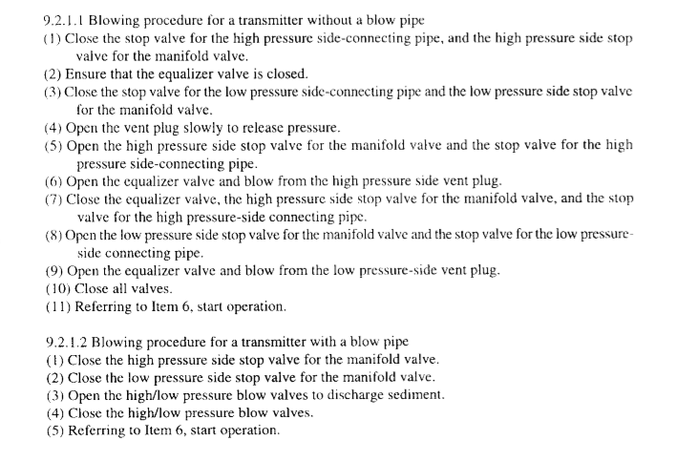
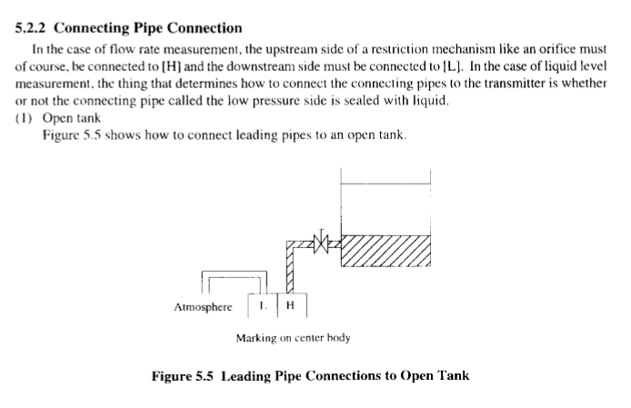
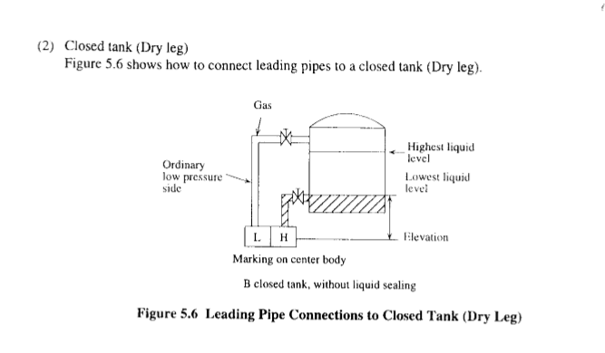
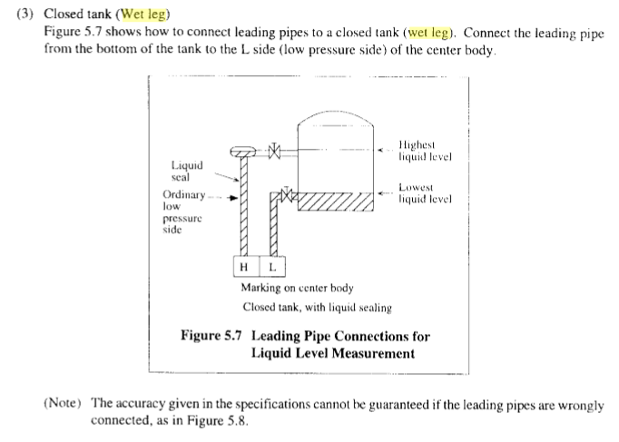
The flow of steam may damage the transmitter if the equalising valve (2) is opened when both the isolating valves (5) and pressure inlet valves (3) are open!
Equalizing valve ဖြင္႔။ အေပၚဘိုြင္လါက ဗါး ၂ လံုးပိတ္။ High & low side dp iso valve ပိတ္။ seal pot ေ၇အၿပည္႔ၿဖည္႔။ ေအါက္က High & low iso valve & vent ေတြဖြင္႔ ေလခ်ဳ။ ၿပီး၇င္ အကုန္ၿပန္ပိတ္။ equalizing valve ပိတ္။ boiler က ဗါး ၂ လံုးဖြင္႔။ dp က high & low ဗါး ၂ လံုးဖြင္႔။
Suction pressure နိမ္႔၇င္ CAPACITY CONTROL VALVE BELLOWS, ADJUST SPRING အါးက CONTROL OIL PRESSURE ထက္ ပိုမ်ားေတါ႔ PUSH PIN က VALVE ကိုလွမ္းတ ြန္းတယ္။ CONTROL OIL ေတ ြ CRANK CASE ကို THROTTLE ၿဖစ္တယ္။CONTROL OIL PRESSURE န ဲေတါ႔ HYDRAULIC RELAY PISTION ကို မတ ြန္းႏိုင္ေတါ႔ COMPRESSOR OIL PUMP ကလါတဲ႔ဆီကUNLOADER POWER ELEMENT PISTON ကို မတ ြ န္းႏိဳင္ဘူး၊ ဒီေတါ႔ LIFTER PINအေပၚတက္မယ္။SUCTION VALVE PLATE ကို တ ြ န္းတင္ထါးမယ္။ UNLOADINGၿဖစ္ေနမယ္။ SUCTION PRESSURE ၿမင္႔၇င္ေတါ႔ adjust စပ၇င္ ကို ေက်ာ္။ push pin ကိုေနာက္တ ြ န္း။ ဒီေတါ႔ THROTTLE ပိတ္မယ္။ CONTROL OIL PRESSURE ၿမင္႔မယ္။ CONTROL OIL PRESSURE ၿမင္႔လါ၇င္ေတါ႔ HYDRAULIC RELAY PISTON ကိုတ ြန္းမယ္။ COMPRESSOR OIL PUMPက လါတ ဲ႔ PRESSURE က UNLOADER POWER ELEMENTS PISTON ကို အေပၚကို တ ြန္းတင္ မယ္။ LIFTER PIN က ေအါက္ကိုဆင္းမယ္။ SUCTION VALVE ၿပန္ထိုင္မယ္။ PISTON LOAD ထမ္းမယ္။ အဲယါးက ြန္း ေအးလါ၇င္ TEV ကထိန္းလို႔ suction pressure က်တါေပါ႔ဲ၊ ဒီေတါ႔ unloader အလုပ္စလုပ္တါတယ္။
က်ပ္၇င္ပူ။ ေလ်ာ၇င္ေအး
1-AC 4 မွာ OVERSPEED ဘယ္လိုစမ္းမလဲ(ဒါက SAFETY SYSTEM ထဲပါတယ္။)
a-KEY OPEN လုပ္၇ပါမယ္။ Opcode 41 rpm detector system 1 ကိုသြါး။ၿပီး၇င္ parameter အကြက္မွာ SI ေၿပာင္း။(UP/DOWNနဲ႔)
B-VALUE မွာ TRUE ေၿပာင္း။ ၿပီး၇င္ ENTER။ --ဒါဆို SIMULATION လုပ္တါၿဖစ္သြါးပါၿပီ
C .ၿပီး၇င္ PARAMETER Rp ကိုၿပန္သြါး။ value ကို ၁၃၈.၄ အေပၚ ( 115% of MCR) ေ၇ာက္ေအါင္တင္။ ENTER နိွပ္။ ဒါဆို overspeed alarm လါပါလိမ္႔မယ္။
စမ္းၿပီးသြါး၇င္ - RP ကို သံုညၿပန္ထါး။ SI ကို FALSE ၿပန္ထါး။ ၿပီး၇င္ ENTER နိပ္။ေသါ႔ပိတ္။ဒါပါဘဲ။

2-သေဘါၤမွာ provision plant compressor ၇ဲ႔ sump oil ေတြခဏေလးနဲ႔ေပ်ာက္သြါးတယ္။ ဘါေၿကာင္႔ၿဖစ္နိုင္လဲ။ ဘါကိုလဲ၇မလဲ
Oil separator လဲ၇န္
3-Fridge compressor တခု၇ဲ႔ Oil separator လဲဖို႔ အသစ္တခု၇ိွတယ္ဆိုပါေတါ႔။ gas welding torch, silver rod ( 15% silver) ေ၇ာ၇ိွတယ္ဆိုပါေတါ႔။အဲဒါေတြ အၿပင္ဘါေတြလိုေသးလဲ၊
သြယ္ထါးတဲ႔ပိုက္ က 22mm ပိုက္ဆို 22.08 mm inside diameter ၇ိွတဲ႔ Cu socket pipe ေတြ။ flux ေတြလိုေသးပါတယ္။ gas welding torch ကို အသစ္ထည္႔တဲ႔Cu pipe ေပၚ အပူေပးၿပိး silver rod အလိုလို အဲဒီ ၀.၀၈ mm gap ထဲ၀င္လါေအါင္လုပ္တါပါ။
4-Gas welding နဲ႔ပတ္သက္လို႔ backfire နဲ႔ flashback ဘါကြါ့လဲ။
တကယ္လို႔ torch tip မွာ burning back ၿဖစ္၇င္ back fire, torch အထဲၿဖစ္ၿဖစ္။ torch mixing chamber ေနာက္ပိုင္းမွာၿဖစ္ၿဖစ္ flame burn ၿဖစ္ခဲ႔၇င္ flash back, ဒါေၿကာင္႔ flash back ကပိုေၿကာက္စ၇ာေကါင္းပါတယ္။ back fire က ၿကားေနၿကအတိုင္းအသံက်ယ္က်ယ္ၿကားၿပီး မီးေတါက္ၿငိမ္းသါြးတါမ်ားပါတယ္။ flash back က hissing or squealing sound ထြက္လါၿပီး tip ထိပ္က flame မွာ မီးခိုးအူလါမယ္။မီးစြယ္ sharp point ၿဖစ္လါမယ္။

5-မီးစက္တလံုး Oblique con rod type ဆိုပါေတါ႔။ con rod ၇ဲ႔ big end bearing bore ovality ဘါေၿကာင္႔ ၿဖစ္တါလဲ။ crankcase inspection လုပ္ေန၇င္း serration စါးတါ မ်ားေနေၿကာင္းမၿဖဳတ္ၿကည္႔ဘဲ လြယ္လြယ္အၿကမ္းဖ်င္း ခန္႔မွန္း နိုင္တဲ႔ နည္းလမ္း၇ိွလါး။
Crank bearing bore ovality ၿဖစ္၇တဲ႔အေၿကာင္း။ suction stroke မွာ ၿဖစ္တဲ႔ ပစ္စတင္၇ဲ႔ inertia force က bearing keep 2 ၿခမ္းကို ဆဲြခြါသလို သက္ေ၇ာက္ပါတယ္။ upper serration mating surface opening ပိုမ်ားလါတယ္။ fretting ေၿကာင္႔ upper serration wear out ပိုၿဖစ္လါတယ္။ ဒီေတါ႔ serration surface – 2 ခုထိတဲ႔area နဲလါတယ္။ bolt ၇ဲ႔ axial force က်လါတယ္။ဒါေၿကာင္႔Serration ေတြပိုစါးလါတယ္။ ၿကာေတါ႔ bearing nut ေတြတိုက္ၿပီး တိုင္းတဲ႔ အခါ bearing bore ဟါ elliptical shape ၿဖစ္လါတယ္။တင္းေအါင္ တိုက္လဲ bearing clearance က်လါၿ႔ပီး bearing ေလါင္တါၿဖစ္လါမယ္။
Crankcase inspection လုပ္တံုး Maker recommend ေပးထါးတဲ႔ torque နဲ႔တိုက္စစ္လို႔ bolt လိုက္လည္လါ၇င္ serration စါးေနၿပီလို႔ အၿကမ္းဖ်င္းယူဆလို႔၇ပါၿပီ။ၿဖဳတ္ၿပီးထပ္စစ္ၿကည္႔ပါ။
6-MC Engine တလံုး starting system မွာ ပါတဲ႔ valve 25 ယိုေန၇င္။မေကါင္း၇င္ ဘါၿဖစ္နုိင္လဲ။
Stop signal လြတ္ထြက္လါနိုင္လို႔ အင္ဂ်င္ run ေနတံုး puncture valve ဆီေလေ၇ာက္လါနိုင္ပါတယ္။
7-MC Engine တလံုး ။ nor control AC 4 ဆိုပါေတါ႔။BRIDGE CONTROL ကေန Emergency local panel ကိုေမါင္းေနတံုးေၿပာင္းလို႔၇လါး။ ၇၇င္ဘယ္လိုေၿပာင္းမလဲ။
အင္ဂ်င္ေမါင္းေနတံုး Emergency control ကိုေၿပာင္းခ်င္၇င္
For changing-over to 'Emergency Control' with running engine, see ltem 8.4
'Emergency Control from Engine Side'.
- Check that valve (105)' which is the "telegraph handle" of the emergency control system, is in the required position. Note that reversing to a new direction is only possible when STOP valve (1 02) is activated.
ေမါင္းေနတဲ႔ direction ဖက္ကို telegraph handle ( emergency console က) ၁၀၅ ကိုထါးပါ။
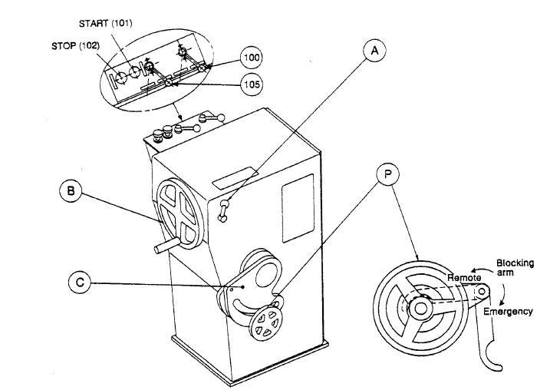
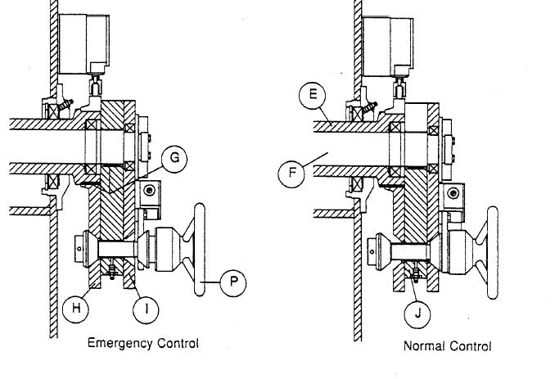
- Turn the handle 'A' anti-clockwise to free the regulating handwheel 'B'.
Regulating handle ကို lock လုပ္တဲ႔ handle A ကို unlock လုပ္ပါ။
3. Put the blocking arm in emergency position.
4. Turn handwheel 'B' to move the innermost lever of the change-over mechanism
Local fuel handwheel B ကို အေပၚက change over mechanism မွာ ေၿပာင္း၇လြယ္တဲ႔အေနေ၇ာက္ေအါင္လွည္ပါ။
'C' to a position where the impact handwheel 'P' is able to enter the tapered
slots in both levers. Quickly, turn the impact handwheel 'P' anti-clockwise. This
causes disconnection of the governor and connection of the regulating
handwheel 'B' to the fuel pumps.
ၿပီး၇င္ေၿပာင္းတဲ႔ impact handwheel P ကို ANTI CLOCKWISE လွည္႔ပါ။
ၿပီးတါနဲ႔ CHANGE POSITION OF VALVE 100 ကို NORMAL ကေန EMERGENCY ကိုေၿပာင္းပါ။ ဒါဆို CONTROL AIR က LOCAL MANOEUVRING ကိုေ၇ာက္လါလိမ္႔မယ္။

8-Nor control AC 4 , MC Engine ဆိုပါေတါ႔။ crash astern နဲ႔ ၇ိုး၇ိုး astern ဘါကြါလဲ။
9-MC Engine ေတြမွာ exhaust valve knocking ၿဖစ္၇င္ဘါကိုၿကည္႔မလဲ။
Exhaust valve knocking is caused by insufficient cushioning in the hydraulic oil system. This is basically due to three different reasons:
- deficiencies in the oil supply,
- errors in the air spring,
- excessive leakage in the high pressure oil system.
1) Deficiencies in the oil supply can, for instance, be:
- air in the oil (foaming), most possibly caused by air being drawn-in at the pump (suction side),
- too low supply pressure,
- too high oil temperature, giving low viscosity.
2) Errors in the air spring system can be:
- incorrect supply pressure (too high).
- a defective or maladjusted safety valve (drain valve).
It is very important that the supply air pressure and the safety valve opening pressure correspond as follows:
Supply pressure (bar) Opening pressure (bar)
5.5 17.5
7.0 21.0
3) Excessive (abnormal) leakages in the high pressure oil system can, for instance, occur at:
A*) a maladjusted or defective throttle screw,
B*) the oil cylinder piston rings, on either cam or exhaust valve sides (new type S-lock rings might help),
C*) the oil cylinder safety valve, on the cam side. This leakage can arise from the valve seats, or from the sealing ring (packing) between the valve and the housing. The sealing ring must be a special narrow steel type,
D*) the puncture non-return valve, caused by spindle
maladjustment, or defective non-return valve seats, E*) high pressure pipe joints, caused either by insufficient/uneven tightening, or by damaged surfaces, F*) the venting valve at the top of the exhaust valve
10-L23/30H Engine ေတြမွာ lambda controller ဆိုတါဘါလဲ။ အဲဒီမွာ ေလလိုင္း ၂ ခုပါတယ္။ အဲဒါေတြဘယ္ကလါလဲ။ အဲဒီ lambda controller က အင္ဂ်င္ rpm ကိုဆြဲဆြဲခ်ေန၇င္ ဘါက္ိုစစ္၇မလဲ၊
11-သေဘါၤေပၚမွာ ballast valve, fuel tank valve ေတြကိုဖြင္႔တဲ႔ valve remote control system မွာ N2 ၿဖည္႔ထါးတဲ႔ BLADDER သံုး Accumulator ပါတယ္ဆိုပါေတါ႔ / အဲဒီ bladder ေကါင္းမေကါင္းဘယ္လိုသိနိုင္မလဲ
Isolate the fully-charged bladder accumulator from the hydraulic system by closing the shut-off valve A. Very slowly discharge the accumulator on the fluid side via drain valve E. The pressure gauge must be constantly monitored during this process. A slow, steady pressure drop is displayed. The pressure only drops abruptly when the accumulator has been completely discharged. The pressure displayed before the drop corresponds to the pre-charge pressure of the bladder accumulator. ေၿဖးေၿဖးၿခင္း pressure က်၇င္ bladder ေကါင္းပါတယ္။

12- ECR control room ၇ ဲ႔ AC 4 မွာ UNIT(PANEL) ၃ ခု၇ိွတယ္။အဲဒါဘါေတြလဲ။DGU မွာ REGULATOR နဲ႔ ACTUATOR ၂ ခုပါတယ္။ တကယ္လို႔ အင္ဂ်င္စနိုးခ်ိန္ေကြ်းတဲ႔ ဆီပမါဏကိုေၿပာင္းခ်င္၇င္ REGULATOR ဖက္ parameter မွာေၿပာင္း၇မလါး။ ACTUATOR ဖက္ က ေၿပာင္း၇မလါး။
Regulator ဖက္ parameter ကေၿပာင္းပါ။
13-AC4 Unit တခု DGU REGULATOR ဖက္မွာ IN DATA ERROR ALARM လါၿပီးေတါ႔ F.O INDEX က သံုညကိုဆင္းသြါးၿပီးၿပန္မတက္လါလို႔ အင္ဂ်င္နိဳးလို႔မ၇ေတါ႔ဘူးတဲ႔။ဘါေၿကာင္႔လဲ။ဘယ္လိုၿပင္မလဲ
Information parameters.
တကယ္လို႔ အင္ဂ်င္ေမါင္းေနတံုး black out ၿဖစ္၇င္ indata error ၀င္နိုင္တယ္။ ecr & BR က lever ေတြသံုညမွာထါးပါ။ scavenge air sensor အတြက္ကေတါ႔ governor unit ကို switch on/off လုပ္ၿကည္႔ပါ္။
PARAMETER 11 & 12 ကေတါ႔ memory function ၇ိွလို႔ errors နဲ႔ latch ၿဖစ္ေနတတ္လို႔ reset ။ ပါ၀ါခ်။တင္ လုပ္လို႔မ၇တတ္ပါ။အဲလိုပါ၀ါအတင္အခ်လုပ္ ၿပီး ၇င္ - value up button နဲ႔ fail တခုထက္ပိုလါ၇ွာၿကည္႔။ၿပီး၇င္
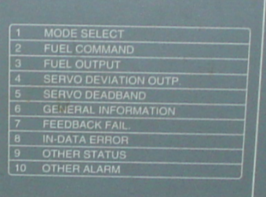
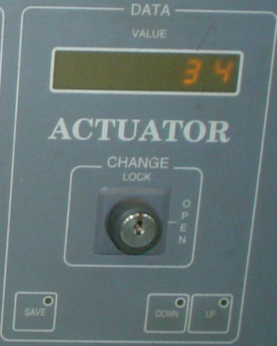
10-other alarm ကိုေ၇ြးပါ။ IN DATA ERROR ဆို၇င္ UP BUTTON နဲ႔ reset လုပ္မွ par 11 &12 memory ကိုေဖ်ာက္နိုင္ပါမယ္။
CE အခန္းထဲကေသါ႔ယူပါ။ CHANGE LOCK KEY ဖြင္႔ပါ။SERVICE CODE 47 ထည္႔ပါ။ၿပီး၇င္ေသါ႔ၿပန္ပိတ္ပါ။ ဒါဆို OP CODE 0- 13 အတြင္းၿကည္႔လို႔၇ပါၿပီ။လိုခ်င္တဲ႔ OP CODE ကိုေ၇ြးပါ။ လိုခ်င္တဲ႔ PARAMETER ကိုသြါးဖို႔ change lock key ကိုၿပန္ဖြင္႔ပါ။ ေၿပာင္းလို႔၇တါဆိုေၿပာင္းနိုင္ပါၿပီ။ ေၿပာင္းလို႔ၿပီး၇င္ service code ကို သံုည ဆိုၿပီးထည္႔ပါ။ save ကိုနိပ္ပါ။ ၿပီး၇င္ change lock key ကိုပိတ္ၿပီး ေသါံ့ကိုၿပန္သိမ္းပါ။
Parameter II & 12 on both sides will give more information.
အဲဒီ PARAMETER 11 &12 ကိုအေပၚ CHANGE LOCK KEY နဲ႔ၿကည္႔နိုင္ပါတယ္။

The Indication lamp and the parameters (11 & 12) has a memory-function that latches up all errors that has occurred. It is possible to scan thruogh with value Up button to see if more than one fail has occured.
After investigating the fail on parameter 11 or 12, select parameter 10 Other Alarm to reset
alarms by pushing the value Up button. The memory on par 11 and 12 will then be reset
also.

14-AC 4 နဲ႔ထိန္းတဲ႔ အင္ဂ်င္ကၿကာလါေတါ႔ FUEL PUMP ေတြက်လါတယ္ဆိုပါေတါ႔။အသစ္ထက္ပိုၿပီး ဆီေက်ြးမွနိုးမယ္ဆို၇င္ ဘယ္လိုလုပ္၇မလဲ
-NORMAL START FUEL SET POINT, HEAVY START FUEL SETPOINT ဆိုၿပီး DGU REGULATOR PARAMETER – 12, 13 မွာ၇ိွပါတယ္။ HEAVY START က ပထမတခါနိုးလို႔ မနိုး၇င္ဒုတိယတခါထပ္နိုး၇င္ေက်ြးတဲ႔ဆီ။
ဒီေတါ႔ ၁၂ကိုခ်ိန္ေပး၇မယ္။ နဂိုက ၄၀ ဆို၇င္ ၄၅ ေလါက္ေပးလိုက္ပါ။
လုပ္ပံုက
၁-DGU ACTUATOR ဖက္က KEY ကိုဖြင္႔။( KEY မဖြင္႔၇င္ ၁ ကေန ၁၀ ထိဘဲေၿပာင္းလို႔၇တယ္။) ၂- ၿပီး၇င္ REGULATOR SIDE က PARAMETER 99 ကိုသြါး။ ၿပီး၇င္ SERVICE CODE ( စါအုပ္မွာေပးထါးတတ္တယ္။ EXPERT parameter ေတြ အတြက္ေတါ႔မ၇ဘူး။) ထည္႔ပါ။ ၃-ၿပီး၇င္ KEY ကိုၿပန္ပိတ္ပါ။ ပိတ္လုိက္တါနဲ႔ REGULATOR SIDE ဖက္က PARAMETER NO အကြက္မွာ သံုည , DATA VALUE အကြက္မွာ သံုည။ ၿပေနလိမ္႔မယ္။ ၄-အဲဒီ DATA VALUE အကြက္မွာ 1 ကိုထည္႔လိုက္၇င္ အဲဒါ Opcode 1 ကိုသြါ့းတါဘဲ။ အဲလို ၁ ထည္႔ၿပီးတါနဲ႔ key ကို ဖြင္႔လိုက္ပါ။ ဒါဆို Opcode 1 အဆင္႔ကိုေ၇ာက္ၿပီ။ parameter မွာ ၁၂ ေ၇ာက္ေအါင္အေပၚေအါက္မွ်ားနဲ႔သြါးပါ။ဒါဆို parameter 12 အတြက္ တန္ဖိုး ၄၀ ဆိုတါလါၿပလိမ္႔မယ္။ အဲဒီ ၄၀ ကို ၄၅ ေလါက္ေ၇ာက္ေအါင္အေပၚေအါက္မ်ွားနဲ႔ေၿပာင္းလိုက္ပါ။ၿပီး၇င္ save ကိုနိပ္ပါ။(key open မွာ save လုပ္ပါ။) ၅-ၿပီး ၇င္ key ကိုၿပန္ပိတ္ပါ။သူဖါသူparameter 99 ကိုၿပလိမ္႔မယ္။ service code သံုညထည္႔ပါ။ key ကိုၿဖဳတ္သိမ္းပါ။မေမ႔ပါနဲ႔။အခန္းထဲသိမ္းထါးပါ။
ဒါဆို အင္ဂ်င္နိွုးလို႔ဆီေက်ြး၇င္ ၄၅ အမွတ္ေ၇ာက္ေအါင္ပိုေက်ြးလိ္မ္႔မယ္။

15-AC 4 (AUTOCHIEF 4) သံုး အင္ဂ်င္စံနစ္တခုမွာ BRIDGE CONTROL ေပးထါးတယ္။ BRIDGE ကေနနိွုးတဲ႔ START SIGNAL ေအါက္ က VALVE 65 ကို ေ၇ာက္မေ၇ာက္ AC4 ကေနဘယ္လိုၿကည္႔မလဲ။
Opcode 66 က ahead solenoid valve အတြက္။ သူက control room I/O SIGNAL အဖြဲံ႔ထဲပါလို႔ သူကိုစမ္း၇င္ I/O COMMIS OP.CODE (49) PUSH BUTTON ကိုနိပ္၇မယ္။(REMOTE CONTROL SYSTEM)( SAFETY SYSTEM မဟုတ္ပါ) ၂ခါနိပ္၇င္ FLASH LIGHT ၿဖစ္မယ္။
ဒါဆို Opcode 66 ၇ဲ႔ ္ PARA D0 ကိုၿကည္႔။B/R LEVER START ထါးလဲ PARA DO က OPEN ဆို START SIGNAL မေ၇ာက္ပါ။
၁၆- CONTROL SYSTEM (AC4) ေလါက္ထိမပါေသးပါဘူး။ေနာက္ပုိင္း NOR CONTROL ေတြမွာပါလါနိုင္လို႔၊ HART PROTOCOL, FIELDBUS PROTOCOL, PROFIELDBUS PROTOCOL, ASI PROTOCOL စတါေတြကဘါေတြလဲ။ ဘါကြါ့လဲ၊ PROFIELDBUS DP နဲ႔ PROFIEDBUS PA ဘါကြါ့လဲ။HART MULTIPLEXER ဆိုတါဘါလဲ၊
Hart protocol-ပံုမွန္သံုးတဲ႔ 1 pair wire မွာ signal channel တခုဘဲပါပါတယ္။ hart ဆို၇င္ ၁ pair wire မွာ (2) simultaneous channels ပါပါတယ္။
Fieldbus protocol- fieldbus device မွာ block 3 ခုပါပါတယ္။ ၁-transducer block, 2-resource blocks, 3- function block တိုၿဖစ္ပါတယ္။
Profibus protocol-အဲဒီ BUS စံနစ္က ၇ိွသမ်ွ Discrete I/O & Analog I/O ေတြအကုန္ကို ထိန္နိုင္ဖို႔လုပ္ထါးတါၿဖစ္ပါတယ္။ MAKER မတူလဲ ေ၇ာသံုးနိုင္ဖို႔လုပ္ထါးပါတယ္။
Analog device ေတြကို profibus PA မွာထါးၿပီး motor starter/ vsd စတါေတြ profibus DP မွာထါးပါတယ္။
Asi protocol – bit oriented design ၿဖစ္ပါတယ္။ intelligent wiring solution လို႔လဲေခၚပါတယ္။ ၇ိွသမွ်အါးလံုးကို SINGLE NETWORK wire တလိုင္းထဲနဲ႔ဆက္နိုင္ပါတယ္။
Profibus dp-(DP = Decentralized Periphery) , physical layer(transmission tech) အေနနဲ႔ RS 485,FIBER OPTIC,RS485Is,စတါေတြကိုသံုးပါတယ္။profibus dp နဲ႔ profibus pa ကို dp/pa coupler နဲ႔ဆက္ပါတယ္။ထံုးစံအတိုင္း DP ကအေပၚက ။ PA ကေအါက္ကၿဖစ္ပါတယ္။ PA က FIELD DEVICE ေတြၿဖစ္ၿပီး DP က HMI,REMOTE I/O တို႔ၿဖစ္ပါတယ္။
Profibus pa -သူကို process industry မွာသံုးပါတယ္။ANALOG DEVICE ေတြကို DIGITAL NETWORK ကေနထိန္းတါပါ။ Manchester bus powered physical layer architecture ကိုသံုးပါတယ္။ field device ကို digital network ကတဆင္႔ control system သို႔ဆက္ပါတယ္။
Hart multiplexer-Hart device ကhart data ကို ၇ိုး၇ိုး I/O Card ဆီပို႔ေပးတဲ႔အခါ ၿကားခံဆက္သြယ္ေပးတဲ႔ device ၿဖစ္ပါတယ္။

၁၇-fuel oil & air flow ကို cascade သံုးထါးတဲ႔ boiler combustion system တခုမွာ air flow ကို cascade ထါး၇င္ အ၇မ္းhunting ၿဖစ္တယ္။ air flow control မွာ manual ထါးလိုက္၇င္မၿဖစ္ေတါ႔ဘူး။ဒါဘါေၿကာင္႔ၿဖစ္နိုင္လဲ၊
Air flow feed back signal သို႔ fuel oil feed back signal ေၿကာင္႔
၁၈-boiler တလံုးမွာ fuel နဲ႔ combustion air flow ကို PID CONTROLLER တလံုးစီနဲ႔ခ်ိန္တယ္.။ AIR FLOW CONTROLLER မွာ PID OUTPUT HIGH LIMIT နဲ႔ PID OUTPUT LOW LIMIT ဆိုၿပီး SETTING ၂ ခုပါေနတယ္။ အဲဒါဘါကိုဆိုလိုခ်င္တါလဲ။အဲဒါကိုခ်ိန္၇င္ဘယ္ေန၇ာမွာဘါအက်ိဳးသက္ေ၇ာက္မွဳ၇ိွမယ္ထင္လဲ။
Air damper ဖြင္႔တဲ႔ အမ်ားဆံုး position & အနည္းဆံုး position
၁၉-အဲဒီဘိုြင္လါမွာဘဲ IGNITION ၿဖစ္တဲ႔အခ်ိန္မွာ ေပးတဲ႔ FUEL နဲ႔ AIR ကိုဘယ္လိုခ်ိန္မလဲ။ အေပၚက လို PID OUTPUT LOW & HIGH LIMIT ေတြက ဒီ IGNITION FUEL & AIR SETTING ေတြမွာ အက်ိဳးသက္ေ၇ာက္မွဳ၇ိွနိုင္လါး။
Pid output low က ignition position ထက္ၿမင္႔၇င္ ignition position ေလါက္ထိမဆင္းလါေတါ႔ပါဘူး။
2၀-SLOW SPEED ENGINE ေတြမွာ high peak loading of Bearing ဟါဘယ္အခ်ိန္မွာၿဖစ္နုိင္လဲ။
(low inertia mass force compare to gas pressure force ဆိုေတါ႔ overload အခ်ိန္ေပါ)
21- indicator diagram power card ကေန Pi ကိုတြက္တဲ႔အခါ card area ကို length of indicator card diagram နဲ႔စါး၇တယ္။ အဲဒီ length of indicator card မွာ expansion အဆံုးနဲ႔ compression မစခင္ၿကား ( scavenge port စဖြင္႔ ခ်ိန္ကေန ပိတ္တဲ႔ အခ်ိန္ထိ္ ) ေကါပါလါး။
ပါပါတယ္။ ဘါလို႔လဲဆိုေတါ႔ length of indicator card က TDC ကေန BDC ထိၿဖစ္လို႔ပါ။
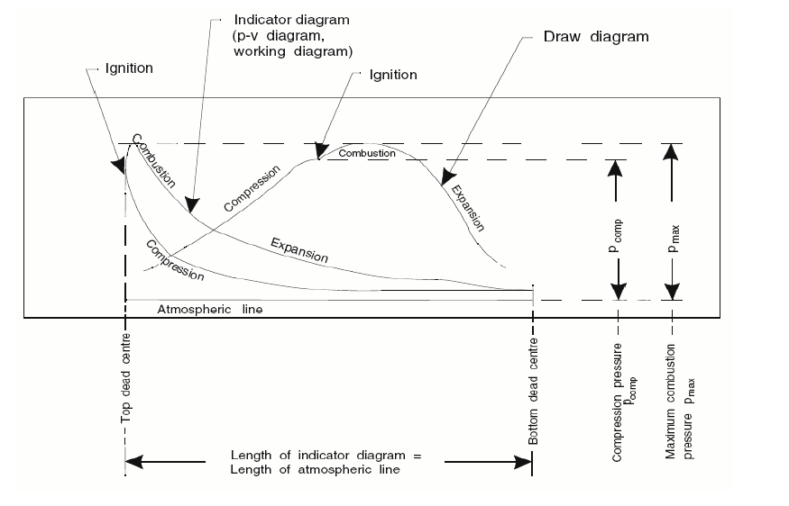
22-MC engine operation shop test report engine specification မွာ cylinder coefficient , bar & kw ဆိုၿပီးပါတတ္တယ္။အဲဒါဘါကိုေၿပာတါလဲ။
23- MC engine indicator card area ကို length of indicator card diagram နဲ႔စါးၿပီး spring constant နဲ႔စါးေပး၇မလါး။ေၿမွာက္ေပး၇မလါး။တြက္လို႔၇လါတဲ႔ pressure က mep လါး။ mip လါး။
စါး၇ပါမယ္။ mip ပါ။
24-အဲဒီ TRAIL RESULT မွာေပးတဲ႔ POWER က mep နဲ႔တြက္တါလါး။ mip နဲ႔တြက္တါ လါး။
Mep နဲ႔တြက္တါပါ။
25-Pe = k2 . n . pe ( k2= 1.7151 for S70MC , 0.6545 for S50MC) လို႔ေပးထါးတယ္။ အဲဒီ k2 ကို MC Engine မွာဘါေခၚလဲ၊
N=rpm, pe-mep
26-boiler ၇ဲ႔ fuel regulator actuator က ေလယိုေနလို႔ နဲနဲ pressure ကစါးေနတယ္။ တကယ္လို႔ fuel controller နဲ႔ air controller က cascade လုပ္ထါး၇င္ဘါၿဖစ္နုိင္လဲ၊
Air controller ပါလိုက္ၿပီး hunting ၿဖစ္လါပါမယ္။
27- SLOW SPEED ENGINE ေတြမွာ high mean loading of Bearing ဟါဘယ္အခ်ိန္မွာၿဖစ္နုိင္လဲ။
Max rpm limit ဖက္ေန၇ာနားက။ torsional vibration လဲမ်ားလါပါတယ္။
28-MCR 127 ေလါက္ေမါင္းနိုင္တဲ႔အင္၈်င္ RPM 70 ေလါက္မွာ OVERLOAD ၿဖစ္နိုင္လါး။တကယ္လို႔ ၿဖစ္နိုင္၇င္ဘယ္အခ်ိန္မ်ိဳးၿဖစ္နိုင္တယ္ထင္လဲ။
ေသါင္တင္တဲ႔အခ်ိန္မ်ိဳး။ quay မွာ mooring လုပ္ၿပီး အင္ဂ်င္ေမါင္းတါမ်ိဳး/propeller မွာ mooring rope ပတ္တါမ်ိဳး
29-Differential pressure transmitter နဲ႔ tank တခုကို level တိုင္းတဲ႔အခါ wet leg နဲ႔ dry leg ဘါကြါလဲ၊
Wet leg ဆို၇င္ tank ေအါက္ၿခမ္း က ယူတဲ႔ပိုက္ကို dp cell ၇ဲ႔ low pressure side မွာတပ္ပါတယ္။ dry leg ဆို tank ေအါက္ၿခမ္းက ယူတဲ႔ပိုက္ကို High pressure side မွာတပ္ပါတယ္။
၃၀-ဘ္ိုိြင္လါ level တိုင္းဘို႔ dp transmitter ကို wet leg သံုးလါး။ dry leg သံုးလါး။
ဘိြုင္လါမွာ level တိုင္းဖို႔ dp transmitter ကို wet leg သံုးၿကပါတယ္။
၃၁-တကယ္လို႔ boiler gauge glass blow down လုပ္သလို wet leg dp transmitter ကို blow down လုပ္ၿပီး ပံုမွန္ အတိုင္း cock ေတြၿပန္ဖြင္႔ခဲ႔ ၇င္ ပံုမွန္ water level ခ်က္ၿခင္းၿပပါ႔မလါး။ ဘါေၿကာင္႔လဲ။
မၿပပါဘူး။ wet leg ၇ဲ႔ seal pot မွာ seal liquid ကုန္သြါးလို႔ၿဖစ္ပါတယ္။
32-တကယ္္လို႔ ဘိုြင္လါကလါတဲ႔ steam flow ကိုတိုင္းတဲ႔ dp transmitter ၇ဲ႔ အ၀င္ isolating valve ေတြ။ diff pressure transmitter ၇ဲ႔ high & low side stop valve ေတြ။ equalizing valve ေတြအကုန္ full turn ဖြင္႔ခဲ႔၇င္ဘါၿဖစ္နိုင္လဲ။
Dp transmitter ပ်က္သါြးနိုင္ပါတယ္။
33- dp transmitter တလံုး၇ဲ႔ high side & low side ေတြ၇ဲ႔ pipe line ေတြမွားဆက္မိ၇င္ dp transmitter ပ်က္နိုင္လါး၊
မပ်က္ပါဘူး။ တိုင္းလို႔၇တဲ႔ result မမွန္၇ံုဘဲ၇ိွပါမယ္။
34- DP TRANSMITTER နဲ႔ CLOSE TANK တခုကို LEVEL တုိင္းတဲ႔အခါ DP CELL ၇ဲ႔ HIGH SIDE နဲ႔ LOW SIDE ကို TANK နဲ႔ ဘယ္လိုဆက္လဲ။ဘါေၿကာင္႔လဲ။
၇ိုး၇ိုး close tank တခုကို dp cell နဲ႔တိုင္းတဲ႔အခါ dry leg ကိုဘဲသံူးၿကလို႔ High side ကို tank ေအါက္ပိုင္းနဲ႔ low side ကို tank အေပၚပိုင္းနဲ႔ဆက္ပါတယ္။
35- Tanks ေတြ၇ဲ႔ VALVES ေတြကို အပိတ္အဖြင္႔လုပ္တဲ႔ remote valve control system တခု၇ဲ႔ hydraulic pump ဟါ valve ေတြကိုအပိတ္အဖြင္႔မလုပ္လဲ SYSTEM PRESSURE က်လို႔ PUMP ကလည္လိုက္၇ပ္လိုက္ၿဖစ္ေနတယ္။အဲဒါဘါလို႔လဲ။
အဲဒါ ပံုမွန္ပါဘဲ။ tank အပိတ္အဖြင္႔ ဗါး ေတြ၇ဲ႔ pilot valve ေတြက နဲနဲေတါ႔ leak ၇ိွၿကတါပါဘဲ။
၃၆-တကယ္လို႔ STEAM FLOW တခုကို DIFFERENTIAL PRESSURE TRANSMITTER နဲ႔ တိုင္း၇င္ TRANSMITTER ၇ဲ႔ HIGH PRESSURE SIDE & LOW PRESSURE SIDE ကိုဘယ္လိုဆက္မလဲ၊
၃၇-MC ENGINE ၇ဲ႔ EXHAUST VALVE COOLING WATER OUTLET မွာ ORIFICE တခုထည္႔ထါးတယ္။ အဲဒါဘါလို႔ထည္႔ထါးလဲ။
လိုအပ္တဲ႔ pressure ကို cylinder liner အတြက္၇ေအါင္။ဒါမွ cavitation ၿဖစ္တါ။ေလခိုတါနဲ ၿပီး liner crack ၿဖစ္တါကို ကါကြယ္နိုင္မွာပါ
38- ကိုယ္႔၇ဲ႔ အင္ဂ်င္ ၁၀၀% rpm က ၁၂၇ ဆိုပါေတါ႔။ ကုန္တင္ထါးၿပီး ၇ာသီဥတုနဲနဲဆိုးတဲ႔အခ်ိန္ ၇ံုးက rpm 124 ေလါက္တင္ခ်င္တယ္ဆို၇င္ အင္ဂ်င္လဲမနာေအါင္ rpm လဲ ၁၂၄ ေပးထါးနိုင္ေအါင္ AC 4 မွာဘယ္လိုခ်ိန္မလဲ၊( သေဘါၤက DOCK ဆင္းတါ သိပ္မၿကာေသးဘူးဆိုပါေတါ႔)
Load diagram မွာ line 2 နဲ႔ line 6 ၿကားက အင္ဂ်င္ overload မၿဖစ္ဘဲေမါင္းနိုင္တဲ႔ ေန၇ာတခုပါ။ heavy running propeller curve ၿဖစ္တဲ႔ line 2 အထက္က မေမါင္းသင္႔ပါဘူး။ rpm 124 ဆိုေတါ႔ ၉၇.၆% engine speed , အင္ဂ်င္ shaft power 87% ေလါက္ဆို၇င္ေတါ႔အေကါင္းဆံုးေပါ႔။ဒါေပမဲ႔မ၇နိုင္ေလါက္ပါဘူး။ ဒါေတါ႔အလြန္ဆံုး 90 % ေလါက္ဘဲခ်ိန္ထါးသင္႔ပါတယ္။ MC Engine operation file က official test measure data မွာ ၉၀% အတြက္ fuel pump index ပါပါလိမ္႔မယ္။ အဲဒါနဲ႔မွန္းၿပီး DGU REGULATOR PANEL က PARA 6 MAN RPM LIMIT ကို ၁၂၄ ထါး။ PARA 7 MAN FUEL LIMIT ကိုခုနင္က FUEL PUMP INDEX ေလါက္၇ေအါင္ခ်ိန္ေပး။ၿပီးေတါ႔ POWER CARD ယူၿပီး POWER ကိုတြက္ယူပါ။လိုသလို MAN FUEL LIMIT ကိုအတိုးအေလ်ာ႔လုပ္ယူပါ။
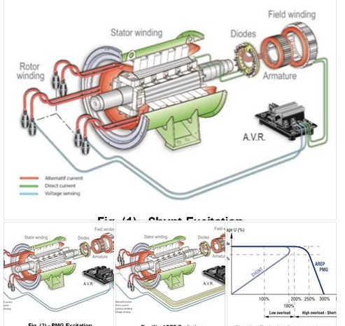
ကံဳခဲ႔ဖူးတဲ႔၊ Oil Fired Drum Type Water Tube Boiler ရဲ႕ Steam Coil Arrangements နဲ႔ Steam Quality"
.
(ႀကာေတာ႔ႀကာပါၿပီ။ လြန္ခဲ႔တဲ႔၊
(၁၀) နွစ္ခန္႔၊ ကာလတုန္းက၊
ကိုယ္ေတြ႔၊ အၿဖစ္အပၽက္ပါ။
.
(၂) နွစ္ေလာက္၊
'ဟင္းသီးဟင္းရြက္ဆီ' ဆိုတဲ႔၊
vegetable oil ေတြ၊
cargo operation ၿပဳလုပ္ခဲ႔တဲ႔၊
product tanker သေဘ္ာတစီးကို၊
လြွဲေၿပာင္းလက္ခံယူခဲ႔ရပါတယ္။
.
လြွဲေၿပာင္းလက္ခံၿပီးတဲ႔၊ ေနာက္ပိုင္း၊
ပထမဆံုး၊ ခရီးစဥ္မွာ၊ 'ေရနံဆီ' ဆိုတဲ႔၊
kerosene တင္ခဲ႔ပါတယ္။
.
'ေရနံဆီ' တင္ၿပီး၊ ဒုတိယ၊ ခရီးစဥ္မွာေတာ႔၊
'စားအုန္းဆီ' ဆိုတဲ႔၊ palm oil တင္ရမွာ၊
ၿဖစ္ပါတယ္။
.
'စားအုန္းဆီ' တင္တဲ႔အခါ၊ ဆီေတြ၊
'ခဲပၽစ္' မသြားေစဖို႔၊ tank ေတြထဲမွ၊
heating coil ေတြ၊ အတြင္းသို႔၊
steam ေပးပို႔ကာ၊ အပူေပးရမွာ၊
ၿဖစ္ပါတယ္။
.
(၂) နွစ္ေလာက္၊ ႀကာေအာင္၊
steam ေပးပို႔၊ အပူေပးၿခင္း၊ မရိွခဲ႔တဲ႔၊
heating coil ေတြရဲ႕၊ အေၿခအေနကို၊
သိခၽင္တဲ႔အတြက္၊ gas free ၿပဳလုပ္အၿပီး၊
tank ေတြအတြင္းသို႔၊ ဆင္းခဲ႔ပါတယ္။
.
heating coil ေတြရဲ႕၊
seamless joint အဆက္၊
ေနရာတခၽိဳ႕မွာ၊ ေၿခာက္ေသြ႔ေနတာ၊
မေတြ႔ရသမို႔၊ heating coil ေတြ၊
အတြင္းသို႔၊ 'ေရနံဆီ' ေတြ၊
ေရာက္ေနၿပီလို႔၊ ယူဆမိသလို၊
steam traps ေတြနဲ႔၊
steam strainer တခၽိဳ႕ကို၊
ဖြင္႔ႀကည္႔တဲ႔အခါ၊ 'ေရနံဆီ' ေတြ၊
ထြက္ကၽလာတာ၊ ေတြ႔ရပါတယ္။
.
'ကံ' ႀကီးေပတယ္လို႔သာ၊ ဆိုရမွာပါ။
heating coil ေတြထဲ၊
steam ေပးပို႔မိခဲ႔လၽွင္၊
သေဘ္ာတစီးလံုး၊ မေတြးဝံ႔စရာ၊
အၿဖစ္ဆိုးနဲ႔၊ ႀကံဳသြားနိဳင္ပါတယ္။
.
ဒီ post ေလးကေတာ႔၊ ႀကံဳခဲ႔ဖူးတဲ႔၊
အၿဖစ္အပၽက္ကို၊ သတိရမိသမို႔၊
ၿပန္တင္လိုက္တဲ႔၊ post ေလးၿဖစ္ပါတယ္။)
.
Reference and image credit to : Steam engineering tutorials, http://www.SpiraxSarco.com
.
Remark : All references and images herein this pages are for use of educational purpose only. The owner of this pages is not responsible for the consequences in case of violation to copyright, trademark, patent or other intellectual property rights of any third party.............
.
main propulsion system အတြက္၊
internal combustion engine ေတြ၊
တတ္ဆင္အသံုးၿပဳထားတဲ႔၊
motor ship သေဘ္ာေတြမွာ၊
exhaust gas heat ex-changer မွတဆင္႔၊
steam ကို၊ ထုတ္ယူနိိဳင္ပါတယ္။
.
internal combustion engine ၿဖစ္တဲ႔၊
main engine လည္ပတ္ေမာင္းနွင္ရာမွ၊
ထြက္ေပါါလာတဲ႔၊ exhaust gases ေတြကို၊
exhaust gas heat ex-changer ထဲမွ၊
ၿဖတ္သန္းေစၿပီး၊ steam ထုတ္ယူတဲ႔အတြက္၊
exhaust gas boiler လို႔လည္း၊
ေခါါႀကပါတယ္။
.
generator engine capacity ႀကီးမားတဲ႔၊
သေဘ္ာေတြမွာ၊ main engine မွ၊
exhaust gas ကိုသာမက၊
generator engine ရဲ႕၊
exhaust gases ေတြကိုပါ၊
အသံုးၿပဳႀကပါတယ္။
.
main engine လည္ပတ္ေမာင္းနွင္ခၽိန္မွာ၊
auxiliary boiler ၿဖစ္တဲ႔၊
oil fired boiler ကို၊ အသံုးမၿပဳပဲ၊
exhaust gas heat ex-changer မွတဆင္႔၊
steam ထုတ္ယူၿခင္းၿဖင္႔၊
ေလာင္စာဆီ fuel oil သံုးစြဲမွဳ၊
ေခၽြတာ၊ ေလၽွာ႔ခၽနိဳင္တဲ႔အတြက္၊
'economizer' လို႔လည္း၊ ေခါါႀကပါတယ္။
.
Fig. (1) မွာ၊ "Economizer" ဆိုၿပီး၊
ဥပမာအၿဖစ္၊ ေဖာ္ၿပထားပါတယ္။
.
economizer လို႔ေခါါႀကတဲ႔၊
exhaust gas boiler သို႔မဟုတ္၊
exhaust gas heat ex-changer ဟာ၊
သာမန္ heat ex-changer ေတြကဲ႔သို႔၊
tube banks ေတြတတ္ဆင္ထားၿပီး၊
boiler feed water ဆိုတဲ႔ 'ေရ' ကို၊
ၿဖတ္သန္းေစပါတယ္။
.
tubes ေတြရဲ႕၊ အၿပင္ဖက္မွာေတာ႔၊
hot exhaust gas ေတြ၊ ၿဖတ္သန္းေစၿပီး၊
feed water ဆိုတဲ႔ 'ေရ' ကို၊
steam အၿဖစ္၊ ေၿပာင္းလဲရယူပါတယ္။
.
steam ထုတ္ယူတဲ႔အခါ၊
ေရခိုးေရေငြ႔ moisture ေတြ၊
ပါဝင္ေနေသးတဲ႔၊ wet steam အေနနဲ႔သာ၊
ထုတ္ယူ နိဳင္ၿပီး၊ ေရခိုးေရေငြ႔ကင္းစင္တဲ႔၊
dry steam ရရိွေစရန္၊ super heater မွာ၊
ထပ္မံၿဖတ္သန္းပါတယ္။
.
economizer ရဲ႕၊ super heater ဟာလည္း၊
exhaust gas ကို၊ အသံုးၿပဳၿပီး၊
dry steam အၿဖစ္၊ ေၿပာင္းလဲေပးပါတယ္။
.
steam ကို၊ လက္ခံရန္နဲ႔၊
separation process တို႔ကိုို၊
boiler မွ၊ ေဆာင္ရြက္ေပးပါတယ္။
တနည္းအားၿဖင္႔၊ boiler ကို၊
steam receiver အၿဖစ္၊
အသံုးၿပဳၿခင္းၿဖစ္သလို၊
ပင္လယ္ၿပင္မွာ၊ သေဘ္ာ၊ ေမာင္းနွင္၊
သြားလာေနစဥ္၊ auxiliary boiler ၿဖစ္တဲ႔၊
oil fire boiler ကို၊ ရပ္တန္႔ထားၿပီး၊
exhaust gas boilers မွတဆင္႔၊
steam ထုတ္ယူၿခင္းလည္း၊ ၿဖစ္ပါတယ္။
.
သေဘ္ာေတြမွာ၊ steam ကို၊
ေယဘုယၽအားၿဖင္႔၊ အပူေပးရန္၊
အသံုးၿပဳႀကပါတယ္။
အထူးသၿဖင္႔၊ စက္ေမာင္းဆီ fuel oil ေတြကိုို၊
အပူေပးၿပီးမွသာ၊ အသံုးၿပဳလို႔၊ ရတဲ႔အတြက္၊
fuel tank ေတြအတြင္းမွ၊
heating coil ေတြအတြင္းသို႔၊
steam ေပးပို႔ကာ၊ အပူေပးပါတယ္။
.
product tankers နဲ႔၊ crude oil carrier ဆိုတဲ႔၊
ေရနံတင္၊ သေဘ္ာေတြမွာေတာ႔၊
တင္ေဆာင္တဲ႔၊ cargo အမၽိဳးအစားအလိုက္၊
အပူေပးရန္၊ လိုအပ္ၿပီး၊
cargo tank ေတြအတြင္းရိွ၊
heating coil ေတြသို႔၊
steam ေပးပို႔၊ အပူေပးပါတယ္။
.
heating coil ေတြအတြင္းသို႔၊
steam ေပးပို႔ကာ၊ အပူေပးတဲ႔အခါ၊
submerged steam coils ဆိုတဲ႔၊
tank ေတြရဲ႕၊ ေအာက္ေၿခမွာ၊
heating coil ေတြ၊ တတ္ဆင္အပူေပးတဲ႔၊
နည္းလမ္းနဲ႔၊ steam jackets ဆိုတဲ႔၊
tank ေတြရဲ႕၊ နံရံမွာ၊ heating coil ေတြ၊
တတ္ဆင္အပူေပးတဲ႔၊ နည္းလမ္းဆိုၿပီး၊
(၂) မၽိဳး၊ ရိွပါတယ္။
.
"Steam Coil Arrangements"
.
crude oil, edible oils, tallow နဲ႔၊
molasses အစရိွတဲ႔၊ cargo ေတြဟာ၊
သာမန္ၿပင္ပ၊ အပူရိွန္ ဆိုတဲ႔၊
'ambient temperatures မွာ၊
'ေစးပၽစ္' ေနပါတယ္။
တနည္းအားၿဖင္႔၊ 'ေစးပၽစ္မွဳ' ဆိုတဲ႔၊
viscosity index ပမာဏ၊ ၿမင္႔မား၊
ေနတယ္လို႔၊ ဆိုနိဳင္ပါတယ္။
.
viscosity ကၽဆင္းသြားရန္၊
steam ၿဖင္႔၊ အပူေပးၿပီးမွသာ၊
cargo pump ေတြၿဖင္႔၊
discharge ေဆာင္ရြက္နိဳင္မွာ၊
ၿဖစ္ပါတယ္။
.
cargo tank ေတြအတြင္း၊
တတ္ဆင္ထားရိွမယ္႔၊
steam coil ရဲ႕ အရြယ္အစားကို၊
ေရြးခၽယ္တဲ႔အခါ၊ heat transfer area ကို၊
" Ợ = U A ∆T " ဆိုတဲ႔၊ ပံုေသနည္းၿဖင္႔၊
တြက္ခၽက္ရယူပါတယ္။
.
heat transfer area ကို၊
တြက္ခၽက္ရယူယူတဲ႔အခါ၊ "U" ဆိုတဲ႔၊
'heat transfer coefficient' တန္ဘိုး၊
တနည္းအားၿဖင္႔ steam coil ေတြမွ၊
ရရိွလာမယ္႔၊ heat emission rate ကို၊
မွန္ကန္စြာ၊ ေရြးခၽယ္ရန္၊ လိုအပ္ပါတယ္။
.
steam ကို initial supply အေနနဲ႔၊
စတင္ေပးပို႔အခါ၊ control valve မွာ၊
ၿဖစ္ေပါါလာမယ္႔၊ CPD ဆိုတဲ႔၊
'critical pressure drop' ေႀကာင္႔၊
upstream absolute pressure ရဲ႕၊
(58 %) ပမာဏကိုသာ၊ steam coil ေတြမွ၊
လက္ခံရရိွပါတယ္။ Fig. (2) မွာ၊
"Valve pressure drop" ဆိုၿပီး၊
ဥပမာအၿဖစ္၊ ေဖာ္ၿပထားပါတယ္။
.
steam coil ေတြကို၊ steam manifold နဲ႔၊
condensate manifold တို႔၊ အႀကားမွာ၊
အလၽွားလိုက္၊ အၿပိဳင္ parallel ပံုသ႑န္၊
ေနရာခၽထားေလ႔၊ ရိွပါတယ္။
.
steam ကို၊ အပူေပးစဥ္၊ အပူဆံုးရံွဳးမွဳဆိုတဲ႔၊
heat loss ေႀကာင္႔၊ ေငြ႔ရည္ဖြဲ႔ၿခင္း၊ condensate ေပါါေပါက္လာတဲ႔အတြက္၊
steam manifold ရဲ႕၊ အနိမ္႔ပိုင္းေနရာမွာ၊
condensate manifold တတ္ဆင္ထားပါတယ္။
Fig. (3) မွာ၊ "Steam coils in a rectangular
tank" ဆိုၿပီး၊ ဥပမာအၿဖစ္၊ ေဖာ္ၿပထားပါတယ္။
.
steam trap သို႔မဟုတ္၊ pump trap သို႔၊
condensate အလြယ္တကူ၊
စီးဆင္းသြားေစရန္၊
condensate manifold ရဲ႕၊
ေအာက္ေၿခ၊ bottom ေနရာမွာ၊
drain line ထည္႔သြင္း၊ တတ္ဆင္ထားၿပီး၊
ထပ္မံဝင္ေရာက္လာတဲ႔၊ steam flow ဟာ၊
condensate ေတြကို၊ coil အတြင္းမွ၊
တြန္းထုတ္လိုက္မွာ၊ ၿဖစ္ပါတယ္။
.
tank ေတြအတြင္း၊ steam coil ရဲ႕၊ design နဲ႔၊
ေနရာခၽထားမွဳ layout တို႔ဟာ၊ အပူေပးမယ္႔၊
process fluid အမၽိဳးအစားေပါါ၊ မူတည္ၿပီး၊
ကြဲၿပားမွဳရိွပါတယ္။
.
corrosive solution အမၽိဳးအစား၊
process fluid ေတြအတြက္၊
lead covered steel, copper နဲ႔၊
titanium alloy ကဲ႔သို႔၊
corrosion resistant material steam coil ေတြ၊ အသံုးၿပဳပါတယ္။
.
steam coil connection ေတြရဲ႕၊
lining နဲ႔ packing ေတြ၊ wear down အၿဖစ္၊
'ပြန္းစား' သြားနိဳင္တဲ႔အတြက္၊
coil ရဲ႕ အဝင္၊ အထြက္၊ inlet နဲ႔၊
outlet connection အဆက္ေတြကို၊
tank အၿပင္ဖက္မွာသာ၊
တတ္ဆင္ထားပါတယ္။
.
steam coil ေတြကို၊ tank အတြင္းမွာ၊
inlet မွ၊ out let အထိ၊ တၿဖည္းၿဖည္းနိွမ္႔ကာ၊
တတ္ဆင္ထားတဲ႔အတြက္၊ condensate ဟာ၊
tank ရဲ႕၊ ေအာက္ေၿခ၊ bottom ေနရာမွာသာ၊
တည္ရိွေနမွာ၊ ၿဖစ္ပါတယ္။
.
steam in let နဲ႔ out let connection ဟာ၊
tank ရဲ႕၊ အၿပင္ဖက္၊ တနည္းအားၿဖင္႔၊
main deck ကဲ႔သို႔၊ tank ရဲ႕အထက္၊
အၿမင္႔ေနရာမွာ၊ ရိွေနတဲ႔အတြက္၊
rising discharge pipe ကဲ႔သို႔၊
arrangement ေတြ၊ အသံုးၿပဳၿပီး၊
condensate ကို၊ ဖယ္ထုတ္ယူပါတယ္။
.
rising discharge arrangement မွာ၊
seal နဲ႔၊ small bore dip pipe တို႔ကို၊
တတ္ဆင္၊ အသံုးၿပဳပါတယ္။
.
seal arrangement ဟာ၊
condensate အနည္းငယ္ကို၊ စုယူၿပီး၊
water seal အေနနဲ႔၊ ေဆာင္ရြက္ေပးသလို၊
steam locking ၿဖစ္ေပါါမွဳကိုလည္း၊
တားဆီးေပးပါတယ္။ Fig. (4) မွာ၊
"Rising discharge pipe
arrangement " ဆိုၿပီး၊
ဥပမာအၿဖစ္၊ ေဖာ္ၿပထားပါတယ္။
.
water seal မရိွခဲ႔လၽွင္၊ steam ဟာ၊
pipe bottom မွ၊ condensate ေတြကို၊
သယ္ယူသြားၿပီး၊ riser မွာ၊
တတ္ဆင္ထားတဲ႔၊ steam trap ကို၊
ပိတ္ဆို႔ေစနိဳင္ပါတယ္။
.
condensate level ၿမင္႔တက္လာတဲ႔အခါ၊
temporary water seal ၿဖစ္ေပါါလာၿပီး၊
riser ရဲ႕ေအာက္ေၿခနဲ႔၊ steam trap တို႔၊
အႀကားမွာ၊ locked steam အၿဖစ္၊
ထိမ္းသိမ္းေပးထားပါတယ္။
.
locked steam ဟာ၊ 'ေငြ႔ရည္' ဆိုတဲ႔၊
condenses အၿဖစ္၊ ေၿပာင္းလဲလာတဲ႔အခါ၊
steam trap 'ပြင္႔' သြားၿပီး၊
water slug ကို၊ riser မွတဆင္႔၊
အေပါါသို႔၊ တြန္းပို႔ကာ၊ discharge အေနနဲ႔၊
စြန္႔ထုတ္လိုက္မွာ၊ ၿဖစ္ပါတယ္။
.
temporary water seal မရိွေတာ႔တာနဲ႔၊
steam ၿပန္လည္ဝင္ေရာက္လာၿပီး၊
riser မွတဆင္႔၊ အေပါါသို႔၊ စီးတက္ကာ၊
steam trap ကို၊ ၿပန္လည္ပိတ္ေစပါတယ္။
.
တနည္းအားၿဖင္႔၊ dip pipe ရဲ႕၊
အခၽင္း bore ဟာ၊ အရြယ္အစား၊
ေသးငယ္တဲ႔အတြက္၊ steam ပမာဏ၊
အနည္းငယ္သာ၊ ဝင္ေရာက္ၿပီး၊
locked steam အေနနဲ႔၊ အေပါါအထိ၊
တက္ကာ၊ riser ကို၊ ပိတ္ေပးၿခင္းလည္း၊
ၿဖစ္ပါတယ္။
.
rising discharge process ၿဖစ္ေပါါမွဳဟာ၊
steam coil အတြင္း၊ steam အဆက္မၿပတ္၊
စီးဆင္းေနစဥ္၊ ေပါါေပါက္တဲ႔အတြက္၊
အလြန္လၽွင္ၿမန္ပါတယ္။
.
သေဘ္ာ ရဲ႕၊ main deck အေပါါမွာ၊
လမ္းေလၽွာက္သြားေနစဥ္၊
steam trap မွ၊ condense steam ေတြ၊
ထြက္လာတဲ႔အခါမွသာ၊
temporary water seal မွတဆင္႔၊
discharge ၿပဳလုပ္လိုက္တာကို၊
သိနိဳင္ပါတယ္။
.
rising discharge arrangement မွ၊
temporary water seal အလုပ္၊ လုပ္ပံုဟာ၊
"inert gas systems" ေတြရဲ႕၊
'wet type deck seal unit' အလုပ္လုပ္ပံုနဲ႔၊
အေၿခခံအားၿဖင္႔၊ တူညီပါတယ္။
.
'wet type deck seal unit' မွာ၊
sealing water ကို၊ permanently အၿဖစ္၊
အၿမဲၿဖည္႔သြင္းထားတာၿပီး၊
sealing water အတြင္း၊ 'inert gas' ေတြ၊
ၿဖစ္သန္းၿပီးမွ၊ ေရာပါလာတဲ႔၊
'ေရ' ကို၊ demister pad ၿဖင္႔၊ စစ္ယူပါတယ္။
.
'rising discharge arrangement မွာေတာ႔၊
water seal ဟာ၊ temporary seal ၿဖစ္ၿပီး၊
locked steam အေနနဲ႔၊ တြန္းပို႔လုိက္တဲ႔၊
condensate ကို၊ steam trap မွ၊
discharge ၿပဳလုပ္ပါတယ္။
.
တခၽိဳ႕ product ေတြမွာ၊ deposit ေတြ၊
ေရာေနွာ၊ ပါဝင္ေနၿပီး၊ tanks ေတြရဲ႕၊
ေအာက္ေၿခ bottom မွာ အနယ္ထိုင္ေလ့၊
ရိွပါတယ္။ deposit ေတြ၊ မၽားၿပားလာတဲ႔အခါ၊
tank bottom မွ၊ steam coil ေတြကို၊
ဖံုးအုပ္လာၿပီး၊ အပူကူးေၿပာင္းမွဳဆိုတဲ႔၊
heat transferring ကို၊
ကၽဆင္းေစပါတယ္။
.
tank ေတြရဲ႕၊ ေဘးနံရံေတြမွတဆင္႔၊ အပူေပးမယ္႔၊ "side hung coil arrangement" ကို၊ အနယ္အနွစ္ deposit ၿဖစ္ေပါါနိဳင္တဲ႔၊
product ေတြ၊ အပူေပးတဲ႔အခါ၊
တတ္ဆင္အသံုးၿပဳေလ့ရိွပါတယ္။
Fig. (5) မွာ၊ "Side hung coils arrangement"
ဆိုၿပီး၊ ဥပမာအၿဖစ္၊ ေဖာ္ၿပထားပါတယ္။
.
တခါတရံမွာ၊ အပူေပးမယ္႔ vessel တခုလံုးကို၊
steam coil ေတြနဲ႔၊ အၿပင္မွ၊ ဖံုးအုပ္အပူေပးတဲ႔၊
arrangement မၽိဳးကိုလည္း၊ အသံုးၿပဳေလ့ရိွၿပီး၊
"jacketed vessel arrangement" လို႔ေခါါပါတယ္။
.
အပူဆံုးရွဳးမွဳ heat losses မၿဖစ္ေပါါေစရန္၊
steam jackets ေတြအေပါါမွ၊ အပူကာ၊
heat insulation ၿဖင္႔ထပ္မံ၊ ဖံုးအုပ္ထားတာကို၊
ေတြ႔ရမွာၿဖစ္ပါတယ္။ Fig. (6) မွာ၊
"Jacketed vessel arrangement" ဆိုၿပီး၊
ဥပမာအၿဖစ္၊ ေဖာ္ၿပထားပါတယ္။
.
submerged steam coils arrangements နဲ႔၊
jacket vessel arrangement တို႔မွာ၊
steam coil ေတြရဲ႕၊ အပူကူးေၿပာင္းမွဳနံွဳး၊
heat emission rate တနည္းအားၿဖင္႔၊
'overall heat transfer coefficient' တို႔၊
မတူညီတာကို၊ ေတြ႔ရပါတယ္။
.
သေဘ္ာေတြရဲ႕၊ tank ေတြအတြင္းမွ၊
product cargo ေတြကို၊ အပူေပးတဲ႔အခါ၊
heating surface area ႀကီးမားတဲ႔အတြက္၊
submerged steam coils arrangements နဲ႔၊
side hung arrangements ေတြကိုသာ၊
တတ္ဆင္အသံုးၿပဳႀကပါတယ္။
.
"Steam Quality"
.
အသံုးၿပဳတဲ႔ Steam ဟာ၊
လံုေလာက္တဲ႔ပမာဏ၊
correct quantity ရိွၿခင္း၊
temperature နဲ႔၊
pressure မွန္ကန္ၿခင္း၊
ေလ air နဲ႔၊ အေငြ႔မပၽံနိဳင္တဲ႔၊
in-condensable gases ဓါတ္ေငြ႔ေတြ၊
ပါဝင္မွဳမရိွၿခင္းနဲ႔၊ dry and clean ဆိုတဲ႔၊
ေၿခာက္ေသြ႔သန္႔ရွင္းၿခင္း၊ စတဲ႔အခၽက္ေတြနဲ႔၊
ၿပည္႔စံုရန္၊ လိုအပ္ပါတယ္။
.
လံုေလာက္တဲ႔၊ steam ပမာဏရိွၿပီး၊
temperature နဲ႔၊ pressure မွန္ကန္မွသာ၊
အပူစီးဆင္းမွဳ၊ sufficient heat flow ရရိွၿပီး၊
အပူစီးကူးမွဳ heat transferring ကို၊
ၿပဳလုပ္ေပးနိဳင္မွာ၊ ၿဖစ္ပါတယ္။
.
system ကို start-up လုပ္စဥ္၊
steam pipes ေတြနဲ႔၊
equipment ေတြအတြင္းသို႔၊
'ၿပင္ပေလ' ဆိုတဲ႔၊ outside air တနည္းအားၿဖင္႔၊
atmospheric air နဲ႔၊
in-condensable gases ေတြ၊
ဝင္ေရာက္တတ္ပါတယ္။
.
system ကို၊ pure steam အၿပည္႔ၿဖည္႔ကာ၊
shutdown ၿပဳလုပ္ထားေပမယ္႔၊
ေငြ႔ရည္ဖြဲ႔မွဳ condense ေႀကာင္႔၊
'resultant vacuum' ဆိုတဲ႔၊ ေလဟာနယ္၊
ေပါါေပါက္လာၿပီး၊ ၿပင္ပမွ၊ ေလ နဲ႔၊
gases ေတြကို၊ system အတြင္းသို႔၊
ဆြဲယူ၊ သြင္းတတ္ပါတယ္။
.
ၿပင္ပေေလ outside air နဲ႔၊ gases ေတြဟာ၊
steam နဲ႔၊ ေရာေနွာသြားၿပီး၊
အပူကူးေၿပာင္းေပးမယ္႔၊
heat transfer surface မၽက္နွာၿပင္မွာ၊
ႀကားခံအတားအဆီး insulation အေနနဲ႔၊
heat transfer barrier အၿဖစ္၊
တည္ရိွေနကာ၊ အပူကူးေၿပာင္းမွဳစြမ္းရည္ကို၊
ကၽဆင္းေစတတ္ပါတယ္။
.
system အတြင္းသို႔၊ steam စတင္၊
ဝင္ေရာက္လာတဲ႔အခါ၊ steam ဟာ၊
ၿပင္ပေလ outside air နဲ႔ gases ေတြကို၊
drain point ေတြသို႔၊ ေရာက္သြားတဲ႔အထိ၊
'တြန္း' ထုတ္လိုက္မွာ၊ ၿဖစ္ၿပီး၊
remote point လို႔ေခါါတဲ႔၊
steam အဝင္၊ in let point မွ၊
အေဝးဆံုး၊ အကြာအေဝးရိွ၊
drain point အထိ၊ 'တြန္း' ထုတ္နိဳင္တာ၊
ေတြ႔ရပါတယ္။
.
ၿပင္ပေလ နဲ႔၊ gases ေတြအလြယ္တကူ၊
ထြက္နိဳင္ေစဖို႔၊ steam traps ေတြရဲ႕၊
air venting capacity ေကာင္းမြန္ရန္၊
လိုအပ္သလို၊ remote points ေတြမွာလည္း၊
automatic air vents ေတြ၊
တတ္ဆင္ထားရန္၊ လိုအပ္ပါတယ္။
.
'Steam Traps' - steam trap အမၽိဳးအစားေတြကို၊
primary categories အေနနဲ႔၊ mechanical,
thermostatic နဲ႔၊ thermodynamic trap ဆိုၿပီး၊
ေတြ႔နိဳင္ပါတယ္။
.
အသံုးမၽားတဲ႔၊ steam traps ေတြကေတာ႔၊
inverted bucket steam trap,
float thermostatic steam trap,
traditional thermostatic steam trap နဲ႔၊
thermodynamic disc steam trap တို႔ၿဖစ္ၿပီး၊
အသံုးၿပဳမယ္႔၊ application အပါါ၊
မူတည္ကာ၊ ေရြးခၽယ္တတ္ဆင္ႀကပါတယ္။
Fig. (7) မွာ၊ "Float thermostatic
steam trap" နဲ႔၊ "Traditional
thermo-dynamic steam trap" တို႔ကို၊
ဥပမာအၿဖစ္၊ ေဖာ္ၿပထားပါတယ္။
.
အသံုးၿပဳမယ္႔၊ application အရ၊
oil transfer & storage,
hospital equipment, industrial dryer,
laundry equipment, presses,
process equipment,
space heating equipment, steam mains နဲ႔၊
tanks and vats ဆိုၿပီး၊ အုပ္စုေတြ၊
ခြဲၿခားထားတဲ႔အထဲမွ၊ သေဘ္ာေတြမွာ၊
oil transfer & storage, steam mains နဲ႔၊
tanks and vats တို႔အတြက္၊ ေရြးခၽယ္၊
တတ္ဆင္သင္႔တဲ႔၊ steam trap ေတြကို၊
Fig. (8) မွာ၊ "Steam Trap application
guide" ဆိုၿပီး၊ ဥပမာအၿဖစ္၊
ေဖာ္ၿပထားပါတယ္။
.
'Steam Strainer' - boiler feed
water ထဲမွာလည္း၊ ၿပင္ပေလ၊ ေရာေနွာ၊
ပါဝင္ေနတတ္ပါတယ္။
.
boiler make-up water နဲ႔၊
condensate တို႔ကို၊
exposed atmosphere ၿဖစ္တဲ႔၊
feed tank မွ၊ ေပးသြင္းတဲ႔အတြက္၊
nitrogen, oxygen နဲ႔၊ carbon dioxide တို႔၊
ေရာေနွာ၊ ေပၽာ္ဝင္ေနေလ႔ရိွပါတယ္။
.
boiler feed water ကို၊ အပူေပးတဲ႔အခါ၊
steam မွာ၊ gas ေတြ၊ ေရာေနွာ၊ ပါဝင္သြားၿပီး၊
system အတြင္းသို႔၊ ေရာက္ရိွသြားပါတယ္။
.
'ၿပင္ပေလ' ဆိုတဲ႔၊ atmospheric air မွာ၊
nitrogen (78 %), oxygen (21 %) နဲ႔၊
carbon dioxide (0.03 %) ပါဝင္၊ ပါတယ္။
.
ေရမွာ၊ ေပၽာ္ဝင္နိဳင္မွဳ solubility အေနနဲ႔၊
oxygen ဟာ၊ nitrogen ထက္၊
(၂) ဆခန္႔၊ 'ပို' မၽားၿပီး၊
carbon dioxide ကေတာ႔၊
oxygen ထက္၊ အဆ (၃၀) ခန္႔၊
'ပို' မၽားပါတယ္။
.
boiler feed water မွာ၊ oxygen နဲ႔၊
carbon dioxide တို႔၊ ပိုမိုေပၽာ္ဝင္ေနၿပီး၊
boiler နဲ႔၊ piping ဆိုတဲ႔၊
steam system ကို၊
corrosion ၿဖစ္ေပါါေစနိဳင္ပါတယ္။
.
exposed atmosphere ၿဖစ္တဲ႔၊
feed tank မွာ၊ temperature အပူခၽိန္၊
အေနနဲ႔၊ 80° C ေအာက္သို႔၊
မကၽဆင္းေစရန္၊ ထိမ္းသိမ္းထားမွသာ၊
oxygen နဲ႔၊ carbon dioxide ေတြဟာ၊
'ၿပင္ပေလထု' atmosphere ထဲသို႔၊
အလြယ္တကူ၊ ထြက္သြားနိဳင္မွာ၊ ၿဖစ္ပါတယ္။
.
steam pipe ေတြရဲ႕၊
အတြင္းနံရံ inner wall ေတြမွာ၊
carbonate deposit ေတြနဲ႔၊
rust ေတြဟာ၊ scale ဆိုတဲ႔၊
'အလြွာ' တခုအေနနဲ႔၊ ရိွေနတတ္ပါတယ္။
.
scale ဟာ၊ ႀကားခံအတားအဆီး၊
'heat transfer barrier' အၿဖစ္၊
တည္ရိွေနၿပီး၊ အပူကူးေၿပာင္းမွဳကို၊
ကၽဆင္းေစပါတယ္။
.
boiler feed water treatment ေဆာင္ရြက္ရာမွာ၊
မွားယြင္း၊ လုပ္ေဆာင္မွဳေတြနဲ႔၊
boiler water ရဲ႕၊
droplets impurities ေတြေႀကာင္႔လည္း၊
scale ေတြ၊ ေပါါေပါက္တတ္ပါတယ္။
.
ဒါ႔အၿပင္၊ initially installed အေနနဲ႔၊
steam piping system ကို၊
စတင္၊ တတ္စဥ္မွာ၊ welding slag ေတြနဲ႔၊
excess jointing material ေတြဟာ၊
piping system အတြင္း၊ ကၽန္ေနခဲ႔ၿပီး၊
dirt ေတြအၿဖစ္၊ ရိွေနတတ္ပါတယ္။
.
scale နဲ႔၊ rust fragments ေတြဟာ၊
pipe bend အေကြးေနရာေတြမွာ၊
erosion rate ၿမင္႔မားေစသလို၊
steam traps ေတြနဲ႔၊ valves ေတြရဲ႕၊
orifices ေတြကိုလည္း၊
'ပိတ္ဆို႔' ေစတတ္ပါတယ္။
.
fragments ေတြကို၊
pipeline strainer တတ္ဆင္ၿပီး၊
ဖယ္ထုတ္နိဳင္ပါတယ္။ Fig. (9) မွာ၊
"Steam strainer" ဆိုၿပီး၊ ဥပမာအၿဖစ္၊
ေဖာ္ၿပထားပါတယ္။
.
pipeline strainer ေတြကို၊
steam trap, flow-meter,
pressure reducing valve နဲ႔၊
control valve ေတြရဲ႕၊ အဝင္ဘက္၊
upstream မွာ၊ တတ္ဆင္ပါတယ္။
.
ေငြ႔ရည္ဖြဲ႔ၿခင္း condensate မၿဖစ္ေပါါေစရန္နဲ႔၊
water-hammer မၿဖစ္ေပါါေစရန္၊
strainers ကို၊ steam lines sides မွာ၊
ေဘးတုိက္အေနအထားၿဖင္႔သာ၊
တတ္ဆင္သင္႔ပါတယ္။
.
ေဘးတိုက္အေနအထားၿဖင္႔၊
တတ္ဆင္ထားတဲ႔အတြက္၊
strainer screen area ဟာ၊
steam flow နဲ႔၊ အမၽားဆံုး၊
ထိေတြ႔နိဳင္မွာလည္း၊ ၿဖစ္ပါတယ္။
.
'Water-hammer' - steam ဟာ၊
piping system အတြင္း၊ အပူဆံုးရံွဳးမွဳ၊
heat losses ၿဖစ္ေပါါရာမွ၊
condense အေနနဲ႔၊ အေငြ႔ပၽံၿပီး၊
ေငြ႔ရည္ဖြဲ႔ကာ၊ steam pipe ေတြရဲ႕၊
အတြင္းနံရံ inner wall ေတြမွာ၊
droplets ေတြအၿဖစ္၊ ရိွေနတတ္ပါတယ္။
.
steam flow မွ၊ တြန္းထုတ္လိုက္တဲ႔အတြက္၊
droplets ေတြဟာ၊ အလြွာပါး film အေနနဲ႔၊
ဖြဲ႔တည္လာၿပီး၊ pipe ရဲ႕၊ ေအာက္ေၿခေနရာမွာ၊
'စုဖြဲ႔' ေနပါတယ္။
.
အၿခား၊ droplets ေတြနဲ႔၊ ထပ္မံေပါင္းစုမိၿပီး၊
film ဟာ၊ အလြွာပါးအဆင္႔ကေန၊
water slug အၿဖစ္၊ ဖြဲ႔တည္လာပါတယ္။
.
water slug ဟာ၊ 25 - 30 m/ s နံွဳးၿဖင္႔၊
စီးဆင္းေနတဲ႔၊ steam velocity အလၽွင္နဲ႔၊
အတူ၊ piping system အတြင္း၊
လၽွင္ၿမန္စြာ၊ ေရြွ႕လၽားပါတယ္။
.
water slug ေတြဟာ၊ dense အေနနဲ႔၊
ထူထပ္သိပ္သည္းကာ၊
in-compressible ဆိုတဲ႔၊ ဖိိသိပ္လို႔မရတဲ႔၊
အေနအထားမၽိဳးၿဖင္႔၊ ဖြဲ႔စည္းေနတာၿဖစ္ၿပီး၊
steam ရဲ႕တြန္းအားေႀကာင္႔၊
ၿမင္႔မားတဲ႔အလၽွင္ high velocity ၿဖင္႔၊
လၽွင္ၿမန္စြာ၊ ေရြွ႕လၽွားရာမွ၊
'kinetic energy' ၿဖစ္ေပါါလာပါတယ္။
.
လၽွင္ၿမန္စြာ၊ ေရြွ႕လၽွားလာတဲ႔၊
water slug ေတြဟာ၊ piping system ရဲ႕၊
အေကြးေနရာ bend ေတြနဲ႔၊
T joint ပံုသ႑န္၊ အဆက္ေနရာေတြကို၊
ေရာက္လာတဲ႔အခါ၊ အတားအဆီးဆိုတဲ႔၊
obstruction အၿဖစ္၊ ႀကံဳေတြ႔ရပါတယ္။
.
အဲဒီအခါ၊ kinetic energy မွ၊
'pressure energy' သို႔၊ ေၿပာင္းလဲသြားၿပီး၊
'pressure shock' ကို၊ ၿဖစ္ေပါါေစပါတယ္။
.
water slug ေတြေႀကာင္႔၊ piping system ရဲ႕၊
အတားအဆီး obstruction ေနရာေတြမွာ၊
ေပါါေပါက္တဲ႔ pressure shock ဟာ၊
ဆူညံတုန္ခါမွဳဆိုတဲ႔၊ noise နဲ႔၊
vibration ကို၊ ၿဖစ္ေပါါေစၿပီး၊
water-hammer လို႔ေခါါႀကပါတယ္။
.
Fig. (10) မွာ၊ "Water slug and Potential
sources of water-hammer" ဆိုၿပီး၊
ဥပမာအၿဖစ္၊ ေဖာ္ၿပထားပါတယ္။
.
water hammer ဟာ၊ steam piping
system နဲ႔၊ fittings ေတြကို၊
ထိခိုက္ပၽက္စီးနိဳင္ေစတဲ႔အၿပင္၊
အခန္႔မသင္႔ပါက၊ explosive effect ဆိုတဲ႔၊
'ပြင္႔ထြက္ေပါက္ကြဲမွဳ' နဲ႔ အတူ၊
hazardous situation အၿဖစ္၊
ထိခိုက္၊ နာကၽင္မွဳ၊ ေဘးအနၱရာယ္ကိုပါ၊
ၿဖစ္ေပါါေစတတ္ပါတယ္။
.
condensate ေတြကို၊ piping system ရိွ၊
အနိမ္႔ပိုင္း low point ေနရာေတြမွ၊
ဖယ္ထုတ္နိုင္ပါတယ္။
ဒါ႔အၿပင္၊ water slugs ေတြကိုလည္း၊
valves နဲ႔၊ pipe fittings ေတြရဲ႕၊
downstream အထြက္၊ ေနရာေတြမွ တဆင္႔၊
ဖယ္ထုတ္နိုင္ပါတယ္။
.
'Steam Separator' - boiler feed water
treatment ၿပဳလုပ္တဲ႔အခါ၊ မွားယြင္းတဲ႔၊
incorrect chemical ေတြကို၊
အသံုးၿပဳမိရာမွတဆင္႔၊
boiler feed water မွာ၊ chemical ေတြနဲ႔၊
အၿခားေသာ၊ materials ေတြ၊
ေရာေနွာပါဝင္သြားၿပီး၊
heat transfer surfaces ေတြမွာ၊
deposits ေတြအၿဖစ္၊
ဖြဲ႔တည္ေနတတ္ပါတယ္။
.
အခၽိန္ကာလ၊ ႀကာၿမင္႔လာတာနဲ႔အမၽွ၊
deposits ေတြ၊ ပိုမိုမၽားၿပားလာၿပီး၊
boiler ရဲ႕၊ efficiency ကို၊
ကၽဆင္းေစပါတယ္။
.
ဒါ႔အၿပင္၊ boiler ကို၊ firing အေနနဲ႔၊
'မီးထိုး' တဲ႔အခါ၊ tubes ေတြအတြင္း၊
deposits ေတြ၊ ဖြဲ႔တည္ေနတဲ႔အတြက္၊
အပူဆံုးရံွဳးမွဳဆိုတဲ႔၊ heat looses ေတြ၊
ၿဖစ္ေပါါေစသလို၊ ေၿခာက္ေသြ႔ေနမယ္႔၊
dry steam အၿဖစ္၊ မရရိွနိဳင္တာကို၊
ေတြ႔ရပါတယ္။
.
deposits ေတြေႀကာင္႔၊ steam ဟာ၊
moisture droplets ေတြနဲ႔၊ ေရာေနွာေနၿပီး၊
wet steam အၿဖစ္၊ စိုစြတ္ေနတတ္ပါတယ္။
.
စိုစြတ္ေနတဲ႔၊ wet steam ကို၊
baffles plate ေတြ 'ခံ' ထားတဲ႔၊
steam separator မွာ၊ ၿဖတ္သန္းေစၿပီး၊
moisture droplets ေတြနဲ႔၊ ေလအပါအဝင္၊
in-condensable gas ေတြကို၊
ဖယ္ထုတ္ယူနိဳင္ပါတယ္။ Fig. (11) မွာ၊
"Steam separator" ဆိုၿပီး၊
ဥပမာအၿဖစ္၊ ေဖာ္ၿပထားပါတယ္။
.
သေဘ္ာေတြမွာ၊ cargo Heating အေနနဲ႔၊
အသံုးၿပဳမယ္႔ steam ရဲ႕၊ quality ဟာ၊
ေကာင္းမြန္ရန္၊ လိုအပ္ပါတယ္။
.
steam မွာ၊ ေလ နဲ႔၊ in-condensable
gases ေတြ၊ ေရာေနွာပါဝင္ေနၿပီး၊
ေၿခာက္ေသြ႔သန္႔ရွင္းမွဳ၊ မရိွတဲ႔အခါ၊
temperature နဲ႔၊ pressure မွားယြင္းမွဳေတြလည္း
ပါါေပါက္လာမွာၿဖစ္ပါတယ္။
.
"Dalton's Law of Partial Pressures" အရ၊
အမွန္တကယ္ရရိွမယ္႔၊ 'effected steam
pressure' တြက္ယူၿခင္းကို၊ Fig. (12) မွာ၊ ဥပမာအၿဖစ္၊ ေဖာ္ၿပထားပါတယ္။
.
Dalton's Law of Partial Pressures ဟာ၊
'thermodynamic relationship' ၿဖစ္ၿပီး၊
pressure ကို၊ "bar a" အေနနဲ႔၊
သတ္မွတ္ပါတယ္။
.
steam နဲ႔၊ ေလတို႔၊ ေရာေနတဲ႔အခါ၊
temperature ကၽဆင္းေနပါတယ္။
ေလနဲ႔ gases ေတြရဲ႕၊ pressure ဟာ၊
steam pressure နဲ႔၊ ထပ္မံေပါင္းစပ္ၿပီး၊
total pressure အေနနဲ႔သာ၊
ေဖာ္ၿပေနမွာၿဖစ္ပါတယ္။
.
ဥပမာ၊ steam/ air mixture total pressure ကို၊
4 bar a အၿဖစ္၊ ေဖာ္ၿပေနၿပီး၊
steam volume ¾ နဲ႔၊ ေလ ¼ ရိွခဲ႔လၽွင္၊
Dalton's Law of Partial Pressures အရ၊
¾ X 4 bar a = 3 bar a ဆိုၿပီး၊
တြက္ယူတဲ႔အခါ၊ steam ရဲ႕၊
effected pressure ဟာ၊
3 bar a သာ၊ ရိွေႀကာင္းေတြ႔ရပါတယ္။
.
အဲဒီအခါ၊ Fig. (13) မွာ၊ ဥပမာအၿဖစ္၊
ေဖာ္ၿပထားတဲ႔၊ "Steam tables" အရ၊
ရိွရမယ္႔ saturation temperature ဟာ၊
144°C မွာမရိွပဲ၊ 134°C မွာသာ၊
ရိွေနတာကို၊ ေတြ႔ရမွာၿဖစ္ပါတယ္။
.
'saturation temperature' ကို၊
အတိအကၽ၊ မရရိွတဲ႔အခါ၊
အပူေပးရမယ္႔၊ cargo တနည္းအားၿဖင္႔၊
product ရဲ႕၊ ဓါတ္ဂုဏ္သတၱိနဲ႔၊
ရုပ္ဂုဏ္သတၱိဆိုင္ရာ၊ chemical and
physical changes ေၿပာင္းလဲမွဳေတြလည္း၊
အနည္းနဲ႔အမၽား၊ ၿဖစ္ေပါါတတ္ပါတယ္။
. စြန္႔ထုတ္ ေရဆုိးတြင္ဆီပါ၀င္မွဳတုိင္းစက္ (Oil content monitor – 15 ppm bilge alarm)
ေရတြင္ဆီပါ၀င္မွဳတုိင္းတာျခင္းအေျခခံနည္းစံနစ္ (Measurement principle)
****
ညီညီေထြး (Chief Engineer)
Oil content monitor တြင္ တစ္ခုထက္ပုိေသာ photo detector ကုိ အသုံးျပဳထားျပီး photo detector မွေပးပုိ႔ ေသာ အခ်က္အလက္မ်ားကုိ CPU မွလက္ခံရရွိကာ ေရတြင္ပါ၀င္လာေသာ အရာ၀တၱဳေလးမ်ား ၊ အစိတ္အပုိင္းေလးမ်ား ၊ ေရႏွင့္ေရာေႏွာေနေသာ ဆီ ၏ အေရာင္အဆင္း ၊ ပုံသ႑န္ႏွင့္အရြယ္အစားတုိ႔ကုိ အလင္းျပန္ျခင္း (reflected) ၊ အလင္း ကြက္ျဖစ္ျခင္း (scattering) စသည့္ ကြဲျပားျခားနားေသာနည္းလမ္းမ်ားျဖင့္ ဆီႏွင့္ ဆီပါ၀င္ေနမွဳေပၚမူတည္ကာ အလင္းယုိင္ ျခင္း (refracted) ၊ အလင္းထုတ္လႊတ္ျခင္း (transmitted light) ပုံစံမ်ားျဖင့္ အဆက္မျပတ္တြက္ခ်က္ေပးပါသည္။ ဤသုိ႔ ေသာနည္းစံနစ္ကုိ completely optical continuous measurement method ဟုေခၚပါသည္။
Oil content monitor တြင္ အလင္း၏လွဳိင္းအလွ်ား (wave length) ၊ အလင္းေရာင္ရရွိမွဳ (amount of light) ႏွင့္ အျခားေသာ အခ်က္အလက္မ်ားကုိ သတ္မွတ္ထားေသာ ဆီပါ၀င္မွဳအတုိင္းအဆ အတြင္း၌ ပုံေသ ခ်ိန္ညွိထားသည္ျဖစ္၍ ဆီပါ၀င္မွဳတုိးလာပါက ေစာင့္ၾကည့္တုိင္းတာေပးေနေသာ photo detector ၏ အလင္းေရာင္ရရွိမွဳ အေျပာင္းအလဲေၾကာင့္ မ်ဥ္းေျဖာင့္အတုိင္းတသမတ္အလွ်င္ျဖင့္သြားေနေသာအလင္းအျဖစ္ထုတ္လႊတ္ေပးထားသည့္မူလခ်ိန္ညွိထားေသာအလင္း တန္းတြင္ ယိမ္းယုိင္မွဳ ျဖစ္လာရျပီး အလင္းယို္င္မွဳ (refracted) ေလွ်ာ့နည္းသြားရစဥ္တြင္ အလင္းျပန္ျခင္း (reflected) ႏွင့္ အလင္းကြက္ျဖစ္ျခင္း (scattering) တုိ႔ တုိးပြားလာရပါသည္။ ထုိေျပာင္းလဲလာမွဳကုိ CPU မွ မူလအခ်က္အလက္မ်ား ႏွင့္ နုိင္းယွဥ္တြက္ခ်က္ စစ္ေဆးျခင္းျဖင့္ အလင္းေရာင္ေျပာင္းလဲမွဳျဖစ္စဥ္ အနည္းဆုံးအခုိက္အတန္႔မွာပင္ ဆီပါ၀င္မွဳအတုိင္း အတာကုိ တုိင္းယူရရွိနုိင္ျခင္းျဖစ္ပါသည္။
ေယဘူယ်အားျဖင့္ ဆီပါ၀င္မွဳတုိင္းစက္မ်ား (Oil content monitors) တြင္ ေအာက္ေဖာ္ျပပါ အေျခခံနည္းစံနစ္မ်ား ကုိ အသုံးျပဳေလ့ရွိပါသည္။
1) ေနာက္က်ိမွဳတုိင္းတာျခင္းနည္းစံနစ္ (Turbidity meter)
2) အနီေအာက္ႏွင့္ခရမ္းလြန္ေရာင္ျခည္စုတ္ယူျခင္းနည္းစံနစ္ (Infrared and ultra violent light absorption method)
3) ေတာက္ပမွဳတုိင္းတာျခင္းနည္းစံနစ္ (Fluorometry)
4) အျခားနည္းလမ္းမ်ား (Other methods)
တုိ႔ျဖစ္ၾကပါသည္။
ေနာက္က်ိမွဳတုိင္းတာျခင္းနည္းစံနစ္ (Turbidity meter) တြင္ ထုတ္လႊတ္လို္က္ေသာအလင္း၏ ျပင္းအား (intensity of light) သုိ႔မဟုတ္ စုတ္ယူခံထားရသည့္အလင္းေၾကာင့္ ပါးလႊာေနသည့္ အလင္းကြက္ (scattering light) တုိ႔ကုိ အသုံးျပဳ၍ bilge water နမူနာ ေပၚသုိ႔ အလင္းသက္ေရာက္စဥ္ ဆီပါ၀င္မွဳတုိင္းတာျခင္းျဖစ္ပါသည္။
အနီေအာက္ႏွင့္ခရမ္းလြန္ေရာင္ျခည္စုတ္ယူျခင္းနည္းစံနစ္ (Infrared and ultra violent light absorption method) မွာ ၎တုိ႔၏ဓာတုဖြဲ႔စည္းပုံကုိအေျခခံတည္ေဆာက္ထားျခင္းျဖစ္ပါသည္။ နည္းစံနစ္၏အေျခခံသေဘာမွာအရာ၀တၱဳတစ္ခုတြင္ အလင္းကုိစုတ္ယူထားနုိင္ေသာ ဂုဏ္သတၱိရွိ၍ ေရာင္စဥ္ျဖာျခင္းျဖင့္ အလင္းစုတ္ယူထားမွဳကုိ ေဖာ္ျပေပးပါသည္။ အလင္း စုတ္ယူထားနုိင္မွဳအနည္းအမ်ားသည္အဆုိပါအရာ၀တၱဳတြင္ေပ်ာ္၀င္ေနေသာ၀တၱဳပစၥည္းမ်ားႏွင့္ အခ်ဳိးက်လွ်က္ရွိျပီး အလြန္ ေသးငယ္ေသာအလင္းျပင္းအား ႏွင့္ စုတ္ယူျခင္းခံခဲ့ရသည့္ အလင္းလႊတ္ပင္ရင္းမွထုတ္လႊတ္လုိက္ေသာ ပါးလႊာေနသည့္ အလင္းတုိ႔ကုိ နုိင္းယွဥ္တြက္ခ်က္ေပးျခင္းျဖစ္ပါသည္။ ဤနည္းစံနစ္သည္ တိက်မွဳျမင့္မားျပီး ဆီအမ်ဳိးအစားေပၚမူတည္ျခင္း လည္းမရွိပါ။
ေတာက္ပမွဳတုိင္းတာျခင္းနည္းစံနစ္ (Fluorometry) တြင္ ဆီသည္ ခရမ္းလြန္ေရာင္ျခည္အားျဖင့္ ထုတ္လႊတ္စဥ္ အေရာင္ ေတာက္ပမွဳကုိ ထုတ္လႊတ္ေပး၍ ထုိအေရာင္ေတာက္ပမွဳ ျပင္းအားသည္ ဆီပါ၀င္မွဳ ပမာဏႏွင့္အခ်ဳိးက်လွ်က္ရွိပါသည္။ ဤနည္းစံနစ္ကုိ ဆီပါ၀င္မွဳနဳန္းနည္းပါးေသာအဆင့္ႏွင့္ ဆီပါ၀င္မွဳနဳန္းျမင့္မားေသာအဆင့္ ႏွစ္မ်ဳိးစလုံးအတြက္ အသုံးျပဳပါ သည္။ အဆုိပါနည္းစံနစ္သည္ ေရထဲတြင္တြဲဖက္ပါ၀င္ေနသည့္ အစုိင္အခဲအရာ၀တၱဳပစၥည္းမ်ားေပၚသုိ႔ အက်ဳိးသက္ေရာက္ မွဳမရွိေသာ္လည္း ဆီအမ်ဳိးအစား ကြဲျပားမွဳတြင္ ၾကီးမားစြာအက်ဳိးသက္ေရာက္မွဳရွိပါသည္။
အျခားနည္းလမ္းမ်ား (Other methods) မွာ Arguster ၊ Quartz-crystal oscillator ၊ Dielectric constant ႏွင့္ Optical reflection method တုိ႔ျဖစ္ၾကပါသည္။
ေအာက္တြင္ေဖာ္ျပထားေသာပုံမ်ားမွာ Fellow Kogyo Co., Ltd မွထုတ္လုပ္ေသာ FOCAS-2000 ႏွင့္ FOCAS-1800 Oil content monitor (15 ppm bilge alarm) တုိ႔ကုိ ေဖာ္ျပထားပါသည္။ အဆုိပါ Oil content monitor ၏ လုပ္ငန္းေဆာင္ရြက္နုိင္မွဳသည္ 15 ppm bilge alarm နွင့္ပါတ္သက္၍ IMO ၏ MEPC.107(49) resolution ပါ သတ္မွတ္ခ်က္မ်ားႏွင့္ ကုိက္ညီေသာ အခ်က္အလက္မ်ားအတုိင္း ထုတ္လုပ္ထားျခင္းျဖစ္ကာ ဂ်ပန္ ၊ ဥေရာပသမဂၢ ၊ တရုတ္ ၊ ကုိးရီးယား ႏွင့္ အေမရိကန္ျပည္ ေထာင္စုကမ္းေျခေစာင့္တပ္ (USCG) တုိ႔မွ ေထာက္ခံ အတည္ျပဳလက္မွတ္မ်ားရရွိထားေသာ အီလက္ထရြန္းနစ္ နည္းစံနစ္ သုံးပစၥည္းတစ္မ်ဳိးျဖစ္ပါသည္။ Oil content monitor သည္ bilge water တြင္ ဆီပါ၀င္ေနမွဳကုိ bilge separator ေမာင္း ထားစဥ္တေလွ်ာက္လုံးတုိင္းတာေပးေနမည္ျဖစ္ပါသည္။ အကယ္၍ bilge separator မွ စစ္ထုတ္ေပးေသာေရတြင္ ၾကိဳတင္ သတ္မွတ္ထားေသာ ဆီ ပါ၀င္မွဳ 15 ppm သုိ႔ေရာက္ရွိပါက သတိေပးခ်က္ (alarm) ျမည္၍ bilge separator မွ ေရဆုိး စြန္႔ထုတ္မွဳ ရပ္တန္႔ (shutdown) သြားေစရန္အတြက္ ဒီဇုိင္းထုတ္ထားျခင္းျဖစ္ပါသည္။ ထုိ႔ေၾကာင့္ ေရဆုိးစြန္႔ထုတ္မွဳတြင္ ဆီပါ၀င္မွဳသည္ 15 ppm ေအာက္တြင္သာ ခြင့္ျပဳေပးမည္ျဖစ္၍ ထုိအေျခအေနကုိ monitor တြင္ “Normal” ဟု ေဖာ္ျပေန မည္ျဖစ္ပါသည္။ 15 ppm bilge alarm စံနစ္၏ တိက်မွဳလက္မွတ္ (accuracy certificate) ႏွင့္ ခြင့္ျပဳခ်က္လက္မွတ္ (approval certificate) တုိ႔ကုိ ထုတ္လုပ္သူ အဖြဲ႔အစည္းမွ၎ ၊ Classification society (CLASS) မွ၎ ၊ ေသခ်ာစြာ စစ္ေဆး၍ အတည္ျပဳထုတ္ေပးရပါသည္။
Oil content monitor – 15 ppm bilge alarm ကုိ အေထြေထြစီမံခန္႔ခြဲျခင္း
****
(General management of oil content monitor-15ppm bilge alarm)
သေဘၤာ၏ IOPP (International Oil Pollution Prevention Certificate) သက္တမ္းတုိးသည့္ အခ်ိန္တုိင္း IMO ၏ MEPC.107(49) resolution ပါ သတ္မွတ္ခ်က္စံနဳန္းမ်ားေအာက္တြင္ Oil content monitor-15 ppm bilge alarm သည္ ေကာင္းမြန္ မွန္ကန္ျခင္း ရွိ မရွိကုိ ၅ ႏွစ္တၾကိမ္ေသခ်ာတိက်စြာစစ္ေဆးရမည္ျဖစ္ျပီး စစ္ေဆးခ်က္မွတ္တမ္းကုိလဲ အေထာက္အထားအျဖစ္သိမ္းဆည္းထားရမည္ျဖစ္ပါသည္။ ထုိ႔အျပင္ 15 ppm bilge alarm စစ္ေဆးျခင္းႏွင့္ ျပဳျပင္ထိန္း သိမ္းမွဳဆုိင္ရာ ကိစၥမ်ားအတြက္ maker ၏ instruction manual တြင္ ေဖာ္ျပခ်က္မ်ားအတုိင္း ပုံမွန္ ျပဳျပင္ထိန္းသိမ္းမွဳမ်ား လုပ္ေဆာင္ေပးရမည္ျဖစ္ပါသည္။
Oil content monitor ၏ memory card တြင္ ေန႔ရက္ ႏွင့္ အခ်ိန္တုိ႔ကုိ သေဘၤာအခ်ိန္အတုိင္း ခ်ိန္ညွိေပးထားရန္ လုိအပ္ပါသည္။ Memory card သည္ (သတိေပးခ်က္ျမည္မွဳ အၾကိမ္ေပၚမူတည္၍ ခန္႔မွန္းေျခ လေပါင္း ၁၀၀ ထိ) လုံ ေလာက္ေသာ capacity ထိ မွတ္တမ္းတင္ သိမ္းဆည္းထားနုိင္ျပီး Oil content monitor ကုိ power ေပးထားသည္မွစ၍ သေဘၤာမွေရဆုိးစြန္႔ထုတ္စဥ္ အေျခအေနအရပ္ရပ္ရွိအခ်က္အလက္မ်ား ၊ ခ်ိန္ညွိထားေသာအခ်က္အလက္မ်ားႏွင့္ ဆီပါ၀င္ မွဳတုိ႔ကုိ ၁၈ လၾကာမွတ္တမ္းတင္ေပးထားမည္ျဖစ္၍ဆိပ္ကမ္းအာဏာပုိင္အဖြဲ႔အစည္းမွ စစ္ေဆးလာသည့္အခါ သိမ္းဆည္း ထားေသာအခ်က္အလက္မ်ားကုိ ကၽြမ္းက်င္စြာထုတ္ေဖာ္ ျပသနုိင္ရန္လုိအပ္ပါသည္။ ထုိ႔ေၾကာင့္ memory card မွ သိမ္း ဆည္းထားေသာအခ်က္အလက္မ်ားကုိ ၁၈ လ ၾကာေအာင္ ဖ်က္ဆီးျခင္းမျပဳပဲသိမ္းဆည္းထားရမည္ျဖစ္ပါသည္။ အကယ္ ၍ memory card ကုိ အသစ္လဲလွယ္ရန္လုိအပ္ပါက maker ၏ instruction manual တြင္ ေဖာ္ျပခ်က္မ်ားအတုိင္း ေဆာင္ရြက္သြားရန္ျဖစ္ပါသည္။ Oil content monitor တြင္ တပ္ဆင္ထားေသာ battery မွာ သေဘၤာတြင္ ရုတ္တရက္ လွ်ပ္စစ္ဓါတ္အားျပတ္ေတာက္၍ အေမွာင္က် (blackout) သြားပါက လွ်ပ္စစ္ဓါတ္အားရရွိေနေစရန္ တပ္ဆင္ေပးထားျခင္း ျဖစ္ျပီး ၂ ႏွစ္ထိ အသုံးျပဳနုိင္ပါသည္။
ရႊင္လန္းပါေစ။
ပုံစာမ်ား။
ပုံ-၁။ Detailed illustration of light and oil particle
ပုံ-၂။ FOCAS-2000 Oil content monitor and sensor unit
ပုံ-၃။ FOCAS-1800 Oil content monitor and sensor unit
ပုံ-၄။ FOCAS-1800 Oil content monitor

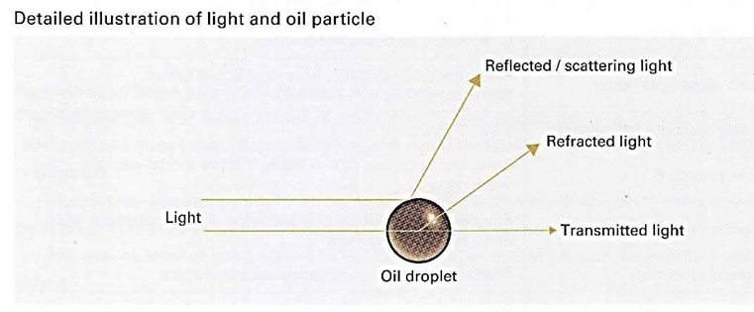

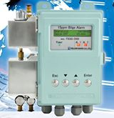

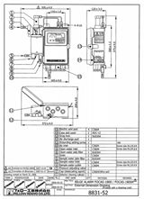

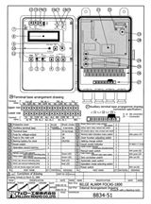

Top of Form

tern Tube Bearing & Lubrication System
။။။။။။။။။။။။။။။။။။။။။။။။။။။။။။။။။။။။။။။။။။။။။။။။။။။။
သေဘာၤရဲ႔ Propeller Shaft ကို Tail Shaft or Tail End Shaft လို႔လည္း ေခၚပါတယ္..။
သူဟာ..သေဘာၤကိုယ္ထည္ Hull ကို ၿဖတ္ၿပီး အၿပင္ထြက္ရမယ္.။
ၿပီးမွ Propeller ကိုတပ္ရမယ္..။
အဲဒီလို Hull ကို ၿဖတ္ထြက္တဲ႔အခါ..ေရလံုေအာင္စီမံႏိုင္ဘို႔.
Stern Tube ထဲက ၿဖတ္ၿပီ ထြက္ပါတယ္..။
။။။။။။။။။
Shaft က Stern Tube ထဲမွာ လည္ပတ္တဲ႔အခါ Bearing လိုလာပါတယ္.။ Lubrication လိုလာပါတယ္..။
ေရွးက..Water Lubrication System ၿဖစ္ပါတယ္..။
Bearing က LIgnum Vitea ၿဖစ္ပါတယ္..။ သက္ရင္႔ သက္မာ တမ်ိဳးပါ..။
Aft မွာ Seal မလုပ္ထားဘူး.၊ Fordward မွာေတာ႔..စက္ခန္းထဲ ေရ၀င္နည္းေအာင္ Gland ရွိပါတယ္..။
။။။။။။။။။
ေနာက္ပိုင္းေတာ႔ Oil Lubrication System သံုးလာပါတယ္..။
Bearing က White Metal ၿဖစ္ၿပီး..။ ဆီမထြက္ ..ေရမ၀င္ေအာင္
Forward Seal ေကာ..Aft Seal ပါရွိပါတယ္..။
။။။။။။။။။
အခု Water Lubrication ၿပန္ေခတ္စားလာၿပန္ပါၿပီ.။
၁၀ ႏွစ္ေက်ာ္ပါၿပီ..။
။။။။။။။။။
ထိပ္တန္း Maker တခုၿဖစ္တဲ႔ Thordon ရဲ႔.2016.Technical Paper ေလးကို
ဖတ္ၿဖစ္ေအာင္ PDF ကို JPEG ေၿပာင္းၿပီး..တင္ေပးလိုက္ပါတယ္..။
။။။။။။။။
၀င္းေအာင္
ေရေႀကာင္းေက်ာင္းဆရာ
အခ်ိန္၇သေလါက္ေၿဖေပးလိုက္ပါတယ္။ ကုန္ခ်ေနတဲ႔အခ်ိန္ဆိုေတါ႔ နဲနဲေတါ႔အလုပ္မ်ားလို႔ပါဆ၇ာ
1-AC 4 မွာ OVERSPEED ဘယ္လိုစမ္းမလဲ(ဒါက SAFETY SYSTEM ထဲပါတယ္။)
a-KEY OPEN လုပ္၇ပါမယ္။ Opcode 41 rpm detector system 1 ကိုသြါး။ၿပီး၇င္ parameter အကြက္မွာ SI ေၿပာင္း။(UP/DOWNနဲ႔)
B-VALUE မွာ TRUE ေၿပာင္း။ ၿပီး၇င္ ENTER။ --ဒါဆို SIMULATION လုပ္တါၿဖစ္သြါးပါၿပီ
C .ၿပီး၇င္ PARAMETER Rp ကိုၿပန္သြါး။ value ကို ၁၃၈.၄ အေပၚ ( 115% of MCR) ေ၇ာက္ေအါင္တင္။ ENTER နိွပ္။ ဒါဆို overspeed alarm လါပါလိမ္႔မယ္။
စမ္းၿပီးသြါး၇င္ - RP ကို သံုညၿပန္ထါး။ SI ကို FALSE ၿပန္ထါး။ ၿပီး၇င္ ENTER နိပ္။ေသါ႔ပိတ္။ဒါပါဘဲ။

2-သေဘါၤမွာ provision plant compressor ၇ဲ႔ sump oil ေတြခဏေလးနဲ႔ေပ်ာက္သြါးတယ္။ ဘါေၿကာင္႔ၿဖစ္နိုင္လဲ။ ဘါကိုလဲ၇မလဲ
Oil separator လဲ၇န္
3-Fridge compressor တခု၇ဲ႔ Oil separator လဲဖို႔ အသစ္တခု၇ိွတယ္ဆိုပါေတါ႔။ gas welding torch, silver rod ( 15% silver) ေ၇ာ၇ိွတယ္ဆိုပါေတါ႔။အဲဒါေတြ အၿပင္ဘါေတြလိုေသးလဲ၊
သြယ္ထါးတဲ႔ပိုက္ က 22mm ပိုက္ဆို 22.08 mm inside diameter ၇ိွတဲ႔ Cu socket pipe ေတြ။ flux ေတြလိုေသးပါတယ္။ gas welding torch ကို အသစ္ထည္႔တဲ႔Cu pipe ေပၚ အပူေပးၿပိး silver rod အလိုလို အဲဒီ ၀.၀၈ mm gap ထဲ၀င္လါေအါင္လုပ္တါပါ။
4-Gas welding နဲ႔ပတ္သက္လို႔ backfire နဲ႔ flashback ဘါကြါ့လဲ။
တကယ္လို႔ torch tip မွာ burning back ၿဖစ္၇င္ back fire, torch အထဲၿဖစ္ၿဖစ္။ torch mixing chamber ေနာက္ပိုင္းမွာၿဖစ္ၿဖစ္ flame burn ၿဖစ္ခဲ႔၇င္ flash back, ဒါေၿကာင္႔ flash back ကပိုေၿကာက္စ၇ာေကါင္းပါတယ္။ back fire က ၿကားေနၿကအတိုင္းအသံက်ယ္က်ယ္ၿကားၿပီး မီးေတါက္ၿငိမ္းသါြးတါမ်ားပါတယ္။ flash back က hissing or squealing sound ထြက္လါၿပီး tip ထိပ္က flame မွာ မီးခိုးအူလါမယ္။မီးစြယ္ sharp point ၿဖစ္လါမယ္။

5-မီးစက္တလံုး Oblique con rod type ဆိုပါေတါ႔။ con rod ၇ဲ႔ big end bearing bore ovality ဘါေၿကာင္႔ ၿဖစ္တါလဲ။ crankcase inspection လုပ္ေန၇င္း serration စါးတါ မ်ားေနေၿကာင္းမၿဖဳတ္ၿကည္႔ဘဲ လြယ္လြယ္အၿကမ္းဖ်င္း ခန္႔မွန္း နိုင္တဲ႔ နည္းလမ္း၇ိွလါး။
Crank bearing bore ovality ၿဖစ္၇တဲ႔အေၿကာင္း။ suction stroke မွာ ၿဖစ္တဲ႔ ပစ္စတင္၇ဲ႔ inertia force က bearing keep 2 ၿခမ္းကို ဆဲြခြါသလို သက္ေ၇ာက္ပါတယ္။ upper serration mating surface opening ပိုမ်ားလါတယ္။ fretting ေၿကာင္႔ upper serration wear out ပိုၿဖစ္လါတယ္။ ဒီေတါ႔ serration surface – 2 ခုထိတဲ႔area နဲလါတယ္။ bolt ၇ဲ႔ axial force က်လါတယ္။ဒါေၿကာင္႔Serration ေတြပိုစါးလါတယ္။ ၿကာေတါ႔ bearing nut ေတြတိုက္ၿပီး တိုင္းတဲ႔ အခါ bearing bore ဟါ elliptical shape ၿဖစ္လါတယ္။တင္းေအါင္ တိုက္လဲ bearing clearance က်လါၿ႔ပီး bearing ေလါင္တါၿဖစ္လါမယ္။
Crankcase inspection လုပ္တံုး Maker recommend ေပးထါးတဲ႔ torque နဲ႔တိုက္စစ္လို႔ bolt လိုက္လည္လါ၇င္ serration စါးေနၿပီလို႔ အၿကမ္းဖ်င္းယူဆလို႔၇ပါၿပီ။ၿဖဳတ္ၿပီးထပ္စစ္ၿကည္႔ပါ။
6-MC Engine တလံုး starting system မွာ ပါတဲ႔ valve 25 ယိုေန၇င္။မေကါင္း၇င္ ဘါၿဖစ္နုိင္လဲ။
Stop signal လြတ္ထြက္လါနိုင္လို႔ အင္ဂ်င္ run ေနတံုး puncture valve ဆီေလေ၇ာက္လါနိုင္ပါတယ္။
7-MC Engine တလံုး ။ nor control AC 4 ဆိုပါေတါ႔။BRIDGE CONTROL ကေန Emergency local panel ကိုေမါင္းေနတံုးေၿပာင္းလို႔၇လါး။ ၇၇င္ဘယ္လိုေၿပာင္းမလဲ။
အင္ဂ်င္ေမါင္းေနတံုး Emergency control ကိုေၿပာင္းခ်င္၇င္
For changing-over to 'Emergency Control' with running engine, see ltem 8.4
'Emergency Control from Engine Side'.
1. Check that valve (105)' which is the "telegraph handle" of the emergency control system, is in the required position. Note that reversing to a new direction is only possible when STOP valve (1 02) is activated.
ေမါင္းေနတဲ႔ direction ဖက္ကို telegraph handle ( emergency console က) ၁၀၅ ကိုထါးပါ။
2. Turn the handle 'A' anti-clockwise to free the regulating handwheel 'B'.
Regulating handle ကို lock လုပ္တဲ႔ handle A ကို unlock လုပ္ပါ။
3. Put the blocking arm in emergency position.
4. Turn handwheel 'B' to move the innermost lever of the change-over mechanism
Local fuel handwheel B ကို အေပၚက change over mechanism မွာ ေၿပာင္း၇လြယ္တဲ႔အေနေ၇ာက္ေအါင္လွည္ပါ။
'C' to a position where the impact handwheel 'P' is able to enter the tapered
slots in both levers. Quickly, turn the impact handwheel 'P' anti-clockwise. This
causes disconnection of the governor and connection of the regulating
handwheel 'B' to the fuel pumps.
ၿပီး၇င္ေၿပာင္းတဲ႔ impact handwheel P ကို ANTI CLOCKWISE လွည္႔ပါ။
ၿပီးတါနဲ႔ CHANGE POSITION OF VALVE 100 ကို NORMAL ကေန EMERGENCY ကိုေၿပာင္းပါ။ ဒါဆို CONTROL AIR က LOCAL MANOEUVRING ကိုေ၇ာက္လါလိမ္႔မယ္။

8-Nor control AC 4 , MC Engine ဆိုပါေတါ႔။ crash astern နဲ႔ ၇ိုး၇ိုး astern ဘါကြါလဲ။
အေတၚမ်ားမ်ားသိၿကမွာပါ။
9-MC Engine ေတြမွာ exhaust valve knocking ၿဖစ္၇င္ဘါကိုၿကည္႔မလဲ။
Exhaust valve knocking is caused by insufficient cushioning in the hydraulic oil system. This is basically due to three different reasons:
1) deficiencies in the oil supply,
2) errors in the air spring,
3) excessive leakage in the high pressure oil system.
1) Deficiencies in the oil supply can, for instance, be:
a) air in the oil (foaming), most possibly caused by air being drawn-in at the pump (suction side),
b) too low supply pressure,
c) too high oil temperature, giving low viscosity.
2) Errors in the air spring system can be:
a) incorrect supply pressure (too high).
b) a defective or maladjusted safety valve (drain valve).
It is very important that the supply air pressure and the safety valve opening pressure correspond as follows:
Supply pressure (bar) Opening pressure (bar)
5.5 17.5
7.0 21.0
3) Excessive (abnormal) leakages in the high pressure oil system can, for instance, occur at:
A*) a maladjusted or defective throttle screw,
B*) the oil cylinder piston rings, on either cam or exhaust valve sides (new type S-lock rings might help),
C*) the oil cylinder safety valve, on the cam side. This leakage can arise from the valve seats, or from the sealing ring (packing) between the valve and the housing. The sealing ring must be a special narrow steel type,
D*) the puncture non-return valve, caused by spindle
maladjustment, or defective non-return valve seats, E*) high pressure pipe joints, caused either by insufficient/uneven tightening, or by damaged surfaces, F*) the venting valve at the top of the exhaust valve
10-L23/30H Engine ေတြမွာ lambda controller ဆိုတါဘါလဲ။ အဲဒီမွာ ေလလိုင္း ၂ ခုပါတယ္။ အဲဒါေတြဘယ္ကလါလဲ။ အဲဒီ lambda controller က အင္ဂ်င္ rpm ကိုဆြဲဆြဲခ်ေန၇င္ ဘါက္ိုစစ္၇မလဲ၊
ေလလိုင္းတခုက OVERSPEED DEVICE က ။ ေနာက္တလိုင္းက CHARGE AIR LINE က။ OVERSPEED DEVICE က 3WAY VALVE OVERHAUL လုပ္သင္႔ပါတယ္။
11-သေဘါၤေပၚမွာ ballast valve, fuel tank valve ေတြကိုဖြင္႔တဲ႔ valve remote control system မွာ N2 ၿဖည္႔ထါးတဲ႔ BLADDER သံုး Accumulator ပါတယ္ဆိုပါေတါ႔ / အဲဒီ bladder ေကါင္းမေကါင္းဘယ္လိုသိနိုင္မလဲ
Isolate the fully-charged bladder accumulator from the hydraulic system by closing the shut-off valve A. Very slowly discharge the accumulator on the fluid side via drain valve E. The pressure gauge must be constantly monitored during this process. A slow, steady pressure drop is displayed. The pressure only drops abruptly when the accumulator has been completely discharged. The pressure displayed before the drop corresponds to the pre-charge pressure of the bladder accumulator. ေၿဖးေၿဖးၿခင္း pressure က်၇င္ bladder ေကါင္းပါတယ္။
BLADDER သံုး HYDROPHORE TANK နဲ႔တူပါတယ္။
12- ECR control room ၇ ဲ႔ AC 4 မွာ UNIT(PANEL) ၃ ခု၇ိွတယ္။အဲဒါဘါေတြလဲ။DGU မွာ REGULATOR နဲ႔ ACTUATOR ၂ ခုပါတယ္။ တကယ္လို႔ အင္ဂ်င္စနိုးခ်ိန္ေကြ်းတဲ႔ ဆီပမါဏကိုေၿပာင္းခ်င္၇င္ REGULATOR ဖက္ parameter မွာေၿပာင္း၇မလါး။ ACTUATOR ဖက္ က ေၿပာင္း၇မလါး။
Regulator ဖက္ parameter ကေၿပာင္းပါ။
13-AC4 Unit တခု DGU REGULATOR ဖက္မွာ IN DATA ERROR ALARM လါၿပီးေတါ႔ F.O INDEX က သံုညကိုဆင္းသြါးၿပီးၿပန္မတက္လါလို႔ အင္ဂ်င္နိဳးလို႔မ၇ေတါ႔ဘူးတဲ႔။ဘါေၿကာင္႔လဲ။ဘယ္လိုၿပင္မလဲ
Information parameters.
တကယ္လို႔ အင္ဂ်င္ေမါင္းေနတံုး black out ၿဖစ္၇င္ indata error ၀င္နိုင္တယ္။ ecr & BR က lever ေတြသံုညမွာထါးပါ။ scavenge air sensor အတြက္ကေတါ႔ governor unit ကို switch on/off လုပ္ၿကည္႔ပါ္။
PARAMETER 11 & 12 ကေတါ႔ memory function ၇ိွလို႔ errors နဲ႔ latch ၿဖစ္ေနတတ္လို႔ reset ။ ပါ၀ါခ်။တင္ လုပ္လို႔မ၇တတ္ပါ။အဲလိုပါ၀ါအတင္အခ်လုပ္ ၿပီး ၇င္ - value up button နဲ႔ fail တခုထက္ပိုလါ၇ွာၿကည္႔။ၿပီး၇င္
10-other alarm ကိုေ၇ြးပါ။ IN DATA ERROR ဆို၇င္ UP BUTTON နဲ႔ reset လုပ္မွ par 11 &12 memory ကိုေဖ်ာက္နိုင္ပါမယ္။
CE အခန္းထဲကေသါ႔ယူပါ။ CHANGE LOCK KEY ဖြင္႔ပါ။SERVICE CODE 47 ထည္႔ပါ။ၿပီး၇င္ေသါ႔ၿပန္ပိတ္ပါ။ ဒါဆို OP CODE 0- 13 အတြင္းၿကည္႔လို႔၇ပါၿပီ။လိုခ်င္တဲ႔ OP CODE ကိုေ၇ြးပါ။ လိုခ်င္တဲ႔ PARAMETER ကိုသြါးဖို႔ change lock key ကိုၿပန္ဖြင္႔ပါ။ ေၿပာင္းလို႔၇တါဆိုေၿပာင္းနိုင္ပါၿပီ။ ေၿပာင္းလို႔ၿပီး၇င္ service code ကို သံုည ဆိုၿပီးထည္႔ပါ။ save ကိုနိပ္ပါ။ ၿပီး၇င္ change lock key ကိုပိတ္ၿပီး ေသါံ့ကိုၿပန္သိမ္းပါ။
Parameter II & 12 on both sides will give more information.
အဲဒီ PARAMETER 11 &12 ကိုအေပၚ CHANGE LOCK KEY နဲ႔ၿကည္႔နိုင္ပါတယ္။

The Indication lamp and the parameters (11 & 12) has a memory-function that latches up all errors that has occurred. It is possible to scan thruogh with value Up button to see if more than one fail has occured.
After investigating the fail on parameter 11 or 12, select parameter 10 Other Alarm to reset
alarms by pushing the value Up button. The memory on par 11 and 12 will then be reset
also.

14-AC 4 နဲ႔ထိန္းတဲ႔ အင္ဂ်င္ကၿကာလါေတါ႔ FUEL PUMP ေတြက်လါတယ္ဆိုပါေတါ႔။အသစ္ထက္ပိုၿပီး ဆီေက်ြးမွနိုးမယ္ဆို၇င္ ဘယ္လိုလုပ္၇မလဲ
-NORMAL START FUEL SET POINT, HEAVY START FUEL SETPOINT ဆိုၿပီး DGU REGULATOR PARAMETER – 12, 13 မွာ၇ိွပါတယ္။ HEAVY START က ပထမတခါနိုးလို႔ မနိုး၇င္ဒုတိယတခါထပ္နိုး၇င္ေက်ြးတဲ႔ဆီ။
ဒီေတါ႔ ၁၂ကိုခ်ိန္ေပး၇မယ္။ နဂိုက ၄၀ ဆို၇င္ ၄၅ ေလါက္ေပးလိုက္ပါ။
လုပ္ပံုက
၁-DGU ACTUATOR ဖက္က KEY ကိုဖြင္႔။( KEY မဖြင္႔၇င္ ၁ ကေန ၁၀ ထိဘဲေၿပာင္းလို႔၇တယ္။) ၂- ၿပီး၇င္ REGULATOR SIDE က PARAMETER 99 ကိုသြါး။ ၿပီး၇င္ SERVICE CODE ( စါအုပ္မွာေပးထါးတတ္တယ္။ EXPERT parameter ေတြ အတြက္ေတါ႔မ၇ဘူး။) ထည္႔ပါ။ ၃-ၿပီး၇င္ KEY ကိုၿပန္ပိတ္ပါ။ ပိတ္လုိက္တါနဲ႔ REGULATOR SIDE ဖက္က PARAMETER NO အကြက္မွာ သံုည , DATA VALUE အကြက္မွာ သံုည။ ၿပေနလိမ္႔မယ္။ ၄-အဲဒီ DATA VALUE အကြက္မွာ 1 ကိုထည္႔လိုက္၇င္ အဲဒါ Opcode 1 ကိုသြါ့းတါဘဲ။ အဲလို ၁ ထည္႔ၿပီးတါနဲ႔ key ကို ဖြင္႔လိုက္ပါ။ ဒါဆို Opcode 1 အဆင္႔ကိုေ၇ာက္ၿပီ။ parameter မွာ ၁၂ ေ၇ာက္ေအါင္အေပၚေအါက္မွ်ားနဲ႔သြါးပါ။ဒါဆို parameter 12 အတြက္ တန္ဖိုး ၄၀ ဆိုတါလါၿပလိမ္႔မယ္။ အဲဒီ ၄၀ ကို ၄၅ ေလါက္ေ၇ာက္ေအါင္အေပၚေအါက္မ်ွားနဲ႔ေၿပာင္းလိုက္ပါ။ၿပီး၇င္ save ကိုနိပ္ပါ။(key open မွာ save လုပ္ပါ။) ၅-ၿပီး ၇င္ key ကိုၿပန္ပိတ္ပါ။သူဖါသူparameter 99 ကိုၿပလိမ္႔မယ္။ service code သံုညထည္႔ပါ။ key ကိုၿဖဳတ္သိမ္းပါ။မေမ႔ပါနဲ႔။အခန္းထဲသိမ္းထါးပါ။
ဒါဆို အင္ဂ်င္နိွုးလို႔ဆီေက်ြး၇င္ ၄၅ အမွတ္ေ၇ာက္ေအါင္ပိုေက်ြးလိ္မ္႔မယ္။

15-AC 4 (AUTOCHIEF 4) သံုး အင္ဂ်င္စံနစ္တခုမွာ BRIDGE CONTROL ေပးထါးတယ္။ BRIDGE ကေနနိွုးတဲ႔ START SIGNAL ေအါက္ က VALVE 65 ကို ေ၇ာက္မေ၇ာက္ AC4 ကေနဘယ္လိုၿကည္႔မလဲ။
Opcode 66 က ahead solenoid valve အတြက္။ သူက control room I/O SIGNAL အဖြဲံ႔ထဲပါလို႔ သူကိုစမ္း၇င္ I/O COMMIS OP.CODE (49) PUSH BUTTON ကိုနိပ္၇မယ္။(REMOTE CONTROL SYSTEM)( SAFETY SYSTEM မဟုတ္ပါ) ၂ခါနိပ္၇င္ FLASH LIGHT ၿဖစ္မယ္။
ဒါဆို Opcode 66 ၇ဲ႔ ္ PARA D0 ကိုၿကည္႔။B/R LEVER START ထါးလဲ PARA DO က OPEN ဆို START SIGNAL မေ၇ာက္ပါ။
၁၆- CONTROL SYSTEM (AC4) ေလါက္ထိမပါေသးပါဘူး။ေနာက္ပုိင္း NOR CONTROL ေတြမွာပါလါနိုင္လို႔၊ HART PROTOCOL, FIELDBUS PROTOCOL, PROFIELDBUS PROTOCOL, ASI PROTOCOL စတါေတြကဘါေတြလဲ။ ဘါကြါ့လဲ၊ PROFIELDBUS DP နဲ႔ PROFIEDBUS PA ဘါကြါ့လဲ။HART MULTIPLEXER ဆိုတါဘါလဲ၊
Hart protocol-ပံုမွန္သံုးတဲ႔ 1 pair wire မွာ signal channel တခုဘဲလြတ္တယ္။ hart ဆို၇င္ ၁ pair wire မွာ (2) simulanous channels ပါပါတယ္။
Fieldbus protocol- fieldbus device မွာ block 3 ခုပါပါတယ္။ ၁-transducer block, 2-resource blocks, 3- function block တိုၿဖစ္ပါတယ္။
Profibus protocol-အဲဒီ BUS စံနစ္က ၇ိွသမ်ွ Discrete I/O & Analog I/O ေတြအကုန္ကို ထိန္နိုင္ဖို႔လုပ္ထါးတါၿဖစ္ပါတယ္။ MAKER မတူလဲ ေ၇ာသံုးနိုင္ဖို႔လုပ္ထါးပါတယ္။
Analog device ေတြကို profibus PA မွာထါးၿပီး motor starter/ vsd စတါေတြ profibus DP မွာထါးပါတယ္။
Asi protocol – bit oriented design ၿဖစ္ပါတယ္။ intelligent wiring solution လို႔လဲေခၚပါတယ္။ ၇ိွသမွ်အါးလံုးကို SINGLE NETWORK wire တလိုင္းထဲနဲ႔ဆက္နိုင္ပါတယ္။
Profibus dp-(DP = Decentralized Periphery) , physical layer(transmission tech) အေနနဲ႔ RS 485,FIBER OPTIC,RS485Is,စတါေတြကိုသံုးပါတယ္။profibus dp နဲ႔ profibus pa ကို dp/pa coupler နဲ႔ဆက္ပါတယ္။ထံုးစံအတိုင္း DP ကအေပၚက ။ PA ကေအါက္ကၿဖစ္ပါတယ္။ PA က FIELD DEVICE ေတြၿဖစ္ၿပီး DP က HMI,REMOTE I/O တို႔ၿဖစ္ပါတယ္။
Profibus pa -သူကို process industry မွာသံုးပါတယ္။ANALOG DEVICE ေတြကို DIGITAL NETWORK ကေနထိန္းတါပါ။ Manchester bus powered physical layer architecture ကိုသံုးပါတယ္။ field device ကို digital network ကတဆင္႔ control system သို႔ဆက္ပါတယ္။
Hart multiplexer-Hart device ကhart data ကို ၇ိုး၇ိုး I/O Card ဆီပို႔ေပးတဲ႔အခါ ၿကားခံဆက္သြယ္ေပးတဲ႔ device ၿဖစ္ပါတယ္။
၁၇-fuel oil & air flow ကို cascade သံုးထါးတဲ႔ boiler combustion system တခုမွာ air flow ကို cascade ထါး၇င္ အ၇မ္းhunting ၿဖစ္တယ္။ air flow control မွာ manual ထါးလိုက္၇င္မၿဖစ္ေတါ႔ဘူး။ဒါဘါေၿကာင္႔ၿဖစ္နိုင္လဲ၊
F.O FLOW FEED BACK OR AIR FLOW FEED BACK မမွန္လို႔
၁၈-boiler တလံုးမွာ fuel နဲ႔ combustion air flow ကို PID CONTROLLER တလံုးစီနဲ႔ခ်ိန္တယ္.။ AIR FLOW CONTROLLER မွာ PID OUTPUT HIGH LIMIT နဲ႔ PID OUTPUT LOW LIMIT ဆိုၿပီး SETTING ၂ ခုပါေနတယ္။ အဲဒါဘါကိုဆိုလိုခ်င္တါလဲ။အဲဒါကိုခ်ိန္၇င္ဘယ္ေန၇ာမွာဘါအက်ိဳးသက္ေ၇ာက္မွဳ၇ိွမယ္ထင္လဲ။
AIR DAMPER MAX POSITION & MIN POSITION
၁၉-အဲဒီဘိုြင္လါမွာဘဲ IGNITION ၿဖစ္တဲ႔အခ်ိန္မွာ ေပးတဲ႔ FUEL နဲ႔ AIR ကိုဘယ္လိုခ်ိန္မလဲ။ အေပၚက လို PID OUTPUT LOW & HIGH LIMIT ေတြက ဒီ IGNITION FUEL & AIR SETTING ေတြမွာ အက်ိဳးသက္ေ၇ာက္မွဳ၇ိွနိုင္လါး။
fuel controller နဲ႔ air controller မွာ ignition အခ်ိန္အတြက္ သတ္သတ္ခ်ိန္ေပးနိုင္ပါတယ္။ ဒါေပမဲ႔ PID LOW OUTPUT က ပိုၿမင္႔ေန၇င္ အဲဒီ IGNITION အတြက္ခ်ိန္ထါးတဲ႔အမွတ္ကိုေ၇ာက္လါမွာမဟုတ္ပါဘူး။
2၀-SLOW SPEED ENGINE ေတြမွာ high peak loading of Bearing ဟါဘယ္အခ်ိန္မွာၿဖစ္နုိင္လဲ။
(low inertia mass force compare to gas pressure force)
(low inertia mass force compare to gas pressure force ဆိုေတါ႔ overload အခ်ိန္ေပါ)
21- indicator diagram power card ကေန Pi ကိုတြက္တဲ႔အခါ card area ကို length of indicator card diagram နဲ႔စါး၇တယ္။ အဲဒီ length of indicator card မွာ expansion အဆံုးနဲ႔ compression မစခင္ၿကား ( scavenge port စဖြင္႔ ခ်ိန္ကေန ပိတ္တဲ႔ အခ်ိန္ထိ္ ) ေကါပါလါး။
ပါပါတယ္။ ဘါလို႔လဲဆိုေတါ႔ length of indicator card က TDC ကေန BDC ထိၿဖစ္လို႔ပါ။
22-MC engine operation shop test report engine specification မွာ cylinder coefficient , bar & kw ဆိုၿပီးပါတတ္တယ္။အဲဒါဘါကိုေၿပာတါလဲ။
23- MC engine indicator card area ကို length of indicator card diagram နဲ႔စါးၿပီး spring constant နဲ႔စါးေပး၇မလါး။ေၿမွာက္ေပး၇မလါး။တြက္လို႔၇လါတဲ႔ pressure က mep လါး။ mip လါး။
စါး၇ပါမယ္။ mip ပါ။
24-အဲဒီ TRAIL RESULT မွာေပးတဲ႔ POWER က mep နဲ႔တြက္တါလါး။ mip နဲ႔တြက္တါ လါး။
Mep နဲ႔တြက္တါပါ။
25-Pe = k2 . n . pe ( k2= 1.7151 for S70MC , 0.6545 for S50MC) လို႔ေပးထါးတယ္။ အဲဒီ k2 ကို MC Engine မွာဘါေခၚလဲ၊
CYLINDER COEFFICIENT , BAR & KW
N=rpm, pe-mep
26-boiler ၇ဲ႔ fuel regulator actuator က ေလယိုေနလို႔ နဲနဲ pressure ကစါးေနတယ္။ တကယ္လို႔ fuel controller နဲ႔ air controller က cascade လုပ္ထါး၇င္ဘါၿဖစ္နုိင္လဲ၊
Air controller ပါလိုက္ၿပီး hunting ၿဖစ္လါပါမယ္။
27- SLOW SPEED ENGINE ေတြမွာ high mean loading of Bearing ဟါဘယ္အခ်ိန္မွာၿဖစ္နုိင္လဲ။
Max rpm limit ဖက္ေန၇ာနားက။ torsional vibration လဲမ်ားလါပါတယ္။
28-MCR 127 ေလါက္ေမါင္းနိုင္တဲ႔အင္၈်င္ RPM 70 ေလါက္မွာ OVERLOAD ၿဖစ္နိုင္လါး။တကယ္လို႔ ၿဖစ္နိုင္၇င္ဘယ္အခ်ိန္မ်ိဳးၿဖစ္နိုင္တယ္ထင္လဲ။
ေသါင္တင္တဲ႔အခ်ိန္မ်ိဳး။ quay မွာ mooring လုပ္ၿပီး အင္ဂ်င္ေမါင္းတါမ်ိဳး/ propeller ထဲ mooring rope ၀င္တါမ်ိဳး
29-Differential pressure transmitter နဲ႔ tank တခုကို level တိုင္းတဲ႔အခါ wet leg နဲ႔ dry leg ဘါကြါလဲ၊
Wet leg ဆို၇င္ tank ေအါက္ၿခမ္း က ယူတဲ႔ပိုက္ကို dp cell ၇ဲ႔ low pressure side မွာတပ္ပါတယ္။ dry leg ဆို tank ေအါက္ၿခမ္းက ယူတဲ႔ပိုက္ကို High pressure side မွာတပ္ပါတယ္။
၃၀-ဘ္ိုိြင္လါ level တိုင္းဘို႔ dp transmitter ကို wet leg သံုးလါး။ dry leg သံုးလါး။
ဘိြုင္လါမွာ level တိုင္းဖို႔ dp transmitter ကို wet leg သံုးၿကပါတယ္။
၃၁-တကယ္လို႔ boiler gauge glass blow down လုပ္သလို wet leg dp transmitter ကို blow down လုပ္ၿပီး ပံုမွန္ အတိုင္း cock ေတြၿပန္ဖြင္႔ခဲ႔ ၇င္ ပံုမွန္ water level ခ်က္ၿခင္းၿပပါ႔မလါး။ ဘါေၿကာင္႔လဲ။
မၿပပါဘူး။ wet leg ၇ဲ႔ seal pot မွာ seal liquid ကုန္သြါးလို႔ၿဖစ္ပါတယ္။
32-တကယ္္လို႔ ဘိုြင္လါကလါတဲ႔ steam flow ကိုတိုင္းတဲ႔ dp transmitter ၇ဲ႔ အ၀င္ isolating valve ေတြ။ diff pressure transmitter ၇ဲ႔ high & low side stop valve ေတြ။ equalizing valve ေတြအကုန္ full turn ဖြင္႔ခဲ႔၇င္ဘါၿဖစ္နိုင္လဲ။
Dp transmitter ပ်က္သါြးနိုင္ပါတယ္။
33- dp transmitter တလံုး၇ဲ႔ high side & low side ေတြ၇ဲ႔ pipe line ေတြမွားဆက္မိ၇င္ dp transmitter ပ်က္နိုင္လါး၊
မပ်က္ပါဘူး။ တိုင္းလို႔၇တဲ႔ result မမွန္၇ံုဘဲ၇ိွပါမယ္။
34- DP TRANSMITTER နဲ႔ CLOSE TANK တခုကို LEVEL တုိင္းတဲ႔အခါ DP CELL ၇ဲ႔ HIGH SIDE နဲ႔ LOW SIDE ကို TANK နဲ႔ ဘယ္လိုဆက္လဲ။ဘါေၿကာင္႔လဲ။
၇ိုး၇ိုး close tank တခုကို dp cell နဲ႔တိုင္းတဲ႔အခါ dry leg ကိုဘဲသံူးၿကလို႔ High side ကို tank ေအါက္ပိုင္းနဲ႔ low side ကို tank အေပၚပိုင္းနဲ႔ဆက္ပါတယ္။
35- Tanks ေတြ၇ဲ႔ VALVES ေတြကို အပိတ္အဖြင္႔လုပ္တဲ႔ remote valve control system တခု၇ဲ႔ hydraulic pump ဟါ valve ေတြကိုအပိတ္အဖြင္႔မလုပ္လဲ SYSTEM PRESSURE က်လို႔ PUMP ကလည္လိုက္၇ပ္လိုက္ၿဖစ္ေနတယ္။အဲဒါဘါလို႔လဲ။
အဲဒါ ပံုမွန္ပါဘဲ။ tank အပိတ္အဖြင္႔ ဗါး ေတြ၇ဲ႔ pilot valve ေတြက နဲနဲေတါ႔ leak ၇ိွၿကတါပါဘဲ။
၃၆-တကယ္လို႔ STEAM FLOW တခုကို DIFFERENTIAL PRESSURE TRANSMITTER နဲ႔ တိုင္း၇င္ TRANSMITTER ၇ဲ႔ HIGH PRESSURE SIDE & LOW PRESSURE SIDE ကိုဘယ္လိုဆက္မလဲ၊
ORIFICE မတိုင္ခင္ကို HIGH SIDE, ORIFICE ေနာက္ပိုင္းကို LOW SIDE
၃၇-MC ENGINE ၇ဲ႔ EXHAUST VALVE COOLING WATER OUTLET မွာ ORIFICE တခုထည္႔ထါးတယ္။ အဲဒါဘါလို႔ထည္႔ထါးလဲ။
လိုအပ္တဲ႔ pressure ကို cylinder liner အတြက္၇ေအါင္။ဒါမွ cavitation ၿဖစ္တါ။ေလခိုတါနဲ ၿပီး liner crack ၿဖစ္တါကို ကါကြယ္နိုင္မွာပါ
38- ကိုယ္႔၇ဲ႔ အင္ဂ်င္ ၁၀၀% rpm က ၁၂၇ ဆိုပါေတါ႔။ ကုန္တင္ထါးၿပီး ၇ာသီဥတုနဲနဲဆိုးတဲ႔အခ်ိန္ ၇ံုးက rpm 124 ေလါက္တင္ခ်င္တယ္ဆို၇င္ အင္ဂ်င္လဲမနာေအါင္ rpm လဲ ၁၂၄ ေပးထါးနိုင္ေအါင္ AC 4 မွာဘယ္လိုခ်ိန္မလဲ၊( သေဘါၤက DOCK ဆင္းတါ သိပ္မၿကာေသးဘူးဆိုပါေတါ႔)
Load diagram မွာ line 2 နဲ႔ line 6 ၿကားက အင္ဂ်င္ overload မၿဖစ္ဘဲေမါင္းနိုင္တဲ႔ ေန၇ာတခုပါ။ heavy running propeller curve ၿဖစ္တဲ႔ line 2 အထက္က မေမါင္းသင္႔ပါဘူး။ rpm 124 ဆိုေတါ႔ ၉၇.၆% engine speed , အင္ဂ်င္ shaft power 87% ေလါက္ဆို၇င္ေတါ႔အေကါင္းဆံုးေပါ႔။ဒါေပမဲ႔မ၇နိုင္ေလါက္ပါဘူး။ ဒါေတါ႔အလြန္ဆံုး 90 % ေလါက္ဘဲခ်ိန္ထါးသင္႔ပါတယ္။ MC Engine operation file က official test measure data မွာ ၉၀% အတြက္ fuel pump index ပါပါလိမ္႔မယ္။ အဲဒါနဲ႔မွန္းၿပီး DGU REGULATOR PANEL က PARA 6 MAN RPM LIMIT ကို ၁၂၄ ထါး။ PARA 7 MAN FUEL LIMIT ကိုခုနင္က FUEL PUMP INDEX ေလါက္၇ေအါင္ခ်ိန္ေပး။ၿပီးေတါ႔ POWER CARD ယူၿပီး POWER ကိုတြက္ယူပါ။လိုသလို MAN FUEL LIMIT ကိုအတိုးအေလ်ာ႔လုပ္ယူပါ။တခုသတိထါး၇မွာက ncr ဆိုတဲ႔ normal continuous rpm က ၈၅% power ဆိုတါကိုဘဲ။ ၈၅% ထက္မေက်ာ္ေအါင္ထါးပါ။၈၂% က အေကါင္းဆံုးပါဘဲ၊
An important parameter for a marine diesel engine is the rating figure, usually stated as bhp or kW per cylinder at a given rev/min.
Although enginebuilders talk of continuous service rating (csr) and maximum continuous rating (mcr), as well as overload ratings, the rating which concerns a shipowner most is the maximum output guaranteed by the enginebuilder at which the engine will operate continuously day in and day out. It is most important that an engine be sold for operation at its true maximum rating and that a correctly sized engine be installed in the ship in the first place; an under-rated main engine, or more particularly an auxiliary, will inevitably be operated at its limits most of the time. It is wrong for a ship to be at the mercy of two or three undersized and thus over-rated auxiliary engines, or a main engine that needs to operate at its maximum continuous output to maintain the desired service speed.
Prudent shipowners usually insist that the engines be capable of maintaining the desired service speed fully loaded, when developing not more than 80 per cent (or some other percentage) of their rated brake horsepower. However, such a stipulation can leave the full-rated power undefined and therefore does not necessarily ensure a satisfactory moderate continuous rating, hence the appearance of continuous service rating and maximum continuous rating. The former is the moderate in-service figure, the latter is the enginebuilder's set point of mean pressures and revolutions which the engines can carry continuously.
Normally a ship will run sea trials to meet the contract trials speed (at a sufficient margin above the required service speed) and the continuous service rating should be applied when the vessel is in service. It is not unknown for shipowners to then stipulate that the upper power level of the engines in service should be somewhere between 85-100 per cent of the service speed output, which could be as much as 20 per cent less than the engine maker's guaranteed maximum continuous rating.
39-Bottom of Form

39-boiler တလံုး၇ဲ႔ safety factor ဆိုတါဘါ လဲ၊
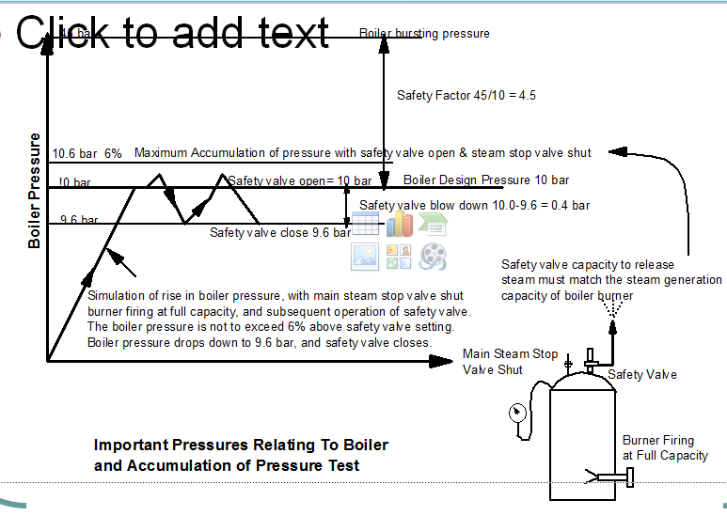
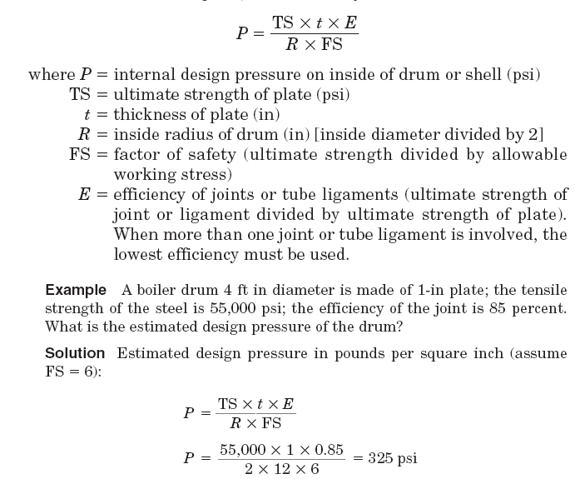
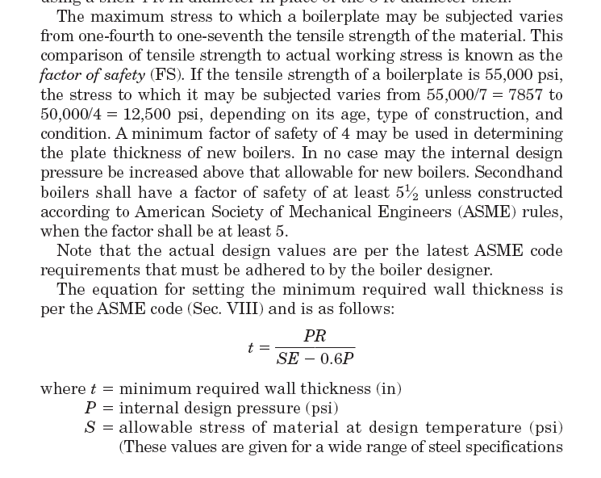
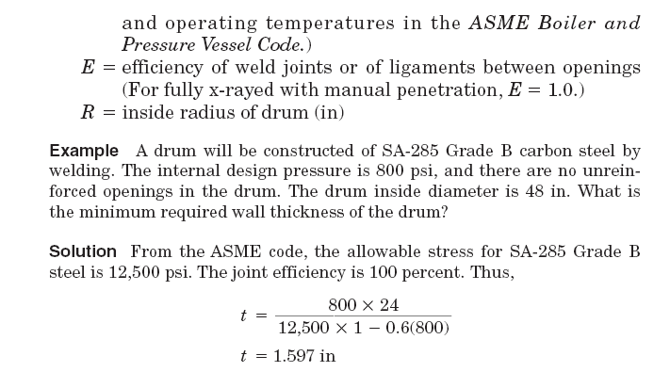
Safety factor ဆိုတါ Boiler bursting pressure ကို boiler design pressure နဲ႔ စါးထါးတါပါ။ အမ်ားအါးၿဖင္႔ ၄.၅ ေလါက္၇ိွၿကတါပါဘဲ၊(အသစ္ဆို၇င္ ၄ ေလါက္။အေဟါင္းဆို၇င္ ၅.၅ ေလါက္)
၃၉- ဘိြဳင္လါတလံုးမွာ safety factor ဆိုတါဘါလဲ။ boiler bursting pressure နဲ႔ဘယ္လိုဆက္နြုယ္ေနလဲ။
Boiler တလံုးကိုသံုးတဲ႔အခါ သူ႔၇ဲ႔ plate ေတြကိုသက္ေ၇ာက္ေနတဲ႔ max stress က သူကိုတည္ေဆါက္ထါးတဲ႔ material tensile stress ၇ဲ႔ ေလးပံုတပံုကေန ၇ ပံု တပံု ေလါက္ထိ၇ိွတယ္ဆိုပါတယ္။အဲဒီ actual working stress နဲ႔ tensile stress ၇ဲ႔ နွိုင္းယွဥ္ အခ်ိဳးကို safety factor လို႔ေခၚပါတယ္။ new boiler ဆို၇င္ ၄ ေလါက္အထိေပးၿပီး second hand boiler ဆို၇င္ ၅.၅ ေလါက္ဘဲ ေပးပါေတါ႔တယ္။
P=(TS x t x E)/( R x FS) ၿဖစ္ပါတယ္။
P= internal design pressure on inside of drum or shell,TS=ultimate strength of plast, t=Thickness of plate, R=inside radius of drum, FS=factor of safety(ultimate strength divided by allowable working stress),E = efficiency of joints or tube ligaments(ultimate strength of joint divided by ultimate strength of plate, when more than one joint or tube ligament is involved the lowest efficiency must be used)
အဲဒီေတါ႔-Safety factor ဆိုတါ Boiler bursting pressure ကို boiler design pressure နဲ႔ စါးထါးတါပါ။ အမ်ားအါးၿဖင္႔ ၄.၅ ေလါက္၇ိွၿကတါပါဘဲ၊(အသစ္ဆို၇င္ ၄ ေလါက္။အေဟါင္းဆို၇င္ ၅.၅ ေလါက္)
၄၀-L.T SYSTEM နဲ႔ COOLING လုပ္တဲ႔ MC ENGINE AIR COOLER တခု အတြက္ - တကယ္လို႔ LT CENTRAL COOLER CLEAN မလုပ္တါၿကာလို႔ COOLING EFFICIENCY သိပ္က်၇င္ဘါၿဖစ္နိုင္သလဲ။
သတိၿပဳ၇မွာက h.t system မွာ deaerator ပါေပမဲ႔ LT SYSTEM မွာမပါပါဘူး။ ဒါေၿကာင္႔ LT Temperature သိပ္ၿမင္႔လါၿပီး တကယ္လို႔ LT PUMP ေတြ wearing ring ေတြသိပ္စါးေန၇င္ pump efficiency ပါက်ေန၇င္ pump မွာေလခိုၿပီး pump pressure က်တတ္ပါတယ္။အဲဒီလုိ pump pressure က်၇င္ charge air cooler ကိုအၿဖတ္မွာ LT water ေတြ steam ၿဖစ္ပါလိမ္႔မယ္။ ( load 85% မွာ charge air inlet air cooler ဟါ 148’C ေလါက္၇ိွပါတယ္။) ဒါဆို air cooler tube ေတြေပါက္တါၿဖစ္လါပါလိမ္႔မယ္။ ေနာက္ၿပီး air cooler အထြက္ LT pressure က rpm 120 ေလါက္မွာ charge air pressure ထက္နဲပါတယ္။ ( air cooler မွာ LT Pressure -1.7 bar , charge air pressure - ၁.၉၂ bar )ဒါေၿကာင္႔ charge air က LT System ထဲ၀င္ဘို႔မ်ားပါတယ္။
၄၁- RADAR ေတြမွာ MEGNETRON ဆိုတါဘါလဲ။ MEGNETRON မပါတဲ႔ RADAR ၇ိွလါး။
KEY OSCILLATOR TRANSMITTER မွာ၇ိွတဲ႔ MEGNETRON ဆိုတါ POWER OSCILLATOR ELECTRON TUBE တခုပါ။ MAGNETIC FIELD OF CATHODE နဲ႔ ELECTRIC FIELD PRODUCE FROM PLATE တို႔ CYLINDERICAL CAVITIES ထဲမွာ PERPENDICULAR ၿဖစ္ေအါင္ TUNE လုပ္လို႔ rf ELECTRIC FIELD ေပၚလါပါတယ္။ ELECTRON TUBE ထဲက ELECTRON ေတြဟါ အဲဒီ FIELD ေတြနဲ႔ INTERACT ၿဖစ္ၿပီး ၆၀၀ - ၃၀၀၀၀ MEGAHZ ၇ိွ MICROWAVE PULSE ေတြကိုထုတ္ေပးပါတယ္။ အဲဒီ MICROWAVE PULSE ေတြက္ို COUPLER ကတဆင္ ANNTENA ဆိပို႔ေပးပါတယ္။
တကယ္လို႔ POWER AMPLIFIER TRANSMITTER ကိုသံုးခဲ႔၇င္ MEGNETRON မပါေတါ႔ပါဘူး။
၄၂- RADAR ေတြမွာ ANTENNA ေတြက TRANSMIT လုပ္တါလါး။ RECEIVE လုပ္တါလါး။
ANTENNA SYSTEM တခုဟါ Transmitter ကလါတဲ႔ electromagnetic energy ကိုလြင္႔ေပးပါတယ္။ ၿပီးေတါ႔ returning echo ကုိဖမ္းယူၿပီး receiver ဆီကိုပို႔ေပးပါတယ္။အဲဒီအလုပ္ ၂ ခုကို တိုင္ပင္က်က် လုပ္နိုင္ဖို႔ duplexer ဆိုတါပါပါတယ္။
43-CARGO TANK LEVEL တိုင္းတဲ႔ TANK RADAR WAVE နဲ႔ XBAND RADAR တခု၇ဲ႔ WAVE ဘါကြါလဲ၊
Frequency ကေတါ႔ကြါၿကတါပါဘဲ။ x band radar ဆို၇င္ ၉၄၁၀ MHZ, S-BAND RADAR ဆို၇င္ ၃၀၅၀ MHZ အဲဒီလိုကြါၿကတါပါဘဲ။
Cargo tank level တိုင္းတဲ႔ tank radar system တခုကထြက္တဲ႔ microwave power က 1mW ထက္နဲ႔ပါတယ္။ international standard က power density 1mW /cm2 ဆို၇င္ေဘးကင္းတယ္ဆိုပါတယ္။
ေနကထြက္တဲ႔ အလင္း၇ဲ႔ power density က ၁၀၀-၁၅၀ mW/cm2 ဆိုဘဲ၊
FR/FAR – 2865 SW RADAR တလံုး၇ဲ႔ microwave power က 60 KW ( အဲဒါက PEAK POWER ေနာ္) ေလါက္၇ိွပါတယ္။ AVERAGE POWER ဆို ၆၀ WATT ေလါက္၇ိွမွာပါ။ ဘါဘဲၿဖစ္ၿဖစ္ေဘးမကင္းတါေတါ႔ေသခ်ာပါတယ္။
၄၄- အခ်ိဳ႔မီးစက္ေတြမွာ ဘါလို႔ RESILIENT MOUNTING ေတြထိုင္ခိုင္းတါလဲ။ ၇ိုး၇ိုး RIGID MOUNTING ဆိုဘါၿဖစ္နိုင္လဲ။
သေဘါၤလိုက္၇တါတကယ္ပါဘဲ။ လခ အမ်ားၿကီး၇တယ္သါဆိုတယ္။ ေကါင္းေကါင္းလဲမစါးမေသါက္၇ဘူး။ စါေတြေန႔မအိပ္ညမအိပ္ဖတ္ေန၇ၿပီးသူမ်ားေလးစါးေလါက္တဲ႔ ဘြဲ႔ထူး။ဂုဏ္ထူးေတြလဲမ၇လါဘူး။ce သါဆိုတယ္။တေန႔ boiler suit ၂ ထည္လဲ၇ေလါက္ေအါင္ အလုပ္လုပ္ေန၇တံုး။ ပညာတတ္မိဘေတြလို အိမ္က ကေလးေတြကိုစိတ္ညစ္ေအါင္ ဗ်စ္ေတါက္ ဗ်စ္ေတါက္လဲ ပြါးလို႔မ၇ဘူး။ ကြါပ။ကုန္းေပၚကအ၇ာ၇ိွေတြနဲ႔။ အ၇ာ၇ိွဗုိက္ကေလး ေတါင္မထြက္နုိင္၇ွာဘူး။စိတ္ညစ္လို႔ စေတ႔တပ္တင္ၿကည္႔တါ။ အဟဲ။
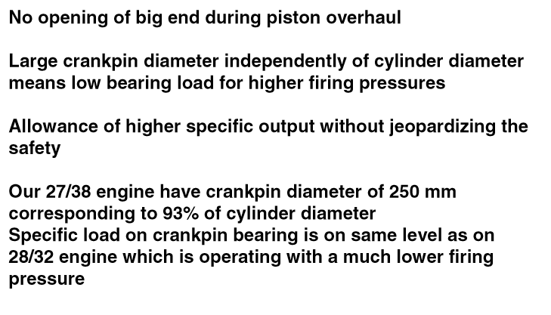
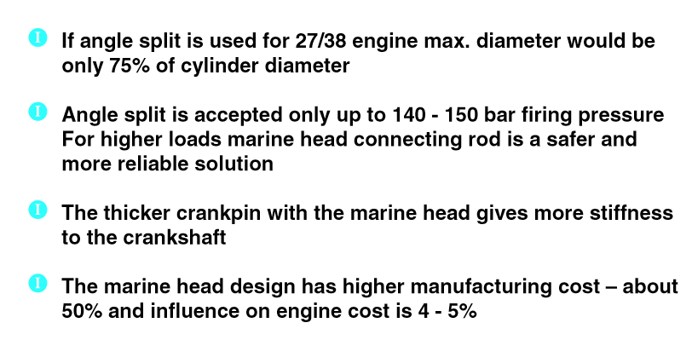
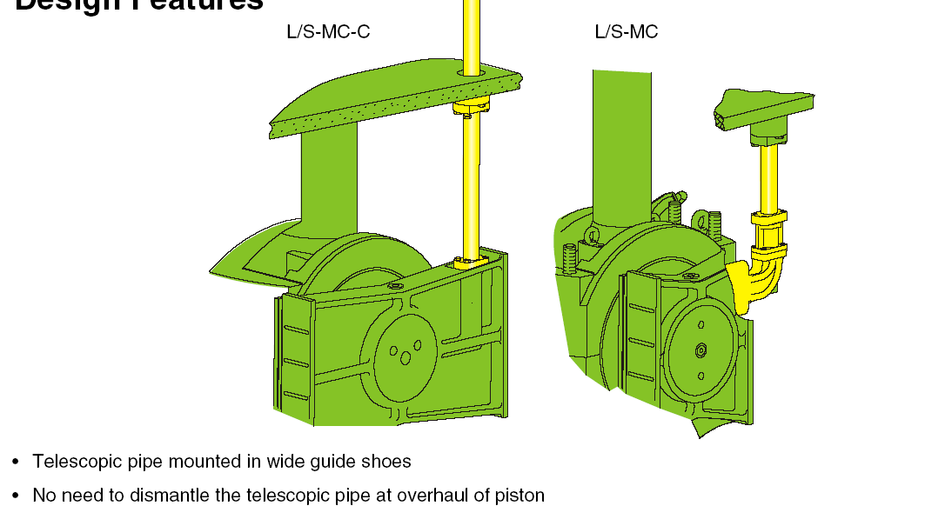

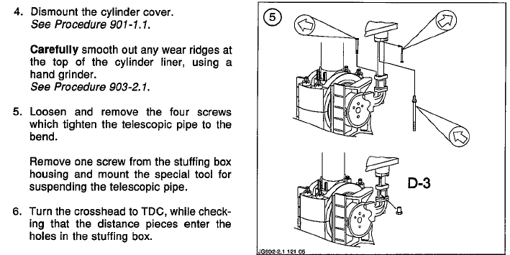

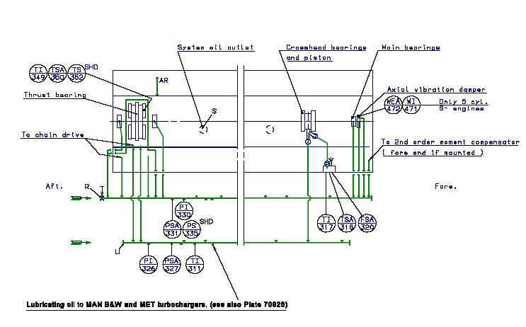
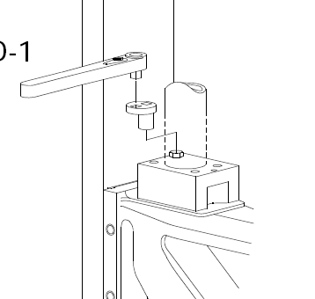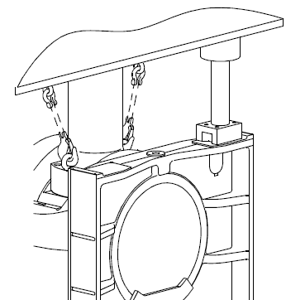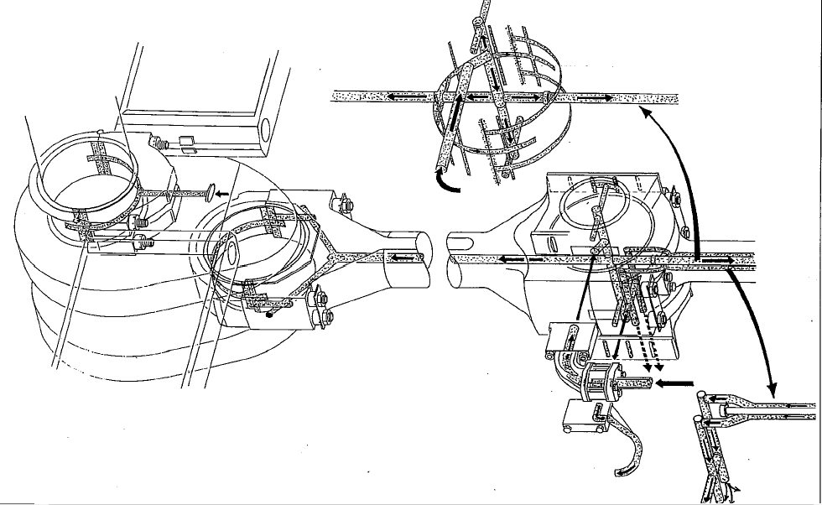
ၿကံုသမွ်။ဆံုသမွ်။ မၿကံုလဲ ၿကိုၿပီး ေၿကာက္ ထါးတါ။
၄၅- 6S50MC-C အင္ဂ်င္တလံုး၇ဲ႔ အင္ဂ်င္ေအါက္က BILGE WELL LEVEL ၿမင္႔တါ ဂ၇ုမစိုက္ဘဲပစ္ထါးတါ M.E SYSTEM LUBE OIL WATER CONTENT တက္လါသတဲ႔။ အဲဒီေ၇ ဘယ္ေန၇ာက ၀င္သြါးတါလဲ၊ ဘယ္ေန၇ာကိုစစ္၇မလဲ။
၄၆-BRIDGE ေပၚက ANEMOMETER မွာ ဘါမွမၿပေတါ႔လို႔ စစ္ၿကည္႔ေတါ႔ WIND TRANSMITER ကလါတဲ႔ SIGNAL ၿကိုး ၂ ေခ်ာင္း ကို ေတြ႔တယ္။ INSTRUCTION BOOK ဖတ္ၿကည္႔ေတါ႔ NMEA 0183 SIGNAL LEVEL တဲ႔။ အဲဒါဘါေၿပာတါလဲ။ SIGNAL လါ မလါအၿကမ္းဖ်င္းတုိင္းလို႔၇မလါး။
၄၇- အဲဒီ NMEA 0183 SIGNAL က ANEMOMETER အၿပင္ေနာက္ဘယ္ေတြသြါးနိုင္ေသးသလဲ။
၄၈-OBLIQUE TYPE ( ANGLE SPLIT) CONNECTING ROD သံုး 4 STROKE အင္ဂ်င္အတြက္ MAX FIRING PRESSURE LIMIT ၇ိွလါး။၇ိွ၇င္ဘယ္ေလါက္လဲ။ ဘါေၿကာင္႔လဲ၊
၄၉- ေနာက္ပိုင္း 4 STROKE အင္ဂ်င္ေတြဟါ OBLIQUE ( ANGLE SPLIT) TYPE CONNECTING ROD ကိုသိပ္မသံုးၿကေတါ႔ဘဲ 3 PIECES MARINE HEAD TYPE CONNECTING ROD ေတြကိုဘဲ အသံုးမ်ားလါၿကတယ္။ဘါလို႔လဲ၊
၅၀- S90MC-C နဲ႔ S50MC-C တို႔၇ဲ႔ FUEL INJECTION PUMP SUCTION VALVE ဘါကါြလဲ၊
၅၁-fuel pump gear reversing link အတြက္ Hydraulic damping ထည္႔ထါးတါ S90MC-C Engine မွာလါး။ S50MC-C Engine မွာလါး။
၅၂-ဟိုအ၇င္ MC အင္ဂ်င္ေတြတံုးက PISTON OVERHAUL လုပ္ဖို႔ PISTON ထုတ္၇င္ TELESCOPIC PIPE ၿဖဳတ္ခိုင္းတယ္။ အခု MC-C Engine ေတြမွာ အဲဒီလိုၿဖဳတ္ခိုင္းလါး။ဘါေၿကာင္႔လဲ၊
၅၃-MC-C Engine ေတြမွာ twin stay bolt သံုးလို႔၇လါတဲ႔ေကါင္းက်ိဳးေတြကဘါေတြလဲ။
၅၄-အိမ္က ေ၇တိုင္ကီ ထဲက ေ၇ LEVEL ကို Differentail pressure transmitter နဲ႔တိုင္းမယ္ဆို၇င္ dry leg သံုးမလါး။ wet leg သံုးမလါး။
၄၅- 6S50MC-C အင္ဂ်င္တလံုး၇ဲ႔ အင္ဂ်င္ေအါက္က BILGE WELL LEVEL ၿမင္႔တါ ဂ၇ုမစိုက္ဘဲပစ္ထါးတါ M.E SYSTEM LUBE OIL WATER CONTENT % တက္လါသတဲ႔။ အဲဒီေ၇ ဘယ္ေန၇ာက ၀င္သြါးတါလဲ၊ ဘယ္ေန၇ာကိုစစ္၇မလဲ။
45-For 6S50MC-C Engine – after long time high level of bilge under main engine, main engine system lube oil water contamination was increased. From where, water ingressed into main engine system oil. Which location do you need to check for this situation?
There was return bellow at engine bedplate for the purpose of system oil return from c/case to sump. These bellows are attached to c/case with gaskets and nuts. Need to check bellow leakage or loose nuts at attached flanges.
အင္ဂ်င္၇ဲ႔ bedplate ကေန sump ထဲကိုၿပန္သြါးတဲ႔ bellow ေတြ၇ိွပါတယ္။ အဲဒါကို အင္ဂ်င္ crankcase ထဲ႔ ၀င္ၿကည္႔၇င္ gasket နဲ႔ nut ေတြနဲ႔ တြဲထါးတါေတြ႔လိမ္႔မယ္။ အဲဒီ bellow ေတြေပါက္တါၿဖစ္ၿဖစ္။ နပ္ကေလးေတြေခ်ာင္ေန၇င္ ၿဖစ္ၿဖစ္ crankcase ထဲကို ေ၇ၿပန္၀င္နိုင္ပါတယ္။
၄၆-BRIDGE ေပၚက ANEMOMETER မွာ ဘါမွမၿပေတါ႔လို႔ စစ္ၿကည္႔ေတါ႔ WIND TRANSMITER ကလါတဲ႔ SIGNAL ၿကိုး ၂ ေခ်ာင္း ကို ေတြ႔တယ္။ INSTRUCTION BOOK ဖတ္ၿကည္႔ေတါ႔ NMEA 0183 SIGNAL LEVEL တဲ႔။ အဲဒါဘါေၿပာတါလဲ။ SIGNAL လါမလါအၿကမ္းဖ်င္းတုိင္းလို႔၇မလါး။
46-Anemometer was out of order. There were 2 signal wires from transmitter and signal was mentioned as NMEA 0183 at instruction book. What is the meaning of NMEA 0183. How to check signal was missing or not.
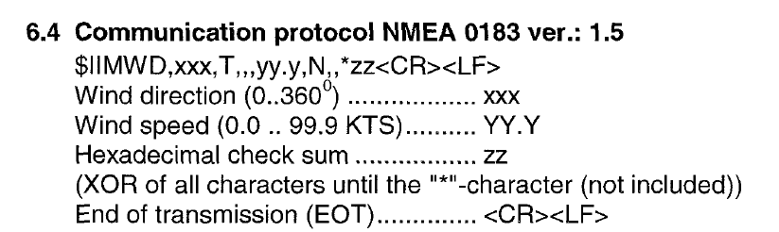
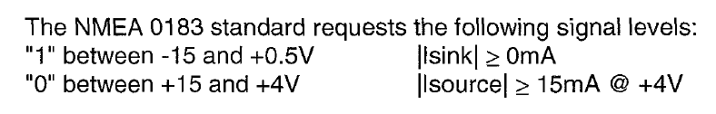
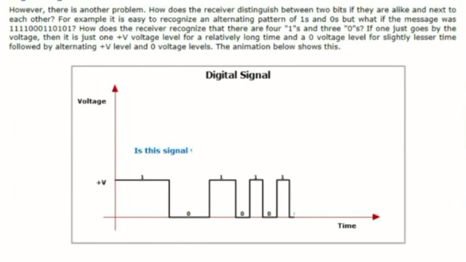
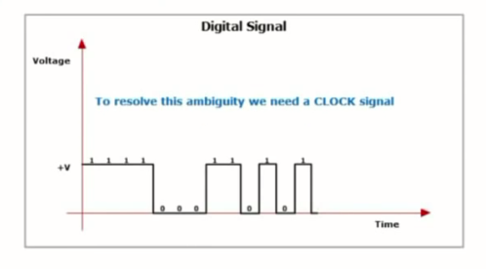
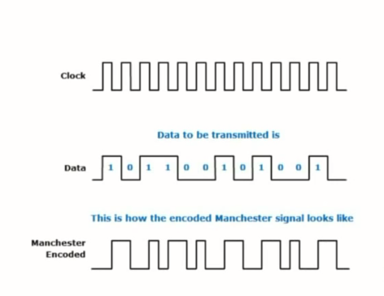
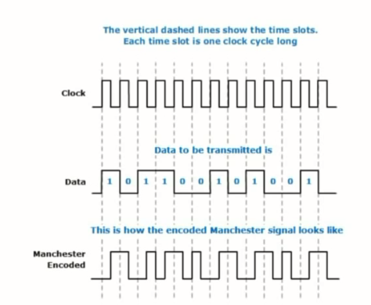
NMEA 0183 IS Message type signal. (1) between -15 and +0.5 V, (0) between +15 and +4 V.
Communication protocol - $II MWD,xxx,T,,,yy.y,N,,*zz<CR><LF>
(xxx=wind direction),YY.Y = wind speed, hexadecimal check sum = zz, end of transmission(EOT)=<CR><LF>
NMEA 0183 ဆိုတါ message type signal ၿဖစ္ပါတယ္။ 1 က -15V နဲ႔ +0.5V ၿကား၇ိွ၇မွာၿဖစ္ၿပီး 0 က +15 နဲ႔ +4V ၿကား၇ိွ၇မွာၿဖစ္ပါတယ္။ အဲဒီ ဗို႔အါးေတြေလါက္၇ိွေန၇င္ signal ၇ိွတယ္ေၿပာနုိင္ပါတယ္။
၄၇- အဲဒီ NMEA 0183 SIGNAL က ANEMOMETER အၿပင္ေနာက္ဘယ္ေတြသြါးနိုင္ေသးသလဲ။
Radar , VDR စတါေတြကိုသြါးပါတယ္။
၄၈-OBLIQUE TYPE ( ANGLE SPLIT) CONNECTING ROD သံုး 4 STROKE အင္ဂ်င္အတြက္ MAX FIRING PRESSURE LIMIT ၇ိွလါး။၇ိွ၇င္ဘယ္ေလါက္လဲ။ ဘါေၿကာင္႔လဲ၊
48-What is the max firing pressure limit for oblique type ( angle split) con rod type 4 stroke engine. What factors govern this limitation?
140-150 BAR ဟါ ANGLE SPLIT CON ROD သံုး 4 STROKE အင္ဂ်င္ေတြအတြက္ အမ်ားဆံုး FIRING PRESSURE LIMIT ပါဘဲ၊ ဘါလို႔လဲ ဆိုေတါ႔ ANGLE SPLIT CON ROD ၇ဲ႔ Crankpin diameter က liner ၇ဲ႔ ၇၅% ေလါက္၇ိွခ်ိန္မွာ marine head type (shank type) con rod ကိုသံုးခဲ႔၇င္ crankpin diameter က လိုင္နာ၇ဲ႔ ၉၃% ေလါက္၇ိွလါမွာၿဖစ္လို႔ specific load on crankpin bearing က မတူလို႔ၿဖစ္ပါတယ္။
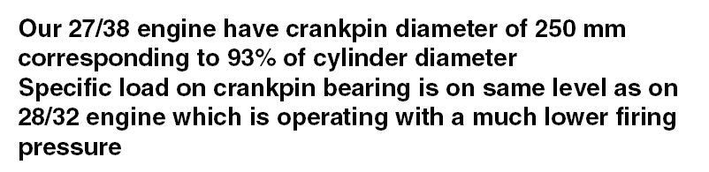
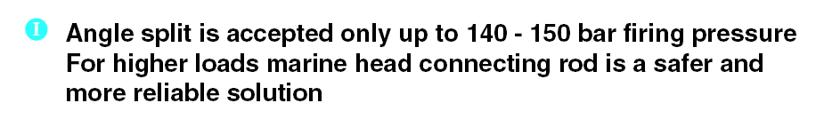
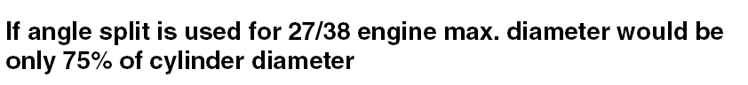
Angle split is accepted only up to 140-150 bar firing pressure. Marine head type con rod crankpin diameter was 93% of cylinder diameter. If angle split is used, diameter would be only 75% of cylinder diameter.
၄၉- ေနာက္ပိုင္း 4 STROKE အင္ဂ်င္ေတြဟါ OBLIQUE ( ANGLE SPLIT) TYPE CONNECTING ROD ကိုသိပ္မသံုးၿကေတါ႔ဘဲ 3 PIECES MARINE HEAD TYPE CONNECTING ROD ေတြကိုဘဲ အသံုးမ်ားလါၿကတယ္။ဘါလို႔လဲ၊
49-High power 4 stroke engines are mostly constructed with marine head type con rod. Why ?
As per above data, specific load on crankpin bearing of marine head type is lower than angle split type con rod. Hence, marine head type con rod is more safer and reliable.
အေပၚကေၿပာခဲ႔သလို႔ higher load ဆို၇င္ marine head type con rod က ပိုၿပီး safer & reliable ၿဖစ္လို႔ပါ။
၅၀- S90MC-C နဲ႔ S50MC-C တို႔၇ဲ႔ FUEL INJECTION PUMP SUCTION VALVE ဘါကါြလဲ၊
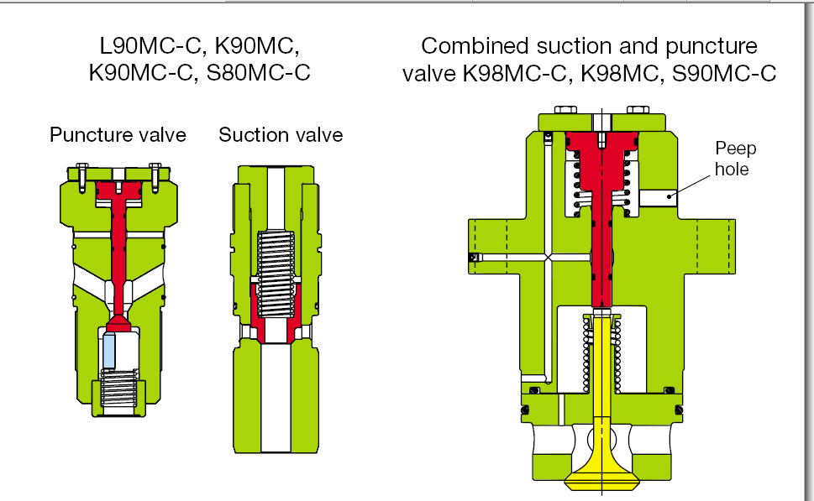
S90MC-C ဆို၇င္ Combine suction and puncture valve ၿဖစ္ၿပီး S50MC-C ဆို၇င္ Puncture valve & suction valve ကတခုစီၿဖစ္ပါတယ္။
50-What is the difference between S90MC-C & S50MC-C regarding with fuel injection pump suction valve and puncture valve.
S90MC-C used combined suction and puncture valve. FOR S50MC-C – suction valve and puncture valve were separately constructed.
၅၁-fuel pump gear reversing link အတြက္ Hydraulic damping ထည္႔ထါးတါ S90MC-C Engine မွာလါး။ S50MC-C Engine မွာလါး။
51-Which engine designed with hydraulic damping device at fuel pump gear reversing link. S90MC-C OR S50MC-C ?
S90MC-C
S90MC-C အင္ဂ်င္မွာပါ။
၅၂-ဟိုအ၇င္ MC အင္ဂ်င္ေတြတံုးက PISTON OVERHAUL လုပ္ဖို႔ PISTON ထုတ္၇င္ TELESCOPIC PIPE ၿဖဳတ္ခိုင္းတယ္။ အခု MC-C Engine ေတြမွာ အဲဒီလိုၿဖဳတ္ခိုင္းလါး။ဘါေၿကာင္႔လဲ၊
52-If MC Engine piston overhaul, we need to disconnect telescopic pipe from crosshead. But, for MC-C Engine, no need to dismantle the telescopic pipe at piston overhaul. Why?
-telescopic pipe was mounted in wide guide shoe. So, no need to dismantle the telescopic pipe at overhaul of piston.
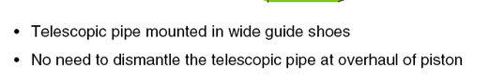
MC-C အင္ဂ်င္ေတြမွာ Telescopic pipe ကို guide shoes ေပၚလါထို္င္ထါးလို႔ ၿဖဳတ္စ၇ာမလိုဘူးဆိုပါတယ္။
၅၃-MC-C Engine ေတြမွာ twin stay bolt သံုးလို႔၇လါတဲ႔ေကါင္းက်ိဳးေတြကဘါေတြလဲ။
53-What are the adventage of twin stay bolt at MC-C engine

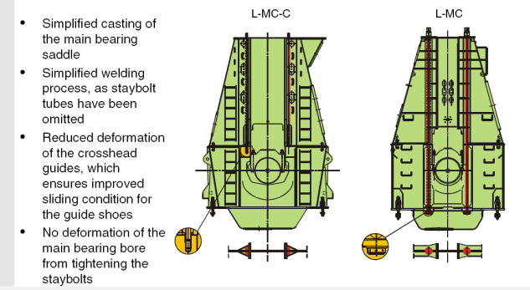
Simplified casting of the main bearing saddle, simplified welding process, as staybolt tubes have been omitted, reduced deformation of the crosshead guides,which ensures improved sliding condition for the guide shoes, no deformation of the main bearing bore from tightening the staybolts.
Main bearing saddle ကို casting လုပ္၇ာမွာလြယ္သြါးပါတယ္။ staybolt tube မပါေတါ႔လို႔ welding process လြယ္သြါးပါတယ္။ crosshead guide deformation ေလ်ာ႔သြါးလို႔ guide shoes ၇ဲ႔ sliding condition ကိုတိုးတက္ေစပါတယ္။ staybolt ေတြတိုက္တဲ႔အခါ main bearing bore ေတြ deformation မၿဖစ္ေတါ႔ပါဘူး။
၅၄-အိမ္က open type ေ၇တိုင္ကီ ထဲက ေ၇ LEVEL ကို Differentail pressure transmitter နဲ႔တိုင္းမယ္ဆို၇င္ dry leg သံုးမလါး။ wet leg သံုးမလါး။
54-Your home used open type fresh water high tank. If you like to install differential pressure transmitter for level measurement, what method do you deploy ( dry leg or wet leg)
You can deploy dry leg method. You have to connect d.p cell low side to atmosphere and D.p cell high side to tank bottom side.
Dry leg ကိုသံုးပါမယ္။ low side ကို atmosphere ဖက္ထါးၿပီး high side ကို tank ေအါက္ေၿခနားထါးပါမယ္။
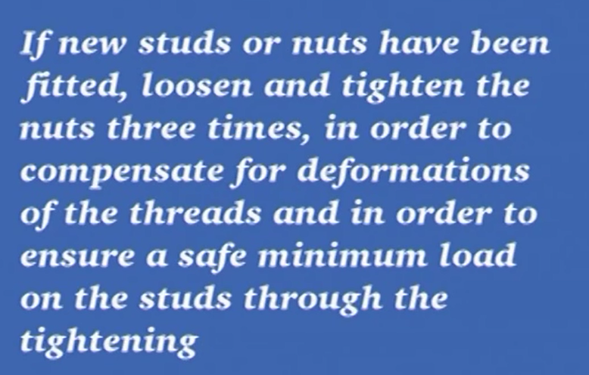
55-ICCP System တခုမွာ dock မတက္ခင္ cell 1-200 mV, cell 2 -200 mV, current – 10 A ၿပတယ္။
Dock ကဆင္းၿပီးေတါ႔ cell 1- 57 mV, cell 2- 138 mV, current – 0 A ၿပတယ္။ အဲဒါဘါလို႔လဲ။တကယ္လို႔ cell 1=57 mV,cell 2 =138 mV, current = 8 A မ်ားၿပေနခဲ႔၇င္ဘါေတြၿဖစ္သြါးနိုင္လဲ။
Now vessel was protected by paint in good condition. Vessel covered with new paint after docking. This current 8 Amp will destroy the paint.
တကယ္လို႔ ref cell 1- 380 mV, ref cell 2- 390 mV, အဲဒီအခ်ိန္မွာ anode 1- 1.67 V, anode 2- 1.66 V, max output of anode -3.6 V – 11 A ဆို၇င္ေကါ။ anode ေတြမေကါင္းေတါ႔ပါ။ ref cell ကေတါ႔ေကါင္းနိင္ပါတယ္။
56-BOILER တလံုး စေမါင္းၿပိး IGNITION ၿဖစ္ၿပီး MAIN F.O VALVE ဖြင္႔ၿပီးခ်ိန္ FLAME FAILURE ၀င္သြါးတယ္ဆို၇င္ဘါေတြစစ္မလဲ။
-STEAM ATOMIZATION ေပးတဲ႔ဗါးမပြင္႔၇င္
-FUEL OIL ေပးတဲ႔ဗါးမပြင္႔၇င္
-ေပးတဲ႔ FUEL PRESSURE နဲေန၇င္( PI POSITIONER သြါးမသြါးစစ္ပါ)
- ဆီနဲ႔ေလအခ်ိဳးမွာ ေလအ၇မ္းမ်ားေန၇င္
- FLAME SCANNER အါးနဲေန၇င္(FLAME SCANNER လဲၿကည္႔။POSITION ေၿပာင္းၿကည္႔ပါ။SCANNER RAR 7 ဆို၇င္ OUTPUT VOLTAGE 0.5 VDC ေလါက္အနဲဆံုး၇ိွတတ္ပါတယ္။)
- FLAME SIZE ေသးေန၇င္ ( ေက်ြးတဲ႔ေလ-COMBUSTION AIR ကိုေလ်ာ႔ခ်ေပး၇င္ FLAME SIZE ၿကီးလါပါလိမ္႔မယ္။မီးခိုးကိုေတါ႔ဂ၇ုစုိက္ပါ။)
57-anemometer လိုဟါေတြ။ rosemount 5600 radar level transmitter ေတြကလါတဲ႔ SIGNAL WIRE ေတြ၇ဲ႔ GROUND ကို တဖက္ထဲမွာခ်ခိုင္းထါးတယ္။ဘါလို႔လဲ။
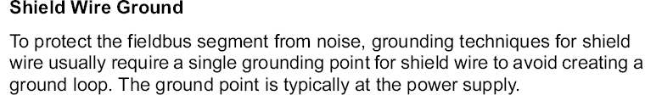
58-AC 4 မွာ DIGITAL GOVERNOR UNIT ဘဲသံုးလို႔၇လါး။ WOODWARD GOVERNOR လို HYDRAULIC GOVERNOR ေကါသံုူးလို႔၇လါး။
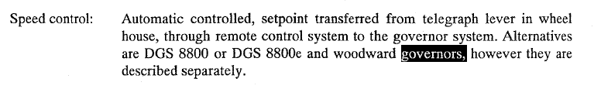
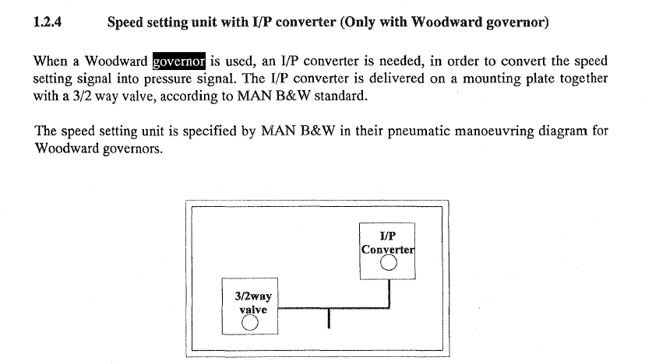
သံုးလို႔၇ပါတယ္။ man bnw က ip convertor တခု၇ယ္။ 3/2 way valve တလံုး၇ယ္နဲ႔ တြဲ သံုးခိုင္းထါးပါတယ္။
59- Time lubrication has little merit လို႔ ေၿပာခဲ႔၇င္-မွန္တယ္ေၿပာမလါး။မွားတယ္ေၿပာမလါး။ဘါလို႔လဲ။
မွားပါတယ္။ Alph lubricator timing is based on two signals from the angle encoder, a TDC cyl 1 marker and a crankshaft position trigger. The alpha lubrication system is normally timed to inject cyl oil into the piston ring pack during the compression stroke.
Alpha lubricator က angle encoder နဲ႔ တြက္ခ်က္ၿပီး time lubrication လုပ္ပါတယ္။

Correct time injection means , delivering correct amount of cylinder oil to a specified area in correct instant, at which the piston is moving very slowly relating to angular motion of the crank.
The oil should be timely injected between piston ring , especially 1st & 2nd ring , while piston moving up. At this time the cylinder is in low pressure phase and ensure to deliver the lubricant to cold region of cylinder.
In practically , it is very difficult to achieve and require very rapid rate of injection with overwhelming pressure to existing pressure in the area of injection.
The delivery of cylinder oil take place twice in each revolution of the crankshaft and discharged through the small bore pipes to various feed point in cylinder. At this point , oil travel time between the lubricator and feed point , called time lag, is become major problem for timed lubrication.
Time lag is very difficult to calculate with respect to piston movement. It is depend on the variations of…….
- Pipe length
- Compressibility of using oil
- Change of oil viscosity due to change of ambient temperature
Oil injection time from lubricator quills are also very difficult to determine , due to the gas trap and existing pressure in that area. Engine speed and load condition are always vary , so oil injection time is also very difficult to determine , because the injection period is only about 2 ‘ of crank angle.Therefore , correct injection time is very difficult to achieve and having little merits.
The purposes of cylinder lubrication are….
- To distribute cylinder oil all over liner surface uniformly
- To get correct sealing effect
- To reduce frictional wear between piston rings & liner
- Effectively counter measure to cold & hot corrosion effected by combustion products by additives contents…..ect.
Being difficult to achieve correct injection time , cylinder lubrication is not satisfactory to the above mentioned purpose and having little merits.
Therefore Multilevel Lubricating System are developed and aided by provision of oil grooves adjacent to the feed points.
The advantages of these improvements are..
- Can charge the oil into cylinder more continuous flow rate than intermittently.
- Achieve proper distribution of cylinder oil around the liner
- Greater oil film thickness due to lower rolls of quills , guard against adhesion and scuffing
- High refreshing rate of oil due to upper row of quills for neutralizing the corrosive products
- Double the numbers of quill gives better circumferential oil distribution and safeguard uneven wear of liner.

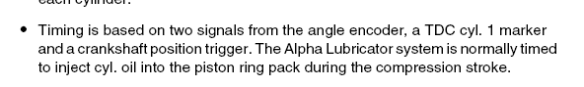
Alph lubricator timing is based on two signals from the angle encoder, a TDC cyl 1 marker and a crankshaft position trigger. The alpha lubrication system is normally timed to inject cyl oil into the piston ring pack during the compression stroke.
60-WIND INDICATOR က SIGNAL ၿကိုး SHIELD ဟိုဖက္ဒီဖက္မွာ GROUND ခ်ဖို႔ အစ တခုစီပါေနတယ္။ ဘယ္လို GROUND ခ်၇င္ေကါင္းမလဲ။၂ - စ-လံုးဂေ၇ာင္းခ်၇င္ေကါင္းမလါး။တစ ထဲဂေ၇ာင္းခ်၇င္ေကါင္းမလါး။
Ground loop မၿဖစ္ေအါင္ တဖက္ထဲဘဲ ground ခ်ခိုင္းပါတယ္။
61- ALFA LAVAL SU 830 က CLOSING WATER နဲ႔ OPENING WATER က ပိုက္တေခ်ာင္းထဲကဘဲ အတူတူ ၀င္သြါးတယ္။အဲဒီ CLOSING WATER နဲ႔ OPENINGဘယ္လိုအလုပ္လုပ္ၿကလဲ။ CLOSING WATER ေပး၇င္ BOWL OPEN မၿဖစ္သြါးနိုင္ဘူးလါး။
Operating slide ကိိုထိန္းတဲ႔ HOLDER မွာ CLOSNG WATER & OPENING WATER ကို စည္းၿခားေပးတဲ႔ DRAIN ေပါက္ပါပါတယ္။
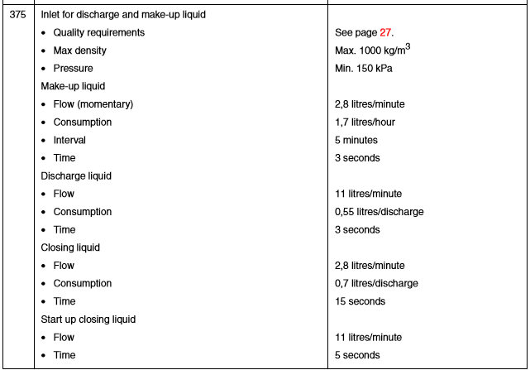
ဒါေၿကာင္႔ CLOSING LIQUID ကို ၂.၈ LTR/MINUTE ထက္ပိုေပး၇င္အဲဒီ စည္းကိုေက်ာ္သြါးလို႔ BOWL ပြင္႔ပါတယ္။
62- STX 6L23/30H အင္ဂ်င္မွာပါတဲ႔ LAMBDA SYSTEM ကဘါေတြကို CONTROL လုပ္တါလဲ၊
ေ၇းၿပီး
63- main engine governor system တခုမွာ fuel rack position feed back လိုပါတယ္။ AC 4 စံနစ္တခုမွာ တပ္ထါးတဲ႔ Woodward governor တခုနဲ႔ digital governor unit တခု - အဲဒီ feed back ယူတါဘယ္လိုကြါမလဲ။
Dgu က သူဟါသူ angle encoder နဲ႔feed back ယူပါတယ္။ woodward ကေတါ႔ fuel regulating shaft မွာ distance sensor တပ္ၿပီးfeed back ယူတတ္ပါတယ္။
64-MC Engine တခု၇ဲ႔ exhaust valve မွာ W seat ဆိုတါဘါလဲ ။ အဲဒါကိုသံုးလို႔၇တဲ႔ အက်ိဳးေတြကဘါလဲ။
Exhaust valve seat ကို W ပံုေပၚေအါင္ လုပ္ထါးပါတယ္။ valve မပိတ္ခင္ scavenge ကလါတဲ႔ ေလကို အဲဒီ အခ်ိဳင္႔ေလထဲဖမ္းယူထါးလိုက္လို႔ valve seat သက္တမ္းကိုပို၇ွည္ေစတယ္လို႔ေၿပာပါတယ္။
65- ST 3000 D/P Cell တခုကို calibrate လုပ္မယ္ဆို၇င္ဘယ္လိုလုပ္၇မလဲ။ smart field communicator ဆိုတါဘါလဲ။
Sfc ဆိုတဲ႔ smart field communicator ကို ၿကားမွာတပ္ၿပီး လုပ္ပါတယ္။ st 3000 d/p cell က hart protocol ကိုသံုးထါးလို႔ပါ။သေဘါဲေပၚမွာအဲဒီ ST 3000 DP CELL သံုးထါးလို႔ ခ်ိန္မယ္ဆို ၇ံုးက AUTOMATION DEPARTMENT က က်ြမ္းက်င္တဲ႔ သူေတြလါခိ်န္ေပးပါတယ္။ အဲဒီ SFC နဲ႔။
66- steam jet ( Y JET) Atomizer boiler burner သံုး ဘိုြင္လါတလံုး တခ်က္တခ်က္မွာ မီးခိုးမဲထြက္လို႔ တၿခား ဘြိဳင္လါက burner နဲ႔ လဲတပ္ၿကည္႔ေတါ႔ မီးခိုးလဲမထြက္ေတါ႔ဘူး။ၿပီးေတါ႔ burner အ၀င္ fuel pressure လဲတက္လါတယ္။ အဲဒါဘါလို႔လဲ။
Atomizer က ဆီေပါက္ေတြ design limit ထက္ေက်ာ္ေနလို႔ပါ။ အသစ္လဲၿပီး အေဟါင္းကိုလြင္႔ပစ္လိုက္ပါ။(ၿပန္သံုးမိေနအံုးမယ္)
67-MAN NR 15/R Turbocharger Nozzle ring ေတြအ၇င္က clamp ေတြ။ nut ေတြနဲ႔ အေသဖမ္းတယ္။ေနာက္ပိုင္း locating pin နဲ႔ဘဲ ထိုင္ေတါ႔တယ္။ အဲဒါဘါလို႔လဲ။
Heat ေၿကာင္႔ expand ၿဖစ္တါက္ို ခ်ဳပ္ထါးသလိုၿဖစ္ၿပီး crack ေတြၿဖစ္လါလို႔ပါ။
68-ICCP System တခုမွာ dock မတက္ခင္ cell 1-200 mV, cell 2 -200 mV, current – 10 A ၿပတယ္။
Dock ကဆင္းၿပီးေတါ႔ cell 1- 57 mV, cell 2- 138 mV, current – 0 A ၿပတယ္။ အဲဒါဘါလို႔လဲ။တကယ္လို႔ cell 1=57 mV,cell 2 =138 mV, current = 8 A မ်ားၿပေနခဲ႔၇င္ေကါ ။
Current =0 က dock ဆင္းကါစ ေဆးသုတ္ထါးတါေကါင္းလို႔ပါ။ ၈ amp ၿပ၇င္ ပိတ္သါထါးလိုက္ပါ။ ေဆးေတြပ်က္ကုန္လိမ္႔မယ္။
69-F.O သံုး Steam Y jet burner သံုး BOILER တလံုးစေမါင္းတဲ႔အခ်ိန္ IGNITION ၿဖစ္ၿပီး MAIN F.O VALVE ဖြင္႔ၿပီးခ်ိန္ FLAME FAILURE ၀င္သြါးတယ္ဆို၇င္ဘါေတြစစ္မလဲ။
-STEAM ATOMIZATION ေပးတဲ႔ဗါးမပြင္႔၇င္
-FUEL OIL ေပးတဲ႔ဗါးမပြင္႔၇င္
-ေပးတဲ႔ FUEL PRESSURE နဲေန၇င္( IP POSITIONER သြါးမသြါးစစ္ပါ)
- ဆီနဲ႔ေလအခ်ိဳးမွာ ေလအ၇မ္းမ်ားေန၇င္
- FLAME SCANNER အါးနဲေန၇င္(FLAME SCANNER လဲၿကည္႔။POSITION ေၿပာင္းၿကည္႔ပါ။SCANNER RAR 7 ဆို၇င္ OUTPUT VOLTAGE 0.5 VDC ေလါက္အနဲဆံုး၇ိွတတ္ပါတယ္။)
- FLAME SIZE ေသးေန၇င္ ( ေက်ြးတဲ႔ေလ-COMBUSTION AIR ကိုေလ်ာ႔ခ်ေပး၇င္ FLAME SIZE ၿကီးလါပါလိမ္႔မယ္။မီးခိုးကိုေတါ႔ဂ၇ုစုိက္ပါ။)
70- woodward governor သံုး မီးစက္ေတြမွာ fuel rack position sensor မပါဘဲ cpp system main engine ေတြမွာ တပ္ထါးတဲ႔ woodward governor က်ေတါ႔ ဘါလိ္ု႔ fuel rack position sensor( distance sensor) တပ္၇တါလဲ၊
မီးစက္ေတြက load kw ကို rpm အတက္အက်အေနနဲ႔ေၿပာင္းေပးပါတယ္။သူဟါသူ generator side ဖက္ကေန load shadding ေတြ။ safety ေတြနဲ႔ထိန္းသြါးပါလိမ္႔မယ္။ cpp main engine က်ေတါ႔ အဲဒါမ်ိဳးမ၇ိွေတါ႔ overload မၿဖစ္ေအါင္ pitch, rpm, fuel rack position ကို cpu သံုး controller ထဲထည္႔ေပးၿပီး ထြက္လါတဲ႔ signal နဲ႔ ထိန္း၇ပါတယ္။
71-MC ENGINE S50MC-C တလံုး၇ဲ႔ FUEL INJECTION PUMP ကို FUEL OIL ဘယ္ကေနဘယ္လို ၀င္သလဲ။ HIGH PRESSURE PIPE ကိုဘယ္ကေနဘယ္လိုထြက္သြါးသလဲ။
ပလန္ဂ်ာေအါက္အဆင္းမွာ ပလန္ဂ်ာအေပၚဖက္ေန၇ာ suction valve ေဘးက pressure က fuel pump casing မွာ၇ိွတဲ႔ booster pump pressure ၇ိွ ဆီ ထက္နဲေတါ႔ suction valve spring ကိုဆြဲမၿပီး အထဲ၀င္လါၿကပါတယ္။ပလန္ဂ်ာ effective stroke မွာ plunger အေပၚက ဖိအါးကပိုမ်ားလို႔ suction valve သူေန၇ာသူၿပန္ထိုင္ေတါ႔ suction valve အလယ္မွာ၇ိွ အေပါက္ကေန pressurize fuel oil ေတြက delivery ပိုက္ကိုသြါ့းပါတယ္။
72-အဲဒီ MC ENGINE S50MC-C FUEL PUMP မွာ BOOSH TYPE FUEL PUMP လို DELIVERY NON RETURN VALVE ပါလါး။
BOOSH TYPE FUEL INJECTION PUMP ေတြကေတါ႔ အဲဒီ DELIVERY VALVE မလံု၇င္ COMBUSTION မေကါင္းေတါ႔ဘူး။
မပါပါဘူး။fuel valve က non return valve က သတ္မွတ္ထါးတဲ႔ pressure ေ၇ာက္တါနဲ႔ဆီၿဖတ္။ၿပီး၇င္သတ္မွတ္ pressure ေ၇ာက္တါနဲ႔ recirculate လုပ္စတါေတြလုပ္ပါတယ္။
73- အခုေနာက္ပိုင္း main engine ကို 4 stroke အင္ဂ်င္သံုးတဲ႔ သေဘါၤေတြမွာ redundancy propulsion အေနနဲ႔ shaft generator ကိုေမၚတါအၿဖစ္သံုးၿပိး PTH အေနနဲ႔သံုးၿကတယ္။ အဲဒီလုိသံုးတဲ႔အခါ induction motor အေနနဲ႔သံုးလါး။ synchronize motor အေနနဲ႔သံုးၿကလါး။ဘါလို႔လဲ။
လ်ွပ္စစ္ ေမၚတါနဲ႔ ပန္ကါလွည္႔တဲ႔ လ်ပ္စစ္ သေဘါၤေတြမွာ သံုးၿကတါက 3 phase synchronous motor ပါဘဲ။ ေနာက္ ၿပီး 4 stroke engine သံုး cpp propulsion မွာ redundancy propulsion အေနနဲ႔ shaft generator ကို ေမၚတါေၿပာင္းၿပီးပန္ကါကိုၿပန္လွည္႔၇င္လဲ ဒီလို ေမၚတါမ်ိဳးပါဘဲ။(PTO & PTH လို႔ေၿပာၿကပါတယ္။ PTO ဆိုတါ POWER TAKE OUT – Engine ကေန shaft generator ကိုေမါင္းတါ။ PTH – power take home – shaft generator ကို ေမၚတါေၿပာင္း-မီးစက္ပါ၀ါနဲ႔ ပန္ကါလွည္႔ၿပီး အိမ္ၿပန္တါ) သူက no load to full load တင္တဲ႔ အတြင္း constant speed နဲ႔ တက္နိုင္လို႔လဲၿဖစ္ပါတယ္။သူလည္နဳန္းက ေတါ႔ ပါတဲ႔ pole အေ၇အတြက္နဲ႔ ေက်ြးတဲ႔လ်ပ္စီး၇ဲ႔ ၿကိမ္နွုန္းေပၚတည္ပါတယ္။မီးစက္တလံုးက နဂိုကတဲက rotary diode နဲ႔ ၇ိဳတါကို D.C ေပးထါးလို႔ Synchronous motor ေၿပာင္းလို႔လြယ္ပါတယ္။

74-sulzer engine fuel injection valve အတြက္ high pressure pipe / return circulating pipe / supply circulating pipe စတဲ႔ပိုက္ေတြလိုတယ္။ MAN B&W MC –C Engine အတြက္ကေတါ႔ high pressure pipe/ return pipe ဒါဘဲလိုတယ္။ဘါလို႔လဲ၊
Non return valve နဲ႔ mc engine ေတြမွာ circulate လုပ္လို႔
75-အဲလို MC-C Engine မွာ circulating oil ကို ေတါက္ေလ်ာက္ေပးနိုင္ေအါင္ ဘယ္ကေနေပးေနလဲ။ pressure ဘယ္ေလါက္၇ိွေနမယ္ထင္လဲ၊
အင္ဂ်င္ေမါင္းခ်ိန္မွာ ၁၅ ဘါးေလါက္ဆို circulating oil အတြက္ non return valve ပြင္႔ေပးပါတယ္။၇ပ္ထါးခိ်န္ဆို၇င္ Booster pump pressure 7-8 bar ေလါက္အၿကမ္းဖ်င္း၇ိွပါတယ္။

58-AC 4 မွာ DIGITAL GOVERNOR UNIT ဘဲသံုးလို႔၇လါး။ WOODWARD GOVERNOR လို HYDRAULIC GOVERNOR ေကါသံုူးလို႔၇လါး။
Is autochief 4 control system only compactible with digital governor unit? Can be operated with woodward governor or not?
59-Time lubrication has little merit လို႔ ေၿပာခဲ႔၇င္-မွန္တယ္ေၿပာမလါး။မွားတယ္ေၿပာမလါး။ဘါလို႔လဲ။
What is your suggestion about this opinion “ Time lubrication has little merit”
60-WIND INDICATOR က SIGNAL ၿကိုး SHIELD ဟိုဖက္ဒီဖက္မွာ GROUND ခ်ဖို႔ အစ တခုစီပါေနတယ္။ ဘယ္လို GROUND ခ်၇င္ေကါင္းမလဲ။၂ - စ-လံုးဂေ၇ာင္းခ်၇င္ေကါင္းမလါး။တစ ထဲဂေ၇ာင္းခ်၇င္ေကါင္းမလါး။
There was 2 ground strips at the each ends of signal wire that come from wind indicator. How to make ground with these strips?
61- ALFA LAVAL SU 830 က CLOSING WATER နဲ႔ OPENING WATER က ပိုက္တေခ်ာင္းထဲကဘဲ အတူတူ ၀င္သြါးတယ္။အဲဒီ CLOSING WATER နဲ႔ OPENINGဘယ္လိုအလုပ္လုပ္ၿကလဲ။ CLOSING WATER ေပး၇င္ BOWL OPEN မၿဖစ္သြါးနိုင္ဘူးလါး။
Alfa laval SU 830 purifier’s closing water & opening water are supplied with only one pipe. So, if you open ‘closing water’, purifier can run into “open bowl” mode. How did alfa laval prevent this intentionally bowl open.
62- STX 6L23/30H အင္ဂ်င္မွာပါတဲ႔ LAMBDA SYSTEM ကဘါေတြကို CONTROL လုပ္တါလဲ၊
What are the functions of STX 6L23/30H’s LAMBDA SYSTEM.
63- main engine governor system တခုမွာ fuel rack position feed back လိုပါတယ္။ AC 4 စံနစ္တခုမွာ တပ္ထါးတဲ႔ Woodward governor တခုနဲ႔ digital governor unit တခု - အဲဒီ feed back ယူတါဘယ္လိုကြါမလဲ။
Every main engine governor system need fuel rack position feed back for control. Regarding with AC 4 System fuel rack position feed back – how to arrange at woodward hydraulic governor & a digital governor unit.
64-MC Engine တခု၇ဲ႔ exhaust valve မွာ W seat ဆိုတါဘါလဲ ။ အဲဒါကိုသံုးလို႔၇တဲ႔ အက်ိဳးေတြကဘါလဲ။
What is the W seat at exhaust valve bottom piece of MC engine. What are the adventages of this W seat.
65- ST 3000 D/P Cell တခုကို calibrate လုပ္မယ္ဆို၇င္ဘယ္လိုလုပ္၇မလဲ။ smart field communicator ဆိုတါဘါလဲ။
How do you calibrate ST 3000 D/P Cell. What is the smart field communicator?
66- steam jet ( Y JET) Atomizer boiler burner သံုး ဘိုြင္လါတလံုး တခ်က္တခ်က္မွာ မီးခိုးမဲထြက္လို႔ တၿခား ဘြိဳင္လါက burner နဲ႔ လဲတပ္ၿကည္႔ေတါ႔ မီးခိုးလဲမထြက္ေတါ႔ဘူး။ၿပီးေတါ႔ burner အ၀င္ fuel pressure လဲတက္လါတယ္။ အဲဒါဘါလို႔လဲ။
At steam jet Y Type atomizer boiler burner, boiler was sometime emitting black smoke. So, we change with other burner from st by boiler. After ch/o with this burner, found frequently emit black smoke was stopped and burner inlet fuel oil pressure also increase. What is the root cause of this malfunction.
၁၀-MAN NR 15/R Turbocharger Nozzle ring ေတြအ၇င္က clamp ေတြ။ nut ေတြနဲ႔ အေသဖမ္းတယ္။ေနာက္ပိုင္း locating pin နဲ႔ဘဲ ထိုင္ေတါ႔တယ္။ အဲဒါဘါလို႔လဲ။
MAN NR 15/R turbocharger old design nozzle ring came with clamps and nuts. But latter design only use locating pin to assemble nozzle ring. Why they change design.
67-ICCP System တခုမွာ dock မတက္ခင္ cell 1-200 mV, cell 2 -200 mV, current – 10 A ၿပတယ္။Dock ကဆင္းၿပီးေတါ႔ cell 1- 57 mV, cell 2- 138 mV, current – 0 A ၿပတယ္။ အဲဒါဘါလို႔လဲ။တကယ္လို႔ cell 1=57 mV,cell 2 =138 mV, current = 8 A မ်ားၿပေနခဲ႔၇င္ေကါ ။
At one ICCP System – before docking – cell 1-200mV,cell 2-200 mV, current -10 A
After dock- cell 1 – only 57mV, cell 2 -138 mV, current -0 A. How do you think about these data.
If cell 1- 57 mV, cell 2 -138 mV, current = 8A . what is your action on these data.
68-F.O သံုး Steam Y jet burner သံုး BOILER တလံုးစေမါင္းတဲ႔အခ်ိန္ IGNITION ၿဖစ္ၿပီး MAIN F.O VALVE ဖြင္႔ၿပီးခ်ိန္ FLAME FAILURE ၀င္သြါးတယ္ဆို၇င္ဘါေတြစစ္မလဲ။
69- woodward governor သံုး မီးစက္ေတြမွာ fuel rack position sensor မပါဘဲ cpp system main engine ေတြမွာ တပ္ထါးတဲ႔ woodward governor က်ေတါ႔ ဘါလိ္ု႔ fuel rack position sensor( distance sensor) တပ္၇တါလဲ၊
70-MC ENGINE S50MC-C တလံုး၇ဲ႔ FUEL INJECTION PUMP မွာ FUEL OIL ဘယ္ကေနဘယ္လို ၀င္သလဲ။ HIGH PRESSURE PIPE ကိုဘယ္ကေနဘယ္လိုထြက္သြါးသလဲ။
71- Centrifugal pump သံုး cargo pump တခု၇ဲ႔ AUS ( AUTO UNLOADING SYSTEM) တခု Stripping စလုပ္တဲ႔အခါ gas extraction valve & vacuum pump ေတြပံုမွန္အလုပ္လုပ္ေပမဲ႔ separator level ကေတၚေတၚနဲ႔တက္မလါဘူး။ vacuum pump က Pressure က ၁ ဘါးေလါက္မွာ ေတၚေတၚၿကာေနတယ္။အဲဒါဘါလို႔လဲ၊ အဲဒါမ်ိဳးေနာက္မၿဖစ္ေအါင္ဘါေတြလုပ္၇မလဲ၊
At centrifugal pump cargo pump AUS system, when start stripping, separator level can not go up to normal level with continuous running of vacuum pump with gas extraction valve open position. At vacuum pump side, found vacuum pump pressure about 1 bar. What is the root cause of this malfunction. How to prevent happen again this malfunctioning.
72-အခုေနာက္ပိုင္း main engine ကို 4 stroke အင္ဂ်င္သံုးတဲ႔ သေဘါၤေတြမွာ redundancy propulsion အေနနဲ႔ shaft generator ကိုေမၚတါအၿဖစ္သံုးၿပိး PTH အေနနဲ႔သံုးၿကတယ္။ အဲဒီလုိသံုးတဲ႔အခါ induction motor အေနနဲ႔သံုးလါး။ synchronize motor အေနနဲ႔သံုးၿကလါး။ဘါလို႔လဲ။
73-sulzer engine fuel injection valve အတြက္ high pressure pipe / return circulating pipe / supply circulating pipe စတဲ႔ပိုက္ေတြလိုတယ္။ MAN B&W MC –C Engine အတြက္ကေတါ႔ high pressure pipe/ return pipe ဒါဘဲလိုတယ္။ဘါလို႔လဲ၊
74-အဲလို MC-C Engine မွာ circulating oil ကို ေတါက္ေလ်ာက္ေပးနိုင္ေအါင္ ဘယ္ကေနေပးေနလဲ။ circulating oil pressure ဘယ္ေလါက္၇ိွေနမယ္ထင္လဲ၊
75-MC engine fuel injection pump ေတြ၇ဲ႔ spill hole ေတြမွာ cavitation ၿဖစ္ၿကသတဲ႔။ spill hole ၇ဲ႔ အေပၚဖက္ပိုင္းမွာၿဖစ္လါး။ ေအါက္ဖက္အပိုင္းမွာၿဖစ္လါး။ ဘါလို႔လဲ၊
76-တကယ္လို႔ mc engine တလံုး၇ပ္ထါးခ်ိန္ unit တလံုးက effective stroke မွာ၇ပ္သြါးတယ္ဆိုပါေတါ႔။ spill hole ေတြကိုလဲ plunger ကပိတ္ထါးၿပီ။အဲဒီအခ်ိန္မွာ fuel injector ကို ဘယ္က ဆီနဲ႔ circulate လုပ္ေနလဲ။
77-AC4 မွာ START TOO LONG SIGNAL ဘယ္ေတါ႔ေပးလဲ
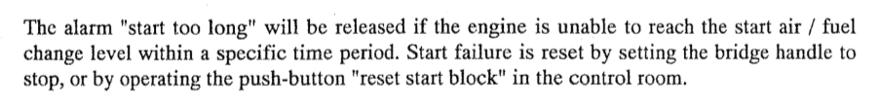
78-VFD MOTOR ေတြက္ို INVERTER DUTY AC INDUCTION MOTOR ေတြသံုး၇င္ပိုေကါင္းတယ္တဲ႔။ဘါလို႔လဲ၊
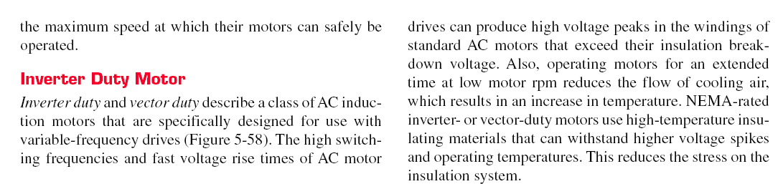
79- harmonic filter ဆိုတါဘါလဲ။အဲဒါမတပ္၇င္ဘါၿဖစ္နိုင္လဲ။အဲဒီ harmonic distortion ကဘါလို႔ၿဖစ္တါလဲ၊
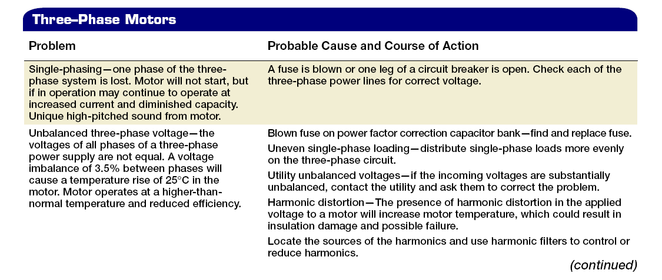
IGBT သံုး VFD ေတြလို non linear load ေတြသံုးခဲ႔၇င္ HARMONIC DISTORTION ေပၚတတ္ပါတယ္။
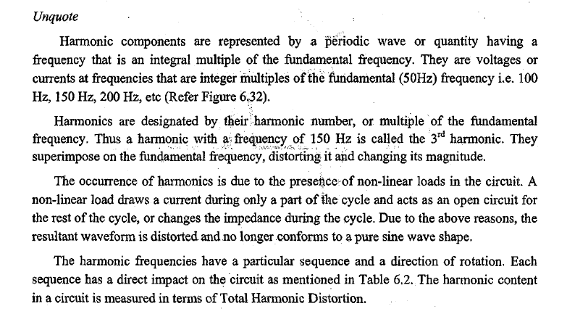
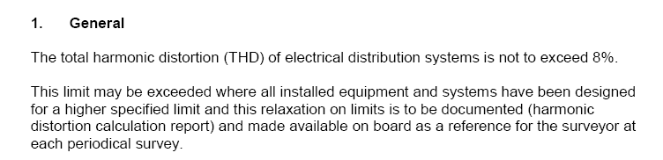
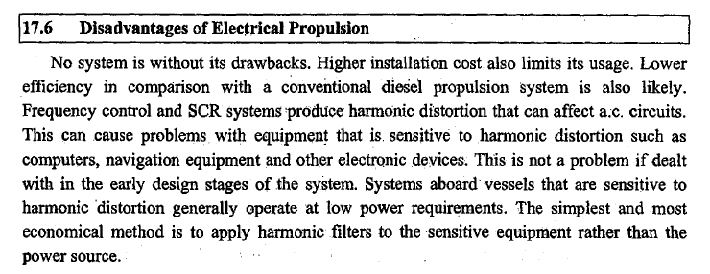
80- NON LINEAR LOAD ေတြပါတဲ႔ သေဘါၤေတြအတြက္ PMG GENERATOR ေတြက ပိုသင္႔ေတၚတယ္လို႔ေၿပာၿကတယ္။ဘါလို႔လဲ။
81-သေဘါၤေပၚမွာသံုးတဲ႔ earth indication lamp စံနစ္နဲ႔ earth fault instrument type စံနစ္ ဘါကြါလဲ။အဲဒီစံနစ္ေတြက ႔ earth fault current ဘယ္ေလါက္အထိတိုင္းနိုင္လဲ၊
82-MC Engine aux blower flange မွာ၇ိွတဲ႔ vent hole ကို plug ပိတ္မိ၇င္ ဘါၿဖစ္နိုင္လဲ
အဲလိုပိတ္မိ၇င္ တကယ္လို႔ blower shaft seal မလံုခဲ႔၇င္ ယိုလါတဲ႔ေလေတြက sludge, impurities ေတြနဲ႔အတူ bearing ဆီ တြန္း၀င္လါလို႔ bearing lubricant ေတြကိုဖယ္ထုတ္ပစ္ပါလိမ္႔မယ္။ဒါဆို bearing ခဏေလးနဲ႔ ပ်က္စီးပါလိမ္မယ္။
83-တကယ္လို႔ low load နဲ႔ေမါင္းတါ aux blower လည္လိုက္။၇ပ္လိုက္ၿဖစ္တဲ႔ rpm မွာအၿကာၿကီးေမါင္းခဲ႔၇င္ ဘါၿဖစ္နိုင္လဲ
အ၇င္ဆံုးကေတါ႔ charge air receiver ထဲက flap valve ေတြပ်က္ပါလိ္မ္႔မယ္။ၿပီး၇င္ blower ၇ဲလ်ပ္စစ္ပိုင္းေတြလါလိမ္႔မယ္။ေနာက္ဆံုးမေတါ႔ blower ေပါ႔။
84-windlass / mooring winch ေတြရဲ႔ hydraulic motor ကို gear box မွာလါတပ္တဲ႔အခါ gear နဲ႔မခ်ိတ္ဘဲ spline shaft နဲ႔တပ္ၿကတယ္။ဘါလို႔လဲ၊
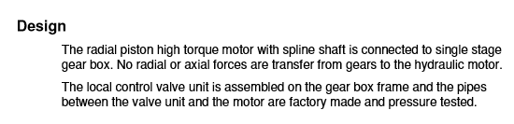
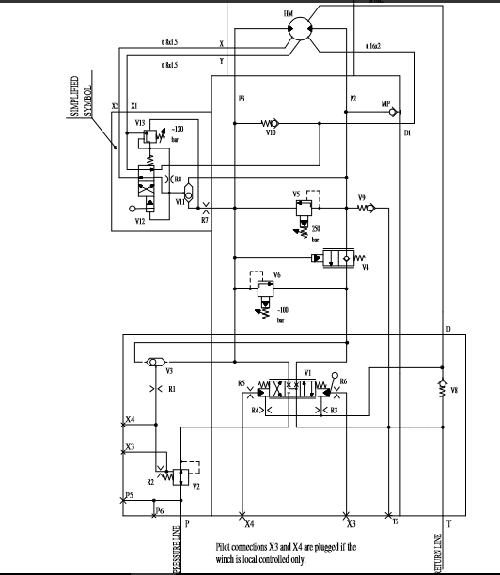
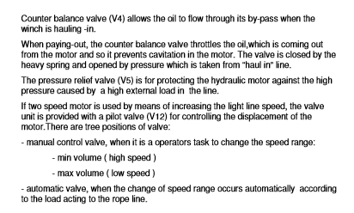
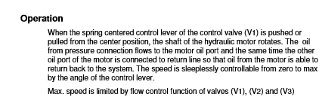

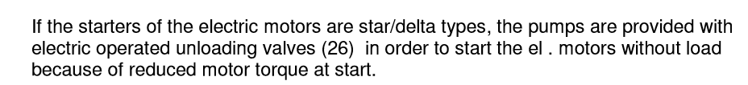
၈၅-အခ်ိဳ႔ hydraulic windlass system ေတြမွာ unloading valve ပါတတ္ၿပီး အခ်ိဳ႔မွာ မပါၿကဘူး။ဘါကြါလို႔လဲ၊
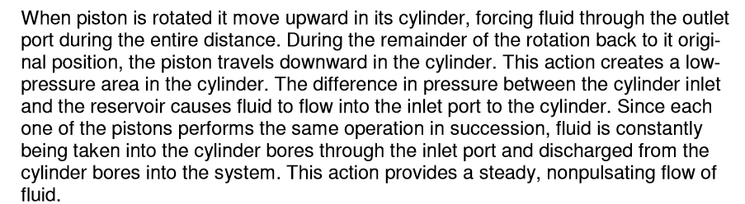
၈၆-အေတၚမ်ားမ်ား piston pump ေတြမွာ pulsating flow ၿဖစ္လို႔ အထြက္ဖက္မွာ shock absorber ဘူးေတြထည္႔ထါးေပး၇တယ္။ windlass က axial piston pump ေတြမွာေကါ shock absorber ပါလါး။ဘါလို႔လဲ၊
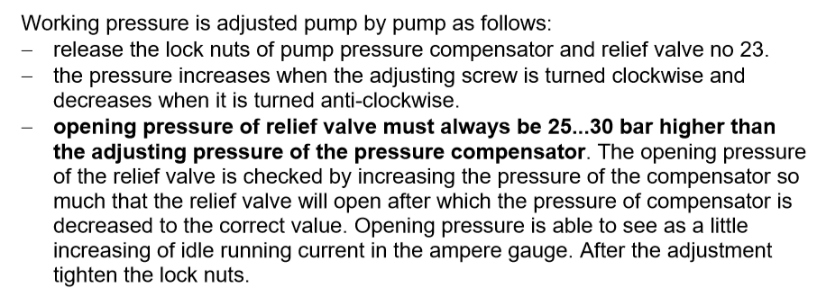
87-pressure compensator ပါတဲ႔ mooring winch hydraulic pump ေတြမွာ pressure compensator & relief valve အတြဲ လိုက္ပါလါတတ္တယ္။ တကယ္လို႔ relief valve setting pressure နဲေနလို႔ idle နဲ႔ေမါင္းေနတံုး relief valve ပြင္႔ခဲ႔၇င္ ေမၚတါ ampere တက္မလါး။က်မလါး။
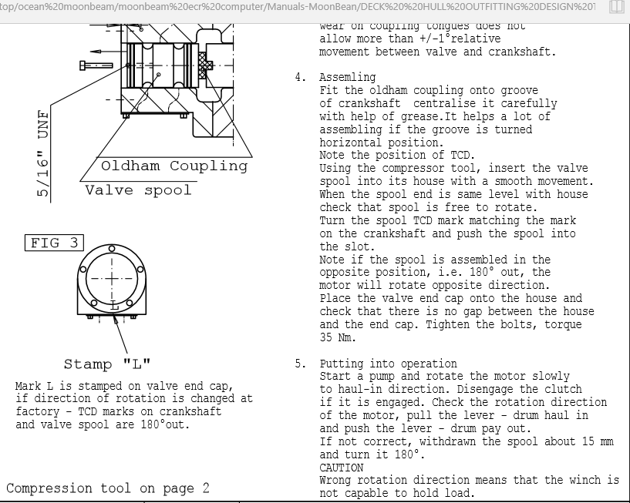
၈၈- mooring winch motor တလံုး dock မွာ servicing လုပ္ၿပီးၿပန္တပ္ေတါ႔ နဂို direction နဲ႔ေၿပာင္းၿပန္လည္ေနသတဲ႔။ ဘါေၿကာင္႔ၿဖစ္နုိင္သလဲ၊
89-ပန္႔တလံုးၿပန္ထိုင္၇င္ alignment ခ်ိန္ၿကပါတယ္။လက္ခံနုိင္ေလါက္တဲ႔ အေကါင္းဆံုး misalignment tolerance ေတြကဘယ္ေလါက္လဲ၊
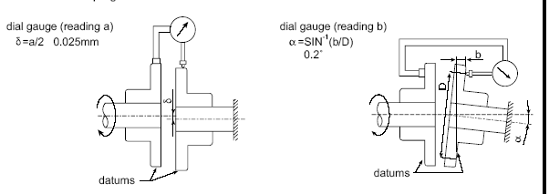
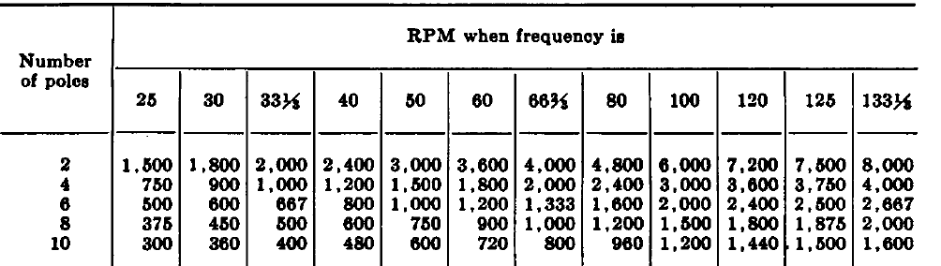
၉၀-rpm 720 ၇ိွတဲ႔အင္ဂ်င္သံုး alternator နဲ႔ rpm ၁၂၀၀ ၇ွိအင္ဂ်င္သံုး alternator ၂ ခု ဘါကြါလဲ။

91-MAN B&W အင္ဂ်င္ေတြမွာတပ္ထါးတတ္တဲ႔Atlas load depended lubricator ေတြမွာ load depended ေက်ြးတဲ႔ပမါဏဘယ္ေလါက္ခ်ိန္ထါးလဲ ဆိုတါ ကို ဘယ္လိုၿကည္႔လဲ၊အဲလိုေက်ြးတဲ႔အခ်ိန္က ဘယ္ေလါက္လဲ။
၉၂- S50MC-C အင္ဂ်င္တလံုး၇ဲ႔ ACTUAL FEED RATE ကိုဘယ္လိုခ်ိန္မလဲ
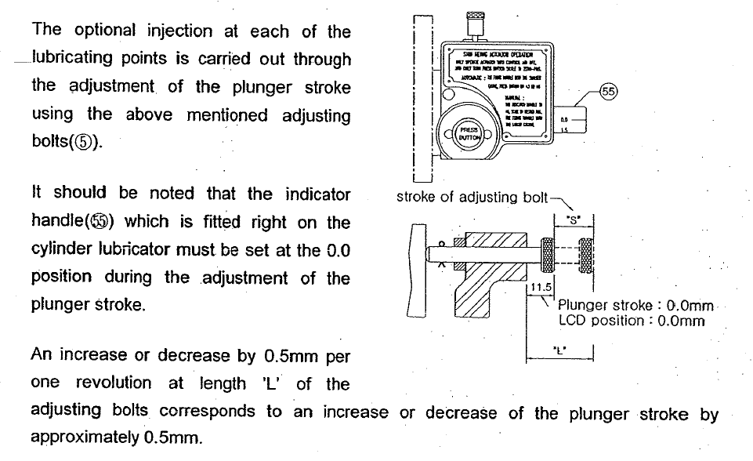
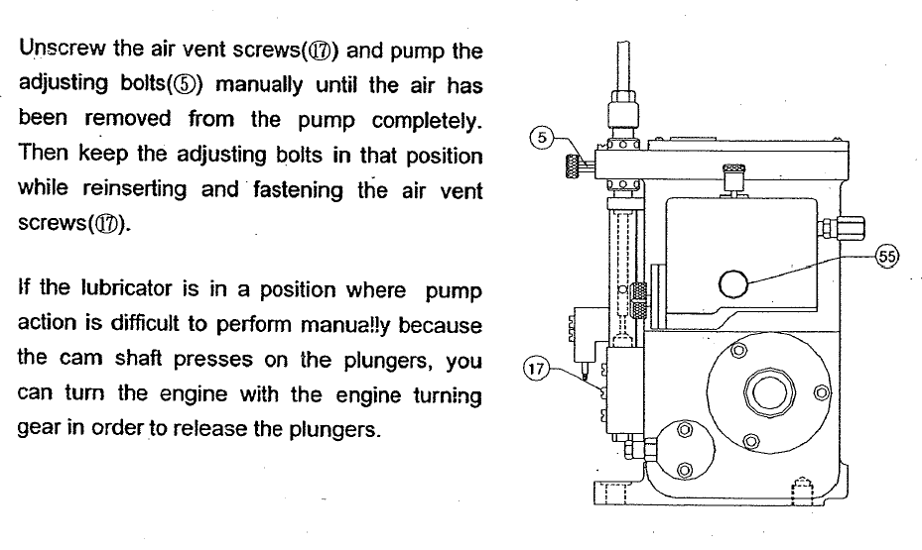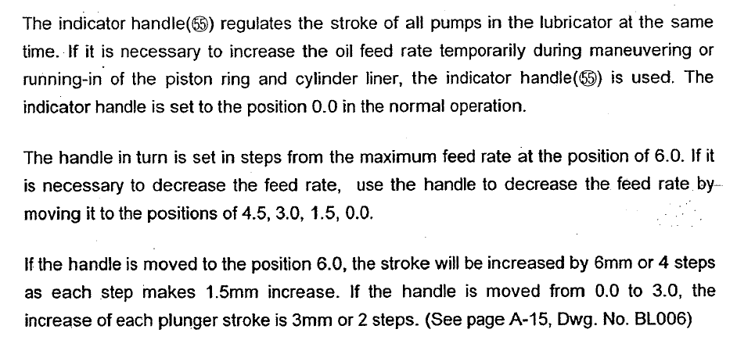
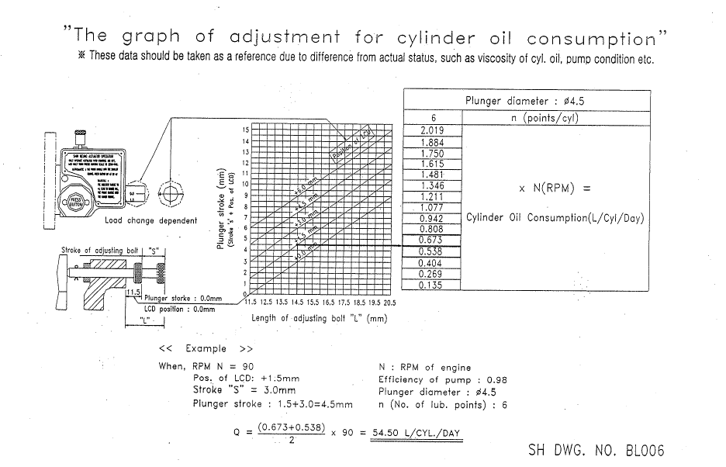
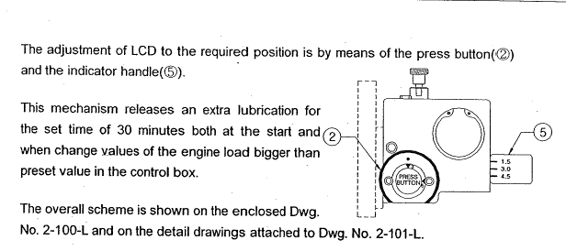
တကယ္လို႔ အင္ဂ်င္စနိဳးခ်ိန္နဲ႔ load change တါသိပ္မ်ားတဲ႔အခ်ိန္မွာဘဲ ဆလင္ဒါ၀ိုင္ပိုေပးတဲ႔ ပမါဏကိုခ်ိန္ခ်င္၇င္ press button မွာ၇ိွတဲ႔ 0 press button မွာ၇ိွတဲ႔ 0,3,6 စတါကိုလွည္႔ခ်ိန္ေပး၇ပါမယ္။ဒါဆိူ အဲဒီ ခ်ိန္ထါးတဲ႔ပမါဏကို ၃၀ မိနစ္ပိုေပးၿပီး၇င္ နဂိုေက်ြးနုန္းကိုၿပန္ဆင္းပါလိမ္႔မယ္။
ခ်ိန္နည္းက ေက်ြးတဲ႔ေလလိုင္းကိုၿဖဳတ္။ပိတ္ပါ။ပံုမွာပါတဲ႔ fixing handle (၃)ကို အေပၚဆြဲမပါ။indicator handle (5) ကုိ 0.0 position မွာထါးပါ။(မထါး၇င္ press handle လွည္႔လို႔မ၇ပါဘူူး) ၿပီး၇င္ press handle (၂) ကိုလိုတဲ႔ position ေ၇ာက္ေအါင္လွည္႔ပါ။(3 – LCD STROKE + 3mm), 6- - LCD STROKE + 6 mm) ၃၀မိနစ္ပိုေက်ြးပါလိမ္႔မယ္။သတိၿပဳစ၇ာ fixing handle က အေပၚမတဲ႔ အေနအထါးမွာ၇ိွေနပါလိ္မ္႔မယ္။ ေအါက္အေနအထါးမွာမ၇ိွပါဘူး။တကယ္အလုပ္လုပ္မလုပ္အင္ဂ်င္နိုးခိ်န္မွာindicator handle လည္မလည္ ဆင္းၿကည္႔ပါ။

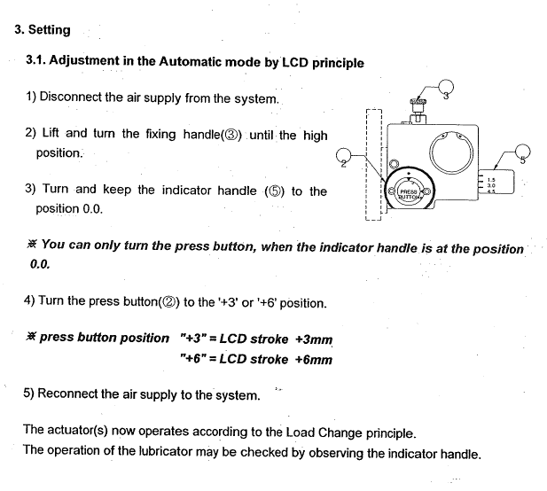
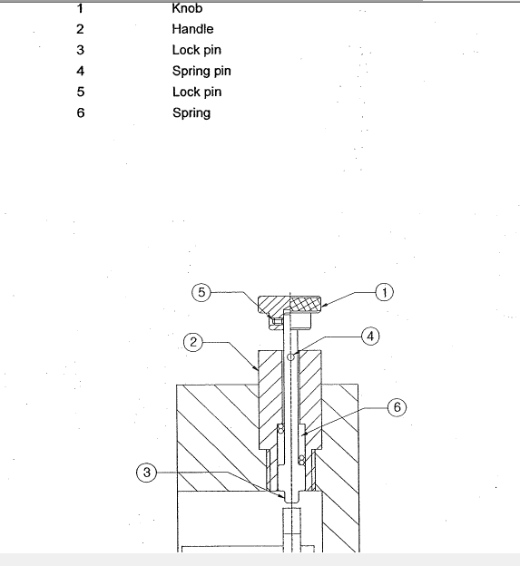
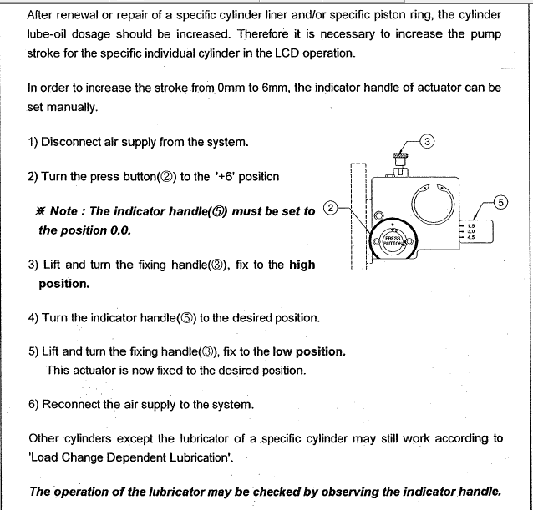
တကယ္လို႔ အင္ဂ်င္ကိုင္ၿပီးခါစ - running in cyl oil ပိုေက်ြးခ်င္၇င္ေတါ႔ ေလပိုက္ပိတ္။ၿဖဳတ္ပါ။indicator handle 5 ကို 0.0 မွာထါးၿပီး၇င္ press button 2 ကို +၆ မွာထါးပါ။
ၿပီး၇င္ fixing handle 3 ကို အေပၚအေနအထါးမွာထါးပါ။indicator handle ကိုလိုတဲ႔ပမါဏထါးပါ။ fixing handle ကို low position မွာထါးပါ။ ေလၿပန္ေက်ြးပါ။
အဲဒီမွာေတြ႔ပါလိမ္႔မယ္။ fixing handle က low position မွာပါ။ အဲဒါ အင္ဂ်င္ကိုင္ၿပီးခါစပါဘဲ။ ၿပီး၇င္ fixing handle က high position ကိုၿပန္ထါး။ indicator handle က လဲ 0,0ကိုၿပန္ထါးၿကပါတယ္။
ဒါေၿကာင္႔ပံုမွန္၇ိဳး၇ုိး အေၿခအေနဆို၇င္ fixing handle high position, indicator handle – 0.0 position, press button 3- 6 position ေလါက္၇ိွပါတယ္။ အနဲအမ်ားကို adjusting bolt နဲ႔ဘဲခ်ိန္ၿကပါတယ္။
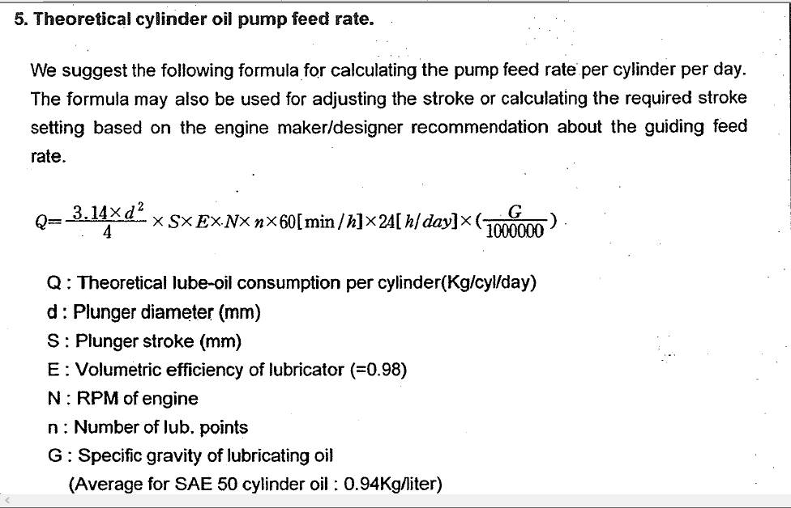
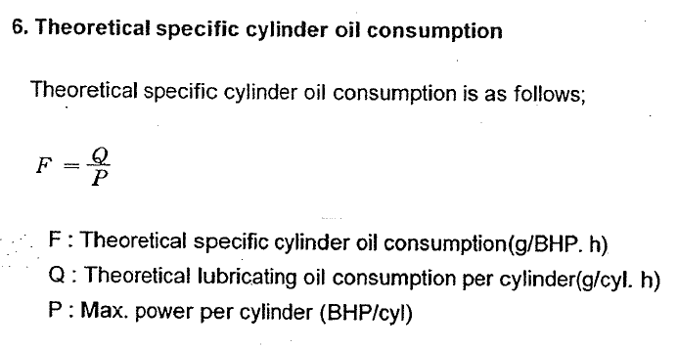
F=(Q x SG cyl)/P x {(1000/24}
F= recommened feed rate
Q= recommened cylinder oil consumption PER LTR /day
SG cyl=S.G of cylinder oil
P= MCR horse power
F=260x0.925x1000/11190/24= 0.896 g/BHP h( Recommend feed rate at MCR= 0.7 TO 1.0, IF 1.0 –Qa =290)
Qx =Qy x (RPMx/RPMy)2
Qx=260(120/127)2=232
IF Qy=290 ---- Qx = 260
Can be adjusted between 232 to 260 ltr/day
when turn the adjusting bolt CCW – 1 rev – 0.5 mm of stroke increase
if turn C.W – 1 REV – 0.5 MM STROKE DECREASE
တကယ္ေက်ြး၇မဲ႔ ပမါဏက ေတါ႔ Under piston space inspection လုပ္တဲ႔အခါေတြ႔၇တဲ႔ piston ring မွာ ဆလင္ဒါ၀ိုင္စိုစြတ္မွဳအေၿခအေန။ လိုင္နာ ဆီငတ္မွဳ၇ိွမ၇ိွ။စတါေတြကိုၿကည္႔၇ပါတယ္။
Man b&W recommend ကေတါ႔
Specific cyl oil feed rate – 0.7 g/BHP h ---- 1.0 g/BHP h
Or – 1.0 g/kwh --- 1.4 g/kwh ၿဖစ္ပါတယ္။
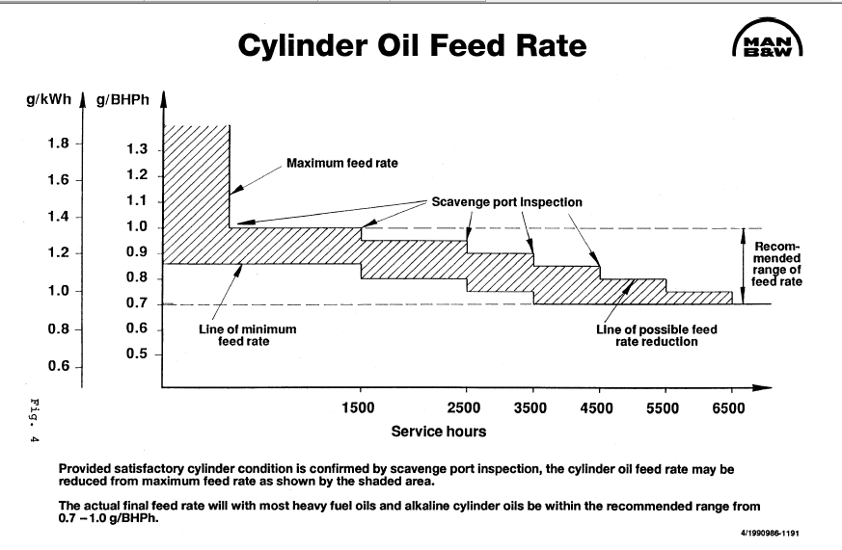
Load depended ကိုေတါ႔ 3 to ၆ ထိထါးခိုင္းပါတယ္။
တကယ္လို႔ inspection လုပ္ခ်ိန္ abnormal condition ကို unit တခုခုမွာေတြ႔ခဲ႔၇င္ feed rate ကို ၅၀% ပိုေပးပါ။ ေနာက္ၿပိး ဘါေၿကာင္႔ ၿဖစ္တယ္ဆိုတဲ႔အေၿကာင္း၇ွာေတြ႔လို႔ ၿပင္ၿပီး၇င္ နဂိုအတိုင္းၿပန္ထါးဘို႔မေမ႔ပါနဲ႔။
ဒါက SERVICE LETTER SL 91-286 /OG OCT 1991 ကိုကိုးကါးထါးတါပါ။
ဘါဘဲေၿပာေၿပာ actual feed rate ကိုဆံုးၿဖတ္တါက scavenge port inspection ကေန ေတြ႔၇တဲ႔အေၿခအေန ေပၚမူတည္ၿပီး ဆံုးၿဖတ္၇တါဘဲၿဖစ္ပါတယ္။
အၿကမ္းဖ်င္းစခ်ိန္ဖို႔ကေတါ႔ MAN B&W ၇ဲ႔ အေတြ႔အၿကံုအ၇ဆို၇င္
Base on the service experience, our general recommendation can be summarized as follow
Specific cyl oil feed rate – 0.7 g/BHP h --- 1.0 g/BHP h (or) 1.0 g/kWh – 1.4 g/KWh
တကယ္လို႔ အင္ဂ်င္တလံုးက run in ကိုေသေသခ်ာခ်ာ လုပ္ခဲ႔မယ္။အေပၚက တန္ဖိုးေတြက nominal MCR အတြက္ၿဖစ္ပါတယ္။
အင္ဂ်င္စနိဳးခ်ိန္နဲ႔ MANOEUVRING, SUDDEN LOAD CHANGE အခ်ိန္ေတြမွာ AT LEAST 2 STEP ဒါမွမဟုတ္ အမ်ားဆံုး SETTING ကိုခ်ိန္ခိုင္းထါးပါတယ္။LCD Lubricator type ဆို၇င္ press button position – 6 ေလါက္ေပါ႔။
ေနာက္ၿပီး scavenge port inspection လုပ္လို႔ ပံုမွန္မဟုတ္တဲ႔အေၿခအေနေတြ႔၇င္ FEED RATE ကို ၅၀% ပိုေပးခိုင္းပါတယ္။ ၿပင္ၿပီး၇င္ ၿပန္ေလ်ာ႔ပါ။
RPM အမ်ိဳးမ်ိုုးအတြက္ FEED RATE တြက္ခ်င္၇င္ေတါ႔
Qx =Qy * ( RPMx/RPMy)2 နဲ႔တြက္ပါ။ Qx = NEW FEED RATE, Qy= OLD FEED RATE, RPMx= NEW RPM, RPMy = OLD RPM
အေပၚက ပံုေသနည္းက LOAD ဟါ RPM ၂ထပ္ကိန္းနဲ႔ေၿပာင္းတယ္ဆိုတဲ႔ CUBIC PROPELLER CURVE ကိုအေၿခခံၿပီး ထုတ္ထါးတဲ႔ ပံုေသနည္းၿဖစ္ပါတယ္။(ဒါမွမဟုတ္လဲ mep အခ်ိုဳးနဲ႔ဆိုလဲ၇ပါတယ္။)
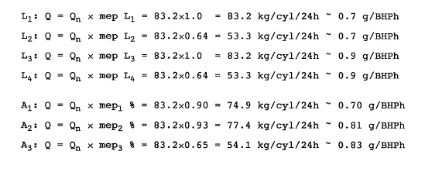
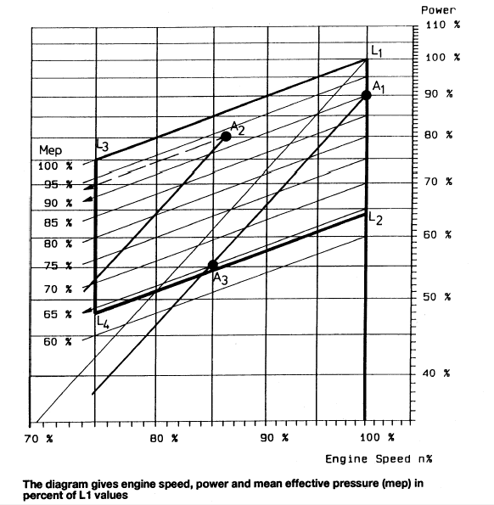
ဘါဘဲေၿပာေၿပာ NEW LINER BREAKING IN ( လုိင္နာအသစ္။ အိုဗါေဟါလုပ္ခဲ၇င္) INDICATOR HANDLE ကိ္ုအဆံုးတင္(၄.၅) မွာထါးဘို႔ေၿပာထါးပါတယ္။
အင္ဂ်င္ SPEED ကို ၂ နာ၇ီကေန ၄ နာ၇ီအတြင္း ၈၀% ေ၇ာက္ေအါင္တင္ပါတဲ၊ၿပီး၇င္ အဲဒီ RPM နဲ႔ ၆ နာ၇ီေမါင္းပါတဲ႔။ၿပိးေတါ႔မွ 80% အထက္ RPM ကို ၁၂-၁၄ နာ၇ီအတြင္းေၿဖးေၿဖးခ်င္းၿမွင္႔တင္ပါ။
ၿပီး၇င္ SCAVENGE PORT INSPECTION လုပ္ပါ။ အဲဒီ ၀.၈၅ g/BHP h နဲ႔ အနဲဆံုး ၁၅၀၀ နာ၇ီေလါက္ေမါင္းပါ။
ၿပန္ေလ်ာ႔ခ်င္၇င္ 0.05 g/BHP h နွုန္းနဲ႔ေလ်ာ႔ခ်ပါ။ၿပီး၇င္ နာ၇ီ ၁၀၀၀ ၿကာ၇င္ scavenge port inspection ထပ္လုပ္ပါ။
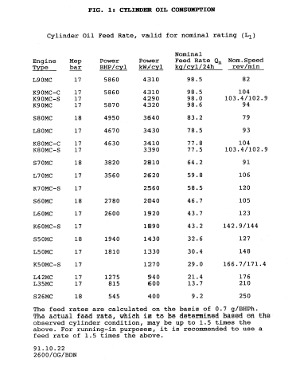
"Basic Encoder & Decoder - (၁) - Encoder : Incremental Rotary Encoder and Linear Encoder"
.
Reference & Credit to : (1) Basics of rotary encoders: Overview and new technologies by Elisabeth Eitel , Machine Design Magazine, 7 May 2014., (2) Multi-turn absolute encoders by Repas Robert, Machine Design Magazine, 20 February 2013., (3) Process Instruments and Controls Handbook 5 th Edition by G. K. McMillan and D.M. Considine (ed.), McGraw Hill 1999., (4) Linear Position Sensors : Theory and Application by David S. Nyce, John Wiley & Sons Inc., New Jersey, 2003.
.
(Remark : All publications and images herein this page are for use of educational purpose only. The owner of this page is not responsible for the consequences in case of violation to copyright, trademark, patent or other intellectual property rights of any third party.)
.
(b) - "Incremental Rotary Encoder -encoder" လည္ပတ္ရာမွ၊ cyclical outputs ထုတ္ေပးမယ္႔၊ encoder အမၽိဳးအစားၿဖစ္ၿပီး၊ mechanical type, optical type နဲ႔ magnetic type incremental rotary encoder ဆိုၿပီး၊ ေတြ႔ရပါတယ္။ mechanical type incremental rotary encoder ေတြမွာ၊ debouncing (switching) ပါဝင္ၿပီး၊ အလြယ္တကူ၊ ဥပမာေပးရလၽွင္၊ digital potentiometers ေတြကို၊ mechanical type incremental rotary encoder အၿဖစ္၊ သတ္မွတ္နိဳင္ပါတယ္။
.
incremental rotary encoder ေတြဟာ၊ velocity ကဲ႔သို႔၊ motion related information ေတြကို၊ output signal အၿဖစ္၊ အလြယ္တကူ၊ ထုတ္ေပးနိဳင္ပါတယ္။
ေယဘုယၽအေနနဲ႔၊ incremental rotary encoder ေတြမွာ၊ sensor (၂) ခု၊ ပါဝင္ပါတယ္။
.
incremental rotary encoder ေတြမွ၊ optional third output အေနနဲ႔၊ reference ဆိုတဲ႔ "index" ကိုလည္း၊ ထုတ္ေပးနိဳင္ပါတယ္။ positioning systems ကဲ႔သို႔၊ applications ေတြမွာ၊ "index" signal ကို၊ absolute reference အၿဖစ္၊ အသံုးၿပဳႀကၿပီး၊ index output ကိုေတာ႔၊ labeled "Z" ဆိုကာ၊ သံုးနံွဳးေဖာ္ၿပေလ့၊ ရိွပါတယ္။
.
optical type incremental rotary encoder ေတြကို၊ ၿမန္နံွဴးၿမင္႔ higher speeds applications ေတြနဲ႔၊ အေသးစိတ္၊ တိကၽမွဳလိုအပ္တဲ႔၊ higher degree of precision applications ေတြမွာ၊ အသံုးၿပဳႀကပါတယ္။ incremental encoders ေတြဟာ၊ direction ကိုပါ၊ ဖတ္ရွဳနိဳင္တဲ႔အတြက္၊ position နဲ႔၊ velocity တို႔ကို၊ track motion အၿဖစ္၊ တိုင္းတာနိဳင္သလို၊ rotary motion ကိုသာမက၊ linear motion ကိုပါ၊ တိုင္းတာနိဳင္တာ၊ ေတြ႔ရပါတယ္။ Fig. (1) မွာ၊ "Encoder ROD 420" ဆိုၿပီး၊ optical type incremental rotary encoder တလံုးကို၊ ဥပမာအၿဖစ္၊ ေဖာ္ၿပထားပါတယ္။
.
optical type incremental rotary encoder ေတြမွ၊ ထုတ္ေပးတဲ႔၊ output signal (၂) ခုကို၊ A & B လို႔၊ သတ္မွတ္ႀကၿပီး၊ cyclical outputs တနည္းအားၿဖင္႔၊ 90 degrees out of phase အေနအထားၿဖင္႔၊ တည္ရိွေနမယ္႔၊ quadrature outputs ေတြလည္း၊ ၿဖစ္ပါတယ္။ Fig. (2) မွာ၊ "State diagram" ဆိုၿပီး၊ ဥပမာအၿဖစ္၊ ေဖာ္ၿပထားပါတယ္။ တနည္းအားၿဖင္႔၊ 90 degrees out of phase အေနအထားၿဖင္႔၊ တည္ရိွေနမယ္႔၊ quadrature outputs ေတြၿဖစ္တဲ႔အတြက္၊ count up pulse နဲ႔၊ count down pulse ဆိုတဲ႔၊ signal ေတြကို၊ decode အၿဖစ္၊ incremental rotary encoder ဆိုတဲ႔၊ transducer မွ၊ ထုတ္ေပးၿခင္းလည္း၊ ၿဖစ္ပါတယ္။ Fig. (3) မွာ၊ "Two square waves in quadrature (clockwise rotation)" ဆိုၿပီး၊ ဥပမာအၿဖစ္၊ ေဖာ္ၿပထားပါတယ္။
.
software သို႔၊ A & B outputs ေတြကို၊ decode အၿဖစ္၊ ေပးသြင္းတဲ႔အခါ၊ edge သို႔မဟုတ္ polling ဆိုတဲ႔၊ process အေနနဲ႔၊ ဖတ္ယူၿပီး၊ state diagram ဆိုတဲ႔၊ table ကိုေတာ႔၊ decode direction အၿဖစ္၊ အသံုးၿပဳပါတယ္။ ဥပမာ၊ last value 00 နဲ႔၊ လက္ရိွ current value 01 ဆိုၿပီး၊ decode အၿဖစ္၊ ဖတ္ယူရရိွခဲ႔လၽွင္၊ state diagram ဆိုတဲ႔၊ table အရ၊ device ဟာ၊ clockwise direction ၿဖင္႔၊ တဝက္ half step လည္ပတ္ခဲ႔ၿခင္း၊ သို႔မဟုတ္ ေရြွ႕လၽွားခဲ႔ၿခင္း ရယ္လို႔၊ software (microprocessor or microcontroller) မွ၊ ဖတ္ယူပါတယ္။ mechanical type ေတြမွာေတာ႔၊ debouncing (switching) ပါရိွေနတဲ႔အတြက္၊ state အေၿပာင္းအလဲ၊ ဖတ္ယူရာမွာ၊ certain number of times အေနနဲ႔၊ အခၽိန္အနည္းယူၿပီးမွ၊ outputs ကို၊ decode အၿဖစ္၊ ရရိွနိဳင္တာ၊ ေတြ႔ရပါတယ္။
.
incremental encoders ေတြဟာ၊ index output ဆိုတဲ႔၊ labeled "Z" (Z signal) ကို၊ ထုတ္ေပးနိဳင္သလို၊ ‘Z’ signal ဟာ၊ 90° rising ၿဖင္႔၊ ၿဖစ္ေပါါပါတယ္။ အခၽိဳ႕ incremental encoders ေတြကေတာ႔၊ additional differential signals ၿဖစ္တဲ႔၊ “/A”, “/B” နဲ႔၊ “/Z” signal ေတြကိုပါ၊ ထုတ္ေပးနိဳင္ပါတယ္။ A, B, Z နဲ႔၊ “/A”, “/B” , /Z” signal အစံုလိုက္ကို၊ controller မွ၊ နိွဳင္းယွဥ္ကာ၊ control system ရိွ၊ transmission period အတြင္း၊ error ေလၽွာ႔နည္းသြားေစရန္၊ ပိုမို၊ ေဆာင္ရြက္လာနိဳင္တာ၊
ေတြ႔ရပါတယ္။ incremental encoders အမၽားစုရဲ႕၊ out put signal ေတြဟာ၊ square signal ေတြၿဖစ္ပါတယ္။ Fig. (4) မွာ၊ "Incremental Pulse Diagram A, B, Z" ဆိုၿပီး၊ ဥပမာအၿဖစ္၊ ေဖာ္ၿပထားပါတယ္။
.
အခၽိဳ႕ incremental encoders ေတြကေတာ႔၊ square signal ဆိုတဲ႔၊ quadrature square waves (၂) ခု အစား၊ quadrature sine waves ဆိုတဲ႔ sine and cosine signal ေတြကို၊ output အၿဖစ္၊ ထုတ္ေပးၿပီး၊ sine wave encoder လို႔၊ ေခါါပါတယ္။ arctangent function ၿဖင္႔၊ လည္ပတ္မွဳနံွဳးထား၊ အမၽိဳးမၽိဳးေၿပာင္းလဲေနမယ္႔ applications ေတြနဲ႔၊ arbitrary levels ဆိုတဲ႔၊ ေရြွလၽွားမွဳအမၽိဳးမၽိဳးေၿပာင္းလဲေနမယ္႔၊ applications ေတြမွာ၊ incremental encoder အမၽိဳးအစားတခုၿဖစ္တဲ႔၊ 'sine wave encoder' ေတြကို၊ transducer အၿဖစ္၊ တတ္ဆင္၊ အသံုးၿပဳႀကပါတယ္။
.
ေယဘုယၽအေနနဲ႔၊ rotary encoders ေတြကို၊ servomotors, permanent magnet brushless motors ေတြအပါအဝင္၊ industrial equipmentမွ၊ motor shaft ရဲ႕ position ကို၊ code အၿဖစ္၊ controller မွ၊ ဖတ္ယူရရိွနိဳင္ရန္၊ တတ္ဆင္၊ အသံုးၿပဳတယ္လို႔၊ ဆိုနိဳင္ပါတယ္။ incremental (quadrature) encoders ေတြကို၊ induction motor type servomotors ေတြမွာ၊ တတ္ဆင္၊ အသံုးၿပဳႀကၿပီး၊ absolute encoders ေတြကိုေတာ႔၊ permanent magnet brush-less motors ေတြမွာသာ၊ တတ္ဆင္အသံုးၿပဳၿခင္းလည္း၊ ၿဖစ္ပါတယ္။
.
permanent magnet brush-less motors ေတြမွာ၊ တတ္ဆင္၊ အသံုးၿပဳတဲ႔အခါ၊ rotary encoder ဟာ၊ feedback device ဆိုတဲ႔ transducer အၿဖစ္၊ ေဆာင္ရြက္ေပးပါတယ္။ လည္ပတ္ေနမယ္႔၊ rotor magnet နဲ႔ stator winding position တို႔ကို၊ ဖတ္ယူၿပီး၊ drive controller သို႔၊ reference (feedback) အၿဖစ္၊ decoding ေပးသြင္းကာ၊ synchronize အေၿခအေနၿဖင္႔၊ ေမာင္းနွင္လည္ပတ္ေစၿခင္းလည္း၊ ၿဖစ္ပါတယ္။ တနည္းအားၿဖင္႔၊ load ေႀကာင္႔၊ motor winding current ေၿပာင္းလဲမွဳ၊ ၿဖစ္ေပါါတဲ႔အခါ၊ rotor magnets ရဲ႕၊ particular position range ကို၊ sense ၿပဳလုပ္ကာ၊ ရုန္းအားဆိုတဲ႔၊ maximum torque results ရရိွလာေစရန္၊ drive controller သို႔၊ transducer မွ၊ reference (feedback) ေပးပို႔ၿခင္း၊ ၿဖစ္ပါတယ္။ Fig. (5) မွာ၊ permanent magnet brush-less motor with encoder ဆိုၿပီး၊ ဥပမာအၿဖစ္၊ ေဖာ္ၿပထားပါတယ္။
.
(ii) - "Linear Encoder" – sensor, transducer သို႔မဟုတ္၊ read head paired ရယ္လို႔၊ သတ္မွတ္၊ ေခါါဆို္နိဳင္ပါတယ္။ output အၿဖစ္၊ analog or digital signal ထုတ္ေပးၿပီး၊ decoded အၿဖစ္၊ DRO ဆိုတဲ႔ digital readout သို႔မဟုတ္၊ motion controller သို႔၊ ေပးသြင္းပါတယ္။ linear encoders ေတြကိုလည္း၊ absolute နဲ႔ incremental ဆိုၿပီး၊ ေတြ႔နိဳင္ပါတယ္။
.
linear encoders ေတြကို၊ coordinate-measuring machines, laser scanners, calipers, gear measurement, tension testers နဲ႔၊ digital read outs (DROs) အစရိွတဲ႔၊ measurement applications ေတြနဲ႔၊ servo controlled motion system, machine tools, pick-and-place PCB assembly equipment; semiconductors handling and test equipment, wire bonders, printers နဲ႔၊ digital presses အစရိွတဲ႔၊ motion system applications ေတြမွာ၊ transducer (device) အၿဖစ္၊ တတ္ဆင္၊ အသံုးၿပဳႀကပါတယ္။
.
Instrumentation နယ္ပယ္မွ၊ "linear encoders" ေတြဟာ၊ optical, magnetic, inductive, capacitive နဲ႔၊ eddy current နည္းလမ္းေတြ၊ အသံုးၿပဳၿပီး၊ အလုပ္လုပ္ႀကပါတယ္။ absolute နဲ႔ incremental linear encoders" ေတြကို၊ (i) - Scale/ reference based linear encoders နဲ႔၊ (ii) - Without scales linear encoders ဆိုၿပီး၊ ခြဲၿခားနိဳင္ပါတယ္။
.
"Scale/ reference based Optical linear encoder" ေတြမွာ၊ infrared LEDs, visible LEDs, miniature light-bulbs နဲ႔၊ laser diodes အစရိွတဲ႔၊ components ေတြကို၊ light source အၿဖစ္၊ အသံုးၿပဳထားပါတယ္။ Fig. (6) မွာ၊ "infra-red LED - Scale/ reference based Optical linear encoder" ဆိုၿပီး၊ ဥပမာအၿဖစ္၊ ေဖာ္ၿပထားပါတယ္။
.
accurate အေနနဲ႔၊ တိကၽေသၿခာမွဳ၊ ရိွတဲ႔အတြက္၊ optical encoders ေတြကို၊ industrial automation applications ေတြမွာ၊ အမၽားဆံုး၊ တတ္ဆင္အသံုးၿပဳေလ့၊ ရိွႀကပါတယ္။ industrial environments မွာ၊ ရိွေနတတ္တဲ႔၊ အမွဳန္အမြွား၊ အစအန dust ေတြနဲ႔၊ vibration ေတြကို၊ ကာကြယ္နိဳင္ရန္၊ encoder device ကို၊ extra protection ၿဖင္႔၊ ဖံုးအုပ္ထားပါတယ္။
.
"Scale/ reference based Optical linear encoders" ေတြဟာ၊ typical incremental scale အေနနဲ႔၊ micrometers မွ sub-micrometer အထိ၊ ဖတ္ယူၿပီး၊ output (encoding signal) ထုတ္ေပးနိဳင္သလို၊ interpolation ဆိုတဲ႔၊ data points ေတြကိုလည္း၊ nano-meter အရြယ္အစားအထိ၊ ဖတ္ယူကာ၊ encoding signal အၿဖစ္၊ output ထုတ္ေပးနိဳင္ပါတယ္။
.
"Scale/ reference based Magnetic linear encoders" ေတြကေတာ႔၊ active ဆိုတဲ႔၊ magnetized သို႔မဟုတ္၊ passive ဆိုတဲ႔၊ variable reluctance scales ေတြနဲ႔၊ position ကို၊ sense-coils, Hall effect နဲ႔ magnetoresistive readhead မွတဆင္႔၊ ဖတ္ယူကာ၊ output signal ထုတ္ေပးတဲ႔၊ encoder အမၽိဳးအစား၊ ၿဖစ္ပါတယ္။ Fig. (7) မွာ၊ magnetic tape gratings ေတြနဲ႔၊ magnetoresistive readhead အသံုးၿပဳထားတဲ႔၊ Scale/ reference based Magnetic linear encoder တခုကို၊ ဥပမာအၿဖစ္၊ ေဖာ္ၿပထားပါတယ္။ typical incremental scale အေနနဲ႔၊ hundred micrometers မွ၊ millimeters အထိ၊ ဖတ္ယူၿပီး၊ encoding signal အၿဖစ္၊ output ထုတ္ေပးနိဳင္ပါတယ္။
.
"Scale/ reference based Capacitive linear encoders" ေတြဟာ၊ reader (head) နဲ႔၊ scale အႀကားမွ၊ capacitance တန္ဘိုး၊ အေၿပာင္းအလဲကို၊ ဖတ္ယူကာ၊ output signal ထုတ္ေပးပါတယ္။ အလြယ္တကူ ဥပမာေပးရလၽွင္၊ အၿမဲတမ္း၊ ေတြ႔ၿမင္၊ ကိုင္တြယ္သံုးစြဲေနကၽ၊ digital calipers ေတြဟာ၊ Scale/ reference based Cpacitive linear encoders ေတြလည္၊ ၿဖစ္ႀကပါတယ္။ sensitive ၿဖစ္လြန္းတဲ႔၊ transducer အမၽိဳးအစားၿဖစ္ၿပီး၊ industrial environments မွာ၊ ရိွေနတတ္တဲ႔၊ အမွဳန္အမြွား၊ အစအန dust ေတြေႀကာင္႔၊ relative permittivity အေနနဲ႔၊ output တန္ဘိုး၊ အလြယ္တကူ၊ ေၿပာင္းလဲသြားနိဳင္တာ၊ ေတြ႔ရပါတယ္။
.
"Scale/ reference based Inductive linear encoders" ေတြကိုလည္း၊
coolant-proof ၿဖင္႔၊ ဖံုးအုပ္ထားတဲ႔၊ transducers ေတြအၿဖစ္၊ measurement applications ေတြမွာ၊ အသံုးၿပဳႀကတာ၊ ေတြ႔ရပါတယ္။ Fig. (8) မွာ၊ Scale/ reference based Inductive linear encoder တခုကို၊ ဥပမာအၿဖစ္၊ ေဖာ္ၿပထားပါတယ္။
.
"Scale/ reference based Eddy currents linear encoders" ေတြမွာလည္း၊ inductive coil အသံုးၿပဳကာ၊ scale ကို၊ ဖတ္ယူၿပီး၊ encoding signal အၿဖစ္၊ output ထုတ္ေပးပါတယ္။ တနည္းအားၿဖင္႔၊ AC circuit ရဲ႕၊ inductance ေၿပာင္းလဲမွဳမွတဆင္႔၊ output signal ရယူၿခင္း၊ ၿဖစ္ပါတယ္။ Fig. (9) မွာ၊ "Scale/ reference based Eddy currents scale linear encoder" တခုကို၊ ဥပမာအၿဖစ္၊ ေဖာ္ၿပထားပါတယ္။
.
Without scales linear encoders အၿဖစ္၊ "Optical image sensor" ဆိုတဲ႔၊ linear encoder ေတြကို၊ အသံုးၿပဳႀကပါတယ္။ image ရဲ႕ displacement ေၿပာင္းလဲမွဳမွတဆင္႔၊ comparing function အေနနဲ႔၊ နိွဳင္းယွဥ္ကာ၊ encoding signal အၿဖစ္၊ output ထုတ္ေပးပါတယ္။ resolutions အေနနဲ႔၊ 1 nano millimeter အရြယ္အစားအထိ၊ ဖတ္ယူနိဳင္ပါတယ္။ Fig. (10) မွာ၊ Optical sensor – without scale linear encoder ဆိုၿပီး၊ ဥပမာအၿဖစ္၊ ေဖာ္ၿပထားပါတယ္။
.
"Output signal formats" - linear encoders ေတြဟာ၊ analog သို႔မဟုတ္၊ digital outputs ထုတ္ေပးမယ္႔၊ transducers ေတြၿဖစ္ပါတယ္။
industrial standard အရ၊ analog output ကို၊ sine နဲ႔ cosine quadrature signals ေတြအၿဖစ္၊ ထုတ္ေပးပါတယ္။ Fig. (11) မွာ၊ "Sine and cosine quadrature signal output from linear encoders" ဆိုၿပီး၊ ဥပမာအၿဖစ္၊ ေဖာ္ၿပထားပါတယ္။
.
မူလက၊ industrial standard အေနနဲ႔၊ 12 µA peak-peak current signals ကို၊ output signal အၿဖစ္၊ သတ္မွတ္ခဲ႔ရာမွ၊ ေနာက္ပိုင္းမွာေတာ႔၊ 1V peak to peak voltage signals ဆိုၿပီး၊ ေၿပာင္းလဲသတ္မွတ္ခဲ႔ပါတယ္။
1V peak to peak voltage signal ဟာ၊ lower band width signal ၿဖစ္တဲ႔အတြက္၊ emc ဆိုတဲ႔ electromagnetic compatibility emissions လည္း၊ ေလၽွာ႔နည္း၊ ကၽဆင္းသြားတာ၊ ေတြ႔ရပါတယ္။
.
linear encoders ေတြရဲ႕၊ overall accuracy နဲ႔၊ errors တို႔ဟာ၊ readhead
အေပါါ၊ မူတည္ေနပါတယ္။ linearity နဲ႔ slope ဆိုတဲ႔၊ scale ရဲ႕၊ ပံုသ႑န္၊ အေနအထားေတြေႀကာင္႔လည္း၊ scaling factor errors ေတြ၊
ေပါါေပါက္တတ္ပါတယ္။ ဒါ႔အၿပင္၊ cyclic error သို႔မဟုတ္၊ SDE ဆိုတဲ႔၊ sub-divisional error ေတြဟာလည္း၊ scale အစိတ္အကူးအေၿပာင္းမွာ၊ read head မွ၊ ဖတ္ယူစဥ္၊ read head error mechanisms ဆိုၿပီး၊ ေပါါေပါက္တတ္ပါတယ္။
.
ေနာက္ပိုင္းမွာေတာ႔၊ accuracy ပိုမို၊ ေကာင္းမြန္လာေစရန္၊ automatic signal compensation mechanisms အၿဖစ္၊ automatic offset compensation (AOC), automatic balance compensation (ABC) နဲ႔၊ automatic gain control (AGC) အစရိွတဲ႔၊ module ေတြကို၊ transducers ေတြနဲ႔၊ တြဲဖက္၊ တတ္ဆင္၊ အသံုးၿပဳလာႀကပါတယ္။
.
linear encoders ေတြရဲဲ႕၊ sine နဲ႔ cosine quadrature signals ေတြကို၊ scale period အတြင္း၊ sub-divide အၿဖစ္၊ interpolate အေနနဲ႔၊ ဖတ္ယူတဲ႔အခါ၊ quadrature square waves signals ဆိုတဲ႔၊ measurement resolution ပိုမို၊ ေကာင္းမြန္မယ္႔၊ digital signals ေတြ၊ ရရိွလာပါတယ္။ Fig. (12) မွာ၊ "A and B quadrature channels" ဆိုၿပီး၊ ဥပမာအၿဖစ္၊ ေဖာ္ၿပထားပါတယ္။ quadrature square waves signal ရဲ႕၊ channels (၂) ခုအႀကားမွ၊ edges ေတြဟာ၊ encoder ရဲ႕၊ resolution ၿဖစ္ပါတယ္။ reference mark ဆိုတဲ႔၊ index pulse ကိုလည္း၊ resolution wide ရဲ႕၊ one to four units တိုင္းမွာ၊ တႀကိမ္စီ၊ ထုတ္ယူပါတယ္။
.
built-in interpolation အေနနဲ႔၊ signal transmission ေဆာင္ရြက္ၿခင္း၊ တနည္းအားၿဖင္႔ built-in digital processing ၿဖစ္သလို၊ high frequency နဲ႔၊ fast edge speed signals အၿဖစ္၊ output signal ထုတ္ယူတဲ႔အခါ၊ emc ဆိုတဲ႔ electromagnetic compatibility emissions ၿမင္႔တက္လာတာ၊ ေတြ႔ရပါတယ္။
.
linear encoders ေတြရဲဲ႕၊ analog သို႔မဟုတ္၊ digital incremental output signals ေတြကို၊ absolute reference သို႔မဟုတ္၊ positioning signals အၿဖစ္၊ သတ္မွတ္နိဳင္ပါတယ္။ index signal ကို၊ scale ရဲ႕ one unit တိုင္းမွာ၊ ထုတ္ယူၿပီး၊ position identify အၿဖစ္၊ အသံုးၿပဳရန္၊ auto-correlator pattern ဆိုတဲ႔၊ Barker code အၿဖစ္၊ ထုတ္ယူေလ့ရိွသလို၊ တခါတရံ chirp pattern အၿဖစ္၊ ထုတ္ယူေလ႔ရိွတာ၊
ေတြ႔ရပါတယ္။ Fig. (13) မွာ၊ Barker code နဲ႔၊ chirp pattern signals ေတြကို၊ ဥပမာအၿဖစ္၊ ေဖာ္ၿပထားပါတယ္။
.
read head's position ကို၊ define အေနနဲ႔၊ မွတ္သားထားနိဳင္ရန္၊ DCRM ဆိုတဲ႔၊ distance coded reference marks ေတြကိုလည္း၊ scale ရဲ႕၊ unique pattern အၿဖစ္၊ ထည္႔သြင္းထားေ့လ့၊ ရိွပါတယ္။ ဒါ႔အၿပင္၊ multiple နဲ႔ equally spaced reference marks ေတြကိုလည္း၊ scale ရဲ႕၊ unique pattern အၿဖစ္၊ ထည္႔သြင္းထားေ့လ့၊ ရိွၿပီး၊ magnet သို႔မဟုတ္၊ optically ဆိုတဲ႔၊ အသံုးၿပဳမယ္႔ applications အရ၊ labels အၿဖစ္၊ ေရြးခၽယ္အသံုးၿပဳနိဳင္သလို၊ painted over အၿဖစ္၊ သုတ္ေဆးၿဖင္႔၊ ဖံုးအုပ္ကာ၊ ဖယ္ရွား၊ အသံုးၿပဳႀကတာ၊ ေတြ႔ရပါတယ္။ suitably encoded scales အၿဖစ္၊ multi-track, vernier, digital code နဲ႔၊ pseudo-random code ေတြကို၊ linear encoders မွ၊ position without movement သို႔မဟုတ္၊ reference position ၿဖင္႔၊ determine အေနနဲ႔၊
sense ၿပဳလုပ္ကာ၊ ဖတ္ယူပါတယ္။
.
absolute linear encoders ေတြကို၊ serial communication protocols အၿဖစ္၊ Fanuc, Mitsubishi, FeeDat (Fagor Automation), EnDat, DriveCliq, Panasonic နဲ႔၊ Yaskawa တို႔ရဲ႕၊ products ေတြမွာ၊ အသံုးၿပဳထားတာ၊ ေတြ႔ရသလို၊ အလြယ္တကူ၊ အသံုးၿပဳနိဳင္မယ္႔၊ BiSS ဆိုတဲ႔၊ open standards protocols ကိုလည္း၊ အခၽိဳ႕ makers ေတြရဲ႕၊ products ေတြမွာ၊ ထည္႔သြင္းလာတာ၊ ေတြ႔ရပါတယ္။
.
linear encoders အမၽားစုမွာ၊ optical ဒါမွမဟုတ္၊ magnetic built-in limit switches ေတြကို၊ ထည္႔သြင္းထားၿပီး၊ encoder ရဲ႕၊ ေရြွ႕လၽွားမွဳအဆံုးသတ္ၿခင္း end-of-travel သို႔မဟုတ္၊ drive ရဲ႕ လားရာ direction axis တို႔ကို၊ determine အေနနဲ႔၊ sense ၿပဳလုပ္ကာ၊ on-power up အၿဖစ္၊ controller သို႔၊ signal ေပးသြင္းပါတယ္။
.
linear encoders ေတြကို၊ အလံုပိတ္ enclosed နဲ႔၊ open ဆိုၿပီး၊ ေတြ႔ရပါတယ္။ အလံုပိတ္ enclosed linear encoders ေတြကို၊ machine-tools applications ေတြကဲ႔သို႔၊ အႀကမ္းပတမ္းအသံုးၿပဳေလရိွတဲ႔၊ hostile environments ေတြမွာ၊ transducers အၿဖစ္၊ တတ္ဆင္အသံုးၿပဳႀကပါတယ္။ aluminium extrusion enclosing ၿဖင္႔၊ ဖံုးအုပ္ထားသလို၊ Flexible lip seals နဲ႔၊ ဆက္သြယ္ထားတဲ႔၊ read head မွ၊ scale ကို၊ ဖတ္ယူပါတယ္။
.
တတ္ဆင္ထားတဲ႔၊ mechanical arrangement ေတြေႀကာင္႔၊ fraction နဲ႔၊ hysteresis imposed တို႔၊ ေပါါေပါက္နိဳင္သလို၊ တိကၽမွဳကိုလည္း၊ limited accuracy အေနနဲ႔သာ၊ ရရိွနိဳင္ပါတယ္။ Fig. (14) မွာ၊ enclosed linear encoder တတ္ဆင္ထားၿပီး၊ CNC program အသံုးၿပဳထားတဲ႔၊ crankshaft grinder ရဲ႕၊ machine tool platform ကို၊ ဥပမာအၿဖစ္၊
ေဖာ္ၿပထားပါတယ္။ highest accuracy, lowest measurement hysteresis နဲ႔၊ lowest friction applications ေတြအတြက္ေတာ႔၊ open linear encoders ေတြ၊ တတ္ဆင္အသံုးၿပဳႀကပါတယ္။
.
linear encoders ေတြအတြက္၊ scale အၿဖစ္၊ transmissive (glass) သို႔မဟုတ္၊ reflective scales ေတြကို၊ အသံုးၿပဳပါတယ္။ အသံုးၿပဳထားတဲ႔၊ scale materials ေတြကို၊ chrome on glass, metal (stainless steel, gold plated steel, Invar), ceramics (Zerodur) နဲ႔၊ plastic ဆိုၿပီး၊ ေတြ႔ရပါတယ္။ scales ေတြကို၊ self-supporting, thermally mastered to the substrate ဆိုတဲ႔၊ adhesive နဲ႔၊ adhesive tape သို႔မဟုတ္၊ track mounted အၿဖစ္၊ တတ္ဆင္ထားႀကပါတယ္။ track mounting အၿဖစ္၊ တတ္ဆင္ထားတဲ႔၊ scale ဟာ၊ thermal expansion coefficient အေကာင္းဆံုးၿဖစ္ၿပီး၊ အရြယ္အစားႀကီးမားတဲ႔၊ applications ေတြမွာ၊ အသံုးၿပဳႀကပါတယ္။
- Gyrocompass က ဘါလို႔ေၿမာက္ဖက္ကိုၿပေနတါလဲ၊အေတၚမ်ားမ်ား gyrocompass မွာ gyrosphere ဆိုၿပီးပါတယ္။အဲဒါဘါလဲ၊gyrocompass တလံုးအလုပ္လုပ္တါ ပံုမွန္ဟုတ္မဟုတ္ အလြယ္ဆံုးဘါကိုစစ္ၿကလဲ၊
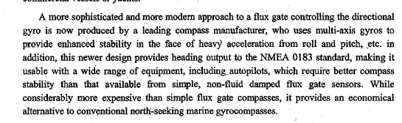
- Turbine diffusor ပါတဲ႔ မီးစက္ တါဗိုခ်ာဂ်ာတလံုး surging ၿဖစ္လို႔ အင္ဂ်င္လဲmajor overhaul လုပ္ၿပီး။ air cooler လဲ acc 9 နဲ႔ ၂၄ နာ၇ီစိမ္ၿပီးေဆးၿပီး။ၿပီး turbocharger cartridge တခုလံုးအသစ္လဲၿပီး။ဂါဗနာလဲစစ္ၿပီး - surging ကမေပ်ာက္ဘူး ၿဖစ္ေနတယ္။ဘါဆက္လုပ္ၿကမလဲ။( မွတ္ခ်က္ - load အနိမ္႔မွာေတါ႔ သိပ္မဆိုးဘူး။ load မ်ားမွပိုၿဖစ္တယ္ဆိုပါေတါ႔)
- Inert gas generator တလံုးကိုထိန္းတဲ႔ PLC ၇ဲ႔ ANALOG OUTPUT MODULE ႔ပ်က္သြါးတယ္။ အဲဒီ IGG မွာ၇ိွတဲ႔ SCRUBBER S.W PUMP ကို START လုပ္တါ၇ယ္။IGNITION PLUG ကို ignite လုပ္တဲ႔စံနစ္ ၇ယ္။ IGG CAPACITY ကို CONTROL လုပ္တဲ႔ ဗါး၇ယ္။ INERT GAS OXYGEN CONTENT ကို CONTROL လုပ္တဲ႔ ဆီဗါးကိုထိန္းတဲ႔ စံနစ္၇ယ္ စတါေတြမွာ ဘယ္ဟါ က အလုပ္မလုပ္ေတါ႔ဘို႔ပိုနီးစပ္လဲ။
- ဘိုင္လါတလံုး၇ဲ႔ CASCADE စံနစ္တခုမွာ FUEL CONTROLLER နဲ႔ AIR CONTROLLER ၂ ခုပါတယ္။ AIR CONTROLLER မွာ FD FAN damper ကို ဖြင္႔ဖို႔ေပးတဲ႔ SIGNAL ကေပးေၿကာင္းၿပေနေပမဲ႔ AIR PRESSURE တက္မလါေတါ႔ FUEL CONTROLLER က ဆီေက်ြးတါၿပန္ဆြဲခ်ေနတယ္။ CARGO TURBINE ကလဲ RPM တင္ဖို႔လိုေနၿပီ။ ဘါကိုသြါးၿပီး ခ်ိန္ၿက။ ၿပင္ၿကမလဲ၊
- Steering gear 2 လုံးကို follow up mode နဲ႔ ၿပိဳင္ေမါင္း၇င္ no 2 က Hydraulic loop fault alarm လါၿပီး Hydraulic lock နဲ႔ ၇ပ္သြါးတယ္။ တလံုးစီ non follow up mode နဲ႔ေမါင္းၿကည္႔ေတါ႔ အိုေကဘဲ။ အလြယ္ဆံုးဘါကိုစစ္မလဲ။
- ၇ိုက္ဖယ္ေသနတ္ေၿပာင္းတခုမွာ ေၿပာင္း၇စ္ဘါလို႔လုပ္ထါး၇တါလဲ၊
- MC S 50MC & S 70 MC အင္ဂ်င္ ၂ လံုး၇ဲ႔ Fuel high pressure pipe ေတြ၇ဲ႔ ( distance from pipe end to thrust bushing lower edge ) တူလါး။
- AIR COMPRESSOR တလံုးမွာေပးထါးတဲ႔ ၁၈၀ M3/HR (FAD) ဆိုတါဘါလဲ၊
FREE AIR DELIVERY – FAD

၁-MC-C Engine တလံုး piston ring လဲမယ္ ။CPR Ring ကို ၿပန္တပ္အခါ ring expander tool သံုးၿပီးၿပန္တပ္၇တယ္။ အဲလို expand လုပ္တဲ႔အခါ အမ်ားဆံုး cpr ring expand လုပ္နိုင္တဲ႔သတ္မွတ္ခ်က္ limit ၇ိွလါး။၇ိွ၇င္ဘယ္မွာၿကည႔္၇မလဲ။
၂-MC-C Engine air cooler tube leakage ၿဖစ္ေနတယ္။္ air cooler မၿဖဳတ္ဘဲနဲ႔ ဘယ္ tube ေပါက္ေနတယ္ဆိုတါဘယ္လို၇ွာမလဲ။
Vacuum tool နဲ႔။ အဲဒီ tool မွာtube တဖက္ကိုပိတ္ဖို႔ rubber plug ပါတယ္။တဖက္က ၇ာဘါပလပ္နဲ႔ပိတ္ၿပီး တဖက္ကို VACUUM TOOL နဲ႔ TUBE အထဲ VACUUM ၇ေအါင္လုပ္။တကယ္လို႔ VACUUM မ၇၇င္ TUBE ေပါက္ေနၿ႔ပီ။
၃- ပံုမွန္ P I Convertor တလံုးကို ေက်ြးတဲ႔ 4-20 mA signal ၇ဲ႔ ဗို႔ (volt ) ကဘယ္ေလါက္လဲ၊
5 volt max (၁-၅ ဗို႔)
၄-thermocouple တခုက ထုတ္ေပးတဲ႔ signal က mV လါး။ mA လါး။
mV
၅-တကယ္လို႔ exhaust turbine တလံုး၇ဲ႔ exhaust က vacuum မ၇ေတါ႔၇င္ အဲဒီ turbine ကို steam ေပးေနတဲ႔ boiler မွာ ဘါ effect သက္ေ၇ာက္မလဲ၊
Boiler pressure တင္လို႔မ၇ေတါ႔ပါ။
၆-အခုေနာက္ပိုင္း ဘုိြင္လါတို႔။ incinerator တ္ို႔မွာ ပါတဲ႔ fuel supply valve က ၂ ခုတန္းဆက္ထါးလါး။ တခုတည္းလါး။
ဗါး ၂ ခုတန္းဆက္ထါးပါတယ္။
၇- spare အေနနဲ႔ ေ၇ွ႔လူေတြ စိတ္ထင္တိုင္းလဲထါးတဲ႔ flame sensor ေတြ၇ိွတယ္။ ထံုးစံအတိုင္း ‘can use” လို႔ေ၇းထါးၿကတါဘဲ။ တကယ္ေကါင္းမေကါင္း ဘယ္လိုစစ္မလဲ၊
မီးထိုးၿကည္႔၇င္
၈- MC-C Engine ပစ္စတင္ထုတ္ေတါ႔ အခက္အခဲေတ႔ြနုိင္တဲ႔ Liner မွာ၇ိွတဲ႔ wear ridge ကို ေဖ်ာက္၇မယ္။ ဘယ္လိုေဖ်ာက္မလဲ၊
၉-WOODWARD UG GOVERNOR တလံုးမွာ Compensating adjustment & needle valve adjustment ၇ိွပါတယ္။ဘယ္ဟါ က ဘါအတြက္ adjust လုပ္တါလဲ။ compensating adjustment လုပ္ဖို႔လိုမလိုဘယ္လိုသိနုိင္လဲ။ ဘယ္လို adjustment လုပ္မလဲ။
၁၀-တကယ္လုိ႔ 4-20 mA signal ကို 250 ohm precision resistor တခုနဲ႔ တန္းဆက္ၿပီးvolt signal အၿဖစ္ convert လုပ္၇င္ ဘယ္ေလါက္၇ိွမယ္ထင္လဲ၊
၁၁-MC-C engine အိုဗါေဟါလုပ္လို႔ pc ring ၿဖဳတ္၇င္ ဘယ္လိုၿဖဳတ္မလဲ။new spare pc ring ၇ိွလို႔ လဲသင္႔လါး။
၁၂-PISTON RING INSPECTION လုပ္ၿကည္႔တါ MANUAL ကအတိုင္း သစ္သါးေခ်ာင္းေလးနဲ႔ ဖိၿကည္႔ေတါ႔ ၿပန္ကန္အါးေတါ႔၇ိွတါပါဘဲ။ အဲလိုၿပန္ကန္တဲ႔အါး၇ိွတါနဲ႔ အဲဒီ RING မက်ိဳးဘူးလို႔ အေသအခ်ာေၿပာနိုင္လါး။
၁၃-တကယ္လို႔ EXHAUST TURBINE တလံုး၇ဲ႔ EJECTOR CONDENSOR CONDENSATE RETURN LINE က FLOAT STEAM TRAP အလုပ္မလုပ္ခဲ႔၇င္ဘါၿဖစ္နိုင္လဲ။
14- tanker ေတြ၇ဲ႔ hazardous area ေတြကို intrinsic electrical power supply လုပ္တဲ႔ exi barrier ေတြမွာ zener diode ေတြကိုဘါအတြက္သံုးထါးသလဲ၊
၁၅-အဲဒီ barrier ေတြမွာပါတဲ႔ fuse က hazardous area ဖက္မွာလါး ။ non hazardous area ဖက္မွာလါး။
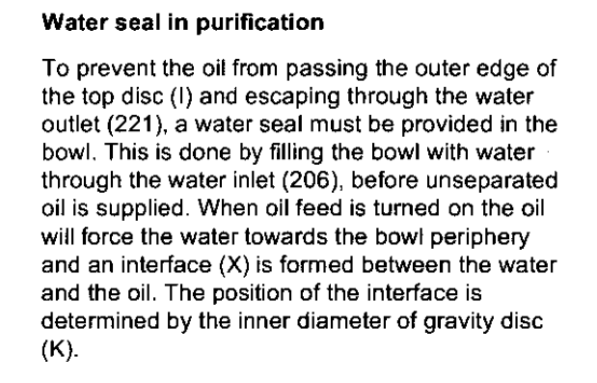
၁-MC-C Engine တလံုး piston ring လဲမယ္ ။CPR Ring ကို ၿပန္တပ္အခါ ring expander tool သံုးၿပီးၿပန္တပ္၇တယ္။ အဲလို expand လုပ္တဲ႔အခါ အမ်ားဆံုး cpr ring expand လုပ္နိုင္တဲ႔သတ္မွတ္ခ်က္ limit ၇ိွလါး။၇ိွ၇င္ဘယ္မွာၿကည႔္၇မလဲ။
၂-MC-C Engine air cooler tube leakage ၿဖစ္ေနတယ္။္ air cooler ဆြဲမထုတ္ဘဲနဲ႔ ဘယ္ tube ေပါက္ေနတယ္ဆိုတါဘယ္လို၇ွာမလဲ။
၃- ပံုမွန္ P I Convertor တလံုးကို ေက်ြးတဲ႔ 4-20 mA signal ၇ဲ႔ ဗို႔ (volt ) ကဘယ္ေလါက္လဲ၊
၄-thermocouple တခုက ထုတ္ေပးတဲ႔ signal က mV လါး။ mA လါး။
၅-တကယ္လို႔ exhaust turbine တလံုး၇ဲ႔ exhaust က vacuum မ၇ေတါ႔၇င္ အဲဒီ turbine ကို steam ေပးေနတဲ႔ boiler မွာ ဘါ effect သက္ေ၇ာက္မလဲ၊
၆-အခုေနာက္ပိုင္း ဘုိြင္လါတို႔။ incinerator တ္ို႔မွာ ပါတဲ႔ fuel supply valve က ၂ ခုတန္းဆက္ထါးလါး။ တခုတည္းလါး။
၇- spare အေနနဲ႔ ေ၇ွ႔လူေတြ စိတ္ထင္တိုင္းလဲထါးတဲ႔ boiler flame sensor ေတြ၇ိွတယ္။ ထံုးစံအတိုင္း ‘can use” လို႔ေ၇းထါးၿကတါဘဲ။ တကယ္ေကါင္းမေကါင္း ဘယ္လိုစစ္မလဲ၊
၈- MC-C Engine ပစ္စတင္ထုတ္ေတါ႔ အခက္အခဲေတ႔ြနုိင္တဲ႔ Liner မွာ၇ိွတဲ႔ wear ridge ကို ေဖ်ာက္၇မယ္။ ဘယ္လိုေဖ်ာက္မလဲ၊
၉-WOODWARD UG GOVERNOR တလံုးမွာ Compensating adjustment & needle valve adjustment ၇ိွပါတယ္။ဘယ္ဟါ က ဘါအတြက္ adjust လုပ္တါလဲ။ compensating adjustment လုပ္ဖို႔လိုမလိုဘယ္လိုသိနုိင္လဲ။ ဘယ္လို adjustment လုပ္မလဲ။
၁၀-တကယ္လုိ႔ 4-20 mA signal ကို 250 ohm precision resistor တခုနဲ႔ တန္းဆက္ၿပီးvolt signal အၿဖစ္ convert လုပ္၇င္ ဘယ္ေလါက္၇ိွမယ္ထင္လဲ၊
၁၁-MC-C engine အိုဗါေဟါလုပ္လို႔ pc ring ၿဖဳတ္၇င္ ဘယ္လိုၿဖဳတ္မလဲ။new spare pc ring ၇ိွတယ္။လဲ၇င္ေကါင္းမလါး။
၁၂-PISTON RING INSPECTION လုပ္ၿကည္႔တါ MANUAL ကအတိုင္း သစ္သါးေခ်ာင္းေလးနဲ႔ ဖိၿကည္႔ေတါ႔ ၿပန္ကန္အါးေတါ႔၇ိွတါပါဘဲ။ အဲလိုၿပန္ကန္တဲ႔အါး၇ိွတါနဲ႔ အဲဒီ RING မက်ိဳးဘူးလို႔ အေသအခ်ာေၿပာနိုင္လါး။
၁၃-တကယ္လို႔ EXHAUST TURBINE တလံုး၇ဲ႔ EJECTOR CONDENSOR CONDENSATE RETURN LINE က FLOAT STEAM TRAP အလုပ္မလုပ္ခဲ႔၇င္ဘါၿဖစ္နိုင္လဲ။
14- tanker ေတြ၇ဲ႔ hazardous area ေတြကို intrinsic electrical power supply လုပ္တဲ႔ exi barrier ေတြမွာ zener diode ေတြကိုဘါအတြက္သံုးထါးသလဲ၊
၁၅-အဲဒီ barrier ေတြမွာပါတဲ႔ fuse က hazardous area ဖက္မွာလါး ။ non hazardous area ဖက္မွာလါး။
၁၆-အဲဒီ zener barrier မွာ hazardous area ကိုစီးတဲ႔ max current ကိုဘါနဲ႔ limit လုပ္ထါးသလဲ။
၁၇-ဟိုအ၇င္တံုးက 0-40 mA signal ကိုသံုးၿကတယ္ ။ အခုသိပ္မသံုးေတါ႔ဘူး။ဘါလိ္ု႔လဲ၊
၁၈- pneumatic signal သံုး positioner တခုမွာ nozzle & flapper နဲ႔ဆက္ထါးတဲ႔ Pilot valve ဆိုတါပါတတ္တယ္။ အဲဒီ ကေန actuator ကို drive လုပ္တဲ႔ ေလကိုထုတ္ေပးတတ္တယ္။ အဲဒီေလကိုအပိတ္အဖြင္႔လုပ္ေပးတဲ႔ valve seat နဲ႔ valve spindle မွာ ဘယ္ဟါက flapper နဲ႔ဆက္ထါးတတ္လဲ။
၁၉- air condition carrier compressor ေတြမွာပါတတ္တဲ႔ lub oil cut out ကို၀င္တဲ႔ ပိုက္ က တေခ်ာင္းလါး။ ၂ ေခ်ာင္းလါး။ ဘါလို႔လဲ။

20- 6L23/30 H မီးစက္တလံုး၇ဲ႔ တါဘိုခ်ာဂ်ာ NR 15 R တလံုး bearing & Labyrinth ring လဲဖို႔ turbine rotor & compressor wheel စတါေတြၿဖဳတ္၇တယ္။ အဲဒါေတြၿပန္တပ္၇င္ ဒီအတိုင္းတပ္လို႔၇လါး။ ဘါေတြကိုၿကည္႔၇မလဲ၊
၂၁- အဲဒီ NR 15 R မွာ JET ASSIST ပါတတ္တယ္။အဲဒီ တါဘိုခ်ာဂ်ာ၇ဲ႔ COMPRESSOR CASING က ဘါထူးၿခားလဲ၊ဘါၿဖစ္လို႔ jet assist သံုးထါးတါလဲ။
၂၂-AUX BOILER F.D FAN က STAR – DELTA နဲ႔ ေမါင္းတယ္။ အဲဒီမွာ TIMER က DELTA ေၿပာင္းဘို႔လုပ္ေပးတယ္။ အဲဒီ TIMER ကေန PLC ကို SIGNAL ေပးတယ္။ တကယ္လို႔ DELTA မေၿပာင္း၇င္ F.D FAN DAMPER ကို PLC က ဖြင္႔ခြင္႔မေပးဘူး။ အဲလို ဖြင္႔လို႔မ၇တါကို MANUAL နဲ႔ DAMPER ကိုသြါးဖြင္႔၇င္ ဘါၿဖစ္မလဲ၊
23- alfa laval SU831 purifier မွာ purifier shaft ကိ္ု ေမၚတါကေန belt နဲ႔ လွည္႔တယ္။အဲဒီ purifier မွာ bowl height တိုင္းဖို႔လိုလါး။ဘါေတြတိုင္းဖို႔လိုလဲ။
24-LP PISTON & HP PISTON ၇ယ္ပါတဲ႔ ့့HATLAPA V150 2 STAGE COMPRESSOR တလံုးမွာ H P VALVE မလံုလို႔ LP SIDE က Relief valve ပြင္႔တယ္။တကယ္လို႔ အဲဒီ relief valve ခ်ိန္တါမွားလို႔ မပြင္႔ခဲ႔၇င္ compressor ရဲ႔ LP Stage မွာ ဘါေတြၿဖစ္နိုင္လဲ။
၂၅- alfa laval SU831 purifier မွာ bowl opening & closing အတြက္ ေ၇လိုင္း ၂ ခုမပါဘဲ တခုတည္းပါတယ္။ ဘယ္လို bowl အဖြင္႔ အပိတ္လုုပ္လဲ၊ closing water valve ဖြင္႔၇င္ bowl open မၿဖစ္နိုင္ဘူးလါး။
26-purifier ေတြမွာလိုအပ္တဲ႔ rpm မ၇၇င္ ဘါလို႔ဆီလ်ံွတါလဲ။ lafa laval MMPX 404 မွာ running hour အတိုင္း BELT အသစ္လဲၿပီးေတါမွ ၿပန္ေမါင္းေတါ႔ ဆီလ်ွံေနတယ္။ ဘါေၿကာင္႔ၿဖစ္နိုင္လဲ။

